Project / Subproject  IDA/EINRC framework 501998  Specific Agreement-4/EIONET | Authors  TietoEnator Corporation | Date issued / Version  11 April 2001/0.31/  14.6.2001/0.4 | Analysis Report
Client  European Commission  DG Environment / B 1 | Info  Analysis of Current Situation and Definition of User Requirements |  | Reference / Page  EINRC_META_URDv0.4.doc  / 1 of 52

EUROPEAN COMMISSION
ENVIRONMENT DIRECTORATE-GENERAL
IDA-Programme -Framework Contract No 501 998 - 4th Specific Agreement

Einrc - Eionet

Current situation and user requirements
META: Common tool for Environmental Metadata in EIONET

Modification history

Date | Version | Authors | Reason for modification
31.1.2001 | V 0.01 | K. Lounamaa | First internal draft based on existing documentation
30.3.2001 | V 0.1 | K. Lounamaa  J. Heinlaid | First draft
5.4.2001 | v 0.2 | E.Palosuo | Comments incorporated
6.4.2001 | v 0.3 | K.Lounamaa  J. Heinlaid | Changed according to comments.  Chapter 8 added
11.4.2001 | v0.31 | H. Saarenmaa | Comments incorporated
14.6.2001 | v0.4 | E.Palosuo | Chapter 1.2 with short overview of current situation

APPROVAL PROCEDURE
Reviewer | Version(-s) | Start  Date | Finish  Date | Required modification/Approval/Comments
Project Team | v0.3 | 6.4.2001 | 19.4.01 | Approved without comments
Project Leader | v0.31 | 6.4.2001 | 11.4.01 | Approved with comments incorporated
Meta User Group | v031 | 7.6.2001 | 11.6.01 | Approved by NMC CIRCLE UG in FARO meeting without comments
Einrc Mgt Team | v0.4 | 19.7.01 | 7.8.01
Project Officer

Table of Contents

1. Background 4
1.1 Background and development proposals 4
1.2 Current situation 4
1.2.1 Current features in EIONET's data collection 4
1.2.2 Metadata activities in EIONET 5
1.2.3 What could be reused from US EPA 6
1.3 List of sources and reference material 6
2. Requirements for the Data dictionary 8
2.1 Requirements from the Call-for-tender 8
2.2 Requirements from ReportNet v 03 9
2.3 Requirements from ISO 11179 10
2.3.1 General requirements 10
2.3.2 Requirements from part 4: Rules and guidelines for the formulation of the definition of a data element 10
3. Requirements for the Content registry 13
3.1 Requirements from the Call-for-tender 13
3.2 Requirements from ReportNet v 03 14
4. Architectural requirements 16
5. Data dictionary: Conceptual model 18
5.1 Conceptual data model 18
5.2 Basic attributes of data elements according to ISO 11179 19
5.3 Business process 'Registering EIONET's data definitions' 22
5.4 Use cases 22
Generally, use cases can be seen on three levels: 22
5.4.1 Main Use Case View 23
5.4.2 Modify Use Case View 24
5.4.3 Export / Import Use Case View 26
6. Content registry: conceptual model 28
6.1 Dublin core and GELOS element sets 28
6.2 Conceptual data model 31
6.3 Business process 'Registering metainformation into Content registry' 32
6.4 Use cases 32
6.4.1 Main Use Case View 33
6.4.2 Modify Use Case View 35
6.4.3 Export / Import Use Case View 36
7. Technical architecture of the Metadata system 38
8. Proposed attributes for data definitions and content descriptions 41
8.1 Preliminary attributes for data definitions 41
8.1.1 Samples 42
8.2 Proposed attributes for content descriptions 45

Annexes:
Annex 1: Mission Report US EPA meeting 16.2.2001/Stefan Jensen

Background

Background and development proposals
One of EIONET's main goals is to provide an information infrastructure for being able gradually to build more harmonised and more automated network based processes for data collection, storage and reporting (Reportnet). Internet based technology and XML -based standards are used. This META project is part of this infrastructure work with the objective of answering to users' questions:
- What is the data
- Where is the data.

Central building blocks for EIONET's Metadata system are:
- Inventory of EIONET's environmental data definitions and XML Schemas in a Data dictionary tool with multi-user access over the web to its services. This tool answers the question "What is the data?".
- Content registry based on XML content management: a catalogue of reported data sets on EIONET sites and links to these reported data sets on EIONET sites. This tool answers the question "Where is the data?".

The design principles for the target Metadata system are
- The objective is an integrated system, it must integrate into the existing infrastructure, especially CIRCA
- The system will be a tool for harmonisation, it must follow standards, especially ISO/IEC 11179 and Dublin Core recommendations.
- Although human interfaces will be needed, the physical system architecture will be primarily machine-to-machine (or peer-to-peer) providing logical semantic network.

Current situation

Current features in EIONET's data collection

The EEA and its topic centre partners have developed many ways to collect environmental data from data suppliers in EIONET member states. These data are currently stored in various diversified databases in distributed locations around Europe. No systematic method and tools for the national EIONET sites to store the reported data files are available yet, but will be developed in future.

Some problems or missing useful features:
- Common method for sharing best practices and tools is missing.
- No central EIONET source is available for sharing, harmonising and reusing environmental data definitions. EIONET's data definitions reside in distributed media, in documents, in applications, or not in visible transferable format, implicitly in expert brains. New database and data collection system developments have to start from scratch.
- Possibilities for harmonisation and standardisation across topics are unidentified. Member states have to accept different terms for same concepts and report data to EIONET with various methods and tools depending on the (sub-)topic.
- Reported data sets gathered from diverse sources may not be comparable and reliable if national providers have not been able to compare definitions of their monitored data with required data.
- Consistent format and tools for creating and sharing data definitions are missing.
- Users of EIONET's data don't know where in EIONET nodes the reported data sets are and what the quality of data in them is.

The META system is aimed to removing these problems.

Metadata activities in EIONET

A full inventory of metadata activities has not been put together yet in EIONET. Such an inventory will be a later activity and a basis for further extending the scope of Metadata system's Content registry and possibly for starting to harmonise metadata in EIONET's systems. It could identify roughly the following areas:

At the EEA level:
- the Directory of Information Resources (DIR): metadata on EEA products (publications, SERIS); some national products – currently used to underpin the reference centre information
- the EIONET directory – taken out of the DIR and maintained in the CIRCLE environment
- the Web-ROD metadatabase (a merger of REC, old ROD, EU legislation in force ...)
- metadata within EEA applications like NATLAN (and their might be more)
- metadata within the EEA’s data warehouse
- metadata in the Information Centre of the EEA (e.g. of publication or library items)
- metadata of documents handled in CIRCLE (also part of the EIONET level)
- metadata of data flow projects in EEA (some – or all? – of them in CIRCLE in document form)

At EIONET level:
- metadata with ETC databases maintained at ETC level.. At ETC level there are quite a few meta databases e.g. Waste has developed several catalogue systems, Airbase and Waterbase have such aspects ...
- metadata in portal applications (like the one encouraged with ZOPE in EIOAPP)
- metadata about environmental data in member states (CDS like applications)
- other metadata services in member states, such as GEIN, Sweionet and the IFEN system.

Besides the metadata question we have to look at where we get “standardising” information from – in the sense of what ISO11179 demands (definitions, lists, footprints, glossaries, thesauri - both, domain specific and general...). This must be based on a consensus processes in the various domains (or business areas). This process has presumably been started in each area and needs examination as to how far it has been carried.

What could be reused from US EPA

Stefan Jensen paid a visit to US EPA in February 2001 and summarises:
The Missionrep-us-epa 16.2.2001/Stefan Jensen (Annex 1) highlights areas of activities at US-EPA. Still, it is extremely hard to translate/transfer it into the EIONET environment - we would need to identify topic areas and compare these to the US-EPA work. Until now the EIONET has a very different focus in topic areas. While at US-EPA main topic areas tackled are chemistry, biology and substances (see www.epa.gov/edr ), the best developed topic areas in the EIONET network are air quality and emission and some inland water aspects (increasingly supported through the new water framework directive) and - to a degree - biodiversity and waste issues.

The possible reuse of best practices in US EPA is initially not of an IT nature. In order to get there, work is needed on the standardisation level - bringing people inside the identified domains together and having them agree on their relevant "standards" (definitions, formats ...) is crucial!

US EPA system has been studied in this project but not reused.

List of sources and reference material
The user needs and the requirements for the new system were collected from the following sources:

Source | Description
EEA/Hannu Saarenmaa | 1) e-mails  2) http://eea.eionet.eu.int:8980/irc/eionet-circle/eionet-telematics/info/data/  en/reportnet03/  3) e-EIONET-GIP-02-wham[1].ppt
Call for Tender | sa4-091 RequirementsFinal.doc
ISO 11179
US EPA/EDR web site | http://www.epa.gov/edr/
ETC/CDS | http://www.mu.niedersachsen.de/system/cds/
SWEIONET | http://smn.environ.se/ and http://smn.environ.se/schema/
Working meeting at the EEA | 19.02.2001
Project kick-off | 02.03.2001
Project team telemeeting | 26.03.2001

The following standard and industry specifications are referenced in this analysis:

Reference material | Description
XML standards:  - XML 1.0  - XML Schema  - RDF | http://www.w3.org/TR/REC-xml  http://www.w3.org/XML/Schema  http://www.w3.org/RDF/
ebXML specifications | http://www.ebxml.org/
Dublin Core recommendations | www.dublincore.org/documents
SOAP - Simple Object Access Protocol | http://msdn.microsoft.com/xml/general/soapspec.asp
XMI - XML Metadata Interchange and UML - Unified Modelling Language | http://www.omg.org/technology/xml/index.htm
LDAP - Lightweight Directory Access Protocol | http://www.ietf.org/html.charters/wg-dir.html
UML | http://www.omg.org/technology/uml/index.htm
UDDI | http://www.uddi.com/, http://www.juddi.org/
CIRCA API | http://eea.eionet.eu.int:8980/Members/irc/eionet-circle/eionet-telematics/library?l=/circle_specification
Napster and OpenNAP protocols
W3 Consortium semantic net initiative

This analysis is divided into two parts: "Data dictionary" and "Content registry" and thus the two target systems are analysed separately. Nevertheless, the proposed system architecture is common to the both target systems providing high interoperability.

The requirements are presented in the sections 2, 3 and 4. The tables in each section list the user requirements collected from the existing source material. The requirements are transformed to functional requirements that describe how the system shall fulfil the original user requirements. The functional requirement column also sets the scope and limitations whenever applicable. Each requirement has a unique Id that can be used as reference code, for example REQ5.

Requirements for the Data dictionary

Requirements from the Call-for-tender

Id | Requirement | Functional requirement
 | A metadata registry to which specific data exchange modules, data warehouses, and new projects that need data definitions can refer and where they can share their definitions. | The Metadata system shall consist of  - a Data dictionary that contains the definitions. In this context we mean with the term 'definitions' both definitions of individual data elements (= definitions of EIONET parameters) and definitions of XML schemas used in processes for collecting topic specific data sets.  - data access interface for applications (data exchange modules; data warehouses ...)  - data access interface for humans and groups (projects)
 | Data dictionary based on XML schemas | The Data dictionary system shall be based on W3C XML Schema specification and tools: http://www.w3.org/XML/Schema.  The W3C Proposed recommendation 24 October 2000 shall be followed.
 | It shall be possible to define objects (concepts), their attributes, their data types, and allowable values. | The conceptual model of Data dictionary shall be based on ISO11179: Specification and standardisation of data elements.  The definitions of data elements shall be described in XML schema language.  The XML schema language shall be used to validate the allowed values (and value domains) of data elements in XML instance files.(= in data sets to be registered into Repositories)
 | It shall be possible to define relationships between objects | The data model shall be developed using object-oriented methodology (UML). The model shall include relationship attribute (inherits, association, dependency).
 | There shall be a user interface that allows these definitions to be created, browsed, and edited. | The user interface shall have at least the functions:  - create definition  - search definition by keyword  - browse sorted list of definitions. The sorting order shall be configurable.  - edit an existing definition  - delete definition  The users' roles:  - end users (read, search, browse)  - data administrators, stewards (full access to data owned by them)  - system administrator (full access to all data)  - the need for data reviewer role shall be studied
 | Definitions shall be possible to be selected for export and imported to and from XML Schema files. | The user interface shall have the functions  - Select definitions using search function  - Export the result set to a XML schema file  - Import from a XML schema file  - Select the XML schema by filename (on user's local machine) or URL (on any Web server)

Requirements from ReportNet v 03
Id | Usage requirement | Functional requirement
 | Harmonisation. Document for new database developers the shared definitions that could be reused. Browseable user interface and UML notation is necessary for this. | The Data dictionary shall have both human and application-to-application interface.  The human user interface shall allow users to:  - search and browse definitions (see [REQ5])  - export definitions in XML schema format  - convert XML schema to UML (using XMI interchange format)  The Data dictionary shall have an XML message interface (SOAP) that allows applications to:  - send requests (queries) to the Data dictionary  - receive results in XML
 | Link to directory data. Each person can choose 0-many parameters they are experts of. | The Data dictionary shall provide a LDAP interface, which allows Directory users to  - create links to definitions of the Data dictionary (e.g. definitions of specific topic area)  The Directory implementation is out of scope of Data dictionary.  If the Directory application provides an LDAP interface to the development of the data dictionary, a proper communication should be made operational in the project.
 | The models that process indicator data from the contents of the repository can use these definitions (although also processing rules are needed) | The data model of Data dictionary could include formula attribute. The syntax of its content would be application dependent, e.g. it could contain an Excel calculation rule, MathXML, ...

Requirements from ISO 11179

General requirements

The general requirements for the Data dictionary (i.e. part of EIONET's Metadata system) are:
- Provide common understanding of the meaning, representation and identification of the data for both the owners and users.
- Metadata about data elements is stored in Data dictionary
- Metadata must be consistently specified and easily located
- Registration is the process of documenting metadata. Registration must be carried out at the data element level.
- There is a need to register also "metadata about metadata" for example technical metadata containing usernames, timestamps and other registration information (see example of attributes 6.1 - 6.19 in chapter 5.2).
- Users must be able to interpret the descriptions correctly and unambiguously.
- Basic attributes of data elements are defined in part 3 of the standard. Attributes can be mandatory, conditional or optional. See section 5.2 for description of the basic attributes.
- Unique numerical identifiers are assigned to each registered data element, as well as the property and object class represented by the data element.
- The Data Dictionary must be possible to use from other applications. Especially, it must be possible to use from the Reporting Obligations Database so that for each obligation, the required data elements can be identified and linked to. From the Repository application, it must be possible among the metainformation to show which data elements are contained in the document concerned. For the user directory, people who have proposed data definitions and are responsible of the definitions must be possible to identify. The Data Exchange Modules must be able to retrieve from the Data Dictionary the relevan data definitions for validation. Naturally, the content registry must be able to point to the relevant data elements. This list can be continued and is not exhaustive.

These requirements are important especially when the EEA specifies guidelines and rules for EIONET's business process 'Registering metadata about EIONET's data elements'.

Requirements from part 4: Rules and guidelines for the formulation of the definition of a data element

One of the attributes in the ISO11179 metadata set for describing data elements is a verbal 'Definition'. In this context the term 'Definition' refers to this verbal attribute. The following rules give guidelines for writing standardised verbal definitions:

Id | Rule | Functional requirement
 | Each data element must have a well-formed verbal definition, clearly understood by every user | Rules that are simple enough should be implemented in the system as part of the business logic.  Definition texts are expressed as natural language statements. In order to implement rules the system should support parsing of natural language statements  The lack of natural language parsers is a limitation to automatic checking. Nevertheless some of the simple rules could be implemented without linguistic parsing especially if the language is English. For example  - compare words and sentences  - check if word is in plural  - check if sentence is negative  - check if word is an abbreviation
 | An associated glossary of terms used in the definitions must be established | The glossary of terms should be a part of the Data dictionary. The system should check that the terms are properly used.  Basis for this Glossary shall come from the current GEMET vocabulary, extended by the EEA Glossary. A sensiblke mechanism for suggesting further definitions by the user shall be implemented. This shall make use of the user management and login facilities of the application.  As an additional feature – to validate GEMET definitions in “real life applications”, a function for adding comments to the current GEMET suggestions shall be added.
 | Definitions must be unique within a dictionary and have a single meaning | The system should check that the text of the definition is unique within the Data dictionary and that the expression is in singular (an exception is made if the concept itself is in plural).
 | Definition must state what the concept is, not only what it is not | The system should check the sentence is in positive, not containing negatives.
 | Definitions must be expressed with descriptive phrase or sentence(s). | The system should check that the definition is not just the words of the name (in different order). If more than a phrase is used, the system should check that the sentence is grammatically correct.
 | Definitions must contain only commonly understood abbreviations. | The system should check that full words, not only abbreviations are used. The abbreviation could be given in brackets. The exception being the common abbreviations that should be included in the glossary, for example i.e., e.g.
 | Definitions must be expressed without embedding definitions of other data elements. | The system should check that the definition does not contain the definition of other concept. (The definition can contain other terms which should be provided in the glossary.) For the situation where the related definition is necessary, the system should provide a way to access the definition by the relational attribute.
 | Newly added definitions are usually not invented by a user but taken from a well recognised source or they are the result of a thorough discussion inside a topic area. | The system should provide a place for making a reference to the definition source. There shall be a special dictionary to cover these sources. A simple solution can be to maintain a list of these sources.
Id | Guideline | Functional requirement
 | A definition of data element should:  - State the essential meaning of the concept  - Be precise and unambiguous  - Be concise  - To be able to stand alone  - Be expressed without embedding rationale, functional usage, domain information, or procedural information  - Avoid circular reasoning  - There might be more recommendations on how to deal with definitions | The guidelines and examples shall be made accessible to the users both in hypertext and printable form.  The system shall include comprehensive and context sensitive help facility that provides the guidelines and examples.

Requirements for the Content registry

Requirements from the Call-for-tender
Part of the ReportNet architecture is to design Repository system for storing reported data sets/content files reported from the Member States. The Repository system needs to be tightly integrated with the Data dictionary and a central Content registry as specified in the following requirements:

Id | Requirement | Functional requirement
 | The Repository tool to be developed takes an XML export file from a DEM such as those for AE, AQ, IW or NC, and involves the users of these databases in the process. For integration purposes it should also be able to take an XML file from the DIR or from other sources complying to the selected XML schema.  These definitions have then be uploaded to a CIRCA library, or similar repository of native XML content.  It will keep track of these uploaded contents or delivered data. | The system shall register metainformation about the content/resources stored in Repositories. In this context the registered resource/content is a data set. The registration shall be carried out at the data set level, e.g. Excel sheet, XML file, ...  The system shall consist of  - central metainformation database, accessible by application-to-application protocol  - interface/gateway for integration into the repositories, especially CIRCA  - automatic registration tool  - tool which allows users to search metainformation and locate data sets and their contents  - administrative user interface  The Content registry tool shall allow user to  - select the proper topic specific schema from the Data dictionary  - fill metainformation about the registered resource/data set in XML file format  - validate the XML file against the schema  The metainformation search tool shall allow user to  - search by metainformation fields  - locate registered resources also outside the repository the user is currently using.  (this needs an ALL option in the Repository pick list)  - follow a link (URL) to registered resources whenever possible  (in the current UI prototype, URI concept is used for the link)
 | It shall be possible to register with this metainformation the actual databases and XML data files where such definitions have been used. | The metainformation shall include a link to the topic specific schema of the registered XML data file/resource. The schema is provided by the Data dictionary.  This link information can be used to associate the registered resource with the data element definitions of the schema
 | Those shared elements that can be taken from the Dublin Core and GELOS definitions will have to be initially populated. | The metainformation contents will follow the Dublin Core and GELOS schemas when applicable. How this metainformation is included in Repository designs will be specified when designing application integration architecture.  The Dublin Core Metadata Element Set V1.1 specification with DCMI recommendations will be followed.  The GELOS element set will follow the ETC/CDS specification.  Should there be a conflict, please confirm solution with EEA.  The metainformation format shall be presented in XML, namely RDF syntax according to W3C recommendation.  The metainformation model shall be open and easily configurable for future additions and modifications of elements and their attributes.

Requirements from ReportNet v 03

Id | Usage requirement | Functional requirement
 | Describe the contents of the files in the repository. When files are uploaded in a repository, a metainformation page similar to the current CIRCA document library pages will have to be filled. From choice-lists – maintained in the Data Dictionary - the user chooses the entities and attributes. These can then later be used to categorise the contents of the repository and look at it from various angles. | The event when a user uploads a document in a Repository (e.g. CIRCA library) is triggered and the following sequence of tasks will be carried out:  - user fills the metainformation form and selects the classification keywords from a choice-list. This list is based on the topic specific schema and it's provided by the Data dictionary.  - notification message is sent either by email or PUSH  - metainformation is extracted from the notification message  - metainformation is stored in a central database  - the Content registry user interface allows users to search by metainformation fields and subject keywords
 | Be a reference data base for DEMs. DEM output files in XML should be formatted to comply with certain XML Schemata. | The Content registry tool shall allow users to:  - select the proper topic specific schema from the Data dictionary  - validate the populated XML file against the schema
 | Describe data needs of obligations in the ROD. The current parameter section on ROD can actually be replaced with the new component.  (Indeed, this has to happen)  (This is actually a Data Dictionary requirement.) | The Content registry could allow users to  - Link RO-POOL parameters (currently identified in RO-POOL by name) to relevant data elements and schemas in Data dictionary.  - Specify customer-specific Style Sheet definitions XSLs and link to relevant RO-POOL obligation(-s) and to the relevant XML schema that includes all parameters needed by the customer in his XSL. The same XML schema may be linked to more than one XSL, thus one reported data file in a repository may be used to delivering data to several external customers if so agreed.
 | In the Content registry, describe where is content of certain parameters. | The Content registry will be a centralised service that provides metainformation about the registered data files/resources. The metainformation includes location information which is usually, but not restricted to, an online link (URL).
 | Search engines at EEA and EIONET could use these definitions to locate sources of data. Every database home page could contain in meta tags the served parameters. | The metainformation could be formatted and added to XML (or HTML) document's meta-section, so that the metadata-aware search engines could extract and index the metainformation.  Other possibility could be that the search engines harvest the central metainformation database.  Are there any suggestions for these search engines?  The DCMI suggests some (http://www.dublincore.org/resources/faq/#whatsearchenginessupport). EEA is currently checking for own experiences with them.
 | Allow users responsible of tracking national deliveries to international reporting to search delivered data sets by date, obligation, and responsible person. | Be ready to interface with NaMod, Workflow, if those subprojects provide the exact mechanism….  The interface shall be defined through shared metadata in the same description model (DC) and using XML.

Architectural requirements
Id | Architectural requirement | Functional requirement
 | The contractor shall propose solutions where possible.  The functionalities shall be packaged into one or several common tools that can be integrated with the existing EIONET systems, mainly CIRCA, Zope and MySQL. | TE shall re-use existing methodology and technology whenever possible and stick to recommended standards.  The solution shall be based on the following methodology and technology:  - Tieto Object modelling methodology (UML)  - Rational Rose modelling tool  (what’s that? Is it important to know for EEA?)  - UML to XML conversion and vice-versa (XMI as interchange format)  - XML server solution with Java classes, and MySQL database  - XML based SOAP as application-to-application protocol  - CIRCA interface/gateway through CIRCA API  Both the Data dictionary and the Content registry will be primarily XML stores where XML files will serve as the "master copy" of the contents. In Data dictionary the XML Schema syntax will be used and in Content registry the RDF syntax will be used. The MySQL database is needed for to provide indexing, search facility, administrative and technical metadata, administrative and managing functions and so on.  (Can we please learn what is kept in this DB and what in the XML files?)  The 100% XML in-out architecture will provide the best interoperability with all the existing tools and applications.
 | One possibility is to adopt a commercial or open source XML Schema editor for the specified work. | TE recommends the following tools:  - XMLSpy v 3.5. (www.xmlspy.com: license fee $ 150 - 200 per user).  - SoftQuad XMetaL (http://www.softquad.com/)  Do we need both? What are the Pro’s and Con’s?
 | Solutions reusable from open sources and/or other environmental institutions, especially US EPA where the subject has been studied extensively, shall be given priority, if appropriate. | US EPA contains about 6000 definitions but their content can't be re-used in EIONET. Only tools and standards could be re-used. I strongly disagree – we shall make use of the definitions wherever possible! On the other hand I doubt that tools can be re-used (which ones should that be) while we of course look after the same standards.
 | Expertise of the ETC/CDS shall be fully incorporated in the project. | ETC/CDS specifications on the GELOS and Dublin Core will be followed. ETC/CDS staff will review all documents at an early draft stage. I will from now on follow closely this development and co-ordinate the input inhouse.

Data dictionary: Conceptual model

Conceptual data model
The Data dictionary contains the definitions of the ReportNet Parameters. The parameters are described in the following table (source Reportnetv03 web-site). Also the corresponding description according to ISO/IEC 11179 is given.

Concept | Description | ISO/IEC 11179
Parameter | Basic object collected and processed in the Reportnet. The definition of this parameter will be stored in the Data dictionary.  The parameter is defined by means of entities, values, attributes, and units.  The owners and users of the parameter will be defined in the Directory.  The values of parameters are stored in hundreds of files (datasets) that are annually created in each country in the reporting process.  These datasets are uploaded into the content repositories where their metainformation is created and stored in central Content registry.
Entity | The containing object, for instance the medium. For example:  Air, water, industrial facility, ecosystem, habitat, site, … | Object class = a set of abstraction in the real world that can be identified with explicit boundaries and meaning and whose properties follow the same rules.
Attribute | The property of an entity. Examples: concentration of a substance (in the water), proportion of endangered species (in an ecosystem), SO2 emission from industrial facilities (in an area) | Data element = A unit of data for which the definition, representation, and permissible values are specified.
Unit | Description on how the values shall be presented. | The set of representations of permissible instances of the data element.
Value | The value of a parameter. For example:  A number, text string from a definition list of allowable values, … | The value out of set of permissible values pertaining to a data element.

The ebXML specifies two core concepts: elements and aggregates.

Elements are fundamental and reusable building blocks for use in multiple contexts. They are the basic information entities and independent from any specific context.

An element is specified by it's attributes. An attribute identifies a single unit of data whose characteristics (e.g. units, allowable values) are entirely defined by its specification within the Data dictionary.

There are two types of characteristics: 1) characteristics with fixed value ranges and 2) characteristics with units of measure. These are called type 1 characteristics and type 2 characteristics respectively. For example "station size" is type 1 characteristics, it can have one of the values "Largest, Very large, Large, Medium, Small". Whereas "Longitude" is type 2 characteristics, it's value is measured in unit "degrees".

An aggregate is a set of related data elements whose characteristics define a single distinct concept (a party (actor), a place, a product, a service, etc). An important feature is that an aggregate is always defined in a context.

The context describes the environment or discipline in which the entity is applied or from which it originates. For example in EIONET the context can be defined by country, topic, and body.

EIONET "station" is an example of an aggregate. It contains several elements for example "size", "type", "position", ... Position can be further specified by "longitude" and "latitude". The elements of the station can have different values depending on the context, for example "station size" in "lake" context can have a different set of allowable values than in "river" context. In fact, “station” is a subtype of a more generic element “site”….

The Annex 2 contains a preliminary conceptual data model in UML notation.

Basic attributes of data elements according to ISO 11179
The following tables contain the basic attributes of data elements according to ISO/IEC 11179, in other words the metadata set for describing data elements. The first table contains the attributes of business metadata, the second table contains the attributes of administrative metadata.

Table 1: Attributes of business metadata

Name and definition of attribute | Obligation | Responsibility  SO/RO/RA
1. Identifying attributes
- Name | M | P/R/R
Single or multi word designation assigned to a data element.
- Identifier | M | -/-/A
A language independent unique identifier of a data element within a Registration authority.
- Version | M | -/-/A
Identification of an issue of a data element specification in a series of evolving data element specifications within the Registration authority.
- Registration authority | C | P/-/R
Any organisation authorised to register data elements.
- Synonymous name | O | P/-/R
Single word or multi word designation that is different from the given name, but represents the same data element concept.
- Context | C | P/-/R
A designation or description of the application environment or discipline in which a name and/or synonymous name is applied or originates from
2. Definitional attributes
- Definition | M | P/R/R
Statement that expresses the essential nature of a data element and permits its differentiation from all other data elements.
3. Relational attributes
- Classification scheme | O | P/-/R
A reference to (a) class(es) of a scheme for the arrangement or division of objects into groups based on characteristics which the objects have in common.
- Keyword(s) | O | P/-/R
One or more significant words used for retrieval of data elements.
- Related data reference | O | P/-/R
A reference between the data element and any related data.
- Type of relationship | C | P/-/R
An expression that characterises the relationship between the data element and related data.
4. Representational attributes
- Representation category | M | P/-/R
Type of symbol, character or other designation used to represent a data.
- Form of representation | M | P/-/R
Name or description of the form of representation for the data element, e.g. quantitative value, code, text, icon, ...
- Data type of data element values | M | P/-/R
A set of distinct values for representing the data element value.
- Maximum size of data element values | M | P/-/R
The maximum number of storage units to represent the data element value.
- Minimum size of data element values | M | P/-/R
The minimum number of storage units to represent the data element value.
- Layout of representation | C | P/-/R
The layout of characters in data element values expressed by a character string representation.
- Permissible data element values | M | P/R/R
The set of representations of permissible instances of the data element, according to the representation form, layout, datatype and maximum and minimum size specified in the corresponding attributes. The set can be specified by name, by reference to a source, by enumeration of the representation of the instances, or by rules for generating the instances.
5. Administrative attributes
- Responsible organisation | M | P/-/R
The organisation responsible for the contents of the mandatory attributes by which the data element is specified.
- Registration status | C | -/-/A
A designation of the position in the registration life-cycle of a data element.
- Submitting organisation | O | P/-/R
The organisation that has submitted the data element for addition, change or cancellation.
- Comments | O | P/-/R
Remarks on the data element.
Obligation:
M = mandatory, O = optional, C = conditional
Responsibility:
P = Provide, A = Assign, R = Review
Organisations:
SO = Submitting organisation, RO = Responsible Organisation, RA = Registration Authority

Table 2: Administrative metadata attributes

Name of attribute | Obligation | Responsibility  SO/RA
- Administrative status | M | -/A
- Address of submitting organisation (SO) | M | P/R
- Name of SO's contact person | M | P/R
- Title of SO's contact person | O | P/R
- Postal address of SO's contact person | M | P/R
- Electronic mail address of SO's contact person | O | P/R
- Phone number of SO's contact person | M | P/R
- Fax number of SO's contact person | O | P/R
- Telex number of SO's contact person | O | P/R
- Date of original assignment | M | -/A
- Date of last update | C | -/A
- Address of current owner (CO) | M | P/R
- Name of CO's contact person | M | P/R
- Title of CO's contact person | O | P/R
- Postal address of CO's contact person | M | P/R
- Electronic mail address of CO's contact person | O | P/R
- Phone number of CO's contact person | M | P/R
- Fax number of CO's contact person | O | P/R
- Telex number of CO's contact person | O | P/R
Obligation:
M = mandatory, O = optional, C = conditional
Responsibility:
P = Provide, A = Assign, R = Review
Organisations:
SO = Submitting organisation, CO = Current owner, RA = Registration Authority

Business process 'Registering EIONET's data definitions'
The business process related to registering EIONET's data definitions into the Data dictionary has two main steps: defining and registering metadata attributes of EIONET's data elements (EIONET parameters) and of their aggregate elements and designing and registering XML schemas. The process can be described with the following sentences:
- Data administrator defines a data element (= EIONET parameter) by providing information in its metadata attributes, including its verbal description, unit and allowable values.
- Data administrator defines aggregate elements by providing information in its metadata attributes. Most of the aggregate elements are/will be common standardised elements in EIONET, like 'station' or 'topic').
- Data administrator defines a schema that describes the structure and relationships between the data elements and their aggregates.
- Data administrator imports the definitions of data elements, aggregate elements and schemas into the Data dictionary.
- The Data dictionary system registers the definition by giving it an identification number and other technical/administrative attributes and makes it publicly available to administrators, applications, developers, and anyone interested.
- The users search and browse the contents of the Data dictionary and the system allows them to export the definitions.
- The user queries the Data dictionary through a remote process, such as CIRCA upload, for documenting and validating the uploaded file.

Use cases

Generally, use cases can be seen on three levels:

- Main Use Case View – providing view of the most basic and general activities that can be performed by the user.
- Modify Use Case View – providing view of the basic modifying activities on Data dictionary entries.
- Export / Import View – providing view of the basic exporting and importing activities that can be performed with Data dictionary entries.

Each of these use cases below is also more thoroughly explained and exposed.

Main Use Case View

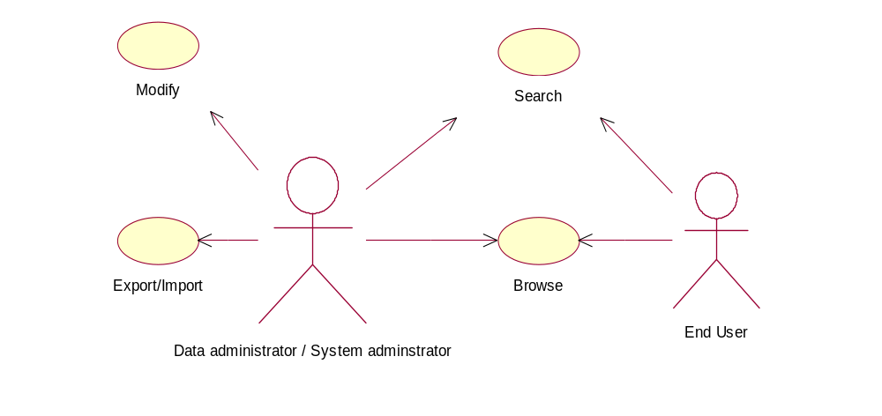

There will be two types of administrators:
- Data Administrators
Have full (read/write) access to ALL data
- System Administrator
Have full (read/write) access to data owned by them
Both of the administrators have to be authenticated in order to perform write (add, edit, delete) operations.
End User is a simple user who has only read-only access (browsing and searching capability) to the dictionary and does not have to log in order to gain that access.

*

'Modify' is a general functionality for both data and system administrators and enables them to:
- add new data definitions
- edit already existing data definitions
- delete already existing data definitions
- define relations between data definitions
This functionality shall be provided via Web form interface where the administrator has to log in to become authenticated.

*

'Export/Import' is a general functionality for both data and system administrators and enables them to:
- import data definitions into the Data dictionary
- export data definitions from the Data dictionary
Both importing and exporting shall take place in XML format. This functionality shall be provided both on the Web-browsing level and on strictly applications level (meaning application-to-application communication, most probably on an XML-based protocol like for example SOAP). Administrators will have to log in to become authenticated to use this functionality.

*

'Search' is a general functionality enabled for all users and enables them to:
- search contents of Data dictionary by a keyword
- search contents of Data dictionary by data
definitions' fields (like name, author, etc)
- set sorting orders for the search results
This functionality shall be provided via the Web form interface, no login procedures are needed.

Query by remote process…. ( Is listed below under “validate” but maybe belongs here too)

*
'Browse' is a general functionality enabled for all users and enables them to:
- browse contents of Data dictionary by data
definitions' fields (like name, author, etc)
- set sorting orders for the browse results
This functionality shall be provided via the Web form interface, no login procedures are needed.

There is no BROWSE option in the UI-prototype!

Modify Use Case View

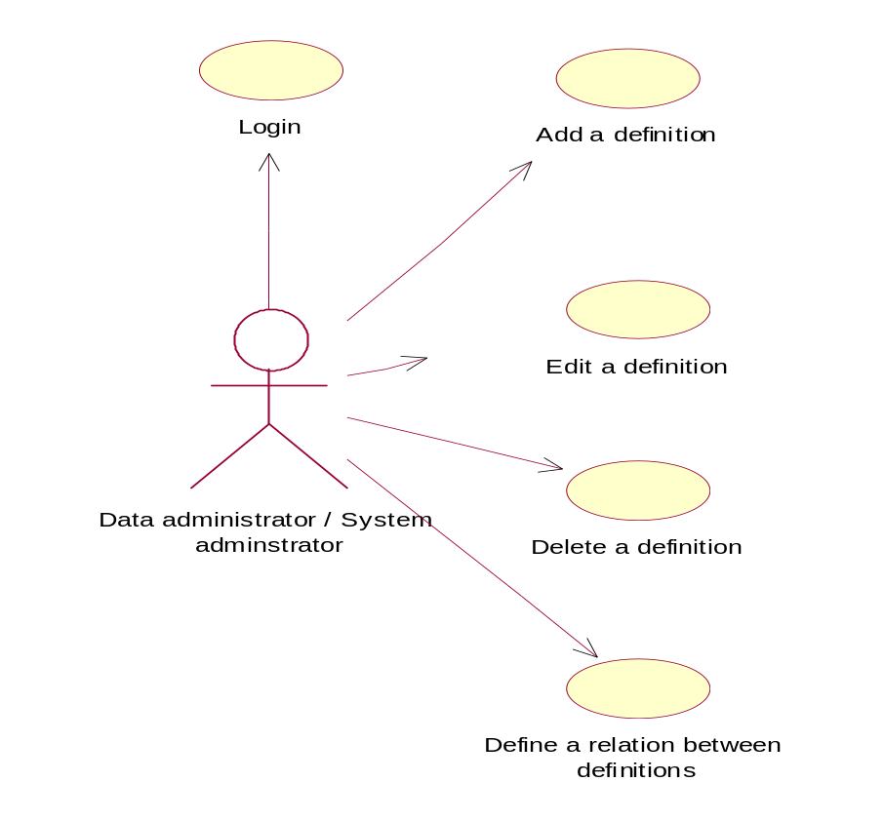

'Login' functionality is mandatory to perform in order to be able to perform any other functionality under the general functionalities of 'Modify' & 'Export/Import'.
Login is done via Web form interface if access is requested by a user or it will be done via application-to-application protocol if access is requested by an application.

*

'Add a definition' enables administrators to add new data definitions to the Data dictionary.
This is done via Web form interface, login has to be performed before doing so.

*

'Edit a definition' enables administrators to edit already existing data definitions in the Data dictionary.
This is done via Web form interface, login has to be performed before doing so.

*

'Delete a definition' enables administrators to delete already existing data definitions from the Data dictionary.
This is done via Web form interface, login has to be performed before doing so.

'Define a relation between definitions' enables administrators to define relations between data definitions existing in the dictionary.
This is done via Web form interface, login has to be performed before doing so.

NB! Note that when a data definition is explicitly modified through updating of its definition fields, the corresponding XML Schema in the schema repository will also be automatically and transparently for the modifier updated.

Export / Import Use Case View
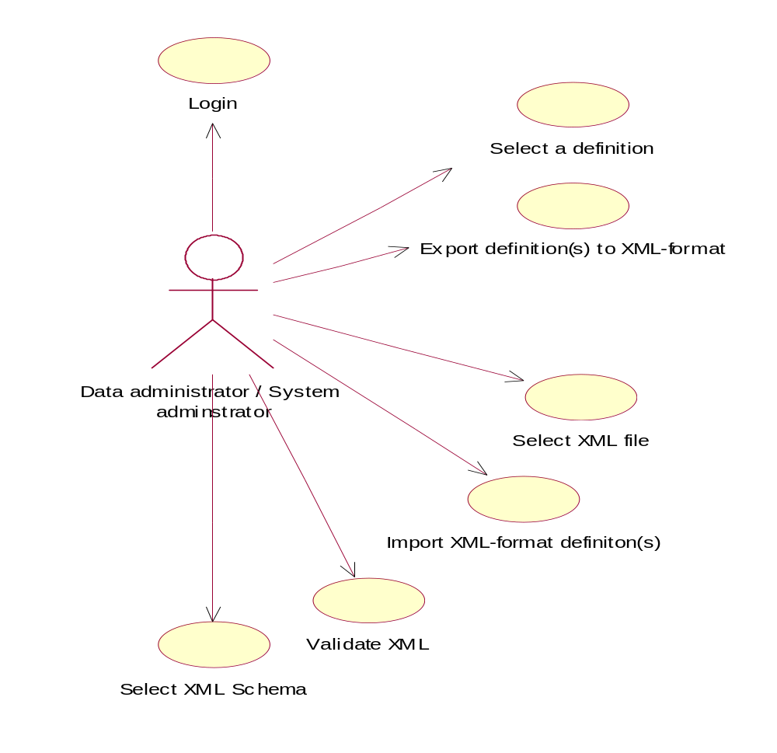
'Select a definition' is functionality provided to the user with the results of 'Browse' or 'Search' and enables to select definitions to be exported.
If this functionality is requested by an application, the identifying and selection of the definitions shall be done via application-to-application protocol.

*

'Export definition(s) to XML-format' enables users to export selected data definitions to XML format files and save them onto a hard drive. This functionality is provided via Web interface.
If requested by an application then it shall be done via application-to-application protocol.

*

'Select XML file' enables users to select the XML format data definitions from their hard drive via Web interface.

*

'Import XML-format definition(s)' enables users to import selected XML format data definitions to the Data dictionary.
This functionality is provided via Web interface. If requested by an application then it shall be done via application-to-application protocol.

*

'Validate XML' enables users to validate the XML format definitions against a selected XML schema, before importing them into the Data dictionary. This is done
via Web-interface.
If requested by an application then it shall be done via application-to-application protocol.

*

'Select XML Schema' enables users to select from a provided list of schemas an XML Schema against which the XML format definitions will be validated before importing them to the Data dictionary.
This is done via Web interface. If requested by an application then it shall be done via application-to-application protocol.

NB! Note that when a data definition is imported in XML Schema format, its definition fields in the dictionary’s database will also be automatically and transparently for the importer updated.

The above mentioned functionalities are only partly implemented into the UI prototype. E.g. the Export part is missing completely. Functions like “validate XML” would be interesting to look at.

Given the comments in ….., please provide a feedback mechanism for commenting the available GEMET definitions – which will become part of the system. Also a use case view for this shall be added:

5.4.4. GEMET / EEA Glossary definiton commenting use case

(sorry, I intended to provide a drawing but the picture could not re-used for changes)

Content registry: conceptual model

Dublin core and GELOS element sets
The Dublin Core Metadata Element Set V1.1 (DCMES) with the recommended qualifiers is presented in the following table: Note: in ISO11179 standard the term 'metadata attribute' is used instead of 'metadata element'

DCMES Element | Element  Refinement(s) | Element  Encoding Scheme(s)
Title | Alternative | -
Creator | - | -
Subject | - | LCSH, MeSH, DDC, LCC, UDC
Description | Table Of Contents  Abstract | -
Publisher | - | -
Contributor | - | -
Date | Created  Valid  Available  Issued  Modified | DCMI Period, W3C-DTF
Type | - | DCMI Type Vocabulary
Format | Extent | -
 | Medium | IMT
Identifier | - | URI
Source | - | URI
Language | - | ISO 639-2, RFC 1766
Relation | Is Version Of  Has Version  Is Replaced By  Replaces  Is Required By  Requires  Is Part Of  Has Part  Is Referenced By  References  Is Format Of  Has Format | URI
Coverage | Spatial | DCMI Point, ISO 3166,DCMI Box, TGN
 | Temporal | DCMI Period, W3C-DTF
Rights | - | -

All DCMES elements are optional and repeatable. The elements can be further refined with the qualifier attributes.

The elements can have any text value but the following encoding schemes are recommended:
- W3C-DTF for time instants.
- DCMI Period for identifying a single time interval using its limits.
- The DCMI Type Vocabulary provides a general, cross-domain list of approved terms that may be used as values for the Resource Type element to identify the genre of a resource.
- DCMI Point for identifying a point in space using its geographic co-ordinates.
- DCMI Box The DCMI Box encoding scheme is a method for identifying a region of space using its geographic limits.
- URI: RFC2396 Uniform Resource Identifiers. The standard includes URL specification.
- ISO 3166 Codes for the representation of names of countries.
- ISO 639-2: Codes for the representation of names of languages.
- Internet RFC 1766: 'Tags for the identification of Language' specifies a two letter code taken from ISO 639, followed optionally by a two letter country code taken from ISO 3166.

The GELOS (Global Environmental Locator System) elements are presented in the following table (source: http://www.schemas-forum.org/workshops/ws2/ws2-presentations/gelos-dc.html ). The semantic interoperability between GELOS and Dublin Core is described by mapping of elements.

Gelos-Element | Gelos Definition | DC-Element | DC Definition
Title | The primary label of the information resource described by the record | DC.Title | A name given to the resource
Type | Type of information resource described by the locator record | DC.Type | The nature or genre of the content of the resource
Abstract | A description of the information resource | DC.Description | An account of the content of the resource
Author | Identifies the organisation/person responsible for the intellectual content of the information resource | DC.Creator | An entity primarily responsible for making the content of the resource.
Author.Organisation | Authors institutional affiliation
Author.Street address | Name of street of authors address
Author.City | Name of city of authors address
Author.State | State in which author.city is located
Author.Zip | Postal Code of authors address
Author.Country | Name of Country of authors address
Author.Network_address | Authors electronic address (email-address)
Author.Telephone | Authors telephone number
Author.Fax | Authors fax number
Date of creation or last update | Date on which the information resource became available or was last updated | DC.Date.  Created  DC.Date.  Modified
Controlled_vocabulary | This element provides the title of a thesaurus or other controlled vocabulary list and the terms drawn from that list used to describe the subject matter covered by the information resource | DC.Subject
Controlled_vocabulary.title | Title of a thesaurus or other controlled vocabulary list
Controlled_vocabulary.terms | Terms drawn from that list used to describe the subject matter covered by the information resource
Uncontrolled vocabulary | Terms used to describe the subject matter covered by the information resource which are not drawn from a thesaurus or controlled vocabulary list
Spatial Coverage | Provides information about the spatial coverage of the information resource | DC.Coverage.  spatial | Spatial characteristics of the intellectual content of the resoure.
Temporal Coverage | Provides information about the temporal coverage of the information resource | DC.Coverage.  temporal | Temporal characteristics of the intellectual content of the resource.
Language of resource | Provides the name(s) of the language(s) in which the information resource is available and the respective ISO 639 standardised code(s). | DC.Language | A language of the intellectual content of the resource
Related resources | Provides references to records describing related resources | DC.Relation | A reference to a related resource
Distributor | Identifies the organisation from which the information resource is available | DC.Publisher | An entity responsible for making the resource available
Distributor.Organisation | Distributors institutional affiliation
Distributor.Street address | Name of street of Distributors address
Distributor.City | Name of city of Distributors address
Distributor.State | State in which Distributor.city is located
Distributor.Zip | Postal Code of Distributors address
Distributor.Country | Name of Country of Distributors address
Distributor.Network_address | Distributors electronic address (email-address)
Distributor.Telephone | Distributors telephone number
Distributor.Fax | Distributors fax number
Distribution medium | Used to indicate the format(s) in which the information resource is available, for example CD-ROM, paper, on-line | DC.Format.  Medium | The material or physical carrier of the resource
URL | Universal Resource Locator | DC.Identifier | An unambiguous reference to the resource within a given context
Access constraints | Constraints, legal or otherwise to accessing the information resource | DC.Rights | Information about rights held in and over the resource
Use constraints | Constraints, legal or otherwise to using the information resource | DC.Rights | Information about rights held in and over the resource
Control Identifier | Unique identifier assigned by the information provider (the GELOS Record Source) to distinguish a record from all other records on a particular GELOS serve | DC.Identifier | An unambiguous reference to the resource within a given context
Original control identifier | A GELOS record may have been created by copying and modifying an existing record from another locator system. This field provides a unique reference to the original record and the name of the originating server
GELOS Record Source | Identifies the organisation that created the GELOS locator record and is responsible for its maintenance
Language of record | Name of the language of the GELOS record and its ISO 639 standardised code
Date of creation or last modification of record | Date on which the GELOS record was created or last modified

Conceptual data model
The above DC and GELOS metainformation sets do not have an explicit reference to the Data dictionary…. (How do we deal with that?)
We have to try another mapping – which DC elements are used for the Dictionary? What are the open questions. Afterwards it should be possible to define a namespace for the Data Dictionary. I will also provide you with the GEMET datamodel which is shared among several thesauri and might be helpful (ACTION 1)

Instead of URL, we may need more detailed description such as: protocol , server, port, (URI/ Interest Group-Library section), public/members, username. Look at Napster protocol…

DCES seems to provide for that (e.g. DC-identifier) – we should look at DCES in the first stage – and keep the option to import GELOS metadata into the Registry!

Also attributes related to ROD and supervision of reporting may be needed. Deadline, responsible person, obligation, ….

We should receive them from a decision making process in the WebROD project (ACTION 2)

The data model of Content registry is simple, it has only one type of entities: metainformation containers.

Where have you got the term “container” from ? why not use metadata set as a general term (we used “data source” in the “GELOS world” – DCMI used DC element set)

The container is a set of metadata elements, for example "dc.creator", "dc.subject", "dc.description", .. where dc is a reference to Dublin Core namespace.

The structure of metainformation container is flat consisting of a sequence of metadata elements. The elements may have attributes, for example Dublin Core element qualifiers.

The data model of Content registry will have two types of containers: DCMES and GELOS. This ensures that the already existing content descriptions of existing repositories can be imported into the Content registry.

Very good! I wonder whether we rather call them metadata set’s?

Business process 'Registering metainformation into Content registry'
When a new Reported data set (new content entry) is registered into a Repository, a metainformation description of this new content entry (Reported data set) has to be created and registered as a new description entry into the Content registry.

The business process related to registering a new entry of metainformation into the Content registry when a Reported data set is registered into a Repository can be described with the following sentences:
- Data administrator uploads the Reported data set into the Repository.
- Data administrator creates the content description of the complete Reported data set using either the DCMES or GELOS metadata element sets as to be decided by the EEA. The purpose of this description is to provide metainformation (e.g. location) on a data set level.
- The Repository system automatically fires a notification event, which is caught by the Content registry system.
- The Content registry system automatically gathers the metainformation of the Reported data set and stores it in the central Content registry database.
- The “metadata publisher” does quality control on these entries
- The Content registry system makes the metainformation publicly available to administrators, applications, and anyone interested (EERC).

This sounds good but how do we make sure that this is done properly on the input side – we might need a mechanism (at least for a while) in which a “metadata publisher” supports the metadata editors (or authors) in this process

Use cases
Content registry is a system where updates by human will be quite rare (see above) and they will appear on administrational level. For the most part, actions in Content registry will take place on application level and they will be event-driven. Meaning that whenever some content (Reported data set) is updated in a content Repository interfaced with Content registry, an event is set up or thrown that triggers exchange of content’s meta-information between the repository and the registry. This could be organised in 2 ways:
- Content registry periodically checks Repositories for new entries and when found, a communication between the Repository and the Registry will take place that will eventually register the content with all its meta-information.
- Repository will notify the Registry of a new update and that is what triggers the registration process.

(I think you picked the second way for the update process – which you explain at another place in the doc)

The use cases below represent activities both for the human and application levels. Meaning that all the functionalities displayed, can be performed both by humans and applications as well.

There are three use cases listed here, on quite the same principles that were in the case of Data dictionary:

- Main Use Case View – providing view of the most basic and general activities that can be performed by the humans and applications.
- Modify Use Case View – providing view of the basic modifying activities on contents’ meta-information entries.
- Export / Import View – providing view of the basic exporting and importing activities that can be performed with contents’ meta-information.

(We need one more user case for someone searching for content uploaded by date and for fulfilment of particular obligation (or workflow event))….

Main Use Case View

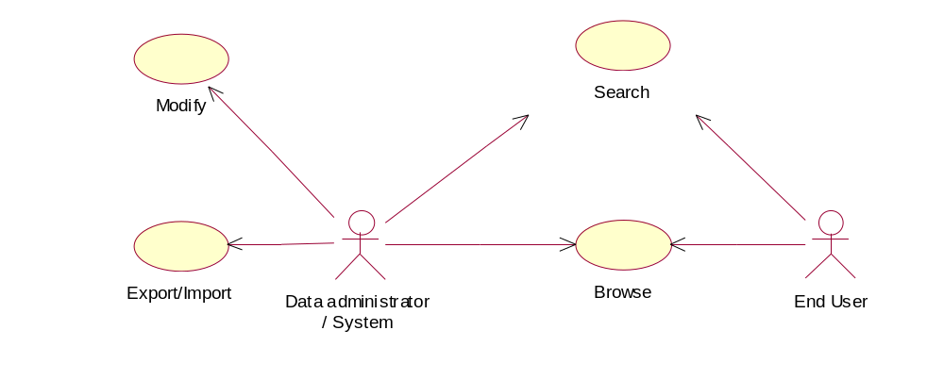

'Export/Import' is a general functionality for both data and system administrators and enables them to (user roles here are the same as for the dictionary):
- Import content descriptions into the Content registry
- Export content descriptions from the Content registry
Both importing and exporting shall take place in XML-based format like for example RDF.
Further down (in the technical architecture) you have selected RDF schemas– I would like to see a little reflection on the pro’s and con’s to use an RDF schema or an XML schema for this. The content resources themselves will not have to be in XML format. This functionality shall be provided both on the Web-browsing level and on strictly application level (meaning application-to-application communication, most probably on an XML-based protocol like for example SOAP).
Administrators will have to log in to become authenticated to use this functionality.

*

'Modify' is a general functionality for both data and system administrators and enables them to:
- Add new content descriptions
- Edit already existing content descriptions
- Delete already existing content descriptions
This functionality shall be provided via Web form interface where the administrator has to log in to become authenticated.

*

'Search' is a general functionality enabled for all users and enables them to:
- Search contents of Content registry by a keyword
- Search contents of Content registry by content description fields.
- Set sorting orders for the search results
This functionality shall be provided via the Web form interface, no login procedures are needed.

'Browse' is a general functionality enabled for all users and enables them to:
- Browse contents of Content registry by content description fields
- Set sorting orders for the browse results
This functionality shall be provided via the Web form interface, no login procedures are needed.

Modify Use Case View
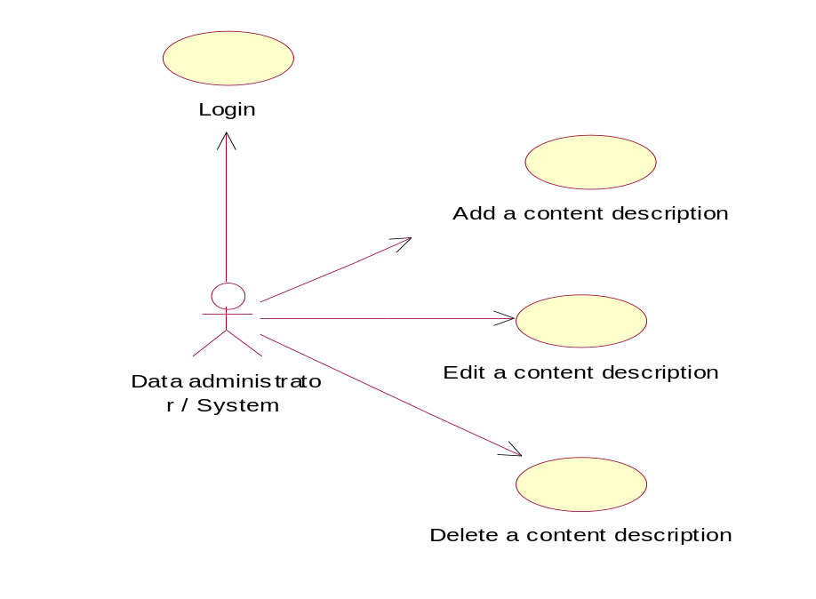
'Login' functionality is mandatory to perform in order to be able to perform any other functionality under the general functionality of 'Modify' & 'Export/Import'.
Login is done via Web form interface if a user requests access or it will be done via application- to-application protocol if access is requested by an application.

*

'Add a content description' enables administrators to add new content descriptions to the Content registry.
This is done via Web form interface, login has to be performed before doing so.

*

'Edit a content description' enables administrators to edit already existing content descriptions in the Content registry.
This is done via Web form interface, login has to be performed before doing so.

*

'Delete a content description' enables administrators to delete already existing content descriptions from the Content registry.
This is done via Web form interface, login has to be performed before doing so.

Export / Import Use Case View
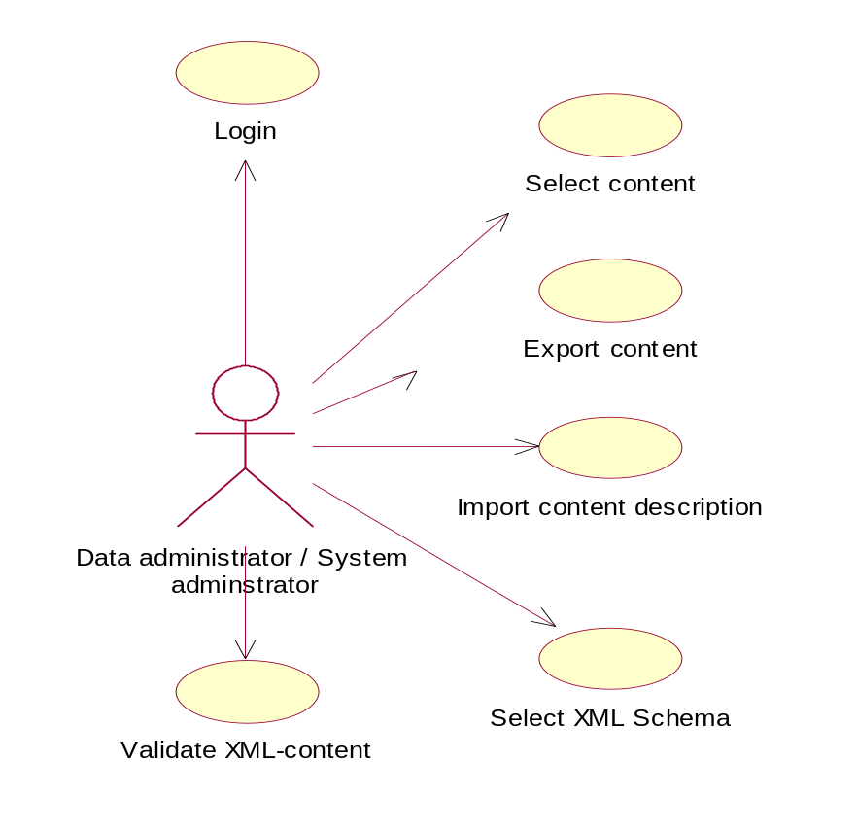
'Login' functionality is mandatory to perform in order to be able to perform any other functionality under the general functionality of 'Modify' & 'Export/Import'.
Login is done via Web form interface if access is requested by a user or it will be done via application- to-application protocol if access is requested by an application.

*

'Select content' is a functionality provided to the user with the results of 'Browse' or 'Search' and enables to select contents to be exported.
If this functionality is requested by an application, the identifying and selection of the definitions shall be done via application-to-application protocol.

*

'Export content' is a functionality that enables users to export/download content resources that were selected and save them on a hard drive.
This functionality is provided via Web interface. If requested by an application then it shall be done via application-to-application protocol.

*

'Import content description' enables users to import description of a new content resource and therefore "register" it. Content descriptions shall be imported on an XML-based format like for example RDF.
This functionality is provided via Web interface. If requested by an application then it shall be done via application-to-application protocol.

*

'Select XML Schema' enables users to select from a provided list of schemas an XMLSchema against which the XML format contents can be validated before importing their descriptions into the Content registry.
This is done via Web interface. If requested by an application then it shall be done via application-to-application protocol.

*

'Validate XML-content' enables users to validate the XML format contents against a selected XML schema, before importing their descriptions into the Content registry. This is done via Web-interface. If requested by an application then it shall be done via application-to-application protocol.

Very good -

Technical architecture of the Metadata system

The following figure shows the preliminary design of components and interfaces of the proposed target system. Both the Data dictionary and Content registry are presented as individual tools of the same META architecture. Although the tools are separated, they will be implemented using the same XML server framework.
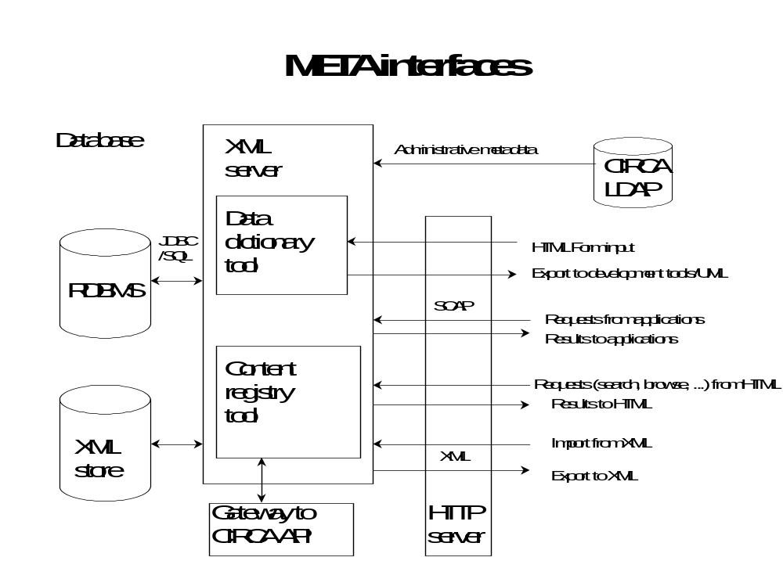
Figure 7.1: Proposed components and interfaces of the Metadata System

The following standard protocols will be supported:
- XML for import and export. XML Schema syntax for Data dictionary and RDF syntax for Content registry.
- SOAP for application-to-application protocol.
- LDAP for accessing administrative metadata in the Directory.
- JDBC for accessing SQL database.

The three tiered system architecture is presented in the following figure:
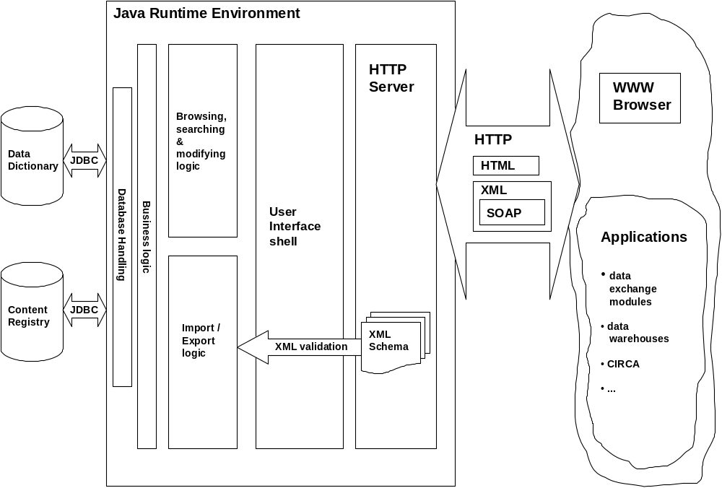

Figure 7.2: Preliminary system architecture of the Metadata System

The above picture represents system architecture both for the Data dictionary and Content registry, as the difference is only in the database. All the infrastructure around the databases follows similar technologies and principles.

The core part of the infrastructure is application software that will be written in Java programming language and therefore the whole application will run in Java Runtime Environment.

As for the communication basis between the Java code and the databases- it will be based on Java DataBase Connectivity (JDBC) driver.

Logically, the application software can be divided into 5 parts:

- Database handling logic- is responsible for performing the basic database operations, like SELECT, UPDATE, INSERT and DELETE operations.
- Business logic- is responsible for suiting and feeding the imported/updated data for the Database handling logic.
- Browsing, searching and modifying logic – is responsible for mediating the user –or application input data between the user client or application and the Business logic.
- Import/Export logic – is responsible for parsing and extracting imported data from XML format and mediating it to the business logic. For the case of export, this logic generates XML format output for the user/application requesting the data.
- User interface shell – is responsible for performing, keeping and maintaining the communication between the browsing-, searching-, modifying-, importing -and exporting logic and clients interfaced with HTTP-based formats.

On the lowest level, HTTP Server handles communication means between the system and it’s clients whether they are humans with a WWW browser or applications providing HTTP based communication formats, like HTML, XML and SOAP based on the latter. As the HTTP Server will also have to provide Java servlets for the clients, it must have compatibility with a Java Servlet Running Engine supporting JSDK 2.2 (Java Servlet Development Kit) and it is going to run in Java Runtime Environment.

XML Schemas, representing the data definitions in the dictionary, will also be provided by the HTTP Server via URL interface. XML Schemas are also used for validating an XML document when such is to be imported or registered in the Content registry. The block arrow with a title of XML Validation serves for that.

Regarding the clients, they are generally divided into 2 groups:

- Humans as users – interfaced with system by WWW browsers.
- Applications as users - interfaced with system by HTTP based formats, like HTML, XML and inter-application communication format SOAP (Simple Object Access Protocol).

Proposed attributes for data definitions and content descriptions

Preliminary attributes for data definitions
This is a preliminary proposal whose intent is to demonstrate the idea and methodology of using XML Schema as language for defining data elements. The attributes presented here represent the minimal set of attributes that can be used to define an element or an aggregate i.e. they represent the mandatory attributes according to ISO1179. Although this is a preliminary version, it can be expected that the attributes presented here will be present also in the final version. The complete set of attributes will be analysed and designed in the later phase of META project. It is Customer's responsibility to evaluate what attributes they want to include and maintain.

The proposal here is represented through sample data definitions based on data elements taken from the Inland Waters project.
(Which IW project?)
We should make sure to use an area where we have stable data flows and which we can use to (pre-) fill registry and dictionary. As I understood, these areas could be either
- Air Emmission or
- Designated Areas

Each sample is given in two forms:

- table form, listing the definition attributes (i.e. metadata attributes) and their meanings.
- XML Schema, providing the formal representation of a definition.

In the future system the two representations will also be present and linked so that a user can add/edit/delete a definition through a Web form that displays the definition attributes in a table-like editable view. And any modifications made through a Web form will also be automatically updated in the corresponding XML Schema in the system’s schema repository. And vice versa. When a definition is added/edited by importing it, the corresponding fields in the database will also be automatically updated and visible in the corresponding Web form.

Attributes proposed here for defining data elements, have been selected based on research in the ISO standards (ISO11179) and DublinCore suggestions (http://www.dublincore.org/documents/dces) that have been developed in this area and also similar systems that already exist, like US Environmental Protection Agency (www.epa.gov).

Selection has been made on the following guiding principles:

- Include at least those attributes that are declared mandatory in ISO11179 standard
- To the above add those that have been found useful in EPA’s experience
- To the above add those missing and suggested by DublinCore

It must be noted that Data dictionary database will be designed by keeping in mind a possibility for adding/removing definitions’ required attributes whenever it might be needed. So the list proposed here, is not by any means final.

Samples are presented for three categories of data elements:

- Elements having fixed value ranges (here Station Size)
- Elements having values measured in units (here Longitude)
- Elements consisting of a set other data elements (aggregates, here Station)

Before the samples, here are short explanations to meanings of each of the definition attributes that will be used below:

Name | The label assigned to the data element
Identifier | The unique identifier assigned to the data element
Version | The version of the data element
Language | The language in which the data element is specified
Definition | A statement that clearly represents the concept and essential nature of the data element
Datatype | Indicates the type of data that can be represented in the value of the data element
Minimum length | Minimum size (in characters) of a data element value
Maximum length | Maximum size (in characters) of a data element value
Allowable values | Permissible data element values
Scale | Maximum number of decimal digits in the fractional part of a decimal data element value
Precision | Maximum number of decimal digits of a decimal data element value
Source | Location of the original source document of the specification

Samples

Station Size

Definition:

Name | Station size
Identifier | 23
Version | 1
Definition | Size of a station as defined by a set of allowable values
Language | English
Datatype | String
Maximum length in characters | 80
Minimum length in  characters | 1
Allowable values | Large
Allowable values | Largest
Allowable values | Medium
Allowable values | Small
Allowable values | Very Large
Source | Location_of_original_source_document

Structure:

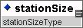

XML Schema:

<?xml version="1.0" encoding="UTF-8"?>
<xsd:schema xmlns:xsd="http://www.w3.org/2000/10/XMLSchema" elementFormDefault="qualified">
<xsd:simpleType name="stationSizeType">
<xsd:annotation>
<xsd:documentation xml:lang="en">
Size of a station as defined by a set of allowable values
</xsd:documentation>
</xsd:annotation>
<xsd:restriction base="xsd:string">
<xsd:minLength value="1"/>
<xsd:maxLength value="80"/>
<xsd:enumeration value="Large"/>
<xsd:enumeration value="Largest"/>
<xsd:enumeration value="Medium"/>
<xsd:enumeration value="Small"/>
<xsd:enumeration value="Very Large"/>
</xsd:restriction>
</xsd:simpleType>
</xsd:schema>

Longitude

Definition:

Name | Longitude
Identifier | 187
Version | 1
Definition | The measure of the angular distance on a meridian east or west of the prime meridian.
Language | English
Datatype | degreeType
Maximum length in characters | 5
Minimum length in  characters | 3
Scale | 2
Precision | 2
Source | Location_of_original_source_document

Structure:

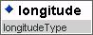

XML Schema:

<?xml version="1.0" encoding="UTF-8"?>
<xsd:schema xmlns:xsd="http://www.w3.org/2000/10/XMLSchema" elementFormDefault="qualified">
<xsd:include schemaLocation="X:\Projects\Meta\Schema\IWsamples\degreeType.xsd"/>
<xsd:complexType name="longitudeType">
<xsd:simpleContent>
<xsd:extension base="degreeType"/>
</xsd:simpleContent>
</xsd:complexType>
</xsd:schema>

<?xml version="1.0" encoding="UTF-8"?>
<xsd:schema xmlns:xsd="http://www.w3.org/2000/10/XMLSchema" elementFormDefault="qualified">
<xsd:simpleType name="degreeType">
<xsd:annotation>
<xsd:documentation xml:lang="en">+/-DDD.dd to +/-DDD.dddddd where D=degree,
d=decimal degree, + = East and - = West of the prime meridian.
A point on the prime meridian is Eastern Hemisphere; the 180th meridian is Western.
</xsd:documentation>
</xsd:annotation>
<xsd:restriction base="xsd:decimal">
<xsd:scale value="6"/>
<xsd:precision value="9"/>
<xsd:minLength value="7"/>
<xsd:maxLength value="11"/>
</xsd:restriction>
</xsd:simpleType>
</xsd:schema>

Station

Definition:

Name | Station
Identifier | 1096
Version | 1
Definition | A geographical point where the measurements take place
Language | English
Source | Location_of_original_source_document

Structure:

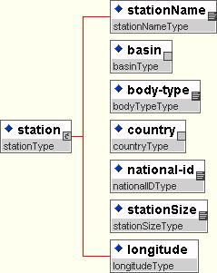

XML Schema:

<?xml version="1.0" encoding="UTF-8"?>
<!-- edited with XML Spy v3.5 NT (http://www.xmlspy.com) by Jan Hus (Novo) -->
<xsd:schema xmlns:xsd="http://www.w3.org/2000/10/XMLSchema" elementFormDefault="qualified">
<xsd:include schemaLocation="X:\Projects\Meta\Schema\IWsamples\types.xsd"/>
<xsd:include schemaLocation="X:\Projects\Meta\Schema\IWsamples\stationSizeType.xsd"/>
<xsd:include schemaLocation="X:\Projects\Meta\Schema\IWsamples\longitudeType.xsd"/>
<xsd:complexType name="stationType">
<xsd:annotation>
<xsd:documentation xml:lang="en">A geographical point where the measurements take place</xsd:documentation>
</xsd:annotation>
<xsd:sequence>
<xsd:element name="stationName" type="stationNameType"/>
<xsd:element name="basin" type="basinType"/>
<xsd:element name="body-type" type="bodyTypeType"/>
<xsd:element name="country" type="countryType"/>
<xsd:element name="national-id" type="nationalIDType"/>
<xsd:element name="stationSize" type="stationSizeType"/>
<xsd:element name="longitude" type="longitudeType"/>
</xsd:sequence>
</xsd:complexType>
</xsd:schema>

Proposed attributes for content descriptions
The proposed set of attributes here for registering a metainformation description into the Content Registry is entirely based on the set suggested by DublinCore.(http://www.dublincore.org/documents/dces). To be more precise, these attributes are in fact data elements in themselves. So one could say that a content description consists of a certain set of data elements.

No sample descriptions are provided here, instead a list of a potential description’s data elements and their explanations.

We should have sample descriptions here, they can come from the following areas
- documents uploaded to CIRCA

if we - and we should – go for service integration at EEA

- documents uploaded into the EERC (and present in the DIR)
- web-pages added to the EERC
- datasets, uploaded to the EERC (data service area)

Like with dictionary, it will be possible to modify content descriptions via a Web form listing the description elements in a table-like view and in that case the corresponding XML Schema will also be automatically updated. And vice versa- adding/editing a new description by importing it in XML Schema format, will also transparently result in the corresponding fields updated in the registry’s database. It must be noted, that human editing will be quite rare in the registry, it is more an event driven application-to-application system.
Of course it would be best to automate this process but I still see the role for a metadata publisher to look over the “machine deliveries”.

Also similarly to the dictionary, content registry’s database will be designed in efforts to provide flexibility adding/removing of descriptions’ elements whenever needed, so the list proposed below, is not meant to be final.
See for example the data service groups approach to combine DCES and ISO19115 metadata for spatial data description.

Especially if we think about the variety of applications inside EEA

Element: Title
Name: | Title
Identifier: | Title
Definition: | A name given to the resource.
Comment: | Typically, a Title will be a name by which the resource is formally known.
Element: Creator
Name: | Creator
Identifier: | Creator
Definition: | An entity primarily responsible for making the content of the resource.
Comment: | Examples of a Creator include a person, an organisation, or a service. Typically, the name of a Creator should be used to indicate the entity.
Element: Subject
Name: | Subject and Keywords
Identifier: | Subject
Definition: | The topic of the content of the resource.
Comment: | Typically, a Subject will be expressed as keywords, key phrases or classification codes that describe a topic of the resource. Recommended best practice is to select a value from a controlled vocabulary or formal classification scheme.
Element: Description
Name: | Description
Identifier: | Description
Definition: | An account of the content of the resource.
Comment: | Description may include but is not limited to: an abstract, table of contents, reference to a graphical representation of content or a free-text account of the content.
Element: Publisher
Name: | Publisher
Identifier: | Publisher
Definition: | An entity responsible for making the resource available
Comment: | Examples of a Publisher include a person, an organisation, or a service. Typically, the name of a Publisher should be used to indicate the entity.
Element: Contributor
Name: | Contributor
Identifier: | Contributor
Definition: | An entity responsible for making contributions to the content of the resource.
Comment: | Examples of a Contributor include a person, an organisation, or a service. Typically, the name of a Contributor should be used to indicate the entity.
Element: Date
Name: | Date
Identifier: | Date
Definition: | A date associated with an event in the life cycle of the resource.
Comment: | Typically, Date will be associated with the creation or availability of the resource. Recommended best practice for encoding the date value is defined in a profile of ISO 8601 and follows the YYYY-MM-DD format.
Element: Type
Name: | Resource Type
Identifier: | Type
Definition: | The nature or genre of the content of the resource.
Comment: | Type includes terms describing general categories, functions, genres, or aggregation levels for content. Recommended best practice is to select a value from a controlled vocabulary (for example, the working draft list of Dublin Core Types ). To describe the physical or digital manifestation of the resource, use the FORMAT element.
Element: Format
Name: | Format
Identifier: | Format
Definition: | The physical or digital manifestation of the resource.
Comment: | Typically, Format may include the media-type or dimensions of the resource. Format may be used to determine the software, hardware or other equipment needed to display or operate the resource. Examples of dimensions include size and duration. Recommended best practice is to select a value from a controlled vocabulary (for example, the list of Internet Media Types defining computer media formats).
Element: Identifier
Name: | Resource Identifier
Identifier: | Identifier
Definition: | An unambiguous reference to the resource within a given context.
Comment: | Recommended best practice is to identify the resource by means of a string or number conforming to a formal identification system. Example formal identification systems include the Uniform resource Identifier (URI) (including the Uniform Resource Locator (URL)), the Digital Object Identifier (DOI) and the International Standard Book Number (ISBN).
Element: Source
Name: | Source
Identifier: | Source
Definition: | A Reference to a resource from which the present resource is derived.
Comment: | The present resource may be derived from the Source resource in whole or in part. Recommended best practice is to reference the resource by means of a string or number conforming to a formal identification system.
Element: Language
Name: | Language
Identifier: | Language
Definition: | A language of the intellectual content of the resource.
Comment: | Recommended best practice for the values of the Language element is defined by RFC 1766 which includes a two-letter Language Code (taken from the ISO 639 standard), followed optionally, by a two-letter Country Code (taken from the ISO 3166 standard). For example, 'en' for English, 'fr' for French, or 'en-uk' for English used in the United Kingdom.
Element: Relation
Name: | Relation
Identifier: | Relation
Definition: | A reference to a related resource.
Comment: | Recommended best practice is to reference the resource by means of a string or number conforming to a formal identification system.
Element: Coverage
Name: | Coverage
Identifier: | Coverage
Definition: | The extent or scope of the content of the resource.
Comment: | Coverage will typically include spatial location (a place name or geographic co-ordinates), temporal period (a period label, date, or date range) or jurisdiction (such as a named administrative entity). Recommended best practice is to select a value from a controlled vocabulary (for example, the Thesaurus of Geographic Names [TGN]) and that, where appropriate, named places or time periods be used in preference to numeric identifiers such as sets of co-ordinates or date ranges.
Element: Rights
Name: | Rights Management
Identifier: | Rights
Definition: | Information about rights held in and over the resource.
Comment: | Typically, a Rights element will contain a rights management statement for the resource, or reference a service providing such information. Rights information often encompasses Intellectual Property Rights (IPR), Copyright, and various Property Rights. If the Rights element is absent, no assumptions can be made about the status of these and other rights with respect to the resource.

Annex 1 Metadata services of US-EPA - metadata registries

Mission Report by Stefan Jensen
Meeting: US-EPA
Date: 16.2.2001
Persons: Meeting 1: Larry Fitzwater (9:00 to 15:30) fitzwater.larry@epa.gov
Meeting 2: Brand Niemann (15:30 to 17:30) niemann.brand@epa.gov

Topic: Metadata services of US-EPA – metadata registries

Meeting 1:

General

The Environmental Data Registry (EDR) is a metadata registry – a level above cataloguing like in the ETC’s DIR example. The purpose is to standardise on the level of data elements. An inventory is built containing around 15 major data systems with ca. 7000 data elements. There is only little redundancy – but in spatial matters.

Most of the systems are referring to single facilities – some of them being represented in the envirofacts datawarehouse (which forms a set of ”federated models”). Those single facilities consist of toxic release, waste facilities, clean waters and air monitoring.

The initial work started in the early 90ies with integrating data at federal agencies, available in different systems, on different computers. One of the goals also being to find a common core.

During the 90ies, the discussion leading towards ISO 11179 (as a way to describe data elements)

In the EDR, co-operate data standards were so far established in the following areas:
- facility (lat/lon)
- address information (around 40 data elements)
- chemistry information
- biological taxonomy (e.g. brown trout)
- industrial classification (activity) NAFTA activity – new set of codes
- date (Y2K) (how to transfer it)

For example, the way how address information is dealt with is based on GILS, FGDC and ISO19115 work.

First systems under the EDR are
- facility registry system
- chemical registry system
- biological registry system based on one approach IT IS (taxonomic serial number) intergovernmental co-operation > follow approach to taxonomy
- terminological reference system

In the next development steps, data elements will receive XML tags and this will be reflected in DTD’s. These XML tags for data elements shall be standardised. The next step is the establishment of a DTD registry. Larry is optimistic to make a link with the www3 consortium and e-business / XML communities.

The application EDR is being built through the SCI co-operation by a team of 18 people, half of them developing software, the other half working on the data side (analysis, input …). The project started 9 years ago and is scheduled for another 3 years. Cost so far ranges around US$ 10 million. In 2000 about US$ 2.3 million have been spent. There is a new EDR version every 3 months.

It is implemented using ORACLE 8.i, Oracle developer and UNIX operating system.

In the demonstration, the excellent feedback and monitoring functions became obvious. There are around 3000 user sessions a day.

Comments:

Larry unfolded in a very detailed and good understandable way the achievements in the area of US-EPA’s EDR. It became even clearer to me, that this is a (necessary) activity which builds on top of a metadata ( and data ) repository. In the moment we have metadata in the DIR and (in some in CIRCLE) and data in CIRCLE (documents) as well as in the E2RC and in the data warehouse and in applications like NATLAN.

We must be aware of the tremendous changes and cost, the new Reportnet architecture will demand. If we start with the metadata registry, we have to realise also the difference in function between US-EPA and EEA. US-EPA has far more administrative and regulatory functions (for which the EDR content is needed) than EEA has got.

Meeting 2:

General:

Brand Niemann presented a couple of very recent development from his point of view.

He is offering an approach described by him as superior to the current ISO 11179 EDR. It allows to leave databases/documents where they are, including metadata and data, in their native format. Metadata stays with the data in XML documents – instead of an ORACLE RDBMS, an XML platform is sufficient.

A guiding principle steering this work is Peer-to-Peer distributed computing ( http://conferences.oreilly.com/p2p ) ( Hannu will love this ! ), based on two new XML based standards that send lean XML messages between the web servers: Content Network Protocol (CNP) and eXtensible Indexing Language (XIL).
He emphasises the building up of an XML based ”content network” ( http://www.fedstats.net/index.htm ). This content network includes an EPA integrated XML registry and repository. It is prepared through ”XML-lizing” the ”old” EDR content ”on the fly”. A software used for this is the NXT3 software including FilemakerPro.
It is available under http://38.218.19.235/NXT/gateway.dll?f=templates&fn=default.htm .

Brand is offering to prototype such an application for us. In order to do this, we would need to provide him with some of our content for him to ”XML-ize”.

He is offering an approach described by him as superior to the current ISO 11179 EDR. It allows to leave databases/documents where they are, including metadata and data, in their native format. Metadata stays with the data in XML documents – instead of an ORACLE RDBMS, an XML platform is sufficient.

In this context, it also became obvious, that Eliot Christian (”our” GILS – and consequently GELOS) messenger for quite a while ) is promoting a combination of UDDI and GILS. (see also: www.xml.gov )

Comments:

Brand advocates some of the latest trends in XML based applications and calls for ”re-purposing” of applications based on XML (and the other technologies mentioned).
It seems to me that the discussion on how to proceed with EDR developments inside US-EPA is controversial although in whichever form XML will be implemented, this is the way. The ”content network” approach seems to suit well to our ”reportnet” architecture because this is exactly what it is.

I feel we need to carefully prototype parts of such an application. Technologies are very new and we might not want to be ”beta-suffering” from this fact. We also have to be careful to be able to bridge this with a variety of applications in and outside EEA which are less technically advanced but function and have an organisational acceptance.

