
Import Tool Installation Guide

Abstract
This document is a guide for installing and using the Natura 2000 / EMERALD SDF Manager Tool.

Ver | Date | Author | Description
0.1 | 21/11/2011 | Alberto Telletxea  atelletxea@bilbomatica.es | First version
1.1 | 14/12/2011 | Alberto Telletxea  atelletxea@bilbomatica.es | Version revised after the Workshop held in Copenhagen
1.2 | 27/02/2012 | Alberto Telletxea  atelletxea@bilbomatica.es | Extended for the upgrade of the software version 2.0
2.0 | 19/03/2012 | Alberto Telletxea  atelletxea@bilbomatica.es  Jérôme Bailly Maitre  refportnatura2000@mnhn.fr | Version revised for the final release
3.0 | 06/09/2013 | Alberto Telletxea  atelletxea@bilbomatica.es | Create multiple PDFs, new habitats and species lists.
4.0 - 4.1 | 10/06/2014 | Jaanus Heinlaid  jaanus.heinlaid@tripledev.ee | First changes after making the tool compliant for EMERALD too.
4.2.1 | 10/09/2014 | Jaanus Heinlaid  jaanus.heinlaid@tripledev.ee | More hints on the default MySQL user.
4.2.2 | 16/08/2015 | George Sofianos  gso@eworxsa.com | - Improvements in parsing Dates when importing from XML and MDB.  - UI improvements.
4.2.3 | 01/12/2015 | George Sofianos  gso@eworxsa.com | - Update habitat type reference code list for Emerald.  - Corrected check for updated tables.
4.3.0 | 26/08/2016 | George Sofianos  gso@eworxsa.com | - new feature enabling validation of species names for other species against Catalogue of Life.  - Improved user interface when working with the list of other species using the free-text option or the species selection menu.  - Fix for when importing and exporting sites, numeric fields without a value set (i.e. null values) would get the value 0 assigned.  - Fix for when importing sites already existing in the application database, duplicates of certain information for a site was generated, for example species names in the other species-section.  - Upgrades in code Libraries  - Fix for the issue of the conflicting schema versions for describing impact codes.  - Fix for failed imports when the documentation description is empty.
4.3.2 | 15/10/2019 | Vasilis Skiadas  vs@eworxsa.com | - Code Cleanup  - Improve main panel size, center button  - improvements on biogeographic region optional percentage value  - UI Improvements  - Dates handling improvements  - Code Libraries upgrades  - Emerald Database updates  - Allow null values for site type  - Fixed bug in PDF export Functionality truncating a table column

1 Introduction 4
2 INSTALLATION GUIDE 4
2.1 Prerequisites 5
2.1.1 .NET Framework 5
2.1.2 Microsoft Access 5
2.1.3 MySQL database 5
2.2 Install the SDF Manager Tool 6
2.2.1 Configuration when behind a proxy 6
2.3 Run the SDF Manager Tool 6
2.3.1 Specific look for Natura2000 / EMERALD 7
3 User Manual 9
3.1 Manage SDFs: 9
3.1.1 Filter: 9
3.1.2 Edit a site: 11
3.1.3 Delete or duplicate site: 14
3.1.4 Generate PDF: 15
3.2 Import SDFs: 16
3.3 Export SDFs: 18
3.4 Perform checks QA/QC: 20

Introduction
The present manual describes the functionality of the Natura 2000 Manager Tool. This tool is meant to report site description data of Natura 2000 and EMERALD to the European Commission.
The tool will support the following main functionality:
- Manage SDFs (Standard Data Form): Allow users to edit already imported sites and create new sites based on the SDF schema(s) published at: http://bd.eionet.europa.eu/activities/Natura_2000/reference_portal
- Import SDFs: allow users to import SDFs for future editing. Supported import formats:
  - Old MS Access database schema (now covers EMERALD specifics too)
  - New MS Access database Schema
  - New XML schema (
- Export SDFs: allow users to export SDF data edited in the tool. Supported export formats:
  - Old MS Access database schema (now covers EMERALD specifics too)
  - New MS Access database Schema
  - New XML schema
- Perform checks: Allow users to perform a quality assurance on the content of the sites imported in the tool (e.g. use of unknown species name, missing important content, etc).

INSTALLATION GUIDE
These are the steps to follow for the installation of the new SDF Manager Tool. Basically, these steps refer to the prerequisites to be installed previous the execution of the tool. Once all these prerequisites have been accomplished and the tool is launched properly; these prerequisites will not need to be installed again.
These prerequisites are three software products:
- .Net Framework 4.0 (it has to be downloaded from the Microsoft official web site)
- Microsoft Access 2003, 2007 or 2010 (for importing/exporting sites from/to MS Access)
- MySQL (this software can be downloaded from the Natura 2000 Reference Portal - https://cdr.eionet.europa.eu/help/natura2000/Natura2000_software, file How_to_MySQL.zip)
All the below steps are for users using computers which do not have MySQL and .Net installed. If you do not have these tools installed, please follow the complete set of instructions below.

Prerequisites

.NET Framework
The relational database in which the information will be stored is MySQL. Prior to the deployment of this database, it is mandatory to install Microsoft .NET Framework 4, available at: http://www.microsoft.com/download/en/details.aspx?id=17851

Microsoft Access
One of the key operations you will probably be doing with this tool is importing/exporting sites from/to an MS Access database. For that, you will need to have MS Access installed on your computer. The versions supported by the tool are:
- MS Access 2003
- MS Access 2007
- MS Access 2010

MySQL database
MySQL is an open source relational database used underneath the SDF Manager Tool.
The installation package for MySQL is made available in the Natura 2000 Reference Portal (folder How_to_MySQL.zip). In addition, a MySQL user manual (How_to_MySQL.doc) details the steps to install/update/delete MySQL.
NB! Install the mysql version described below and not the latest version.
The steps to follow are:
- Open the file How_to_MySQL.zip, available in the Reference Portal https://cdr.eionet.europa.eu/help/natura2000/Natura2000_software
- Double click mysql-installer-5.5.24.1.msi;
- Follow the given installation instructions (a detailed explanation is given in How_to_MySQL.doc);
- The root user will be asked for a password in order to be able to start the Import Tool. The default MySQL root user password is simply empty.
Note: Users already using this version of MySQL can skip the installation process.

Install the SDF Manager Tool
The installer of SDF Manager Tool comes as an executable file (e.g. named usually like SDFManagerSetup.exe or SDFManagerSetup_v00.exe). In order to install the tool, you need to execute it. It is a simple installation wizard that asks you for the following things:
- Whether you want to use this tool for working with Natura 2000 or EMERALD sites.
- Location in your computer where you want to install the tool (default is C:\SDFManager). NB! The path should not contain white spaces and also the user should have write access to the selected directory.
- Name of the Start Menu folder for this tool (default is SDFManager).
- Whether you want to create a Desktop Shortcut for this tool.
NB! If you want to use this tool both for working both with Natura2000 and EMERALD, you have to install it once for Natura2000 and once for EMERALD, choosing the relevant option in installer. But then be sure to choose different locations for them! Once done, the two versions of the tool will not interfere with each other and you can work safely with both.

Configuration when behind a proxy
The application can run behind a proxy. If any error appears, then apply the following exceptions:
  - Go to “Control Panel” -> “Network and Internet” ->” Internet Options”
  - Open “Connections” ->”LAN settings” , then check the:
"Bypass proxy server for local addresses" .
  - Then click on “Advanced” and add "127.0.0.1;dd.eionet.europa.eu" in there.

Run the SDF Manager Tool
Once the tool has been installed, you can run it either by double-clicking on the relevant shortcut that was created on the desktop or from the relevant group in Start Menu.

At first run of the tool, you will first be presented with a "startup screen" depicted on the below screenshot. There you will have to supply the following information:

- Whether you want to run this tool in Natura2000 or EMERALD mode. You already specified that in the installation wizard, but this is basically your chance to change your mind, if you want to. The choice you make here shall be final!
- The host, port, username and password of your MySQL database.
  - For the host and port the default values are "localhost" and "3306". You don't need to change them, unless you want to run the tool against a MySQL database that is running on some other computer. Then you need to change the value of host.
  - For the username and password, please supply the MySQL root user's credentials that you entered during MySQL installation, or the name and password of another user if you created a special user for this tool in MySQL. If you don't remember having specified a MySQL user, try with username "root" and password empty.

Once you have entered the above settings, click "Save". The tool will now connect to the MySQL server. Should you not have it running for some reason, the tool will display a relevant error message and you can try again after having made sure that the MySQL is running.

After successful connection to MySQL, the tool will create the necessary database tables and open the main window (further documented in the next chapters).

NB! On a computer with little resources (i.e. little memory, not very powerful processor), this step might take a long time to complete. It is a one-time step not repeated afterwards.

It could range from several seconds even to 2-3 minutes! Please be patient and wait for the process to complete. However, if it hasn't succeeded after 4-5 minutes, something has probably gone wrong and you have to try again.

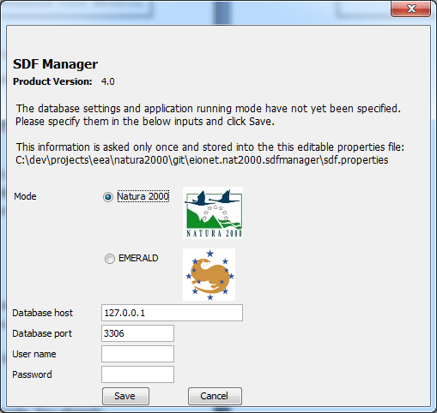

Specific look for Natura2000 / EMERALD
As indicated for several times above, the tool can run either for working with Natura2000 or EMERALD sites. Depending on the choice you made, the look and feel of the tool's input forms will be different.

In Natura2000 mode you will see titles and logos reflecting Natura2000 themes. Similarly, in EMERALD mode the titles and logos will be specific to EMERALD.

NB! In addition to the different titles and logos, some user inputs will be different too. For example in EMERALD mode that choice of dates on the SDF editor's Identification tab are different from those in Natura2000 mode. Same applies to the values of site type dropdown.

In the below user manual, where the usage is same for Natura2000 and EMERALD, you will see screenshots with Natura2000 logos. But where the usage is specific to EMERALD, you will screenshots with EMERALD logos.

User Manual

Manage SDFs:
The user will use this area of the application to create new SDFs or modify already imported SDFs.
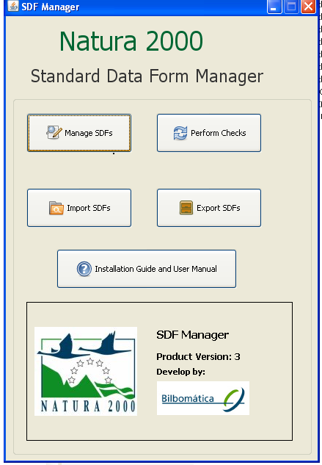

Filter:
This capability allows users to search by different filter types inside the different sites that have been already imported in the application. These are the filters that can be used in the application:

- General:
- By Sitetype
- By Sitecode
- By Sitename

- Geography:
- By Region
- By Bioregion
- By Area by Hectares
- By Marine Area by Hectares

- Dates:
- In Natura2000 mode:
  - By Date Site Classified as SPA
  - By Date Site Proposed as SCI
  - By Date Site Confirmed as SCI
  - By Date Site Designated as SAC
- In EMERALD mode:
  - By Date site proposed as ASCI
  - By Date site confirmed as candidate ASCI
  - By Date site confirmed as ASCI
  - By Date site designated as ASCI

- Species:
- By Species Name
- By Species Group
- By Other Species Name
- By Other Species Group
- By Sensitive Species (YES or NO)

- Habitats:
- By Habitats Name
- By Habitats Class

The below screenshot provides an example of the SDF filter window. By switching between the tabs in the window's upper region you can choose a different set of filters to search by.

If you have no filters applied, the window displays all sites that the tool has found in its underlying database. Please note that if it's thousands of sites, listing them all might take a bit of time.

Also, please keep in mind that you have to “Reset Filter” to go back to the original situation where all of the sites imported were shown in the list
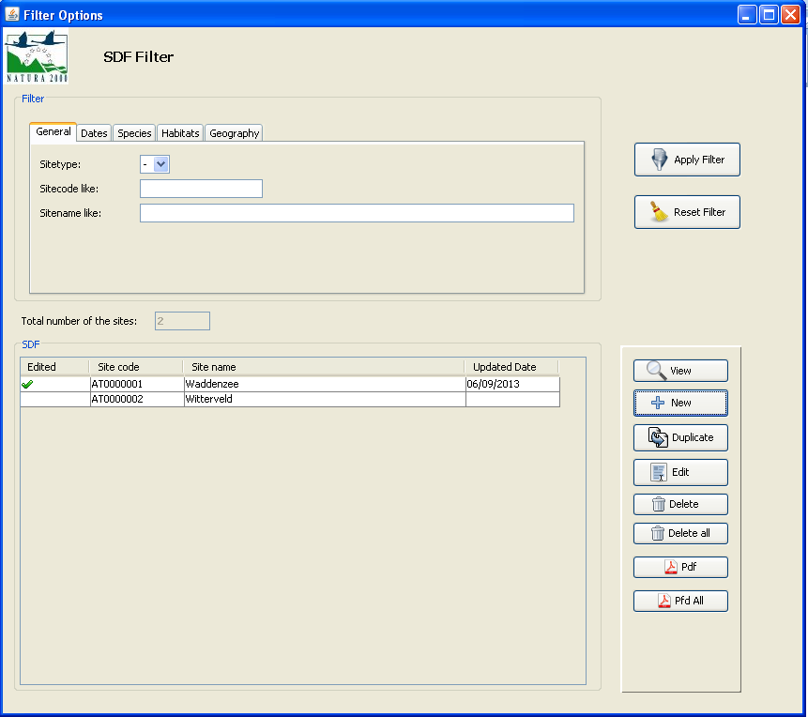

Edit a site:
The editor will allow user to create a new site and fulfil all the data associated for that site through the different forms and also modify an existing one.
The different forms for the completion of the data are aligned with the new Natura 2000 SDF XML schema, covering also the specifics of EMERALD where needed (and if you run the tool in EMERALD mode). All this ancillary information is documented at the Natura 2000 Reference Portal:
http://bd.eionet.europa.eu/activities/Natura_2000/reference_portal

The capture below shows the buttons to create a new SDF or for editing an existing one. In the latter case, select a site you wish to edit and then click the "Edit" button.

When the user clicks on “New”, a window will appear to assign a site code (9 characters code).
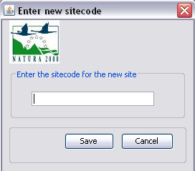
Afterwards, the user will go through different sections that the SDF proposes (see capture below):
- Site identification
- Location
- Ecological info
- Description
- Protection status
- Management
- Maps
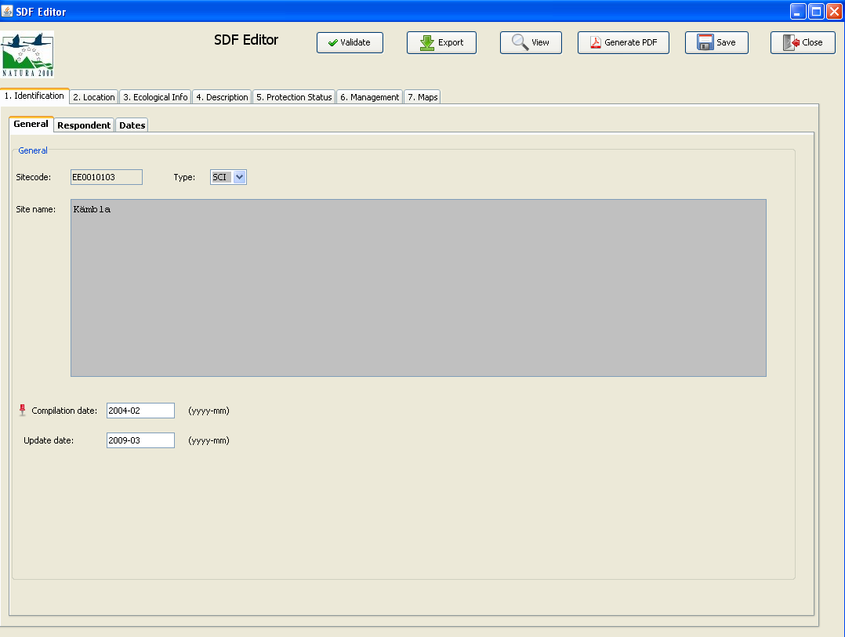

The user will be able to do certain operations during the edition process:

- View the site in the SDF Print form (by clicking in “View”) or generate a PDF. The print form will be shown in a web browser, like this:
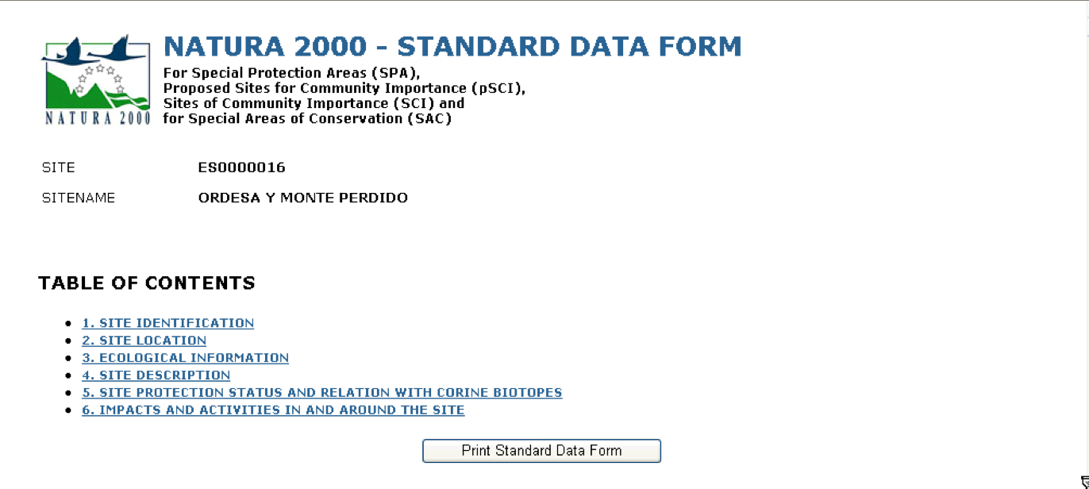

The tool supports the following browsers:
- Chrome (any version)
- Internet Explorer 7 or higher
- Firefox 3.6 or higher
- Validate the site being edited against the schema (by clicking "Validate" on the editor window). The users will be informed through a log of the different errors of the data edited against the schema.
- Save (by clicking on “Save”). This will save the edited data in the local database. The user can go back to the site later if the save action has been executed.
- Export (by clicking on “Export”). The user can export a single site to the new SDF XML format in the hard drive of the computer used.

Delete or duplicate site:
The user will be allowed to:
- delete a single site or multiple sites
- duplicate a site
This functionality allows users to better manage the list of sites that they finally wish to export. For selecting multiple sites from the list (e.g. for deletion), select them while holding down teh Shift key. For deleting all sites, use the "Delete all" button, but make sure you want to do that.

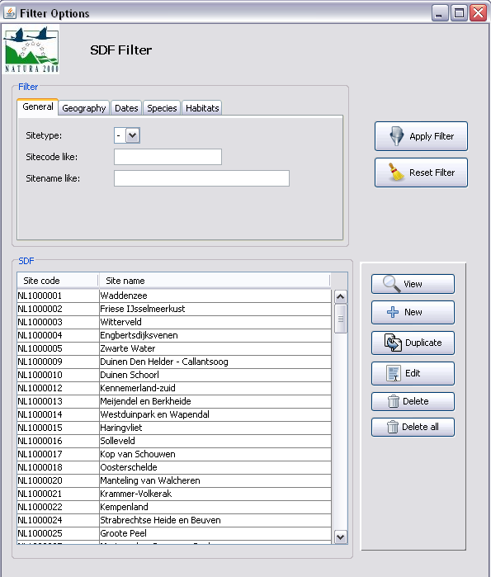

Generate PDF:
Through the "Pdf" button the user will be allowed to generate PDFs of the selected sites (single or multiple selection).
Through the "Pdf All" button the user will be allowed to generate PDFs of all the existing sites.
In both cases, the following message will be displayed

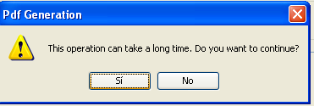

If the user continues with the PDF generation, a new window will be displayed to select the path where the PDFs will be generated into.
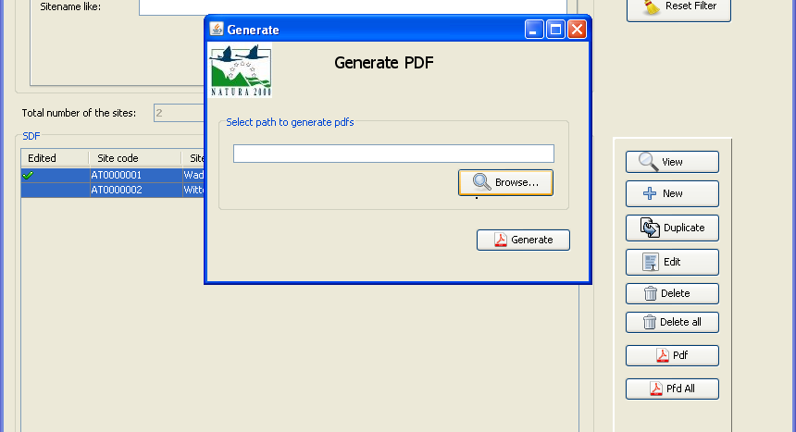

Import SDFs:
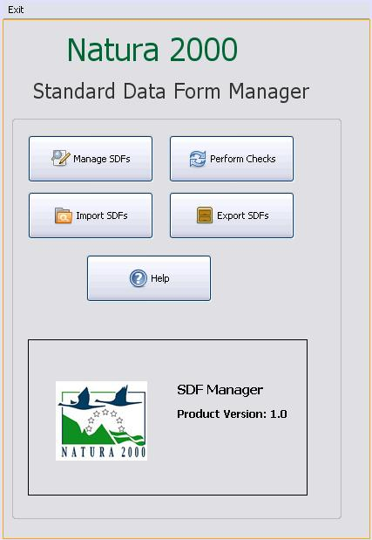
The user will be able to import existing SDFs from other formats, such as XML an MS Access. The import process will store the data in the tool's local database, allowing the user to edit the imported data inside the tool.
The import formats that the tool allows are:
- XML (following New SDF schema)
- MS Access DB (old template)
- MS Access DB (new template)
The user will be allowed to browse in her/his local directories and select the file to import. Besides, the user will have to set up the character encoding system for the import.
Note: MS Access still uses single-byte encoding of characters. Due to the low number of possible characters in single-byte encoding, Europe was partitioned into regions using similar diacritical marks. Countries in the traditional Western Europe use “ISO-8859-1”. Other countries (e.g. SK, HU, etc.), should try with “ISO-8859-2”. XML should always be “UTF-8”.
During the import process, system informs at every moment about the site processing.
An information message is displayed when import process finishes successfully. In case of errors, the import process stops and the error log will be opened or you will be asked to look for further information in the generated log file in the "log" directory where the tool was installed into.
See the capture below with these settings.
NB! In EMERALD mode there will be less choices, as EMERALD mode recognizes import databases in both old and new SDF formats.
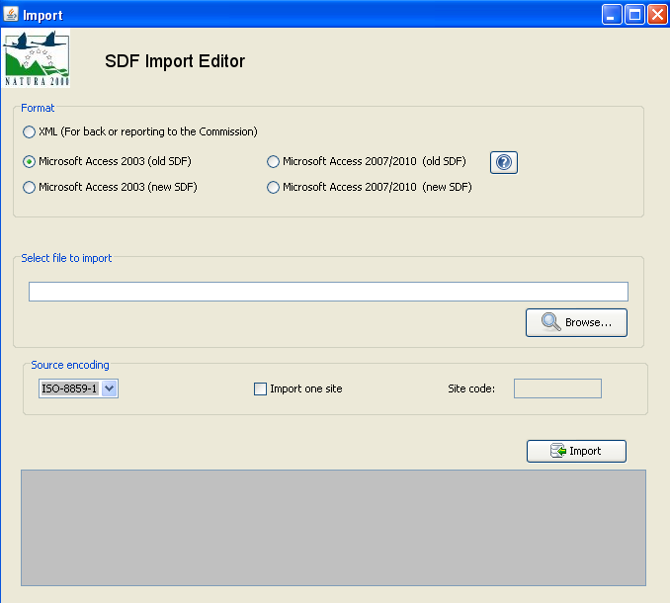

Export SDFs:

The user will be able to export from the tool the imported/edited SDFs. The export process will create a file and store it in the local hard drive of the computer.
The export formats that the tool allows are:
- XML (following New SDF schema)
- MS Access DB (new template)

NB! Please note that the exporting function also performs the validation of sites that are being exported. The validation is done according to the rules defined by the SDF XML Schema. If any of the sites' validation will fail, you will get an error message and log informing about it at the end of the export process. However, this does not mean that the export has failed: it is just information about invalidities in your sites. If there is fatal problem in the course of export, the export is stopped and you will get a relevant error message.
Any of the exported is files will then be importable back, should you need to. For EMERALD mode, this means you can export EMERALD sites into new SDF format, and then import back from it. The tool automatically recognizes which format the to-be-imported file follows.

An example screenshot of the SDF export window is depicted in the below figure.
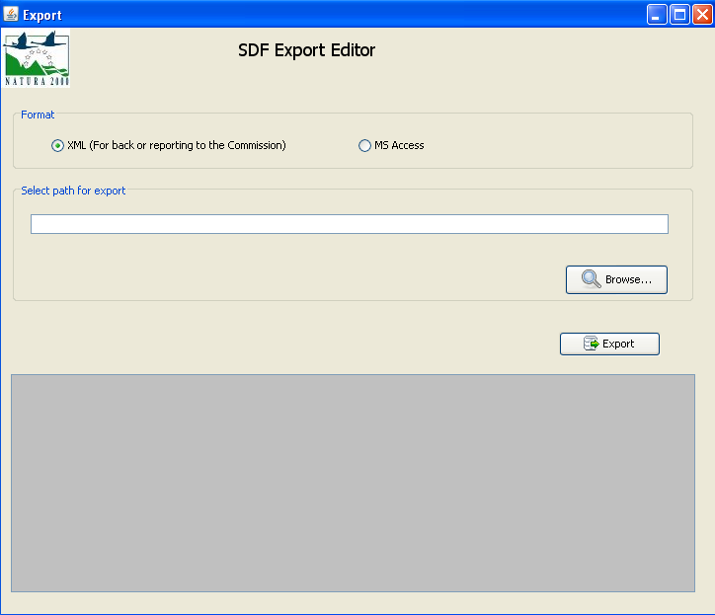

Perform checks QA/QC:
The user will be able to check the consistency of the content of the data by checking the data edited in the tool based on several criteria (e.g. for finding unknown species names used, unknown birds codes, unknown habitat types. etc). The checking criteria can be chosen from the first dropdown of the QA Checks Editor as depicted on the below screenshot. Any found issues can then be fixed by selecting a site in the list in the same window, and clicking "Edit SDF".
