
Import Tool Installation Guide
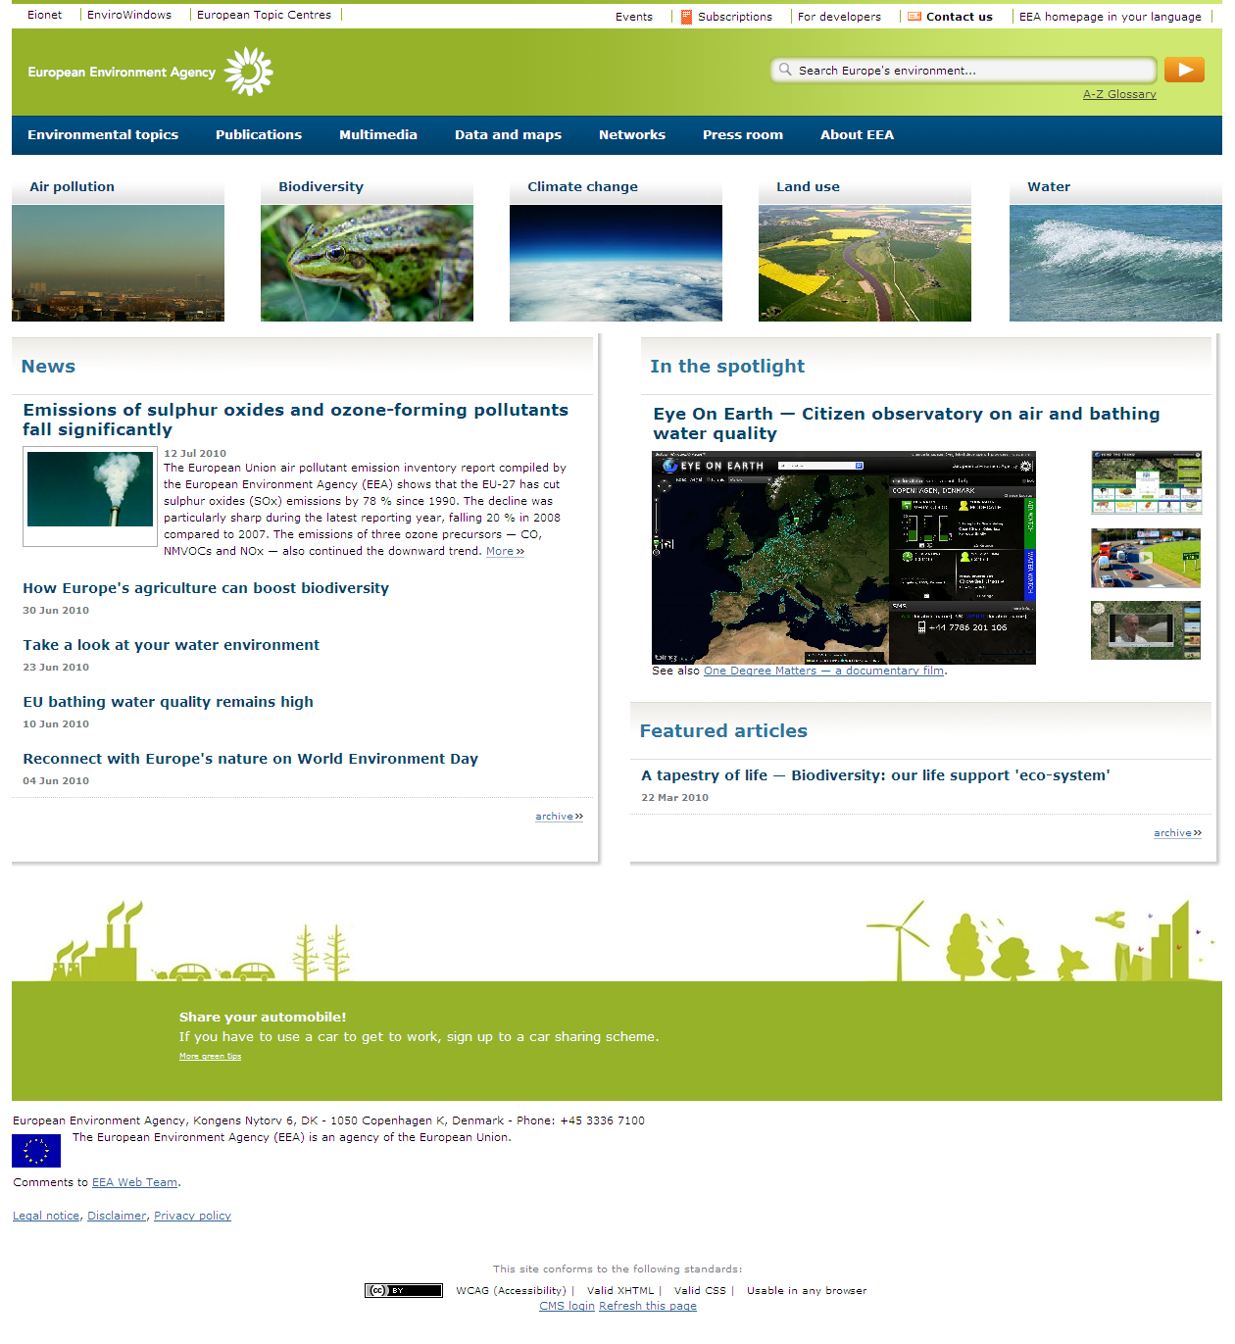
European Environment Agency

Abstract
This document includes a guide for the process of the Nature 2000 Backup & Restore DB

Ver | Date | Author | Description
1.0 | 15/12/2011 | Maika Alarcon | First version

1 Natura 2000 DB (Backup&Restore) 3
1.1 Backup Natura2000 DB 3
1.2 Restore natUra2000 DB 3
1.3 Advanced Export Options 3

Natura 2000 DB (Backup&Restore)
Backup process requires the use of the MySQL workbench directly.
To open this tool, click in Start button:
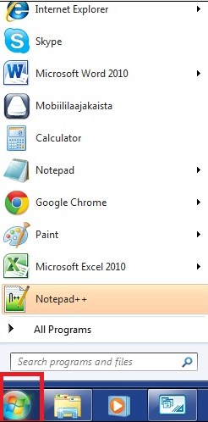
A windows menu is displayed:

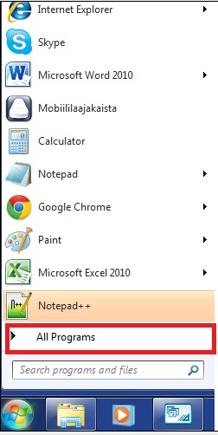
Click on “All Programs” and all the installed programs in the computer are displayed:
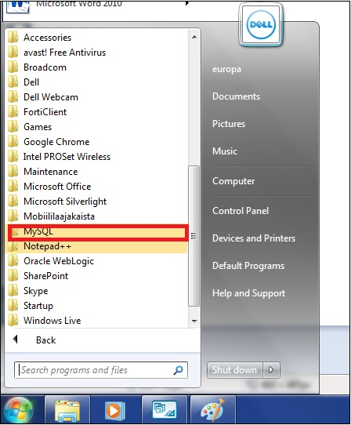
Search “MySQL” and click on it. The submenu is displayed:
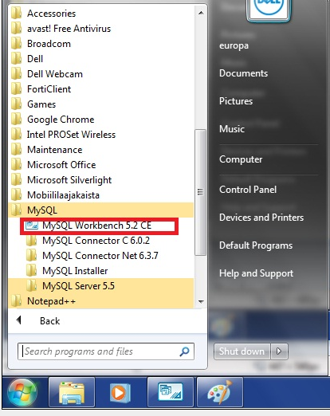

Select “MySQL Workbench 5.2.CE” and click on it.
MySQL Workbench is opened and the Workbench principal page is displayed.
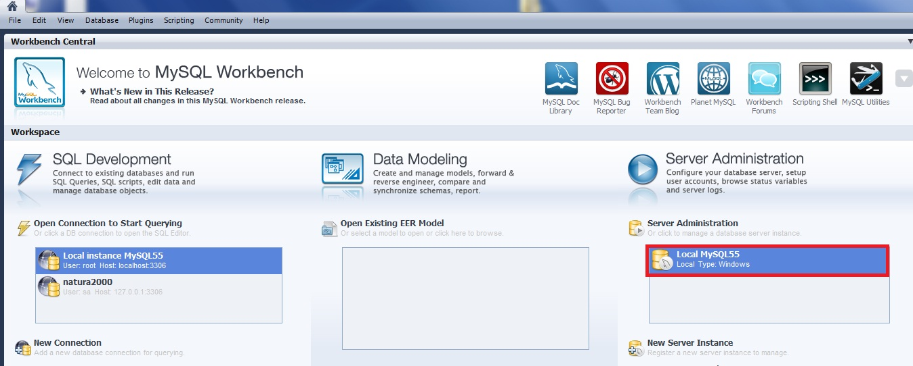
Select “Local MySQL 55” and click on it.
A pop up is displaying asking for password for root user.

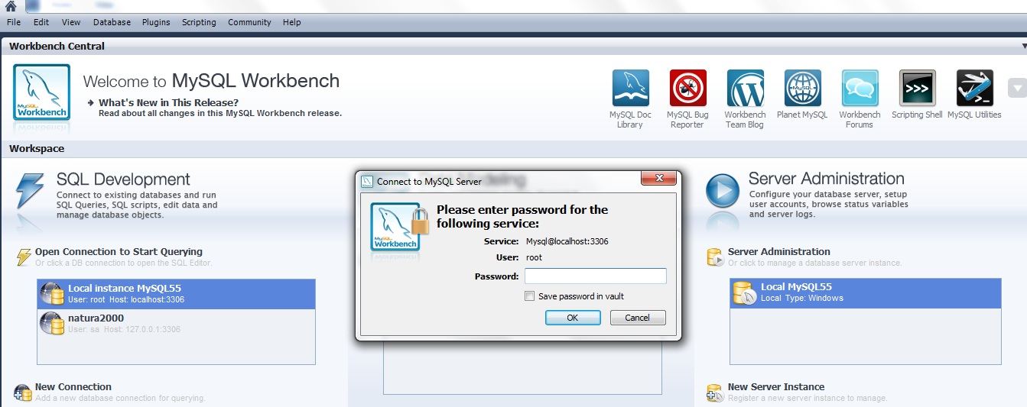

Fill the password of the root and click on “Save” button.
The admin Workbench is displayed,
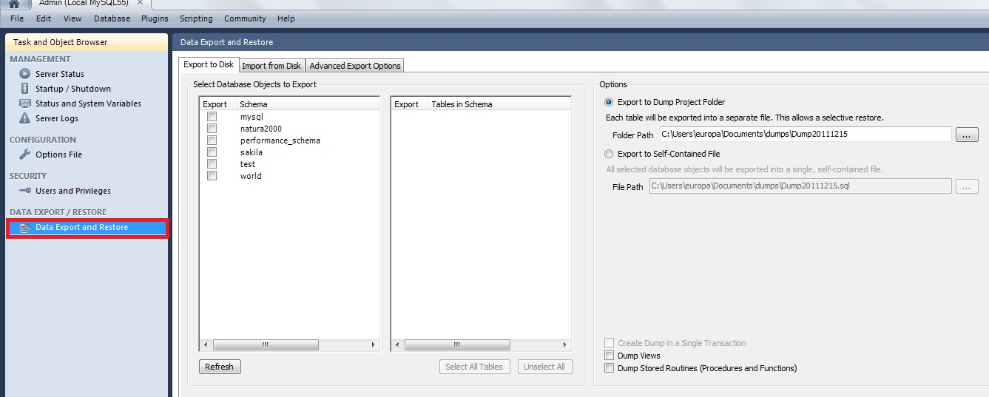

Select “Data Export and Restore” in the left menu, and click on it, the “Data Export and Restore” page is displayed.
There are three options:
- Export to Disk
- Import from Disk
- Advanced Export Options

Backup Natura2000 DB
Select “natura2000” from the list in the “Export to Disk” page
There are two options available in the right side:
- Export to Dump Project Folder (option selected by default) (one file for each table)
- Export to Self Contained File (one file for all the tables)
It’s also possible to choose the directory where the file/s will be stored.
Select one of them and the directory for the file/s, and click on “Start Export” button.
A pop up is opened, asking for password for the root user.

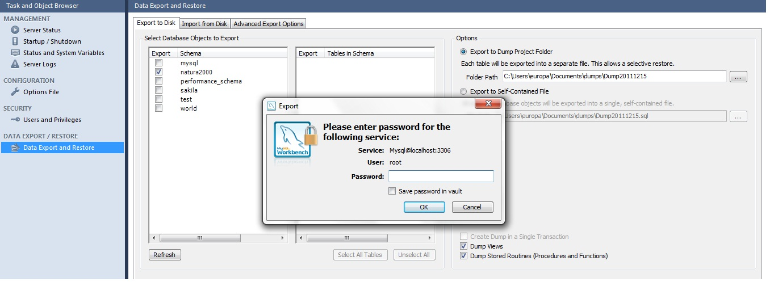
Fill the password and click on “Save”.
The export process is started.
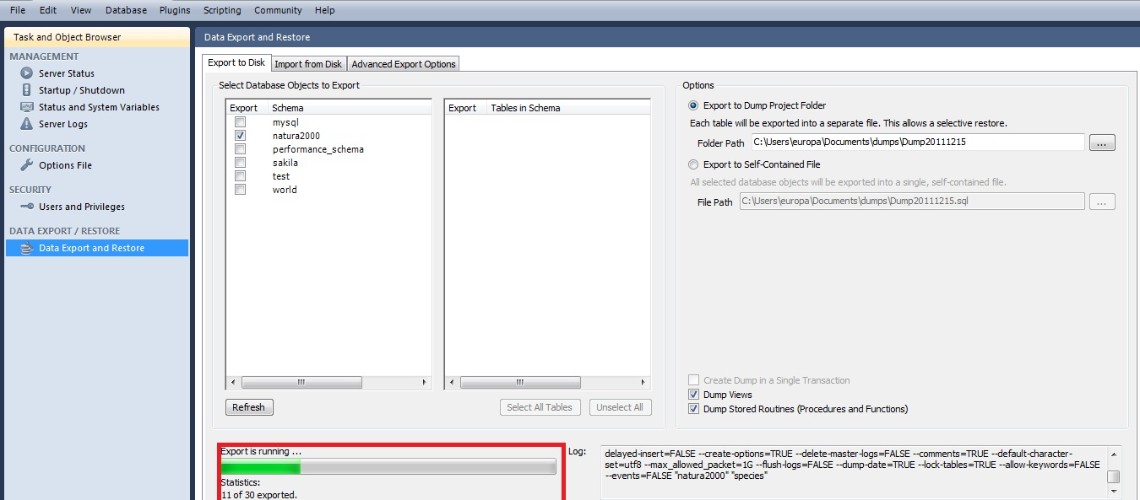

When the export process is finished, go to the directory and the backup file/s is there.
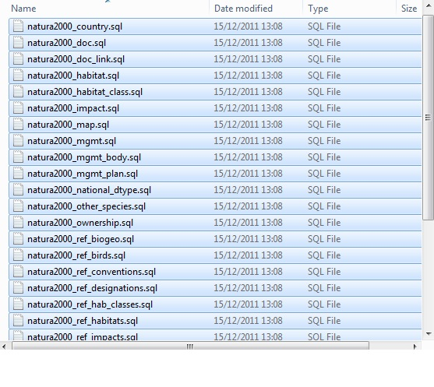

Restore natUra2000 DB
Click on “Import from Disk” tab and the Import from Disk page is displayed. There are two different options like in export process:
- Import to Dump Project Folder (option selected by default) (one file for each table)
- Import to Self Contained File (one file for all the tables)
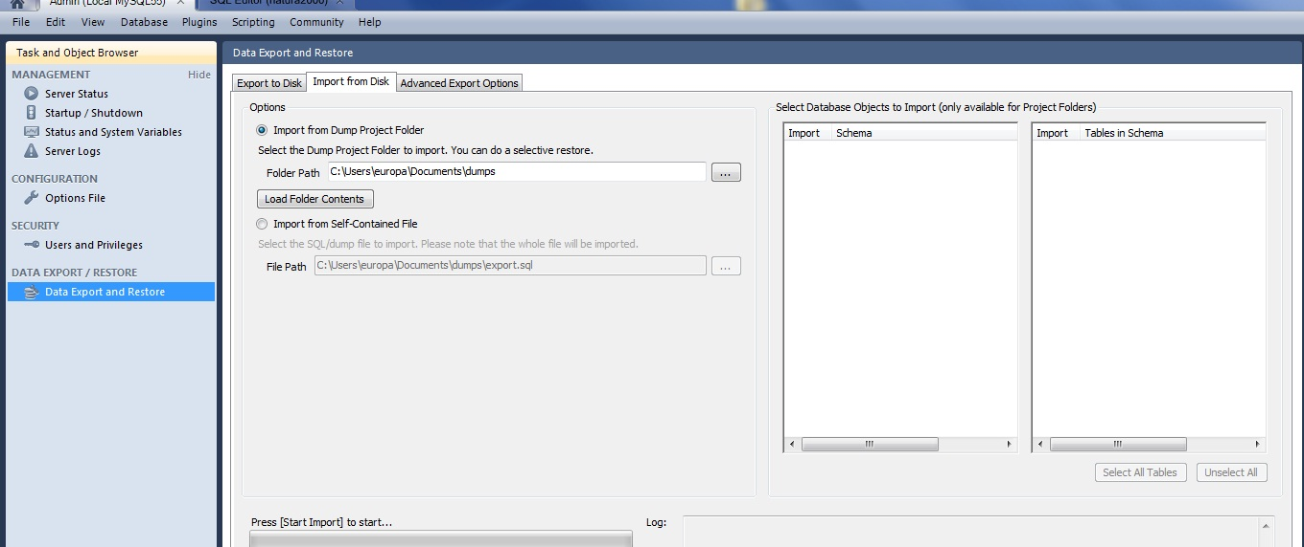

Select the same option that it’s selected on the export process, and select the folder path of the files (in case of the “Import to Dump Project Folder”) or the path of the file in the other case, and click on “Start Import”.

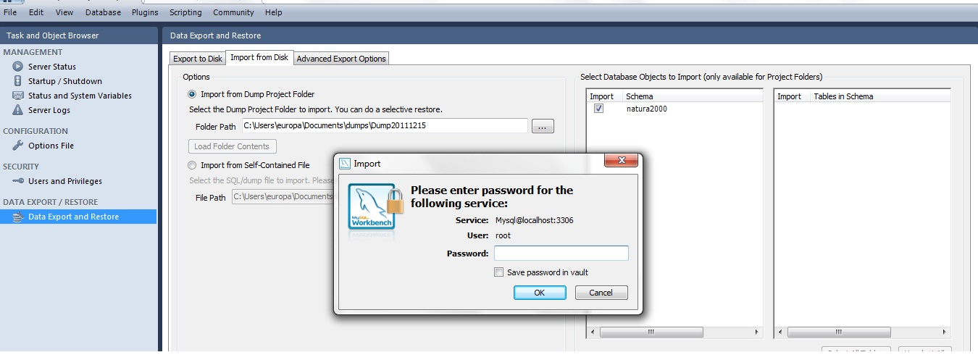
A pop up is opened, asking for password of the root user.
Fill the password, and click on “Save” button.
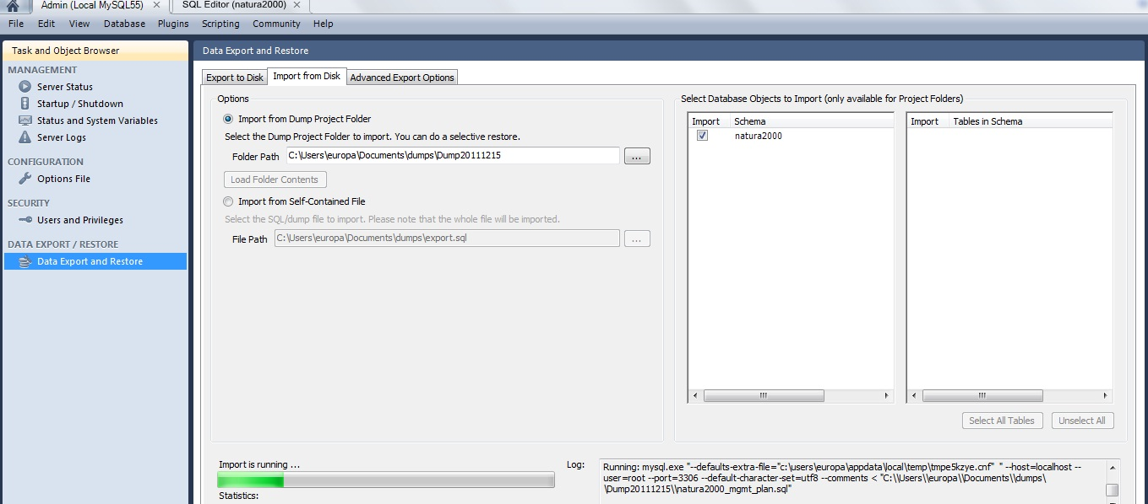
The import process is started.
In order to assure that everything is ok; user can launch the SDF Manager tool and check the data.

Advanced Export Options
Click on “Advanced Export Options” tab, and all the options available for this process are displaying.
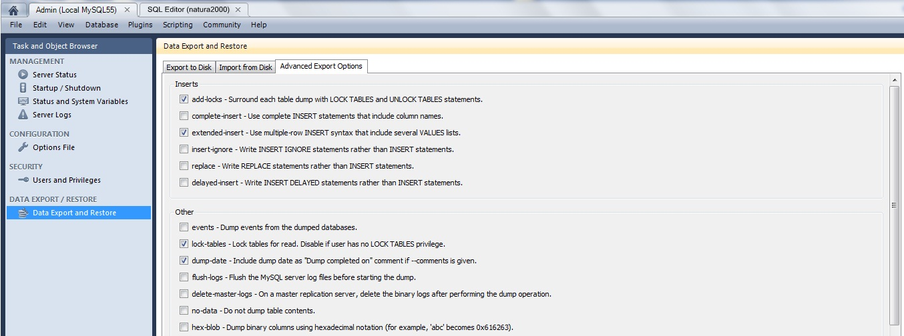
Users can customize the export process from this dialog.

