Project / Subproject  IDA/EINRC framework 501998 SA-7/EIONET |  | Author  TietoEnator | Date  2003-03-27/v0.41  2003-04-11/v1.0  2003-11-27/v2.1  2004-04-26/v3.01  2004-08-31/v4.0 | Data Model
Project:  ROD | Info  ROD Data Model diagram with table structures |  |  | Pages:  6

Data model

Diagram

The data model diagram is given below.

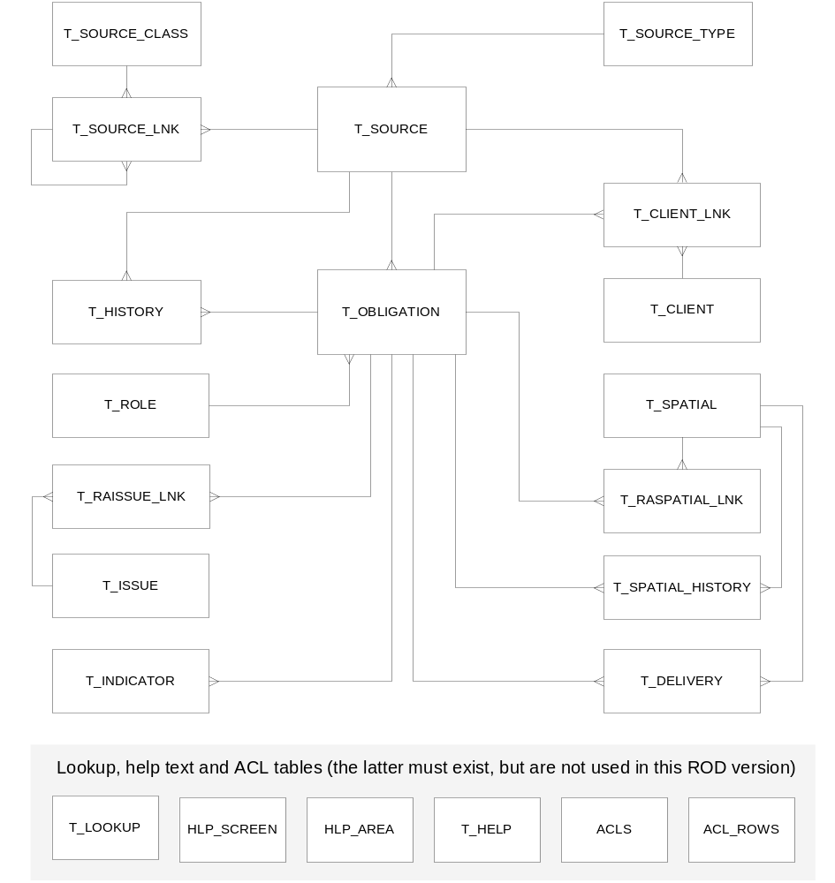

Structure of Tables
T_SOURCE_CLASS
+---------------+---------------------+------+-----+---------+----------------+
| Field | Type | Null | Key | Default | Extra |
+---------------+---------------------+------+-----+---------+----------------+
| PK_CLASS_ID | int(10) unsigned | | PRI | NULL | auto_increment |
| CLASSIFICATOR | varchar(20) | YES | | NULL | |
| CLASS_NAME | varchar(255) | | | | |
| NEW | tinyint(3) unsigned | | | 1 | |
+---------------+---------------------+------+-----+---------+----------------+

T_SOURCE_LNK
+---------------------+------------------+------+-----+---------+----------------+
| Field | Type | Null | Key | Default | Extra |
+---------------------+------------------+------+-----+---------+----------------+
| PK_SOURCE_LNK_ID | int(10) unsigned | | PRI | NULL | auto_increment |
| FK_SOURCE_CHILD_ID | int(10) unsigned | | MUL | 0 | |
| CHILD_TYPE | enum('S','C') | | | S | |
| FK_SOURCE_PARENT_ID | int(10) unsigned | | MUL | 0 | |
| PARENT_TYPE | enum('S','C') | | | S | |
+---------------------+------------------+------+-----+---------+----------------+

T_HISTORY
+---------------+------------------+------+-----+---------+----------------+
| Field | Type | Null | Key | Default | Extra |
+---------------+------------------+------+-----+---------+----------------+
| PK_HISTORY_ID | int(10) unsigned | | PRI | NULL | auto_increment |
| ITEM_ID | int(10) | YES | | NULL | |
| ITEM_TYPE | char(1) | YES | | NULL | |
| ACTION_TYPE | char(1) | YES | | NULL | |
| LOG_TIME | datetime | YES | | NULL | |
| USER | varchar(100) | YES | | NULL | |
| DESCRIPTION | text | YES | | NULL | |
+---------------+------------------+------+-----+---------+----------------+

T_ROLE
+------------------+--------------+------+-----+---------+-------+
| Field | Type | Null | Key | Default | Extra |
+------------------+--------------+------+-----+---------+-------+
| ROLE_NAME | varchar(255) | | | | |
| ROLE_EMAIL | varchar(255) | | | | |
| ROLE_URL | text | YES | | NULL | |
| ROLE_ID | varchar(255) | | PRI | | |
| ROLE_MEMBERS_URL | varchar(255) | YES | | NULL | |
| LAST_HARVESTED | datetime | YES | | NULL | |
| STATUS | int(1) | | PRI | 0 | |
| PERSON | varchar(255) | YES | | NULL | |
| INSTITUTE | varchar(255) | YES | | NULL | |
+------------------+--------------+------+-----+---------+-------+

T_RAISSUE_LNK
+-------------+------------------+------+-----+---------+-------+
| Field | Type | Null | Key | Default | Extra |
+-------------+------------------+------+-----+---------+-------+
| FK_ISSUE_ID | int(10) unsigned | | PRI | 0 | |
| FK_RA_ID | int(10) unsigned | | PRI | 0 | |
+-------------+------------------+------+-----+---------+-------+

T_ISSUE
+-------------+------------------+------+-----+---------+----------------+
| Field | Type | Null | Key | Default | Extra |
+-------------+------------------+------+-----+---------+----------------+
| PK_ISSUE_ID | int(11) unsigned | | PRI | NULL | auto_increment |
| ISSUE_NAME | varchar(100) | | | | |
| FK_DD_GUID | int(11) unsigned | YES | | NULL | |
| DD_URL | varchar(255) | YES | | NULL | |
+-------------+------------------+------+-----+---------+----------------+

T_INDICATOR
+-----------------+--------------+------+-----+---------+----------------+
| Field | Type | Null | Key | Default | Extra |
+-----------------+--------------+------+-----+---------+----------------+
| PK_INDICATOR_ID | int(10) | | PRI | NULL | auto_increment |
| FK_RA_ID | int(10) | | | 0 | |
| NUMBER | varchar(100) | | | | |
| TITLE | varchar(255) | YES | | NULL | |
| URL | varchar(255) | YES | | NULL | |
| OWNER | varchar(255) | YES | | NULL | |
+-----------------+--------------+------+-----+---------+----------------+

T_SOURCE
+---------------------+------------------+------+-----+---------+----------------+
| Field | Type | Null | Key | Default | Extra |
+---------------------+------------------+------+-----+---------+----------------+
| PK_SOURCE_ID | int(10) unsigned | | PRI | NULL | auto_increment |
| FK_TYPE_ID | int(10) unsigned | | MUL | 0 | |
| SOURCE_CODE | varchar(50) | | | | |
| TITLE | text | | MUL | | |
| CELEX_REF | varchar(255) | YES | | NULL | |
| LEGAL_NAME | varchar(255) | | MUL | | |
| URL | text | YES | | NULL | |
| SECRETARIAT | text | YES | | NULL | |
| SECRETARIAT_URL | varchar(255) | YES | | NULL | |
| ABSTRACT | text | YES | | NULL | |
| EC_ACCESSION | date | YES | | NULL | |
| EC_ENTRY_INTO_FORCE | date | YES | | NULL | |
| DRAFT | enum('Y','N') | YES | | NULL | |
| COMMENT | text | YES | | NULL | |
| LAST_MODIFIED | date | YES | | NULL | |
| ISSUED_BY | text | YES | | NULL | |
| VALID_FROM | date | YES | | NULL | |
| ALIAS | text | YES | MUL | NULL | |
| ISSUED_BY_URL | varchar(255) | YES | | NULL | |
| FK_CLIENT_ID | int(10) | YES | | NULL | |
| LAST_UPDATE | timestamp(14) | YES | | NULL | |
| RM_NEXT_UPDATE | date | YES | | NULL | |
| RM_VERIFIED | date | YES | | NULL | |
| RM_VERIFIED_BY | varchar(50) | YES | | NULL | |
| GEOGRAPHIC_SCOPE | varchar(255) | YES | | NULL | |
| DGENV_REVIEW | char(1) | YES | | NULL | |
| RM_VALIDATED_BY | varchar(50) | YES | | NULL | |
+---------------------+------------------+------+-----+---------+----------------+

T_OBLIGATION
+-------------------------+-------------------+------+-----+---------+------------+
| Field | Type | Null | Key | Default | Extra |
+-------------------------+-------------------+------+-----+---------+------------+
| PK_RA_ID | int(10) | | PRI | NULL | auto_incr. |
| FK_SOURCE_ID | int(10) unsigned | | MUL | 0 | |
| VALID_SINCE | date | YES | | NULL | |
| TITLE | varchar(255) | | | | |
| FORMAT_NAME | varchar(100) | YES | | NULL | |
| REPORT_FORMAT_URL | varchar(255) | YES | | NULL | |
| REPORT_FREQ_DETAIL | varchar(50) | YES | | NULL | |
| REPORTING_FORMAT | text | YES | | NULL | |
| DATE_COMMENTS | varchar(255) | YES | | NULL | |
| LAST_UPDATE | date | YES | | NULL | |
| TERMINATE | enum('Y','N') | | | N | |
| REPORT_FREQ | varchar(25) | YES | | NULL | |
| COMMENT | text | YES | | NULL | |
| RESPONSIBLE_ROLE | varchar(255) | YES | | NULL | |
| NEXT_DEADLINE | date | YES | | NULL | |
| FIRST_REPORTING | date | YES | | NULL | |
| REPORT_FREQ_MONTHS | int(3) | YES | | NULL | |
| NEXT_REPORTING | varchar(255) | YES | | NULL | |
| VALID_TO | date | YES | | NULL | |
| FK_DELIVERY_COUNTRY_IDS | varchar(255) | YES | | NULL | |
| NEXT_DEADLINE2 | date | YES | | NULL | |
| RM_NEXT_UPDATE | date | YES | | NULL | |
| RM_VERIFIED | date | YES | | NULL | |
| RM_VERIFIED_BY | varchar(50) | YES | | NULL | |
| LAST_HARVESTED | datetime | YES | | NULL | |
| LOCATION_PTR | varchar(255) | YES | | NULL | |
| LOCATION_INFO | varchar(255) | YES | | NULL | |
| LEGAL_MORAL | enum('L','M','V') | YES | | L | |
| FK_CLIENT_ID | int(10) | YES | | NULL | |
| DESCRIPTION | text | YES | | NULL | |
| RESPONSIBLE_ROLE_SUF | int(1) | | | 1 | |
| NATIONAL_CONTACT | varchar(255) | YES | | NULL | |
| NATIONAL_CONTACT_URL | varchar(255) | YES | | NULL | |
| COORDINATOR_ROLE | varchar(255) | YES | | NULL | |
| COORDINATOR_ROLE_SUF | int(1) | | | 1 | |
| COORDINATOR | varchar(255) | YES | | NULL | |
| COORDINATOR_URL | varchar(255) | YES | | NULL | |
| PARAMETERS | text | YES | | NULL | |
| VALIDATED_BY | text | YES | | NULL | |
| EEA_PRIMARY | int(1) | YES | | 0 | |
| EEA_CORE | int(1) | YES | | 0 | |
| FLAGGED | int(1) | YES | | 0 | |
| AUTHORITY | varchar(255) | YES | | NULL | |
| OVERLAP_URL | varchar(255) | YES | | NULL | |
+-------------------------+-------------------+------+-----+---------+------------+

T_SOURCE_TYPE
+------------+---------------------+------+-----+---------+----------------+
| Field | Type | Null | Key | Default | Extra |
+------------+---------------------+------+-----+---------+----------------+
| PK_TYPE_ID | int(10) unsigned | | PRI | NULL | auto_increment |
| TYPE | varchar(255) | | MUL | | |
| NEW | tinyint(3) unsigned | | | 1 | |
+------------+---------------------+------+-----+---------+----------------+

T_CLIENT_LNK
+--------------+---------------+------+-----+---------+-------+
| Field | Type | Null | Key | Default | Extra |
+--------------+---------------+------+-----+---------+-------+
| FK_CLIENT_ID | int(10) | | PRI | 0 | |
| FK_OBJECT_ID | int(10) | | PRI | 0 | |
| TYPE | char(1) | | PRI | | |
| STATUS | enum('M','C') | | PRI | M | |
+--------------+---------------+------+-----+---------+-------+

T_CLIENT
+----------------+------------------+------+-----+---------+----------------+
| Field | Type | Null | Key | Default | Extra |
+----------------+------------------+------+-----+---------+----------------+
| PK_CLIENT_ID | int(10) unsigned | | PRI | NULL | auto_increment |
| CLIENT_NAME | varchar(255) | YES | | NULL | |
| CLIENT_ACRONYM | varchar(100) | YES | | NULL | |
| CLIENT_URL | varchar(255) | YES | | NULL | |
| CLIENT_ADDRESS | varchar(255) | YES | | NULL | |
| CLIENT_EMAIL | varchar(255) | YES | | NULL | |
| DESCRIPTION | text | YES | | NULL | |
| POSTAL_CODE | varchar(100) | YES | | NULL | |
| CITY | varchar(255) | YES | | NULL | |
| COUNTRY | varchar(255) | YES | | NULL | |
+----------------+------------------+------+-----+---------+----------------+

T_SPATIAL
+-------------------------+---------------+------+-----+---------+----------------+
| Field | Type | Null | Key | Default | Extra |
+-------------------------+---------------+------+-----+---------+----------------+
| PK_SPATIAL_ID | int(11) | | PRI | NULL | auto_increment |
| SPATIAL_NAME | varchar(100) | | | | |
| SPATIAL_TYPE | char(1) | | MUL | | |
| FK_DD_GUID | int(11) | YES | | NULL | |
| DD_URL | varchar(255) | YES | | NULL | |
| SPATIAL_TWOLETTER | char(2) | YES | | NULL | |
| SPATIAL_ISMEMBERCOUNTRY | enum('Y','N') | YES | | NULL | |
+-------------------------+---------------+------+-----+---------+----------------+

T_RASPATIAL_LNK
+---------------+------------------+------+-----+---------+-------+
| Field | Type | Null | Key | Default | Extra |
+---------------+------------------+------+-----+---------+-------+
| FK_SPATIAL_ID | int(10) unsigned | | PRI | 0 | |
| FK_RA_ID | int(10) unsigned | | PRI | 0 | |
| VOLUNTARY | enum('Y','N') | | PRI | Y | |
+---------------+------------------+------+-----+---------+-------+

T_SPATIAL_HISTORY
+---------------+------------------+------+-----+---------+-------+
| Field | Type | Null | Key | Default | Extra |
+---------------+------------------+------+-----+---------+-------+
| FK_SPATIAL_ID | int(10) unsigned | | | 0 | |
| FK_RA_ID | int(10) unsigned | | | 0 | |
| VOLUNTARY | enum('Y','N') | YES | | N | |
| START_DATE | date | YES | | NULL | |
| END_DATE | date | YES | | NULL | |
+---------------+------------------+------+-----+---------+-------+

T_DELIVERY
+----------------+------------------+------+-----+---------+----------------+
| Field | Type | Null | Key | Default | Extra |
+----------------+------------------+------+-----+---------+----------------+
| PK_DELIVERY_ID | int(10) unsigned | | PRI | NULL | auto_increment |
| RA_URL | text | | | | |
| TITLE | text | | | | |
| UPLOAD_DATE | date | YES | | NULL | |
| DELIVERY_URL | text | | | | |
| TYPE | varchar(100) | YES | | NULL | |
| FORMAT | varchar(100) | YES | | NULL | |
| FK_RA_ID | int(10) | YES | | NULL | |
| FK_SPATIAL_ID | int(11) | YES | | NULL | |
| COVERAGE | varchar(255) | YES | | NULL | |
| STATUS | int(1) | YES | | NULL | |
+----------------+------------------+------+-----+---------+----------------+

T_LOOKUP
+----------+--------------+------+-----+---------+-------+
| Field | Type | Null | Key | Default | Extra |
+----------+--------------+------+-----+---------+-------+
| C_TERM | varchar(100) | | PRI | | |
| CATEGORY | enum* | | PRI | P | |
| C_VALUE | char(1) | YES | | NULL | |
+----------+--------------+------+-----+---------+-------+
*enum('1','2','C','P','L','S','F','UT','ST','I','DGS')

HLP_SCREEN
+-------------+--------------+------+-----+---------+-------+
| Field | Type | Null | Key | Default | Extra |
+-------------+--------------+------+-----+---------+-------+
| SCREEN_ID | varchar(100) | | PRI | | |
| DESCRIPTION | text | | | | |
+-------------+--------------+------+-----+---------+-------+

HLP_AREA
+--------------+--------------+------+-----+---------+-------+
| Field | Type | Null | Key | Default | Extra |
+--------------+--------------+------+-----+---------+-------+
| AREA_ID | varchar(100) | | PRI | | |
| SCREEN_ID | varchar(100) | | PRI | | |
| DESCRIPTION | text | | | | |
| LANGUAGE | varchar(100) | | PRI | | |
| HTML | text | | | | |
| MD5 | varchar(32) | | | | |
| POPUP_WIDTH | varchar(10) | | | 400 | |
| POPUP_LENGTH | varchar(10) | | | 400 | |
+--------------+--------------+------+-----+---------+-------+

T_HELP
+------------+--------------+------+-----+---------+-------+
| Field | Type | Null | Key | Default | Extra |
+------------+--------------+------+-----+---------+-------+
| PK_HELP_ID | varchar(50) | | PRI | | |
| HELP_TITLE | varchar(255) | YES | | NULL | |
| HELP_TEXT | text | YES | | NULL | |
+------------+--------------+------+-----+---------+-------+

ACLS (not used in this ROD version)
+-------------+--------------+------+-----+---------+----------------+
| Field | Type | Null | Key | Default | Extra |
+-------------+--------------+------+-----+---------+----------------+
| ACL_ID | int(11) | | PRI | NULL | auto_increment |
| ACL_NAME | varchar(100) | | MUL | | |
| PARENT_NAME | varchar(100) | YES | | NULL | |
| OWNER | varchar(255) | | | | |
| DESCRIPTION | varchar(255) | YES | | | |
+-------------+--------------+------+-----+---------+----------------+

ACL_ROWS (not used in this ROD version)
+-------------+------------------------------+------+-----+---------+-------+
| Field | Type | Null | Key | Default | Extra |
+-------------+------------------------------+------+-----+---------+-------+
| ACL_ID | int(11) | | PRI | 0 | |
| TYPE | enum('object','doc','dcc') | | PRI | object | |
| ENTRY_TYPE | enum* | | PRI | user | |
| PRINCIPAL | char(16) | | PRI | | |
| PERMISSIONS | char(255) | | | | |
| STATUS | int(1) | YES | | NULL | |
+-------------+------------------------------+------+-----+---------+-------+
*enum('owner','user','localgroup','other','foreign','unauthenticated','authenticated','mask')

