Project / Subproject  IDA/EINRC framework 501998  Specific Agreement-5/EIONET | Authors  TietoEnator Corporation | Date issued / Version  1 September 2004 / v4.02 | Design Report
Client  European Commission  DG Environment/ B 1 | Info  Detailed Design of ROD |  | Reference / Page  0000.doc  / 1 of 1

EUROPEAN COMMISSION

ENVIRONMENT DIRECTORATE-GENERAL

IDA-Programme -Framework Contract No 501 998 – 7th Specific Agreement

Einrc - Eionet

Detailed Design
Reporting Obligations Database


Modification history
Date | Version | Author | Reason for modification
24.01.2003 | 0.1 | Ander Tenno | User Interface part completed; other parts not fully finished yet
04.02.2003 | 0.2 | Kaido Laine | RSS specification added
06.03.2003 | 0.3 | Kaido Laine | Installation Guide
12.03.2003 | 0.4 | Ander Tenno | Technical parts completed
21.03.2003 | 0.41 | Ander Tenno | Minor changes to interface
11.04.2003 | 1.0 | Eeva Palosuo | Status updated to final approved
27.07.2003 | 2.0 | Ander, Kaido | Updated to ROD 2.0 specifications
27.11.2003 | 2.1 | Ander, Kaido | Updates, according to OPS tasks
16.04.2004 | 3.0 | Ander, Kaido | Updated to ROD 3.0 specifications
26.04.2004 | 3.01 | Ander Tenno | Very minor updates
31.08.2004 | 4.0 | Ander Tenno | Updated to ROD 4.0 specifications
01.09.2004 | 4.01 | Ander Tenno | Minor changes
31.03.2006 | 4.02 | Enriko Käsper | Added paragraph: Installing the ROD with ANT

APPROVAL PROCEDURE
Reviewer | Version | Start  Date | Finish  Date | Required modification/Approval/Comments
Project Team | 0.41 | 21.03.03 | 01.04.03 | Approved
Proj.Leader | 0.41 | 21.03.03 | 10.04.03 | Approved
CMT review | 0.41 | 21.03.03 | 11.04.03 | Approved
Commission/Project Officer's Approval

Table of Contents

1 Introduction 4
2 Functionality 5
2.1 Index page 5
2.2 Log in as Administrator 6
2.3 Legislative instruments hierarchy 8
2.4 List of Obligations 9
2.5 Legislative instrument details 13
2.6 Reporting obligation details 16
2.7 Deadlines/Deliveries 21
2.8 RSS / RDF 26
2.9 XML-RPC Methods 27
2.10 Editing other information in ROD 29
3 Conceptual model 30
4 Data model 31
5 Technology 32
6 XMLServer component 33
6.1 XMLServer component class model 35
7 ROD application 36
7.1 ROD application class hierarchy 37
7.2 Package descriptions 37
8 Installation Guide 38
8.1 Installing MySQL 38
8.2 Running MySQL on Linux platform 38
8.3 Loading the ROD database to MySQL 39
8.4 Installing Java run-time and Java development kit 39
8.5 Installing JDBC database driver 40
8.6 Installing Tomcat Servlet engine 40
8.7 Running Tomcat servlet engine with its built-in HTTP server 40
8.8 Installing ROD application software 40
8.9 Installing ROD with ANT 42
8.10 Properties 43
8.11 User Permissions 47
8.12 Scripts 48
Appendix A. ROD application configuration 50
Appendix B. ROD script: harvest.sh 55
Appendix C. ROD script: deadlinecalc.sh 56
Appendix D. ROD script: cleanrod.sql 57
Appendix E. Deployment Descriptor for ROD external services 68
Appendix F. Adding New Legislative Instrument Categories to ROD 69
1. Add a category to T_SOURCE_CLASS table 69
2. Setup the hierarchy in T_SOURCE_LNK table 70

Detailed design of Reporting Obligations system

Introduction
The ROD systems detailed design-paper comprises of several document parts that are typical deliverables from the Detailed Design Phase and Transfer to Operations Phase. It documents the functional and technical detailed designs discussed and agreed with the Customer's project team. The implementation of the ROD- system is based on these designs.
Future developments of the ROD system can build on these descriptions. For this purpose the paper should be kept as a living document and changes and future developments updated into it.
The document comprises of the following parts:
1) ROD web-services to users and database administrators are presented in Chapter 2, Functionality. This section is basically a User’s Guide.
2) Data models are presented in chapters 3 and 4.
- Conceptual model defines how the Customer wants to reflect relationships between legislation / conventions and the interpretations of obligations these place to the national representatives. The conceptual model may be used as reference material by other EU topics should they also consider implementing similar system for their use.
- The Common Data Model is the technical interpretation of the conceptual model.
3) ROD system's technical design is presented in chapters 5 - 7. Object oriented software development process has been used and technical descriptions drawn accordingly. The guiding principle has been to develop generic reusable components complemented with application specific software.
4) Installation Guide in chapter 8 gives instructions how to put up the technical environment and operational ROD system.

Functionality
The ROD system has thin-client architecture, i.e. all data and most of the functionality resides on server and the client application is an ordinary Web-browser. A data communication between server and client takes place over standard HTTP protocol.
This kind of architecture of the ROD system assures its smooth integration into Internet community and especially into EIONET network. Also it does not require any additional software for the client except standard Web-browser (like Netscape Navigator or Internet Explorer), and the system is accessible (if not any special access constraints are not established) from any Internet-connected computer.
The ROD system provides two-level functionality: browsing and searching of legislative instrument/obligation data for all users, and data editing functionality for ROD administrators. Data browsing and searching functionality is available for every user having access to the Internet. To be able to edit ROD content, a user has to log into ROD as administrator and, given she has the required access rights, will have an ability to change data. To log into the system, user has to go through a special URL – the aim was to hide the possibility of data administration from greater public.
The functionality (both read-only and editing pages) is described in the following sections, where the screenshots of system pages are presented and an explanation of the page functionality is given.

Index page
Index page (Figure 1) is the first page that is displayed when a user points her Web-browser to the ROD address at http://rod.eionet.eu.int. This page is also displayed when the user clicks “ROD” link in the menu panel of any of the ROD pages.
The content of the database can be browsed by clicking the links of categorized legislative instruments and reporting obligations. It is also possible to browse ROs by using the search to specify the documents that are going to be displayed. Help is also available for all search and administration interfaces by clicking the help (‘?’) buttons. At the bottom of the screen, various feedback and statistics links are displayed.
Each page in ROD has a Navigation Bar on the left side of the screen where user can navigate to different reporting obligations and deadlines (data sets reported by countries for each of the activities). When users login to the system, they get access to edit pages. Links to maintenance pages and login page are not shown in the Navigation Bar.
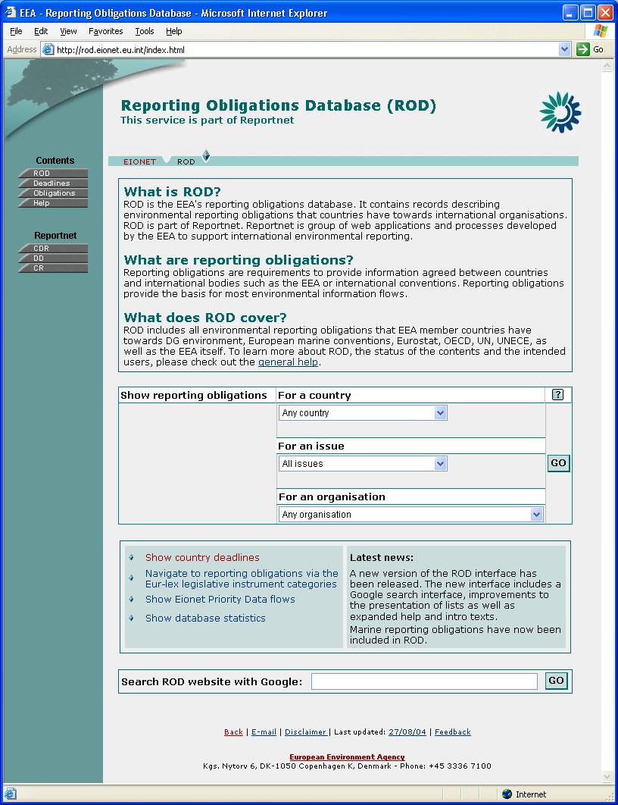
- Index page.
To get access to data administration pages http://rod.eionet.eu.int/login.html has to be used instead of the usual URL.

Log in as Administrator
By entering the login page URL (see above) the screen similar to Figure 2 is shown.
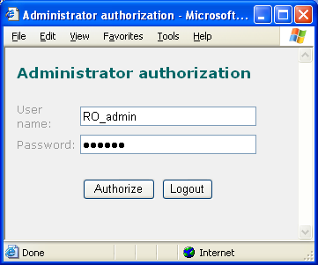
- Login dialog
Here the user has types in the ROD administrator’s user name and password and clicks the ’Authorize’ button to log in. The same window can also be used for logging out by clicking the ‘Logout’ button (no user credentials need to be entered in that case). Alternatively, ‘Logout’ button on the left-hand pane can be clicked.
After clicking the ’Authorize’ button, ROD checks the given credentials and if they are correct, user is logged in as an administrator. Then the user is redirected to the Index page and the ROD/system pages will contain icons for adding, modifying and/or deleting data items, depending on the access rights given to this particular user. Note that the administrative interfaces described in this document have most of the options enabled, something that might not be likely with real users.
Administrator information is stored using HTTP session mechanism, what uses ‘session cookies’ to exchange information between client and server. Therefore for the server to be able to maintain the administrator session, a browser should accept session cookies (check that in Web-browser settings, session cookies are enabled). Also, the administrator session has a timeout, meaning that after certain length of inactivity period (default is 10 hours), the session is declared to be expired and for administrator rights a user has to log in again.
For the ROD system editor pages JavaScript has to be enabled in the browser, because on those pages JavaScript is used to check validity of the input data, etc.
When the entered user name and password were not correct, a page with relevant information is displayed (Figure 3). By clicking the ‘Back’ link on that page, a login dialog will be displayed again and the user can re-enter the administrator credentials.
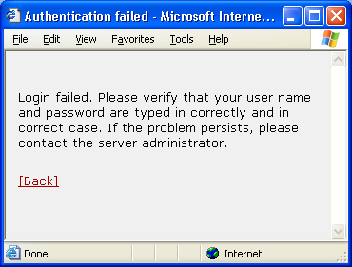
- Login failed dialog

Legislative instruments hierarchy
Legislative instruments, the highest level in the legislative instrument – reporting obligation relationship, can be accessed by clicking on ‘Navigate to reporting obligations via the Eur-lex legislative instrument categories’ in the box below the search form. On legislative instruments page, an instruments hierarchy for the given section is displayed (by clicking the respective button, help is also available, as is – for authorized users – the list of deleted instruments and the ability to add new instrument). For example in Figure 4, a hierarchy for section ‘15.10.20 Pollution and nuisances’ is presented. Under the top-level hierarchy item its sub-sections (15.10.20.10 – 15.10.20.50) are displayed and at the bottom of the page are the instruments belonging to section ‘15.10.20 Pollution and nuisances’.
By clicking on a sub-section link, a legislative instruments hierarchy for that sub-section is displayed (i.e. on this new page the clicked section will be a top level section). Clicking on the legislative instrument link, a page with this legislative instrument data is displayed (see Legislative instrument page section).
When clicking on the top-level section link (e.g. on ‘Pollution and nuisances’ in Figure 5), a legislation hierarchy page starting with its parent section is displayed (in our sample case the hierarchy would start from ’15.10 Environment’).
On the top of the page is a horizontal menu bar, indicating a context of the current page in the ROD application. Most of the ROD application pages contain that context bar.
For legislation hierarchy page it contains items ‘ROD’ and ‘Legislative Instruments’, what will respectively open index page or top-level legislation hierarchy page.
The left menu panel contains items ‘Obligations’– opens the obligations (see List of Obligations section), and ‘Deadlines’ – opens the Country Services part of ROD (see Deadlines/Deliveries section). General help and ROD index page can also be accessed from there. The menu panel will be displayed on all pages in ROD.
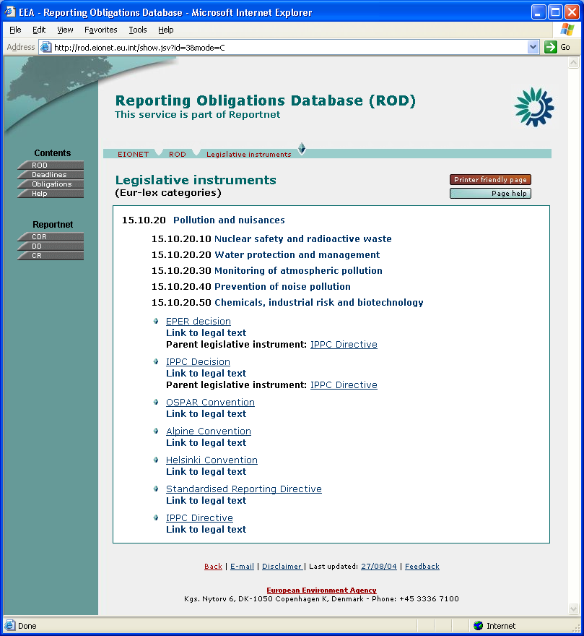
- Legislative instruments hierarchy

List of Obligations
This page (Figure 5) contains a list of reporting obligations (along with the legislative instruments they belong to) that can be picked for viewing/editing. Clicking on ‘Obligations’ link on the left-hand pane will display a list of all obligations. Search on the main page or this page (explained below) can be used to find only desired obligations. New obligations can also be added (assuming the necessary access rights) from this page by clicking the ‘New obligation’ button (not shown).
In addition to above, the detailed page of legislation (see Legislative Instrument Details section) link to this page showing the obligations related this certain legislative instrument.
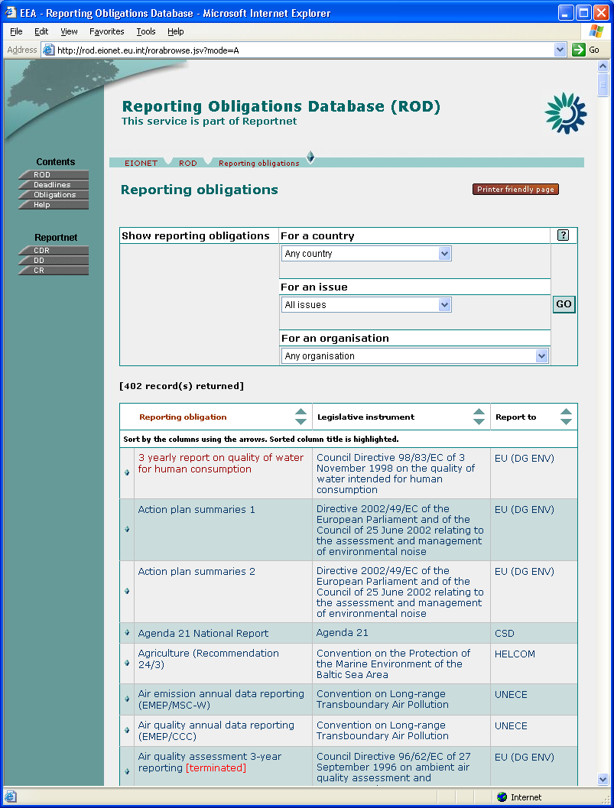
- List of all obligations
This page also displays a search tool similar to the one on the index page (Figure 6). This simple query form allows you to specify which obligations will appear in the list. Possible filters for the search are:
- Environmental issues
- Spatial coverage attributes: countries
- ‘Report To’ organisation.
You can choose only one item from each list. All the items are combined into one query with logical AND operator. For example, by choosing Country = ‘Denmark’ and Environmental issues = ‘Air Quality’ you will get all obligations related to Denmark that concern the Air Quality issue.
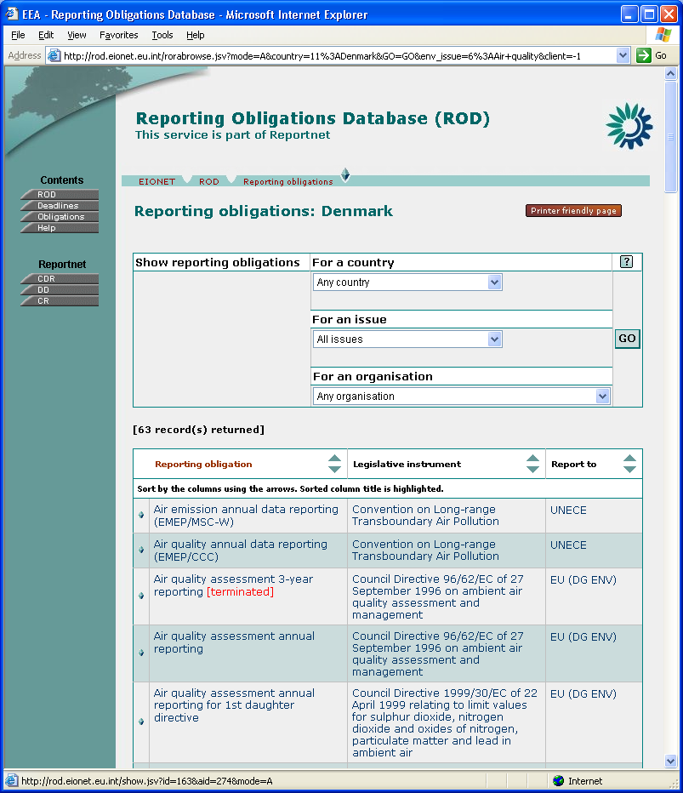
- Search tool for browsing obligations
Note also the help button on the search form. These work similarly on all the forms, so the principle is explained below only once.
For each form, there is an overview help button. On administrative interfaces, there are also context help buttons for each of the form fields. Clicking one of the buttons, popup window with help text is displayed (Figure 7 and Figure 8).
If the user has the required access rights, a checkmark-labelled button will also appear for editing help text. Clicking this button will open a popup window similar to the one displayed on Figure 9.
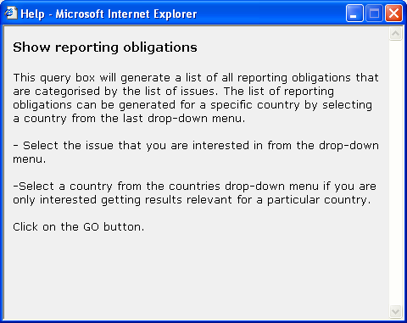
- Help window for search tool for browsing obligations
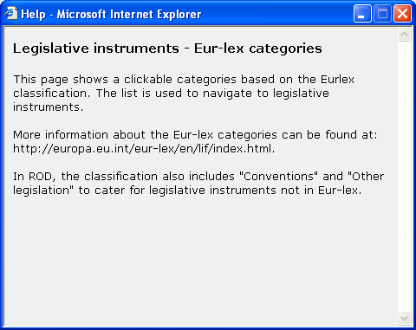
- Legislative instruments hierarchy help
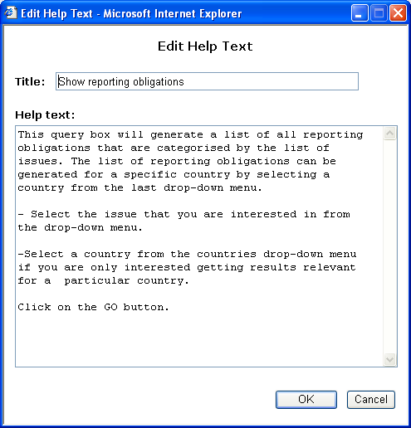
- Editing help text

Legislative instrument details
Legislative instrument’s information will be displayed when a user has selected this legislative instrument from the legislation hierarchy or the Reporting Obligation Details Page. From this screen, it is also possible to navigate to related (or parent) instruments and reporting obligations belonging to this instrument. It is also possible to switch to the edit mode of the document
In Figure 10, a page with legislative instrument ‘Commission Decision 95/337/EC of 25 July 1995 amending Decision 92/446/EEC of 27 July 1992 concerning questionnaires relating to directives in the water sector’ information is displayed. This screen is displayed in administrator mode, having additional icons for creating a new legislative instrument, editing the existing document, adding obligations to this legislative instrument, deleting the instrument, and viewing change history and field descriptions.
The items displayed on this page also depend on whether the legislative instrument is a convention (having its type set to convention) or other type. For convention, more information will be displayed, e.g. convention secretariat, EC accession etc.
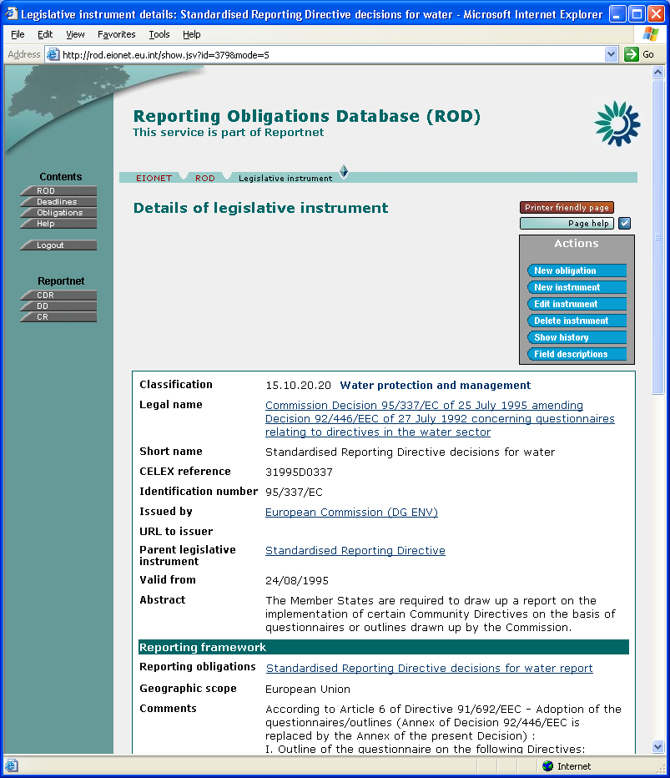
- Legislative instrument details
The blue action buttons on the right of the page are present only for administrators. Clicking on ‘New obligation’ will open a reporting obligation editor for adding a new reporting obligation record belonging to this legislative instrument. ‘New instrument’ will open a page where it is possible to add new legislative instruments. ‘Edit instrument’ opens a legislative instrument editor for this record, and ‘Delete instrument’ deletes the current legislative instrument. Finally, ‘Show history’ will display modification history in a popup window, and ‘Field descriptions’ will show explanations for all fields.
Under ‘Classification’ section, section names where to this legislative instrument belongs are displayed (reporting obligations belonging to this LI are also displayed here). Clicking on the section name will open a legislation hierarchy page for this section.
There can also be other legislative instruments linked to this legislative instrument. This relationship can be either:
- one legislation act relates to another; (parent)
- one legislation act is derived from other(s). (child)
These relationships are reflective, i.e. if legislative instrument A is related to B, then B is derived from A.
Clicking on the linked legislative instrument link, a page with the information of this legislative instrument will be opened.
A user having an administrator’s rights can delete the current record by clicking on ‘Delete instrument’. A confirmation message is displayed and after the user has pressed OK to confirm the delete, all related reporting obligation records with related obligation records will be deleted.
By clicking on the edit icon, a legislative instrument editor is opened (Figures 11 and 12).
Legislative instrument editor page consists of three sections: general attributes section (Figure 11) and, at the bottom part of the screen, convention attributes and record management sections (Figure 12).
To insert a new legislative instrument record, an existing record editor has to be opened and ‘New instrument’ button clicked (alternatively, the same button can be clicked from Legislative Instrument Hierarchy). A legislative instrument editor will appear. After typing in the information and pressing the ‘Save changes’ button, a new legislative instrument record with the entered information will be added to the database.
If the current legislative instrument amends some existing act, then this relationship can be specified by selecting a ‘Parent legislative instrument’ from the list.
For linking one or more items to one legislative instrument (‘Classification’), two select boxes are displayed. In the left-hand box are the items linked to this legislative instrument, and in the right-hand box are the rest of items. For example, a new classification(s) this legislative instrument belongs to can be added by selecting item(s) from the right-hand box and then clicking the ‘←‘ button. Similarly, to remove linked classification, select item(s) from the left-hand box and press the ‘→’ button. To select multiple items from the select box, a CTRL key has to be held down while the items are clicked with the mouse.
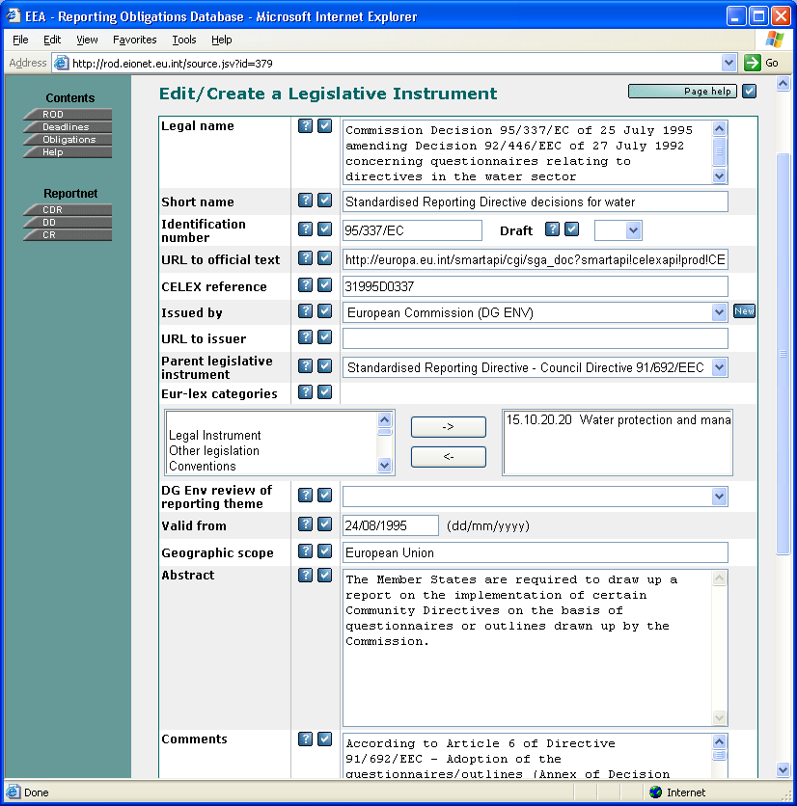
- Legislative instrument editor (a)
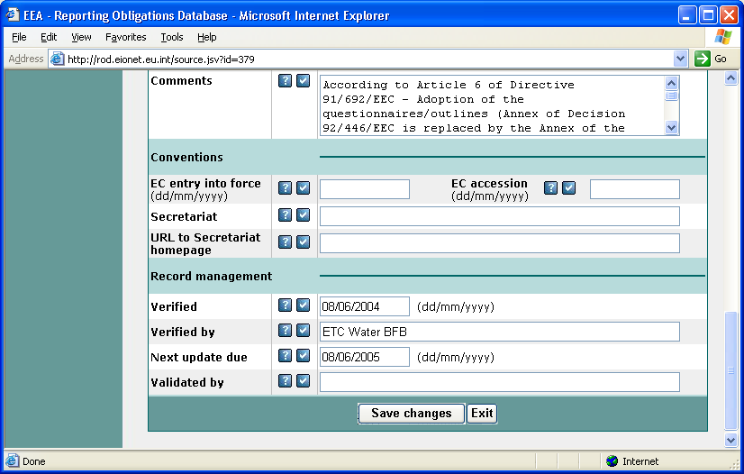
- Legislative instrument editor (b)
The convention attributes will be saved to the database, but for other types of legislative instrument they will not be displayed.
For entering data to the date fields, use the dd/mm/yyyy format.
The record management section is identical to LI and RO. In this section, verifier’s name or initials (‘Verified by’), verification date (‘Verified), next review date (‘Next update due’), and validator’s name or initials (‘Validated by’) can be specified.
The data will be saved to the database by clicking on the ‘Save changes’ button. At first a confirmation message is displayed and after pressing the ‘OK’ button, the data will be saved. A confirmation message to save updated data will be also displayed if user has changed something in the editor but navigates away from this page without saving the changes. This logic applies to all editor pages in the ROD system.

Reporting obligation details
Reporting obligation page (Figure 13) can be opened by clicking a link under ‘Reporting obligations’ on the legislative instrument page (Figure 10) or by clicking on an item in List of Reporting Obligations Page (Figure 5 and 6).
On that page, information about one reporting obligation with its linked activities is displayed. Clicking on the legislative instrument title will send the user back to the legislative instrument page. The same will happen if the user clicks on the ‘Legislation’ button in the context bar.
In the top-right corner are the icons to add, edit and delete the current reporting obligation record, and view change history. When deleting a reporting obligation record, at first confirmation is asked and when it is given, reporting obligation record with related links to submissions will be deleted and the user will be navigated to the parent legislative instrument page.
Clicking ‘New obligation’ will add a new obligation under the same legislative instrument as the obligation being viewed. To add a new obligation under different instrument, the user has to select ‘New obligation’ from the List of Obligations (Figure 5). This would first display legislative instrument hierarchy window, where the parent legislative instrument for the new obligation can be picked. Once this is done, reporting obligation editor (Figure 14) will appear, allowing details for the new obligation to be entered and saved to the database.
In the list of countries reporting according to this obligation, countries reporting voluntarily are marked with asterisk (*). Clicking on the small D button next to the list will provide history about join and leave dates of various countries for this obligation. Similarly, clicking the small D next to ‘Report to’ organization will display the details about this organization.
If parameters and/or indicators have been entered for this obligation, buttons for viewing them will also appear.
Note also the ‘Printer-friendly page’ button – this will open a printer-friendly version of the page. This button is also available in many other ROD pages.

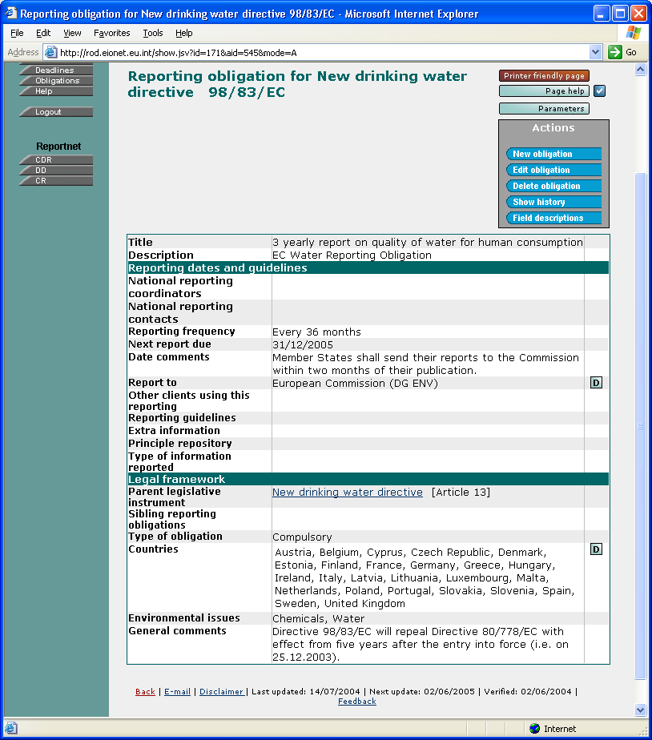
- Reporting obligation details
Reporting obligation editor (Figures 14, 15, and 16) allows updating information for the selected obligation.
‘Valid to’ is a date field that specifies how long the reporting obligation is going to be valid. When entering data, system will provide a default value of ‘31/12/9999’ after a value for ‘Baseline reporting date’ field has been entered or if nothing is entered into ‘Valid to’ field by the time the document is saved.
There are two ways to specify reporting deadline: text based (‘ASAP’, etc.) and date based. Exactly one must be used at the time. To use text based deadline, simply enter a value for ‘Reporting date (text format)’ field and leave ‘Reporting frequency’ field empty. The system will know you want to use text-based deadline.
To use date-based deadlines, enter a value for both ‘Baseline reporting date’ and ‘Reporting frequency in months’ (whole number) fields. From these, ‘Next due date’ is calculated according to the following rules (assuming ‘today’ is 05-12-2002 in our example):
- If the day of the starting date is < 28, a number of months specified in reporting frequency is added to the starting (baseline) date repeatedly, until ‘Next due date’ is in the future. For example, with 15-09-2002 start date and reporting frequency of 3 months, next reporting will be 15-12-2002.
- If the day of the starting date is >= 28, a number of months specified in reporting frequency is added to the starting date, until ‘Next due date’ is in the future¹, and the day set to the end of the month. For example, with 30-11-2002 start date and reporting frequency of 3 months, next reporting will be 28-02-2003.
- If reporting frequency in months is set to zero, the application assumes
non-repeating date and uses ‘Baseline reporting date’ date as the ‘Next due date’.
- The ‘Next due date’ will never be larger than ‘Valid to’ date (no need to report if obligation is no longer valid).
System will recalculate ‘Next due date’ fields for all obligations every day, so they are always up to date.
Editing country coverage (‘Countries reporting formally’ and ‘Countries reporting voluntarily’) and environmental issues is similar to ‘Classification’ editing in Legislative Instrument Edit page (Figure 11).
Value for ‘National Reporting Contacts’ and ‘National Reporting Coordinators’ needs to be CIRCA role (without the country-specific part which will be appended automatically unless ‘Do not append country suffix’ check box is selected), for example eionet-nrc-wtr. Alternatively, it can simply be name and URL.
Environmental issues can be managed by moving items between ‘linked’ and ‘available’ lists (see Legislative instrument page chapter for more information).
Record management (not shown) is the same as described in the legislative instrument section.
Clicking ‘Add a new indicator’ will, unsurprisingly, add a new indicator. A window will pop up where indicator details (title, number, URL, and owner) can be entered.

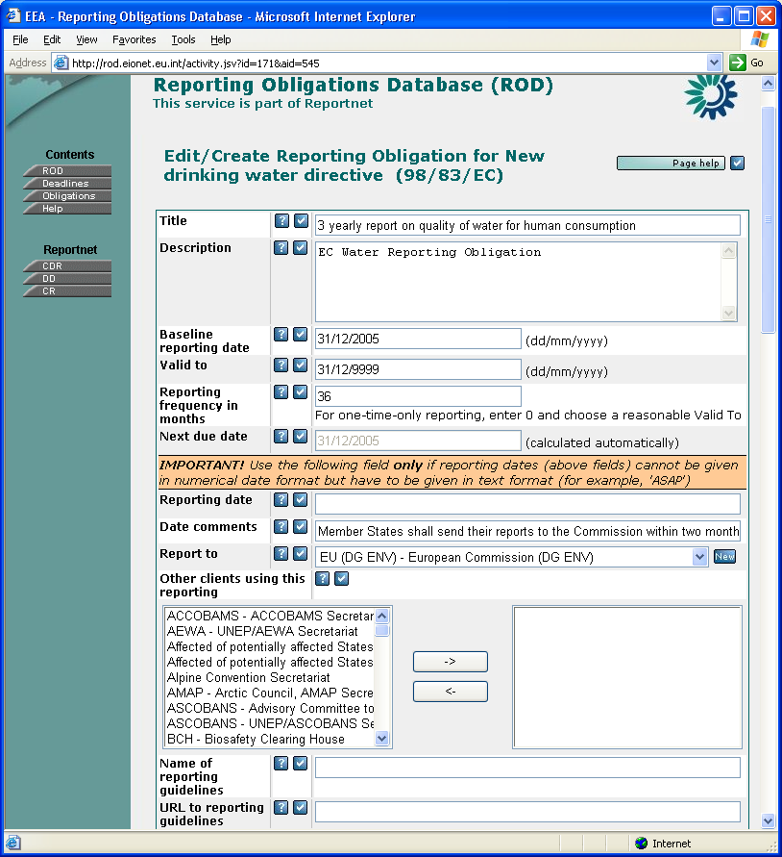
- Obligation editor (a)
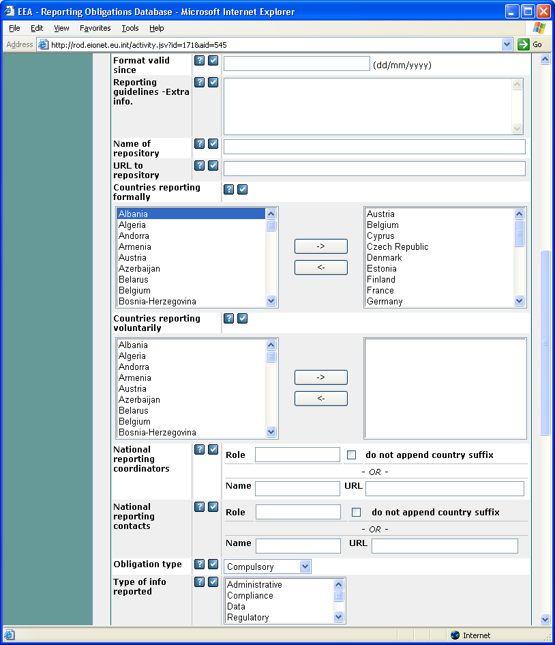
- Obligation editor (b)
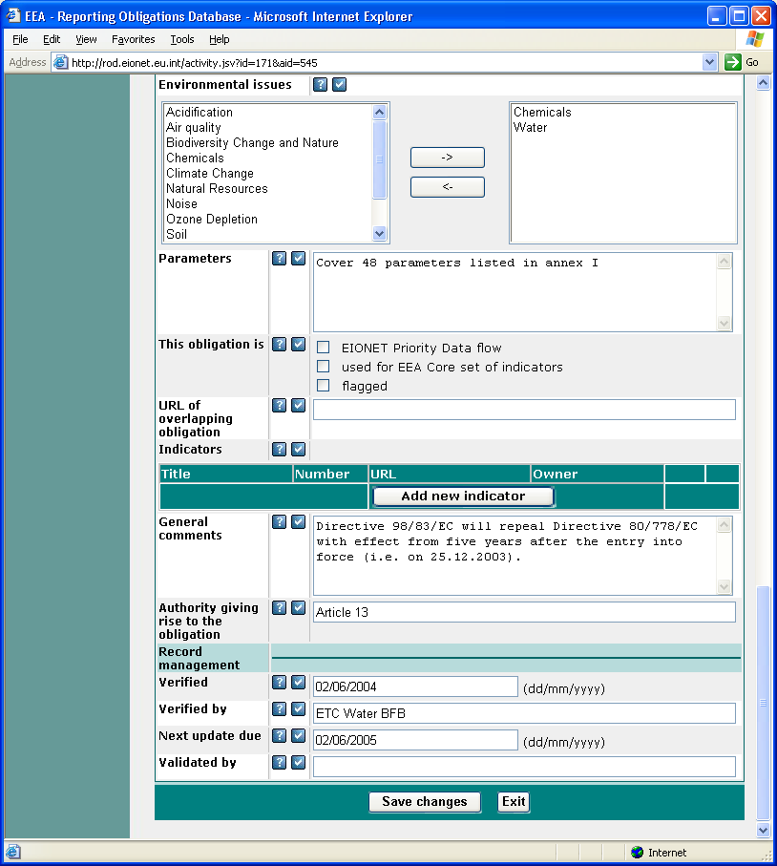
- Obligation editor (c)

Deadlines/Deliveries
Deadlines/Deliveries part of ROD, formerly called Country Services, is a tool that helps member countries to co-ordinate and to supervise their international reporting. It does that by gathering and presenting information from various sources (without containing information in itself), helping the user to track the status of ongoing/future reporting processes. In the current version, it gives an overview of the following:
- Which country had/has to report what? [Info from ROD]
- When was/is the deadline? [Info from ROD]
- When is the deadline after the next deadline? [Info from ROD]
- Is the reported data set in Reportnet? [Info from Content Registry]
- Who was responsible for delivering? [Info from CIRCA Directory]
- To who was the data set delivered? [Info from ROD]
Since Deliveries needs a large amount of information from ROD, it is designed as a part of it.
The process starts by selecting ‘Deadlines’ from the left-hand pane of ROD. The window shown on Figure 17 opens.
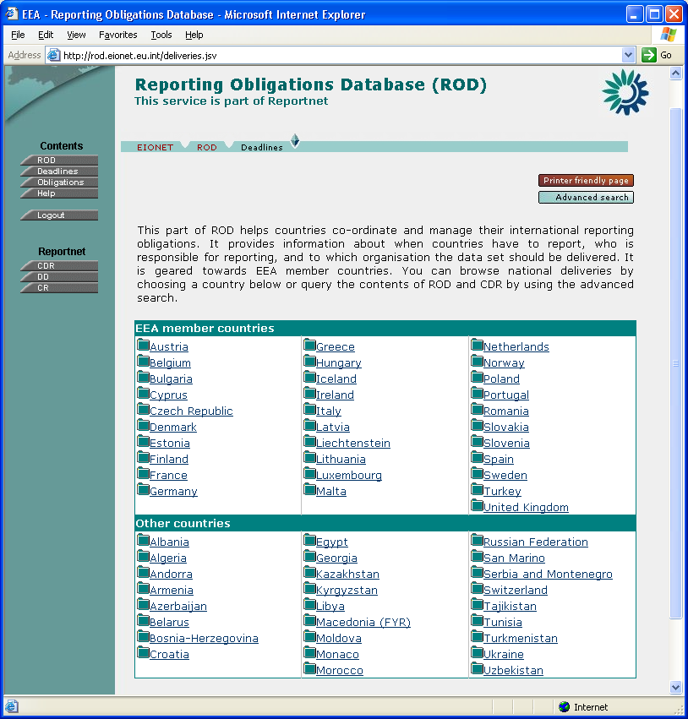
- The entrance window
From this window, you can either choose a country (the countries are divided to EEA member countries and other countries) to see all status data of (reporting obligation) deliveries for this country, or narrow the amount of data by choosing the advanced search. Choosing a country has the same results as choosing advanced search and specifying that country as the only search criteria.
If the user has the necessary access rights, ‘Harvest’ button also becomes available, allowing the data-gathering process from Content Registry and CIRCA Directory to be run manually. Normally this is not necessary, as ROD is set up to gather data automatically at pre-determined intervals (at least daily).
If advanced search is chosen, the search window shown on Figure 18 opens. From this window, you can narrow the number of reporting deliveries whose status you want to view by specifying country, time period, organization, and/or environmental issue. Clicking on ‘Go’ displays the search results as shown on Figure 19.
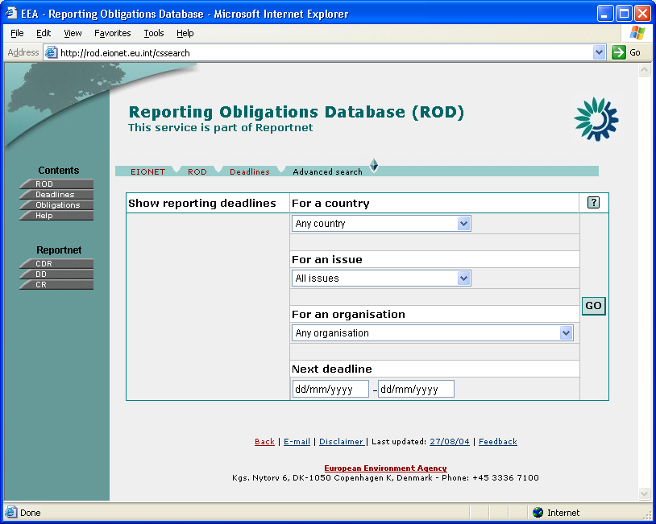
- The advanced search window
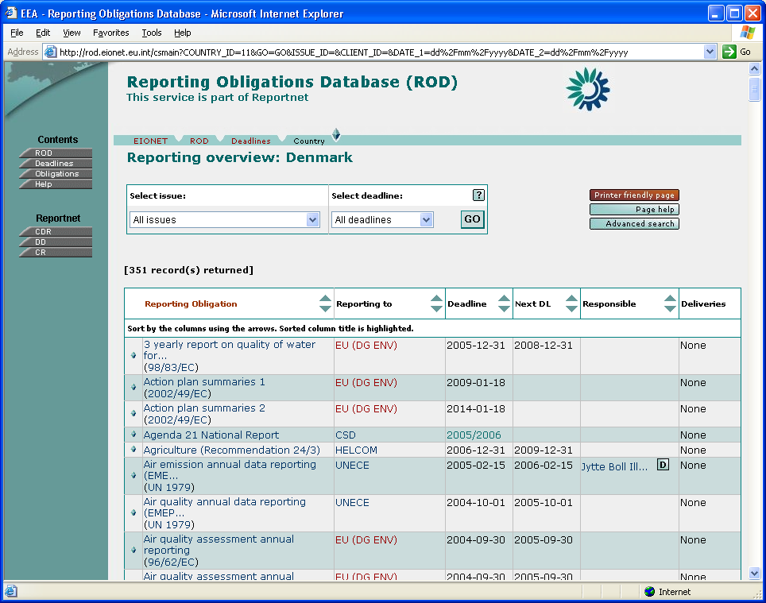
- Search results
In this window, a list with the following headings is displayed (explained in more detail below):
- Reporting Obligation – link to the reporting obligation related to this delivery.
- Reporting to – the organisation the reported data set needs to be sent to.
- Deadline – The date when the data set is/was due.
- Next DL – The deadline after the above.
- Responsible – the local organisation responsible for carrying out the reporting.
- Deliveries – any deliveries that are in Content Registry for the given obligation.
- Country – only displayed if all countries is used as a search criteria in advanced search.
The entire list can be displayed in printer-friendly format by clicking on the ‘Printer- friendly page’ button. Also, it can be sorted according to column headings by clicking the ascending/descending sort buttons next to the desired column heading. In addition, contents of the list can be quickly filtered (without needing to use the Advanced Search) according to issue and/or deadline by choosing them from the search box at the top of the screen and clicking Go.
Reporting Obligation
This is a link to the reporting obligation in ROD related to this delivery. Clicking on it will display the details of the reporting obligation in ROD as shown in Figure 13. To return to Deliveries, click Back in the browser.
If you browse further in ROD, you can return to Deliveries either by clicking Back repeatedly or by clicking Deliveries button in the left-hand pane.
Reporting to
This is the organisation the reported data set needs to be sent to. For this to be available, the ‘Report to’ organization has to be selected (in ROD) in reporting obligation. In the list, organisation names are displayed. Clicking on the link will open the page with organization details as shown on Figure 20.
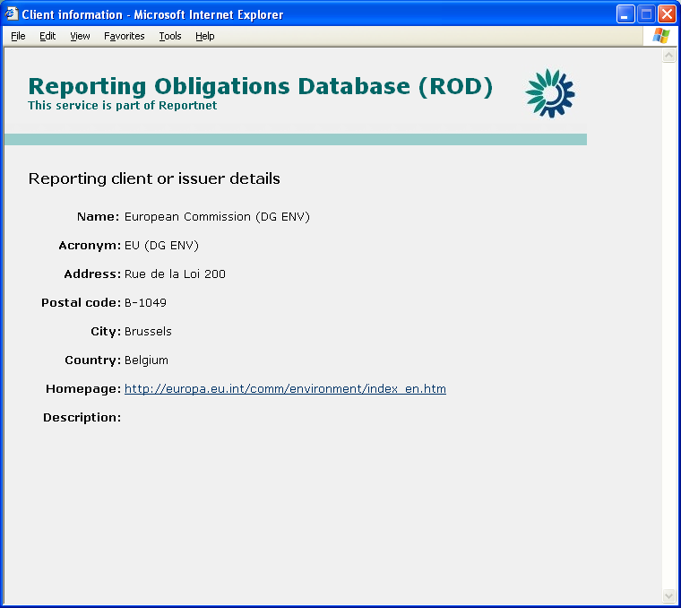
- Reporting client details
Deadline
This is the date when the data set was due. To correctly display the date, ‘Next due date’ needs to be present in reporting obligation (in date format).
Next DL
The deadline after the above.
Responsible
This is the role responsible for carrying out the reporting. For this to be available, general part of the CIRCA Directory role needs to be available in RA description in ROD. Country Services will automatically add a country code (unless ‘Do not append country suffix’ is selected from Edit Reporting Obligation Details page) to the role and query the Directory. Alternatively, if simply name and URL were entered to Edit Reporting Obligation Details page, the system will display the name here (and link to URL).
In the list, person names are displayed. Clicking on the link will open the relevant page in EIONET Directory, displaying public information. More details are available by clicking on the little ‘D’ button next to the link, but this requires logging in to CIRCA. After entering her CIRCA password, the user can see more information for the role (the password only needs to be entered once during every use of ROD) as shown on Figure 21.
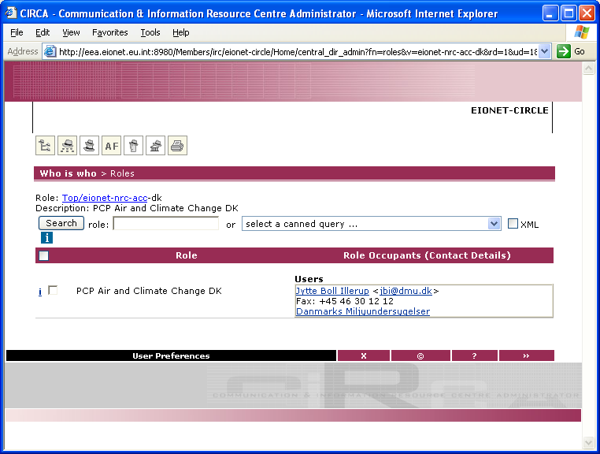
- Responsible persons for the given organisation (role)
Deliveries
If any deliveries are in Content Registry for the given reporting obligation, they can be viewed by clicking Show List. This will display a window similar to the one shown on Figure 22. Note that in order for the link between Content Registry and Country Services to work, the metadata for the delivery in Content Registry needs to contain global RA ID and country code.
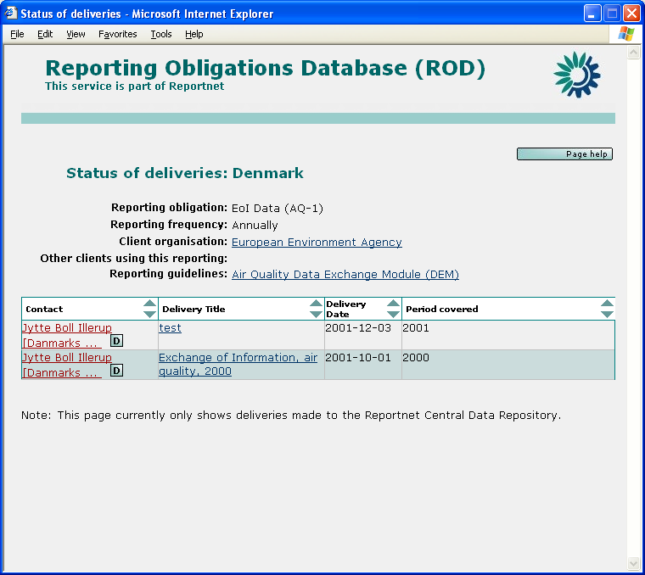
- List of deliveries for the given reporting obligation
In the deliveries window, in addition to general information, the following fields are available for each delivery:
- Contact
- Delivery (envelope or document) title (clicking on it will open the envelope/document).
- Date the delivery was created.
- Period covered by the delivery.
Note 1: ROD does not know or care about the format of the delivery; it gets it from Content Registry. Most of the deliveries are probably envelopes. ROD will then link to the envelope; it has no way of knowing what the contents of the envelope are because there is no such information in Content Registry.
Note 2: Since there is no sure way to associate deliveries with given deadline, all deliveries are shown for each obligation, regardless of the deadline displayed in the main window. The date when each of the deliveries was added to Content Registry can then be compared with the deadline displayed in the main window to find the desired delivery. ‘Period covered’ field helps with this.
Country
This is only displayed if 'All countries' is used as search criteria in advanced search and marks a country given row applies to.

RSS / RDF
The contents of ROD can be used in several different ways. Currently the main way is to browse the website. The contents of the database are also available for use as RSS, RDF and via XML-RPC. For details, see http://rod.eionet.eu.int/text.jsv?mode=R
RSS (version 1.0):
- Reporting Obligation deadlines: available at: http://rod.eionet.eu.int/events.rss; lists reporting obligations with their deadline. Only obligations which has 10% or less time of the period to the deadline.
Lists all obligations linked to environmental issues if specified in the URL.
Note: Use http://rod.eionet.eu.int/events.rss?issues=[issueId1],[issueId2], etc. Example: http://rod.eionet.eu.int/events.rss?issues=8,9.
Lists all obligations linked to countries if specified in the URL.
Note: Use http://rod.eionet.eu.int/events.rss?countries=[countryId1],[country2], etc. Example: http://rod.eionet.eu.int/events.rss?countries=10,5.
Example: http://rod.eionet.eu.int/events.rss?issues=8,9&countries=10,5.
- Reporting Obligation deadlines: available at: http://rod.eionet.eu.int/allevents.rss; lists all reporting obligations with their deadline. Only obligations with a numeric date deadline are listed. This feed is used for the Eionet calendar.
Lists all obligations linked to environmental issues if specified in the URL.
Note: Use http://rod.eionet.eu.int/events.rss?issues=[issueId1],[issueId2], etc. Example: http://rod.eionet.eu.int/events.rss?issues=8,9.
Lists all obligations linked to countries if specified in the URL.
Note: Use http://rod.eionet.eu.int/events.rss?countries=[countryId1],[country2], etc. Example: http://rod.eionet.eu.int/events.rss?countries=10,5.
Example: http://rod.eionet.eu.int/events.rss?issues=8,9&countries=10,5.
- Reporting Obligations: available at: http://rod.eionet.eu.int/obligations.rss; lists all obligations linked to environmental issues specified in the URL.
Note: Use http://rod.eionet.eu.int/obligations.rss?issues=[issueId1],[issueId2], etc. Example: http://rod.eionet.eu.int/obligations.rss?issues=8,9. The issue IDs are: 1 - Climate Change, 2 - Ozone Depletion, 3 - Acidification, 4 - Soil, 6 - Air quality, 7 - Noise, 8 - Natural Resources, 10 - Chemicals, 12 - Various other issues, 13 - Waste, 14 - Biodiversity Change and Nature, 15 - Water.
- Legislative Instruments: available at: http://rod.eionet.eu.int/instruments.rss; lists all legislative instruments.
RDF:
- Reporting Obligations: available at: http://rod.eionet.eu.int/obligations; lists all reporting obligations with linked countries and environmental issues.
- Legislative Instruments: available at: http://rod.eionet.eu.int/instruments; lists all legislative Instruments.
- Countries: available at http://rod.eionet.eu.int/countries; lists all countries.

XML-RPC Methods
Information of ROD can be retrieved by using XML-RPC The XML-RCP router URL is http://rod.eionet.eu.int/rpcrouter and the Service is called WebRODService

At the moment there are five methods available:
getActivities() – returns an ARRAY of STRUCTs, returns all the obligations in an ARRAY, each obligation information put into a STRUCT
Example of an obligation:
{
'COMMENT': 'Resolution 1.8 instructs the Second Meeting of the Parties to review the national reporting format in the light of experience gained from the submission of the first national reports and, if necessary, recommend changes to the format.',
'terminated': '0',
'NEXT_DEADLINE': '', '
SOURCE_TITLE': 'ACCOBAMS',
'DESCRIPTION': 'Triennial National Report',
'details_url': 'http://rod.eionet.eu.int/show.jsv?id=233&#038;aid=556&#038;mode=A',
'TITLE': 'Triennial National Report',
'REPORT_FORMAT_URL': 'http://www.accobams.mc/Accob/Wacco.nsf/Fram5Gb!OpenFrameSet',
'REPORTING_FORMAT': "Resolution 1.8 provides a format for the triennial national report. To avoid redundancy and repetition in successive reports, it is suggested that a format be adopted for the first report submitted by each Party and a more succinct format be used for subsequent reports. Moreover, a slightly different format is suggested for reports to be submitted by Parties that do not border on the area of the Agreement.\n\nThe format will be amended at the end of each Meeting of the Parties in order to take into account Resolutions adopted by the Meeting of the Parties. \n\nThe report is to be submitted in English or French, in triplicate, and accompanied by an electronic version on floppy disk or CD-Rom.\n\nIt is recommended that Parties consult, as appropriate, with relevant non-governmental organisations and others with technical expertise in the preparation of national reports.\n\nThe electronic version of each report received will be available on the Agreement's website.",
'uri': 'http://213.35.204.178:81/webrod/public/obligations/233',
'FORMAT_NAME': 'Format for national reports of the Parties to the Agreement on the Conservation of Cetaceans of the',
'LAST_UPDATE': '2004-01-30',
'PK_RA_ID': '233',
'VALID_SINCE': '2002-03-02',
'NEXT_DEADLINE2': '',
'PK_SOURCE_ID': '556',
'RESPONSIBLE_ROLE': ''
}

getROComplete() – returns an ARRAY of STRUCTs, returns all the obligations in an ARRAY, each obligation information put into a STRUCT All the filed of the obligations are returned
Example of an obligation STRUCT in the ARRAY
{
'REPORT_FREQ': 'annually',
'PK_RA_ID': '8',
'TITLE': 'Yearly report to the Basel Convention',
'TERMINATE': 'N',
'OVERLAP_URL': '',
'REPORT_FREQ_MONTHS': '12',
'FIRST_REPORTING': '1995-12-31',
'NATIONAL_CONTACT': '',
'AUTHORITY': '',
'FK_CLIENT_ID': '6',
'NATIONAL_CONTACT_URL': '',
'FLAGGED': '0',
'VALIDATED_BY': '',
'COMMENT': ": The Convention's secretariat provides the parties to the Convention with prefilled questionnaires. The main request for reporting concerns the amount of different generated wastes and the export and import of them to and from other countries.\nEU Member States have analogous reporting obligation to the European Commission (Waste Shipments Regulation Reporting Obligation from Council Regulation (EEC) no 259/93 of 1 February 1993 on the supervision and control of shipments of waste within, into and out of the European Community) according to Commission Decision 1999/412 /EC of 3 June 1999 concerning a questionnaire for the reporting obligation of Member States pursuant to Article 41(2) of Council Regulation (EEC) No 259/93 (Waste shipments directive).",
'PARAMETERS': '',
'COORDINATOR': '',
'FK_SOURCE_ID': '142',
'COORDINATOR_ROLE': '',
'FORMAT_NAME': 'Transmission of Information questionnaire',
'RM_NEXT_UPDATE': '2004-03-31',
'LEGAL_MORAL': 'L',
'EEA_CORE': '0',
'RM_VERIFIED_BY': 'ETC WMF',
'RM_VERIFIED': '2003-04-25',
'FK_DELIVERY_COUNTRY_IDS': ',28,',
'COORDINATOR_URL': '',
'NEXT_REPORTING': '',
'LAST_HARVESTED': '2004-04-16 10:14:02',
'RESPONSIBLE_ROLE_SUF': '1',
'REPORT_FORMAT_URL':'http://www.basel.int/meetings/sbc/workdoc/manual.html#Transmission',
'VALID_TO': '9999-12-31',
'VALID_SINCE': '',
'LOCATION_PTR': '',
'DATE_COMMENTS': '',
'NEXT_DEADLINE': '2004-12-31',
'DESCRIPTION': 'UNEP Waste Reporting Obligation',
'RESPONSIBLE_ROLE': '',
'REPORT_FREQ_DETAIL': '31 December',
'REPORTING_FORMAT': 'Questionnaire "Transmission of Information" (in accordance with Articles 13 & 16 of the Basel Convention). MS Word text document and MS Excel document (altogether 9 tables).\nManual for the Implementation of the Basel Convention, 10. Transmission of information',
'COORDINATOR_ROLE_SUF': '1',
'LAST_UPDATE': '2003-04-25',
'LOCATION_INFO': '',
'EEA_PRIMARY': '0',
'NEXT_DEADLINE2': '2005-12-31'
}

getROSummary() – returns an ARRAY of STRUCTs, returns all the obligations in an ARRAY, each obligation information put into a STRUCT The STRUCT contains link to obligation , title, last update and description
{
'TITLE': 'Yearly report to the Basel Convention',
'details_url': 'http://rod.eionet.eu.int/show.jsv?id=8&aid=142&mode=A',
'DESCRIPTION': 'UNEP Waste Reporting Obligation', 'LAST_UPDATE': '2003-04-25'
}
getRODeadlines() – returns an ARRAY of STRUCTs, returns all the obligations in an ARRAY, each obligation information put into a STRUCT The STRUCT contains the reporting client name and the next deadline. An example of an obligation data in the STRUCT:

{
'CLIENT_NAME': 'Basel Convention',
'NEXT_DEADLINE': '2004-12-31',
'DATE_COMMENTS': '',
'NEXT_DEADLINE2': '2005-12-31',
'TITLE': 'Yearly report to the Basel Convention'
}

getCountries() - returns an ARRAY of STRUCTs that contains all countries from T_SPATIAL table; each STRUCT has got three country attributes:

  - 'ISO' - the two-letter ISO code in capitals;
  - 'URL' - 'http://rod.eionet.eu.int/spatial/' [T_SPATIAL.PK_SPATIAL_ID];
  - 'NAME'=[T_SPATIAL.SPATIAL_NAME].

Editing other information in ROD
For editing any other information in the ROD (for example the contents in the pick lists) standard SQL queries have to be used. This can be done by data administrators who have direct link to the MySQL database. See also Appendix F.

Conceptual model
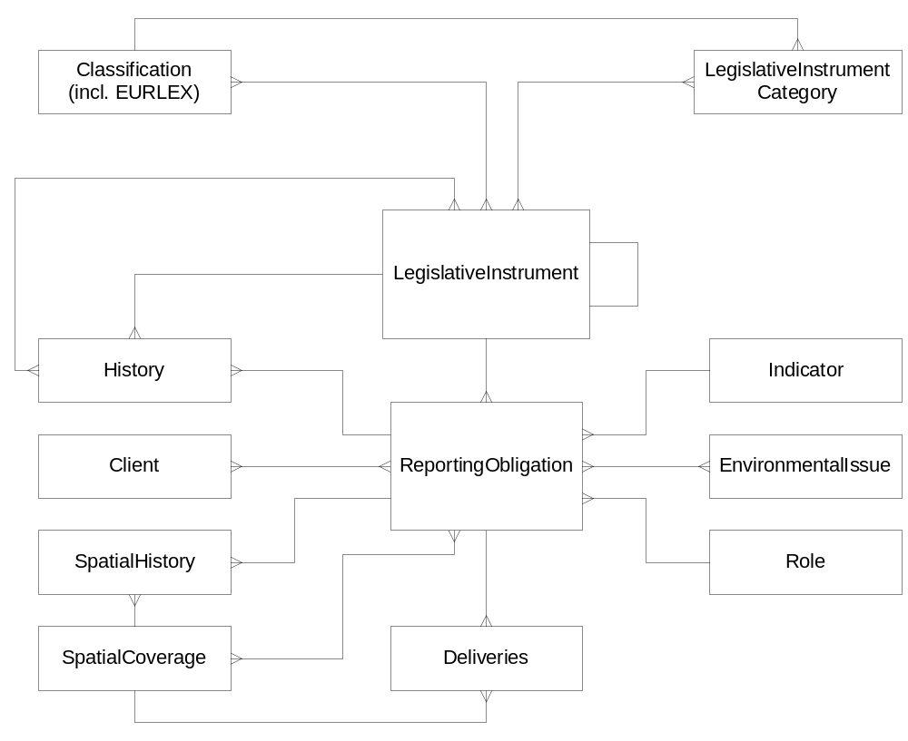
- ROD conceptual model.
The conceptual model diagram is given on Figure 23. For more information, refer to separate Word document called ROD_Elements.

Data model
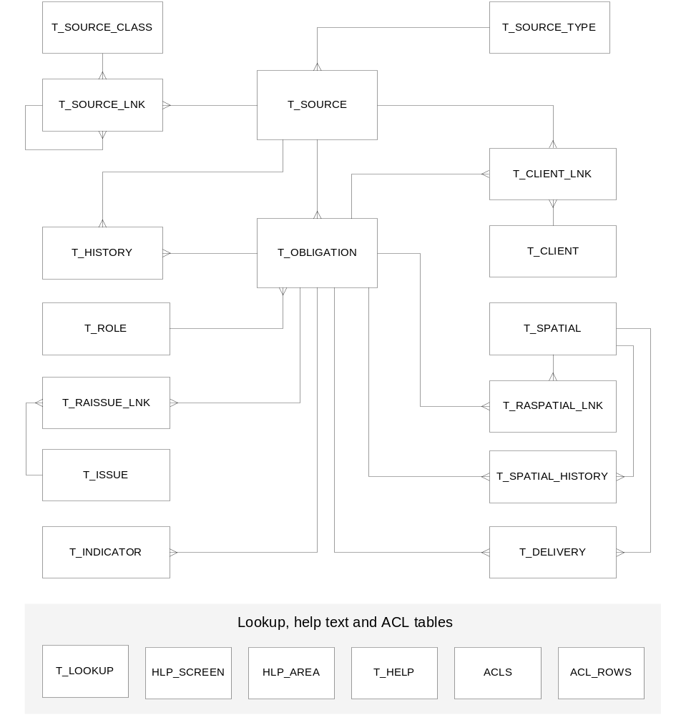
- ROD data model.
The data model diagram is given on Figure 24. For more information, refer to separate Word document called ROD_DataModel.

Technology
The technological platform of the ROD project is based on the thin clients (Web browsers) rendering HTML pages, and the HTTP-server producing the HTML pages and processing posted client data.
Although the data sent to the client (to Web-browser) is formatted to HTML, internally the server is processing data as XML-documents. It allows easily to export ROD data in XML-format to other applications, or to import XML-documents to the ROD content. For creating HTML pages rendered by the client Web-browser, XSLT (eXtensible Stylesheet Language Transformation) technology is used.
The HTTP-server runs Java Servlet engine. For generating XML from database tables and storing XML input to database, as well for performing server-side XSLT transformations, a TietoEnator's XMLServer component is used (see next chapter).
For now, plug-in modules are made and the application is tested with two servlet-engines: Resin and Tomcat.

XMLServer component
The XMLServer component is a set of Java classes to enhance Java Servlet-based HTTP server to support XML-based data exchange. The XMLServer component helps to generate XML from database queries, and to store an XML document to the database. It also incorporates XSLT (eXtensible Stylesheet Language Transformation) processor to transform on server-side the generated XML data to some other presentation format (HTML, WML, PDF), and a proprietary technology to upload HTML form data to the source XML document.
The XMLServer component is built on top Java Servlet SDK (JSDK 2.2, current implementations are based on Caucho Web Server - Resin 1.1.6 and Tomcat 4.1.18, but it should be compatible with any Web server implementing JSDK 2.2). It can be used with any database supporting JDBC, although the XMLServer component takes advantage of DBMS transaction management, therefore preferably the used DBMS should support it.
The core of the XMLServer component is XSQL processor, what generates XML-documents of a certain type, and the same processor is able to store information from XML-documents of this type to the database.
The XMLServer component contains also generic XSQL processor called XRS (XML RecordSet) processor, what is capable of generating XML-documents on most of SQL queries. The main advantage of this processor is, that the query result retains its structural representation (one-to-many relationships between master and detail tables, and what data comes from which table), while in most applications (including various database spreadsheet clients) the query result is flat.
This structural representation makes possible to store the same document to the database by the processor itself without writing query specific update code.
What the programmer has to do, is to specify the data source (i.e. write the SQL queries composing the document), and to data store handler write only business logic-dependent code.
Although the XRS processor might be the most valuable part of the XML-framework, other processors for some other XML document type can be plugged in.
The key characteristics of the XMLServer component are openness and extensibility.

OPENNESS:
- different XSQL processor implementations;
- XML parser and XSLT processor implementations. Currently the XMLServer component is working with Oracle components, and Apache Xerces and Xalan components;
- database connection pool implementation. Default implementation is based on Resin connection pooling, but any other implementation can be used;
- cache implementation. It is a utility module used in the system to cache compiled XSL files and compiled XML-queries. The implementation is expected to realize LRU (last recently used) algorithm. Default implementation is based on Resin LRU cache implementation;
- SQL error analyser implementation, what can provide vendor specific error messages in desired language;
- application specific security policy implementation. All database updates will check the current user rights by calling this application specific policy implementation. The database connection for updates is asked from this security class, so in addition to XMLServer component protection also the database protection can be used;
- application specific HTTP server cache management. This cache management works on HTTP header information about the last modification time of the document compared to the last modification time of the database tables involved in the page generation.

EXTENSIBILITY:
Servlets are the external interface to the XMLServer component. These are sub-classes of the XMLServer component servlets. They could have the following sub-classes:
BaseServletAC
- taking advantage of defined security functions and interface to plugged modules;
FetchServletAC
- in addition provides mechanism for document caching;
XMLServletAC
- uses XSQL processor(s) for XML-document generation and storage, operates with XML-aware client;
XHTMLServletAC
- converts the XSQL-processor generated XML documents to HTML by using given XSLT files. For data storage converts the HTML form data to XML-document of the given document type, what is then passed to XSQL-processor.

The XMLServer component can be used on any platform, where Java 2 (JDK 1.2) runtime is supported.

XMLServer component class model
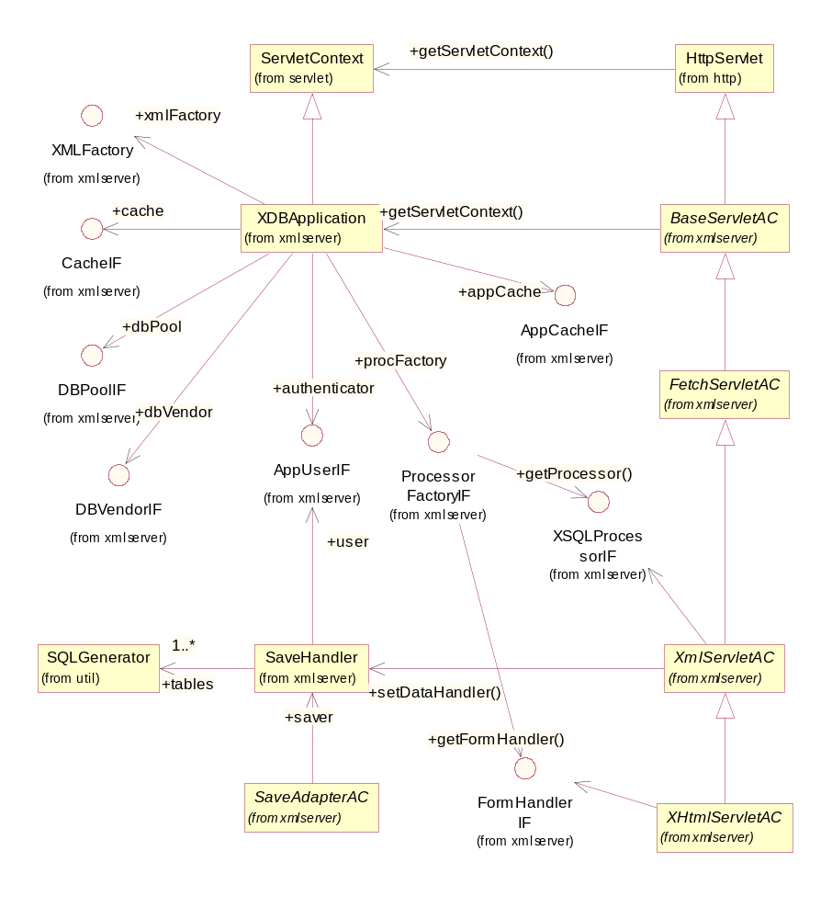
- XMLServer main class diagram.

ROD application
ROD application is entirely built on top of the XMLServer component. It consists of the four types of components:
- Java Servlet classes to generate ROD application HTML pages; extending XMLServer’s com.tee.xmlserver.XHTMLServletAC class;
- XRS query definition files for the XMLServer component to generate XML from database content;
- XSL files for XSLT transformation rules for presenting generated XML documents in HTML format;
- Java classes extending XMLServer’s com.tee.xmlserver.SaveHandler class for application specific data upload code.

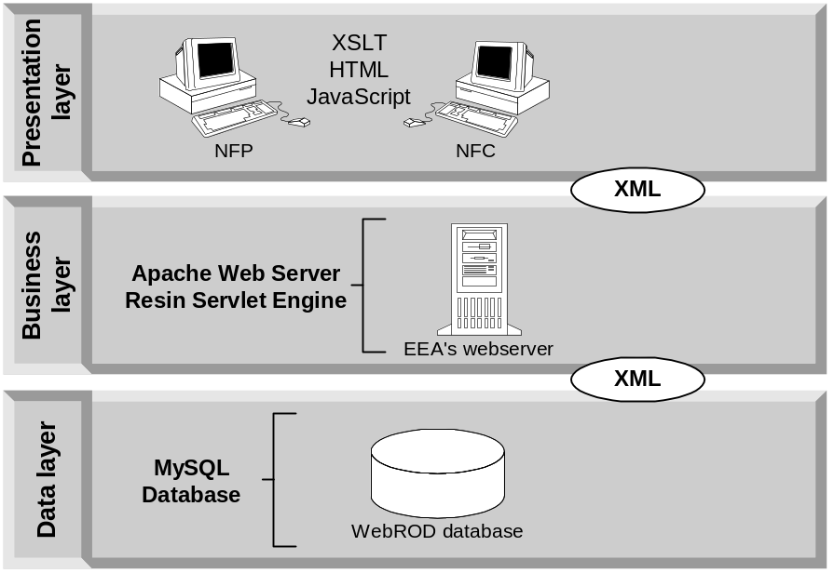

- System Architecture of ROD

ROD application class hierarchy
eionet
rod
countrysrv
servlets
rdf
services
modules

Package descriptions
The functionality of the ROD application classes, belonging to different packages is the following:
- eionet.rod
Servlets, extending XHTMLServletAC in the XMLServer component
- eionet.rod.services
Service interfaces used by the ROD application: File reader, Database connection and Logger.
- eionet.rod.services.modules
Modules, implementing the services, described in the previous section.
- eionet.rod.rdf
Classes, performing operation generating RDF documents.
- eionet.rod.countrysrv
Classes, specific to ROD CountryServices part, including Extractor, harvesting data from Content Registry and user Directory.

- eionet.rod.countrysrv.servlets
Servlets of ROD CountryServices part

Installation Guide
The ROD system consists of the following parts:
- MySQL database server hosting ROD data (version 4 recommended)
- Resin or (preferably) Tomcat Web-server hosting ROD application servlets
- HTTP server (either Apache or Resin built-in HTTP server)

Installing MySQL
As the ROD database uses MyISAM tables, therefore MySQL version 3.23.23 or newer is required (MySQL 4 is recommended):

MySQL is freeware and the latest version can be downloaded at:
· http://www.mysql.com/Downloads/MySQL-3.23/mysql-3.23.28-gamma-pc-linux-gnu-i686.tar.gz
for Linux (Intel libc6 systems) [pc-linux-gnu-i686] systems.

For complete installation guide on Linux, please see the following pages:
· Installing a MySQL Binary Distribution
http://www.mysql.com/documentation/mysql/commented/manual.php?section=Installing_binary
· Installation Layouts
http://www.mysql.com/documentation/mysql/commented/manual.php?section=Installation_layouts

Running MySQL on Linux platform
The Linux installation is usually located at /usr/local/mysql
- Running the MySQL server:
shell> bin/safe_mysqld --user=mysql&
where 'mysql' is the user under which the process will be run.
- Opening the MySQL command prompt:
shell> bin/mysql -u user_name -p

Note! To allow big result sets, you should run the MySQL server with additional option:
--big-tables

Loading the ROD database to MySQL
1. Download the cleanrod.sql from the EEA’s CVS Server (details from Soren Roug) into temporary directory (e.q. /tmp)

2. As MySQL root user create the ROD database and users for the database:

shell> bin/mysql -u root -p

mysql> create database ROD;
mysql> use mysql
mysql> insert into user (Host, User, Password) values('localhost%','RO_admin',password('xxx'));
mysql> insert into user (Host, User, Password) values('localhost%','RO_user',password('aaa'));
mysql> insert into db values('localhost%','ROD','RO_admin','Y','Y','Y','Y','Y','Y','Y','Y','Y','Y');
mysql> insert into db values('localhost%','ROD','RO_user','Y','N','N','N','N','N','N','Y','Y','N');
mysql> exit

3. Reload user privileges information:

shell> bin/mysqladmin -u root -p reload

4. Load ROD table descriptions and data to the database:

shell> bin/mysql -u root -p ROD < /tmp/cleanrod.sql

Installing Java run-time and Java development kit
Java run-time is needed for the Resin servlet engine and also for the ROD application code. But just in some classes need to be re-compiled, it is recommended also to install Java development kit.
Java run-time and development kit come in one complete package and it can be downloaded from the following place:
· http://www.javasoft.com/j2se/1.3/download-linux.html

For complete installation guide please see the following page:
· http://www.javasoft.com/j2se/1.3/install-linux-sdk.html

Installing JDBC database driver
MM MySQL JDBC driver v. 1.2c can be downloaded from
http://www.mysql.com/downloads/contrib.html
Unpack the mm.mysql.jdbc-1.2c.tar.gz archive (e.g into /usr/local) and set the environment variable CLASSPATH to include driver file like: /usr/local/mm.mysql.jdbc-1.2c/mysql_uncomp.jar
Note, that CLASSPATH variable has to be set in the environment, where the Resin Web-server is running.

Installing Tomcat Servlet engine
The source can be downloaded from: http://apache.ut.ee/dist/jakarta/tomcat-4/source/
The binary version (currently 4.1.24) is available at: http://jakarta.apache.org/builds/jakarta-tomcat-4.0/release/v4.1.24/

To install Tomcat Web server, the archive has to be unpacked:
shell> cd /usr/local
shell> tar zxvf jakarta-tomcat-1.1.24.tar.gz

Running Tomcat servlet engine with its built-in HTTP server
To start running the Tomcat HTTP server, you need to start the startup.sh in the /usr/local/jakarta-tomcat-4.1.18/bin directory:
shell> /usr/local/jakarta-tomcat-4.1.18/startup.sh
To stop Tomcat:
shell> /usr/local/jakarta-tomcat-4.1.18/shutdown.sh

Installing ROD application software
The latest version of the package can be downloaded from the EEA’s CVS server (details from Søren Roug)
It is recommended to transfer the files into the /home directory.
The directory structure of application software is as follows:
- ROD - root directory, contains no files but the following subdirectories
- public
- app
- Web-inf
- src
- public/app directory contains all the files, that are not visible to the user and are involved in web-interface
- .xsl files
- .xml files (with *.xrs extension)
- public directory contains all the subfolders and files, that are visible to the user and are involved in web-interface. Data suppliers must have *write* rights in this folder.
- images
- .html files
- .css files
- src directory consists of *.java source files used in the application
- eionet
- rod
- .java
- public/WEB-INF is a directory containing subdirectories for ROD Java classes and servlets. Includes library classes (packed into .jar files) that the application classes will need
- eionet
- rod
- .class
- activation.jar
- castor.jar
- eionet-dir.jar
- jndi.jar
- ldap.jar
- log4j.jar
- mail.jar
- providerutil.jar
- rod.jar
- soap.jar
- tomcat-util.jar
- uit-client.jar
- uit-definition.jar
- uit-help.jar
- uit-security.jar
- uit-server.jar
- xalan-j2-2.6.0.jar
- xerces.jar
- xmlrpc.jar
- xmlserver.jar
- images directory contains all the graphics files.
- .gif files
- .jpg files
- .png files

Before you can run ROD you need to set up the ROD configuration file for Resin or (preferably) Tomcat. ROD specific configuration files are in the ROD/resin-conf directory and it is named resin.conf for resin configuration file and web.xml and services.xml for Tomcat configuration files. For contents of the files please refer to Appendix A in this document.

Installing ROD with ANT
Apache Ant is a Java-based build tool. The latest stable version of Ant is available from the Ant web page http://ant.apache.org/. Running Ant from the command-line is simple: just type ant. When no arguments are specified, Ant looks for a build.xml file in the current directory and, if found, uses that file as the build file and runs the target specified in the default attribute of the <project> tag. To make Ant use a build file other than build.xml, use the command-line option -buildfile file, where file is the name of the build file you want to use.
Build.xml can be found from the root directory of ROD. The default target of the ant call is install, which does the following – creates the folders, copies files and compiles all the classes. The mandatory command-line argument prefix should be defined in the ant call. It refers to the directory, where the application will be installed. Usually it is webapps directory of Tomcat. The ant call looks like as follows:

ant –Dprefix=/home/www/webs install

Other useful targets are:
clean - this target removes all compiled java classes from the build.dir, but does not touch the rest (jsp, html, xml, stylesheets)
compile - compiles all classes
checkProps – checks if any of the properties is missing

Additional optional argument during is vhost. If this property is defined, the application will be installed as a new virtual host. Otherwise it is installed under webapps folder under existing virtual host

Properties
Properties files must be copied into public/WEB-INF/classes folder
rod.properties

ROD application specific properties must be set in file rod.properties Descriptions and example values of different properties are given below.

# settings for ROD urls, used in generated RDF files
rod.url.domain=http://rod.eionet.eu.int
rod.url.namespace=http://rod.eionet.eu.int/activities
rod.url.ro_namespace=http://rod.eionet.eu.int/obligations
#Events for Eionet calendar
rod.url.events=http://rod.eionet.eu.int/events.rss
rod.url.obligations=http://rod.eionet.eu.int/obligations.rss
rod.url.activities=http://rod.eionet.eu.int/activities.rss

#settings for DB connection, used externally by exractor
# !!! ADJUST THESE !!!
db.drv=org.gjt.mm.mysql.Driver
db.url=jdbc:mysql://localhost:3306/WebROD
db.usr=RO_admin
db.pwd=thisisthesecretpassword

# RA_ID namespace prefix in Content Registry
ra.namespace=http://rod.eionet.eu.int/activities#activity

#Country namespace in Content Registry
country.namespace=http://cdr.eionet.eu.int/rdf/countries#country

#Namespace prefix for SPATIALs XML/RPC method getCountries()
spatial.namespace=http://rod.eionet.eu.int/spatial/

#DC elements
contreg.title.predicate=http://purl.org/dc/elements/1.1/title
contreg.date.predicate=http://purl.org/dc/elements/1.1/date
contreg.type.predicate=http://purl.org/dc/elements/1.1/type
contreg.identifier.predicate=http://purl.org/dc/elements/1.1/identifier
contreg.format.predicate=http://purl.org/dc/elements/1.1/format
contreg.coverage.predicate=http://purl.org/dc/elements/1.1/coverage

# remote services
# XML/RPC=0, SOAP=1, if not specified, 0 is used as default
remote.services.type=0
contreg.service.url=http://cr.eionet.eu.int/rpcrouter

# settings for Extractor
# logpath + logfilename need to form a valid path;
# leave path empty for current directory
# if debugmode=true, new log with verbose info is built for each extraction,
# otherwise, less verbose text is appended to previous log.
extractor.logpath=/var/logs/webrod/
extractor.logfilename=extractorlog.txt
extractor.debugmode=true

#ROD schema
schema.namespace=http://rod.eionet.eu.int/schema.rdf

#Schema for Legal instruments
instruments.namespace=http://rod.eionet.eu.int/instruments/

#Schema for env issues
issues.namespace=http://rod.eionet.eu.int/issues/
#Instruments.rss URL
rod.url.instruments=http://localhost:8080/webrod/public/instruments.rss

uit.properties
The settings, related to Access Control Mechanism and public RPC services are given in file uit.properties

# Location of the file for public service descriptions
# !!! ADJUST THIS !!!
services.definition.file=/webs/webrod/public/WebRODService.xml

# folder for permission files, files with *.acl extension are stored here
application.acl.folder=/webs/webrod/public/acls

# file for local groups and users
application.localgroups.file=/webs/webrod/public/acls/rod.group

# file for permissions + descriptions
application.permissions.file=/webs/webrod/public/acls/rod.prms

# ACL owner permission
acl.owner.permission=c

# if true, permissions are allowed to be changed with ACL admin tool
acl.admin=true

#ACL entry for authenticated acces (not belonging to any group)
acl.authenticated.access=authenticated

#ACL entry for anonymous access
acl.anonymous.access=anonymous

# component services
componentservices=HelpService
componentservices.HelpService.provider=com.tee.uit.help.RemoteService

# settings for DB connection (adjust!)
db.driver=org.gjt.mm.mysql.Driver
db.url=jdbc:mysql://x.x.x.x:3306/WebROD
db.user=
db.pwd=

eionetdir.properties
The settings, related to eionet directory are described in this file. Some of them may need adjustement.

# LDAP service settings

# !!! NEEDS ADJUSTEMENT !!!
ldap.url=ldap://eea.eionet.eu.int:8978/

# !!! NEED ADJUSTEMENT, WHEN CIRCA IS UPGRADED TO 3.1
circa.version=2.5

# Circa 3.1, not used in 2.5 implementation
ldap.user.context=ou=DATA,ou=tango,o=IRCUSERS,l=CIRCA

# Circa 3.1, not used in 2.5 implementation
ldap.domain=circa

# Circa v3.1
#ldap.attr.rolename=ou

ldap.context=o=Eionet,l=EUROPE
ldap.ref=throw
ldap.role.dir=ou=Roles
ldap.user.dir=ou=Users
ldap.attr.rolename=cn
ldap.attr.fullname=cn
ldap.attr.roledescription=description
ldap.attr.uid=uid
ldap.attr.mail=mail

#circa settings
# !!! MAY NEED ADJUSTEMENT !!!
circa.vcirca=eionet-circle
circa.url.public=http://eea.eionet.eu.int:8980/Public/irc/
circa.url.members=http://eea.eionet.eu.int:8980/Members/irc/
circa.role.function.prefix=/Home/central_dir_admin?fn=roles&v=
circa.role.function.suffix=&rd=1&ud=1&od=0

# EionetDir 2.1
ldap.organisation.dir=ou=Organisations
ldap.attr.orgid=cn

circa.org.function.prefix=/Home/central_dir_admin?fn=org&act=view&org=
circa.org.function.prefix2=&site=

circa.site=eea

log4j.properties
Settings for the logger.

# !!! ADJUST THESE !!!
log4j.appender.f=org.apache.log4j.RollingFileAppender
log4j.appender.f.File=/var/logs/webrod/webrod.log

# Max log file size
log4j.appender.f.MaxFileSize=1000KB

# Keep three backup files
log4j.appender.f.MaxBackupIndex=3

#specify level, how specific info is needed in log (FATAL, ERROR, INFO, DEBUG)
log4j.rootLogger=INFO, stdout
log4j.category.webrod=INFO, f, stdout

log4j.appender.stdout=org.apache.log4j.ConsoleAppender
log4j.appender.stdout.layout=org.apache.log4j.PatternLayout

# Pattern to output the caller's file name and line number.
log4j.appender.stdout.layout.ConversionPattern=%5p [%t] - %m%n

log4j.appender.f.layout=org.apache.log4j.PatternLayout
log4j.appender.f.layout.ConversionPattern=<%d{DATE}> <%p> <%m>%n

User Permissions
ROD is integrated to Access Control List (ACL) based access control mechanism. It enables to give special permissions to users, self-created user groups or EIONET directory roles. All the descriptions are specified in text files.

rod.prms
In this file the ACL permission descriptions are specified. This file must not be modified:

v:View
i:Insert
u:Update
d:Delete
c:Control
hc:Help Control

rod.group
In this file the local groups and members can be added and removed. The format for the file row is: [group_name]:[member1],[member2],…,[memberN] where member names are user names in Eionet User Directory.

Example:
rod_admin:tennoan,lainekai,haigh,roug,cryan
rod_user:palosuo,jensen

*.acl files
User permissions for different actions are described in files with *.acl extension. The example format for different permissions, admitted to localgroup, user and Directory role are shown below:
The ACL mechanism supports hierarchical structure of ACL’s. That’s why the names of ACL files contain “_” characters, that are used instead of “/” symbols.

circarole:eionet-staff-its:u
localgroup:rod_admin:i,u,d
user:haigh:c

There are the following ACLs and permissions in ROD
Permissions:
v: View
i: Insert
u: update
d: Delete
c: Control Acl
hc: Help control
ACLs: structure
/ <application>
-/obligations
-/instruments
-/ADMIN
-/HELPTEXT
-/HARVEST
-/CLIENT
-/LOCALGROUPS

Acl file names:
_.acl , _obligations.acl, _instruments.acl, _Admin_.acl, _Admin_Helptext.acl, _Admin_Harvest.acl, _Client.acl, _localgroups.acl
ACL permissions, checked for several actions:
Action - ACL:permission(s)
RO: insert/update/delete - /obligations:i,u,d
LI: insert/update/delete - /instruments:i,u,d (If a user has /instruments:d permission, he
can delete related ROs also.)
Client:insert - /CLIENT:i
Issuer:insert - /CLIENT:i
Insert or update helptext - /ADMIN/HELPTEXT:u
View record change history - /ADMIN:v
Harvest CS data - /ADMIN/HARVEST:u

View and manage localgroups’ permissions and membership - /LOCALGROUPS: r,u

Scripts
There are some actions that are needed to happen automatically: extracting information from the Content Registry and User Directory and calculating new deadlines for the Reporting Activities. The two script files have to be put into crontab.

harvest.sh
Usage: harvest.sh {0|1|2}
0: all data
1: deliveries from CR
2: roles from DIR
3: parameters from DD (not implemented yet)
default is 0
It should be enough, if deliveries data is extracted once in a day and roles data once in a week.

deadlinecalc.sh
Usage: deadlinecalc.sh

Appendix A. ROD application configuration

Context tag to be added to server.xml

<!-- !!!!!!!!!!! WEBROD !!!!!!!!!!!!!!!! -->
<Service>
<Engine>
<Host>
<!—- ROD specific -->
<Context path="/webrod" docBase="webrod" debug="0" reloadable="true" crossContext="true">

<Logger className="org.apache.catalina.logger.FileLogger" prefix="rod_log." suffix=".log" timestamp="true"/>
<Resource name="jdbc/webrod" auth="Container" type="javax.sql.DataSource"/>
<ResourceParams name="jdbc/webrod">
<parameter><name>factory</name><value>org.apache.commons.dbcp.BasicDataSourceFactory</value></parameter>
<!-- Maximum number of dB connections in pool. Make sure you configure your mysqld max_connections large enough to handle all of your db connections. Set to 0 for no limit. -->
<parameter><name>maxActive</name><value>100</value></parameter>
<!-- Maximum number of idle dB connections to retain in pool. Set to 0 for no limit. -->
<parameter><name>maxIdle</name><value>30</value></parameter>
<!-- Maximum time to wait for a dB connection to become available in ms, in this example 10 seconds. An Exception is thrown if this timeout is exceeded. Set to -1 to wait indefinitely. -->
<parameter><name>maxWait</name><value>10000</value></parameter>
<!-- MySQL dB username and password for dB connections -->
<parameter><name>username</name><value>[ mysql:username ]</value></parameter>
<parameter><name>password</name><value>[ mysql:pwd ]</value></parameter>
<!-- Class name for mm.mysql JDBC driver -->
<parameter><name>driverClassName</name><value>org.gjt.mm.mysql.Driver</value></parameter>
<!-- The JDBC connection url for connecting to your MySQL dB. -->
<parameter><name>url</name>
<value>jdbc:mysql:[host]:[port]/[WebROD]?autoReconnect=true</value>
</parameter>
</ResourceParams>

</Context>
<!-- ROD specific end -->

</Host>
</Engine>
</Service>

web.xml to be placed into public/WEB-INF folder
<?xml version="1.0" encoding="ISO-8859-1"?>
<!DOCTYPE web-app PUBLIC "-//Sun Microsystems, Inc.//DTD Web Application 2.3//EN"
"http://java.sun.com/dtd/web-app_2_3.dtd">
<web-app>
<display-name>ROD</display-name>
<description>EIONET ROD application</description>
<context-param>
<param-name>application-name</param-name>
<param-value>webrod</param-value>
</context-param>
<context-param>
<param-name>log-level</param-name>
<param-value>4</param-value>
</context-param>
<context-param>
<param-name>module-cache</param-name>
<param-value>com.tee.xmlserver.tomcat.TCCache</param-value>
</context-param>
<context-param>
<param-name>module-db_pool</param-name>
<param-value>com.tee.xmlserver.tomcat.TCDBPool</param-value>
</context-param>
<context-param>
<param-name>authenticator</param-name>
<param-value>eionet.rod.ROUser</param-value>
</context-param>
<context-param>
<param-name>login-error-page</param-name>
<param-value>error.html</param-value>
</context-param>
<context-param>
<param-name>app_cache</param-name>
<param-value>eionet.rod.ROCache</param-value>
</context-param>
<servlet>
<servlet-name>gentext</servlet-name>
<servlet-class>eionet.rod.TxtServlet</servlet-class>
</servlet>
<servlet>
<servlet-name>indicator</servlet-name>
<servlet-class>eionet.rod.Indicator</servlet-class>
</servlet>
<servlet>
<servlet-name>analysis</servlet-name>
<servlet-class>eionet.rod.Analysis</servlet-class>
</servlet>
<servlet>
<servlet-name>index</servlet-name>
<servlet-class>eionet.rod.Index</servlet-class>
</servlet>
<servlet>
<servlet-name>viewhelp</servlet-name>
<servlet-class>eionet.rod.ViewHelp</servlet-class>
</servlet>
<servlet>
<servlet-name>help</servlet-name>
<servlet-class>eionet.rod.Help</servlet-class>
</servlet>
<servlet>
<servlet-name>client</servlet-name>
<servlet-class>eionet.rod.Client</servlet-class>
</servlet>
<servlet>
<servlet-name>addclient</servlet-name>
<servlet-class>eionet.rod.AddClient</servlet-class>
</servlet>
<servlet>
<servlet-name>csindex</servlet-name>
<servlet-class>eionet.rod.countrysrv.servlets.Index</servlet-class>
</servlet>
<servlet>
<servlet-name>csmain</servlet-name>
<servlet-class>eionet.rod.countrysrv.servlets.Main</servlet-class>
</servlet>
<servlet>
<servlet-name>csdeliveries</servlet-name>
<servlet-class>eionet.rod.countrysrv.servlets.Deliveries</servlet-class>
</servlet>
<servlet>
<servlet-name>cssearch</servlet-name>
<servlet-class>eionet.rod.countrysrv.servlets.Search</servlet-class>
</servlet>
<servlet>
<servlet-name>rpcrouter</servlet-name>
<servlet-class>com.tee.uit.servlets.XmlRpcRouter</servlet-class>
</servlet>
<servlet>
<servlet-name>soaprouter</servlet-name>
<servlet-class>com.tee.uit.servlets.SOAPRouter</servlet-class>
</servlet>
<servlet>
<servlet-name>login</servlet-name>
<servlet-class>eionet.rod.LoginServlet</servlet-class>
</servlet>
<servlet>
<servlet-name>countries_rdf</servlet-name>
<servlet-class>eionet.rod.rdf.Countries</servlet-class>
</servlet>
<servlet>
<servlet-name>instruments_rss</servlet-name>
<servlet-class>eionet.rod.rdf.InstrumentsRSS</servlet-class>
</servlet>
<servlet>
<servlet-name>instruments_rdf</servlet-name>
<servlet-class>eionet.rod.rdf.Instruments</servlet-class>
</servlet>
<servlet>
<servlet-name>obligations_rdf</servlet-name>
<servlet-class>eionet.rod.rdf.Activities</servlet-class>
</servlet>
<servlet>
<servlet-name>issue_activities_rss</servlet-name>
<servlet-class>eionet.rod.rdf.IssueActivities</servlet-class>
</servlet>
<servlet>
<servlet-name>events_rss</servlet-name>
<servlet-class>eionet.rod.rdf.Events</servlet-class>
</servlet>
<servlet>
<servlet-name>env</servlet-name>
<servlet-class>com.tee.util.EnvServlet</servlet-class>
</servlet>
<servlet>
<servlet-name>logout</servlet-name>
<servlet-class>eionet.rod.LogoutServlet</servlet-class>
</servlet>
<servlet>
<servlet-name>history</servlet-name>
<servlet-class>eionet.rod.History</servlet-class>
</servlet>
<servlet>
<servlet-name>harvester</servlet-name>
<servlet-class>eionet.rod.Harvester</servlet-class>
</servlet>
<servlet>
<servlet-name>show</servlet-name>
<servlet-class>eionet.rod.Show</servlet-class>
</servlet>
<servlet>
<servlet-name>source</servlet-name>
<servlet-class>eionet.rod.Source</servlet-class>
</servlet>
<servlet>
<servlet-name>rorabrowse</servlet-name>
<servlet-class>eionet.rod.RORABrowse</servlet-class>
</servlet>
<servlet>
<servlet-name>activity</servlet-name>
<servlet-class>eionet.rod.Activity</servlet-class>
</servlet>
<servlet>
<servlet-name>spatialhistory</servlet-name>
<servlet-class>eionet.rod.SpatialHistory</servlet-class>
</servlet>
<servlet>
<servlet-name>helplist</servlet-name>
<servlet-class>eionet.rod.HelpList</servlet-class>
</servlet>
<servlet-mapping>
<servlet-name>helplist</servlet-name>
<url-pattern>/helplist.jsv</url-pattern>
</servlet-mapping>
<servlet-mapping>
<servlet-name>gentext</servlet-name>
<url-pattern>/text.jsv</url-pattern>
</servlet-mapping>
<servlet-mapping>
<servlet-name>indicator</servlet-name>
<url-pattern>/indicator.jsv</url-pattern>
</servlet-mapping>
<servlet-mapping>
<servlet-name>spatialhistory</servlet-name>
<url-pattern>/spatialhistory.jsv</url-pattern>
</servlet-mapping>
<servlet-mapping>
<servlet-name>index</servlet-name>
<url-pattern>/index.html</url-pattern>
</servlet-mapping>
<servlet-mapping>
<servlet-name>analysis</servlet-name>
<url-pattern>/analysis.jsv</url-pattern>
</servlet-mapping>
<servlet-mapping>
<servlet-name>activity</servlet-name>
<url-pattern>/activity.jsv</url-pattern>
</servlet-mapping>
<servlet-mapping>
<servlet-name>viewhelp</servlet-name>
<url-pattern>/viewhelp.jsv</url-pattern>
</servlet-mapping>
<servlet-mapping>
<servlet-name>help</servlet-name>
<url-pattern>/help.jsv</url-pattern>
</servlet-mapping>
<servlet-mapping>
<servlet-name>client</servlet-name>
<url-pattern>/client.jsv</url-pattern>
</servlet-mapping>
<servlet-mapping>
<servlet-name>addclient</servlet-name>
<url-pattern>/addclient.jsv</url-pattern>
</servlet-mapping>
<servlet-mapping>
<servlet-name>csindex</servlet-name>
<url-pattern>/deliveries.jsv</url-pattern>
</servlet-mapping>
<servlet-mapping>
<servlet-name>csmain</servlet-name>
<url-pattern>/csmain</url-pattern>
</servlet-mapping>
<servlet-mapping>
<servlet-name>csdeliveries</servlet-name>
<url-pattern>/csdeliveries</url-pattern>
</servlet-mapping>
<servlet-mapping>
<servlet-name>cssearch</servlet-name>
<url-pattern>/cssearch</url-pattern>
</servlet-mapping>
<servlet-mapping>
<servlet-name>rpcrouter</servlet-name>
<url-pattern>/rpcrouter</url-pattern>
</servlet-mapping>
<servlet-mapping>
<servlet-name>soaprouter</servlet-name>
<url-pattern>/soaprouter</url-pattern>
</servlet-mapping>
<servlet-mapping>
<servlet-name>login</servlet-name>
<url-pattern>/login_servlet</url-pattern>
</servlet-mapping>
<servlet-mapping>
<servlet-name>instruments_rdf</servlet-name>
<url-pattern>/instruments</url-pattern>
</servlet-mapping>
<servlet-mapping>
<servlet-name>instruments_rss</servlet-name>
<url-pattern>/instruments.rss</url-pattern>
</servlet-mapping>
<servlet-mapping>
<servlet-name>obligations_rdf</servlet-name>
<url-pattern>/obligations</url-pattern>
</servlet-mapping>
<servlet-mapping>
<servlet-name>countries_rdf</servlet-name>
<url-pattern>/countries</url-pattern>
</servlet-mapping>
<servlet-mapping>
<servlet-name>issue_activities_rss</servlet-name>
<url-pattern>/obligations.rss</url-pattern>
</servlet-mapping>
<servlet-mapping>
<servlet-name>events_rss</servlet-name>
<url-pattern>/events.rss</url-pattern>
</servlet-mapping>
<servlet-mapping>
<servlet-name>env</servlet-name>
<url-pattern>/env</url-pattern>
</servlet-mapping>
<servlet-mapping>
<servlet-name>logout</servlet-name>
<url-pattern>/logout_servlet</url-pattern>
</servlet-mapping>
<servlet-mapping>
<servlet-name>history</servlet-name>
<url-pattern>/history.jsv</url-pattern>
</servlet-mapping>
<servlet-mapping>
<servlet-name>harvester</servlet-name>
<url-pattern>/harvester.jsv</url-pattern>
</servlet-mapping>
<servlet-mapping>
<servlet-name>show</servlet-name>
<url-pattern>/show.jsv</url-pattern>
</servlet-mapping>
<servlet-mapping>
<servlet-name>source</servlet-name>
<url-pattern>/source.jsv</url-pattern>
</servlet-mapping>
<servlet-mapping>
<servlet-name>rorabrowse</servlet-name>
<url-pattern>/rorabrowse.jsv</url-pattern>
</servlet-mapping>
<session-config>
<session-timeout>600</session-timeout> <!-- minutes -->
</session-config>

<!-- the application server might allow directory listing.
The welcome-files are used to overcome workings of such feature
-->
<welcome-file-list>
<welcome-file>index.html</welcome-file>
</welcome-file-list>
<resource-ref>
<description>ROD DB</description>
<res-ref-name>jdbc/webrod</res-ref-name>
<res-type>javax.sql.DataSource</res-type>
<res-auth>Container</res-auth>
</resource-ref>
<security-constraint>
<web-resource-collection>
<web-resource-name>
Restricted Area
</web-resource-name>
<url-pattern>/app/*</url-pattern>
</web-resource-collection>
</security-constraint>

<!-- force the entire application to security constraint CONFIDENTIAL -->
<!-- as a result the non-SSL connector will redirect using the redirectPort
value to the SSL connector -->
<!-- first match wins -->
<!-- transport-guarantee can be NONE, INTEGRAL, CONFIDENTIAL -->
<!-- define SSL security>
<security-constraint>
<web-resource-collection>
<web-resource-name>XslXmlFiles</web-resource-name>
<description>app files</description>
<url-pattern>/app/*</url-pattern>
<url-pattern>/images/*</url-pattern>
<http-method>GET</http-method>
<http-method>POST</http-method>
</web-resource-collection>
<user-data-constraint>
<transport-guarantee>NONE</transport-guarantee>
</user-data-constraint>
</security-constraint>
<security-constraint>
<web-resource-collection>
<web-resource-name>Entire Application</web-resource-name>
<url-pattern>/*</url-pattern>
</web-resource-collection>
<user-data-constraint>
<transport-guarantee>CONFIDENTIAL</transport-guarantee>
</user-data-constraint>
</security-constraint>
<!end def SSL security -->
</web-app>

Appendix B. ROD script: harvest.sh

#!/bin/sh
# !!!!!!!!!!!!!!!!!! ADJUST THESE !!!!!!!!!!!!!!!!!!
rod=/prj/rod2/public
java=/prj/javaserv/jdk1.2.2/bin/java

libpath=$rod/WEB-INF/lib
# !!!!!!!!!!!!!!!!! CHECK, if mysql JAR is correct !!!!!!!!!!!!!!
cp=/prj/javaserv/mm.mysql.jdbc-1.2c/mysql_uncomp.jar

cp=$cp:$libpath/ldap.jar
cp=$cp:$libpath/jndi.jar
cp=$cp:$libpath/providerutil.jar
cp=$cp:$libpath/eionet-dir.jar
cp=$cp:$libpath/rod.jar:$libpath/xmlserver.jar:$libpath/xmlrpc.jar
cp=$cp:$libpath/uit-client.jar:$libpath/log4j.jar:$CLASSPATH

if [ "$1" = "" ] ; then
i="0"
else
i=$1
fi;

if [ "$i" = "0" ] || [ "$i" = "1" ] || [ "$i" = "2" ] ; then
$java -cp $cp eionet.rod.countrysrv.Extractor $1
else
echo "Usage: eionet.rod.countrysrv.Extractor {0|1|2} "
echo "0:all data, 1:deliveries, 2:roles"
fi;

Appendix C. ROD script: deadlinecalc.sh

#!/bin/sh
# !!!!!!!!!!!!!!!!!! ADJUST THESE !!!!!!!!!!!!!!!!!!
rod=/prj/rod2/public
java=/prj/javaserv/jdk1.2.2/bin/java
libpath=$rod/WEB-INF/lib

# !!!!!!!!!!!!!!!!! CHECK, if mysql JAR is correct !!!!!!!!!!!!!!
cp=/prj/javaserv/mm.mysql.jdbc-1.2c/mysql_uncomp.jar

cp=$cp:$libpath/rod.jar:$libpath/xmlserver.jar
cp=$cp:$libpath/log4j.jar:$CLASSPATH
$java -cp $cp eionet.rod.DeadlineCalc

Appendix D. ROD script: cleanrod.sql
-- MySQL dump 8.23
--
-- Host: localhost Database: WebROD
---------------------------------------------------------
-- Server version 3.23.58

--
-- Table structure for table `ACLS`
--

CREATE TABLE ACLS (
ACL_ID int(11) NOT NULL auto_increment,
ACL_NAME varchar(100) NOT NULL default '',
PARENT_NAME varchar(100) default NULL,
OWNER varchar(255) NOT NULL default '',
DESCRIPTION varchar(255) default '',
PRIMARY KEY (ACL_ID),
UNIQUE KEY ACL_NAME (ACL_NAME,PARENT_NAME)
) TYPE=MyISAM;

--
-- Table structure for table `ACL_ROWS`
--

CREATE TABLE ACL_ROWS (
ACL_ID int(11) NOT NULL default '0',
TYPE enum('object','doc','dcc') NOT NULL default 'object',
ENTRY_TYPE enum('owner','user','localgroup','other','foreign','unauthenticated','authenticated','mask') NOT NULL default 'user',
PRINCIPAL char(16) NOT NULL default '',
PERMISSIONS char(255) NOT NULL default '',
STATUS int(1) default NULL,
PRIMARY KEY (ACL_ID,TYPE,ENTRY_TYPE,PRINCIPAL)
) TYPE=MyISAM;

--
-- Table structure for table `HLP_AREA`
--

CREATE TABLE HLP_AREA (
AREA_ID varchar(100) NOT NULL default '',
SCREEN_ID varchar(100) NOT NULL default '',
DESCRIPTION text NOT NULL,
LANGUAGE varchar(100) NOT NULL default '',
HTML text NOT NULL,
MD5 varchar(32) NOT NULL default '',
POPUP_WIDTH varchar(10) NOT NULL default '400',
POPUP_LENGTH varchar(10) NOT NULL default '400',
PRIMARY KEY (AREA_ID,SCREEN_ID,LANGUAGE)
) TYPE=MyISAM;

--
-- Table structure for table `HLP_SCREEN`
--

CREATE TABLE HLP_SCREEN (
SCREEN_ID varchar(100) NOT NULL default '',
DESCRIPTION text NOT NULL,
PRIMARY KEY (SCREEN_ID)
) TYPE=MyISAM;

--
-- Table structure for table `T_CLIENT`
--

CREATE TABLE T_CLIENT (
PK_CLIENT_ID int(10) unsigned NOT NULL auto_increment,
CLIENT_NAME varchar(255) default NULL,
CLIENT_ACRONYM varchar(100) default NULL,
CLIENT_URL varchar(255) default NULL,
CLIENT_ADDRESS varchar(255) default NULL,
CLIENT_EMAIL varchar(255) default NULL,
DESCRIPTION text,
POSTAL_CODE varchar(100) default NULL,
CITY varchar(255) default NULL,
COUNTRY varchar(255) default NULL,
PRIMARY KEY (PK_CLIENT_ID)
) TYPE=MyISAM;

--
-- Table structure for table `T_CLIENT_LNK`
--

CREATE TABLE T_CLIENT_LNK (
FK_CLIENT_ID int(10) NOT NULL default '0',
FK_OBJECT_ID int(10) NOT NULL default '0',
TYPE char(1) NOT NULL default '',
STATUS enum('M','C') NOT NULL default 'M',
PRIMARY KEY (FK_CLIENT_ID,FK_OBJECT_ID,TYPE,STATUS)
) TYPE=MyISAM;

--
-- Table structure for table `T_DELIVERY`
--

CREATE TABLE T_DELIVERY (
PK_DELIVERY_ID int(10) unsigned NOT NULL auto_increment,
RA_URL text NOT NULL,
TITLE text NOT NULL,
UPLOAD_DATE date default NULL,
DELIVERY_URL text NOT NULL,
TYPE varchar(100) default NULL,
FORMAT varchar(100) default NULL,
FK_RA_ID int(10) default NULL,
FK_SPATIAL_ID int(11) default NULL,
COVERAGE varchar(255) default NULL,
STATUS int(1) default NULL,
PRIMARY KEY (PK_DELIVERY_ID)
) TYPE=MyISAM COMMENT='Delivery information from Content Registry to the reporting ';

--
-- Table structure for table `T_DUMMY`
--

CREATE TABLE T_DUMMY (
DUMMY varchar(255) default NULL
) TYPE=MyISAM;

--
-- Table structure for table `T_HELP`
--

CREATE TABLE T_HELP (
PK_HELP_ID varchar(50) NOT NULL default '',
HELP_TITLE varchar(255) default NULL,
HELP_TEXT text,
PRIMARY KEY (PK_HELP_ID)
) TYPE=MyISAM;

--
-- Table structure for table `T_HISTORY`
--

CREATE TABLE T_HISTORY (
PK_HISTORY_ID int(10) unsigned NOT NULL auto_increment,
ITEM_ID int(10) default NULL,
ITEM_TYPE char(1) default NULL,
ACTION_TYPE char(1) default NULL,
LOG_TIME datetime default NULL,
USER varchar(100) default NULL,
DESCRIPTION text,
PRIMARY KEY (PK_HISTORY_ID)
) TYPE=MyISAM;

--
-- Table structure for table `T_INDICATOR`
--

CREATE TABLE T_INDICATOR (
PK_INDICATOR_ID int(10) NOT NULL auto_increment,
FK_RA_ID int(10) NOT NULL default '0',
NUMBER varchar(100) NOT NULL default '',
TITLE varchar(255) default NULL,
URL varchar(255) default NULL,
OWNER varchar(255) default NULL,
PRIMARY KEY (PK_INDICATOR_ID)
) TYPE=MyISAM;

--
-- Table structure for table `T_INFO_LNK`
--

CREATE TABLE T_INFO_LNK (
FK_RA_ID int(10) NOT NULL default '0',
FK_INFO_ID char(1) NOT NULL default '',
PRIMARY KEY (FK_RA_ID,FK_INFO_ID)
) TYPE=MyISAM;

--
-- Table structure for table `T_ISSUE`
--

CREATE TABLE T_ISSUE (
PK_ISSUE_ID int(11) unsigned NOT NULL auto_increment,
ISSUE_NAME varchar(100) NOT NULL default '',
FK_DD_GUID int(11) unsigned default NULL,
DD_URL varchar(255) default NULL,
PRIMARY KEY (PK_ISSUE_ID),
KEY PK_ISSUE_ID (PK_ISSUE_ID)
) TYPE=MyISAM;

--
-- Table structure for table `T_LOOKUP`
--

CREATE TABLE T_LOOKUP (
C_TERM varchar(100) NOT NULL default '',
CATEGORY enum('1','2','C','P','L','S','F','UT','ST','I','DGS') NOT NULL default 'P',
C_VALUE char(1) default NULL,
PRIMARY KEY (C_TERM,CATEGORY)
) TYPE=MyISAM;

--
-- Table structure for table `T_OBLIGATION`
--

CREATE TABLE T_OBLIGATION (
PK_RA_ID int(10) NOT NULL auto_increment,
FK_SOURCE_ID int(10) unsigned NOT NULL default '0',
VALID_SINCE date default NULL,
TITLE varchar(255) NOT NULL default '',
FORMAT_NAME varchar(100) default NULL,
REPORT_FORMAT_URL varchar(255) default NULL,
REPORT_FREQ_DETAIL varchar(50) default NULL,
REPORTING_FORMAT text,
DATE_COMMENTS varchar(255) default NULL,
LAST_UPDATE date default NULL,
TERMINATE enum('Y','N') NOT NULL default 'N',
REPORT_FREQ varchar(25) default NULL,
COMMENT text,
RESPONSIBLE_ROLE varchar(255) default NULL,
NEXT_DEADLINE date default NULL,
FIRST_REPORTING date default NULL,
REPORT_FREQ_MONTHS int(3) default NULL,
NEXT_REPORTING varchar(255) default NULL,
VALID_TO date default NULL,
FK_DELIVERY_COUNTRY_IDS varchar(255) default NULL,
NEXT_DEADLINE2 date default NULL,
RM_NEXT_UPDATE date default NULL,
RM_VERIFIED date default NULL,
RM_VERIFIED_BY varchar(50) default NULL,
LAST_HARVESTED datetime default NULL,
LOCATION_PTR varchar(255) default NULL,
LOCATION_INFO varchar(255) default NULL,
LEGAL_MORAL enum('L','M','V') default 'L',
FK_CLIENT_ID int(10) default NULL,
DESCRIPTION text,
RESPONSIBLE_ROLE_SUF int(1) NOT NULL default '1',
NATIONAL_CONTACT varchar(255) default NULL,
NATIONAL_CONTACT_URL varchar(255) default NULL,
COORDINATOR_ROLE varchar(255) default NULL,
COORDINATOR_ROLE_SUF int(1) NOT NULL default '1',
COORDINATOR varchar(255) default NULL,
COORDINATOR_URL varchar(255) default NULL,
PARAMETERS text,
VALIDATED_BY text,
EEA_PRIMARY int(1) default '0',
EEA_CORE int(1) default '0',
FLAGGED int(1) default '0',
AUTHORITY varchar(255) default NULL,
OVERLAP_URL varchar(255) default NULL,
PRIMARY KEY (PK_RA_ID),
KEY FK_SOURCE_ID (FK_SOURCE_ID)
) TYPE=MyISAM;

--
-- Table structure for table `T_RAISSUE_LNK`
--

CREATE TABLE T_RAISSUE_LNK (
FK_ISSUE_ID int(10) unsigned NOT NULL default '0',
FK_RA_ID int(10) unsigned NOT NULL default '0',
PRIMARY KEY (FK_ISSUE_ID,FK_RA_ID)
) TYPE=MyISAM;

--
-- Table structure for table `T_RASPATIAL_LNK`
--

CREATE TABLE T_RASPATIAL_LNK (
FK_SPATIAL_ID int(10) unsigned NOT NULL default '0',
FK_RA_ID int(10) unsigned NOT NULL default '0',
VOLUNTARY enum('Y','N') NOT NULL default 'Y',
PRIMARY KEY (FK_SPATIAL_ID,FK_RA_ID,VOLUNTARY)
) TYPE=MyISAM;

--
-- Table structure for table `T_ROLE`
--

CREATE TABLE T_ROLE (
ROLE_NAME varchar(255) NOT NULL default '',
ROLE_EMAIL varchar(255) NOT NULL default '',
ROLE_URL text,
ROLE_ID varchar(255) NOT NULL default '',
ROLE_MEMBERS_URL varchar(255) default NULL,
LAST_HARVESTED datetime default NULL,
STATUS int(1) NOT NULL default '0',
PERSON varchar(255) default NULL,
INSTITUTE varchar(255) default NULL,
PRIMARY KEY (ROLE_ID,STATUS)
) TYPE=MyISAM COMMENT='Role information from DIRECTORY';

--
-- Table structure for table `T_SOURCE`
--

CREATE TABLE T_SOURCE (
PK_SOURCE_ID int(10) unsigned NOT NULL auto_increment,
FK_TYPE_ID int(10) unsigned NOT NULL default '0',
SOURCE_CODE varchar(50) NOT NULL default '',
TITLE text NOT NULL,
CELEX_REF varchar(255) default NULL,
LEGAL_NAME varchar(255) NOT NULL default '',
URL text,
SECRETARIAT text,
SECRETARIAT_URL varchar(255) default NULL,
ABSTRACT text,
EC_ACCESSION date default NULL,
EC_ENTRY_INTO_FORCE date default NULL,
DRAFT enum('Y','N') default NULL,
COMMENT text,
LAST_MODIFIED date default NULL,
ISSUED_BY text,
VALID_FROM date default NULL,
ALIAS text,
ISSUED_BY_URL varchar(255) default NULL,
FK_CLIENT_ID int(10) default NULL,
LAST_UPDATE timestamp(14) NOT NULL,
RM_NEXT_UPDATE date default NULL,
RM_VERIFIED date default NULL,
RM_VERIFIED_BY varchar(50) default NULL,
GEOGRAPHIC_SCOPE varchar(255) default NULL,
DGENV_REVIEW char(1) default NULL,
RM_VALIDATED_BY varchar(50) default NULL,
PRIMARY KEY (PK_SOURCE_ID),
KEY FK_TYPE_ID (FK_TYPE_ID),
KEY LEGAL_NAME (LEGAL_NAME),
KEY FT_TITLE (TITLE(1)),
KEY TITLE (TITLE(20)),
KEY FT_ALIAS (ALIAS(1)),
KEY ALIAS (ALIAS(20))
) TYPE=MyISAM;

--
-- Table structure for table `T_SOURCE_CLASS`
--

CREATE TABLE T_SOURCE_CLASS (
PK_CLASS_ID int(10) unsigned NOT NULL auto_increment,
CLASSIFICATOR varchar(20) default NULL,
CLASS_NAME varchar(255) NOT NULL default '',
NEW tinyint(3) unsigned NOT NULL default '1',
PRIMARY KEY (PK_CLASS_ID)
) TYPE=ISAM PACK_KEYS=1;

--
-- Table structure for table `T_SOURCE_LNK`
--

CREATE TABLE T_SOURCE_LNK (
PK_SOURCE_LNK_ID int(10) unsigned NOT NULL auto_increment,
FK_SOURCE_CHILD_ID int(10) unsigned NOT NULL default '0',
CHILD_TYPE enum('S','C') NOT NULL default 'S',
FK_SOURCE_PARENT_ID int(10) unsigned NOT NULL default '0',
PARENT_TYPE enum('S','C') NOT NULL default 'S',
PRIMARY KEY (PK_SOURCE_LNK_ID),
UNIQUE KEY FK_SOURCE_CHILD_ID_2 (FK_SOURCE_CHILD_ID,CHILD_TYPE,FK_SOURCE_PARENT_ID,PARENT_TYPE),
KEY FK_SOURCE_CHILD_ID (FK_SOURCE_CHILD_ID,CHILD_TYPE),
KEY FK_SOURCE_PARENT_ID (FK_SOURCE_PARENT_ID,PARENT_TYPE)
) TYPE=ISAM PACK_KEYS=1;

--
-- Table structure for table `T_SOURCE_TYPE`
--

CREATE TABLE T_SOURCE_TYPE (
PK_TYPE_ID int(10) unsigned NOT NULL auto_increment,
TYPE varchar(255) NOT NULL default '',
NEW tinyint(3) unsigned NOT NULL default '1',
PRIMARY KEY (PK_TYPE_ID),
KEY TYPE (TYPE)
) TYPE=ISAM PACK_KEYS=1;

--
-- Table structure for table `T_SPATIAL`
--

CREATE TABLE T_SPATIAL (
PK_SPATIAL_ID int(11) NOT NULL auto_increment,
SPATIAL_NAME varchar(100) NOT NULL default '',
SPATIAL_TYPE char(1) NOT NULL default '',
FK_DD_GUID int(11) default NULL,
DD_URL varchar(255) default NULL,
SPATIAL_TWOLETTER char(2) default NULL,
SPATIAL_ISMEMBERCOUNTRY enum('Y','N') default NULL,
PRIMARY KEY (PK_SPATIAL_ID),
KEY PK_SPATIAL_ID (PK_SPATIAL_ID),
KEY SPATIAL_TYPE (SPATIAL_TYPE)
) TYPE=MyISAM COMMENT='SpatialCoverage';

--
-- Table structure for table `T_SPATIAL_HISTORY`
--

CREATE TABLE T_SPATIAL_HISTORY (
FK_SPATIAL_ID int(10) unsigned NOT NULL default '0',
FK_RA_ID int(10) unsigned NOT NULL default '0',
VOLUNTARY enum('Y','N') default 'N',
START_DATE date default NULL,
END_DATE date default NULL
) TYPE=MyISAM;

--
-- Table structure for table `X_ACTIVITY`
--

CREATE TABLE X_ACTIVITY (
PK_RA_ID int(10) unsigned NOT NULL auto_increment,
FK_RO_ID int(10) unsigned NOT NULL default '0',
FK_SOURCE_ID int(10) unsigned NOT NULL default '0',
VALID_SINCE date default NULL,
TITLE varchar(255) NOT NULL default '',
FORMAT_NAME varchar(100) default NULL,
REPORT_FORMAT_URL varchar(255) default NULL,
REPORT_FREQ_DETAIL varchar(50) default NULL,
REPORTING_FORMAT text,
DATE_COMMENTS varchar(255) default NULL,
LAST_UPDATE date default NULL,
TERMINATE enum('Y','N') NOT NULL default 'N',
REPORT_FREQ varchar(25) default NULL,
COMMENT text,
RESPONSIBLE_ROLE varchar(255) default NULL,
NEXT_DEADLINE date default NULL,
FIRST_REPORTING date default NULL,
REPORT_FREQ_MONTHS int(3) default NULL,
NEXT_REPORTING varchar(255) default NULL,
VALID_TO date default NULL,
FK_DELIVERY_COUNTRY_IDS varchar(255) default NULL,
NEXT_DEADLINE2 date default NULL,
RM_NEXT_UPDATE date default NULL,
RM_VERIFIED date default NULL,
RM_VERIFIED_BY varchar(50) default NULL,
LAST_HARVESTED datetime default NULL,
LOCATION_PTR varchar(255) default NULL,
LOCATION_INFO varchar(255) default NULL,
PRIMARY KEY (PK_RA_ID),
KEY FK_REPORTING_ID (FK_RO_ID)
) TYPE=MyISAM COMMENT='Reporting Activity';

--
-- Table structure for table `X_CLIENT_LNK`
--

CREATE TABLE X_CLIENT_LNK (
FK_CLIENT_ID int(10) default NULL,
FK_OBJECT_ID int(10) default NULL,
TYPE char(1) default NULL,
STATUS char(1) default NULL
) TYPE=MyISAM;

--
-- Table structure for table `X_PARAMETER`
--

CREATE TABLE X_PARAMETER (
PK_PARAMETER_ID int(10) unsigned NOT NULL auto_increment,
PARAMETER_NAME varchar(100) NOT NULL default '',
FK_GROUP_ID int(11) NOT NULL default '0',
FK_DD_GUID int(11) unsigned default NULL,
DD_URL varchar(255) default NULL,
NEW tinyint(3) unsigned NOT NULL default '1',
PRIMARY KEY (PK_PARAMETER_ID),
KEY FK_GROUP_ID (FK_GROUP_ID),
KEY PARAMETER_NAME (PARAMETER_NAME)
) TYPE=ISAM PACK_KEYS=1;

--
-- Table structure for table `X_PARAMETER_LNK`
--

CREATE TABLE X_PARAMETER_LNK (
PK_PARAMETER_LNK_ID int(10) unsigned NOT NULL auto_increment,
FK_PARAMETER_ID int(10) unsigned NOT NULL default '0',
PARAMETER_UNIT varchar(50) default NULL,
FK_RA_ID int(10) unsigned NOT NULL default '0',
FK_UNIT_ID int(11) default NULL,
PRIMARY KEY (PK_PARAMETER_LNK_ID),
KEY FK_PARAMETER_ID (FK_PARAMETER_ID),
KEY FK_RA_ID (FK_RA_ID)
) TYPE=ISAM PACK_KEYS=1;

--
-- Table structure for table `X_PARAM_GROUP`
--

CREATE TABLE X_PARAM_GROUP (
PK_GROUP_ID int(11) NOT NULL auto_increment,
GROUP_NAME varchar(100) NOT NULL default '',
FK_DD_GUID int(11) default NULL,
DD_URL varchar(255) default NULL,
GROUP_TYPE enum('C','S') NOT NULL default 'C',
PRIMARY KEY (PK_GROUP_ID),
KEY PK_GROUP_ID (PK_GROUP_ID)
) TYPE=MyISAM COMMENT='GROUP';

--
-- Table structure for table `X_REPORTING`
--

CREATE TABLE X_REPORTING (
PK_RO_ID int(10) unsigned NOT NULL auto_increment,
FK_SOURCE_ID int(10) unsigned NOT NULL default '0',
LEGAL_MORAL enum('L','M','V') NOT NULL default 'L',
LAST_UPDATE timestamp(14) NOT NULL,
ALIAS varchar(255) default NULL,
REPORT_TO text,
VALID_FROM date default NULL,
RECOGNIZED enum('Y','N') NOT NULL default 'N',
RECOGNIZED_DETAIL varchar(255) default NULL,
REPORT_TO_ROLE varchar(255) default NULL,
FK_CLIENT_ID int(10) default NULL,
RM_NEXT_UPDATE date default NULL,
RM_VERIFIED date default NULL,
RM_VERIFIED_BY varchar(50) default NULL,
PRIMARY KEY (PK_RO_ID),
KEY LEGAL_MORAL (LEGAL_MORAL),
KEY FK_SOURCE_ID (FK_SOURCE_ID)
) TYPE=ISAM PACK_KEYS=1;

--
-- Table structure for table `X_SPATIAL_LNK`
--

CREATE TABLE X_SPATIAL_LNK (
PK_SPATIAL_LNK_ID int(11) NOT NULL auto_increment,
FK_SPATIAL_ID int(11) NOT NULL default '0',
FK_RO_ID int(11) NOT NULL default '0',
VOLUNTARY enum('Y','N') default 'N',
PRIMARY KEY (PK_SPATIAL_LNK_ID),
KEY FK_SPATIAL_ID (FK_SPATIAL_ID),
KEY FK_RO_ID (FK_RO_ID)
) TYPE=MyISAM COMMENT='Links spatial coverage and reporting obligation elements';

--
-- Table structure for table `X_UNIT`
--

CREATE TABLE X_UNIT (
PK_UNIT_ID int(11) unsigned NOT NULL auto_increment,
UNIT_NAME varchar(50) NOT NULL default '',
UNIT_HELP text,
PRIMARY KEY (PK_UNIT_ID)
) TYPE=MyISAM COMMENT='Parameter unit types';

Appendix E. Deployment Descriptor for ROD external services
<?xml version="1.0" encoding="UTF-8"?>
<Services xmlns:xsi="http://www.w3.org/2001/XMLSchema-instance" xsi:noNamespaceSchemaLocation="./services.xsd">
<Service Name="WebRODService" Provider="eionet.rod.services.WebRODService">
<Methods>
<Method Name="getActivities">
<Parameters/>
<Value Type="ARRAY">
<Array Type="STRUCT"/>
</Value>
</Method>
<Method Name="getCountries">
<Parameters/>
<Value Type="ARRAY">
<Array Type="STRUCT"/>
</Value>
</Method>
</Methods>
</Service>
</Services>

Appendix F. Adding New Legislative Instrument Categories to ROD
New LI categories are added by modifying T_SOURCE_CLASS and T_SOURCE_LNK tables in the ROD database. Here are the table structures:

T_SOURCE_CLASS
+---------------+---------------------+------+-----+---------+----------------+
| Field | Type | Null | Key | Default | Extra |
+---------------+---------------------+------+-----+---------+----------------+
| PK_CLASS_ID | int(10) unsigned | | PRI | NULL | auto_increment |
| CLASSIFICATOR | varchar(20) | YES | | NULL | |
| CLASS_NAME | varchar(255) | | | | |
| NEW | tinyint(3) unsigned | | | 1 | |
+---------------+---------------------+------+-----+---------+----------------+

T_SOURCE_LNK
+---------------------+------------------+------+-----+---------+----------------+
| Field | Type | Null | Key | Default | Extra |
+---------------------+------------------+------+-----+---------+----------------+
| PK_SOURCE_LNK_ID | int(10) unsigned | | PRI | NULL | auto_increment |
| FK_SOURCE_CHILD_ID | int(10) unsigned | | MUL | 0 | |
| CHILD_TYPE | enum('S','C') | | | S | |
| FK_SOURCE_PARENT_ID | int(10) unsigned | | MUL | 0 | |
| PARENT_TYPE | enum('S','C') | | | S | |
+---------------------+------------------+------+-----+---------+----------------+

After logging in to the database, carry out the following steps.

1. Add a category to T_SOURCE_CLASS table
The contents of T_SOURCE_CLASS look like this.
+-------------+---------------+--------------------------------------------------+-----+
| PK_CLASS_ID | CLASSIFICATOR | CLASS_NAME | NEW |
+-------------+---------------+--------------------------------------------------+-----+
| 1 | NULL | Legal Instrument | 1 |
| 25 | 15.10 | Environment | 1 |
| 2 | 15.10.10 | General provisions and programmes | 1 |
| 3 | 15.10.20 | Pollution and nuisances | 1 |
| 4 | 15.10.20.10 | Nuclear safety and radioactive waste | 1 |
| 5 | 15.10.20.20 | Water protection and management | 1 |
| 6 | 15.10.20.30 | Monitoring of atmospheric pollution | 1 |
| 7 | 15.10.20.40 | Prevention of noise pollution | 1 |
| 8 | 15.10.20.50 | Chemicals, industrial risk and biotechnology | 1 |
| 9 | 15.10.30 | Space, environment and natural resources | 1 |
| 10 | 15.10.30.10 | Management and efficient use of space ... | 1 |
| 11 | 15.10.30.20 | Conservation of wild fauna and flora | 1 |
| 12 | 15.10.30.30 | Waste management and clean technology | 1 |
| 13 | 15.10.40 | International cooperation | 1 |
| 14 | 15 | Environment, consumers and health protection | 1 |
| 15 | NULL | Conventions | 1 |
| 29 | 13 | Industrial policy and internal market | 1 |
| 28 | 03.50.20 | Plant health | 1 |
| 20 | NULL | | 1 |
| 27 | 03.50 | Approximation of laws and health measures | 1 |
| 23 | NULL | Other legislation | 1 |
| 26 | 03 | Agriculture | 1 |
| 30 | 13.30 | Internal market: approximation of laws | 1 |
| 31 | 13.30.18 | Dangerous substances | 1 |
| 32 | 15.40 | Protection of animals | 1 |
+-------------+---------------+--------------------------------------------------+-----+

Let’s add a new category under 15.10, by the name of ’Other issues’. The first free subclassificator is 15.10.50, so we simply write:

INSERT INTO T_SOURCE_CLASS SET CLASSIFICATOR='15.10.50', CLASS_NAME='Other issues';

Note: when adding new root category, use NULL as the classificator.

2. Setup the hierarchy in T_SOURCE_LNK table
To let the system know where the new category resides in the hierarchy, we need to tie the new category ID together with the ID of its parent category. Continuing with our example, we can see that the PK_CLASS_ID of the parent category (15.10) is 25. The ID of our new category can be found with the following statement:

SELECT PK_CLASS_ID FROM T_SOURCE_CLASS WHERE CLASSIFICATOR='15.10.50';

Let’s say that the returned ID is 34. Now, we simply tie the IDs together with the following statement:

INSERT INTO T_SOURCE_LNK SET FK_SOURCE_CHILD_ID=34, CHILD_TYPE='C', FK_SOURCE_PARENT_ID=25, PARENT_TYPE='C';

Note: when adding new root category, use 1 as the parent ID.

That’s it! The new category should now appear on the Legislative Instruments hierarchy page in ROD and legislative instruments can be added to it through administrative interface.

Actually, the ‘Next due date’ field will update after a given deadline is exceeded by more than ‘Reporting frequency in months’ * 3 days, to allow for some late reporting.

