Ww Project / Subproject  IDA/EINRC framework 501998  Specific Agreement-5/EIONET | Authors  Kaido Laine,  TietoEnator Corporation | Date issued / Version  12 February 2003 / v0.3 | Design Report
Client  European Commission  DG Environment/ B 1 | Info  Detailed Design for Application Integration in EIONET |  | Reference / Page  UIT-DD-v03.doc  / Page 1 of 35

EUROPEAN COMMISSION

ENVIRONMENT DIRECTORATE-GENERAL

IDA-Programme -Framework Contract No 501 998 - 5th Specific Agreement

Einrc - Eionet

Detailed Design
UIT: Application Integration in EIONET


Modification history
Date | Version | Author | Reason for modification
11.10.2002 | V0.1 | Kaido Laine | First draft
24.10.02 | V0.11 | Eeva Palosuo | Comments
04.12.2002 | V0.12 | Kaido Laine | Corrections
13.01.2003 | V0.13 | Kaido Laine | Changing order of chapters
14.01.2003 | V0.2 | Eeva Palosuo | Reviewed and sent for comments
12.02.2003 | V0.3 | Kaido Laine | Single Singon chapter added + minor updates

APPROVAL PROCEDURE
Reviewer | Version | Start  Date | Finish  Date | Required modification/Approval/Comments
Project Team, FrameworkMgr | V0.1  V0.13 | 24.10.02 | 14.01.03 | Approved after incorporating comments
Proj. Leader | V0.2 | 14.01.03
CMT review
Commission/Project Officer's Approval

Table of Contents
1. Objectives and Scope 5
1.1. Objective 5
1.2. Scope 5
2. Analysis of Integration Technologies 6
2.1. Selection criteria for integration technologies to be used in EIONET 6
2.2. Integration Technologies 6
2.2.1. Enterprise application integration (EAI) platforms. 6
2.2.2. Tailored integration solutions. 7
2.2.3. A2A Communication 7
2.2.4. Communication Topology 8
2.3. Recommendations for Integration Options in EIONET now and in the future 8
3. Application Integration Functionality in EIONET 12
3.1. Integration Technologies in EIONET 12
3.2. RPC Services Framework 12
3.2.1. Server-side functionality 13
3.2.2. Client-side functionality 14
3.3. Single Singon 14
3.3.1. Overview 14
3.3.2. Where to go next 15
3.4. ACL Mechanism – first step for Single Signon 15
3.4.1. Access Control List based permission control mechanism 15
3.4.2. ACL Admin Tool 15
3.5. WfTool functionality 15
3.5.1. Remote Activity 15
3.5.2. Error handling of remote calls 16
3.5.3. Using WfTool as a service 16
4. Implementation & Usage of RPC Services Framework 17
4.1. RPC Services Framework Component architecture 17
4.1.1. The server part architecture 17
4.1.1.1. RPC Methods Handler package: com.tee.uit.server 17
4.1.1.2. RPC Router package: com.tee.uit.servlets 17
4.1.2. The client part architecture: RPC Service Client package 20
4.1.3. The service Deployment Descriptor file 21
4.2. Using the RPC Services Framework 23
4.2.1. Setting up an RPC service 23
4.2.2. Using RPC Service 26
4.2.2.1. RPC Service Client for Java 26
4.2.2.2. Python and RPC Service Client 28
4.3. Limitations in RPC Services Framework 29
5. Dataflow process of EEA 30
5.1.1. Steps in the dataflow process 32
5.1.1.1. Step 1 “ROD deadline triggers” (system activity) 32
5.1.1.2. Step 2 “Send early warning” (system activity) 32
5.1.1.3. Step 3 “Send data request” (system activity) 32
5.1.1.4. Step 4 “Upload into Circa/CDR” (user activity + system activity) 32
5.1.1.5. Step 5 “Check delivery status” (system activity) 33
5.1.1.6. Step 6 “Shade simple country map” (system activity) 33
5.1.1.7. Step 7 “Send Reminder” (system) 33
5.1.1.8. Step 8 = Step 5 33
5.1.1.9. Step 9 “Download from Circa / CDR” (user activity) 34
5.1.1.10. Step 10 “Info on each country data processed” (user activity) 34
5.1.1.11. Step 11 (user activity) 34
5.1.1.12. Step 12 (user activity) 34
5.1.2. Notes 35
5.1.3. Improvement needs for the WF demo process 35
- Objectives and Scope

Objective
The goal of this UIT project ‘Application Integration in EIONET’ is to produce an analysis of the integration needs between different applications in EIONET, give recommendations of application integration methodologies for EIONET and to create a common framework for providing methods of several applications for point-to-point communication.

Scope
The following scope was covered with development under Specific Agreement-5:
- Identify concrete areas for application integration.
- Analyse application integration technologies and give recommendations for EIONET.
- Create a common solution for application integration.
- Modify the existing application integrations to use the common framework.
- Analyse EIONET dataflow process and technical possibilities to automate this.

- Analysis of Integration Technologies

Selection criteria for integration technologies to be used in EIONET
The following selection criteria has been specified by the Customer:
- Generic, reusable technical solutions
- As few different solutions as possible (“a handful of mechanisms”)
- Communication between any types of EIONET platforms should be supported. No restriction to applications participating in the communication (for example ZOPE-applications)
- Technologies need to be consistent with web-services ideology now used in EIONET, e.g. open source based
- Technologies should operate in Internet context
- Not complicated to use and not difficult to implement.
- Standard-based: e.g. specification should be on a mature status
- Foolproof for a single-point-of failure
- Extendable, scalable. Possibility to start simple, later going to more complicated architecture and solutions. It should be possible to build the solutions so that we can change the applications without changing the technology below.

Integration Technologies
In general the following categories of integration solutions can be identified:
- Enterprise application integration (EAI) platforms
- Tailored integration solutions.

Enterprise application integration (EAI) platforms.
The idea is that the EAI platform takes care of the communication protocol translation as well as the message delivery. Every integrated application should implement only a very thin adapter that makes its services available to all other applications connected to this EAI platform.
There exist several very powerful commercial solutions. TietoEnator is developing its own application integration service, what different customers can outsource (no need for customers to procure special hardware or software).
In EIONET context the main drawback is probably the cost, because generally the EAI platform solutions are very expensive. An option to consider could be outsourcing this kind of service.

Tailored integration solutions.
The main technologies for application integration are as follows:
- CORBA – historically the first and probably still the strongest application integration platform. Provides very solid base for application integration work.
The main drawback in EIONET context is the lack of open source CORBA implementations. Also experience for developing CORBA-based solutions is both missing on Customer side and in Contractor’s project team.
CORBA has strong support for mainstream programming languages (C, C++, Java, VB), but not so much for newer scripting languages (Perl, Python). Of course the applications written in these languages can be connected to CORBA environment via native code interface (bridging modules written in C or C++), but it will introduce additional quite complex work.
When using CORBA, the services are available for only other CORBA-enabled applications. In practice it may even mean, that on both ends the applications must use the same CORBA implementation.
- Java 2 Enterprise Edition (J2EE) platform. Offers two different technologies suitable for application integration: Java Messaging Service (JMS) – asynchronous message delivery solution, and Remote Method Invocation (RMI).
This approach would be ideal for integrating Java-based applications. Although many EIONET applications are Java-based, integrating non Java-based applications may not be very easy task. Also J2EE based services are outside available for only Java-based clients.
- .NET platform. Provides similar solutions as J2EE. Very new technology and can be used only on certain Microsoft Operating System platforms.
- “Web services”. Basically under “Web Services” we mean XML-based communication over WWW communication channels (HTTP, SMTP).
On communication layer level two main standards apply: XML-RPC and SOAP. Service description (WSDL) and service location (UDDI) layers can be added on top.
“Web Services” solution seems the most suitable for EIONET integration needs, because it does not pose any restrictions on applications to be integrated, as well there are a number of open source implementations available for different computing platforms.
When considering XML-RPC vs. SOAP, the main reason to prefer SOAP is, that it is official recommendation of widely accepted World Wide Web Consortium (W3C), and there are more implementations available than for XML-RPC. Otherwise, both standards should cover EIONET integration needs.

A2A Communication
In application-to-application (A2A) communication two scenarios can be identified:
- Pull (request/reply). A client sends out a request and gets back a reply (usually synchronously, but asynchronous request/reply is also possible).
It is the most common for EIONET applications, where one application sends some service request to another application, what performs requested action and replies the result.
- Push (publish/subscribe). A client publishes its request into a channel (topic), where the channel subscribers receive it. The subscribers may publish their responses to a different channel, where the original client can receive them.
This scenario is for example applicable, when some application is interested in certain updates in some other application data.
A special case in EIONET application integration is Workflow Tool in a scenario, where it is conducting the process flow, but the actual activities are performed by other EIONET applications. While in principle the request to perform certain activity is regular pull scenario, there are some additional criteria, what make simple pull scenario not appropriate.
- Workflow Tool may request to perform activities from very many different applications, and these actions may have reasonably long execution times. Still we don’t want to block running any tasks in Workflow Tool. Also we want to be able meanwhile restart the workflow tool without losing activity execution results.
- Activity performer applications may be temporarily out of service, but we don’t want this to jeopardise the execution of the predefined business process.
These two requirements insist, that the communication between Workflow Tool and activity performer applications should be (1) asynchronous and (2) have some message delivery guarantee. These properties (1, 2) are provided by message oriented middleware (MOM) servers (e.g. JMS implementation). For the scenario described above two publish/subscribe channels are needed: one for outbound messages – activity execution orders sent by Workflow Tool; and another for inbound messages – results from activity performer applications.

Communication Topology
The simplest communication topology is point-to-point communication, where applications communicate pair wise. It is rather suitable for pull type of communication and with the help of service location layer (e.g. UDDI) also the service provider physical location will be transparent.
For push type of communication the message broker architecture will be more suitable. The main problem with point-to-point topology for publish/subscribe scenario is that the publisher has to be modified each time a new subscriber is attached to its service.

Recommendations for Integration Options in EIONET now and in the future
As a result of foregoing reasoning about requirements and options for EIONET application integration two integration architectures are proposed.
- On the figure 1 a traditional “Web Service” architecture based on SOAP communication protocol is displayed. It is suitable for pull type of service requests. The channel location (identified on the figure as step 0) may be left unimplemented at the beginning, or UDDI can be replaced by some proprietary solution (e.g. LDAP directory containing services list).
- On figure 2 a solution suitable for implementing a push type of communication scenario is presented. The green connection lines present the simple publish/subscribe scenario. The scenario for the Workflow Tool communicating with activity performer applications is presented by both green (outbound messages) and red (inbound messages) communication lines.
This solution provides asynchronous communication, message delivery guarantees and transparent way of adding arbitrary number of service subscribers, and still the actual communication takes place on top of SOAP, therefore not posing any additional restrictions on applications wanting to participate in this integration schema.
Note. Workflow Tool itself does not have to connect to the messaging service (MOM) via HTTP/JMS bridge, but can be connected directly via JMS interface.

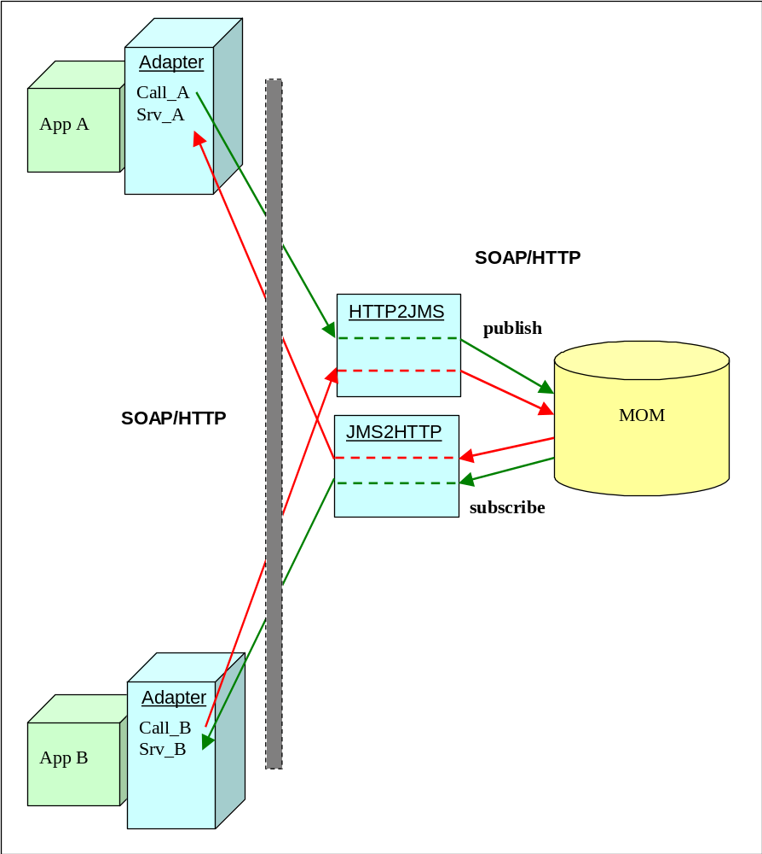
- Request/reply scenario with channel broker and SOAP/HTTP

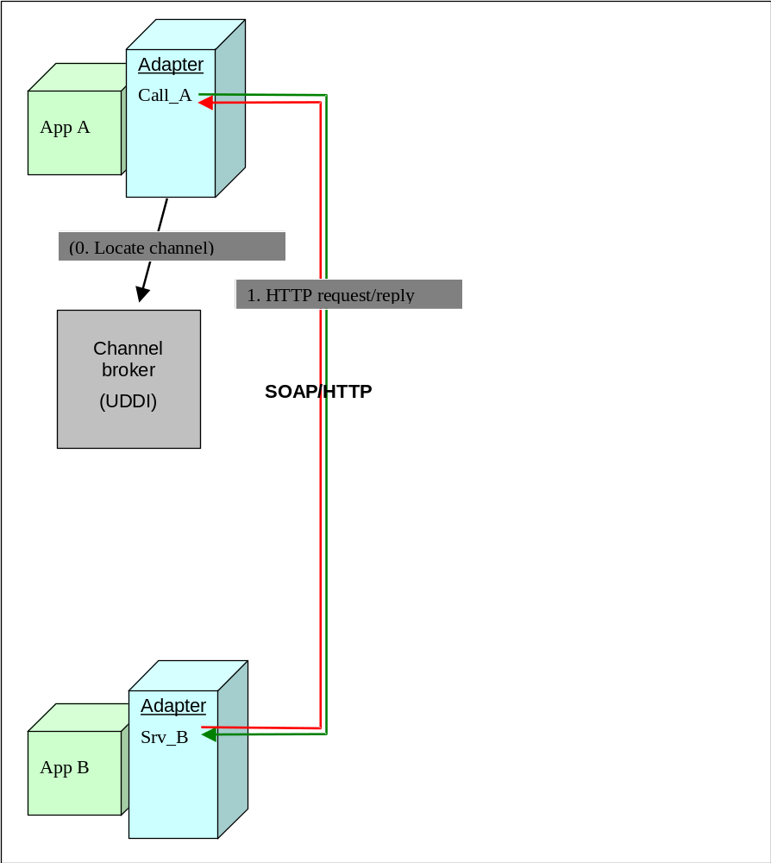
- Publish/subscribe scenario with SOAP/HTTP+JMS
- Application Integration Functionality in EIONET

Integration Technologies in EIONET
The following integration technologies and tools were designed and developed for EIONET in this project:

- RPC Services Framework - a common solution for application integration in EIONET. This is described in chapters 3.2 and chapter 4.
- ACL Mechanism – Access Control List based permission control mechanism - the first step towards Single Sign on in EIONET allowing login against EIONET LDAP User Directory and permissions control in various EIONET tools using a centra ACL Administration Tool. See chapter 3.3.
- RPC Methods Registry - The first version is a word-document describing all methods developed in various Reportnet applications providing services when called via the RPC Services Framework. The document is in EINRC-library:
http://nmc.eionet.eu.int:8980/Members/irc/eionet-nmc/einrc/library?l=/einrc_sa5_2002/uit/methods_registryv02/_EN_2.0_&a=d.
- Prototype for Application integration in Dataflow-process in EIONET – a draft description of the dataflow process was developed and additional functionality to the WfTtool for allowing integration with external applications implemented. See chapters 3.4 and chapter 5.

RPC Services Framework
The RPC Services Framework makes possible to provide methods of any Java servlet-based application i.e. introduce an application as a service.
It also helps applications to call methods of other applications (services).
The framework supports XML/RPC and SOAP communication protocols.

The following figure presents the common architectural components of the RPC Services Framework. Functionality of each component is described in more detail in chapters 3.2.1 – 3.2.2 and 4.
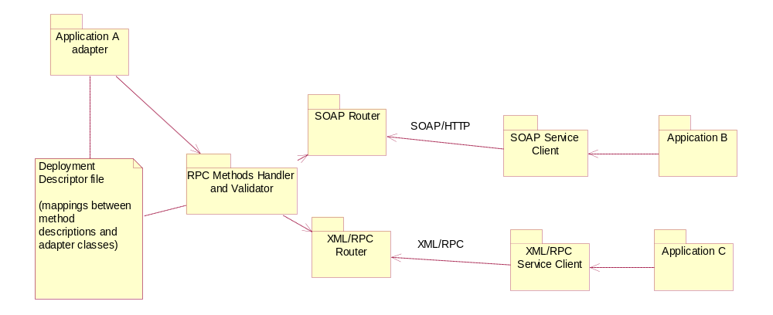
- Common Architecture of RPC Services Framework

The RPC Router reads the method definitions from the Deployment Description file. In this file are also descriptions the adapter classes (in Java), providing the service methods. When an RPC call comes in, first the method signature is checked and if a correct method is found in the class, the correspondence of returned value to the definition in the Deployment Descriptor file is checked as well before the value is returned to the calling client service.

Server-side functionality
No big changes have to be made in the application, acting as a service, but just creating a Service adapter class, where all served methods are described.
There may be several applications offering services running in the same server.
The descriptions of methods are in a Deployment Descriptor file, easily understandable XML-format is used for the descriptions. The following parameters of different methods of the service are identified:
- Service name(s)
- Method name
- Method signature (parameter count and types)
- Method’s value type and description if STRUCT or ARRAY
- Service adapter class name

The framework includes a Method Validator that checks if the method and the value returned by it are compatible with the Deployment Descriptor.
Detailed description and examples of the Deployment Descriptor file below.
The application developers do not have to care, which communication protocol will be used for accessing the service. The services are made available for both communication protocols (XML/RPC and SOAP).

Client-side functionality
A common adapter mechanism is made for accessing other remote services from Java applications. The user must know:
- The name of service
- The URL of services RPC router

Single Singon

Overview
A small research work about the technical possibilities of Single Signon was done during this project. A short summary follows:

    - There exist several trusted authentication servers, for example RSA ClearTrust and SiteMinder. They probably would be good solutions for EEA but they are not for free.

http://www.netegrity.com/products/index.cfm?leveltwo=SiteMinder
http://www.rsasecurity.com/products/cleartrust/

    - Kerberos is a network authentication protocol that was created by MIT as a solution to network security problems. It is designed to provide strong authentication for client-server applications by using secret-key cryptography. It is a good and trusted protocol but there is no Web browser support yet. Probably will be available in future versions.
http://web.mit.edu/kerberos/www/

    - Using MS Passport could be considered, although it may have security holes and there may occur not expected “features”, because of Microsoft’s unfriendly attitude to Java. It is not free a well.
http://www.passport.net/Consumer/Default.asp?lc=1033

Where to go next
First of all it has to be decided, if the Single Signon functionality is really worth resources that would be spent for implementing it. Most of the users of EEA do not work with several applications very often. There is already a common login mechanism implemented in SA-5 that allows users to remember only one username and password – same as for the Circa. If the session timeout is not very long the user has to log to each application, he or she is using, only once or twice in a day.
If it still is decided to implement, the next step can be to change the implemented login mechanism to use JAAS interface and link them to LDAP, because an adapter to LDAP has been implemented in Java (JAAS). Later it can be replaced with Kerberos adapter or any other.

ACL Mechanism – first step for Single Signon

Access Control List based permission control mechanism
The aim of Single Signon is to enable the users to log in once, when using multiple applications. In this project, as the first step to the Single Signon possibility, login against EIONET LDAP User Directory and permissions control, based on Access Control Lists (ACL), was implemented.
See more details in the ACL Mechanism document.

ACL Admin Tool
The ACL Admin Tool was also implemented, based on RPC Services Framework, to make possible changing user permissions. The permissions of several applications can be changed by using the same tool, because the methods are available through “RPC Services Framework”.
See more details in ACL Mechanism document

WfTool functionality
Additional functionality was implemented to the WfTool before the WfTool process was cancelled. The functionality may be used in the future.

Remote Activity
Remote activity is an activity type in the process definition that can communicate with an external service, send parameter(s) and receive value(s) that are bypassed as workflow process parameters.

Error handling of remote calls
If a remote service is not responding or there are any other communication errors, the remote activity will be kept in an active list and it keeps trying to access the remote service until it succeeds.

Using WfTool as a service
A public API was implemented for the WfTool, containing these possibilities:
- Initiating a WF process by an external system.
- Dispatch an activity by an external system.
- Implementation & Usage of RPC Services Framework

RPC Services Framework Component architecture
The RPC Services Framework can be used as an add-in to a servlet-based application. The component is written in Java. The framework includes two parts: one for handling services on the server and publishing them, the other for accessing methods of public services.

The server part architecture
The server part of RPC Services Framework consists of two packages:
- RPC Methods Handler package: com.tee.uit.server
- RPC Router package: com.tee.uit.servlets

RPC Methods Handler package: com.tee.uit.server
The RPC Methods Handler Package “com.tee.uit.server” handles services, made public through the framework. The Description of services must be described in an XML-format file called “Deployment Descriptor” (detailed description below). The package includes tools for reading the method descriptions from the file and passing them to the RPC Service Router(s). The package also has methods for checking the correct signature of the method call and the correspondence between the method value and the deployment descriptor.

RPC Router package: com.tee.uit.servlets
The RPC Router package “com.tee.uit.servlets” includes the router servlets, co-ordinating communication between incoming RPC calls and the application services, described in this server. As the RPC Services Framework supports two communication protocols at the moment there are router servlets in the package that must be mapped to URLs in the servlet engine configuration file. (resin.conf) com.tee.servlets.XmlRpcRouter for XML/RPC and com.tee.servlets.SOAPRouter for SOAP.
When the router servlet is initiated, the method descriptions are read from the description file and put to the roster, called com.tee.server.UITServiceRoster.

Class diagrams of the packages are shown in the figures below:

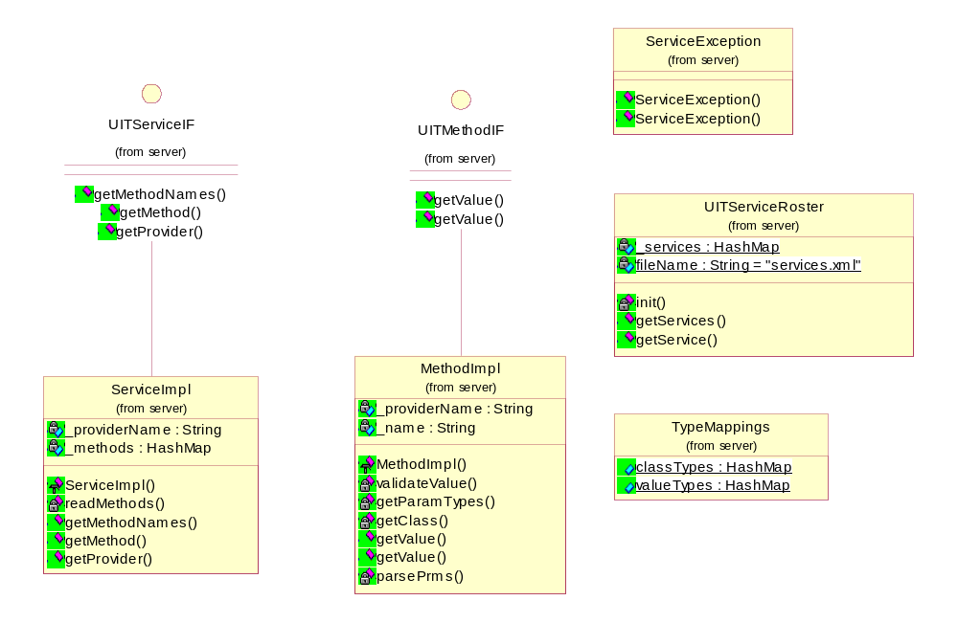

- Class architecture of the RPC Methods Handler package com.tee.uit.server

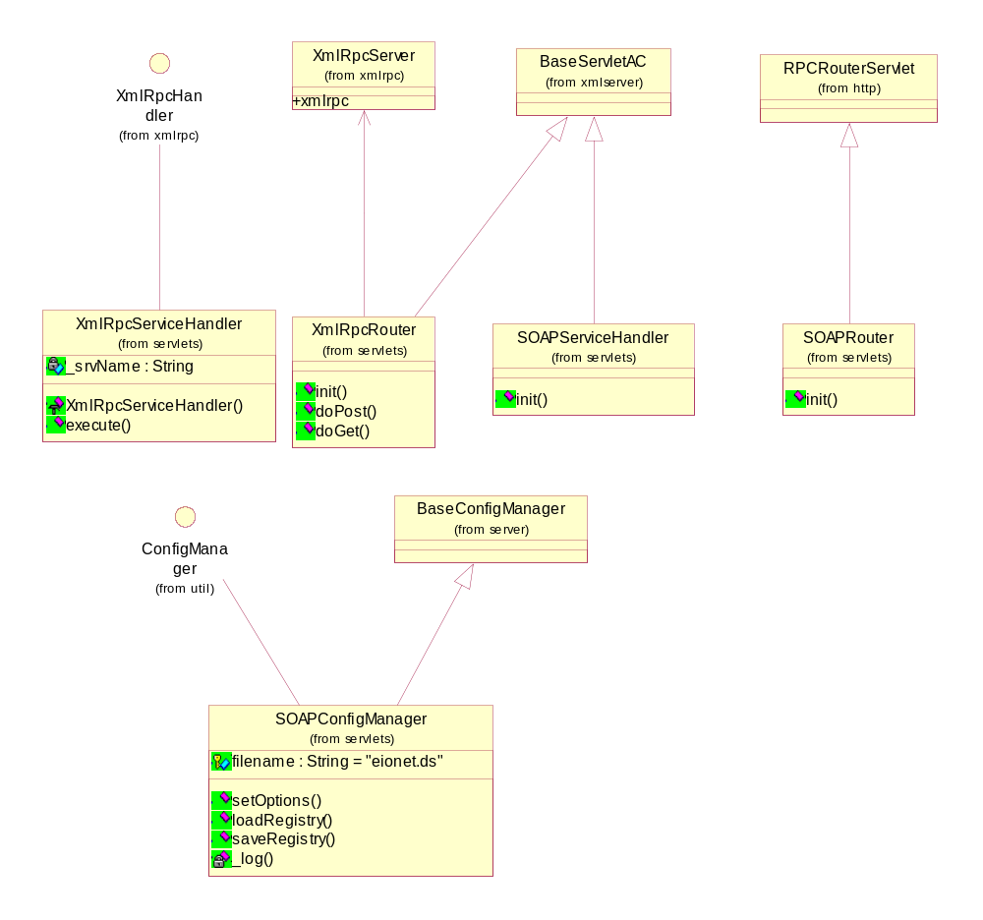

- Class architecture of the RPC Router package com.tee.uit.server

The two packages are included to the uit-server.jar. To use the server part of the RPC Services Framework, the following JAR files should be included to the classpath:
- uit-definition.jar (Java support for the XML-format deployment descriptor, generated by Castor http://www.castor.org)
- castor.jar
- xerces.jar
- xalan.jar
- xmlserver.jar (XML-based query engine)
- xmlrpc.jar (only, if XML/RPC protocol is wanted to be supported)
- soap.jar (only, if SOAP protocol is wanted to be supported)
- mail.jar (only, if SOAP protocol is wanted to be supported)
- activation.jar (only, if SOAP protocol is wanted to be supported)

The client part architecture: RPC Service Client package
The client part of the RPC Services Framework, called RPC Service Client, enables to use public services, when implementing any Java-based application. The tool has got support for XML/RPC and SOAP.
The user of the RPC Service Client, the client-side of the component must know the protocol of the service and the URL of the RPC router.
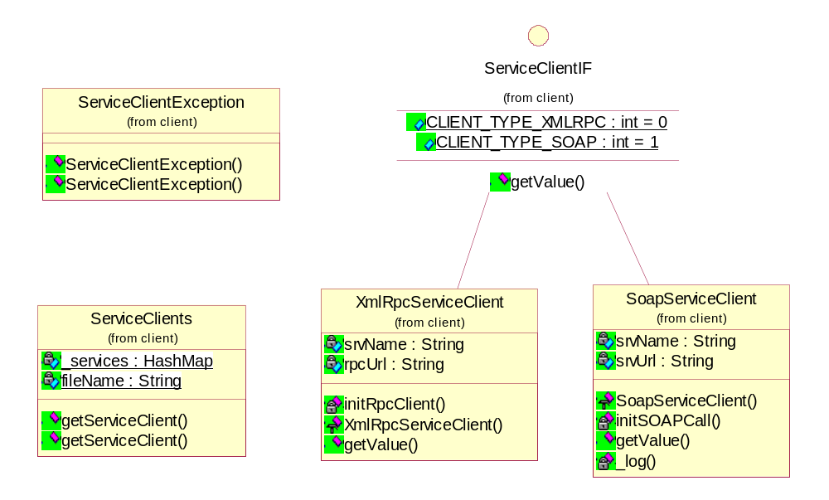

- The class architecture of the RPC Service Client package com.tee.uit.client

The service Deployment Descriptor file
Mappings between the service adapter class(es) and service method descriptions of the service, provided by the application must be described in the Deployment Descriptor file. The description is an XML file that must follow this XML Schema:

<?xml version='1.0' encoding='windows-1257'?>
<xs:schema xmlns:xs="http://www.w3.org/2001/XMLSchema" elementFormDefault="qualified">
<xs:element name="Services" type="ServicesType"/>
<xs:complexType name="ElementType">
<xs:attribute name="Type" type="xs:string" use="required"/>
<xs:attribute name="Name" type="xs:string" />
<xs:attribute name="No" type="xs:string" />
</xs:complexType>
<xs:complexType name="StructType">
<xs:sequence>
<xs:element name="Element" type="ElementType" minOccurs="1" maxOccurs="unbounded"/>
</xs:sequence>
</xs:complexType>
<xs:complexType name="ArrayType">
<xs:sequence>
<xs:element name="Element" type="ElementType" minOccurs="0" maxOccurs="unbounded"/>
</xs:sequence>
<xs:attribute name="Type" type="xs:string" />
</xs:complexType>
<xs:complexType name="ValueType">
<xs:sequence>
<xs:element name="Struct" type = "StructType" minOccurs="0" maxOccurs="1"/>
<xs:element name="Array" type = "ArrayType" minOccurs="0" maxOccurs="1"/>
</xs:sequence>
<xs:attribute name="Type"/>
</xs:complexType>
<xs:complexType name="ParametersType">
<xs:sequence>
<xs:element name="Parameter" type = "ParameterType" minOccurs="0" maxOccurs="unbounded"/>
</xs:sequence>
</xs:complexType>
<xs:complexType name="MemberType">
<xs:attribute name="Type" type="xs:string" use="required"/>
<xs:attribute name="No" type="xs:int" use="required"/>
<xs:attribute name="Name" type="xs:string" use="required"/>
</xs:complexType>
<xs:complexType name="ParamStructType">
<xs:sequence>
<xs:element name="Member" type="MemberType" minOccurs="1" maxOccurs="unbounded"/>
</xs:sequence>
</xs:complexType>
<xs:complexType name="ParameterType">
<xs:sequence>
<xs:element name="ParamStruct" type="ParamStructType" minOccurs="0" maxOccurs="1"/>
</xs:sequence>
<xs:attribute name="Name" type="xs:string" use="required"/>
<xs:attribute name="Type" type="xs:string" use="required"/>
</xs:complexType>

<xs:complexType name="ServicesType">
<xs:sequence>
<xs:element name="Service" type="ServiceType" minOccurs="0" maxOccurs="unbounded"/>
</xs:sequence>
</xs:complexType>

<xs:complexType name="ServiceType">
<xs:sequence>
<xs:element name="Methods" type="MethodsType"/>
</xs:sequence>
<xs:attribute name="Name" type="xs:string" use="required"/>
<xs:attribute name="Provider" type="xs:string" use="required"/>
</xs:complexType>

<xs:complexType name="MethodsType">
<xs:sequence>
<xs:element name="Method" type="MethodType" minOccurs="0" maxOccurs="unbounded"/>
</xs:sequence>
</xs:complexType>

<xs:complexType name="MethodType">
<xs:sequence>
<xs:element name="Parameters" type="ParametersType"/>
<xs:element name="Value" type="ValueType"/>
</xs:sequence>
<xs:attribute name="Name" type="xs:string" use="required"/>
<xs:attribute name="Description" type="xs:string" use="optional"/>
</xs:complexType>

</xs:schema>
- XML schema for the Deployment Descriptor file

The location of the Deployment Descriptor file is given in a file called uit.properties that has to be saved in the classpath of the application

Using the RPC Services Framework

Setting up an RPC service
- Copy uit-definition.jar, uit-server.jar, castor.jar, xmlrpc.jar, xerces.jar and xalan.jar to the applications, you want to set up as a service, library path (e.g. /webapps/webrod/WEB-INF/lib)
- Add the settings inside the <web-app> tags of the application to the resin.conf.

  - Map the XmlRpcRouter servlet and/or SOAP servlet to the URLs you want to be available for the service users:

<!-- needed, if you want to support XML/RPC -->
<servlet servlet-name='xmlrpcrouter' servlet-class='com.tee.uit.servlets.XmlRpcRouter'/>
<servlet-mapping url-pattern='xmlrpcrouter/*' servlet-name='xmlrpcrouter'/>

<!-- needed, if you want to support SOAP -->
<servlet servlet-name='soaprouter' servlet-class='com.tee.uit.servlets.SOAPRouter'/>
<servlet-mapping url-pattern='soaprouter/*' servlet-name='soaprouter'/>

  - Include the JAR files to the classpath, if not existing yet

<!-- NB needed, only if you want to support XML/RPC -->
<classpath id="lib/xmlrpc.jar"/>

<!-- NB these 3 files needed, only if you want to support SOAP -->
<classpath id="lib/soap.jar"/>
<classpath id="lib/mail.jar"/>
<classpath id="lib/activation.jar"/>

<classpath id="lib/castor.jar"/>
<classpath id="lib/xalan.jar"/>
<classpath id="lib/xerces.jar"/>
<classpath id="lib/xmlserver.jar"/>

<classpath id="lib/uit-definition.jar"/>
<classpath id="lib/uit-server.jar"/>

  - Copy uit.properties file to the classpath folder

<web-app id="/webrod" app-dir="/webapps/webrod">

<classpath id="WEB-INF/classes"/>

<!-- NB needed, only if you want to support XML/RPC -->
<classpath id="lib/xmlrpc.jar"/>

<!-- NB needed, only if you want to support SOAP -->
<classpath id="lib/soap.jar"/>
<classpath id="lib/mail.jar"/>
<classpath id="lib/activation.jar"/>

<classpath id="lib/castor.jar"/>
<classpath id="lib/xalan.jar"/>
<classpath id="lib/xerces.jar"/>
<classpath id="lib/xmlserver.jar"/>

<classpath id="lib/uit-definition.jar"/>
<classpath id="lib/uit-server.jar"/>

<!-- needed, if you want to support XML/RPC -->
<servlet servlet-name='xmlrpcrouter' servlet-class='com.tee.uit.servlets.XmlRpcRouter'/>
<servlet-mapping url-pattern='xmlrpcrouter/*' servlet-name='xmlrpcrouter'/>

<!-- needed, if you want to support SOAP -->

<servlet servlet-name='soaprouter' servlet-class='com.tee.uit.servlets.SOAPRouter'/>
<servlet-mapping url-pattern='soaprouter/*' servlet-name='soaprouter'/>

</web-app>

- Create an adapter class in Java that will be the service provider e.g. DemoService.java
- Create all the methods you want to make accessible via RPC Service as public static methods.

package eionet.rod..services;
public class ServiceAdapter {

import java.util.Vector;
public static int addOne( int number ) {
return number++;
}

public static String sayHello( String name ) {
return “Hello, “ + name;
}

public static Hashtable getRecord( String name ) {
Hashtable h = new Hashtable();

h.put(“name”, name);
h.put(“address”, “13, Elm Str”);
h.put(“age”, new Integer(25));

return h;
}

}
Datatypes in Java, supported by XML/RPC and SOAP that can be used as method parameter and value types
java.lang.String
java.lang.Integer
java.lang.Boolean
java.lang.Double
java.util.Date
java.util.Vector
java.util.Hashtable
byte[ ]

- Create the XML Deployment Descriptor file, where the services are described. E.g.

<?xml version="1.0" encoding="UTF-8"?>
<Services xmlns:xsi=http://www.w3.org/2001/XMLSchema-instance xsi:noNamespaceSchemaLocation="./services.xsd">

<Service Name="DemoService" Provider="apps.services.DemoService">
<Methods>
<Method Name="addOne">
<Parameters>
<Parameter Name=" " Type="INT"/>
</Parameters>
<Value Type="INT"/>
</Method>
<Method Name="sayHello">
<Parameters>
<Parameter Name="name" Type="STRING"/>
</Parameters>
<Value Type="STRING"/>
</Method>
<Method Name="getRecord">
<Parameters>
<Parameter Name="name" Type="STRING"/>
</Parameters>
<Value Type="STRUCT">
<Struct>
<Element Name="address" Type="STRING"/>
<Element Name="name" Type="STRING"/>
<Element Name="age" Type="INT"/>
</Struct>
</Value>
</Method>
<Method Name="getArray">
<Parameters>
<Parameter Name="name" Type="STRING"/>
<Parameter Name="num" Type="INT"/>
</Parameters>
<Value Type="ARRAY">
<Array Type=”STRING”/>
</Value>
</Method>
</Methods>
</Service>
</Services>

The types of methods and types in the description XML respond as follows:

java.lang.String STRING
java.lang.Integer INT
java.lang.Boolean BOOLEAN
java.lang.Double DOUBLE
java.util.Date DATE
java.util.Vector ARRAY
java.util.Hashtable STRUCT
byte[ ] BYTE

- Specify the real location of the XML file in uit.properties file.

srvdef.file=/webapps/uit/def/services.xml

- Run resin

Using RPC Service

RPC Service Client for Java

There is an adapter that helps calling services/methods. The user must know:
- the name of the service
- the name and the signature of the method
- the URL of the RPC Router of the service
- the protocol type of the service (XML/RPC or SOAP)

- include uit-client.jar in the classpath
- Put into the Java code

import com.tee.uit.client.ServiceClients;
import com.tee.uit.client.ServiceClientIF;
import com.tee.uit.client.ServiceClientException;

import java.util.Vector;

public class TestClass {
public static void main (String args[]) {
try {
String srvName = "DemoService";
String methName = "sayHello";

//put the correct URL here!!!
String srvUrl=”http://demohost.eionet.eu.int/xmlrpcrouter/”;

Vector params = new Vector();

params.add("Ander") ;

ServiceClientIF srv = ServicesClients.getServiceClient( srvName, srvUrl, ServiceClientIF. CLIENT_TYPE_XMLRPC );
Object value = srv.getValue( methName, params );

System.out.println( methName + "value=" + value);

//test SOAP->
srvUrl=”http://demohost.eionet.eu.int/soaprouter/”;
srv = ServicesClients.getServiceClient( srvName, srvUrl, ServiceClientIF.CLIENT_TYPE_SOAP);

methName=”getRecord”;

value = srv.getValue( methName, params );

System.out.println( methName + "value=" + value);

} catch (Exception e ) {
System.out.println(“Error “ + e.toString());
}
}
}

Python and RPC Service Client
There is no a special tool for Python. Some example uses of different protocols:
XML/RPC

# specify correct URL
import xmlrpclib

server_url="http://rod.eionet.eu.int/rpcrouter"
server=xmlrpclib.Server(server_url)
print server.WebRODService.getActivities()

SOAP
Copy SOAP.py into the library path of Python.

import SOAP

# specify the URL
server_url="http://rod.eionet.eu.int/soaprouter"
server = SOAP.SOAPProxy( server_url , namespace = "urn:WebRODService", encoding = None)

resp = server.getActivities()
itemList = resp._getItemAsList("item")

c=0
while c < len(itemList):
act = itemList[c]
actFields = act._getItemAsList("item")

pkList = actFields[0]
pk = pkList._getItemAsList("value")

titleList = actFields[1]
title = titleList._getItemAsList("value")
print "PK_RA_ID=" + pk[0] + " TITLE=" + title[0]

c=c+1

Limitations in RPC Services Framework
- The RPC Services Framework works in a Java Servlet Engine.
- The client side adapter (RPC Service Client) works with Java applications.
- The set of method parameter and returned value types is limited because of XML/RPC limitations.

- Dataflow process of EEA

During the project, the EEA dataflow process was analysed and a draft for the WfTool process description was designed. To get it work, WfTool needs improvement.
The business process prepared by Sheila Cryan, Stefan Jensen, Hermann Peifer and Søren Roug on 8. and 9.8.2002, and the flowchart based on it are given below.

Dataflow processes for application integration in Reportnet
below schema can be applied for dataflows in Ozone, EoI, Water, Nature, CLRTAP, GHG - shall become generic in this sense
First test shall be done along water data (EWN) deliveries - areas groundwater, rivers, lakes
The deadline for the country delivery is 31 December yearly for the water example (so step 1 and 2 have happened already but this is no problem)
step | action | responsible | remark |  | RN services involved |  | time for data flow
1 | ROD deadline triggers 2 | EEA | provide delivery and reminder dates |  | ROD |  | 180 days before deadline
2 | send early warning | EEA | e-mail to NFPs |  | directory, UIT/WF |  | 180 days before deadline
3a | send data request | EEA | e-mail to NRCs cc: NFPs |  | directory, UIT/WF |  | 120 days before deadline
3b | provide content definition | EEA/ETC | currently through URL link in ROD/CS |  | ROD (later DD)
4 | upload into CDR/CIRCA | countries |  |  | CDR, CIRCA
5 | check delivery status | EEA | UIT/WF searches CR |  | CR, UIT/WF
6 | shade simple country map | EEA | UIT/WF sends trigger |  | none, eEIONET tool
7 | send reminder | EEA | if non-delivery |  | directory, UIT/WF |  | 30 days before deadline
8 | check delivery status | EEA | UIT/WF searches CR , go step 6 |  | CR, UIT/WF |  | 10 days after deadline
9 | download from CDR/CIRCA | ETC | on notification |  | CDR, CIRCA, UIT/WF
10 | info on each country data processed | ETC | displayed in CS/e-mailed to role |  | CS, directory
11a | Delivery of European dataset | ETC | ETC informs EEA |  | DW, directory
11b | Delivery of updated indicator | ETC | ETC informs EEA |  | DW, directory, (later IMT)
11c | Review of updated indicator | EEA | EEA confirms process to ETC |  | DW, directory, (later IMT)
12a | publishing of data | EEA/EERC | EEA informs countries/ETC |  | EDW, directory
12b | publishing of updated indicator | EEA/EERC | EEA informs countries/ETC |  | EDW, directory, (later IMT)
Remarks
To visualise these processes (also communicate erroers) either CS or a ZOPE based visualisation tool (done by EEA) is forseeable
This tool shall provide for the making of internal statistics on dataflows at a later stage (e.g. delivery times(by country and flow ...)
UIT/WF is infact envolved in each step - main areas are just labeled with it
New Acronyms: DW: topic datawarehouse in ETCs; EDW: European datawarehouse = EEA dataservice
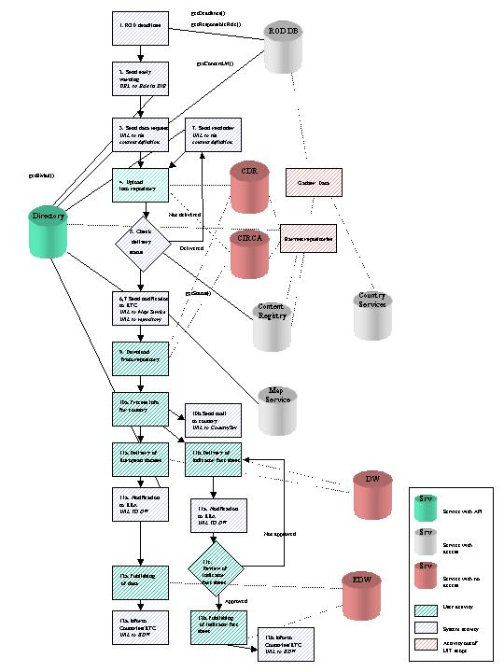
- Dataflow process schema

Steps in the dataflow process

Step 1 “ROD deadline triggers” (system activity)
Description:
A daily working WfTool trigger gets the RA Ids from ROD, which deadline is Today + 180 days. Based on these Ids, it gets reminder dates and responsible role IDs.

The ROD deadline trigger sends a notification to the responsible EEA/ETC-people to start preparations (templates, guidelines, and other relevant material) and to update ROD, and DD accordingly.

The trigger initialises a WF process for each dataflow.

Not decided or specified:
- Get the Dataflow administrator role from ROD and send a notification
- Initiate new RA in ROD based on the new deadline (reporting frequency) of RA.

Step 2 “Send early warning” (system activity)
An early warning notification is sent to NFPs.

Not specified:
- Is NFP-role coded in the process definition or taken from the ROD2 database
- How to proceed, if responsible-role is different from NRC role. (Has to be discussed with NFPs)

The notification shows the link to the responsible for Reporting role in DIR
The notification shows URL to the RA in ROD.

Step 3 “Send data request” (system activity)
A Data request is sent to NFPs, NRCs.

URL to the content definition (Later DD) is included to the message body or shown in the activity page of WfTool.

Step 4 “Upload into Circa/CDR” (user activity + system activity)
NB! From step 4 it will be actually a branch for each country, it means there will be different activities for all the countries until step 10 (inc).

The user uploads the delivery (dossier) to the repository.
- A trigger (step 5) is running and checks the Content Registry in specified intervals, if the delivery is uploaded. If it is, the work item is dispatched and no needed to dispatch it manually in user activity screen.
- The user (or dataflow administrator) can forward the Work item manually, using a user activity screen. It might be needed for example, if the delivery metadata is not completed correctly or the process is wanted to forward before the Content Registry gets it harvested.

Not specified:
Detailed specification of this step implementation

Step 5 “Check delivery status” (system activity)
The system trigger checks from the content registry, if the data has been delivered (status from Repository is ‘Delivered’). If yes, it goes to Step 6, if no, it goes to step7.

Not specified:
The exact delivery metadata specification (fields, statuses, etc).

Step 6 “Shade simple country map” (system activity)
Comment: The Map Service is just a service drawing maps based on parameters. It means, no maps, status info or anything is stored anywhere. We can only provide a link with the existing parameters: country code, colour (based on status of delivery).
There will be certain colours described for each status of delivery. An e-mail notification with the URL to Map Service where countries are shaded with status colours is sent to the ETC.

Send a notification to ETC, provide a link to the next WfTool user activity page and URL to MAP Service and URL to repository, got from the Content Registry.

Not specified:
Which service should provide this functionality.

NB! Go to step 9.

Step 7 “Send Reminder” (system)
If the result of Step 5 is false, sends a reminder to the country to NFP and to the responsible for reporting-role. The message includes a link to Map Service (with status overview of all countries) and URL to RA.

Step 8 = Step 5
(Loop twice, if not delivered.)

Step 9 “Download from Circa / CDR” (user activity)
The ETC user is shown a WfTool activity page, where the link to repository is shown. The user can download the data. If (s)he has completed it, the “Dispatch” button is clicked.

Not specified:
A dossier in the Repository can contain the data file + additional documents (covering letter, etc). Should the ETC user see links to the individual documents and have the possibility to read/download the selected ones?

It is virtually impossible to handle this step automatically. The system does not understand if the user has downloaded something, because the repositories do not have this kind of message sending functionality.

Step 10 “Info on each country data processed” (user activity)
Process information for each country. Click “Dispatch”, when done. Status-table in WfTool monitor is updated accordingly.

This step is hard to be processed automatically as well because of the reasons described in the previous point.

Step 11 (user activity)
NB! All the process branches meet again at this point.

- European Dataset is composed and sent to DW, notification is sent to EEA with URL to the Map Service
- Indicator fact sheet is composed and uploaded to CIRCA (sent to DW), notification is sent to EEA with URL to the Map Service with complete delivery status.
- If the Indicator fact sheet is not approved by EEA, loop is created and sent back to 11b, if it is, a confirmation is sent to ETC.

All these activities are “user activities” in WfTool and dispatched by clicking the “Dispatch” button.

Step 12 (user activity)
- European dataset is published in EDW, confirmation with URL sent to countries, ETC
- Indicator fact sheet is published in EDW, confirmation with URL is sent to countries ETC

Question: Who in the countries get the confirmation notification: NFPs, Responsible for Reporting-roles, other national roles?
All these activities are user activities in WfTool and dispatched by clicking the “Dispatch” button.

Notes
This dataflow process in the WfTool cannot have control over data contents. It can only guide the documents’ delivery process.
The status of the process and different branches can be checked by the WF Monitor tool.
The process definition for the WfTool is not designed. That’s why the parameters of the WF process are not described in the technical description.
User activities to ETC data flow administrator are relevant. Then he has a simple access from his notification to WfTool services, including the Wf Monitor service. The benefits to the ETC dataflow administrator comes from the fact that he doesn’t need to keep track of what has happened based on email-notifications in his mailbox, but the WfTool helps him to track which material he has uploaded and handled. Possibility to easily link to the monitor service is also one of the benefits. Appearance of the monitor service has to be designed to provide an easy table-based status view and access to the deliveries. In addition the MPP-based status view over all countries is provided.

Improvement needs for the WF demo process
What has to be done to make the demo process “reasonable” and understandable:
- A page showing values got from the remote activity has to be made in the WfMonitor (3 days)
- Adapters for external services to be used by the WfTool (2 day) Comment: As the adapters are made anyway in the UIT project, it is just changing them to the format, used by WfTool
- Create sensible data fields and input/output parameters to the demo process definition (1 day)
- Sample data to the external databases (0,5 days)
- Nice user activity page layouts (0,5 days)

Total: 7 days

