USER MANUAL

How to deliver data on the

Large Combustion Plants (LCP) through Reportnet <http://rod.eionet.europa.eu/obligations/9>

*(emission inventories under Directive 2001/80/EC)*

These guidelines explain how to use the electronic infrastructure for reporting information to the European

Commission in pursuance of Directive 2001/80/EC of the European Parliament and of the Council of 23 October 2001 on the limitation of emissions of certain pollutants into the air from large combustion plants.

**How to deliver**

All deliveries are provided via the Reportnet Central Data Repository (CDR), which is maintained by the European Environment Agency (EEA).

**Summary of the delivery process**

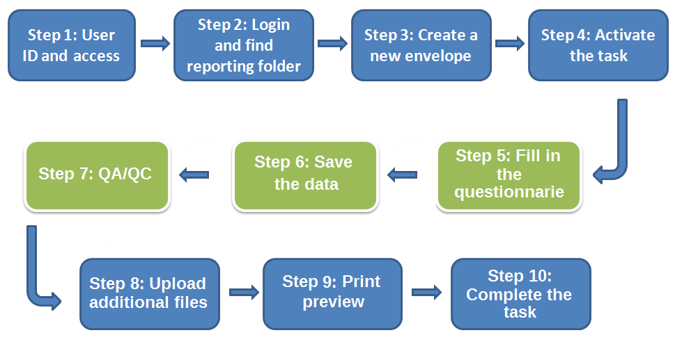

* **Step 1: User accounts and access permissions**

In order to report, an Eionet account with user name and password is required as well as permission to upload the national delivery. Please inform DG ENV and EEA about who will be the person(s) responsible for the reporting, so that the necessary arrangements can be made. The person(s) who do not yet have an EIONET account will receive an e-mail with their EOINET login and password. All persons nominated as reporter will receive upload rights to the CDR. Only new reporters will receive a notification on this from the Eionet Helpdesk ([helpdesk@eionet.europa.eu](mailto:helpdesk@eionet.europa.eu)).

* **Step 2: Login to the Central Data Repository and open your folder**

You can access EEA’s Central Data Repository (CDR) at <http://cdr.eionet.europa.eu>

When preparing for LCP questionnaire delivery, you first have to log in by using your Eionet user name and password and then navigate to the respective folder of you country (see the links below).

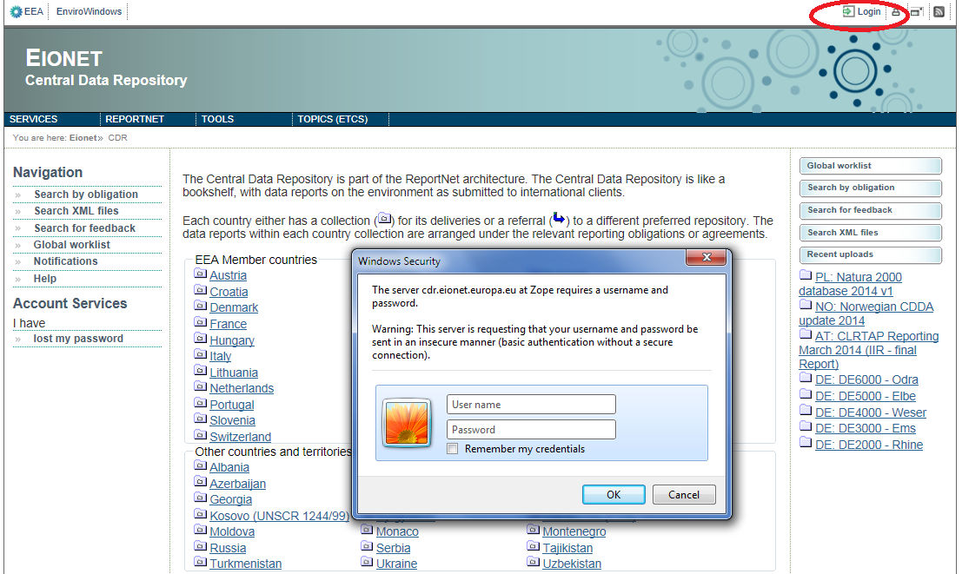

Country URL to "LCP Directive (2001/80/EC) Emission summaries" reporting folder

|  |  |  |
| --- | --- | --- |
| **Country** | | **LCP emission summaries reporting deliveries to CDR** |
| **Name** | **ISO** | **Hyperlink to national folder** |
| Austria  Belgium  Bulgaria  Croatia  Cyprus  Czech Republic  Denmark  Estonia  Finland  France  Germany  Greece  Hungary  Iceland  Ireland  Italy  Latvia  Liechtenstein  Lithuania  Luxembourg  Malta  Netherlands  Norway  Poland  Portugal  Romania  Slovakia  Slovenia  Spain  Sweden  Switzerland  Turkey  United Kingdom | AT  BE  BG  HR  CY  CZ  DK  EE  FI  FR  DE  GR  HU  IS  IE  IT  LV  LI  LT  LU  MT  NL  NO  PL  PT  RO  SK  SI  ES  SE  CH  TR  UK | <http://cdr.eionet.europa.eu/at/eu/lcpes>  <http://cdr.eionet.europa.eu/be/eu/lcpes>  <http://cdr.eionet.europa.eu/bg/eu/copy_of_lcpes>  <http://cdr.eionet.europa.eu/hr/eu/lcpes>  <http://cdr.eionet.europa.eu/cy/eu/lcpes>  <http://cdr.eionet.europa.eu/cz/eu/lcpes>  <http://cdr.eionet.europa.eu/dk/eu/lcpes>  <http://cdr.eionet.europa.eu/ee/eu/lcpes>  <http://cdr.eionet.europa.eu/fi/eu/lcpes>  <http://cdr.eionet.europa.eu/fr/eu/lcpes>  <http://cdr.eionet.europa.eu/de/eu/lcpes>  <http://cdr.eionet.europa.eu/gr/eu/lcpes>  <http://cdr.eionet.europa.eu/hu/eu/lcpes>  <http://cdr.eionet.europa.eu/is/eu/lcpes>  <http://cdr.eionet.europa.eu/ie/eu/lcpes>  <http://cdr.eionet.europa.eu/it/eu/lcpes>  <http://cdr.eionet.europa.eu/lv/eu/lcpes>  <http://cdr.eionet.europa.eu/li/eu/lcpes>  <http://cdr.eionet.europa.eu/lt/eu/lcpes>  <http://cdr.eionet.europa.eu/lu/eu/lcpes>  <http://cdr.eionet.europa.eu/mt/eu/lcpes>  <http://cdr.eionet.europa.eu/nl/eu/lcpes>  <http://cdr.eionet.europa.eu/no/eu/colp0r8w/colshr9cw>  <http://cdr.eionet.europa.eu/pl/eu/lcpes>  <http://cdr.eionet.europa.eu/pt/eu/lcpes>  <http://cdr.eionet.europa.eu/ro/eu/lcpes>  <http://cdr.eionet.europa.eu/sk/eu/lcpes>  <http://cdr.eionet.europa.eu/si/eu/lcpes>  <http://cdr.eionet.europa.eu/es/eu/lcpes>  <http://cdr.eionet.europa.eu/se/eu/colqedr6a>  <http://cdr.eionet.europa.eu/ch/eu/lcpes>  <http://cdr.eionet.europa.eu/tr/eu/lcpes>  <http://cdr.eionet.europa.eu/gb/eu/lcpes> |

* **Step 3: Create a new envelope**

Now **create a new envelope** which will contain your data delivery by clicking on the button ‘New envelope’ at the upper right corner of the screen:

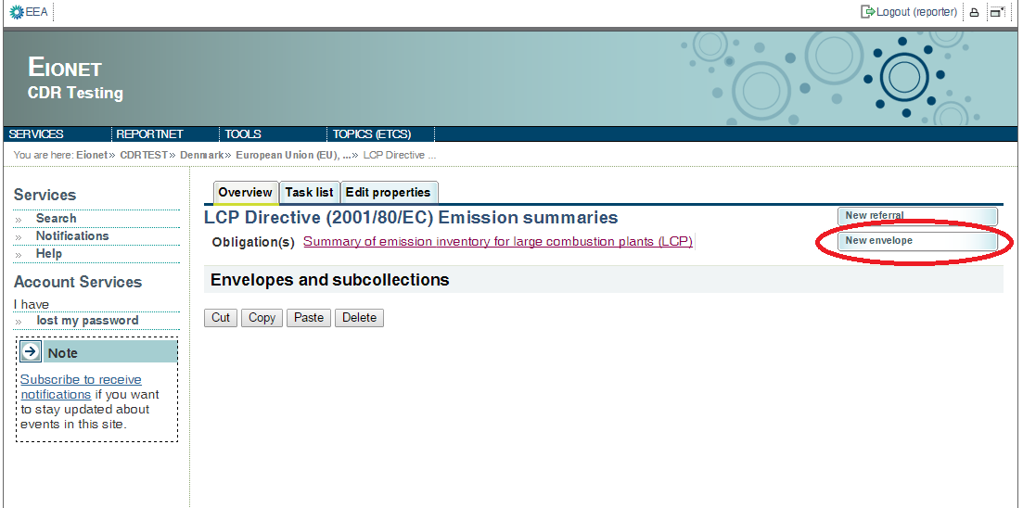

# Provide meaningful details about your delivery on the “Add Envelope” page. At least “Title” and “Relating to which year” fields have to be filled in.

# The Envelope title should briefly summarise the delivery by providing the information about the reporting country, obligation and year. Then it will be easier for the reporter and other stakeholders to find the delivery. “Relating to which year” indicates the period the report will cover.

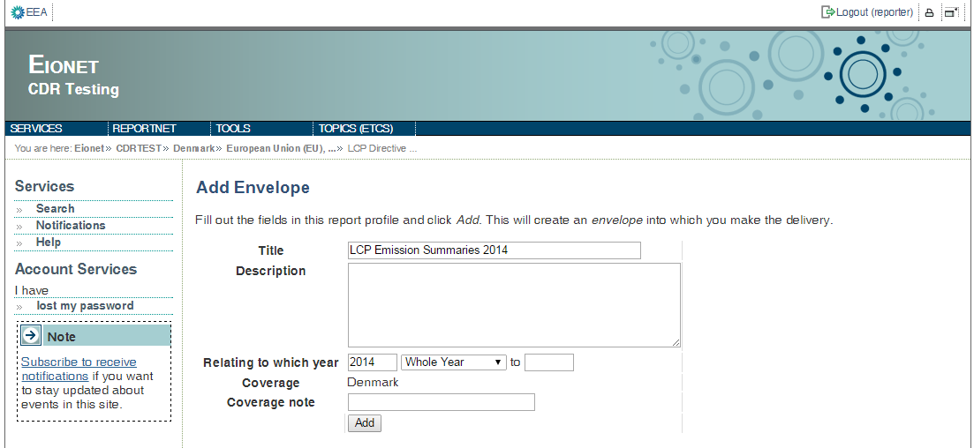

After clicking "Add" button the envelope is created and listed in the LCP reporting folder.

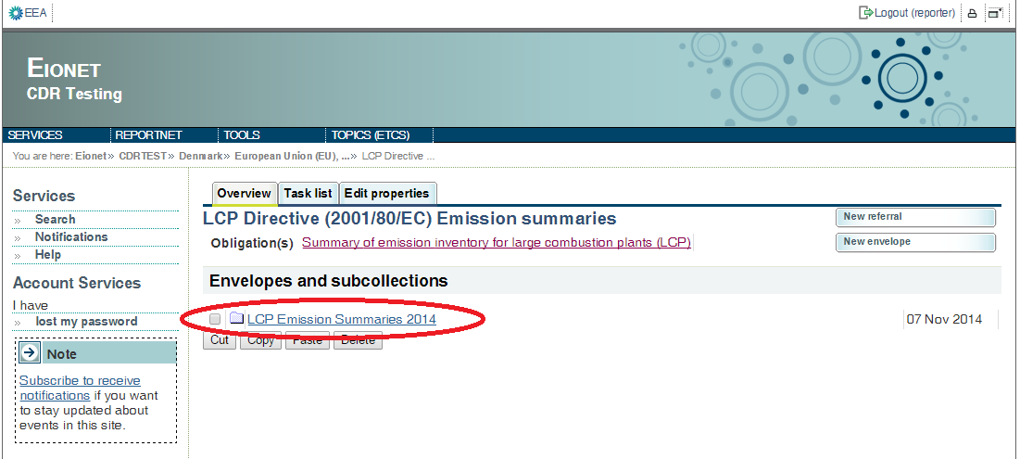

* **Step 4: Activate the task**

The way to start the work in the envelope is to enter the envelope by clicking on the envelope name and activate the **Draft** task by clicking on the <*Activate task: Draft*> link or by pressing the <*Activate task*> button.

Activating means that you have reserved the envelope for yourself to work on. Other users will not be able to modify it until the envelope is deactivated or released. Your new envelope is now in Draft status and files can be added.

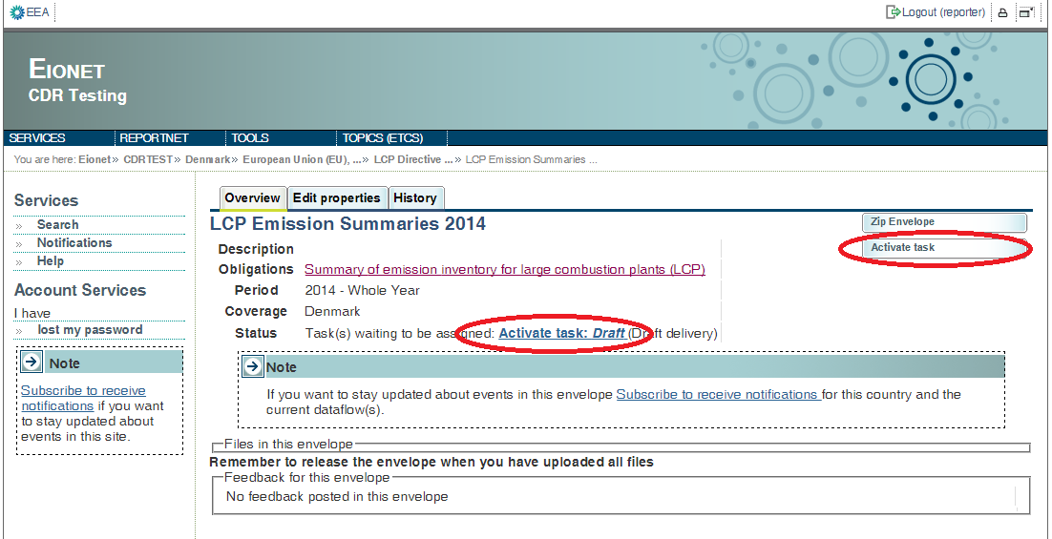

* **Step 5 Start to fill out the online questionnaire**

The next step is to fill in your report by using the online questionnaire, which can be achieved by clicking on the link on top of the envelope:

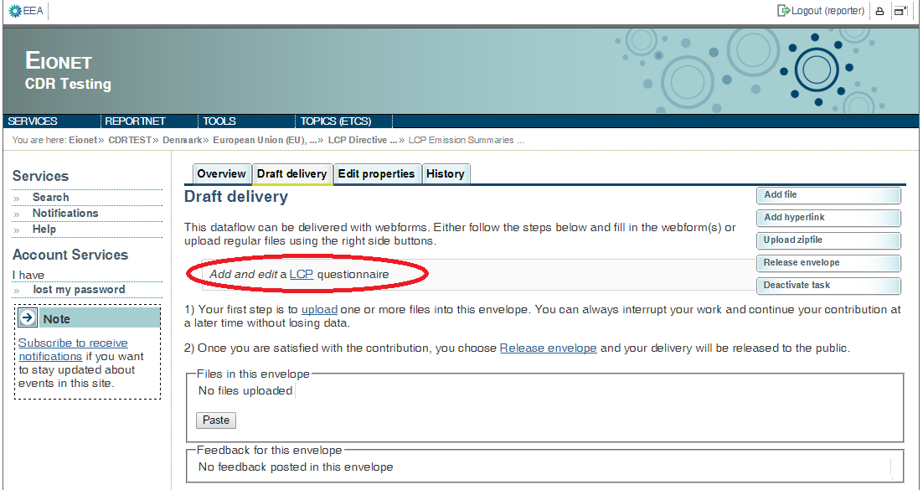

**Data Preloading**

The first time you open the web-form it will take some time to pre-load the plants from the previous report, in aid of the reporting process. All the plants of the previous reporting round will be fetched, with their previous name, and if available their location data from the E-PRTR database. A message will appear informing you for this operation.

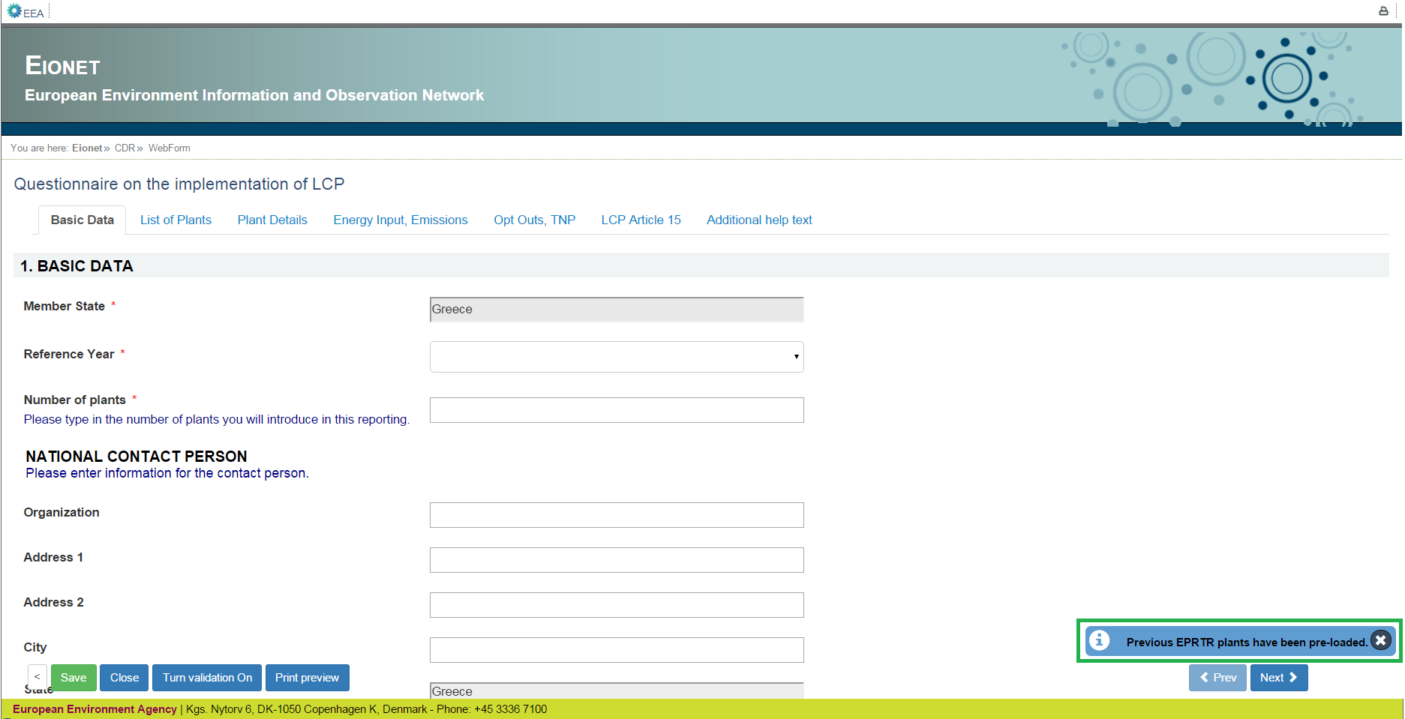

**N.B.**

The automatic linking might not cover all the required information. Please double check the data and add or fix the values, if necessary. In case of a plant that was pre-loaded, has some of its attributes this year changed (e.g. different Plant Name), you should not delete the pre-loaded plant and add a new one, because it will be assigned a new Plant ID. You will have to edit the plant attributes, as explained in the following sections.

**General principles of using the online questionnaire**

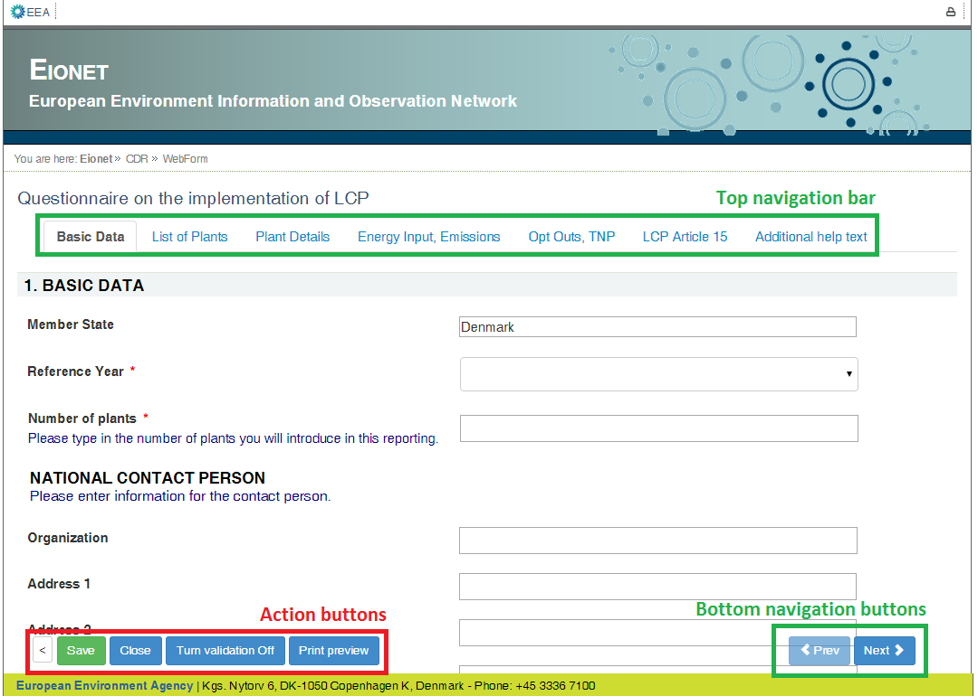

The questionnaire is divided into 6 reporting forms and the form with additional help texts.

**Navigation**

* All the forms are accessible from the **top navigation bar** (tabs) below the questionnaire title. The active form tab is displayed in bold font.
* The **bottom navigation buttons** under the reporting form contains links to the **next** and **previous** forms. After filling in one form you don’t have to scroll on top of the page, but you can continue by clicking on the **Next** button.
* The **bottom navigation bar** with **action buttons** can be turned invisible by clicking on the left most grey “<” button. This feature is useful in case you have a small screen and you want to make more space for questions. The bottom navigation bar and action buttons can be restored by clicking green “>” button in the same location.

**Reporting forms**

* **Basic data** – Basic data about the report and national contact person. Member state field is filled in automatically. It is required to select the reference year and fill in the number of plants, as well as at least an email for further communication if need be (between reporter and EEA).
* **List of plants** – on this form it is possible to add new plants, insert basic information about the plants and plants' location. The automatic linking between LCP plants and E-PRTR installations data has been established. The linked data has been pre-loaded automatically when opening the form for the first time. The automatic linking might not cover all the required information. Please double check the data and add or fix the values, if necessary. On this form it is also possible to delete plants from the list.
* **Plant Details** – on this form detailed data about the plants can be entered.
* **Energy Input, Emissions** – on this form data for energy input and total emissions to air can be entered.
* **Opt Outs, TNP** – on this form data for opt-outs and the transitional national plan can be entered.
* **LCP Art 15** - on this form data for LCP Art 15(3) can be entered.
* **Additional help text** - on this form additional guidance of how to fill in reporting forms can be found.

**Action buttons**

* **Save** – saves the data in the CDR envelope in an XML file. All input fields are validated before saving the file. The form will notify you when you try to save invalid data.
* **Turn validation On/Off –** you can turn the validation on and off at any time to see if inserted data follow the rules.
* **Close** – closes the online questionnaire and goes back to CDR envelope, after prompting you to save if necessary.
* **Print preview**–opens the questionnaire in printable format in a new window. **NB** You need to disable the pop-up blocker for this site if it is turned on.

**View mode of the reporting forms**

All the reporting forms are opened in view mode by default. The data is not editable in view mode. The view mode of the forms simplifies the browsing of the data by providing the following functionality:

* The visible rows of the table are limited to 50 rows and it is possible to browse through the pages if there are more than 50 entries. Use paging buttons on top of the table to navigate between the pages.
* The table entries can be filtered by the plant name when inserting the search string into the search box on upper right corner of the table
* The table rows can be sorted when clicking on column header. The tables are sorted by plant name by default.
* The view mode of the table displays validation errors next to the reported value, when validation is turned on.

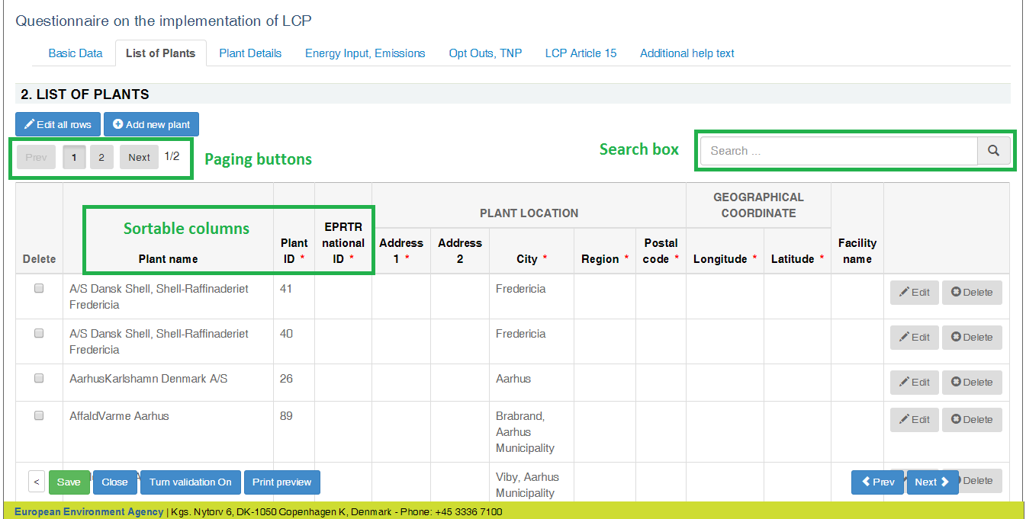

**Edit mode of the reporting forms**

All the tabular reporting forms can be switched to edit mode by clicking on  button.

The edit mode allows you to edit the table like an Excel spreadsheet and contains basic validation functionality e.g. the background of cells containing text in numeric fields turns red.

The rows can be sorted by clicking on the column header.

From the “List of plants” form it is possible to add a new row (plant). You may add one new row at a time, and a new “Plant Id” is automatically generated after clicking “Edits done”.

On the rest of the forms, the fields Plant Name and Plant Id are not editable.

The navigation to other forms is disabled when switching to edit mode. Click on  button to finish editing and go back to view mode.

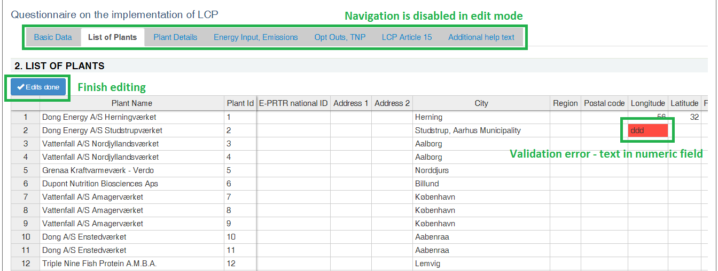

**Copy and paste data from Excel**

The edit mode of the form behaves similarly as MS Excel spreadsheet. It is possible to select an area (multiple rows and columns), and copy and paste it to other forms. It is also possible to select multiple cells in Excel spreadsheet and copy the data to reporting form, but there are certain limitations when doing this:

* decimal values have to use points instead of commas
* columns containing checkboxes accept only "true" or "false" (in lower case) values. “True”, “TRUE”, “Y”, “1” won’t work. Instead they will generate “#bad value#”.
* you cannot copy and paste values into read-only fields:
  + PlantName on all forms except "List of Plants"
  + PlantID, which is read-only on all forms
  + fields that are read-only by default, but will be editable after ticking the checkbox value - these fields are on "Plant Details", "Opt Outs, TNP" and "LCP Article 15" pages

**NB!** Before pasting data from Excel, you should make sure that the plants on the Excel spreadsheet and the webform are in the same order, e.g. by alphabetical sort.  
**NB!** The fields that are editable after ticking a checkbox, will remain empty and have to be filed manually.  
**NB!** Please verify the copy-pasted data by comparing the source values in Excel and paste results on  
webform, to be sure that the data and formatting was transferred correctly. Fix differences if needed.

**Add new plants one by one**

It is possible to add new plants one by one only on "List of Plants" form by clicking on  button on top of the table. It is required to fill in all mandatory fields to be able to successfully add a plant.

If "EPRTR national ID" value is entered, then it is possible to automatically load the installation data from E-PRTR database and link it to plant data by clicking on  button. The confirmation to fill in data automatically is asked, if the data is found for given EPRTR national ID.

**NB!** **You should be adding only plants that were not reported in the previous round, since if they were, they will have been pre-loaded. Before adding a new plant please check the available plants, by using the search box.**

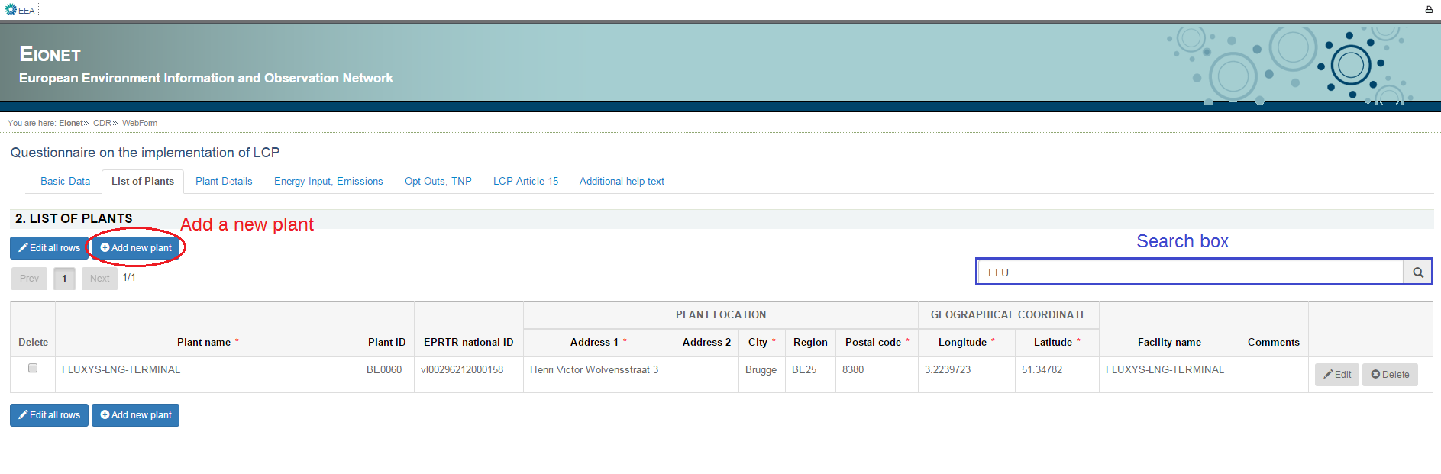

**Edit rows one by one**

Besides modifying the table rows in edit mode, it is also possible to edit rows one by one when clicking "Edit" button at the end of the row. The functionality is especially useful when the form displays validation errors in read only mode.

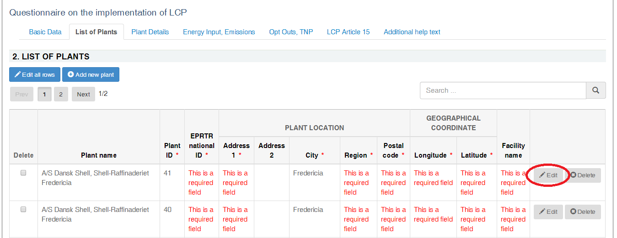

After clicking on "Edit" button a modal dialogue will be open with the data from selected row.

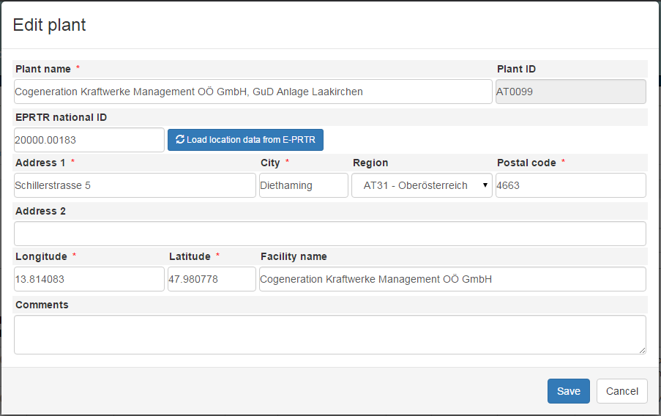

**Delete plants**

It is possible to delete plant rows only on "List of Plants" form. The deletion can be done one by one by using "Delete" buttons in right most column. The multiple plant rows can be deleted by using checkboxes in the left most column and clicking red "Delete selected" button under the table.

The deletion of a plant is permanent and should be performed with caution. Re-adding a plant that was deleted will result in a mismatch of the auto-generated Plant ID. On the case that a plant had an attribute changed from the previous report, you should edit the plant as explained above.

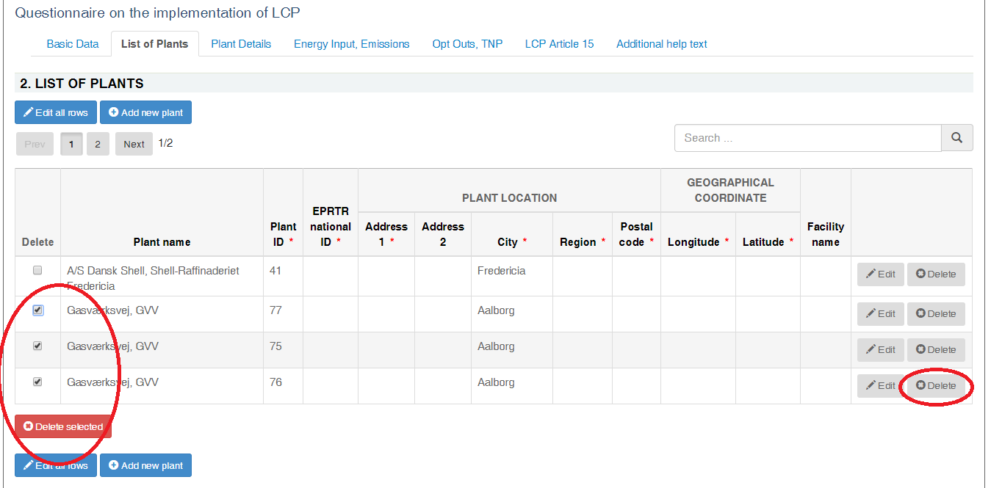

* **Step 6 Save data**

**NB! The online questionnaire does NOT save your changes automatically**

Save operation runs after clicking the 'Save' button on the main window. It also runs every time you click the 'Save' button in some modal view. It does not run automatically after editing with ‘Edit all rows’ button. A notification will appear after a save operation, informing you about the current state of the questionnaire. There are 3 types of messages.

1. If the questionnaire is incomplete, meaning that there are mandatory fields that have been not been filled yet, then the following message appears. The mandatory fields are denoted with an asterisk. You may turn the validation on, and the missing values will be flagged with red messages.

You don’t have to fill in all data at once, this is for your information.

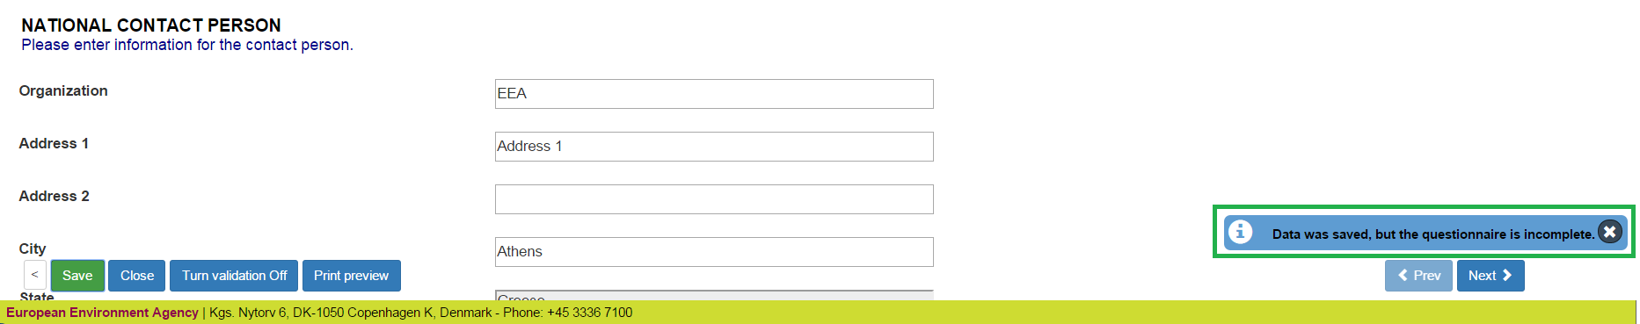

1. If all the mandatory fields have been filled, then some basic Quality Assurance/ Quality Control (QA/QC) rules will run after the save operation

1.1 Basic data completeness

1.2 Number of plants

2.1 Unequivocal naming of plants

3.2 Rated thermal input value

3.4 Plausibility of capacity added

3.5 Plausible reporting of substantial change

3.6 Date of start of operation and legal status

If one or more from the above QA/QCs fail then the message “Data was saved but the questionnaire did not pass some QAs” appears after the save operation :

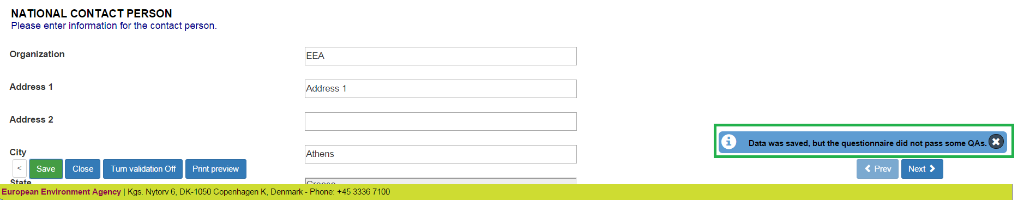

1. If all of the above QA/QCs pass then green message “Data is saved successfully” appears :

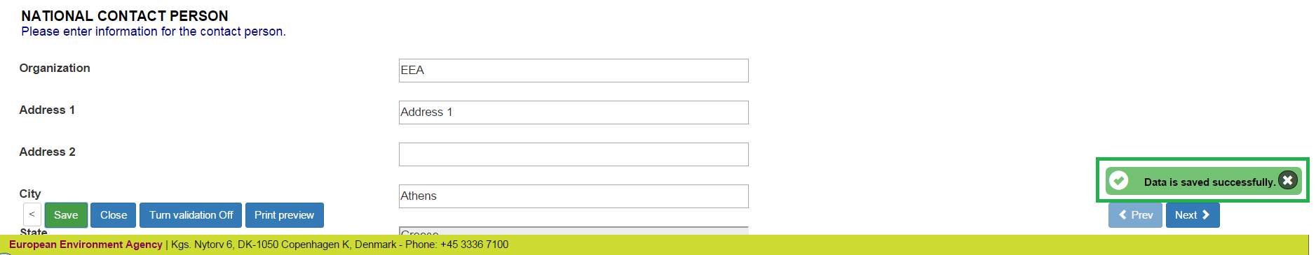

These QA/QCs are preliminary, and the main QA/QC functionality is explained in **step 7.**

**N.B.** **You don’t have to fill in all data at once. You can go back and modify the online questionnaire for completions or amendments later at any time in CDR :**

**either by clicking on the “Modify the LCP questionnaire" link on envelope pageor by clicking on the corresponding XML file name in the list of files and then clicking on the “Edit with Web form” link on document details page**

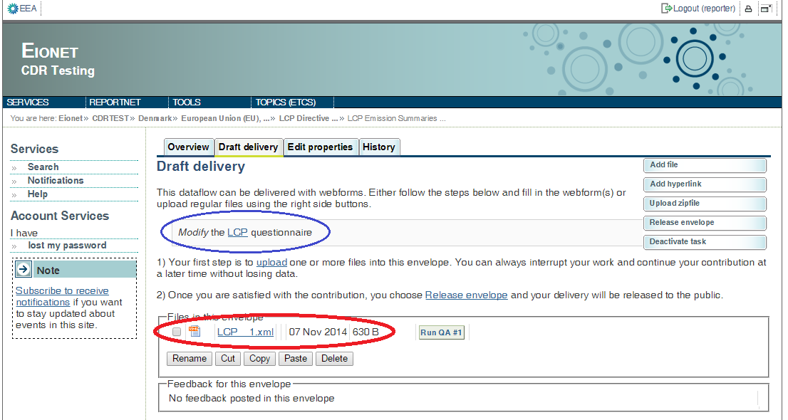

* **Step 7: QA/QC**

**The first step** of the QA/QC process is running the QA #1. The “Run QA #1” button initiates a technical validation of the file according to the xml schema. You should begin this process if the last message on the Save operation was the green “Data is saved successfully”.

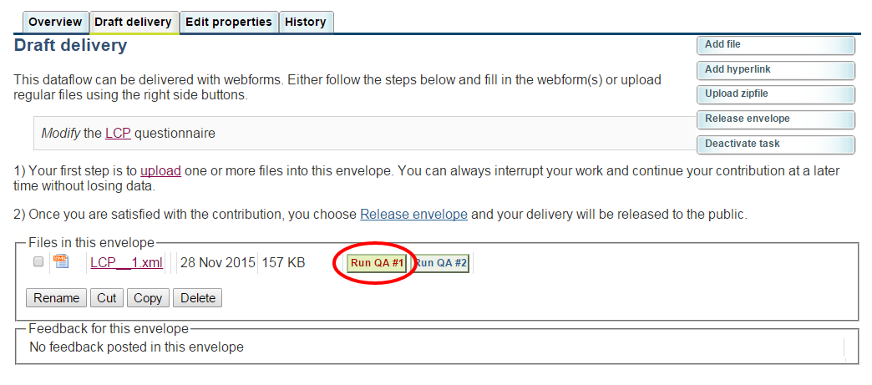

The result should be looking like this :

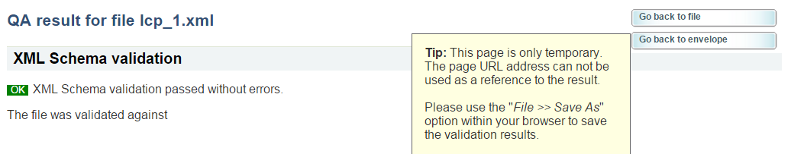

**Then** you should run the QA #2, which initiates a quality check on the reported data (after click on Go back to envelope / Go back to file).

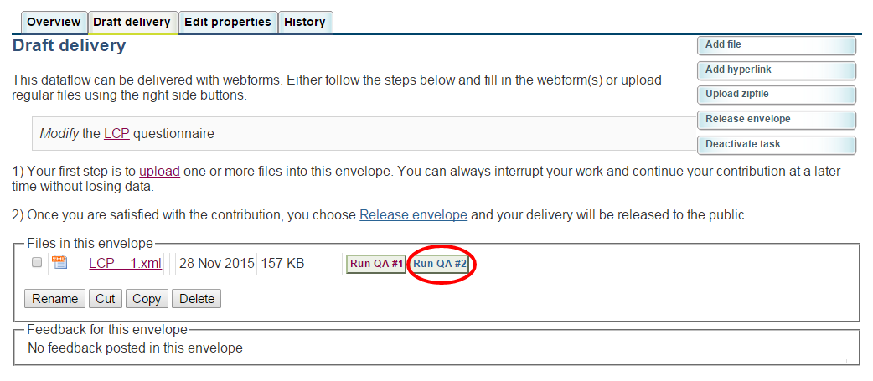

After allowing the QA/QC script a few moment to run, it presents the results in a new page.

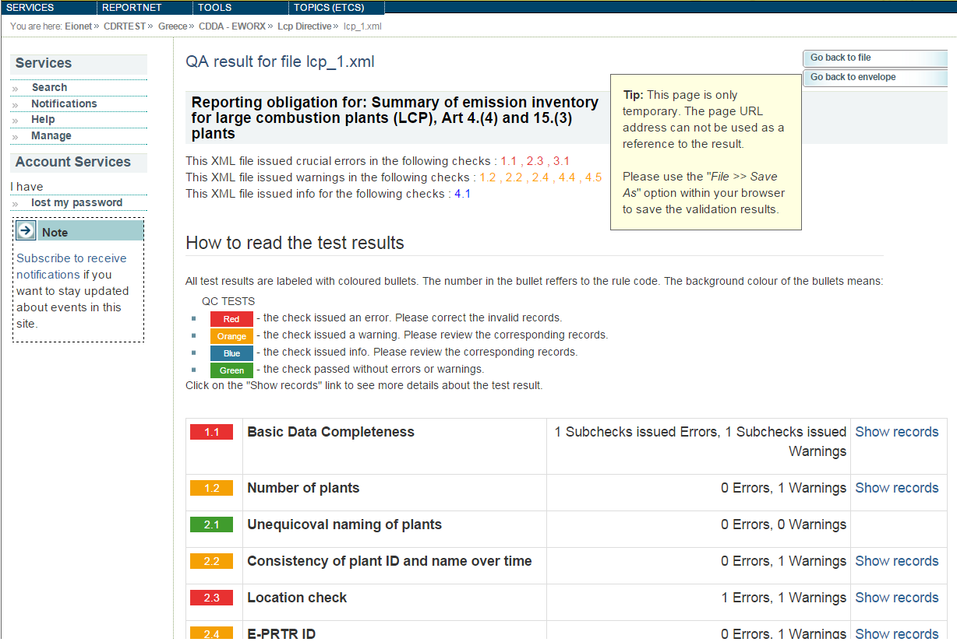

On the top are the concentrating results of the QA, displaying if any checks issued errors. If there are checks with errors, after reviewing the corresponding records you should edit the data through the web form and re-do this step.  
Warnings and info may issued by checks for some records that should be reviewed for their integrity, in order to improve data quality.

There is a table of all the checks that ran with a colour coded bullet that shows the status of the check, the check’s name and the results. If there are errors, warnings or info for a check, there is a ‘Show records’ button, which will present the related fields along with an explanation.

Some of the QA rules check the data validity of the report, such as the legal status being one of the allowed values, that the plants are all over 50MW, that the number of the reported plants are the same number written in the Basic Data etc.

QA/QC 3.4 : checks that when ExtensionBy50MWorMore was ticked in the webform that the capacity added field is indeed a value of 50 or more.

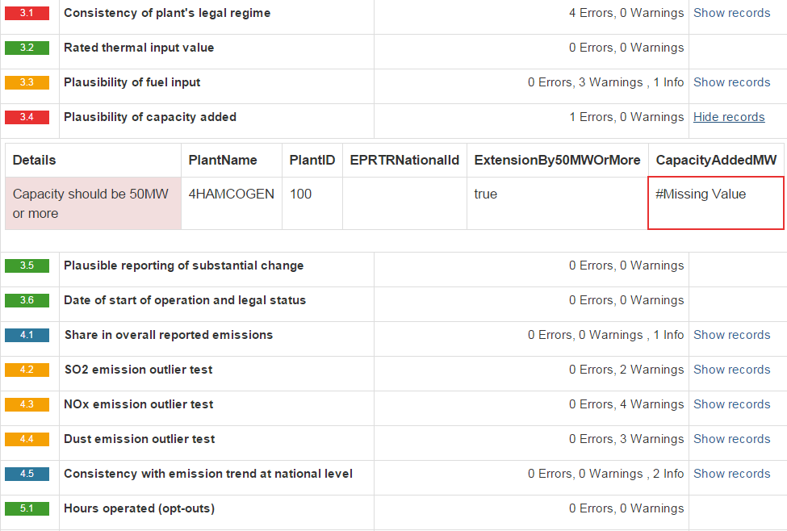

Some of the QA rules check for plausibility of the reported values and then issue info or warnings if something differs from the expected values. For many a reasons this difference can be plausible, but the records should be examined because there is a possibility for wrong data entry.

QA/QC 4.1 : you can see as an information the percentage of overall reported emissions to the CLRTAP emissions.

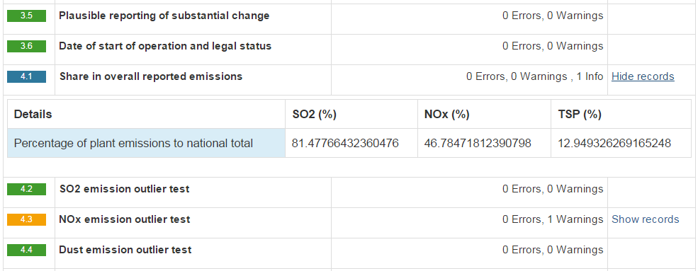

QA/QC 4.5 : shows an info if there is a significant change in the reported amounts of emissions compared to the average of the last 3 reports, or a warning if there is a very big change in the emissions.

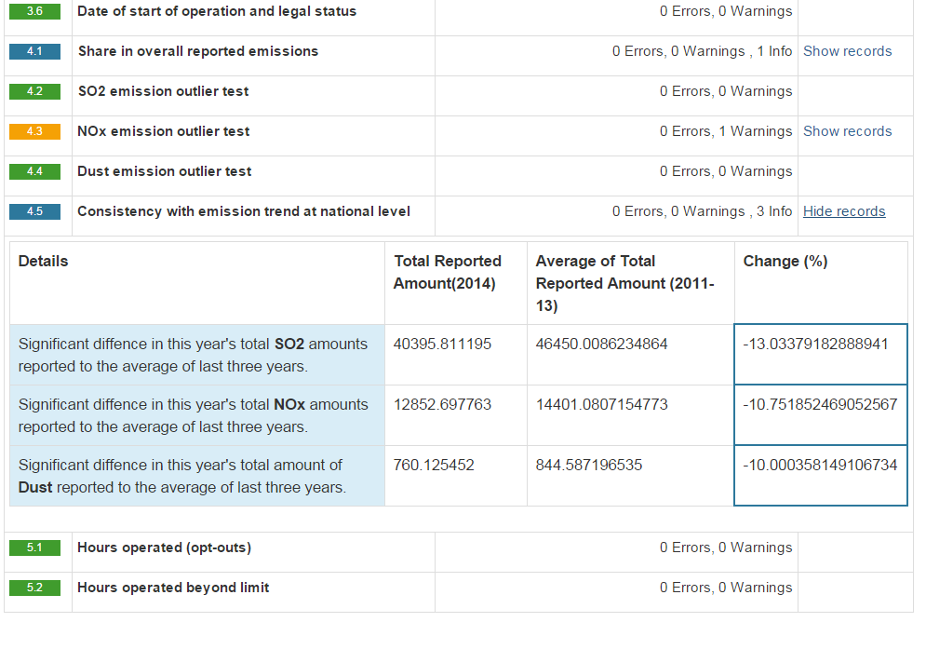

In checks 4.2- 4.4, an expected emission is calculated by using the total input reported. Because of different operational procedures the reported emissions may well vary from the expected values, but the records should be reviewed because there is the possibility of wrong data input.

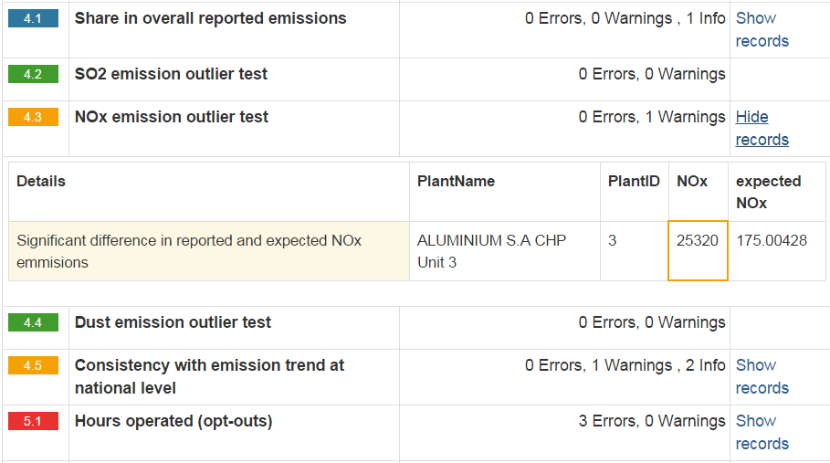

QA/QC 3.1 : If there is a change of a plant’s legal regime, then it is mandatory to have provided a comment in the plant details. If there is no comment text, the plant will be flagged with an error.

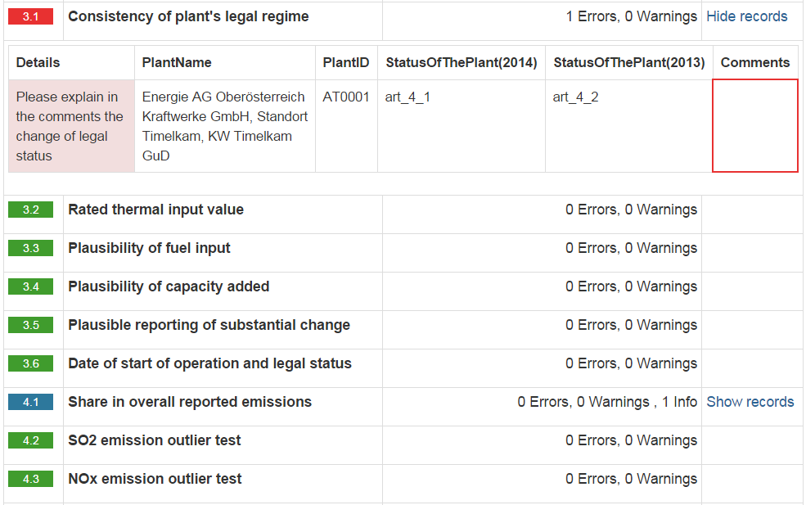

You should provide a comment in case of change of legal regime in the “Plant details” form, by editing the plant under question.

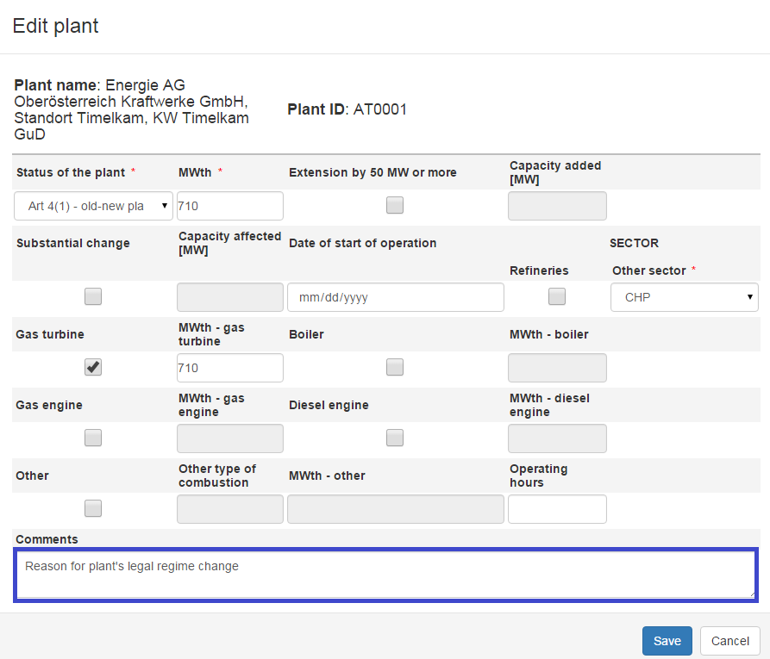

If there is a comment for the legal change the QA/QC will flag the plant with info, and present the details (the comment and the plant’s current and former legal regime).

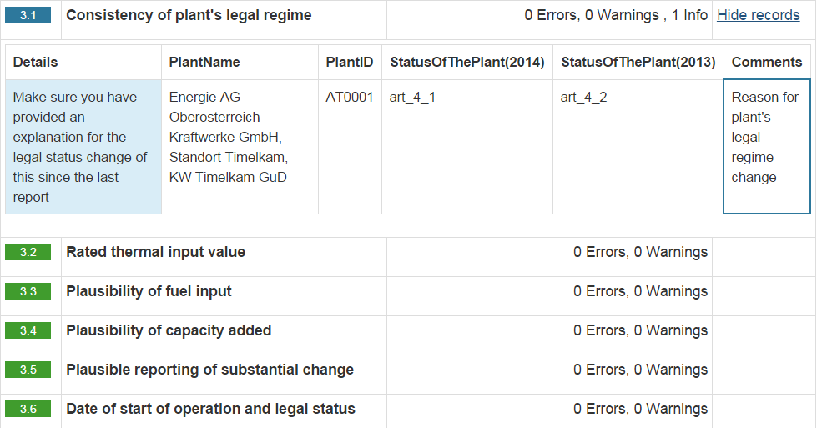

QA/QC 3.6 : if a “Date of start of operation” has been reported it is checked to be consistent with the Status of the plant. The criteria are the following: If "Status of plant" is "Art. 4(1)" or "Art. 4(3)", "Date of start of operation" must be no later than 27 November 2003. If "Status of plant" is "Art. 4(2)", "Date of start of operation" must be after 27 November 2003.

* **Step 8: Upload additional files**

You can upload and submit additional files in the envelope.

You can restrict the uploaded file from public view by ticking the box “*Restricted from public view*”.

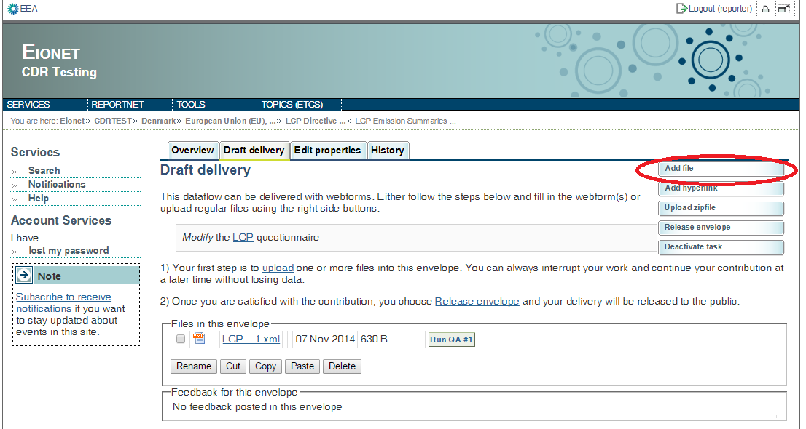

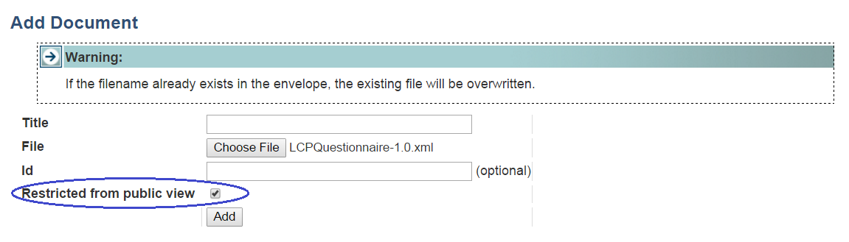

* **Step 9: Download or print out the report (optional)**

You can download or print out the report in CDR. This functionality is available on document details page. Click on the XML file name on CDR envelope to open the **Document details** page. All available formats are available at the top of the page in “View file as“ area.

Click on the “**HTML preview**” link to download in HTML format or print the report.

Click on the “**Excel preview**” link to download in report in Excel format.

Click on the “**Original**“ link to open the raw XML file in your browser.

The Document details page contains also a link to the online questionnaire. Just click on the link “*Edit file with Web form*” if you have found something to change or amend in the answers and you are able to edit all the answers.

"**Run QA #..**" button is available both on envelope page and document details page.

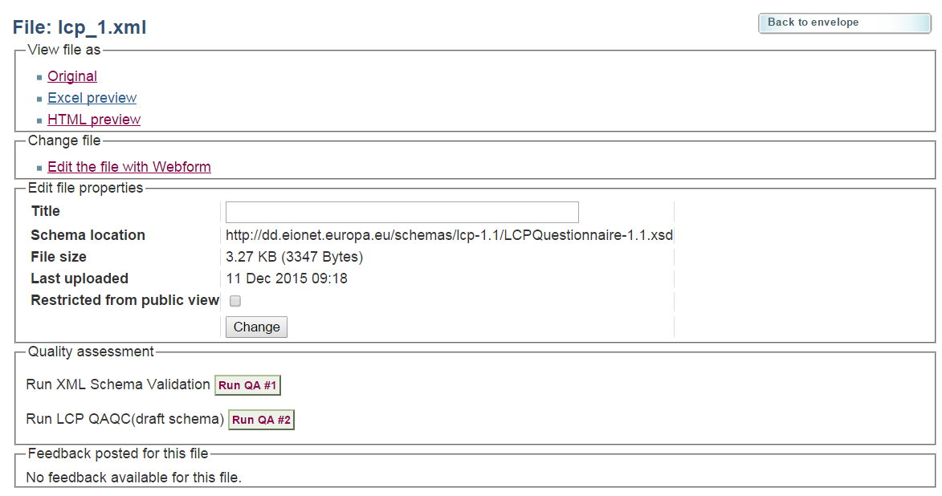

**Example of Print preview:**

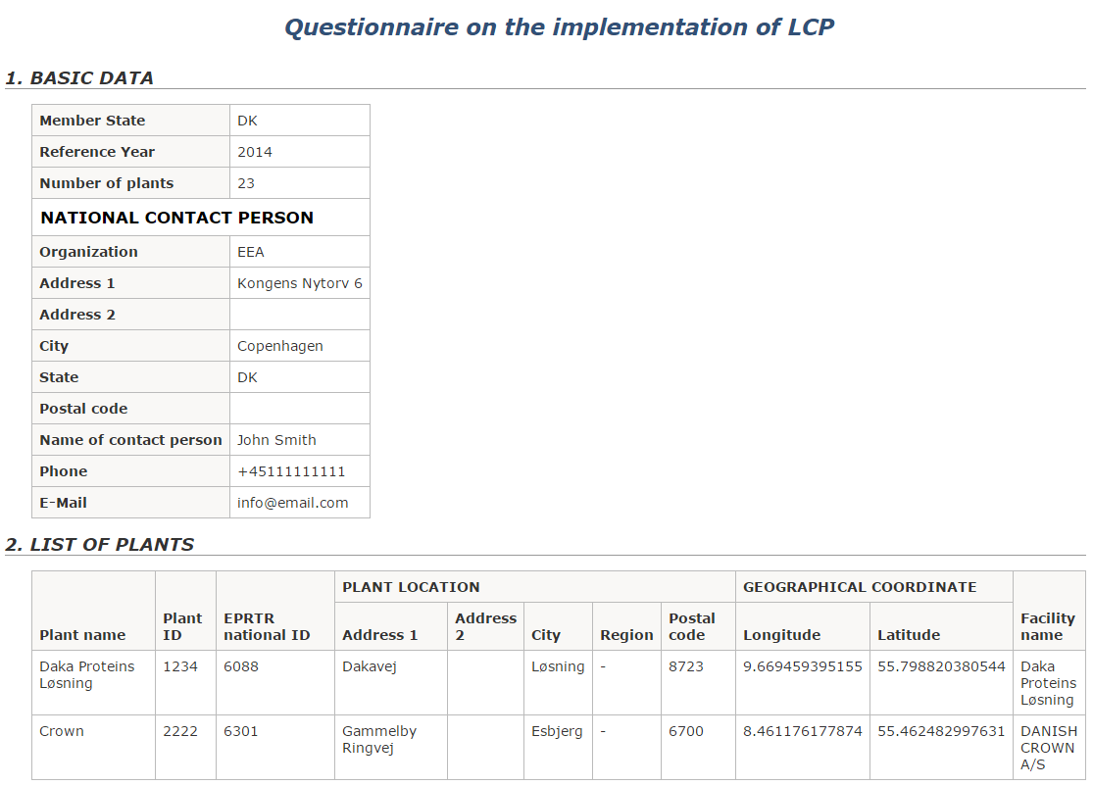

* **Step 10: Complete task**

When you **finish the drafting of your work**, you need to click on the right side button “**Release envelope**”.

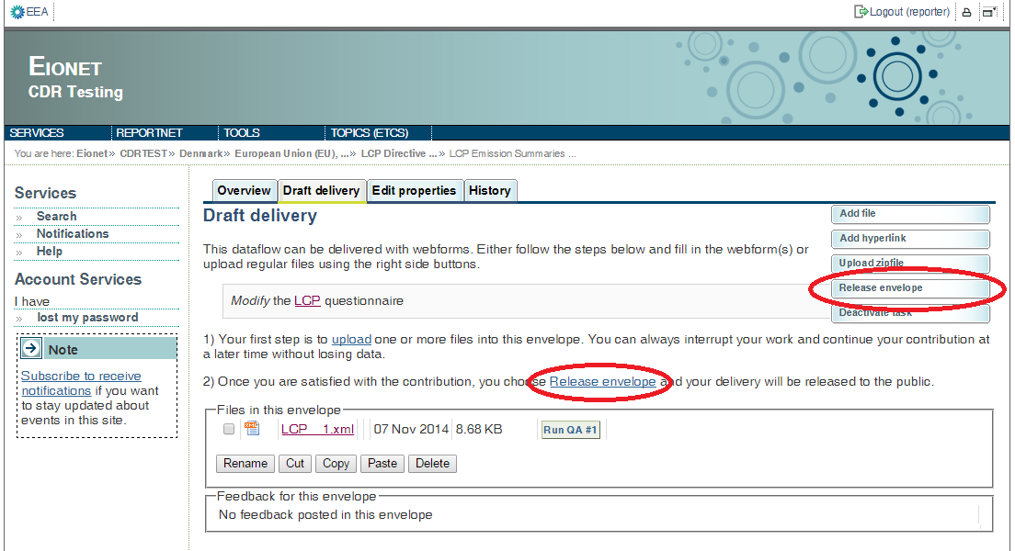

Now the report is submitted and received by the EU and the envelope is available to the public (if you did not tick the box “Restricted from public view”. After a few minutes, confirmation of receipt message and automatic feedback is stored automatically in the envelope's feedback area. Additional feedback might be provided by the Commission or EEA.

You may review the confirmation of receipt by clicking the corresponding link on the envelope.

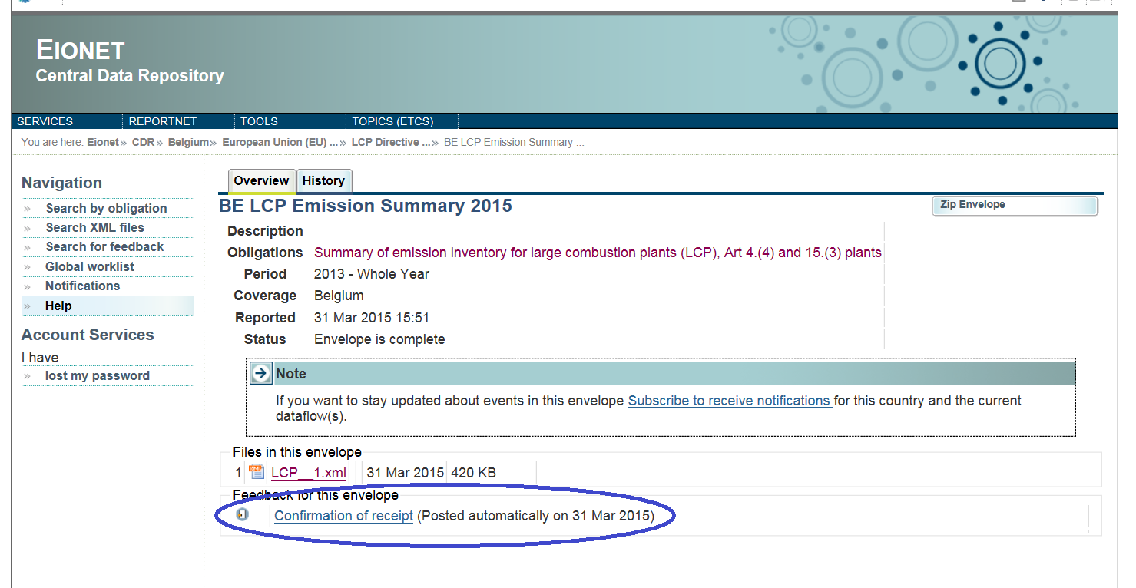

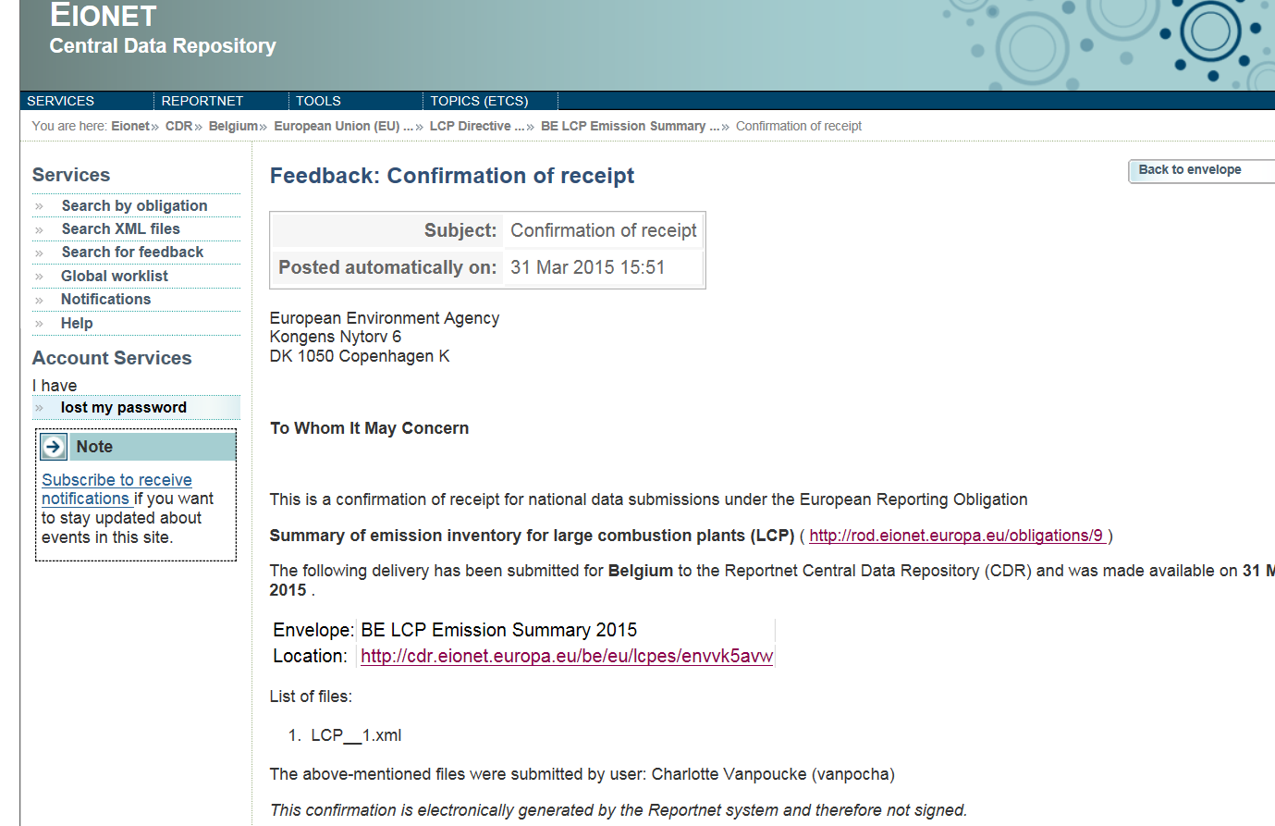

# Getting help

CDR help: <http://cdr.eionet.europa.eu/help>

|  |  |
| --- | --- |
| For technical assistance with access to CDR and the submission process.  Questions related to LCP emission summaries questionnaire reporting will be forwarded to the technical team. | [helpdesk@eionet.europa.eu](mailto:helpdesk@eionet.europa.eu) |