USER MANUAL

How to deliver data on the

Large Combustion Plants (LCP) through Reportnet <http://rod.eionet.europa.eu/obligations/9>

*(emission inventories under Directive 2001/80/EC)*

These guidelines explain how to use the electronic infrastructure for reporting information to the European

Commission in pursuance of Directive 2001/80/EC of the European Parliament and of the Council of 23 October 2001 on the limitation of emissions of certain pollutants into the air from large combustion plants.

**How to deliver**

All deliveries are provided via the Reportnet Central Data Repository (CDR), which is maintained by

the European Environment Agency (EEA).

**Summary of the delivery process**

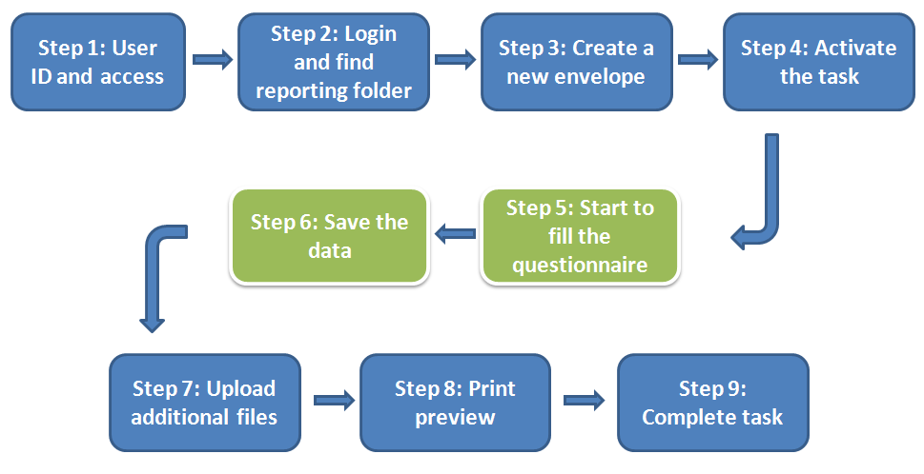

* **Step 1: User accounts and access permissions**

In order to report, an Eionet account with user name and password is required as well as permission to upload the national delivery. Please inform DG ENV and EEA about who will be the person(s) responsible for the reporting, so that the necessary arrangements can be made. The person(s) who do not yet have an EIONET account will receive an e-mail with their EOINET login and password. All persons nominated as reporter will receive upload rights to the CDR. Only new reporters will receive a notification on this from the Eionet Helpdesk ([helpdesk@eionet.europa.eu](mailto:helpdesk@eionet.europa.eu)).

* **Step 2: Login to the Central Data Repository and open your folder**

You can access EEA’s Central Data Repository (CDR) at <http://cdr.eionet.europa.eu>

When preparing for LCP questionnaire delivery, you first have to log in by using your Eionet user name and password and then navigate to the respective folder of you country (see the links below).

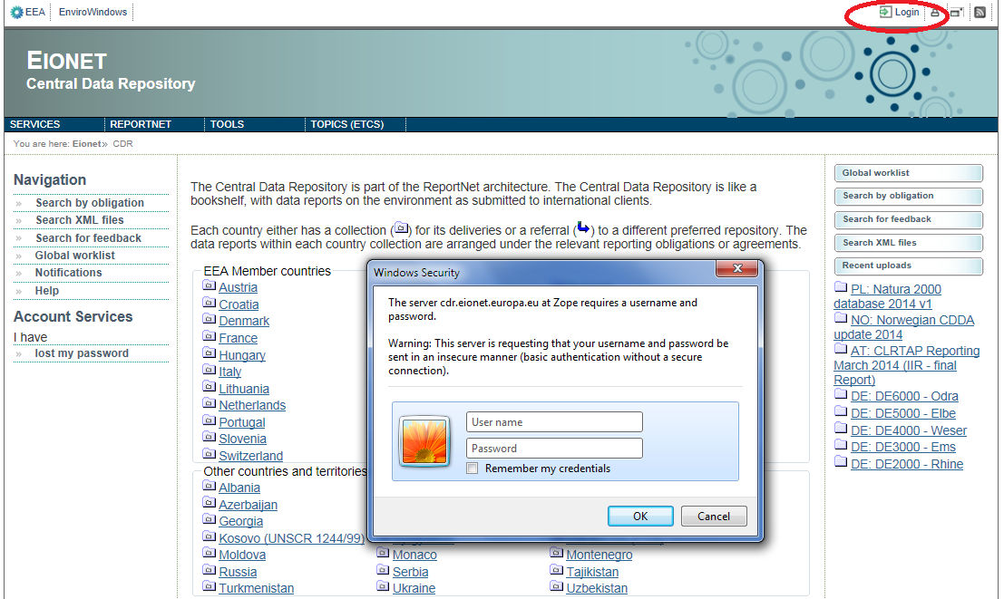

Country URL to "LCP Directive (2001/80/EC) Emission summaries" reporting folder

|  |  |  |
| --- | --- | --- |
| **Country** | | **LCP emission summaries reporting deliveries to CDR** |
| **Name** | **ISO** | **Hyperlink to national folder** |
| Austria  Belgium  Bulgaria  Croatia  Cyprus  Czech Republic  Denmark  Estonia  Finland  France  Germany  Greece  Hungary  Ireland  Iceland  Italy  Latvia  Liechtenstein  Lithuania  Luxembourg  Malta  Netherlands  Norway  Poland  Portugal  Romania  Slovakia  Slovenia  Spain  Sweden  Switzerland  Turkey  United Kingdom | AT  BE  BG  HR  CY  CZ  DK  EE  FI  FR  DE  GR  HU  IS  IE  IT  LV  LI  LT  LU  MT  NL  NO  PL  PT  RO  SK  SI  ES  SE  CH  TR  UK | <http://cdr.eionet.europa.eu/at/eu/lcpes>  <http://cdr.eionet.europa.eu/be/eu/lcpes>  <http://cdr.eionet.europa.eu/bg/eu/copy_of_lcpes>  <http://cdr.eionet.europa.eu/hr/eu/lcpes>  <http://cdr.eionet.europa.eu/cy/eu/lcpes>  <http://cdr.eionet.europa.eu/cz/eu/lcpes>  <http://cdr.eionet.europa.eu/dk/eu/lcpes>  <http://cdr.eionet.europa.eu/ee/eu/lcpes>  <http://cdr.eionet.europa.eu/fi/eu/lcpes>  <http://cdr.eionet.europa.eu/fr/eu/lcpes>  <http://cdr.eionet.europa.eu/de/eu/lcpes>  <http://cdr.eionet.europa.eu/gr/eu/lcpes>  <http://cdr.eionet.europa.eu/hu/eu/lcpes>  <http://cdr.eionet.europa.eu/is/eu/lcpes>  <http://cdr.eionet.europa.eu/ie/eu/lcpes>  <http://cdr.eionet.europa.eu/it/eu/lcpes>  <http://cdr.eionet.europa.eu/lv/eu/lcpes>  <http://cdr.eionet.europa.eu/li/eu/lcpes>  <http://cdr.eionet.europa.eu/lt/eu/lcpes>  <http://cdr.eionet.europa.eu/lu/eu/lcpes>  <http://cdr.eionet.europa.eu/mt/eu/lcpes>  <http://cdr.eionet.europa.eu/nl/eu/lcpes>  <http://cdr.eionet.europa.eu/no/eu/colp0r8w/colshr9cw>  <http://cdr.eionet.europa.eu/pl/eu/lcpes>  <http://cdr.eionet.europa.eu/pt/eu/lcpes>  <http://cdr.eionet.europa.eu/ro/eu/lcpes>  <http://cdr.eionet.europa.eu/sk/eu/lcpes>  <http://cdr.eionet.europa.eu/si/eu/lcpes>  <http://cdr.eionet.europa.eu/es/eu/lcpes>  <http://cdr.eionet.europa.eu/se/eu/colqedr6a>  <http://cdr.eionet.europa.eu/ch/eu/lcpes>  <http://cdr.eionet.europa.eu/tr/eu/lcpes>  <http://cdr.eionet.europa.eu/gb/eu/lcpes> |

* **Step 3: Create a new envelope**

Now **create a new envelope** which will contain your data delivery by clicking on the button ‘New envelope’ at the upper right corner of the screen:

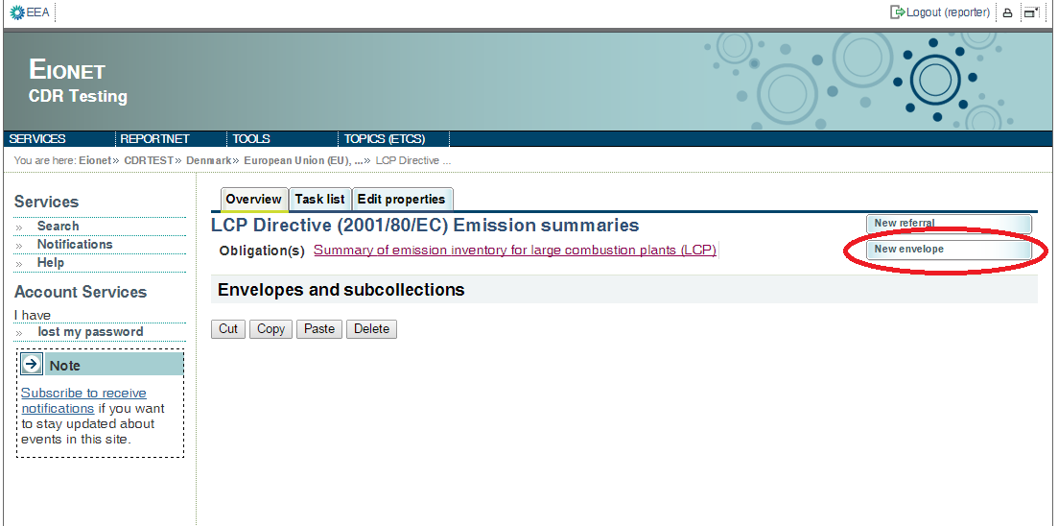

# Provide meaningful metadata about your delivery on the “Add Envelope” page. At least “Title” and “Relating to which year” fields have to be filled in.

# The Envelope title should briefly summarise the delivery by providing the information about the reporting country, obligation and year. Then it will be easier for the reporter and other stakeholders to find the delivery. “Relating to which year” indicates the period the report will cover.

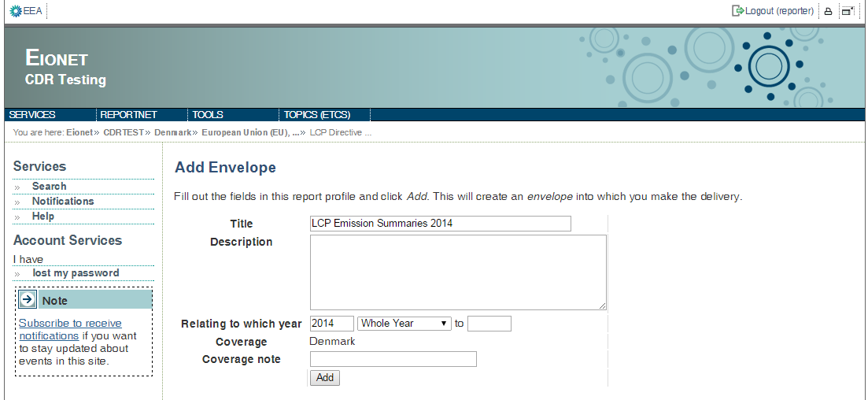

After clicking "Add" button the envelope is created and listed in the LCP reporting folder.

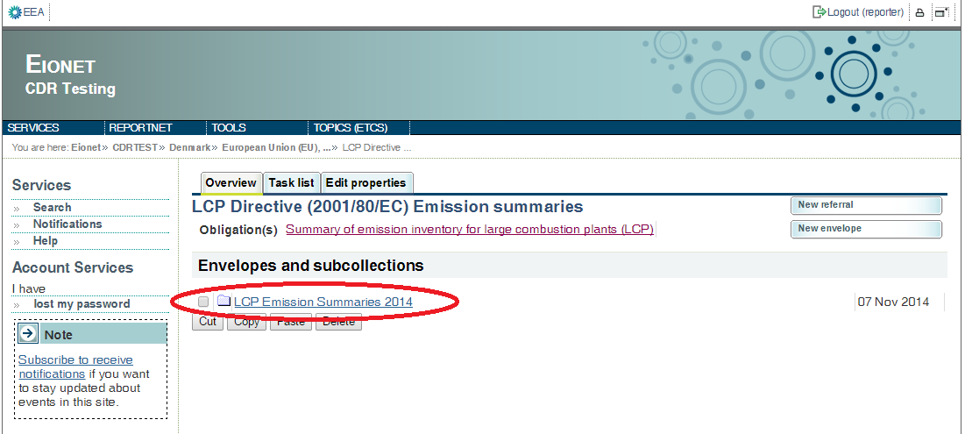

* **Step 4: Activate the task**

The way to start the work in the envelope is to enter the envelope by clicking on the envelope name and activate the **Draft** task by clicking on the <*Activate task: Draft*> link or by pressing the <*Activate task*> button.

Activating means that you have reserved the envelope for yourself to work on. Other users will not be able to modify it until the envelope is deactivated or released. Your new envelope is now in Draft status and files can be added.

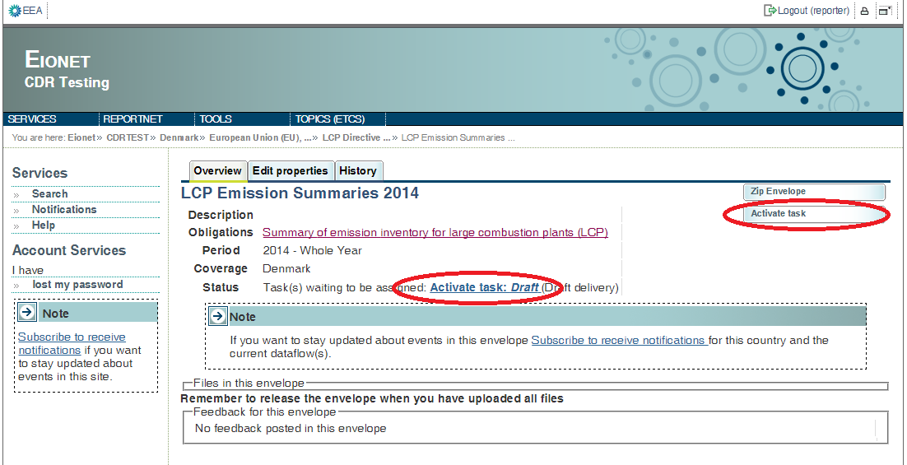

* **Step 5 Start to fill out the online questionnaire**

The next step is to fill in your report by using the online questionnaire, which can be achieved by clicking on the link on top of the envelope:

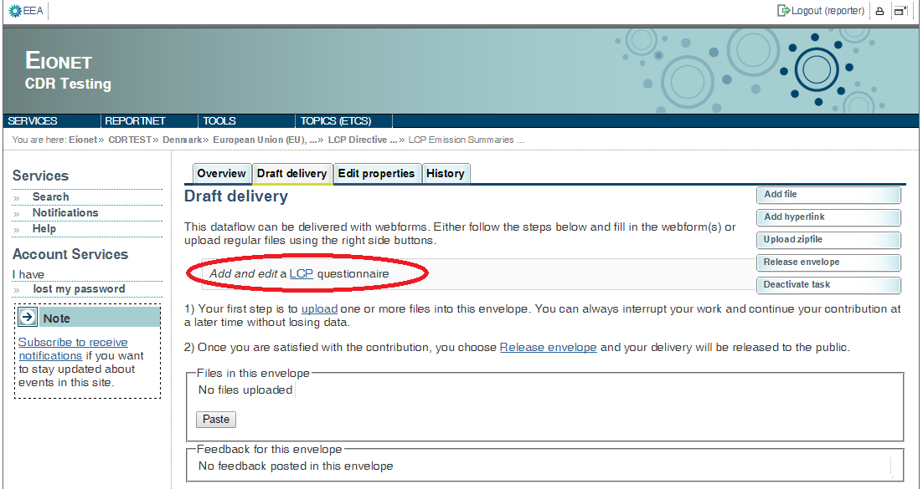

It takes some seconds to load up the questionnaire. After opening the questionnaire you will see the following screen:

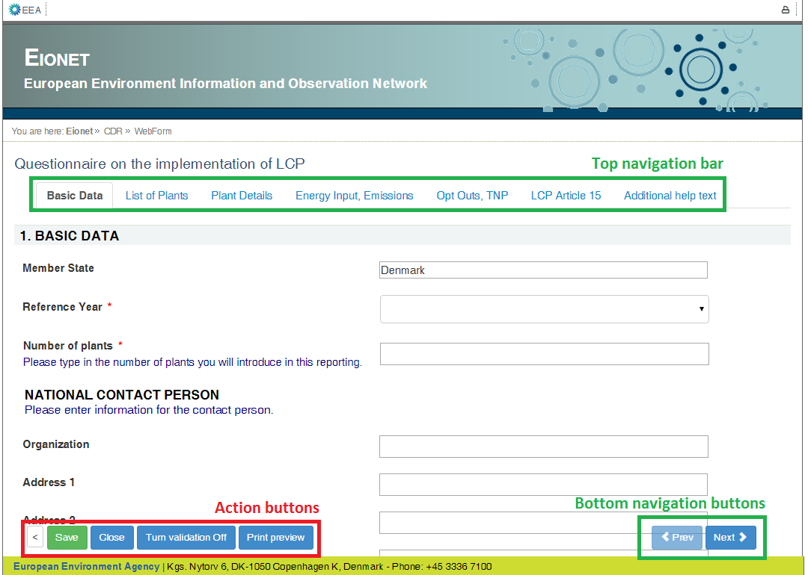

**General principles of using the online questionnaire**

The questionnaire is divided into 6 reporting forms and the form with additional help texts.

**Navigation**

* All the forms are accessible from the **top navigation bar** (tabs) below the questionnaire title. The active form tab is displayed in bold font.
* The **bottom navigation buttons** under the reporting form contains links to the **next** and **previous** forms. After filling in one form you don’t have to scroll on top of the page, but you can continue by clicking on the **Next** button.
* The **bottom navigation bar** with **action buttons** can be turned invisible by clicking on the left most gray “<” button. This feature is useful in case you have a small screen and you want to make more space for questions. The bottom navigation bar and action buttons can be restored by clicking green “>” button in the same location.

**Reporting forms**

* **Basic data** – Basic data about the report and national contact person. Member state field is filled in automatically. It is required to select the reference year and fill in the number of plants.
* **List of plants** – on this form it is possible to add new plants, insert basic information about the plants and plants' location. The automatic linking between LCP plants and E-PRTR installations data have been established. The linked data is pre-loaded automatically when opening the form for the first time. The automatic linking might not cover all the required information. Please double check the data and add or fix the values, if necessary. On this form it is also possible to delete plants from the list.

Once the plant data is complete, data on other reporting forms can be entered.

* **Plant Details** – on this form detailed data about the plants can be entered.
* **Energy Input, Emissions** – on this form data for energy input and total emissions to air can be entered.
* **Opt Outs, TNP** – on this form data for opt-outs and the transitional national plan can be entered.
* **LCP Art 15** - on this form data for LCP Art 15(3) can be entered.
* **Additional help text** - on this form additional guidance of how to fill in reporting forms can be found.

**Action buttons**

* **Save** – saves the data in the CDR envelope in an XML file. All the input fields are validated before saving the file. The form warns you when you try to save invalid data. All errors are displayed in red.
* **Turn validation On/Off –** you can turn the validation on and off at any time to see if inserted data follow the rules. Validation is turned on automatically every time you save the form.
* **Close** – closes the online questionnaire and goes back to CDR envelope, after prompting you to save if necessary.
* **Print preview**–opens the questionnaire in printable format in a new window. NB You need to disable the pop-up blocker for this site if it is turned on.

**View mode of the reporting forms**

All the reporting forms are opened in view mode by default. The data is not editable in view mode. The view mode of the forms simplifies the browsing of the data by providing the following functionality:

* The visible rows of the table are limited to 50 rows and it is possible to browse through the pages if there are more than 50 entries. Use paging buttons on top of the table to navigate between the pages.
* The table entries can be filtered by the plant name when inserting the search string into the search box on upper right corner of the table
* The table rows can be sorted when clicking on column header. The tables are sorted by plant name by default.
* The view mode of the table displays validation errors next to the reported value, when validation is turned on.

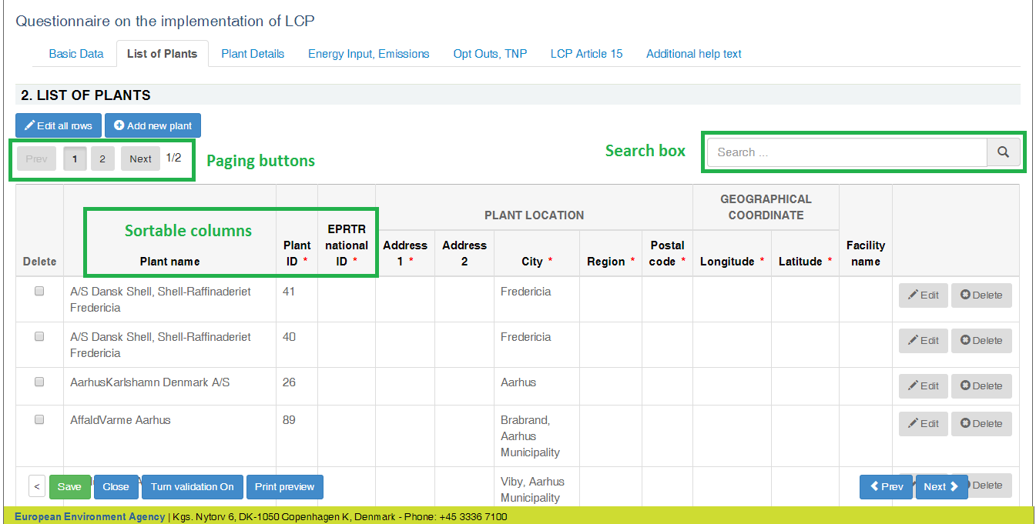

**Edit mode of the reporting forms**

All the tabular reporting forms can be switched to edit mode by clicking on  button. All the fields will be editable just like in MS Excel spreadsheet.

The edit mode contains basic validation functionality. The background of cells containing text in numeric fields turns red.

The rows can be sorted by clicking on the column header.

It is possible to add new rows, delete rows and edit plant name and plant ID only on "List of plants" form. The first two columns are automatically filled and disabled on the remaining forms.

The navigation to other forms is disabled when switching to edit mode. Click on  button to finish editing and go back to view mode.

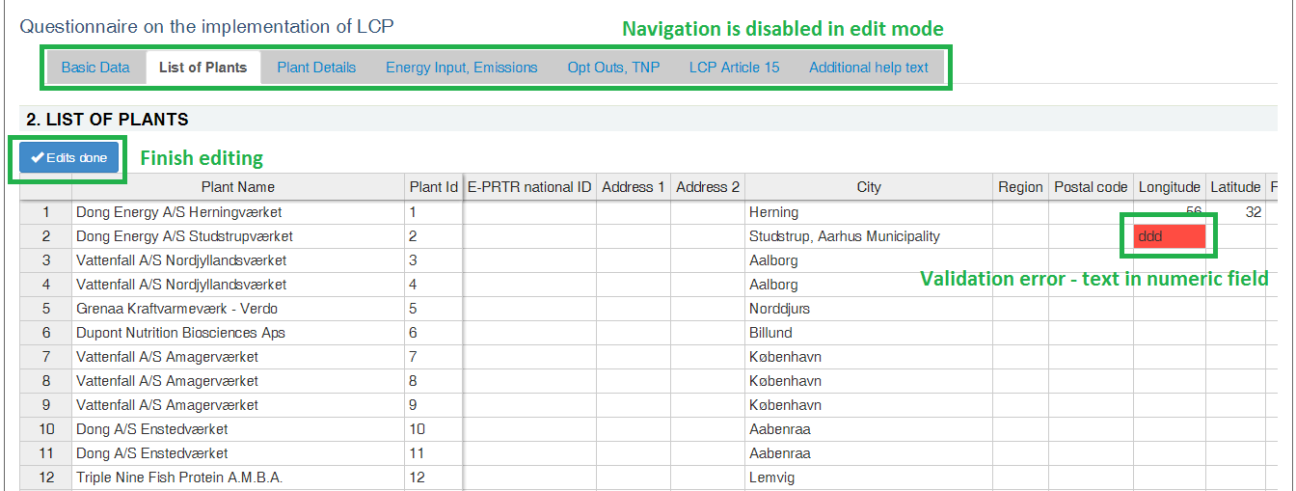

**Copy and paste data from Excel**

The edit mode of the form behaves similarly as MS Excel spreadsheet. It is possible to select an area (multiple rows and columns), copy and paste it to other forms. It is also possible to select multiple cells in Excel spreadsheet and copy the data to reporting form, but there are certain limitations when doing this:

* decimal values have to use points instead of commas
* columns containing checkboxes accept only "true" or "false" (in lower case) values. “True”, “TRUE”, “Y”, “1” won’t work. Instead they will generate “#bad value#”.
* you cannot copy and paste values into read-only fields:
  + PlantName and Plant ID on all forms except "List of Plants"
  + fields that are read-only by default, but will be editable after ticking the checkbox value - these fields are on "Plant Details", "Opt Outs, TNP" and "LCP Article 15" pages

**NB!** please verify the copy-pasted data by comparing the source values in Excel and paste results on webform, to be sure that the data and formatting was transferred correctly. Fix differences if needed.

**Add new plants one by one**

It is possible to add new plants one by one only on "List of Plants" form by clicking on  button on top of the table. It is required to fill in all mandatory fields to be able to successfully add a plant.

If "EPRTR national ID" value is entered, then it is possible to automatically load the installation data from E-PRTR database and link it to plant data by clicking on  button. The confirmation to fill in data automatically is asked, if the data is found for given EPRTR national ID.

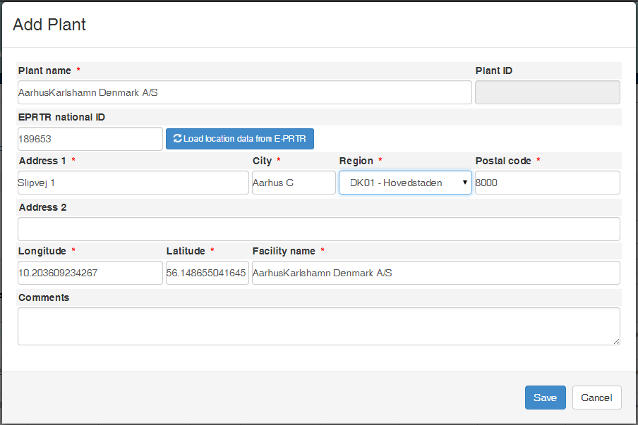

**Edit rows one by one**

Beside modifying the table rows in edit mode, it is also possible to edit rows one by one when clicking "Edit" button at the end of the row. The functionality is especially useful when the form displays validation errors in read only mode.

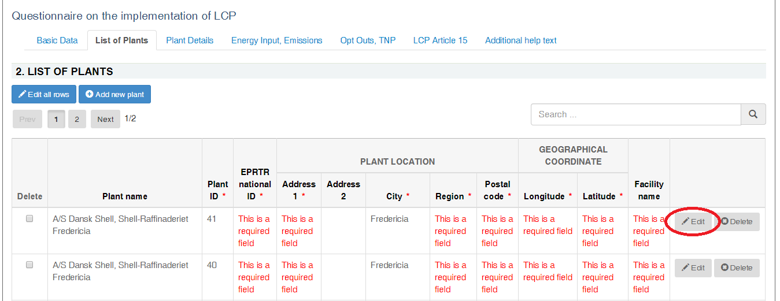

After clicking on "Edit" button a modal dialogue will be open with the data from selected row.

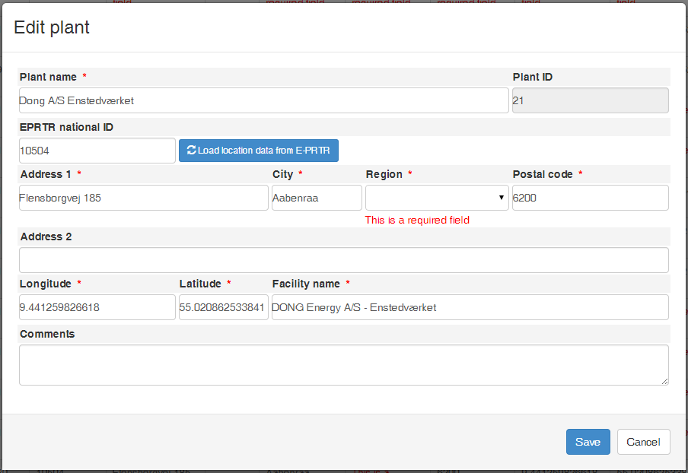

**Delete plants**

It is possible to delete plant rows only on "List of Plants" form. The deleting can be done one by one by using "Delete" buttons in right most column. The multiple plant rows can be deleted by using checkboxes in the left most column and clicking red "Delete selected" button under the table.

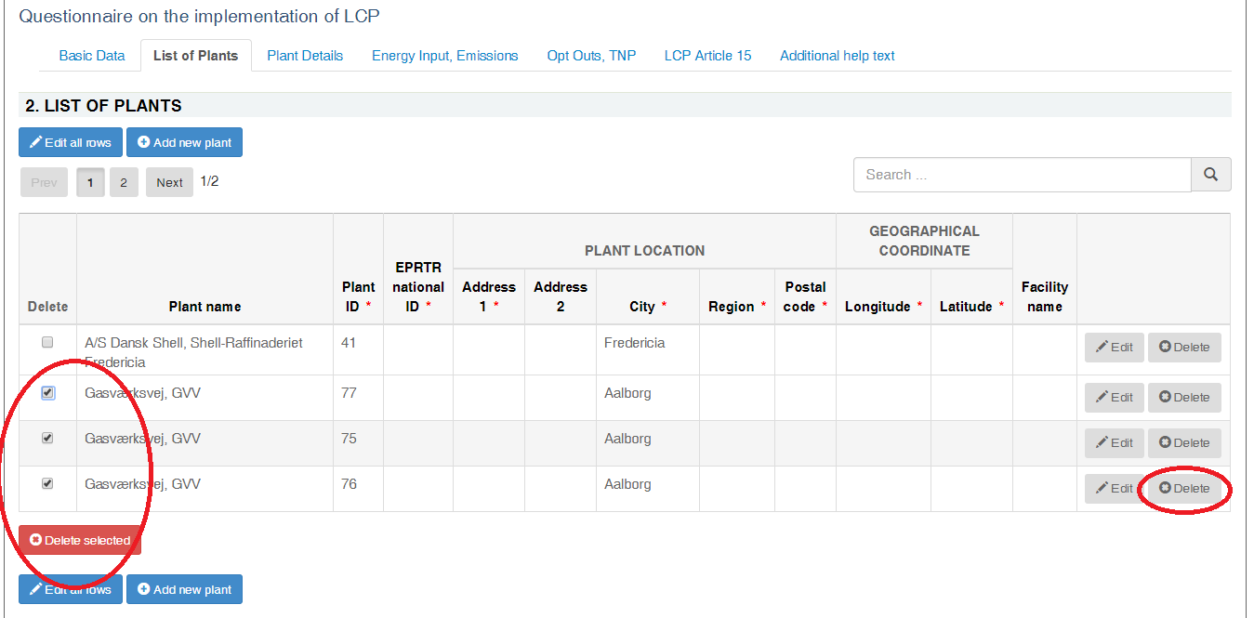

* **Step 6 Save data**

**NB! The online questionnaire does NOT save your changes automatically.** Inserted answers can be saved at any time by clicking on the “**Save**” button in the bottom of the page. The data is saved in XML file (LCP__1.xml) in CDR envelope. Green confirmation message appears in the right bottom corner if the saving was successful.

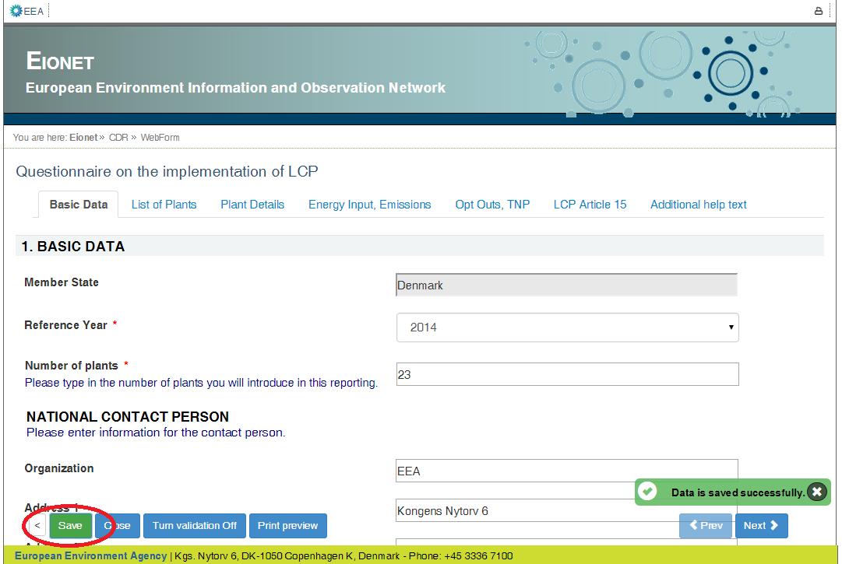

You don’t have to fill in all data at once. You can go back and modify the online questionnaire for completions or amendments later at any time in CDR:

* either by clicking on the “*Modify the LCP questionnaire"* link on envelope page
* or by clicking on the corresponding XML file name in the list of files and then clicking on the “*Edit with Web form*” link on document details page

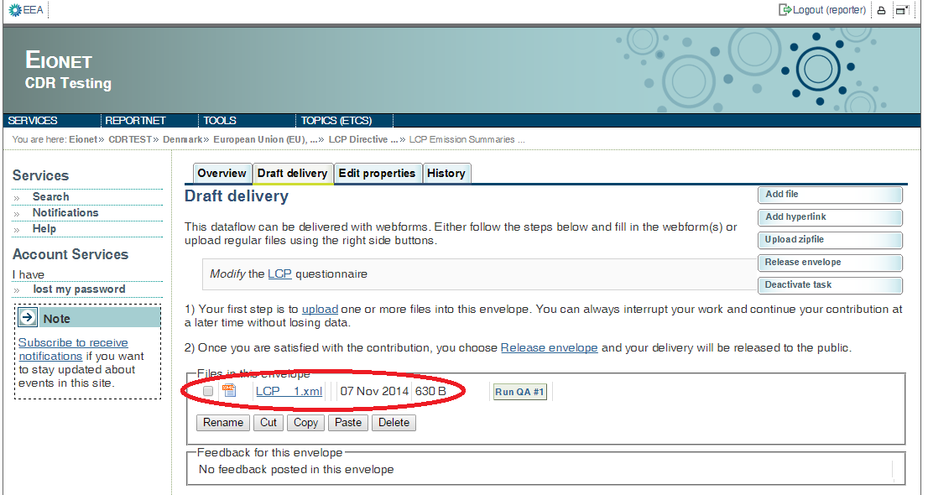

* **Step 7: Upload additional files**

You can upload and submit additional files in the envelope.

You can restrict the uploaded file from public view by ticking the box “*Restricted from public view*”.

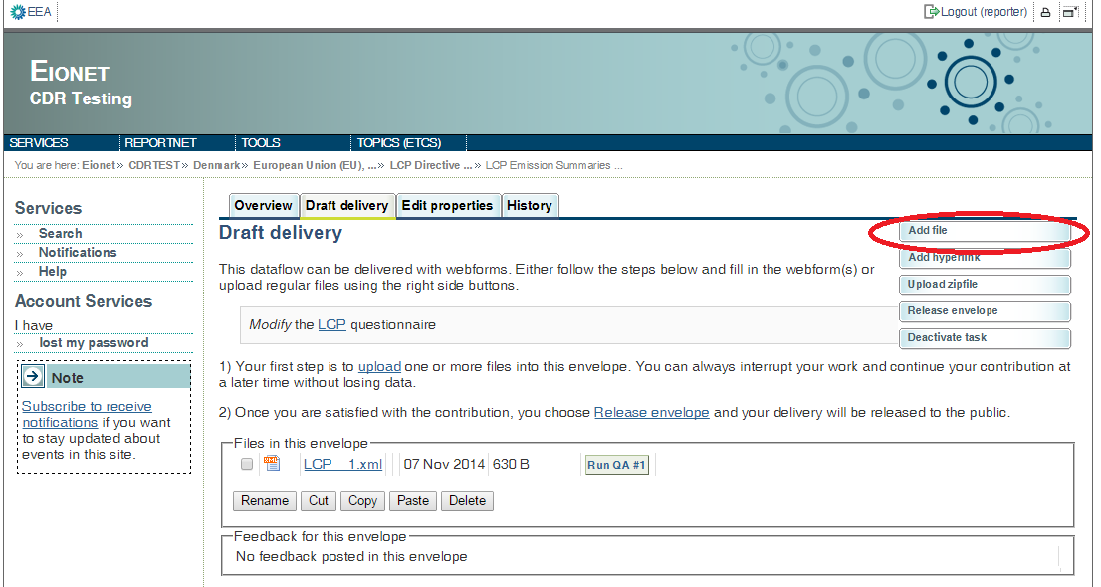

* **Step 8: Download or print out the report (optional)**

You can download or print out the report in CDR. This functionality is available on document details page. Click on the XML file name on CDR envelope to open the **Document details** page. All available formats are available at the top of the page in “View file as“ area.

Click on the “**HTML report**” link to download in HTML format or print the report.

Click on the “**Original**“ link to open the raw XML file in your browser.

The Document details page contains also a link to the online questionnaire. Just click on the link “*Edit file with Web form*” if you have found something to change or amend in the answers and you are able to edit all the answers.

"**Run QA #..**" button is available both on envelope page and document details page. This button initiates a technical validation of the file, which is a standard Reportnet functionality, but not needed for the general web forms-reporting.

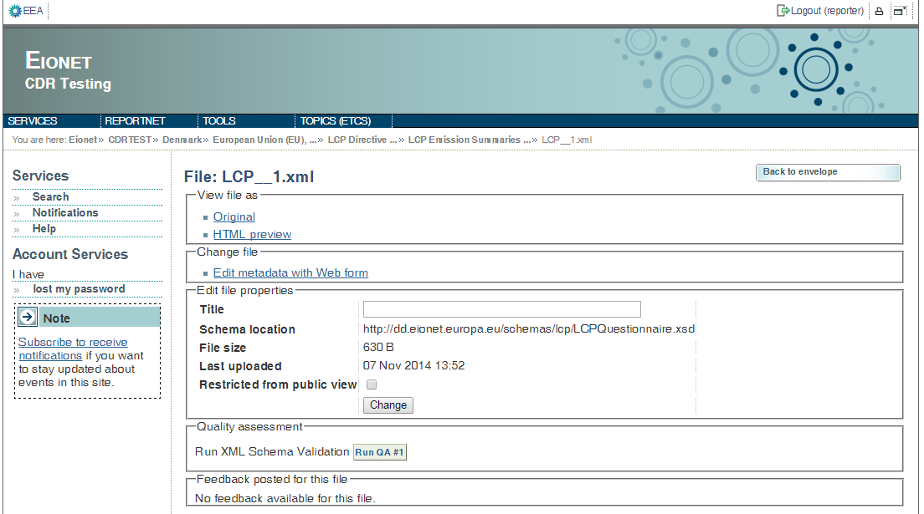

**Example of Print preview:**

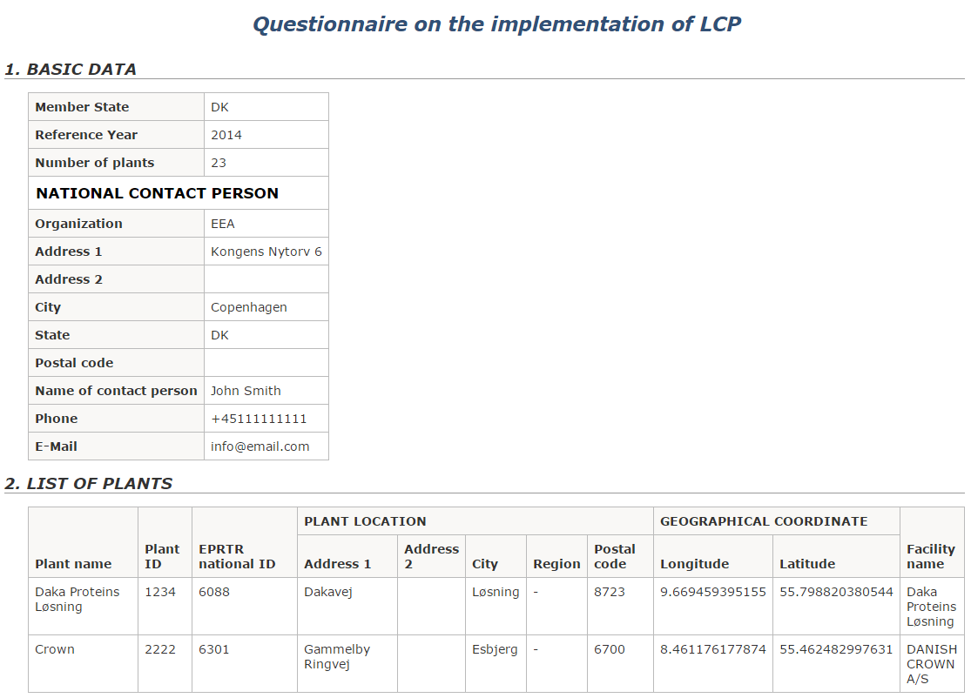

* **Step 9: Complete task**

When you finish the drafting of your work, you need to click on the right side button “**Release envelope**”.

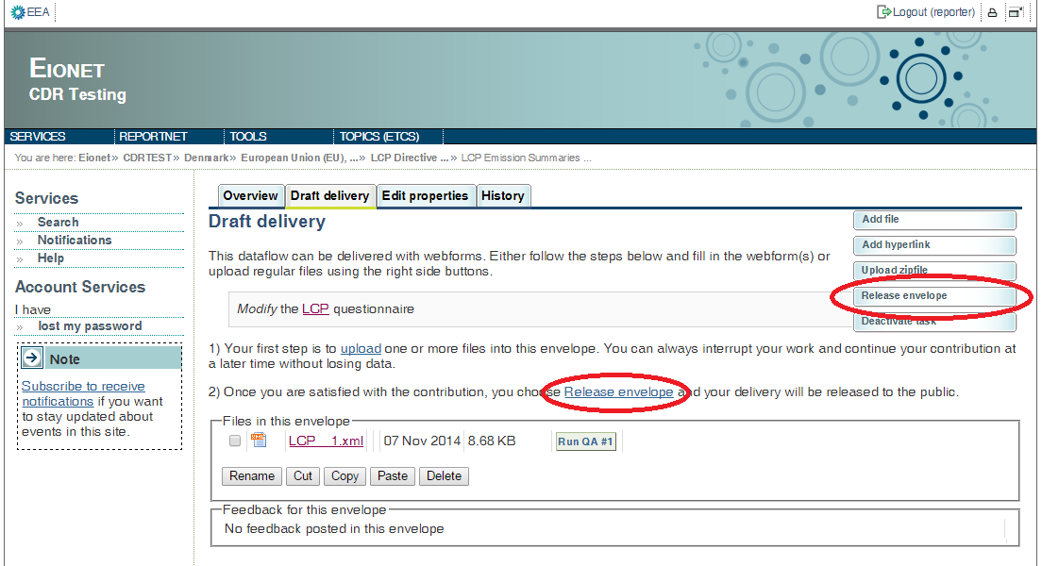

Now the report is submitted and received by the EU and the envelope is available to the public. After a few minutes, confirmation of receipt message and automatic feedback is stored automatically in the envelope's feedback area. Additional feedback might be provided by the Commission or EEA.

The result of the automatic quality assessment contains technical information about the validity of reported data and is useful for data receivers.

# Getting help

CDR help: <http://cdr.eionet.europa.eu/help>

|  |  |
| --- | --- |
| For technical assistance with access to CDR and the submission process.  Questions related to LCP emission summaries questionnaire reporting will be forwarded to the technical team. | [helpdesk@eionet.europa.eu](mailto:helpdesk@eionet.europa.eu) |