Supplementary material for:

The role of DNA-binding specificity in the evolution
of bacterial regulatory networks

Irma Lozada-Chávez, Vladimir Espinosa Angarica, Julio Collado-Vides and Bruno Contreras-Moreira

Supplementary methods

M1. Estimation of contact-based specificity
These are the steps followed to estimate the a priori binding specificity of a given transcription factor T based on its contact pattern:
- The most similar protein-DNA complex C in the Protein Data Bank (PDB) [28] is identified using PSI-BLAST[29] and the set of residues contacting nitrogen bases is defined, using the TFmodeller program with default parameters[30]. These contacting residues are considered to be the specific subset S of the complete protein-DNA interface.
- C is used to scan a 40% non-redundant library of protein-DNA complexes using MAMMOTH[31] with a log (e-value) cut-off of 4.5 in order to get a list L of structurally similar complexes.
- For every complex in L, residues in contact with DNA nitrogen bases are mapped to residues in T through MAMMOTH alignments. The complete set of L mapped residues is considered to be the non-specific subset NS of the protein-DNA interface in T. This step is very sensitive to the size of L, so we skipped cases in which the final NS set included fewer contacts than the mean minus one standard deviation, to exclude cases where the number of available similar complexes was no sufficient (12.9 contacts for E. coli and 12.4 for B. subtilis).
- We estimate the specificity of T as the ratio S/ (NS+S), such as in the work of Luscombe and Thornton [32].
Following these steps we were able to estimate specificities for 49 TFs in E. coli and for 33 TFs in B. subtilis.

Supplementary tables

Table S1. Transcriptional regulatory interactions of Escherichia coli K12 from RegulonDB release version 5.5 (http://regulondb.ccg.unam.mx/) and for Bacillus subtilis from DBTBS release version 4.1 (http://dbtbs.hgc.jp/).

k: Total number of regulated genes by a transcription factor (TF) with known DNA binding sites.
n: Total number of DNA binding sites that have been characterized for a TF.

Escherichia coli  RegulonDB version 5.5 |  |  |  | Bacillus subtilis  DBTBS version 4.1
Transcription Factor | k  # genes | n  # bsDNA |  | Transcription Factor | k  # genes | n  # bsDNA
crp|16131236|b3357 | 276 | 207 |  | comK|16078106|BG11059 | 47 | 120
fis|16131149|b3261 | 76 | 121 |  | phoP|16079963|BG10363 | 35 | 65
ihf|1788005|b1712 | 160 | 78 |  | ccpA|16080026|BG10376 | 97 | 48
arcA|16132218|b4401 | 92 | 77 |  | mtrB|16079334|BG10278 | 4 | 41
narL|16129184|b1221 | 81 | 76 |  | spoIIID|16080695|BG10408 | 11 | 39
fnr|16129295|b1334 | 135 | 75 |  | spo0A|16079478|BG10765 | 12 | 38
lrp|16128856|b0889 | 59 | 54 |  | degU|16080602|BG10393 | 19 | 37
fur|16128659|b0683 | 36 | 47 |  | tnrA|16078396|BG11805 | 31 | 37
h-ns|1787489|b1237 | 45 | 34 |  | abrB|16077105|BG10100 | 72 | 34
cpxR|16131752|b3912 | 10 | 33 |  | codY|16078680|BG10968 | 29 | 34
lexA|16131869|b4043 | 14 | 23 |  | gerE|16079893|BG10355 | 20 | 31
metJ|16131776|b3938 | 10 | 23 |  | fur|16079409|BG11766 | 34 | 26
ompR|16131282|b3405 | 14 | 20 |  | purR|16077115|BG10110 | 22 | 24
argR|16131127|b3237 | 22 | 18 |  | dnaA|16077069|BG10065 | 2 | 16
flhD|49176166|b1892 | 26 | 18 |  | spoVT|16077124|BG10119 | 15 | 16
glpR|16131297|b3423 | 8 | 18 |  | hpr|16078063|BG10659 | 14 | 14
phoP|16129093|b1130 | 2 | 18 |  | perR|16081061|BG12227 | 12 | 13
soxS|16131888|b4062 | 20 | 18 |  | cssR|16080354|BG14131 | 3 | 12
phoB|16128384|b0399 | 31 | 17 |  | glnR|16078808|BG10424 | 8 | 12
tyrR|16129284|b1323 | 10 | 17 |  | resD|16079369|BG10534 | 13 | 12
marA|16129490|b1531 | 14 | 16 |  | sinR|16079517|BG10754 | 6 | 12
purR|16129616|b1658 | 27 | 16 |  | ylbO|16078573|BG13367 | 2 | 12
malT|16131294|b3418 | 10 | 15 |  | araR|16080450|BG11913 | 12 | 11
narP|16130130|b2193 | 21 | 14 |  | rocR|16081087|BG10723 | 3 | 11
araC|16128058|b0064 | 7 | 13 |  | comA|16080219|BG10381 | 10 | 10
fruR|16128073|b0080 | 25 | 12 |  | ctsR|16077151|BG10145 | 11 | 10
cytR|16131772|b3934 | 10 | 10 |  | glpP|16077992|BG10185 | 5 | 10
fadR|16129150|b1187 | 7 | 10 |  | lexA|16078848|BG10678 | 4 | 10
gntR|49176356|b3438 | 9 | 10 |  | rok|16078488|BG13307 | 1 | 10
iclR|16131844|b4018 | 3 | 10 |  | ccpC|16078478|BG13297 | 2 | 9
nac|16129930|b1988 | 10 | 10 |  | citT|16077826|BG12577 | 1 | 8
nagC|16128652|b0676 | 9 | 10 |  | fnr|16080784|BG11343 | 8 | 8
trpR|16132210|b4393 | 11 | 10 |  | yycF|16081093|BG10001 | 4 | 8
oxyR|16131799|b3961 | 12 | 9 |  | pucR|16080295|BG13983 | 15 | 7
cysB|16129236|b1275 | 17 | 8 |  | deoR|16080994|BG10982 | 1 | 6
dnaA|16131570|b3702 | 8 | 8 |  | ydiH|16077664|BG12205 | 4 | 6
iscR|16130456|b2531 | 3 | 8 |  | ahrC|16079481|BG10309 | 7 | 5
deoR|16128808|b0840 | 6 | 7 |  | cggR|16080448|BG14085 | 1 | 5
galR|16130741|b2837 | 5 | 7 |  | iolR|16081028|BG11364 | 3 | 5
galS|16130089|b2151 | 3 | 7 |  | mta|16080713|BG12482 | 4 | 5
mlc|16129552|b1594 | 8 | 7 |  | citR|16078008|BG10853 | 1 | 4
melR|16131944|b4118 | 2 | 6 |  | gltR|16079720|BG11942 | 1 | 4
modE|16128729|b0761 | 35 | 6 |  | hrcA|16079603|BG10662 | 2 | 4
rob|16132213|b4396 | 8 | 6 |  | paiA|16080268|BG10695 | 1 | 4
torR|16128961|b0995 | 10 | 6 |  | paiB|16080267|BG10696 | 1 | 4
caiF|49175992|b0034 | 10 | 4 |  | pyrR|16078611|BG10712 | 1 | 4
fhlA|16130638|b2731 | 26 | 4 |  | tenA|16078230|BG10791 | 4 | 4
gcvA|16130715|b2808 | 3 | 4 |  | xre|16078316|BG10994 | 4 | 4
metR|16131677|b3828 | 3 | 4 |  | ykmA|16078380|BG13239 | 1 | 4
rhaS|16131745|b3905 | 4 | 4 |  | adaA|16077249|BG10166 | 2 | 3
xylR|16131440|b3569 | 5 | 4 |  | bkdR|16079466|BG11721 | 7 | 3
ada|16130150|b2213 | 4 | 3 |  | gltC|16078907|BG10810 | 2 | 3
dcuR|16131950|b4124 | 7 | 3 |  | levR|16079762|BG10677 | 1 | 3
idnR|16132086|b4264 | 4 | 3 |  | yufM|16080205|BG12348 | 3 | 3
lacI|49176012|b0345 | 3 | 3 |  | zur|16079565|BG11668 | 3 | 3
pspF|49176097|b1303 | 6 | 3 |  | acoR|16077877|BG11790 | 4 | 2
uxuR|16132145|b4324 | 2 | 3 |  | ccpB|16081139|BG10045 | 2 | 2
cbl|16129929|b1987 | 4 | 2 |  | fruR|16078502|BG12589 | 2 | 2
cynR|16128323|b0338 | 3 | 2 |  | gabR|16077457|BG12042 | 2 | 2
exuR|16130989|b3094 | 3 | 2 |  | gutR|16077681|BG10178 | 2 | 2
ilvY|16131631|b3773 | 1 | 2 |  | licT|16080959|BG10474 | 2 | 2
malI|16129578|b1620 | 2 | 2 |  | lytR|16080618|BG10404 | 3 | 2
paaX|16129360|b1399 | 12 | 2 |  | mntR|16079508|BG11702 | 5 | 2
rhaR|16131746|b3906 | 1 | 2 |  | sacT|16080858|BG10593 | 4 | 2
slyA|16129600|b1642 | 1 | 2 |  | sacY|16080893|BG10559 | 1 | 2
treR|16132063|b4241 | 2 | 2 |  | treR|16077849|BG11011 | 1 | 2
uhpA|16131539|b3669 | 1 | 2 |  | xylR|16078822|BG11986 | 2 | 2
xapR|16130331|b2405 | 2 | 2 |  | yfhP|16077928|BG12890 | 1 | 2
betI|49176011|b0313 | 3 | 1 |  | yocG|16078980|BG13520 | 1 | 2
birA|16131807|b3973 | 5 | 1 |  | ywfK|16080817|BG10635 | 2 | 2
cusR|16128554|b0571 | 4 | 1 |  | arsR|16079634|BG11301 | 3 | 1
evgA|16130301|b2369 | 1 | 1 |  | azlB|16079725|BG11914 | 4 | 1
fecI|16132114|b4293 | 6 | 1 |  | birA|16079301|BG11206 | 7 | 1
glcC|16130880|b2980 | 5 | 1 |  | bltR|16079711|BG10904 | 2 | 1
hyfR|49176231|b2491 | 10 | 1 |  | bmrR|50812267|BG10304 | 1 | 1
kdpE|16128670|b0694 | 3 | 1 |  | exuR|16078302|BG13211 | 1 | 1
lrhA|16130224|b2289 | 2 | 1 |  | glcT|16078452|BG12593 | 3 | 1
mhpR|16128331|b0346 | 6 | 1 |  | hxlR|16077416|BG11184 | 2 | 1
nhaR|16128014|b0020 | 2 | 1 |  | kdgR|16079270|BG11398 | 3 | 1
rbsR|16131621|b3753 | 5 | 1 |  | kipR|16077477|BG11214 | 6 | 1
soxR|16131889|b4063 | 1 | 1 |  | lacR|16080470|BG12435 | 5 | 1
tdcA|16131011|b3118 | 6 | 1 |  | licR|16080911|BG11346 | 1 | 1
tdcR|16131012|b3119 | 7 | 1 |  | lmrA|16077337|BG12612 | 1 | 1
yiaJ|16131445|b3574 | 9 | 1 |  | lrpA|16077572|BG12122 | 1 | 1
zraR|16131834|b4004 | 2 | 1 |  | lrpB|16077573|BG12123 | 1 | 1
 |  |  |  | med|50812218|BG13126 | 1 | 1
 |  |  |  | tenI|16078231|BG10792 | 1 | 1
 |  |  |  | xpf|16078321|BG10998 | 10 | 1
 |  |  |  | yfiA|16077886|BG11847 | 1 | 1
 |  |  |  | 89 TFs | 726 | 940
85 TFs | 1593 | 1314

Table S2. Paralogous groups after assigning SUPERFAMILY and PFAM domains (see Materials and Methods), including 151 transcription factors of Escherichia coli.

† Gene(s) that belongs to other PFAM group [not shown].
* PFAM group that include more gene members than their SFAM family [not shown].
Ψ PFAM group that is shared with other SFAM family.
Transcription factor genes

SFAM domain-# | PFAM  domain-# | # genes | # TFs | Members

Groups of orthologous TFs formed by congruence in domains and total members
46689-1  46767-1  53155-1  57884-1 | PF00165.12-2  PF01035.11-1  PF02805.5-1  PF02870.6-1 | 1 | 1 | 16130150|b2213|ada
46689-1  52540-1  55021-1  55785-1 | PF00158.16-1  PF01842.14-1 | 1 | 1 | 16129284|b1323|tyrR
46689-1  52540-1  55781-2 | PF00158.16-1  PF01590.15-1  PF02954.9-1  PF07728.4-1 | 1 | 1 | 16130638|b2731|fhlA
46785-1  50037-1  55681-1 | PF02237.6-1  PF03099.9-1  PF08279.1-1 | 1 | 1 | 16131807|b3973|birA
46785-1  48008-1 | PF00392.11-1  PF07840.2-1 | 1 | 1 | 16129150|b1187|fadR
46785-1  50331-2 | PF00126.16-1  PF03459.7-2 | 1 | 1 | 16128729|b0761|modE
46785-1  51306-1 | PF00717.13-1  PF01726.7-1 | 1 | 1 | 16131869|b4043|lexA
46785-1  55252-1 | PF01316.12-1  PF02863.9-1 | 1 | 1 | 16131127|b3237|argR
48295-1  52540-1 | PF00308.8-1  PF08299.1-1 | 1 | 1 | 16131570|b3702|dnaA
47598-1 | PF01340.10-1 | 1 | 1 | 16131776|b3938|metJ
48295-1 | PF01371.10-1 | 1 | 1 | 16132210|b4393|trpR
63592-1 | PF05247.3-1 | 1 | 1 | 49176166|b1892|flhD

Groups of paralogous TFs formed by congruence in domains and total members
47413-1  53822-1 | PF00356.11-1  PF00532.11-1 | 14 | 11 | 16128073|b0080|fruR 16129281|b1320|ycjW 16129578|b1620|malI 16129616|b1658|purR 16130089|b2151|galS 16130621|b2714|ascG 16130741|b2837|galR 16130970|b3075|ebgR 16131621|b3753|rbsR 16131772|b3934|cytR 16132063|b4241|treR 16132086|b4264|idnR 49176012|b0345|lacI 49176356|b3438|gntR
46785-1  55781-1 | PF01614.9-1 | 8 | 3 | 16128257|b0272|yagI 16128331|b0346|mhpR 16128490|b0506|allR 16129781|b1827|kdgR 16130183|b2248|yfaX 16131445|b3574|yiaJ 16132120|b4299|yjhI 90111675|b4018|iclR
46785-1  54909-1 | PF01037.10-1 | 3 | 1 | 16128856|b0889|lrp 16131611|b3743|asnC 90111137|b0447|ybaO
46785-1  51206-1 | PF00027.18-1  PF00325.11-1 | 2 | 2 | 16129295|b1334|fnr 16131236|b3357|crp
47729-1 | PF00216.11-1 | 4 | 1 | 16128425|b0440|hupB 16128879|b0912|ihfB 16129668|b1712|ihfA 16131830|b4000|hupA
81273-2 | PF00816.10-1 | 2 | 1 | 16129198|b1237|hns 16130583|b2669|stpA

Groups of paralogous TFs formed by congruence in domains and TF members
46689-1  52172-1  52540-1 | PF00072.13-1  PF00158.16-1  PF02954.9-1 PF07728.4-1 | 3 | 1 | 16131708|b3868|glnG 16131834|b4004|zraR  †16130157|b2220|atoC
46785-1  53850-1 | PF00126.16-1  PF03466.9-1 | 45 | 12 | 16128014|b0020|nhaR 16128195|b0208|yafC 16128239|b0254|perR 16128301|b0316|yahB 16128323|b0338|cynR 16128488|b0504|ybbS 16128867|b0900|ycaN 16129236|b1275|cysB 16129289|b1328|ycjZ 16129300|b1339|abgR 16129485|b1526|yneJ 16129553|b1595|ynfL 16129617|b1659|ydhB 16129929|b1987|cbl 16129930|b1988|nac 16130095|b2157|yeiE 16130224|b2289|lrhA 16130296|b2364|dsdC 16130331|b2405|xapR 16130335|b2409|yfeR 16130462|b2537|hcaR 16130715|b2808|gcvA 16130743|b2839|lysR 16130817|b2916|argP 16130956|b3060|ygiP 16131000|b3105|yhaJ 16131011|b3118|tdcA 16131133|b3243|aaeR 16131393|b3521|yhjC 16131456|b3585|yiaU 16131579|b3711|yidZ 16131631|b3773|ilvY 16131677|b3828|metR 16131799|b3961|oxyR 16132148|b4327|yjiE 49176046|b0768|ybhD 49176402|b4480|hdfR 90111083|b0076|leuO 90111155|b0629|ybeF 90111269|b1422|ydcI 90111335|b1799|yeaT 90111371|b2015|yeeY 90111462|b2577|yfiE 90111513|b2921|ygfI  †16128586|b0603|ybdO
88659-1  88946-1 | PF04542.4-1  PF04545.5-1  PF08281.1-1 | 3 | 1 | 16132114|b4293|fecI  †16130498|b2573|rpoE 16131333|b3461|rpoH
46689-2  55136-1 | PF00165.12-2  PF06445.5-1 | 2 | 1 | 16132213|b4396|rob  †90111109|b0300|ykgA
46689-1  52540-1 | PF00158.16-1  PF02954.9-1  PF07728.4-1 | 2 | 1 | 90111246|b1303|pspF  †16128315|b0330|prpR
52540-1  55781-1 | PF00158.16-1  PF01590.15-1  PF02954.9-1 | 2 | 1 | 90111447|b2491|hyfR  †90111481|b2709|norR
100950-1  46785-1 | PF00455.13-1  PF08220.3-1  PF08279.1-1 | 9 | 1 | 16129245|b1284|yciT 16130614|b2707|srlR 16130642|b2735|ygbI 16130712|b2805|fucR 16131023|b3131|agaR 16131297|b3423|glpR 90111660|b3884|yihW  †16132013|b4191|ulaR 16129724|b1770|ydjF
46894-1  48452-1 | PF00196.10-1 | 2 | 1 | 16131294|b3418|malT  †16130756|b2852|ygeH
100950-1 | PF00455.13-1  PF08220.3-1 | 9 | 1 | *16128808|b0840|deoR 16132121|b4300|sgcR  †16128598|b0615|citF 16128654|b0678|nagB 16130158|b2221|atoD 16130159|b2222|atoA 16131033|b3141|agaI 49176282|b2912|ygfA 49176397|b3718|yieK
46955-1 | PF00376.13-1 | 10 | 1 | 16128471|b0487|cueR 16129125|b1162|ycgE 16130065|b2127|mlrA 16131171|b3292|zntR 16131889|b4063|soxR  †16128543|b0560|nohB 16129104|b1141|ymfG 16129507|b1548|nohA 16130329|b2399|yfeD 90111429|b2398|yfeC
53067-2 | PF00480.10-1 | 25 | 2 | 16128652|b0676|nagC 16129552|b1594|dgsA 16131910|b4084|alsK 90111457|b2550|yphH 90111558|b3222|nanK  †16128057|b0063|araB 16128087|b0094|ftsA 16129082|b1119|nagK 16129761|b1807|yeaZ 16130231|b2296|ackA 16130320|b2388|glk 16130379|b2454|eutJ 16130427|b2502|ppx 16130683|b2776|ygcE 16130710|b2803|fucK 16131008|b3115|tdcD 16131435|b3564|xylB 16131451|b3580|lyxK 16131744|b3904|rhaB 16131764|b3926|glpK 49176118|b1511|lsrK 49176408|b3779|gpp 90111128|b0394|mak 90111380|b2069|yegD 90111564|b3251|mreB

Groups of paralogous TFs formed by groups of domains and same TF members
46894-1  52172-1 | PF00072.13-1  PF00196.10-1  PF04545.5-1  PF08281.1-1  PF00072.13-1  PF00196.10-1 | 10 | 4 | 16129184|b1221|narL  16128519|b0535|fimZ 16129861|b1914|uvrY 16130130|b2193|narP 16130154|b2217|rcsB 16130301|b2369|evgA 16131539|b3669|uhpA  †16129566|b1608|rstA 16132215|b4398|creB 90111499|b2855|ygeK
52172-1 | PF00072.13-1  PF00486.18-1  PF00072.13-1 | 18 | 9 | *Ψ16128384|b0399|phoB 16128554|b0571|cusR 16128670|b0694|kdpE 16128961|b0995|torR 16129093|b1130|phoP 16130019|b2079|baeR 16130313|b2381|ypdB 16130921|b3025|qseB 16131282|b3405|ompR 16131752|b3912|cpxR 16131939|b4113|basR 16132218|b4401|arcA 90111362|b1969|yedW 90111392|b2125|yehT  16128603|b0620|citB 16129196|b1235|rssB 16129834|b1882|cheY 16131950|b4124|dcuR
46785-1 | PF01475.9-1  PF01047.13-1  PF02082.9-1  PF00392.11-1  PF07729.1-1 | 30 | 6 | 16128659|b0683|fur 90111679|b4046|zur  16130596|b2684|mprA 90111289|b1530|marR 90111310|b1642|slyA  16130456|b2531|iscR 16132000|b4178|yjeB  16128106|b0113|pdhR 16129499|b1540|ydfH 16130880|b2980|glcC 16131475|b3604|lldR 16132145|b4324|uxuR 49176329|b3226|nanR 49176392|b4479|dgoR 49176401|b3755|yieP 90111276|b1450|yncC 90111478|b2664|csiR 90111537|b3094|exuR  †16129112|b1149|ymfN 16130581|b2667|ygaV 16130966|b3071|yqjI 16131373|b3501|arsR 49176497|b4357|yjjM 90111706|b4212|ytfH 16128705|b0730|mngR 16130039|b2101|yegW 16131552|b3684|yidP 16131712|b3872|yihL 16131928|b4102|phnF 90111578|b3375|frlR
46689-1 | PF02954.9-1  PF00440.13-1 | 18 | 2 | 16131149|b3261|fis  16128814|b0846|ybjK 16131801|b3963|fabR 49176011|b0313|betI  90111712|b4251|yjgJ  †16128529|b0546|ybcM 16128547|b0564|appY 16129345|b1384|feaR 16131387|b3515|gadW 16128549|b0566|envY 16129458|b1499|ydeO 16130362|b2437|yfeG 16131388|b3516|gadX 16131428|b3557|insJ 16131792|b3954|yijO 16131942|b4116|adiY 90111143|b0502|ylbG 90111689|b4135|yjdC

Groups of paralogous TFs formed by preference in SFAM domains and TF members
46689-1  47454-1  51182-1 | PF00165.12-2 | 1 | 1 | *Ψ16131944|b4118|melR
46689-1  53822-1 | PF00165.12-2 | 1 | 1 | *Ψ16131440|b3569|xylR
46689-2  51182-1 | PF00165.12-2  PF02311.9-1 | 2 | 1 | *Ψ16131746|b3906|rhaR  †16129652|b1696|ydiP
46689-2  51215-1 | PF00165.12-2  PF02311.9-1 | 2 | 2 | *Ψ16128058|b0064|araC 16131745|b3905|rhaS
46689-2 | PF00165.12-2 | 6 | 2 | *Ψ16128290|b0305|ykgD 16130314|b2382|ypdC 16131550|b3680|yidL 16131888|b4062|soxS 90111290|b1531|marA  †90111526|b3010|yqhC

Groups of paralogous TFs only formed by PFAM domains
 | PF07848.2-1  PF08223.1-1 | 1 | 1 | 16129360|b1399|paaX

Table S3. Paralogous groups after assigning SUPERFAMILY and PFAM domains (see Materials and Methods), including 93 transcription factors of Bacillus subtilis.

† Gene(s) that belongs to other PFAM group [not shown].
* PFAM group that include more gene members than their SFAM family [not shown].
Ψ PFAM group that is shared with other SFAM family.
Transcription factor genes

SFAM domain-# | PFAM  domain-# | # genes | # TFs | Members

Groups of orthologous TFs formed by congruence in domains and total members
46689-1 51735-1 52540-1 55785-2 | PF00158.16-1 PF00989.13-2 PF02954.9-1 PF08448.1-2 | 1 | 1 | 16079466|BG11721|bkdR
46785-1 52540-1 53062-1 63520-2 | PF00004.19-1 PF00158.16-1 PF00874.9-2 PF03610.5-1 | 1 | 1 | 16079762|BG10677|levR
46785-2 52794-1 55804-1 63520-2 | PF00359.11-1 PF00874.9-2 PF05043.3-1 PF08279.1-2 | 1 | 1 | 16080911|BG11346|licR
46689-1 52540-1 55781-1 | PF00158.16-1 PF01590.15-1 PF02954.9-1 PF07728.4-1 | 1 | 1 | 16077877|BG11790|acoR
46689-1 52540-1 55785-1 | PF00158.16-1 PF02954.9-1 PF07726.1-1 PF07728.4-1 | 1 | 1 | 16081087|BG10723|rocR
46689-2 57884-1 | PF00165.12-2 PF02805.5-1 | 1 | 1 | 16077249|BG10166|adaA
46785-1 47979-1 | PF01325.9-1 PF02742.5-1 | 1 | 1 | 16079508|BG11702|mntR
46785-1 51206-1 | PF00027.18-1 PF00325.11-1 | 1 | 1 | 16080784|BG11343|fnr
46785-1 51306-1 | PF00717.13-1 PF01726.7-1 | 1 | 1 | 16078848|BG10678|lexA
46785-1 51735-1 | PF02629.8-1 PF06971.3-1 | 1 | 1 | 16077664|BG12205|ydiH
46785-1 53822-1 | PF00392.11-1 PF00532.11-1 | 1 | 1 | 16080450|BG11913|araR
46785-1 55252-1 | PF01316.12-1 PF02863.9-1 | 1 | 1 | 16079481|BG10309|ahrC
46785-1 55681-1 | PF02237.6-1 PF03099.9-1 PF08279.1-1 | 1 | 1 | 16079301|BG11206|birA
46955-1 89082-1 | PF00376.13-1 PF07739.3-1 | 1 | 1 | 16080713|BG12482|mta
48295-1 52540-1 | PF00308.8-1 PF08299.1-1 | 1 | 1 | 16077069|BG10065|dnaA
46894-1 | PF00196.10-1 PF04545.5-1 PF08281.1-1 | 1 | 1 | 16079893|BG10355|gerE
48613-1 | PF03070.5-1 | 1 | 1 | 16078230|BG10791|tenA
51219-1 | PF02081.5-1 | 1 | 1 | 16079334|BG10278|mtrB
110391-1 | PF04309.2-1 | 1 | 1 | 16077992|BG10185|glpP

Groups of paralogous TFs formed by congruence in domains and total members
46785-1 53850-1 | PF00126.16-1 PF03466.9-1 | 19 | 6 | 16077386|BG12009|ycgK 16077430|BG12022|yclA 16078008|BG10853|citR 16078478|BG13297|ccpC 16078903|BG13552|yofA 16078907|BG10810|gltC 16078936|BG13491|yoaU 16079716|BG12288|yrdQ 16079720|BG11942|gltR 16079740|BG12278|yraN 16079992|BG13877|ytlI 16080344|BG14032|yusT 16080452|BG14087|yvbU 16080655|BG10470|alsR 16080669|BG12517|ywqM 16080817|BG10635|ywfK 16080882|BG10570|ywbI 16080939|BG11898|yxjO 16081119|BG10026|yybE
50151-1 63520-2 | PF00874.9-2 PF03123.5-1 | 4 | 4 | 16078452|BG12593|glcT 16080858|BG10593|sacT 16080893|BG10559|sacY 16080959|BG10474|licT
51391-1 | PF02581.6-1 | 2 | 1 | 16078231|BG10792|tenI 16080880|BG10572|thiE

Groups of paralogous TFs formed by congruence in domains and TF members
46689-1 48498-1 | PF00440.13-1 | 10 | 1 | *16077337|BG12612|lmrA 16077599|BG12146|ydeS 16077625|BG12170|ydgC 16077904|BG12894|yfiR 16078079|BG10432|yhgD 16080411|BG14062|yvaF 16080501|BG12428|yvdT 16081051|BG11108|yxaF 50812197|BG14194|yezE  †16079907|BG12330|ysiA
46785-1 53383-1 | PF00155.11-1 PF00392.11-1 | 6 | 1 | *16077457|BG12042|gabR 16077585|BG12133|ydeF 16077591|BG12139|ydeL 16077604|BG12151|ydfD 16078013|BG13015|yhdI 50812213|BG13101|yisV
55729-1 | PF00583.14-1 | 48 | 1 | 16077488|BG12054|ydaF 16077602|BG12149|ydfB 16077627|BG12172|ydgE 16077644|BG12186|ydhI 16077660|BG12201|ydiD 16077759|BG11809|yesJ 16077811|BG12962|yfmK 16078014|BG13016|yhdJ 16078095|BG13059|yhfO 16078163|BG13113|yitH 16078164|BG13114|yitI 16078249|BG13159|yjcF 16078254|BG13164|yjcK 16078269|BG13179|yjdG 16078373|BG11421|ykkB 16078574|BG13368|ylbP 16078815|BG12256|ynaD 16078914|BG13472|yoaA 16078929|BG13486|yoaP 16078966|BG13509|yobR 16079033|BG11197|cgeE 16079214|BG13579|yokL 16079381|BG10522|ribT 16079426|BG11754|yqjY 16079698|BG11780|yrkN 16079713|BG10906|bltD 16079885|BG12336|ysnE 16079991|BG13883|ytmI 16080021|BG10369|acuA 16080268|BG10695|paiA 16080442|BG14084|yvbK 16080709|BG12486|ywnH 16080839|BG10612|spsD 16081002|BG11888|yxeL 16081038|BG11354|yxbD 16081081|BG11467|yycN 16081120|BG10027|yybD 16081124|BG10031|yyaT 16081126|BG10033|yyaR  †16077239|BG11571|ybbJ 16078214|BG13132|yjbC 16078458|BG12252|ykwB 16078532|BG13331|ykzC 16078976|BG13516|yocC 16079028|BG13543|yodP 16079424|BG11756|yqkA 16080152|BG13948|yuaI 16080749|BG10938|ywlB
48452-1 | PF00515.17-1 PF00931.12-1 PF05729.2-1 PF07719.6-1 | 16 | 1 | 16077681|BG10178|gutR  †16077351|BG12663|rapJ 16077568|BG12119|rapI 16077751|BG11031|rapH 16078308|BG10652|rapA 16078951|BG12664|rapK 16079316|BG11496|ypiA 16079543|BG11683|yqgP 16079636|BG11299|rapE 16079802|BG13788|yrrB 16079876|BG12338|ysoA 16080534|BG12396|yvcD 16080691|BG11967|rapD 16080722|BG11965|rapB 16080798|BG11968|rapF 16081082|BG11466|rapG
53067-2 | PF00480.10-1 | 16 | 1 | 16077653|BG12195|ydhR 16078822|BG11986|xylR 16079541|BG11685|glcK  †16077659|BG12200|ydiC 16077994|BG10187|glpK 16078511|BG10987|mreBH 16078592|BG10231|ftsA 16078824|BG10807|xylB 16078916|BG13474|yoaC 16079463|BG11724|buk 16079855|BG10326|mreB 16079931|BG11905|araB 16079999|BG10813|ackA 16080172|BG12385|yulC 16081058|BG10649|gntK 50812298|BG10916|mbl
53697-1 | PF01380.12-1 PF01418.8-1 | 6 | 1 | 16077237|BG11569|ybbH 16077886|BG11847|yfiA  †16077238|BG11570|ybbI 16077414|BG11182|hxlB 16080187|BG12366|pgi 16080314|BG14002|yurP
88659-1 | PF04545.5-1 PF08281.1-1 | 5 | 1 | 16078321|BG10998|xpf 16080376|BG14147|yvrI  †16078660|BG10829|ylxM 16079692|BG10919|spoIIIC 16078258|BG13168|yjcO
89447-1 | PF04014.8-1 | 4 | 2 | 16077105|BG10100|abrB 16077124|BG10119|spoVT 16078512|BG10988|abh  †16078577|BG11425|yllB
53822-1 | PF02608.4-1 | 3 | 1 | 16080206|BG12349|yufN 50812218|BG13126|med  †16080649|BG10881|rbsB

Groups of paralogous TFs formed by groups of domains and same TF members
46894-1 52172-1 | PF00072.13-1 PF00196.10-1  PF00072.13-1 PF00196.10-1 PF08281.1-1  PF00072.13-1  PF00072.13-1  PF00486.18-1 | 12 | 5 | 16077269|BG12723|ybdJ 16080219|BG10381|comA 16080361|BG14133|yvqC 16080459|BG12446|yvfU 16080602|BG10393|degU 16080942|BG11895|yxjL  16077998|BG13006|yhcZ 16078980|BG13520|yocG  *Ψ16079478|BG10765|spo0A  *Ψ16080354|BG14131|cssR  †16077609|BG12156|ydfI 16077897|BG12216|yfiK
47413-1 53822-1 | PF00356.11-1 PF00532.11-1  PF00356.11-1 | 11 | 5 | 16078120|BG13079|yhjM 16078147|BG10847|degA 16078302|BG13211|exuR 16078451|BG13327|ykvZ 16079270|BG11398|kdgR 16080026|BG10376|ccpA 16080078|BG12626|msmR 16080516|BG12414|yvdE 16080644|BG10876|rbsR 16081139|BG10045|ccpB  16080470|BG12435|lacR
46785-1 55781-1 | PF01614.9-1  PF01628.11-1 | 2 | 2 | 16077477|BG11214|kipR  16079603|BG10662|hrcA
100950-1 46785-1 | PF00455.13-1 PF08220.3-1  PF00455.13-1 PF08220.3-1 PF08279.1-1 | 4 | 2 | 16078502|BG12589|fruR 16080173|BG12384|yulB  16080683|BG12503|glcR 16081028|BG11364|iolR
52172-1 | PF00072.13-1  PF00486.18-1  PF00072.13-1 | 20 | 5 | *Ψ16077324|BG11167|ycbL 16077443|BG12031|yclJ 16078390|BG13252|ykoG 16079369|BG10534|resD 16079696|BG11782|yrkP 16079963|BG10363|phoP 16080092|BG12340|ytsA 16080375|BG12452|yvrH 16080525|BG12405|yvcP 16081017|BG11126|yxdJ 16081093|BG10001|yycF  *Ψ16077513|BG12074|dctR 16077826|BG12577|citT  16078696|BG10258|cheY 16078857|BG11250|yneI  16080205|BG12348|yufM 16080766|BG10411|spo0F  †16077314|BG10872|ycbB 16077343|BG11998|yccH 16079944|BG11953|lytT
46785-1 | PF01047.13-1  PF01638.8-1  PF00392.11-1  PF07702.3-1  PF01022.10-1  PF01475.9-1  PF01037.10-1  PF04198.2-1 | 68 | 10 | 16077377|BG12003|ycgE 16077544|BG12095|ydcH 16077631|BG12174|ydgG 16077634|BG12177|ydgJ  16077789|BG12868|yetL 16077908|BG12898|yfiV  16077964|BG13003|yhbI 16078063|BG10659|hpr  16078115|BG13074|yhjH 16078380|BG13239|ykmA 16078399|BG13258|ykoM 16078431|BG13310|ykvE  16079229|BG11626|ypoP 16079892|BG12332|ysmB  16080339|BG14027|yusO 16080558|BG14122|yvnA  16080561|BG11018|yvmB 16080697|BG12495|ywoH  16080807|BG12455|ywhA 16080896|BG10556|ywaE 16081053|BG11106|yxaD 16081123|BG10030|yybA  16077416|BG11184|hxlR 16077594|BG12809|ydzF 16077596|BG12143|ydeP 16078440|BG13316|ykvN 16079012|BG13531|yodB 16079955|BG13831|ytcD 16080421|BG14071|yvaP 16081106|BG10013|yybR  16077306|BG12747|ybgA 16077652|BG12194|ydhQ 16077849|BG11011|treR 16078744|BG13423|ymfC  16080309|BG13997|yurK 16080556|BG14124|yvoA  16081065|BG11484|yydK  16077456|BG12781|yczG 16077600|BG12147|ydeT 16077606|BG12153|ydfF 16078972|BG13748|yozA 16079634|BG11301|arsR 16080432|BG14078|yvbA  16077938|BG12227|perR 16079409|BG11766|fur 16079565|BG11668|zur  *Ψ16077572|BG12122|lrpA  *16080448|BG14085|cggR  †16077971|BG11584|yhcF 16078003|BG13011|yhdE 16078910|BG10738|rtp 16078970|BG13513|yobV 16079765|BG12303|yrhO 16079806|BG13813|yrzC 16080054|BG13939|ytzE 16080098|BG13911|ytrA 16080159|BG12342|yuaC 16080427|BG14073|yvaV 16080437|BG14079|yvbF 16080716|BG12479|ywnA 16080810|BG12454|ywgB 16081057|BG10648|gntR  16077319|BG11162|ycbG 16077366|BG12775|yceK 16077464|BG12047|ycnK 16077637|BG12180|ydhC 16077722|BG12874|yezC 16077901|BG12220|padR

Groups of paralogous TFs formed by preference in SFAM domains and same TFs
46785-1 54909-1 | PF01037.10-1 | 5 | 2 | *Ψ16077492|BG12056|lrpC 16077573|BG12123|lrpB  16079725|BG11914|azlB 16080193|BG12361|alaR  †16080664|BG12522|ywrC
46955-1 55136-1 | PF00376.13-1 PF06445.5-1  PF00376.13-1 | 3 | 2 | 16077613|BG12159|ydfL 50812267|BG10304|bmrR  *Ψ16079711|BG10904|bltR
47406-1 47413-1 | PF01381.12-1 | 1 | 1 | *Ψ16079517|BG10754|sinR
46785-1 53271-1 | PF00156.16-1 | 1 | 1 | *Ψ16077115|BG10110|purR
46955-1 | PF00376.13-1 | 7 | 2 | *Ψ16077806|BG12967|yfmP 16078021|BG13023|yhdQ 16078396|BG11805|tnrA 16078808|BG10424|glnR 16079754|BG13777|yraB 16081132|BG10038|yyaN  †16080756|BG11314|ywkC
53271-1 | PF00156.16-1 | 8 | 1 | *Ψ16078611|BG10712|pyrR 16077119|BG10114|prs 16077136|BG10131|hprT 16078620|BG10720|pyrE 16079265|BG11079|xpt 16079815|BG12568|apt 16080742|BG10945|upp  †16080598|BG10397|comFC
47413-1 | PF01381.12-1 | 17 | 2 | *Ψ16077148|BG12701|yazB 16077549|BG12101|ydcN 16078316|BG10994|xre 16078934|BG13754|yozG 16078945|BG13497|yobD 16079137|BG13652|yopS 16079141|BG13648|yopO 16079161|BG13628|yonR 16079416|BG10299|ansR 16079685|BG11258|yqaG 16079687|BG11257|yqaF 16079688|BG11256|yqaE 16080418|BG14159|yvzC 16080419|BG14069|yvaN 16080420|BG14070|yvaO 16080491|BG11858|slr  †16079042|BG13745|yotL

Groups of paralogous TFs only formed by PFAM domains
 | PF03816.4-1 | 3 | 1 | 16080605|BG12449|yvhJ 16080618|BG10404|lytR 16080637|BG12537|ywtF
 | PF04307.4-1 | 2 | 1 | 16077928|BG12890|yfhP 16080388|BG14153|yvsG
 | PF04299.2-1 | 1 | 1 | 16080267|BG10696|paiB
 | PF05848.1-1 | 1 | 1 | 16077151|BG10145|ctsR
 | PF06018.3-1  PF08222.1-1 | 1 | 1 | 16078680|BG10968|codY
 | PF06338.1-1 | 1 | 1 | 16078106|BG11059|comK
 | PF07905.1-1 | 1 | 1 | 16080295|BG13983|pucR

Table S4. Summaries of the roles of global regulators in E. coli and B. subtilis.

Escherichia coli |  | Bacillus subtilis
CRP |  | CcpA
Function | cAMP Receptor Protein ^{1; 2}:  Major global regulator of catabolite repression, genes required for energy production, amino acid and nucleotide metabolism and ion transport systems. | Catabolite Control Protein A ^{3; 4}:  Central regulator of carbon catabolite repression in response to intracellular metabolite levels, also genes involved in membrane bioenergetics, transport and stress-response.
Effector | Cyclic AMP ^{5; 6} | Ser46-phosphorylated forms of HPr and of Crh, Fructose-1,6-bisphosphate and Glucose 6-phosphate ⁷.
FNR |  | TnrA
Function | Fumarate and Nitrate Reduction ^{8; 9}:  Stimulates genes required for fermentation and anaerobic respiration, repressing some genes that function only during aerobic growth. | Transcriptional Nitrogen Regulator protein A ^{10; 11}:  Regulates genes involved in the transport and catabolism of nitrogen containing compounds during a nitrogen-limited growth.
Effector | O₂ trough a [4Fe-4S]²⁺ redox-sensitive iron-sulphur cluster ^{12; 13} | Glutamine synthetase ^{14; 15}.
LRP |  | CodY
Function | Leucine-Responsive regulatory Protein ^{16; 17; 18}:  Controls genes involved in branched-chain amino acid transport, degradation and biosynthesis. LRP is a mediator of the leucine response and regulates genes involved in the production of pili, porins, sugar transporters and nucleotide transhydrogenases. | GTP-sensing transcriptional pleiotropic repressor ^{19; 20; 21}:  Involved in the transition from exponential growth to stationary phase and early sporulation, controlling genes involved in genetic competence, N and acetate metabolism, nutrient limitation, extracellular enzymes, transport systems, intracellular catabolic pathways, chemotaxis and antibiotic synthesis.
Effector | Leucine ¹⁸ | GTP, isoleucine and valine ^{22; 23}.
ArcA |  | spo0A
Function | Aerobic Respiration Control compound A ^{24; 25}:  Regulates the aerobic/anaerobic expression of genes involved in respiration and fermentation, also required for conjugative transfer of plasmids. | Stage 0 SPorulation compound A ^{26; 27}:  Spo0A regulates the initiation of sporulation and various other stationary phase processes. It also prevents chromosomal replication.
Effector | Phosphorylated by ArcB ²⁸, which in turn senses pyruvate, NADH, lactate and acetate | Phosphorylated by Spo0A²⁹, which in turn senses glucose³⁰.
FIS |  | AbrB
Function | Factor-for-Inversion Stimulation protein ^{31; 32}:  Stimulates initiation of chromosome replication and the expression of rRNA and tRNA genes, involved in lambda site-specific recombination in vivo, enhancing integrative and excisive recombination. It also couples DNA topology with physiological changes. | AntiBiotic Resistance protein B ³³:  Regulates the transition between vegetative growth (biofilm formation) and the onset of stationary phase and sporulation, controlling the production of antibiotics and extracellular enzymes.
Effector | Superhelical density of DNA ³⁴ | Superhelical density of DNA? ^{33; 35; 36}
IHF |  | ComK
Function | Integration Host Factor ^{37; 38}:  Introduces sharp bends in the DNA, being required for site-specific recombination, transposition, repair, replication and transcriptional control. IHF is essential in the lysogenic life cycle of bacteriophage lambda. | COMpetence regulatory Protein K ^{39; 40}:  ComK affects homologous recombination and is required for the expression of late competence genes, which are required for binding, fragmentation, and uptake of DNA.
Effector | Curved DNA ⁴¹. | Possibly DNA fragments ³⁹
H-NS
Function | Heat-stable Nucleoid-Structuring protein ^{42; 43}:  Pleiotropic regulator that controls compaction of chromosomal DNA, directly or indirectly controlling adaptation to environment. Represses horizontally acquired genes under normal growth conditions.
Effector | Intrinsically curved DNA ⁴⁴

Table S5. Hydrogen bond scoring matrix.

,---------------------------------------------------------------------------------------------------------------------------------------------------------------------------------------------------------------------------------
, AMINOACIDS THYMINE CYTOSINE ADENINE GUANINE
,---------------------------------------------------------------------------------------------------------------------------------------------------------------------------------------------------------------------------------
,---------------------------------------------------------------------------------------------------------------------------------------------------------------------------------------------------------------------------------
, N1 O2 N3 O4 N1 O2 N3 N4 N9 N7 N6 N1 N3 N9 N7 O6 N1 N2 N3
,---------------------------------------------------------------------------------------------------------------------------------------------------------------------------------------------------------------------------------
,
, ARG R ----------------------------------------------------------------------------------------------------------------------------------------------------------------------------------------------------------------
NE -7.343 1.410 -7.343 1.005 -7.343 1.337 -0.859 -7.343 -7.343 -7.343 -7.343 -7.343 -0.545 -7.343 2.044 2.423 -7.343 -7.343 -0.520 NE
NH1 -7.343 2.509 -7.343 0.717 -7.343 1.624 1.337 -7.343 -7.343 0.552 -7.343 -0.545 1.938 -7.343 3.370 3.192 -7.343 -7.343 0.577 NH1
NH2 -7.343 2.451 -7.343 1.816 -7.343 2.084 0.931 -7.343 -7.343 -7.343 -7.343 -0.545 1.651 -7.343 3.713 3.967 -7.343 -7.343 0.577 NH2
, LYS K ----------------------------------------------------------------------------------------------------------------------------------------------------------------------------------------------------------------
NZ -6.715 1.843 -6.715 1.207 -6.715 1.096 -1.464 -6.715 -6.715 0.925 -6.715 -1.151 0.925 -6.715 2.720 2.930 -6.715 -6.715 -0.030 NZ
, SER S ----------------------------------------------------------------------------------------------------------------------------------------------------------------------------------------------------------------
OG -6.277 1.125 -0.259 0.433 -0.045 1.339 0.647 0.870 -6.277 0.961 0.961 1.184 1.184 -6.277 1.902 1.679 -6.277 2.164 0.986 OG
, THR T ----------------------------------------------------------------------------------------------------------------------------------------------------------------------------------------------------------------
OG1 -6.028 0.814 0.122 1.730 -0.356 0.336 -0.356 1.944 -6.028 1.054 1.054 -6.028 1.054 -6.028 0.674 1.590 -0.018 0.674 -6.028 OG1
, ASN N ----------------------------------------------------------------------------------------------------------------------------------------------------------------------------------------------------------------
OD1 -5.961 -5.961 1.099 -5.961 0.621 -5.961 -5.961 3.104 -5.961 -5.961 4.069 -5.961 -5.961 -5.961 -5.961 -5.961 0.960 3.038 -5.961 OD1
ND2 -5.961 3.178 -5.961 3.806 -5.961 2.565 -5.961 -5.961 -5.961 3.878 -5.961 1.627 3.013 -5.961 2.345 3.357 -5.961 -5.961 2.750 ND2
, GLN Q ----------------------------------------------------------------------------------------------------------------------------------------------------------------------------------------------------------------
OE1 -5.613 -5.613 -5.613 -5.613 -5.613 -5.613 -5.613 2.756 -5.613 -5.613 4.223 -5.613 -5.613 -5.613 -5.613 -5.613 -5.613 4.193 -5.613 OE1
NE2 -5.613 1.444 -5.613 2.542 -5.613 2.910 0.965 -5.613 -5.613 3.763 -5.613 1.972 2.377 -5.613 1.997 3.383 -5.613 -5.613 3.868 NE2
, HIS H ----------------------------------------------------------------------------------------------------------------------------------------------------------------------------------------------------------------
ND1 -5.375 -5.375 -5.375 -5.375 -5.375 -5.375 -5.375 -5.375 -5.375 -5.375 2.055 -5.375 -5.375 -5.375 2.773 3.466 -5.375 -5.375 -5.375 ND1
NE2 -5.375 2.913 -5.375 -5.375 -5.375 3.127 2.434 -5.375 -5.375 -5.375 -5.375 -5.375 2.055 -5.375 3.466 4.477 -5.375 2.080 2.080 NE2
, TYR Y ----------------------------------------------------------------------------------------------------------------------------------------------------------------------------------------------------------------
OH -6.190 0.312 0.312 1.697 -6.190 -0.166 -6.190 -0.166 -6.190 0.148 1.533 -6.190 1.245 -6.190 0.865 0.173 -6.190 1.963 0.173 OH
, GLU E ----------------------------------------------------------------------------------------------------------------------------------------------------------------------------------------------------------------
OE1 -5.136 -5.136 1.290 -5.136 -5.136 -5.136 -5.136 3.854 -5.136 -5.136 1.126 -5.136 -5.136 -5.136 -5.136 -5.136 2.536 2.941 -5.136 OE1
OE2 -5.136 -5.136 -5.136 -5.136 1.504 -5.136 -5.136 3.295 -5.136 -5.136 2.223 -5.136 -5.136 -5.136 -5.136 -5.136 2.941 3.452 -5.136 OE2
, ASP D ----------------------------------------------------------------------------------------------------------------------------------------------------------------------------------------------------------------
OD1 -5.094 -5.094 -5.094 -5.094 -5.094 -5.094 -5.094 3.606 -5.094 -5.094 2.216 -5.094 -5.094 -5.094 -5.094 -5.094 2.646 3.744 -5.094 OD1
OD2 -5.094 -5.094 2.380 -5.094 -5.094 -5.094 -5.094 3.606 -5.094 -5.094 -5.094 -5.094 -5.094 -5.094 -5.094 -5.094 3.850 4.112 -5.094 OD2
, CYS C ----------------------------------------------------------------------------------------------------------------------------------------------------------------------------------------------------------------
SG -3.434 -3.434 -3.434 4.167 3.689 -3.434 -3.434 -3.434 -3.434 -3.434 4.696 -3.434 -3.434 - - - - - - SG
, MET M ----------------------------------------------------------------------------------------------------------------------------------------------------------------------------------------------------------------
SD - - - - - - - - -4.025 -4.025 -4.025 -4.025 -4.025 - - - - - - SD
, TRP W ----------------------------------------------------------------------------------------------------------------------------------------------------------------------------------------------------------------
NE1 - - - - - - - - -4.820 -4.820 -4.820 -4.820 2.444 - - - - - - NE1

Table S6. Van der Waals contacts scoring matrix.
,---------------------------------------------------------------------------------------------------------------------------------------------------------------------------------------------------------------------------------
, AMINOACIDS THYMINE CYTOSINE ADENINE GUANINE
,---------------------------------------------------------------------------------------------------------------------------------------------------------------------------------------------------------------------------------
,---------------------------------------------------------------------------------------------------------------------------------------------------------------------------------------------------------------------------------
, C2 C4 C5 C5M C6 C2 C4 C5 C6 C8 C5 C6 C2 C4 C8 C5 C6 C2 C4
,---------------------------------------------------------------------------------------------------------------------------------------------------------------------------------------------------------------------------------
,
, ARG R ----------------------------------------------------------------------------------------------------------------------------------------------------------------------------------------------------------------
CB -7.343 -7.343 -7.343 1.787 -7.343 -0.859 -0.167 0.526 -7.343 -0.545 -0.545 -0.545 0.552 -7.343 0.683 -7.343 -7.343 -0.703 -7.343 CB
CG -7.343 -0.158 -0.158 1.633 -7.343 0.526 -0.167 -7.343 -7.343 0.552 0.147 0.552 1.400 0.147 0.683 0.683 -0.010 -0.703 -7.343 CG
CZ -0.158 0.535 2.614 3.670 -7.343 0.931 1.537 2.723 2.184 2.018 2.018 1.651 2.018 1.651 2.241 1.781 1.494 0.683 1.599 CZ
, LYS K ----------------------------------------------------------------------------------------------------------------------------------------------------------------------------------------------------------------
CB -6.715 -6.715 -6.715 1.430 -6.715 -0.369 1.016 0.728 -6.715 -0.055 -0.055 0.637 1.553 -0.055 -6.715 -6.715 -0.212 0.480 -6.715 CB
CG 0.332 1.025 0.332 2.123 -6.715 -0.369 -6.715 -0.369 -6.715 0.637 -0.055 0.637 1.042 -6.715 -0.212 1.173 0.885 1.173 0.480 CG
CE -6.715 0.332 0.332 2.411 -6.715 0.728 0.323 1.239 -0.369 1.042 0.637 -6.715 2.023 -6.715 0.480 1.578 2.271 0.480 0.480 CE
, SER S ----------------------------------------------------------------------------------------------------------------------------------------------------------------------------------------------------------------
CB 0.656 -6.277 -0.036 2.447 -6.277 -0.045 0.359 1.206 0.870 -6.277 -6.277 -0.423 1.366 -0.423 0.804 0.111 0.516 0.516 -0.580 CB
, THR T ----------------------------------------------------------------------------------------------------------------------------------------------------------------------------------------------------------------
CB -6.028 -6.028 -6.028 2.828 -6.028 1.028 0.336 0.336 1.028 -6.028 -6.028 -6.028 0.649 -6.028 0.492 -6.028 -6.028 -6.028 -6.028 CB
CG2 1.037 1.730 1.730 3.744 -6.028 1.028 0.336 1.433 1.433 -6.028 -6.028 -6.028 1.747 0.649 2.283 0.492 0.492 0.492 -6.028 CG2
, ASN N ----------------------------------------------------------------------------------------------------------------------------------------------------------------------------------------------------------------
CB -5.961 -5.961 -5.961 2.708 -5.961 -5.961 0.621 1.313 0.621 2.032 -5.961 -5.961 2.320 -5.961 1.470 -5.961 1.875 0.777 0.777 CB
CG -5.961 1.322 -5.961 3.401 -5.961 1.313 0.621 2.565 2.006 2.320 -5.961 -5.961 0.935 -5.961 2.568 -5.961 0.777 -5.961 -5.961 CG
, GLN Q ----------------------------------------------------------------------------------------------------------------------------------------------------------------------------------------------------------------
CB -5.613 -5.613 -5.613 2.765 -5.613 -5.613 -5.613 -5.613 -5.613 -5.613 -5.613 -5.613 -5.613 -5.613 -5.613 1.122 1.122 1.122 -5.613 CB
CG -5.613 -5.613 -5.613 3.276 -5.613 -5.613 -5.613 -5.613 0.965 -5.613 -5.613 -5.613 1.279 -5.613 1.814 2.220 1.122 1.814 1.814 CG
, HIS H ----------------------------------------------------------------------------------------------------------------------------------------------------------------------------------------------------------------
CB -5.375 3.541 -5.375 3.541 -5.375 -5.375 3.245 2.839 -5.375 2.460 3.153 3.559 3.153 3.153 2.996 -5.375 2.303 -5.375 -5.375 CB
CG -5.375 3.541 3.947 4.457 -5.375 -5.375 2.839 2.839 -5.375 3.153 3.846 4.252 3.559 3.559 2.996 3.401 2.303 -5.375 2.996 CG
CD2 -5.375 -5.375 -5.375 -5.375 -5.375 -5.375 -5.375 -5.375 -5.375 -5.375 -5.375 -5.375 -5.375 -5.375 -5.375 -5.375 -5.375 -5.375 -5.375 CD2
, TYR Y ----------------------------------------------------------------------------------------------------------------------------------------------------------------------------------------------------------------
CB 2.144 2.144 -6.190 3.242 -6.190 -6.190 1.442 1.442 -6.190 3.142 -6.190 3.142 2.854 -6.190 -6.190 -6.190 1.599 2.697 -6.190 CB
CG 3.530 3.935 2.144 3.935 -6.190 -6.190 2.135 2.828 1.442 2.854 3.365 3.142 -6.190 2.854 2.985 2.697 2.697 2.697 1.599 CG
CD1 3.935 3.530 3.530 4.223 -6.190 1.442 -6.190 3.051 1.442 1.756 2.854 2.449 2.449 2.854 3.390 3.390 2.291 2.985 3.390 CD1
CD2 3.242 3.753 -6.190 3.753 -6.190 2.540 2.540 3.233 -6.190 3.142 3.365 3.365 1.756 2.854 3.390 2.985 3.208 2.291 1.599 CD2
CZ 3.753 3.935 4.089 4.446 -6.190 2.135 2.135 3.744 3.638 3.835 1.756 1.756 1.756 -6.190 4.083 3.208 2.291 1.599 3.544 CZ
, ALA A ----------------------------------------------------------------------------------------------------------------------------------------------------------------------------------------------------------------
CB 1.705 2.398 2.803 3.844 -4.977 1.004 -4.977 0.314 1.004 2.010 0.627 0.627 1.723 2.010 1.161 0.470 0.470 1.853 0.470 CB
, GLU E ----------------------------------------------------------------------------------------------------------------------------------------------------------------------------------------------------------------
CB -5.136 -5.136 -5.136 2.611 -5.136 -5.136 0.812 -5.136 -5.136 1.818 -5.136 -5.136 -5.136 -5.136 -5.136 -5.136 -5.136 -5.136 -5.136 CB
CG -5.136 -5.136 -5.136 2.611 -5.136 -5.136 1.504 1.504 1.504 1.126 -5.136 -5.136 -5.136 -5.136 -5.136 0.969 0.969 -5.136 -5.136 CG
, ILE I ----------------------------------------------------------------------------------------------------------------------------------------------------------------------------------------------------------------
CB -4.407 -4.407 -4.407 -4.407 -4.407 -4.407 -4.407 2.461 2.461 -4.407 -4.407 2.775 -4.407 -4.407 -4.407 -4.407 -4.407 -4.407 -4.407 CB
CG1 -4.407 -4.407 -4.407 3.163 -4.407 3.559 2.461 -4.407 2.461 -4.407 -4.407 2.775 3.873 -4.407 2.618 3.311 3.311 2.618 3.311 CG1
CG2 3.163 -4.407 -4.407 3.856 -4.407 2.461 2.461 3.154 2.461 4.161 2.775 -4.407 3.468 3.468 3.311 2.618 -4.407 2.618 2.618 CG2
CD1 -4.407 -4.407 -4.407 -4.407 -4.407 -4.407 -4.407 -4.407 -4.407 -4.407 -4.407 -4.407 -4.407 -4.407 -4.407 -4.407 -4.407 -4.407 -4.407 CD1
, ASP D ----------------------------------------------------------------------------------------------------------------------------------------------------------------------------------------------------------------
CB -5.094 1.911 -5.094 1.911 -5.094 -5.094 -5.094 2.595 1.210 1.523 -5.094 2.621 1.523 -5.094 -5.094 -5.094 -5.094 -5.094 1.366 CB
CG -5.094 -5.094 -5.094 3.296 -5.094 1.210 1.902 3.511 2.307 -5.094 -5.094 -5.094 2.216 -5.094 -5.094 -5.094 1.366 2.751 -5.094 CG
, VAL V ----------------------------------------------------------------------------------------------------------------------------------------------------------------------------------------------------------------
CB -4.615 -4.615 -4.615 2.572 -4.615 -4.615 -4.615 -4.615 -4.615 -4.615 -4.615 -4.615 -4.615 -4.615 -4.615 -4.615 -4.615 2.027 -4.615 CB
CG1 2.572 -4.615 -4.615 4.181 -4.615 1.870 2.563 1.870 -4.615 2.877 3.282 2.877 3.975 2.184 2.720 -4.615 2.720 3.125 -4.615 CG1
CG2 -4.615 3.265 -4.615 4.768 -4.615 1.870 -4.615 1.870 -4.615 -4.615 -4.615 2.184 4.129 -4.615 2.027 2.027 2.027 2.027 2.027 CG2
, CYS C ----------------------------------------------------------------------------------------------------------------------------------------------------------------------------------------------------------------
CB -3.434 -3.434 -3.434 4.391 -3.434 -3.434 -3.434 3.689 3.689 4.003 -3.434 -3.434 -3.434 -3.434 - - - - - CB
, PHE F ----------------------------------------------------------------------------------------------------------------------------------------------------------------------------------------------------------------
CB 3.481 3.481 -5.421 -5.421 -5.421 -5.421 2.086 3.185 2.779 2.400 2.400 3.499 4.010 -5.421 -5.421 -5.421 2.243 2.243 -5.421 CB
CG 3.481 3.481 2.788 3.481 -5.421 -5.421 3.185 3.472 2.779 2.400 3.786 2.400 4.010 3.093 2.243 -5.421 2.243 2.243 -5.421 CG
CD1 4.397 3.887 3.481 2.788 -5.421 3.185 2.086 2.086 2.779 3.499 3.786 3.093 3.093 3.499 2.936 2.936 3.629 3.341 -5.421 CD1
CD2 2.788 3.481 2.788 3.887 -5.421 3.185 3.472 3.185 3.185 3.499 4.192 3.499 3.499 3.786 2.243 2.243 2.243 3.341 2.243 CD2
CZ 4.734 3.481 3.887 3.481 -5.421 4.032 3.472 3.472 2.779 4.010 3.499 -5.421 4.346 3.786 2.243 2.936 2.936 3.629 3.341 CZ
, LEU L ----------------------------------------------------------------------------------------------------------------------------------------------------------------------------------------------------------------
CB -5.069 -5.069 -5.069 -5.069 -5.069 1.328 -5.069 -5.069 1.328 1.641 1.641 -5.069 -5.069 1.641 1.484 -5.069 -5.069 -5.069 1.484 CB
CG -5.069 2.029 -5.069 -5.069 -5.069 -5.069 1.328 -5.069 -5.069 -5.069 2.334 2.334 -5.069 -5.069 -5.069 1.484 -5.069 -5.069 1.484 CG
CD1 2.722 2.722 2.029 2.722 -5.069 2.936 2.020 2.020 2.713 3.027 3.432 3.250 3.838 2.739 2.177 1.484 2.177 1.484 1.484 CD1
CD2 -5.069 -5.069 2.029 3.127 -5.069 2.425 1.328 2.020 1.328 2.739 1.641 2.739 3.250 1.641 3.275 2.870 2.582 1.484 2.870 CD2
, MET M ----------------------------------------------------------------------------------------------------------------------------------------------------------------------------------------------------------------
CB -4.025 -4.025 -4.025 -4.025 -4.025 3.636 -4.025 -4.025 -4.025 -4.025 -4.025 -4.025 3.950 -4.025 3.793 -4.025 -4.025 -4.025 -4.025 CB
CG -4.025 -4.025 -4.025 -4.025 -4.025 -4.025 -4.025 -4.025 -4.025 -4.025 -4.025 -4.025 4.643 -4.025 4.486 4.486 -4.025 -4.025 3.793 CG
CE -4.025 -4.025 4.338 4.338 -4.025 -4.025 -4.025 3.636 -4.025 3.950 4.643 4.643 6.030 4.643 3.793 3.793 -4.025 -4.025 3.793 CE
, TRP W ----------------------------------------------------------------------------------------------------------------------------------------------------------------------------------------------------------------
CB -4.820 4.217 4.217 4.217 -4.820 -4.820 3.515 4.901 -4.820 -4.820 -4.820 3.830 3.830 -4.820 -4.820 3.672 4.365 3.672 -4.820 CB
CG 4.217 4.910 4.910 4.217 -4.820 -4.820 3.515 4.901 3.515 -4.820 -4.820 -4.820 3.830 -4.820 -4.820 3.672 3.672 4.365 -4.820 CG
CD1 4.217 4.910 4.217 4.217 -4.820 -4.820 4.208 3.515 4.208 -4.820 -4.820 -4.820 3.830 -4.820 -4.820 -4.820 -4.820 3.672 -4.820 CD1
CD2 -4.820 5.316 5.604 4.910 -4.820 -4.820 4.208 5.307 4.614 3.830 3.830 -4.820 3.830 3.830 -4.820 4.365 4.365 5.058 4.365 CD2
, PRO P ----------------------------------------------------------------------------------------------------------------------------------------------------------------------------------------------------------------
CB 3.575 3.575 2.882 3.980 -4.304 2.181 -4.304 -4.304 2.181 2.495 -4.304 -4.304 4.439 -4.304 2.337 3.030 3.030 -4.304 3.030 CB
CG 2.882 2.882 3.980 4.491 -4.304 2.181 -4.304 -4.304 -4.304 2.495 3.592 3.592 4.691 2.495 3.030 -4.304 -4.304 2.337 2.337 CG

Supplementary figures

Figure S1. Scatter plot of mean normalized information content of 100 random samples versus number of binding sites in E. coli (top) and B. subtilis (bottom). Standard deviation bars are depicted around each mean IC value. A linear fit is also plotted to illustrate the observed correlation coefficients of -0.86 and -0.89. Samples included 30% of the available sites for each TF.

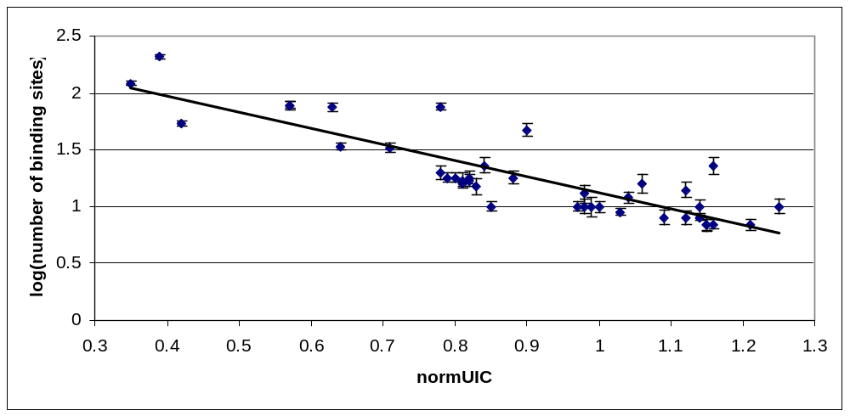
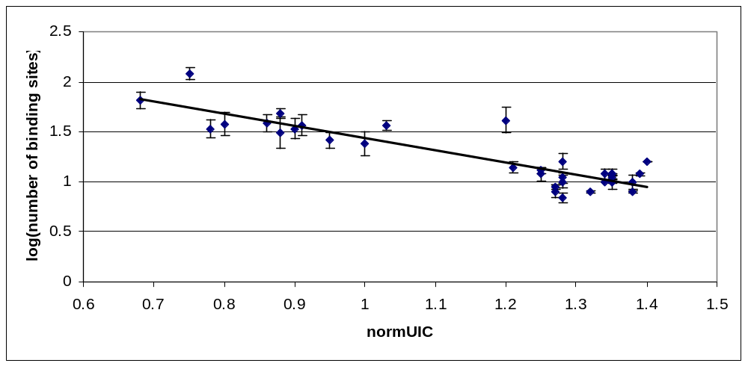

Figure S2. Scatter plot of normalized information content versus number of binding sites in E. coli (top) and B. subtilis (bottom). Information content was calculated using the best 10 columns of the motif in order to show that the observed specificity trend is not dependent on the geometry of the site.

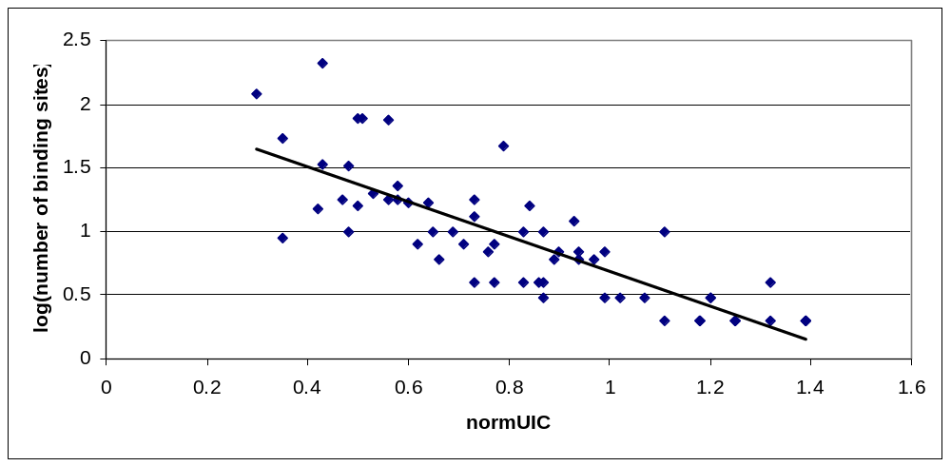

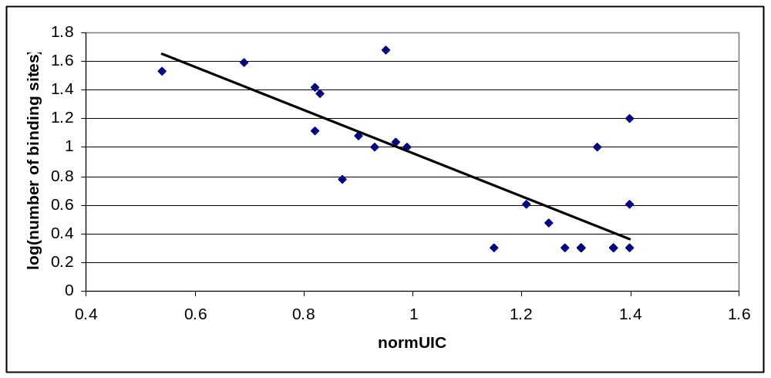

Figure S3. Scatter plot of PWM score variability versus number of binding sites in E. coli (top) and B. subtilis (bottom). Here we re-use the set of position-weight matrices (PWM) used in Figure 2 of the manuscript. We took only matrices derived from at least 2 sites and calculated the score of matching each site to the PWM and then applied Equation 1 to calculate the score variability for each transcription factor (see Materials and Methods).

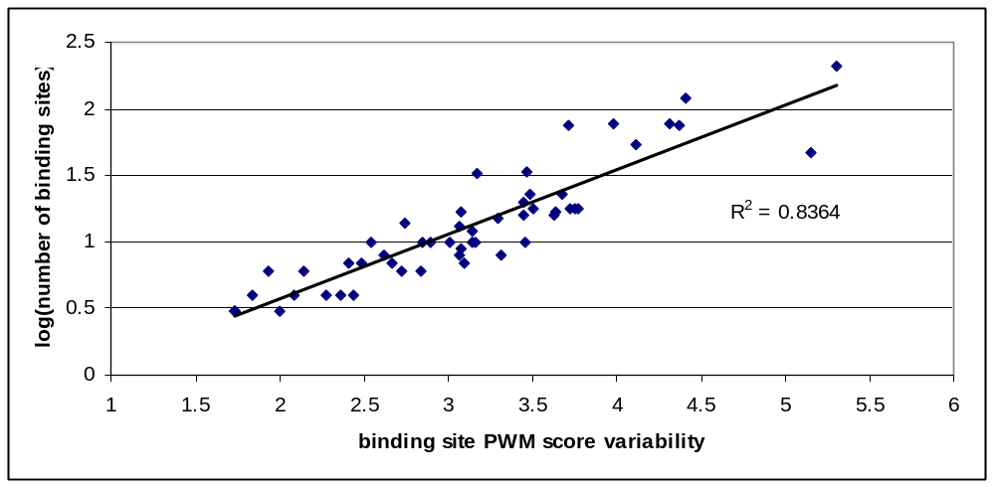
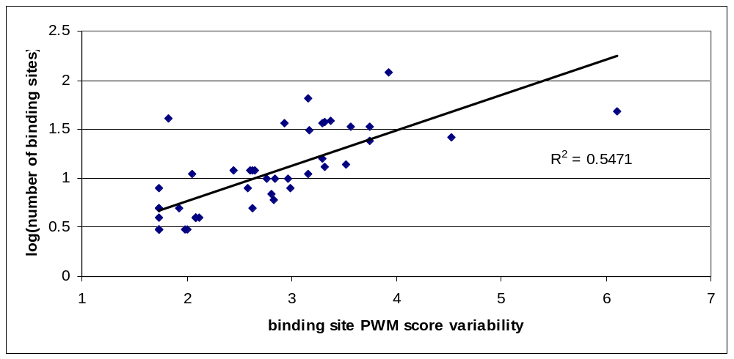

Figure S4. Scatter plot of PWM score coefficient of variability (standard deviation / mean) versus number of binding sites in E. coli (top) and B. subtilis (bottom). Here we re-use the set of position-weight matrices (PWM) used in Figure 2 of the manuscript. We took only matrices derived from at least 2 sites, with standard deviations > 0, and calculated the score of matching each site to the PWM and then applied Equation 1 to calculate the score variability for each transcription factor (see Materials and Methods).
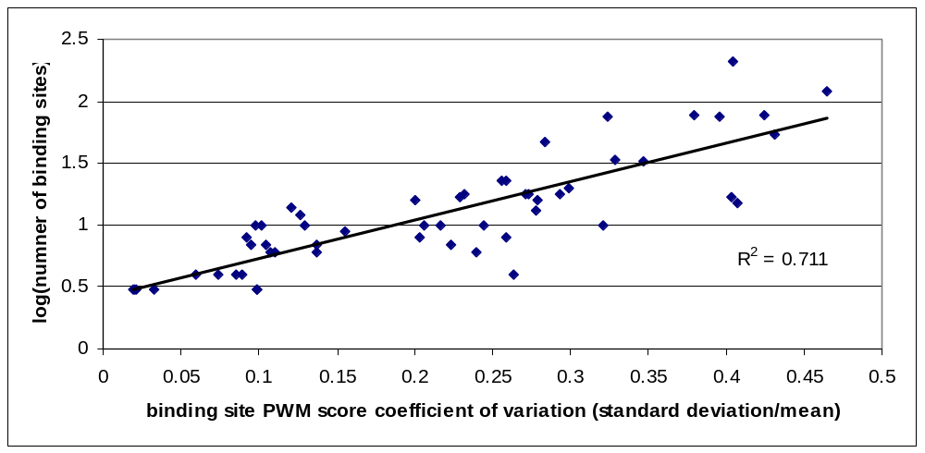

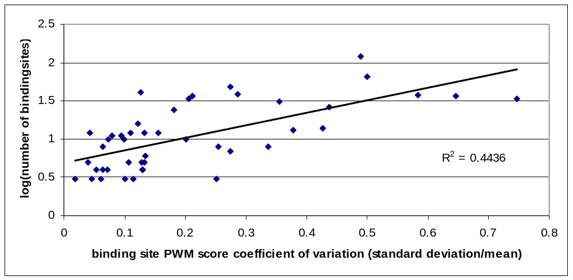

Figure S5. Histogram transcription factor specificities based on contact-based estimates. Data includes 49 TFs of E. coli and 33 TFs from B. subtilis, of which 5 are global regulators. Note that local transcriptions factors show a wide range of specificities, whilst global TFs are clearly among the lowest specific DNA binders, with values in the range 0.17-0.21 .Check Supplementary Methods M1 for details on the calculations.

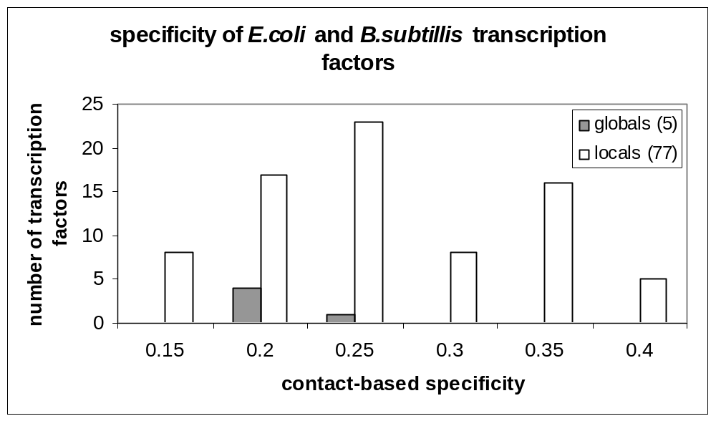

Figure S6. Sequence alignment of DNA-binding regions of FNR orthologs in E. coli (top) and B. subtilis (bottom). Sequence logos describing the recognized binding sites are shown in the same order. Residues predicted by TFmodeller⁴⁵ to contact DNA bases are labeled with + if conserved, otherwise they are marked with -. Sequence logos generated with WEBLOGO ⁴⁶.

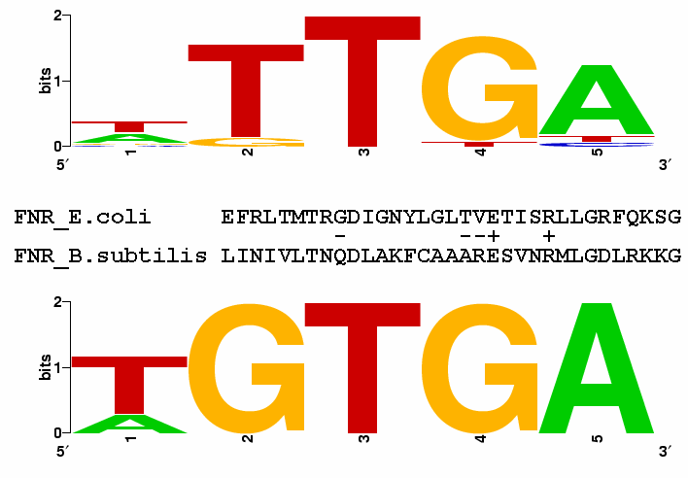

1. Perrenoud, A. & Sauer, U. (2005). Impact of global transcriptional regulation by ArcA, ArcB, Cra, Crp, Cya, Fnr, and Mlc on glucose catabolism in Escherichia coli. J Bacteriol 187, 3171-9.
2. Zheng, D., Constantinidou, C., Hobman, J. L. & Minchin, S. D. (2004). Identification of the CRP regulon using in vitro and in vivo transcriptional profiling. Nucleic Acids Res 32, 5874-93.
3. Lorca, G. L., Chung, Y. J., Barabote, R. D., Weyler, W., Schilling, C. H. & Saier, M. H., Jr. (2005). Catabolite repression and activation in Bacillus subtilis: dependency on CcpA, HPr, and HprK. J Bacteriol 187, 7826-39.
4. Moreno, M. S., Schneider, B. L., Maile, R. R., Weyler, W. & Saier, M. H., Jr. (2001). Catabolite repression mediated by the CcpA protein in Bacillus subtilis: novel modes of regulation revealed by whole-genome analyses. Mol Microbiol 39, 1366-81.
5. Saier, M. H., Jr. (1989). Protein phosphorylation and allosteric control of inducer exclusion and catabolite repression by the bacterial phosphoenolpyruvate: sugar phosphotransferase system. Microbiol Rev 53, 109-20.
6. Zubay, G., Schwartz, D. & Beckwith, J. (1970). Mechanism of activation of catabolite-sensitive genes: a positive control system. Proc Natl Acad Sci U S A 66, 104-10.
7. Lopez, J. M. & Thoms, B. (1977). Role of sugar uptake and metabolic intermediates on catabolite repression in Bacillus subtilis. J Bacteriol 129, 217-24.
8. Becker, S., Holighaus, G., Gabrielczyk, T. & Unden, G. (1996). O2 as the regulatory signal for FNR-dependent gene regulation in Escherichia coli. J Bacteriol 178, 4515-21.
9. Sawers, G. (1999). The aerobic/anaerobic interface. Curr Opin Microbiol 2, 181-7.
10. Wray, L. V., Jr., Ferson, A. E., Rohrer, K. & Fisher, S. H. (1996). TnrA, a transcription factor required for global nitrogen regulation in Bacillus subtilis. Proc Natl Acad Sci U S A 93, 8841-5.
11. Wray, L. V., Jr., Zalieckas, J. M. & Fisher, S. H. (2000). Purification and in vitro activities of the Bacillus subtilis TnrA transcription factor. J Mol Biol 300, 29-40.
12. Jordan, P. A., Thomson, A. J., Ralph, E. T., Guest, J. R. & Green, J. (1997). FNR is a direct oxygen sensor having a biphasic response curve. FEBS Lett 416, 349-52.
13. Khoroshilova, N., Popescu, C., Munck, E., Beinert, H. & Kiley, P. J. (1997). Iron-sulfur cluster disassembly in the FNR protein of Escherichia coli by O2: [4Fe-4S] to [2Fe-2S] conversion with loss of biological activity. Proc Natl Acad Sci U S A 94, 6087-92.
14. Fisher, S. H., Brandenburg, J. L. & Wray, L. V., Jr. (2002). Mutations in Bacillus subtilis glutamine synthetase that block its interaction with transcription factor TnrA. Mol Microbiol 45, 627-35.
15. Wray, L. V., Jr., Zalieckas, J. M. & Fisher, S. H. (2001). Bacillus subtilis glutamine synthetase controls gene expression through a protein-protein interaction with transcription factor TnrA. Cell 107, 427-35.
16. Brinkman, A. B., Ettema, T. J., de Vos, W. M. & van der Oost, J. (2003). The Lrp family of transcriptional regulators. Mol Microbiol 48, 287-94.
17. Newman, E. B. & Lin, R. (1995). Leucine-responsive regulatory protein: a global regulator of gene expression in E. coli. Annu Rev Microbiol 49, 747-75.
18. Willins, D. A., Ryan, C. W., Platko, J. V. & Calvo, J. M. (1991). Characterization of Lrp, and Escherichia coli regulatory protein that mediates a global response to leucine. J Biol Chem 266, 10768-74.
19. Levdikov, V. M., Blagova, E., Joseph, P., Sonenshein, A. L. & Wilkinson, A. J. (2006). The structure of CodY, a GTP- and isoleucine-responsive regulator of stationary phase and virulence in gram-positive bacteria. J Biol Chem 281, 11366-73.
20. Molle, V., Nakaura, Y., Shivers, R. P., Yamaguchi, H., Losick, R., Fujita, Y. & Sonenshein, A. L. (2003). Additional targets of the Bacillus subtilis global regulator CodY identified by chromatin immunoprecipitation and genome-wide transcript analysis. J Bacteriol 185, 1911-22.
21. Sonenshein, A. L. (2005). CodY, a global regulator of stationary phase and virulence in Gram-positive bacteria. Curr Opin Microbiol 8, 203-7.
22. Ratnayake-Lecamwasam, M., Serror, P., Wong, K. W. & Sonenshein, A. L. (2001). Bacillus subtilis CodY represses early-stationary-phase genes by sensing GTP levels. Genes Dev 15, 1093-103.
23. Shivers, R. P. & Sonenshein, A. L. (2004). Activation of the Bacillus subtilis global regulator CodY by direct interaction with branched-chain amino acids. Mol Microbiol 53, 599-611.
24. Alexeeva, S., Hellingwerf, K. J. & Teixeira de Mattos, M. J. (2003). Requirement of ArcA for redox regulation in Escherichia coli under microaerobic but not anaerobic or aerobic conditions. J Bacteriol 185, 204-9.
25. Colloms, S. D., Alen, C. & Sherratt, D. J. (1998). The ArcA/ArcB two-component regulatory system of Escherichia coli is essential for Xer site-specific recombination at psi. Mol Microbiol 28, 521-30.
26. Castilla-Llorente, V., Munoz-Espin, D., Villar, L., Salas, M. & Meijer, W. J. (2006). Spo0A, the key transcriptional regulator for entrance into sporulation, is an inhibitor of DNA replication. Embo J 25, 3890-9.
27. Fujita, M., Gonzalez-Pastor, J. E. & Losick, R. (2005). High- and low-threshold genes in the Spo0A regulon of Bacillus subtilis. J Bacteriol 187, 1357-68.
28. Georgellis, D., Lynch, A. S. & Lin, E. C. (1997). In vitro phosphorylation study of the arc two-component signal transduction system of Escherichia coli. J Bacteriol 179, 5429-35.
29. Molle, V., Fujita, M., Jensen, S. T., Eichenberger, P., Gonzalez-Pastor, J. E., Liu, J. S. & Losick, R. (2003). The Spo0A regulon of Bacillus subtilis. Mol Microbiol 50, 1683-701.
30. Yamashita, S., Kawamura, F., Yoshikawa, H., Takahashi, H., Kobayashi, Y. & Saito, H. (1989). Dissection of the expression signals of the spoA gene of Bacillus subtilis: glucose represses sporulation-specific expression. J Gen Microbiol 135, 1335-45.
31. Cheng, Y. S., Yang, W. Z., Johnson, R. C. & Yuan, H. S. (2000). Structural analysis of the transcriptional activation on Fis: crystal structures of six Fis mutants with different activation properties. J Mol Biol 302, 1139-51.
32. Choe, L. H., Chen, W. & Lee, K. H. (1999). Proteome analysis of factor for inversion stimulation (Fis) overproduction in Escherichia coli. Electrophoresis 20, 798-805.
33. O'Reilly, M. & Devine, K. M. (1997). Expression of AbrB, a transition state regulator from Bacillus subtilis, is growth phase dependent in a manner resembling that of Fis, the nucleoid binding protein from Escherichia coli. J Bacteriol 179, 522-9.
34. Travers, A., Schneider, R. & Muskhelishvili, G. (2001). DNA supercoiling and transcription in Escherichia coli: The FIS connection. Biochimie 83, 213-7.
35. Bobay, B. G., Mueller, G. A., Thompson, R. J., Murzin, A. G., Venters, R. A., Strauch, M. A. & Cavanagh, J. (2006). NMR structure of AbhN and comparison with AbrBN: FIRST insights into the DNA binding promiscuity and specificity of AbrB-like transition state regulator proteins. J Biol Chem 281, 21399-409.
36. Strauch, M. A. (1995). AbrB modulates expression and catabolite repression of a Bacillus subtilis ribose transport operon. J Bacteriol 177, 6727-31.
37. Friedman, D. I. (1988). Integration host factor: a protein for all reasons. Cell 55, 545-54.
38. Landy, A. (1989). Dynamic, structural, and regulatory aspects of lambda site-specific recombination. Annu Rev Biochem 58, 913-49.
39. Hamoen, L. W., Van Werkhoven, A. F., Bijlsma, J. J., Dubnau, D. & Venema, G. (1998). The competence transcription factor of Bacillus subtilis recognizes short A/T-rich sequences arranged in a unique, flexible pattern along the DNA helix. Genes Dev 12, 1539-50.
40. Susanna, K. A., den Hengst, C. D., Hamoen, L. W. & Kuipers, O. P. (2006). Expression of transcription activator ComK of Bacillus subtilis in the heterologous host Lactococcus lactis leads to a genome-wide repression pattern: a case study of horizontal gene transfer. Appl Environ Microbiol 72, 404-11.
41. Shimizu, M., Miyake, M., Kanke, F., Matsumoto, U. & Shindo, H. (1995). Characterization of the binding of HU and IHF, homologous histone-like proteins of Escherichia coli, to curved and uncurved DNA. Biochim Biophys Acta 1264, 330-6.
42. Oshima, T., Ishikawa, S., Kurokawa, K., Aiba, H. & Ogasawara, N. (2006). Escherichia coli histone-like protein H-NS preferentially binds to horizontally acquired DNA in association with RNA polymerase. DNA Res 13, 141-53.
43. Zuber, F., Kotlarz, D., Rimsky, S. & Buc, H. (1994). Modulated expression of promoters containing upstream curved DNA sequences by the Escherichia coli nucleoid protein H-NS. Mol Microbiol 12, 231-40.
44. Owen-Hughes, T. A., Pavitt, G. D., Santos, D. S., Sidebotham, J. M., Hulton, C. S., Hinton, J. C. & Higgins, C. F. (1992). The chromatin-associated protein H-NS interacts with curved DNA to influence DNA topology and gene expression. Cell 71, 255-65.
45. Contreras-Moreira, B., Branger, P. A. & Collado-Vides, J. (2007). TFmodeller: comparative modelling of protein-DNA complexes. Bioinformatics.
46. Crooks, G. E., Hon, G., Chandonia, J. M. & Brenner, S. E. (2004). WebLogo: a sequence logo generator. Genome Res 14, 1188-90.

