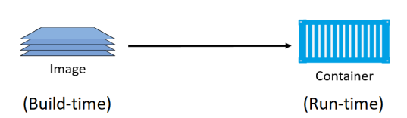

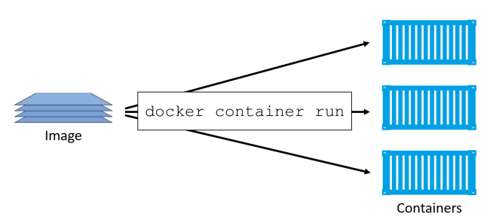

Install docker on Ubuntu

# Add Docker's official GPG key:

sudo apt-get update

sudo apt-get install ca-certificates curl gnupg

sudo install -m 0755 -d /etc/apt/keyrings

curl -fsSL https://download.docker.com/linux/ubuntu/gpg | sudo gpg --dearmor -o /etc/apt/keyrings/docker.gpg

sudo chmod a+r /etc/apt/keyrings/docker.gpg

# Add the repository to Apt sources:

echo \

"deb [arch="$(dpkg --print-architecture)" signed-by=/etc/apt/keyrings/docker.gpg] https://download.docker.com/linux/ubuntu \

"$(. /etc/os-release && echo "$VERSION_CODENAME")" stable" | \

sudo tee /etc/apt/sources.list.d/docker.list > /dev/null

sudo apt-get update

sudo apt-get install docker-ce docker-ce-cli containerd.io docker-buildx-plugin docker-compose-plugin

sudo docker run hello-world

docker run -it --rm -d -p 8080:80 --name web nginx

docker container ls

docker exec -it 7ca3259112d8 /bin/sh

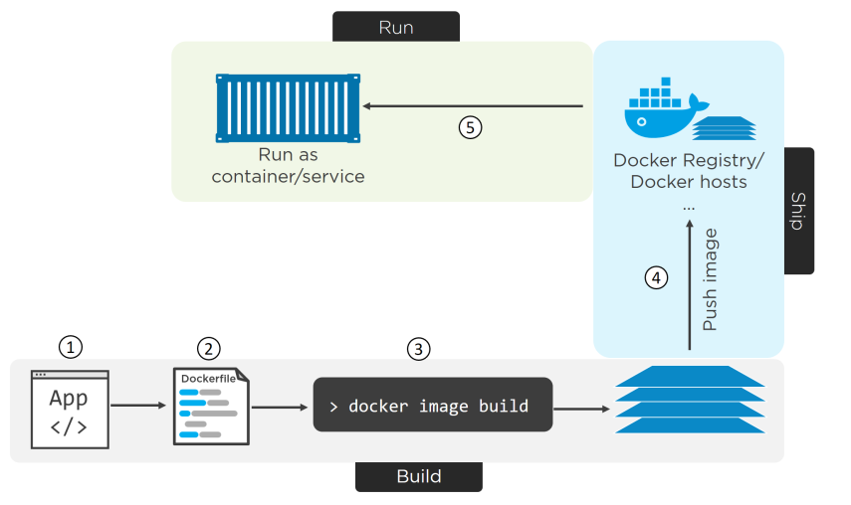

<https://github.com/nigelpoulton/psweb.git>

Do not underestimate the impact of the Dockerfile as a from of documentation! It has the ability to help bridge the gap between development and operations! It also has the power to speed up on-boarding of new developers etc. This is because the file accurately describes the application and its dependencies in an easy-to-read format. As such, it should be treated as code, and checked into a source control system.

docker image build -t web:latest .

docker image ls

docker tag 1f2fd70a7c14 030507770108.dkr.ecr.eu-west-1.amazonaws.com/nh01:new

aws ecr get-login-password --region eu-west-1 | docker login --username AWS --password-stdin 030507770108.dkr.ecr.eu-west-1.amazonaws.com

docker push 030507770108.dkr.ecr.eu-west-1.amazonaws.com/nh01:new