Requirements and Analysis Document for Bobo the Panda  
  
  
Table of Contents  
  
  
  
 Version: 1.1  
  
 Date: 2013-03-26  
  
 Author: Sebastian Sandberg, Victor Larsson, Elvira Jonsson, Oscar Muhr

This version overrides all previous versions.  
  
**1 Introduction**

**1.1 Purpose of application**

A fun game.A sidescrolling platform singleplayer game, where the objective is to go from start to the end, and find a key to unlock the finish line on each level.

**1.2 General characteristics of application**

The application will be a desktop, stand alone, single-player application with a graphical user interface for the Mac/Windows/Linux platforms.

The application is multi level gameplay. The player from point A to point B on the screen and tries to avoid obstacles.In order to complete each level, the player must find a key to unlock the door at the end. The only way to finish the game is by completing all levels.  
 **1.3 Scope of application**

The application does not include multi-player mode. Nothing is transferred between levels, each level is its own chapter.

**1.4 Objectives and success criteria of the project**

It should be possible to play the game on any of the given platforms. The game should contain at least two complete levels. A complete level should contain enemies, obstacles and a key that will grant player progression.

**1.5 Definitions, acronyms and abbreviations**

* GUI, Graphical User interface
* Java, Indepedent programming language
* JRE, Java Runtime Environment
* Player, the user controlled object in the game.
* Level, each independent game environment, where the player must find the key and unlock the door to complete.
* Tiled, the leveleditor used to draw the GUI of each different level.
* Enemies, objects where a collision with the player results in player death.
* Death, when the player dies, he restarts the current level.

**2 Requirements**  
In this section we specify all requirements  
  
**2.1 Functional requirements**  
Create a list of high level functions here (from the use cases).  
  
**2.2 Non-functional requirements**   
  
Possible NA (not applicable).  
  
**2.2.1 Usability**   
  
**2.2.2 Reliability**   
  
**2.2.3 Performance**   
  
**2.2.4 Supportability**  
  
**2.2.5 Implementation**   
  
**2.2.6 Packaging and installation**  
  
**2.2.7 Legal**   
  
**2.3 Application models**  
  
**2.3.1 Use case model**

Start level

Move

Jump

Open Door

Grab key

Collision

Achievement

Player death

End of level

UML and a list of UC names (text for all in appendix)

**2.3.2 Use cases priority**

1. Move
2. Collision
3. Jump
4. Open door
5. End of level
6. Player death
7. Grab key
8. Start level
9. Achievement

**2.3.3 Domain model**  
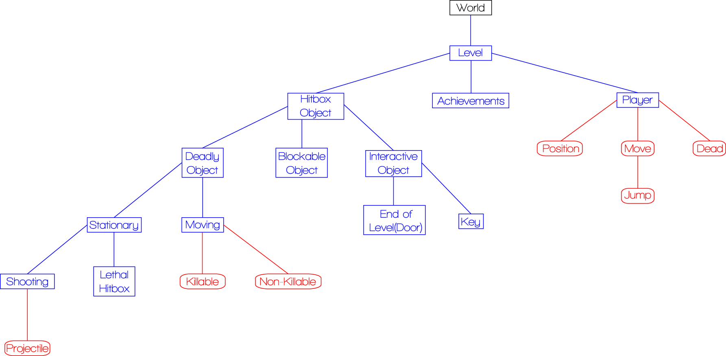  
  
  
**2.3.4 User interface**   
  
Text to motivate a picture.  
  
**2.4 References**  
  
 APPENDIX   
  
 GUI  
  
 Domain model  
  
 Use case texts

**Use Case: Move**

Summary: The player moves Bobo left/right

Priority: High

Extends: -

Includes: Jump

Participators: Player

**Normal flow of events**

**1. Move Bobo left or right**

|  |  |  |
| --- | --- | --- |
|  | **Actor** | **System** |
| 1 | Presses the right or left arrow key |  |
| 2 |  | Moves Player across the screen right/left while key is pressed. |
| 3 | Releases the arrow key |  |
| 4 |  | Stops Player from moving across the screen |

**Alternate flows of events**

**1.1 Modifier is held down to run faster**

|  |  |  |
| --- | --- | --- |
|  | **Actor** | **System** |
| 1.1.1 | Presses modifier in addition to right or left arrow key |  |
| 1.1.2 |  | Moves Player at an increased speed across the screen right/left while keys are pressed. |
| 1.1.3 | Releases the arrow key |  |
| 1.1.4 |  | Stops Player from moving across the screen |

**Use Case: Collission**

Summary: Player collides with various objects..

Priority: High

Extends: -

Includes: -

Participators: Player

**Normal flow of events**

**1. Player collides with blocking object**

|  |  |  |
| --- | --- | --- |
|  | **Actor** | **System** |
| 1 | Player collides with an object |  |
| 2 |  | Stops players movement. |

**Alternate flows of events**

**1.1 Player collides with static lethal object**

|  |  |  |
| --- | --- | --- |
|  | **Actor** | **System** |
| 1 | Player collides with an object |  |
| 2 |  | Stops players movement. |

**2.1. There is terrain in the way blocking Bobos path**

|  |  |  |
| --- | --- | --- |
|  | **Actor** | **System** |
| 2.1.1 |  | Stops Player from moving across the screen |

**2.2. Bobo hits lethal obstacle**

|  |  |  |
| --- | --- | --- |
|  | **Actor** | **System** |
| 2.2.1 |  | Executes Player and the level restarts |

**Use Case: Jump**

Summary: The player makes Bobo jump

Priority: High

Extends: Move

Includes: -

Participators: The player

**Normal flow of events**

**1. Jumping while standing still**

|  |  |  |
| --- | --- | --- |
|  | **Actor** | **System** |
| 1 | Presses the up arrow key |  |
| 2 |  | Moves Bobo in an upwards direction with a deceleration. |
| 3 |  | Once peak is reached Bobo starts moving towards the ground. |
| 4 |  | Bobo stops moving once he hits the ground. |

**Alternate flows of events**

**1.1 Jumping while moving left or right**

|  |  |  |
| --- | --- | --- |
|  | **Actor** | **System** |
| 1.1.1 | Presses the up arrow key + left/right key |  |
| 1.1.2 |  | Moves Bobo in an upwards and a right/left direction with a deceleration. |
| 1.1.3 |  | Once peak is reached Bobo starts moving towards the ground. |
| 1.1.4 |  |  |



**Use Case: Open Door**

Summary: Opens a door, enables player progress

Priority: Mid

Extends: Grab Key

Includes:

Participators: Player, Door-object

**Normal flow of events**

|  |  |  |
| --- | --- | --- |
|  | **Actor** | **System** |
| 1 | Player grabs key |  |
| 2 |  | Sets the door-object status to open |

**Use Case: End of Level**

Summary: Player reaches end of level, next level starts.

Priority: High

Extends:

Includes:

Participators: Player

**Normal flow of events**

**1. Player reaches end of level**

|  |  |  |
| --- | --- | --- |
|  | **Actor** | **System** |
| 1 | Player reaches end of level |  |
| 2 |  | End current level |
| 3 |  | Shows a picture with “Completed Level x” |
| 4 |  | Shows a picture with “Level x+1” |
| 5 |  | Starts Level x+1 |

**Use Case: Player death**

Summary: Player dies by interactive objects, and restarts current level

Priority: High

Extends:

Includes: Collision

Participators: Player, Interactive Object

**Normal flow of events**

**1. Player dies due to interactive object - Deadly leathal hitbox**

|  |  |  |
| --- | --- | --- |
|  | **Actor** | **System** |
| 1 | Player enters a leathal hitbox |  |
| 2 |  | Stops player movement |
| 3 |  | Player status changed to dead |
| 4 |  | Show picture of “You died!” |
| 5 |  | Start game at current level |

**Use Case: Grab Key**

Summary: Player collects an object (a key)

Priority: Mid

Extends: Collision

Includes: Open Door

Participators: Player, key-object

**Normal flow of events**

|  |  |  |
| --- | --- | --- |
|  | **Actor** | **System** |
| 1 | Player collides with key-object |  |
| 2 |  | Indicates that the key has been collected |
| 3 |  | Open Door |