**Abiotic factors that affect Eastern Red-backed Salamander Abundance in Bruce Peninsula**

Eric Peters, Matthew Tulio, Sanjana Khetan

EEB313/5 December 2018

**Abstract**

Biodiversity conservation is an ever-pressing need with the rising extinction rates and presence of harmful and deadly anthropogenic and environmental stressors. A particularly high risk has been demonstrated in amphibian populations around the world. In this data analysis, various populations of the eastern red-backed salamander (*Plethodon cinereus*) are studied from Bruce Peninsula (Ontario, Canada), where the relationship between various environmental factors like air and soil temperature, precipitation, and soil moisture and pH are recorded and compared to the observed abundance of salamanders in that area. The results suggest that the soil temperature and the amount of precipitation received has had the greatest impact on the decline of species abundance from the span of 2003 to 2007. These results raise the need to address the conservation of eastern red-backed salamanders in North America to mitigate the potential negative genetic effects which may arise from a low population size.

**Introduction/Background and Rationale**

In the recent past there has been a major decline in various amphibian populations around the world, the reasons range from a variety of proposals such as climate change, pollution, disease, invasive species and disease to name a few1. The Eastern red-backed salamander is an interesting specimen as it is abundant and has a large geographical range across most of eastern North America and provide a prime test to see if this species is suffering the same fate as the rest of their close relatives. Bruce Peninsula National Park is in Ontario and lies between both Lake Huron and Georgian Bay. Eastern Red-backed salamanders, scientifically known as *Plethodon cinereus*, typically only have a habitat range of a few square meters and can usually be found in extremely high population densities that can exceed over 2500 individuals per hectare2. The eastern red-backed salamander is mostly located in deciduous or mixed forests but have also been found in cool, moist forests such as the white pine or hemlock forests. The preference of this species to be in mature woody areas that contains various debris from the forest such as fallen logs and leaf litter. It has also been known that during hot and dry days this salamander might hide underground. These salamanders are a particularly interesting creature to examine based on their basic biology. *P. cinereus* breathe entirely through their skin as well as the tissue lining that is in their mouths. This feature leaves them as an excellent organism to study regarding the changes in environmental quality that are occurring as these salamanders are susceptible and sensitive to various pollutants and conditions that are in the water and the air. Based on these factors there is significant reason to believe that factors such as air temperature, the amount of precipitation or other factors regarding the soil including temperature, moisture and pH would affect both the health and abundance of the Eastern Red-backed salamander population. Studies performed in both laboratories and the Eastern United States have indicated previously that salamanders have a preference in relation to both higher temperatures and humid soils, which indicates that precipitation and temperature are positively correlated with salamander abundance and would provide the basis to look at if these findings hold true for the populations that are in the Bruce Peninsula3. Work has also been previously completed in the Bruce Peninsula looking at salamander abundance and has shown that population or at least sightings of this species increases following a day of precipitation following the idea that salamanders have an innate preference to areas and conditions which are more moist4. Soil pH also has an immense effect on the viability and presence of eastern red-backed salamanders as information from the IUCN has shown that in New York the organism tended to be absent in areas which had a soil pH which was less than 3.8. From this information salamanders seem to have an aversion to conditions which present as more acidic. Data from the Canadian government on *P. cinereus* abundance in the Bruce Peninsula took into account various abiotic factors in their observations but 5 factors would seem to have the greatest effect on the organism’s population size: Air Temperature, Soil Temperature, Soil Moisture, Soil pH and Precipitation recorded in the past 24 hours. Based upon the biology, preferences and previous information surrounding the Eastern Red-backed Salamander, the data trends which were from 2003-2017 should indicate that abundance would increase along with precipitation, soil moisture and both air and soil temperature and that species abundance would decrease in the case of more acidic soils.

**Methods**

**Data Description**

The data regarding the Eastern Red-backed Salamander was collected by the Government of Canada (Cavan Harpur) from the years of 2003-2017 at various site locations in the Bruce Peninsula5. This data took into account the many factors which may affect the abundance of salamanders at their various locations as well as a set of factors which are more for data-keeping purposes such as: the year, date, time, observer-name, plot name and number, and artificial cover object number and age. In addition to these record-keeping variables, data was also recorded on various conditions and factors which may affect the count of salamanders in the area. Salamander count was recorded by an observer who went out to these sites and visually spotted the presence or absence of this organism and in some cases also recorded the specific type of eastern red-backed salamander, either the readback form or leadback form of the species. In terms of the environmental factors which were evaluated and measured there were several different variables such as: the precipitation in the last 24 hours, the air temperature, the soil temperature, the Beaufort Sky Class and the Beaufort Wind Class which measures how hectic or calm the sky or wind was, the soil moisture as well as the soil pH.

**Data Analysis**

In order to make the data fit the analyses which were about to be done the original data frame was condensed and summarised into a subset of what it originally was. To look at the data from a year to year perspective the following columns were kept in the final frame: Year, Plot Name, Eastern Red-backed Salamander Count, Precipitation in the last 24 hours, Air Temperature, and Soil Temperature, Moisture and pH. Beaufort Sky and Wind Class were disregarded from the study as most of the environmental factors which are crucial for salamander survival and abundance were not affected by the type of wind or the calmness of the sky. Next, in order to look at the year by year trends salamander counts were summed up by year and site, and all of the environmental factors were averaged at their sites for what the yearly average that existed was. The next step was to look at the trends in abundance over time for the salamander population at varying sites as well as seeing the trends in environmental factors over time through the means of a plot. Each of the environmental factors was measured directly against salamander abundance and a linear model/ANOVA was fit against each of the variables to verify if the environmental factor had a significant effect on the abundance of the eastern red-backed salamander. Then to take into account the possibility of random effects, such as the plot site from which salamanders were recorded a linear mixed effects model was created measuring abundance against the presence of each of the five environmental factors while taking into account the differences which may exist between plots. All models and data analyses were computed in RStudio6.

**Results**

When looking at the trends in salamander abundance over time (fig. 1) the obvious observation is that the population experienced an immense decrease in size around 2007, but upon further discovery the observers cut down on the number of sites which they were recording data for, by the end of 2017 they were recording data for 5 key sites: Cameron Lake Dunes, Emmet Lake, Little Cove, Pendall Point and South Cameron Lake. Although the four major sites which were present throughout the eleven years of observation excluded Little Cove. When observing the population trends at the various sites of Bruce Peninsula (fig. 2) it is clear that at the 4 major sites, salamander abundance experiences a decline in population from year to year. Next, to check if there were any trends in the five environmental factors from 2003 – 2017, the yearly average was plotted against time (fig. 3). It was shown that for soil pH at the four major sites the average rarely changed, while small differences were found during a handful of years and at less extensively observed sites. Almost the exact same results were discovered regarding average soil moisture from year to year with the moisture of the soil staying relatively the same. Average Precipitation varied slightly from year to year but overall trend in precipitation, especially at the four major sites was a negative relationship with time. The average air temperature across the various sites at Bruce Peninsula exhibited either slightly upward or slightly downward trends from year to year depending on the site, with the four major sites continuously fluctuating above and below their averages. Lastly, when looking at the yearly averages regarding soil temperature the results are largely similar to the air temperature as the overall average is relatively stable but there exists a significant amount of variability from year to year. By fitting a linear model of salamander abundance (Table 1) against the various environmental factors (ex: Salamander population ~ Average Soil pH) it is shown how strong the effects that these certain environment factors have on salamander abundance (fig. 4). The various effects which are correlated with a positive effect are: soil pH (3.179), soil temperature (1.288), and precipitation in the last 24 hours (2.528). The other two effects of air temperature (-0.5652) and soil moisture (-10.51) demonstrate a negative correlation with salamander abundance. A simple linear model demonstrates that these changing factors do have some effect on salamander abundance over the whole area but, accounting for the random effects that may occur from the data being nested into their various plots is important in distinguishing the true effects of these five environmental variables. Utilizing a linear mixed effects model demonstrates the true effects of the factors on abundance and the average of the top two linear models was utilized as only 2 models had a delta of under 2 (originally starting with the fully saturated model of: Salamander abundance ~ Average Air Temperature + Average Soil Temperature + Average Precipitation in the last 24 hours + Average Soil Moisture + Average Soil pH + (1|Plot Location)), although average air temperature was only included in one of the top models . From this model it is clear to see that these fixed effects have a greater effect on salamander abundance then was originally thought from a basic linear model. On the other end of the spectrum though it was shown that the average air temperature has little to no effect on salamander abundance and was not even included in the top model, which account for around 70% of the weight. All the other environmental factors had larger significant effects on salamander abundance than originally thought as, the new model shows the increased positive effects of precipitation (7.03919), soil pH (33.74660), and soil temperature (2.15545) as well as the largely negative correlation that exists between soil moisture (-28.43504) and salamander abundance. Overall, it was shown that the effects were stronger when accounting for the variability which exists between sites as the linear mixed effects model exhibited a conditional R-squared value of ~0.42.

**Discussion**

Although it is shown that certain factors have an immense effect on the abundance of salamanders at certain time points, it does not necessarily mean that every single one of the 5 environmental factors have caused the steady decline of salamander abundance over the years. When comparing the environmental trends over the 11 years to the correlations that exist between each of the factors and salamander abundance it is clear to see that the steady decline of the salamander population is extremely correlated with steady decrease in both the average precipitation as well as the soil temperature at Bruce Peninsula. These findings are consistent with previous studies that salamanders prefer and thrive in environments which experience more precipitation and warmer temperatures, as decreasing the rain and the temperature of the soil exhibited negative impacts. One result which was not expected was that the soil moisture percentage increasing had a negative effect on the abundance of salamanders, as previous literature has shown that abundance usually increases when the soil moisture percentage is increased. This increase in soil moisture has the opposite trend of precipitation as it increases over time, whereas precipitation is declining. Intuitively this information does not seem correct, but the decreasing temperatures or perhaps a possible change in soil composition could contribute to the increased ability for water retention over time. One possibility for soil moisture is that salamanders do thrive more in areas with increased moisture, but a threshold exists where the trend starts to head downward at a certain point, meaning that salamanders instead of a positive correlation with moisture have an intermediate preference for the environmental factor. Regarding soil pH, although it shows a significant effect on salamander abundance, it can be observed in the trends that it has little to nothing to do with the decrease in salamander abundance over the years as the values recorded for pH in these areas remain relatively stable. Overall, this is by no means a comprehensive list of potential factors which could affect the population of Eastern red-backed salamanders across various sites. Population decline could be due to various unaccounted intrinsic factors caused by the genetic component of the salamander community such as inbreeding depression or a plethora of other external factors such as deforestation and habitat fragmentation by development which has been previously shown to severely impact the Eastern red-backed salamander population in a negative way through population decline and have shown that in urban populations for this organism allelic richness and heterozygosity are decreased7. Population decreases could also be due to various other anthropogenic effects such as pollution and disturbance by noise or vibrations from vehicles. It would be particularly helpful to keep track of this changing population in the upcoming years to monitor the population size and the changing of the various environmental factors. It would also be useful to observe the area for large scale changes such as development and fragmentation as it would provide a greater insight into the possible conservation efforts which could be put into place to prevent the salamander from decreasing past a critical threshold.

**Conclusion**

The state of amphibian persistence and conservation is in dire need of help currently around the globe, and projections shown from one of the must abundant amphibians in North America is just further evidence of this need. The data analysis shows that the two greatest environmental factors on salamander abundance is the effects of precipitation as well as the temperatures of the soil. These factors are strongly correlated with the decline in the eastern red-backed salamander population, but also do not take into account the various anthropogenic effects and disturbance which occurs on a daily to yearly basis. The data outlines a need for conservation efforts for the species. The eastern red-backed salamander population can be affected by a variety of environmental factors which are directly under the influence of the effects of climate change and therefore are susceptible to change from individuals. Further investigations into a comprehensive list of factors must be completed in order to fully address the issue of conservation in salamander and various other amphibian species.

**References**

1Houlahan JE *et al*. 2000. Quantitative evidence for global amphibian population declines. *Nature*. 404: 752 - 755

2Ontario Nature. 2018. Eastern Red-backed Salamander. Retrieved on: 27 November 2018. https://ontarionature.org/programs/citizen-science/reptile-amphibian-atlas/eastern-red-backed-salamander/

3Spotila JR. 1972. Role of Temperature and Water in the Ecology of Lungless Salamanders. *Ecological Monographs*. 42(1).

4St. James K. 2009. The ecological effects of the cleared boundaries of Bruce Peninsula National Park. *UWSpace*. doi: *http://hdl.handle.net/10012/4850*

5Harpur C. 2017. Eastern Red-Backed Salamander – Bruce Peninsula. Parks Canada. url: https://open.canada.ca/data/en/dataset/3571474b-8d75-491d-816e-f84677b81a7c

6RStudio Team. 2015. RStudio: Integrated Development for R. RStudio, Inc., Boston, MA url: http://www.rstudio.com/.

7Noel S, Ouellet M, Galois P, Lapointe FJ. 2007. Impact of urban fragmentation on the genetic structure of the eastern red-backed salamander. *Conservation Genetics*. 8(3): 599 – 606.

**Appendix**

**Figure 1** Salamander Abundance from 2003 - 2017

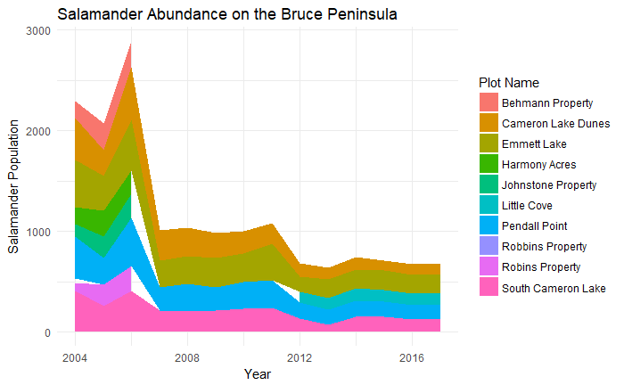

**Figure 2** Salamander Abundance by Plot from 2003 - 2017

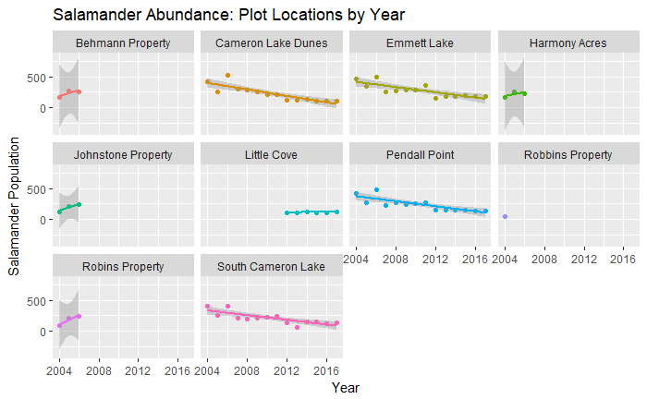

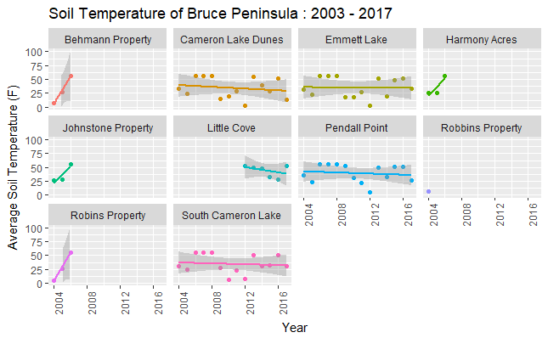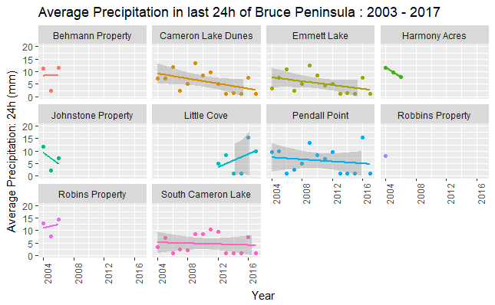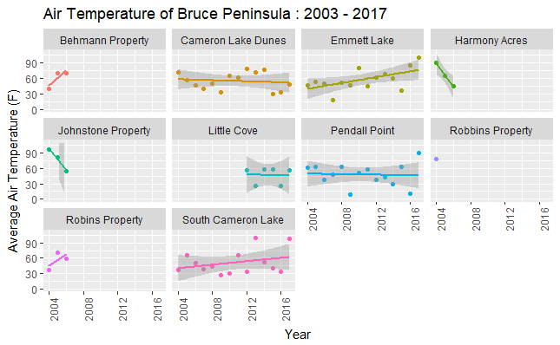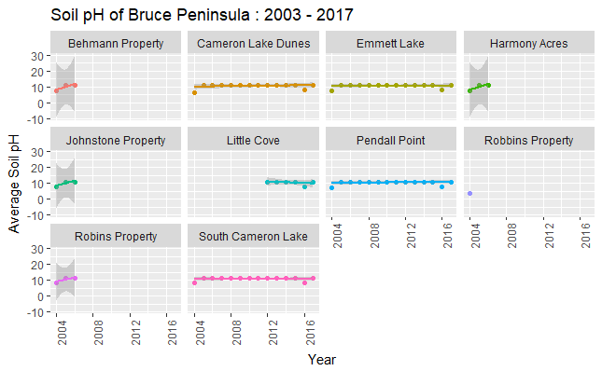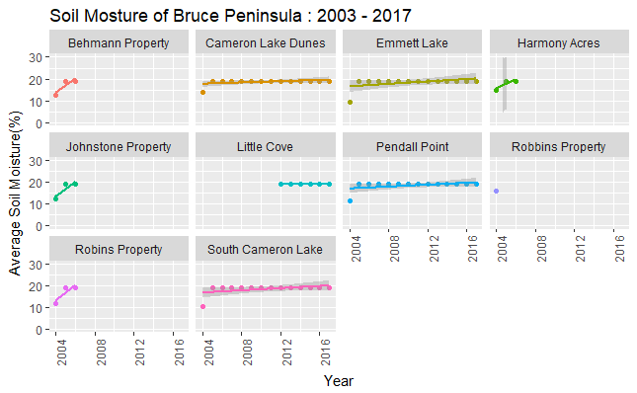

**Figure 3** Environmental Trends from 2003 – 2017 at Bruce Peninsula

|  |  |
| --- | --- |
|  |  |
|  |  |
|  |  |
|  |  |
|  |  |
|  |  |

**Table 1** Effects of various environmental factors on salamander abundance in Bruce Peninsula

|  |  |
| --- | --- |
| Effects on Salamander Abundance (Average) | Effect Size |
| Soil pH | 3.179 |
| Soil Temperature | 1.288 |
| Soil Moisture | -10.51 |
| Air Temperature | -0.5652 |
| Precipitation in Last 24h | 2.528 |

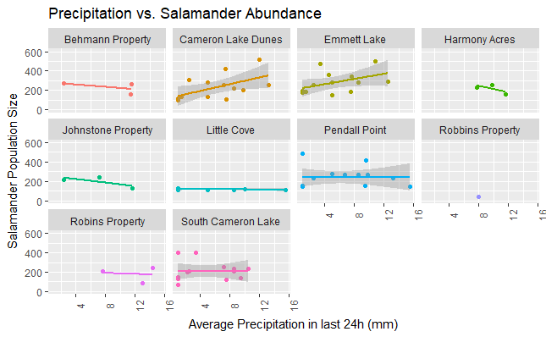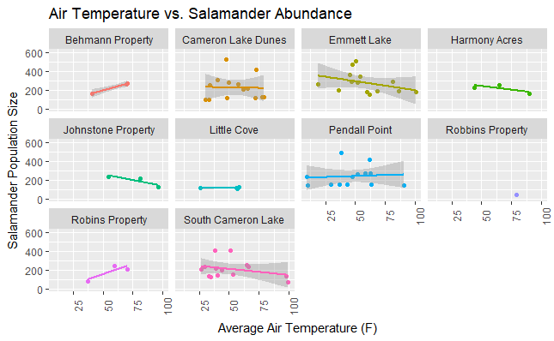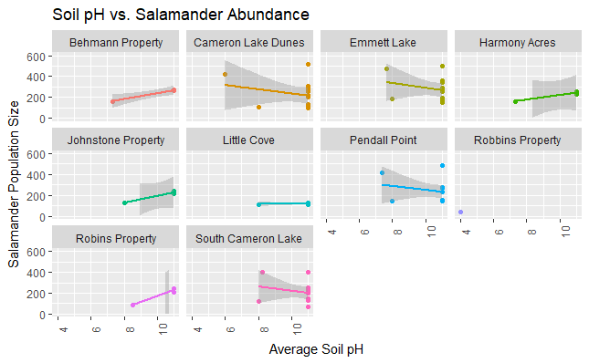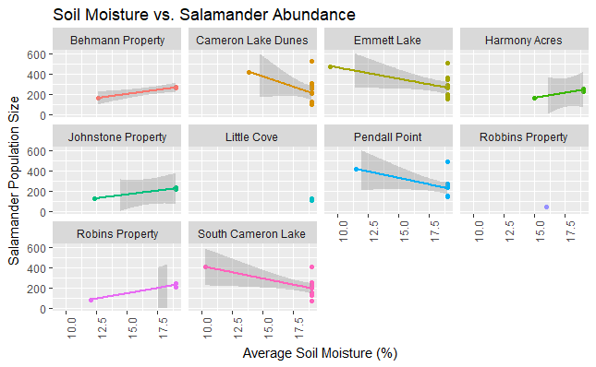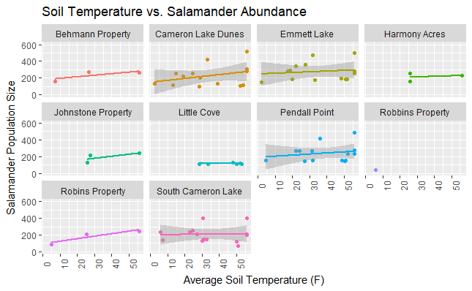

**Figure 4** Various environmental effects against Salamander abundance