**Yearly and Elevational Distribution of *Insecta* Species Richness in Costa Rica**

*Sam Imamovic, Jessica Robichaud, Destiny Sibolibane, Min Xi*

**Abstract**

There is a discrepancy in the literature regarding the change in species richness with increasing elevation. Some studies have indicated that species richness decreases as elevation increases and over time while other studies have found increases in species richness with increasing elevation and over time. As such, we sought to determine variations in *Insecta* species richness across elevation and time within provinces in the Republic of Costa Rica using the *Insecta* of Costa Rica dataset collected by the Instituto [Nacional de Biodiversidad (INBio](https://www.gbif.org/publisher/5c7a5c20-1bd0-11d8-a2da-b8a03c50a862)). Insects were selected as a model organism because they are at the bottom of the trophic system and indicators of ecosystem health; higher insect diversity indicates a healthier ecosystem. Regression analyses were performed to determine how insect species richness and maximum species richness changed with elevation and over time. Accounting for variation between provinces, we found a significant and negative linear association between species richness, elevation, and year. We also found a parabolic relationship between maximum species richness and year, where maximum species richness peaked in 1992 across all provinces. Elevation was not significantly associated with maximum species richness. Our findings suggest that organisms are not adapting to changes in environmental conditions, signifying a need for more conservation efforts to protect organisms in Costa Rica.

**Introduction**

Community assemblages and species richness are important indicators of ecosystem functioning (Batt et al. 2017). Similarly, diversity affects food web stability and ecosystem functioning (Batt et al. 2017). As such, the composition of species in an ecosystem can provide information on ecosystem health (Batt et al. 2017). High species richness usually indicates an older, well-established ecosystem that can support various organisms (Fernandes et al. 2010). Species richness is generally measured at three different levels based on a given area: *alpha, beta, and gamma* (Sepkoski 1988). *Alpha diversity* measures the species richness within a particular community from an ecosystem, whereas *beta diversity* measures taxonomic richness between communities, and *gamma diversity* measures taxonomic richness of multiple communities across different geographic regions (Sepkoski 1988). By measuring these metrics, researchers can better understand which taxonomic groups are most prominent in a given ecosystem. Specifically, comparing *gamma diversity* across an entire ecosystem can be useful in determining why species composition varies across sites and environmental gradients (Bishop et al. 2015).

Understanding how species richness and community assemblages change across space has become increasingly important in light of climate change. Spatial factors such as elevation create naturally occurring environmental gradients that separate communities within an ecosystem (Hodkinson 2005). Climate change has the ability to intensify these environmental gradients by altering abiotic factors such as temperature and precipitation (Wehn et al. 2014). These environmental changes can interact to further affect biotic factors, often altering the composition of existing flora and fauna communities (Wehn et al. 2014). Species are then required to adapt to their changing environment in an attempt to survive (Wehn et al. 2014). Species who are unable to adapt to changes in their environment must instead disperse to new habitats to meet their survival needs (Hodkinson 2005). Dispersal to new habitats leads to range-shifts and new species interactions (Hodkinson 2005; Batt et al. 2017). Failure to adapt to new environments puts organisms at risk of extinction (Hodkinson 2005, Batt et al. 2017). Dispersal also has the potential to alter species richness as species migrate between communities along environmental gradients.

There is a discrepancy in the existing literature regarding the change in species richness with increasing elevation. Previous studies on insects have shown decreases in species richness in communities with increases along elevation gradients (Perillo et al. 2017, Chen et al. 2009). In contrast, other studies have shown increases in species richness with increasing elevation, attributed to rising temperatures at lower elevation (Escobar et al. 2005, Staunton et al. 2016). As such, it is difficult to predict how species richness will change across environmental changes, particularly as climate change intensifies these gradients in environmental conditions. To develop a better understanding of how species will respond to climate change, long-term collections of species richness data can be parried with spatial data to create more comprehensive models of species movement.

Long-term collections of species richness data can be used to determine how species diversity if changing over time (Batt et al. 2017). By assessing long-term trends of species richness, researchers can determine which species have experienced population fluctuations, which species are more sensitive to changes in environmental conditions, and which species are at risk of population decline and will require more management in the future (Batt et al. 2017). This accompanied by data related to temperature, precipitation or other climatic factors can be a useful tool for determining how species respond to climate change (Wehn et al. 2014). Quantifying variations in species richness over time and across space has become increasingly important as climate change alters how species exist and vary within an ecosystem.

Our study sought to determine variations in insect *gamma diversity* across elevation and time within provinces in Costa Rica. Using a long-term data collection published by the National Biodiversity Institute (INBio) of Costa Rica, species richness for insects will be measured across elevation from 1963 to 2015 in order to determine how insect diversity has changed temporally and spatially across seven provinces. Insects are an ideal study organism for this research as they are strong indicators of ecosystem health, often correlating parallel with the diversity and functioning of plant communities (Fernandes et al. 2010). Residing at the bottom of the trophic system, insects are also excellent indicators of the health of higher trophic species because they are a primary food source for higher order insectivorous species. Understanding how insect diversity is changes in a system can be used to extrapolate information on how the whole ecosystem is functioning. Our findings can be used to explore how insects in different communities are responding to changes in their environment as a result of climate change. Based on existing literature, we hypothesized that species richness decreases over time and with increased elevation. Additionally, we hypothesized that species richness trends will vary across orders.

**Methods**

**Data Description**We obtained species richness data for this study from the *Insecta* of Costa Rica dataset collected by the Instituto Nacional de Biodiversidad (INBio; Vargas 2016). This dataset was retrieved from the GBIF (Vargas 2016). GBIF is an online repository of biodiversity, mainly stored as occurrence data. The dataset included information on taxonomic classification, spatial factors, and temporal factors (Vargas 2016). Table 1 outlines the specific variables included in the *Insecta* of Costa Rica dataset

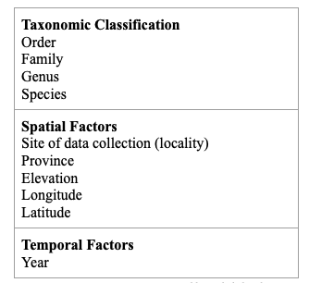

***Table 1*** *- Variables included in the Insecta of Costa Rica dataset.*

*Study Area* Sampling took place in Alajuela, Cartago, Guanacaste, Heredia, Limón, Puntarenas, and San José in the Republic of Costa Rica (8.418 o to 11.156o N, 82.60o to 87.08o W, 0m to 3820m elevation above sea level). Samples were taken from 4221 localities (Figure 1).

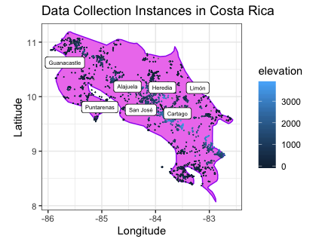

***Figure 1*** *- Map of the Republic of Costa Rica (8.418o to 11.156o N, 82.60o to 87.08o W, 0m to 3820m elevation above sea level). The general location of each province is labelled. The locality of where samples were collected is coloured by elevation.*

The mean annual temperature in Costa Rica is 27°C with a mean rainfall of 4,700 mm per year (Soto & Gama 1997). Costa Rica experiences a dry season from December to March and a rainy season from May to October (Nunes et al. 2016). The sites’ main vegetation includes tropical rain forest in the lowlands and cloud and mixed forests at higher elevations (Dirzo et al. 1997). However, in the last few decades, much of the original rainforest has been converted to field crops and other smaller human-occupied land fragments (Ruiz-Guerra et al. 2013).

*Data Collection*

Data was collected from 1963 to 2015. Data was collected using distinct methods for each species by INBio in the Republic of Costa Rica. However, exact methods of data collection were not specified for all species. To date, we have contacted INBio for additional information regarding the methods of data collection used, but we have yet to receive a reply.

Previous studies citing this dataset have stated that Malaise traps were used to capture *Diptera* (Brown et al. 2018). Other studies have specified that after collection, insect specimens were transported to a laboratory for taxonomic classification and identification in vented polyethylene containers at room temperature surrounded by the material from the environment where they were collected (Vargas-Asens et al. 2014). Taxonomic classification and identification by experts at INBio by examining the morphological characteristics of each insect (Vargas-Asens et al. 2014). In cases where morphological characteristics were unclear, insects were dissected and examined under a microscope for classification and identification (Vargas-Asens et al. 2014).

**Data Analysis**

All statistical analyses were conducted using R 3.6.1. We filtered the dataset to only include records belonging to the *Insecta* family and classified to species level. Additionally, we eliminated all records with missing longitude or latitude data (i.e., values where longitude or latitude were NA or equal to 0, indicating a missing value; Yesson et al. 2007).

To start, we created a venn diagram to ensure that orders were shared across provinces and not unique to a specific area. Shared orders across provinces signified that provinces shared similar species, allowing us to compare species richness across the seven provinces.

Linear regressions were performed using the *lme4* package (Bates et al. 2015). Regression tables were produced by *stargazer* (Hlavac & Marek, 2018), and *MuMIn* (Kamil & Barton 2019) was used to calculate R2 marginal and R2 conditional.

*Species richness by elevation, time, and province*

We visually investigated the variation in species richness by elevation, year, and province using faceted scatterplots. Two linear mixed effects models were created using the *lme4* package to investigate the relationship between species richness and elevation and year. We used species richness as the response variable, and elevation and year as predictors variables. The first model created included province as a random effect whereas the second model included both province and locality (i.e., sub-provincial regions) as random effects. As we had an adequate number of observations, we used the Akaike information Criterion (AIC) to determine the model of best fit. We fitted the model of best fit to the raw species richness data in faceted scatterplots to examine how well the model predicts changes in species richness.

*Maximum species richness by elevation, time, and province*

We sought to investigate whether the geographical range of species changed over time. Since the dataset did not include species range data, the association between range shifts and species richness could not be directly investigated. As such, we used maximum species richness to assess whether species experienced range shifts over time. In using maximum species richness to assess range shifts, we assumed that maximum species richness occurred where most species ranges along the elevational gradient overlapped. Following this assumption, if most species experienced a range shift, this shift would be reflected as a change in where maximum species richness occurred. For example, if most species experienced a range shift down the elevational gradient, this range shift would be reflected as a downward movement of maximum species richness.

As elevation was found to be an insignificant predictor variable, we first created a linear model to examine the relationship between year and maximum species richness. We then created a quadratic model using the *stats* package to examine the association between maximum species richness, and year. Since the quadratic model had a lower AIC value and higher adjusted R-squared value compared to the linear model, we fitted the quadratic model to the raw maximum species richness data to visualize how well the model predicted change in maximum species richness.

Since maximum species richness was not significantly associated with elevation, we visually explored the spread of average elevation at which maximum species richness was found across the seven Costa Rican provinces to allow for a general view of where maximum species richness would be found.

**Results**

*Overall*

After cleaning the dataset, we used data on 24 orders, 555 families, and 13834 species. Of these, 15 of the 24 orders are shared across the seven provinces where data were collected (Figure 2).

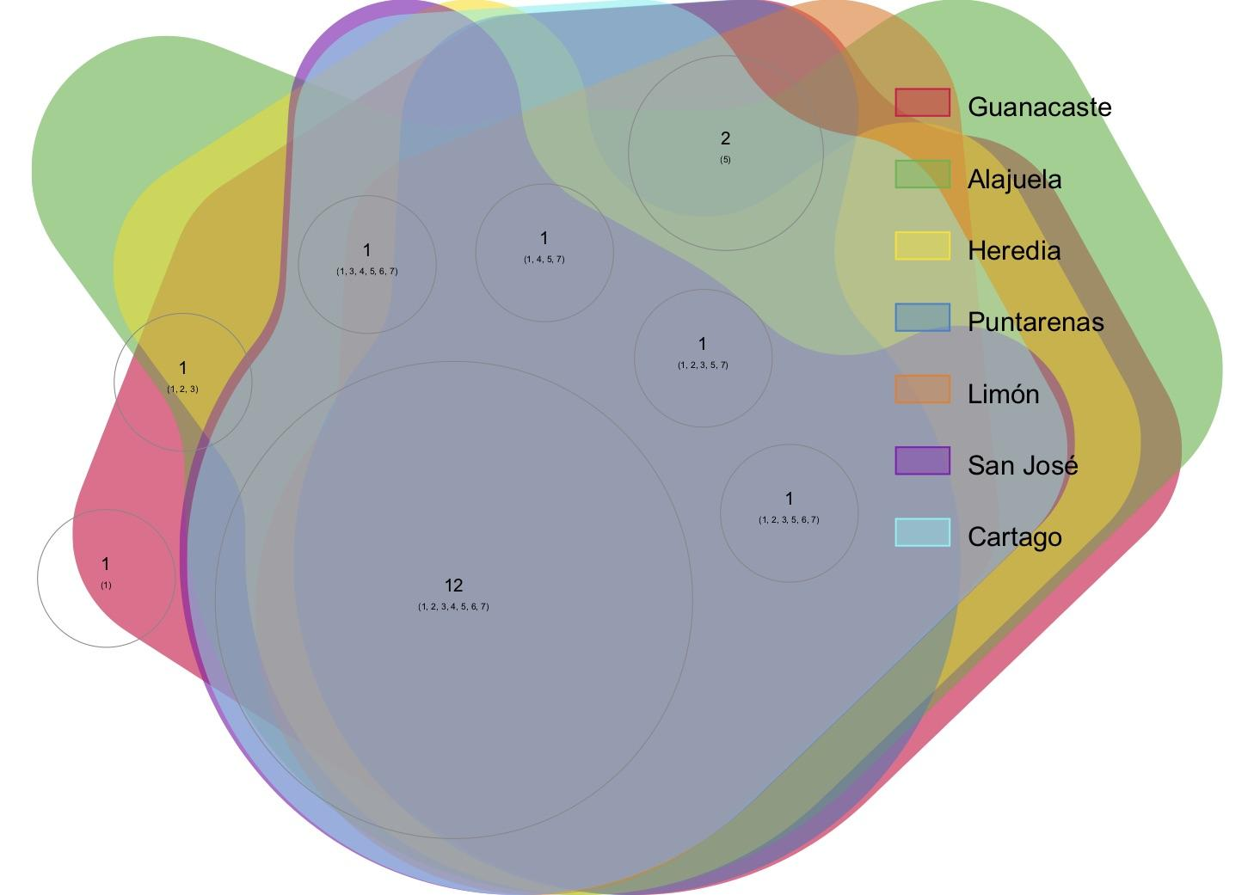

***Figure 2*** *-**The shared and unique insect orders of the provinces of Costa Rica.*

*Species richness decreases with elevation and year*

*Insecta* species richness decreased marginally with year and elevation in Costa Rica. Species richness peaked at different elevations among the seven provinces because the provinces are located at varying altitudes. For example, Limón has the lowest elevation amongst all the provinces so most of the species are situated at a lower elevation (Figure 3). In contrast, Guanacaste is situated at one of the highest elevations among the seven Costa Rican provinces and their species are situated at a higher elevation (Figure 3).

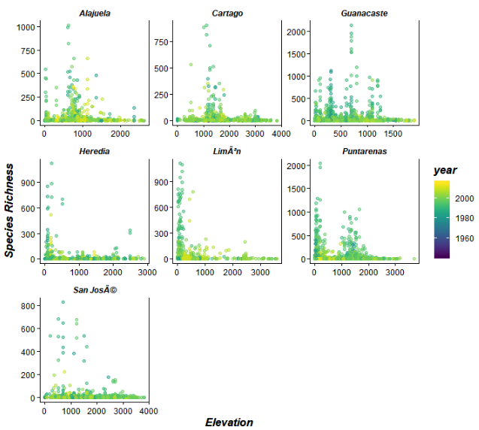

***Figure 3*** *- Scatterplots of Insecta species richness by elevation and year, faceted by province.*

The linear mixed effects model of best fit (AIC 35835.880 versus 114 855.900) used elevation (estimate = -0.00008, standard error = 0.00002, t-statistic = -3.428, p-value<0.001) and year (estimate = -0.016, standard error = 0.002, t-statistic=-7.945, p-value <0.001) as fixed effects and province as a random effect (Table 2). Controlling for the influence of provincial differences, this model showed that elevation and year were significantly and negatively related to species richness (Figure 4; Table 2). Additionally, this linear mixed effects model had an intercept of 3.323, an R2 marginal of 0.008 and R2 conditional of 0.034 (Table 2).

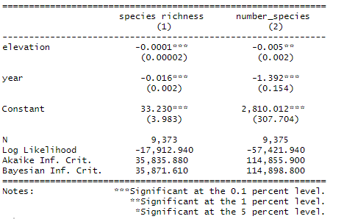

***Table 2*** *-**Regression analysis results of species richness (response variable) on elevation and year (predictor variable). Linear mixed effects model (1) used elevation (estimate = -0.00008, standard error = 0.00002, t-statistic = -3.428, p-value<0.001) and year (estimate = -0.016, standard error = 0.002, t-statistic=-7.945, p-value <0.001) as predictor variables and province as a random effect. Model (1) had an intercept of 3.323, an R2 marginal of 0.008 and R2 conditional of 0.034. Linear mixed effects model (2) used elevation (estimate = -0.005, standard error = 0.002, t-statistic = -2.754, p-value<0.001) and year (estimate = -1.392, standard error = 0.154, t-statistic=-9.040, p-value<0.001) as predictor variables and province and locality as random effects. Model (2) had an intercept of 2.810x103, an R2 marginal of 0.012, and an R2 conditional of 0.200.*

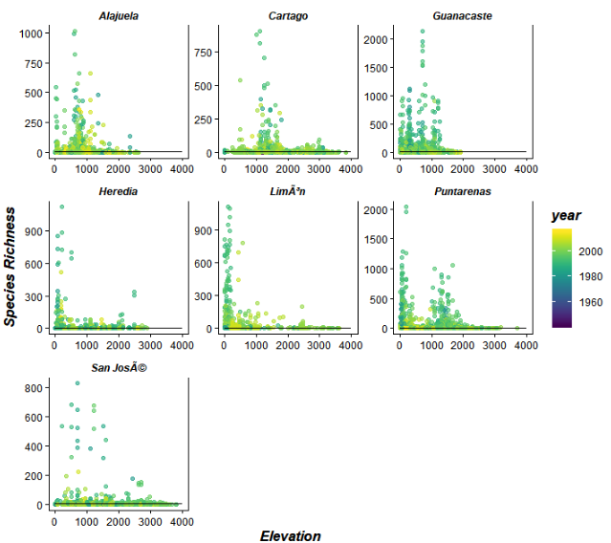

***Figure 4*** *-* *Scatterplots of mixed effect model fitted to species richness data. The mixed effects model used elevation and year as fixed effects and province as a random effect.*

*Year is a significant predictor for maximum species richness*

A quadratic model illustrated that year, but not elevation, was significantly and related to maximum species richness (Figure 5). Across all provinces, maximum species richness increased exponentially and peaked at 1992, before decreasing until the final year of data collection in 2015 (Figure 5).

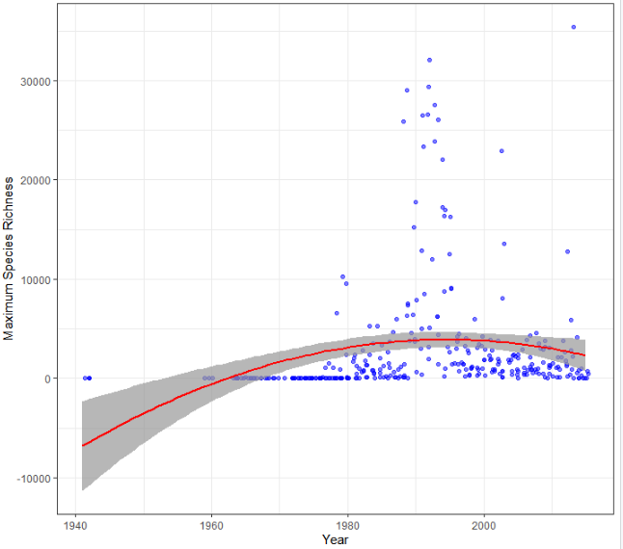

***Figure 5*** *- Quadratic model fitted to maximum species richness by year (AIC = 3318.240, F-statistic = 9.504 on 2 and 322 DF, Intercept = -1.49x107, Estimate (I(year2))= -3.742, Standard error(I(year^2)) = 1.056, p-value (I(year^2)) <0.001, Estimate (year) = 1.493x104, Standard error (year) = 4.197x103, p-value(year) <0.001, R-squared = 0.056, Adjusted R-squared: 0.050.*

Since maximum species richness was not significantly associated with elevation, we graphed the average elevation at which maximum species richness occurred for each province to allow for a general view of where maximum species richness would be found. Overall, we observed that the average elevation of maximum species richness varies over province (Figure 6). The average elevation of maximum species richness was 759.87 ± 67.54m, 1350.60 ± 100.26m, 453.04 ± 62.25m, 276.21 ± 65.49m, 213.43 ± 36.63m, 455.58 ± 83.99m, and 1168.44 ± 91.48m in Alajuela, Cartago, Guanacaste, Heredia, Limón, Puntarenas, and San José, respectively.

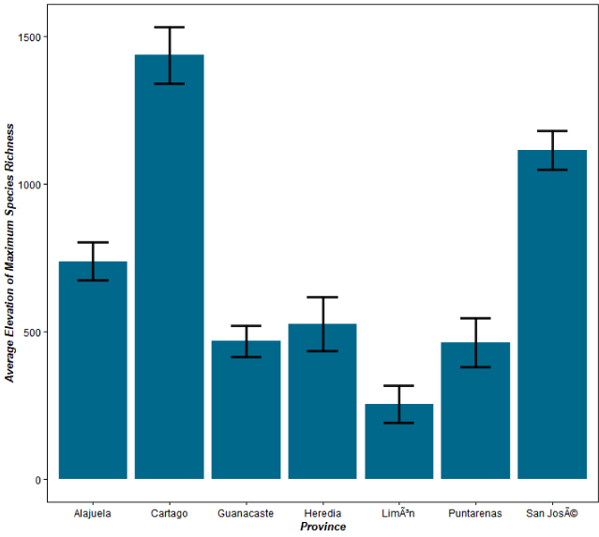

***Figure 6*** *- Bar graph of the average elevation of at which maximum species richness occurred by province (±se mean elevation). Elevation was measured in meters.*

**Discussion**

Based on the *Insecta* of Costa Rica dataset, we found that insectaspecies richness declined with elevation and year across all seven provinces. Furthermore, we found that maximum species richness had a significant paroblic association with year, but not elevation.

Insects are known as indicators of ecosystem health (Rykken et al. 1997; Isarin and Bohncke 1999; Harrison 2010). Changes in species richness by elevation and year are well documented in existing literature (Nunes et al. 2016; Maveety et al. 2011). For example, Hodkinson *et al.* (2005) indicated that insect diversity decreased significantly with increasing altitude and by year.

The negative relationship between elevation, year and species richness. Additionally, there is a parabolic relationship between year and maximum species richness, with a decrease in maximum species richness post-1992. The observed parabolic relationship between year and maximum species richness may be due to changes in conservation efforts. The data was collected in the National Protected Area Systems (NPAS) associated with INBio where conservation efforts have been made since 1976 (Gonzálex-Maya et al. 2015). However, INBio experienced a cut in funding in 1990, which may have led to decreased conservation efforts post-1990, resulting in the observed decrease in species richness and maximum species richness by year (Gonzálex-Maya et al. 2015). These findings suggest that few species are adapting to environmental changes across time and elevation (Summervile and Crist 2003). Thus, our findings suggest a need for increased conservation efforts to better protect organisms and ecosystems in Costa Rica.

To our knowledge, this is the first study to investigate the species richness of various insects across the seven provinces of Costa Rica. The strengths of our study included proper cleaning of data and testing of statistical assumptions.

However, it must be acknowledged that recent studies have questioned the usefulness of species richness as a measurement of ecosystem stability. Species identification on its own does not provide enough information about their ecology and functioning, making taxonomic data limited it its use (Bishop et al. 2015). Phylogenetically related species could share the same functional space in an ecosystem, and therefore species richness loss may not be as harmful to ecosystems (Kearny and Porter 2006). This limitation could be addressed by grouping species by functional groups rather than by just taxonomic identity.

Our study also had several limitations associated with the use of an open source dataset. To start, GBIF data are known to be prone to the misidentification of species, which may lead to an overestimate or underestimate of the species richness in our data (Smith et al. 2018). Additionally, as mentioned previously, the methods of data collection differed to suit the habitat of the distinct species surveyed. Unfortunately, these methods of data collection were not specified by INBio and we were not able to request additional information regarding data collection from INBio so we were not able to adjust for the various sampling methods used for our analyses. Moreover, as previously mentioned, conservation efforts have been made in the NPAS where the data were collected since 1976 (Gonzálex-Maya et al. 2015). Since conservation efforts have been made in the NPAS regions since 1976, the surveyed areas may demonstrate higher species richness in comparison to areas in the wilderness, leading to an overestimate in species richness in our study. Another limitation associated with the dataset used is the lack of data for environmental factors such as temperature, humidity, precipitation, and conservation efforts that may act as confounding variables for the declines in species richness that we observed. For example, previous studies have shown that lower humidity and temperature, and higher precipitation and wind density are associated with higher elevations and these factors may create a harsh environment for insects, leading to a decrease in species richness at high elevations (Wehn et al. 2014). It should also be noted that INBio experienced a cut in funding in 1990, which may have led to decreased conservation efforts post-1990, resulting in the observed decrease in species richness and maximum species richness by year (Gonzálex-Maya et al. 2015). The effects of these confounding factors on species richness should be investigated in future studies.

**Conclusion**

In conclusion, we found that insect species richness declined with elevation and year across all seven provinces. Additionally, we found that maximum species richness had a negative parabolic association with year, but not with elevation. Our findings suggest that insect species in Costa Rica are not adapting well to environmental changes and may be at risk for population decline or extinction in the future, signifying a need for increased conservation efforts to protect these organisms. Further work should be done to determine which specific environmental factors are affecting species richness over time in order to maintain the richness of life and ecosystem functioning in Costa Rica.

**References**

Batt R. D., J. W. Morley, R. L. Selden, M. W. Tingley, and M. L. Pinsky.  
 (2017).Gradualchanges in range size accompany long-term trends in species richness.  
 *Ecology Letters* 20(9): 1148-1157.

Bishop, T. R., M. P. Robertson, B. J. van Rensburh, and C. L. Parr. (2015). Contrasting species

and functional beta diversity in montane ant assemblages. *Journal of Biogeography*

42(9):1776-1786

Brown, B. V., Borkent, A., Adler, P. H., Amorim, D. S., Barber, K., Bickel, D., … Zumbado, M. A. (2018). Comprehensive inventory of true flies (Diptera) at a tropical site. *Communications biology*, 1: 21. doi:10.1038/s42003-018-0022-x

Chen, I. C., H. J. Shiu, S. Benedick, J. D. Holloway, V. K. Chey, H. S. Barlow, J. K. Hill, and

C. D. Thomas. (2009). Elevation increases in moth assemblages over 42 years on tropical mountain. *Proceedings of the National Academy of Sciences of the United States of America* 106(5): 1479-1483.

Escobar, F., J. M. and Lobo, G. Halffter. (2005). Altitudinal variation of dung beetle

(Scarabaeidae: Scarabaeinae) assemblages in the Colombian Andes. *Global Ecology and Biogeography* 14(4): 327-337.

Dirzo, R., González-Soriano, E., Vogt, R.C. (1997). Historia Natural de Los Tuxtlas. Universidad Nacional Autónoma de México, Mexico, 640 p.

Fernandes, G. W., E. D. Almada, and M. A. A. Carnerio. (2010). Gall-inducing insect species

richness as indictors of forest age and health. *Environmental Entomology* 39(4): 1134-1140.

González-Maya, J.F., Víquez-R, L.R., Belant, J.L., Ceballos, G. (2015). Effectiveness of Protected Areas for Representing Species and Populations of Terrestrial Mammals in Costa Rica. *Plos One* 10.

Hodkinson, I. D. (2005). Terrestrial insects along elevation gradients: species and community

responses to altitude*. Biological Reviews* 80(2): 489-513.

Isarin, R.F., Bohncke, S.J. (1999). Mean July temperatures during the Younger Dryas in northwestern and central Europe as inferred from climate indicator plant species. *Quat Res* 51(2): 158–173.

Kearny, M., and W. P. Porter. (2006). Ecologists have already started rebuilding community

ecology from functional traits. *Trends in Ecology and Evolution* 21: 481-482.

Maveety, S.A., Browne, R.A., Erwin, T.L. (2011). Carabidae diversity along an altitudinal gradient in a Peruvian cloud forest (Coleoptera). *Zookeys* 147: 651–666.

Nunes, C.A., Braga, R.F., Figueira, J.E., Neves Fde, S., Fernandes, G.W. (2016). Dung Beetles along a Tropical Altitudinal Gradient: Environmental Filtering on Taxonomic and Functional Diversity. *PLoS One* 11(6): e0157442.

Perillo, L. N., F. Neves, Y. Antonini, and R. P. Martins. (2017). Compositional changes in bee

and wasp communities along Neotropical mountain altitudinal gradient. *PLoS ONE* 12(7): 1-14.

Ruiz-Guerra, B., Hanson, P., Guevara, R., Dirzoi, R. (2013). Richness and Abundance of Ichneumonidae in a Fragmented Tropical Rain Forest. *Neotrop Entomol* 42:458-465.

Rykken, J.J., Capen, D.E., Mahabir, S.P. (1997). Ground beetles as indicators of land type diversity in the Green Mountains of Vermont. *Conserv Biol* 11(2): 522–530.

Sepkoski, J.J. (1988). Alpha, beta, or gamma: where does all the diversity go? *Paleobiology*

4(3): 221-234.

Smith, J.R., Letten, A.D., Ke, P. *et al.* A global test of ecoregions. (2018). *Nat Ecol Evol* **2,**1889–1896.

Soto, M., Gama, L. (1997). Climas. In: González-Soriano E, Dirzo R, Vogt R (eds) Historia Natural de Los Tuxtlas. Universidad Nacional Autónoma de México, México, p 647 p.

Staunton, K. M., A. Nakamura, C. J. Burwell, S. K. A. Robson, and S. E. Williams. (2016).

Elevational distribution of flightless ground beetles in the tropical rainforests of north

eastern Australia. *PLoS ONE* 11(5): 1-21.

Summerville, K.S., Crist, T.O. (2003). Determinants of Lepidopteran community composition and species diversity in eastern deciduous forests: roles of season, ecoregion and patch size. *Oikos* 100:134–148.

Vargas, M. (2016). Insecta of Costa Rica (INBio). Version 1.7. Instituto Nacional de Biodiversidad (INBio), Costa Rica. Occurrence dataset https://doi.org/10.15468/mykn0u accessed via GBIF.org on 2019-12-06.

Vargas-Asensio, G., Pinto-Tomas, A., Rivera, B., Hernandez, M., Hernandez, C., Soto-Montero, S., Murillo, C., Sherman, D.H., Tamayo-Castillo, G. Uncovering the cultivable microbial diversity of Costa Rican beetles and its ability to break down plant cell wall components. *PLoS One* 9(11):e113303.

Wehn, S., S. Lundemo, and J. I. Holten. (2014). Alpine vegetation along multiple

environmental gradients and possible consequences of climate change. *Alpine Botany* 124(2): 155-164.

Yesson, C., Brewer, P.W., Sutton, T., Caithness, N., Pahwa, J.S., Burgess, M., Gray, W.A., White, R.J., Jones, A.C., Bisby, F.A., Culham, A. (2017). How global is the global biodiversity information facility? *PLoS One* 2(11): e1124.