Project Title: Bank_database

Group Member: Yuxiang Zhou

Step 1: database description

Banks use databases to keep track of customer accounts, balances and deposits. Because databases are stored digitally, multiple users in different locations can view the data in more than once place. Because banks store their customer information and balances in a database, you can use any branch for deposits and withdrawals. Databases allow more flexibility because they are in a digital format. In my database, I will create 7 tables, which are used to store customers information, online login info, accounts details and other services etc.… I also make a simple site that connect to my database, the site will allow people to create their own online account, and bank account. People also can check-balance, deposit, withdrawal, loan and check-account-details on the site.

Step 2: Design Entity Relationship Diagram

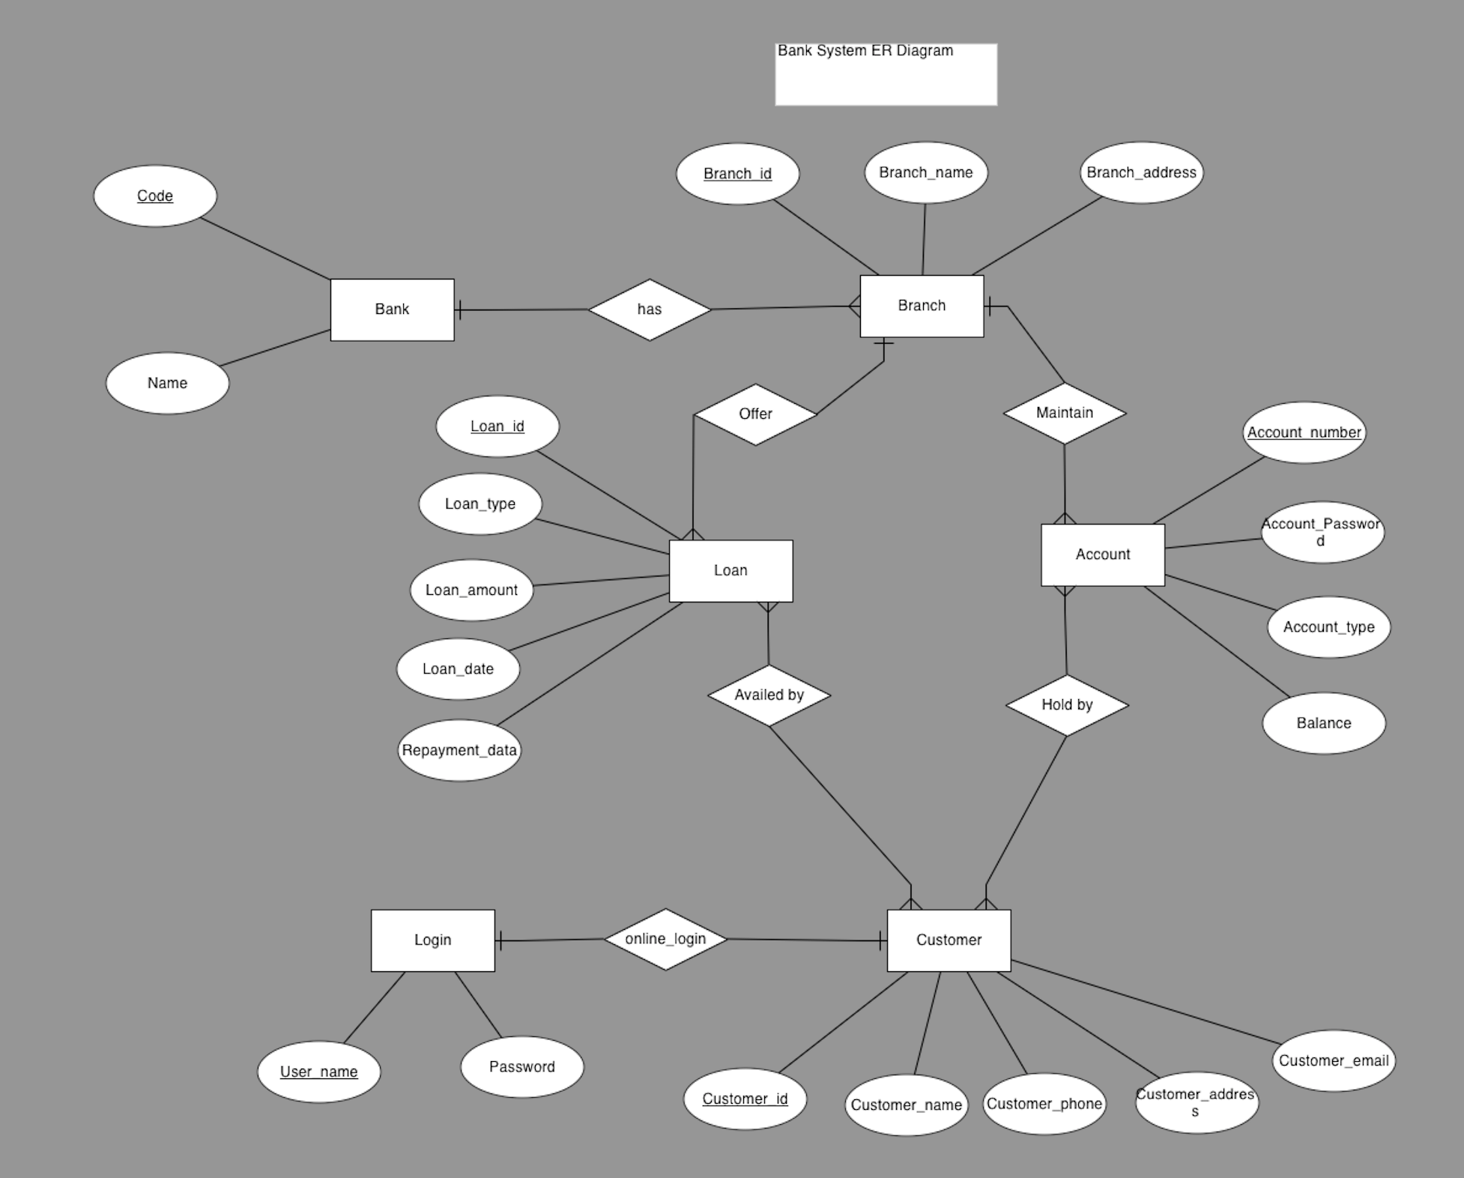

Step 3: Explain ER Diagram

In this ER Diagram, I have Bank, Branch, Loan, Account, Customer, and Login six entities.

Bank entity has 2 attributes: Code and Name, Code is primary key.

Branch entity has three attributes: Branch_id, Branch_name, and Branch_address, Branch_id is primary key.

Loan entity has 5 attributes: Loan_id, Loan_type, Loan_amount, Loan_date, and Repayment_date, Loan_id is primary key.

Account entity has 4 attributes: Account_number, Account_Password, Account_type, and Balance, Account_number is primary key.

Customer entity has 5 attributes: Customer_id, Customer_name, Customer_phone, Customer_address, and Customer_email, Customer_id is primary key.

Login entity has 2 attributes: User_name and Password, User_name is primary key.

Step 4: describe relationships among entity sets

* **Bank has Branches => 1 : N**  
  One Bank can have many Branches but one Branch cannot belong to many Banks, so the relationship between Bank and Branch is one to many relationship.
* **Branch maintain Accounts => 1 : N**  
  One Branch can have many Accounts but one Account cannot belong to many Branches, so the relationship between Branch and Account is one to many relationship.
* **Branch offer Loans => 1 : N**  
  One Branch can have many Loans but one Loan cannot belong to many Branches, so the relationship between Branch and Loan is one to many relationship.
* **Account held by Customers => M : N**  
  One Customer can have more than one Accounts and also One Account can be held by one or more Customers, so the relationship between Account and Customers is many to many relationship.
* **Loan availed by Customer => M : N**  
  (Assume loan can be jointly held by many Customers).  
  One Customer can have more than one Loans and also One Loan can be availed by one or more Customers, so the relationship between Loan and Customers is many to many relationship.
* **Online account binding bank account 1： 1**

One online account binds one bank account. So, the relationship between bank account and online account is one to one.

Setp 5: Convert ER Diagram to Relational Schemas

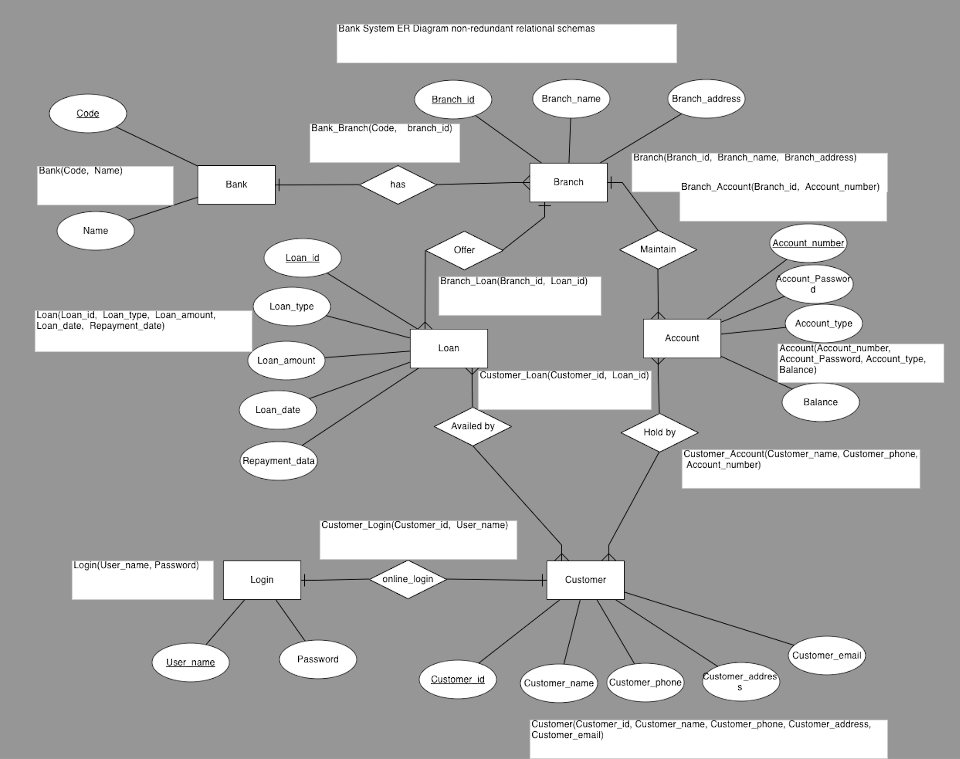

Step 6: Schema Diagram of Database

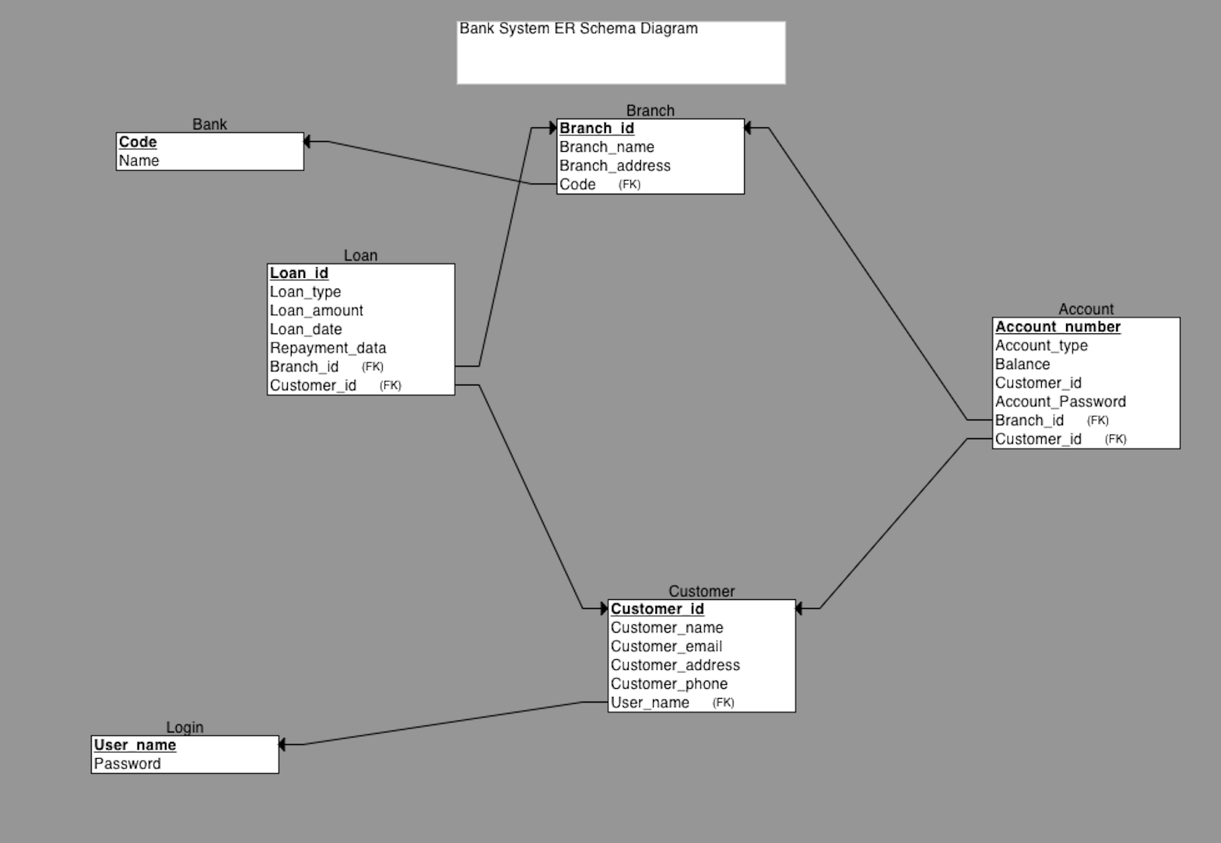

Step 7: Queries and Features

I will put some mysql code below: create table and insert some data, also create to function to set up *random* number for Loan ID and Bank Account

More action will show on project presentation (site part, site only run on my localhost, so, I do not have the site link for this project, but I will post everything to the GitHub and put the link below).

Link to the GitHub: https://github.com/eebbk-zhou/database_project

Mysql code:

create table Bank(

Code varchar(20) primary key,

Name varchar(40)

);

create table Login(

User_name varchar(40) primary key,

Password varchar(40)

);

create table Branch(

Branch_id int primary key,

Branch_name varchar(40),

Branch_address varchar(100),

Code varchar(20),

foreign key (Code) references Bank(Code)

);

create table Customer(

Customer_id mediumint not null AUTO_INCREMENT primary key,

Customer_name varchar(50),

Customer_email varchar(50),

Customer_address varchar(100),

Customer_phone varchar(20),

User_name varchar(40),

foreign key (User_name) references Login(User_name)

);

create table Account(

Account_Number int primary key,

Account_type varchar(50),

Balance int,

Customer_id mediumint,

Branch_id int,

foreign key (Customer_id) references Customer(Customer_id),

foreign key (Branch_id) references Branch(Branch_id),

Account_Password varchar(50)

);

create table Loan(

Loan_id int primary key,

Loan_type varchar(50),

Loan_amount int,

Loan_date date,

Repayment_date date,

Branch_id int,

Customer_id mediumint not null AUTO_INCREMENT,

foreign key (Customer_id) references Customer(Customer_id),

foreign key (Branch_id) references Branch(Branch_id)

);

DELIMITER //

CREATE FUNCTION Set_Account_number()

RETURNS int

BEGIN

DECLARE random_num INT;

declare max_number_limit int;

SET random_num = rand()*(9999999 - 1000000) + 1000000;

set max_number_limit = 9999999 - 1000000 + 1;

label1: WHILE ((random_num in (select Account_Number from Account)) and (max_number_limit != (select count(Account_Number) from Account))) DO

SET random_num = rand()*(9999999 - 1000000) + 1000000;

END WHILE label1;

RETURN random_num;

END; //

DELIMITER ;

DELIMITER //

CREATE FUNCTION Set_Loan_id()

RETURNS int

BEGIN

DECLARE random_num INT;

declare max_number_limit int;

SET random_num = rand()*(9999999 - 1000000) + 1000000;

set max_number_limit = 9999999 - 1000000 + 1;

label1: WHILE ((random_num in (select Account_Number from Account)) and (max_number_limit != (select count(Account_Number) from Account))) DO

SET random_num = rand()*(9999999 - 1000000) + 1000000;

END WHILE label1;

RETURN random_num;

END; //

DELIMITER ;

insert into Bank VALUES('Kent666888', 'Kent Start Bank');

insert into Branch values ('111', 'Kent Star Bank South Branch', '123 Water Street, Kent, Ohio', 'Kent666888');

insert into Branch values ('222', 'Kent Star Bank East Branch', '278 Morris Street, Kent, Ohio', 'Kent666888');

insert into Branch values ('333', 'Kent Star Bank North Branch', '728 Lake Street, Kent, Ohio', 'Kent666888');

insert into Branch values ('444', 'Kent Star Bank West Branch', '999 Main Street, Kent, Ohio', 'Kent666888');

insert into Login values ('jamesadams', 'jamesadams');

insert into Login values ('robertbaker','robertbaker');

insert into Login values ('johnclark', 'johnclark');

insert into Login values ('michaeldavis','michaeldavis');

insert into Login values ('williamevans', 'williamevans');

insert into Login values ('davidfrank', 'davidfrank');

insert into Login values ('richardhills', 'richardhills');

insert into Login values ('josephirwin', 'josephirwin');

insert into Login values ('thomasjones', 'thomasjones');

insert into Login values ('charlesklein', 'charlesklein');

insert into Login values ('christopherlopez', 'christopherlopez');

insert into Login values ('daniemason', 'daniemason');

insert into Customer VALUES (null, 'James Adams', 'james.adams@gmail.com', 'SGT Miranda McAnderson 6543 N 9th Street APO,', '1236667987','jamesadams');

insert into Customer VALUES (null, 'Robert Baker', 'robert.baker@gmail.com', 'Celeste Slater 606-3727 Ullamcorper. Street Roseville NH 11523', '1239872637','robertbaker');

insert into Customer VALUES (null, 'John Clark', 'john.clark@gmail.com', 'Theodore Lowe Ap #867-859 Sit Rd. Azusa New York 39531', '1249872838','johnclark');

insert into Customer VALUES (null, 'Michael Davis', 'michael.davis@gmail.com', 'Calista Wise 7292 Dictum Av. San Antonio MI 47096', '1239891234','michaeldavis');

insert into Customer VALUES (null, 'William Evans', 'william.evans@gmail.com', 'Kyla Olsen Ap #651-8679 Sodales Av. Tamuning PA 10855', '8894312234','williamevans');

insert into Customer VALUES (null, 'David Frank', 'david.frank@gmail.com', 'Forrest Ray 191-103 Integer Rd. Corona New Mexico 08219', '1458539834','davidfrank');

insert into Customer VALUES (null, 'Richard Hills', 'richard.hills@gmail.com', 'Hiroko Potter P.O. Box 887 2508 Dolor. Av. Muskegon KY 12482', '9873541234','richardhills');

insert into Customer VALUES (null, 'Joseph Irwin', 'joseph.irwin@gmail.com', 'Nyssa Vazquez 511-5762 At Rd. Chelsea MI 67708', '7831459878','josephirwin');

insert into Customer VALUES (null, 'Thomas Jones', 'thomas.jones@gmail.com', 'Lawrence Moreno 935-9940 Tortor. Street Santa Rosa MN 98804', '1248971234','thomasjones');

insert into Customer VALUES (null, 'Charles Klein', 'charles.klein@gmail.com', 'Ina Moran P.O. Box 929 4189 Nunc Road Lebanon KY 69409', '8886661424','charlesklein');

insert into Customer VALUES (null, 'Christopher Lopez', 'christopher.lopez@gmail.com', 'Aaron Hawkins 5587 Nunc. Avenue Erie Rhode Island 24975', '1245125674','christopherlopez');

insert into Customer VALUES (null, 'Daniel Mason', 'danie.mason@gmail.com', 'Hedy Greene Ap #696-3279 Viverra. Avenue Latrobe DE 38100', '5673341234','daniemason');

insert into Account values (Set_Account_number(), 'Checking accounts', '1000', 1, '111', 'jamesadams');

insert into Account values (Set_Account_number(), 'Savings accounts', '2424525', 2, '111', 'robertbaker');

insert into Account values (Set_Account_number(), 'Money market accounts', '232223', 3, '111', 'johnclark');

insert into Account values (Set_Account_number(), 'Brokerage accounts', '412231', 4, '444','michaeldavis');

insert into Account values (Set_Account_number(), 'Money market accounts', '757859', 5, '222', 'williamevans');

insert into Account values (Set_Account_number(), 'Checking accounts', '2231', 6, '222', 'davidfrank');

insert into Account values (Set_Account_number(), 'Brokerage accounts', '588321', 7, '444', 'richardhills');

insert into Account values (Set_Account_number(), 'Savings accounts', '67634', 8, '222', 'josephirwin');

insert into Account values (Set_Account_number(), 'Money market accounts', '311', 9, '333', 'thomasjones');

insert into Account values (Set_Account_number(), 'Brokerage accounts', '543344', 10, '333', 'charlesklein');

insert into Account values (Set_Account_number(), 'Checking accounts', '88998', 11, '333', 'christopherlopez');

insert into Account values (Set_Account_number(), 'Savings accounts', '997334', 12, '444', 'daniemason');

insert into Loan values (Set_Loan_id(), null, '0', null, null, '111', 1);

insert into Loan values (Set_Loan_id(), 'Car Loans', '100000', '2019-10-3', '2021-10-3', '111', 2);

insert into Loan values (Set_Loan_id(), null, '0', null, null, '111', 3);

insert into Loan values (Set_Loan_id(), 'Home Loans', '30000', '2019-10-3', '2021-10-3', '444', 4);

insert into Loan values (Set_Loan_id(), null, '0', null, null, '222', 5);

insert into Loan values (Set_Loan_id(), 'Home Loans', '44000', '2019-10-3', '2021-10-3', '222', 6);

insert into Loan values (Set_Loan_id(), null, '0', null, null, '444', 7);

insert into Loan values (Set_Loan_id(), 'Small Business Loans', '90000', '2019-10-3', '2021-10-3', '222', 8);

insert into Loan values (Set_Loan_id(), 'Small Business Loans', '300000', '2019-10-3', '2021-10-3', '333', 9);

insert into Loan values (Set_Loan_id(), null, '0', null, null, '333', 10);

insert into Loan values (Set_Loan_id(), 'Car Loans', '100000', '2019-10-3', '2021-10-3', '333', 11);

insert into Loan values (Set_Loan_id(), null, '0', null, null, '444', 12);