Nebula: Rocket Learning's memory for Claude
How it works and what it does today · October 2026
Nebula gives Claude access to Rocket Learning's own knowledge. People at Rocket Learning (RL) add one connector to their Claude. From then on, Claude can answer questions from RL's actual documents, keep what people learn, and show each person only what they're allowed to see.
We built Nebula and tested it end to end in October 2026 on a live deployment, with Google Drive and real Claude conversations. Google Drive is fully working. Notion and Granola connectors are built but not yet connected to live accounts.
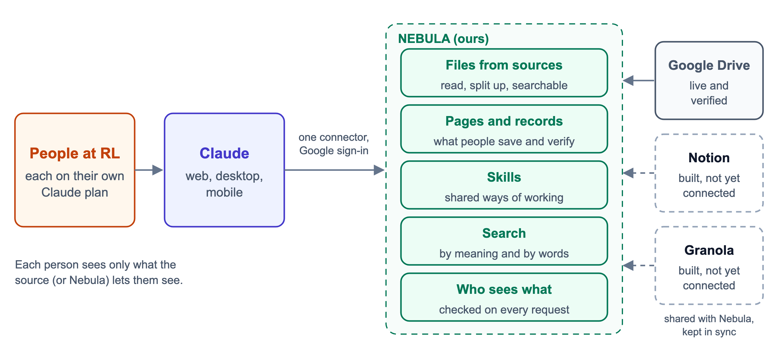
Figure 1. Nebula sits between Claude and RL's sources. People only ever talk to Claude.

How people use it
Everything happens inside Claude. Each person adds Nebula once as a custom connector in Claude and signs in with their Google account.

Bringing documents in
To bring material in, a person shares a Drive folder, a single file or a whole Shared Drive with Nebula's Google address, as an Editor. Nebula only ever reads; Editor is needed because Drive only tells editors who a file is shared with, and Nebula uses that to decide who may see each file.
Nebula checks for new shares every two minutes, then imports and indexes them automatically. Each file stays visible only to the people Drive shares it with. A file that reaches Nebula through two folders is stored once.
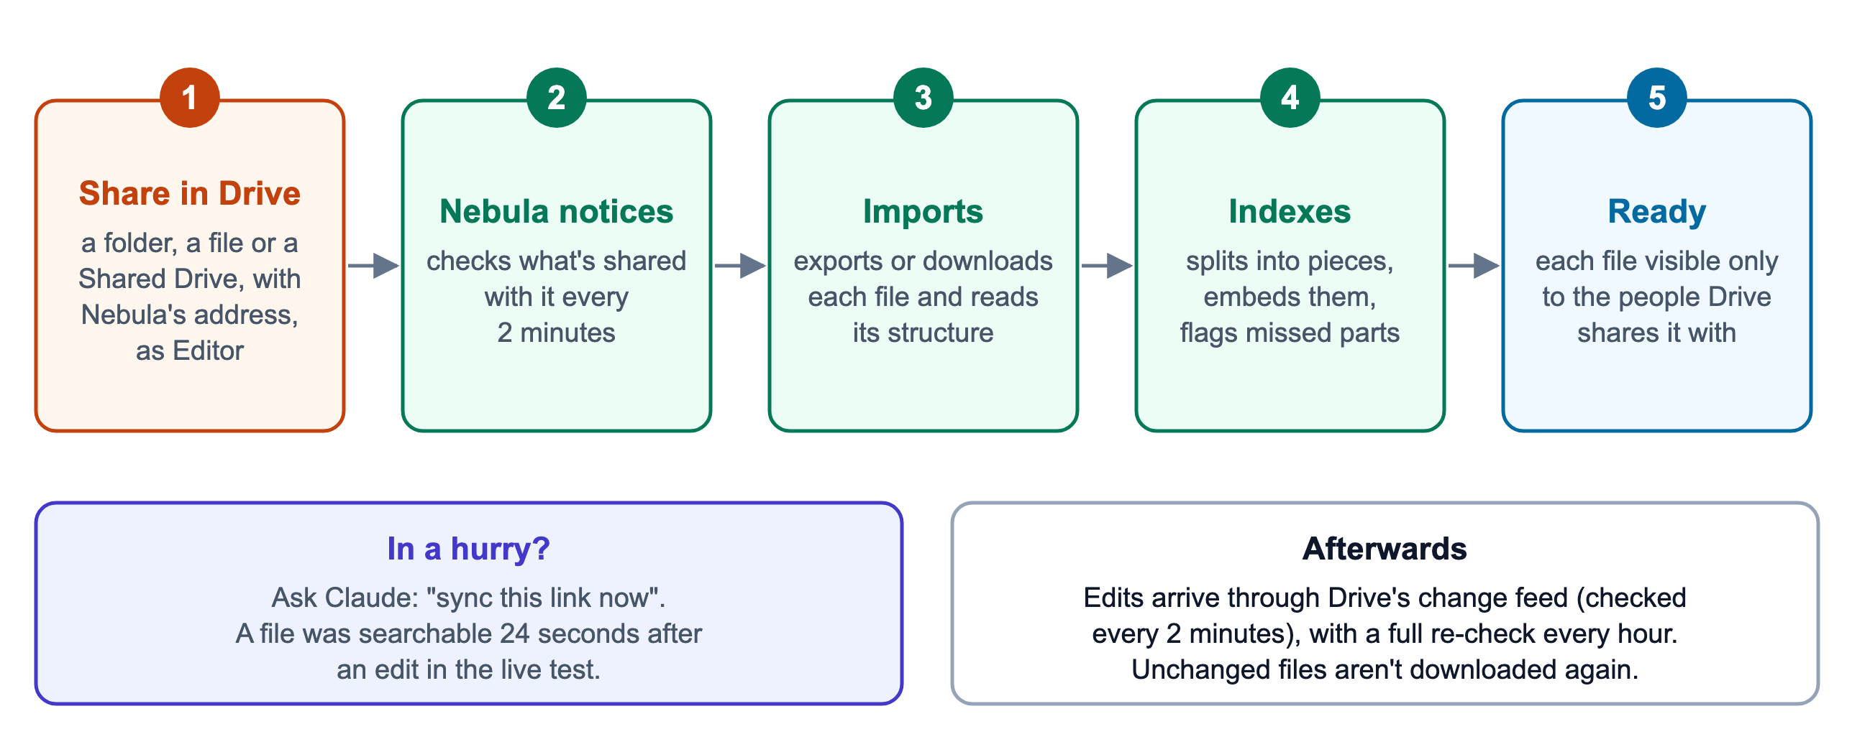
Figure 2. Sharing with Nebula is the whole setup. Asking Claude to sync a link makes it happen at once.

Asking a question
Claude searches Nebula first whenever someone asks about RL's work. Nebula finds matches by meaning and by exact words, re-ranks them, and removes anything the person isn't allowed to see before Claude gets the results. Claude reads short files whole and opens longer ones in full rather than answering from fragments. It cites the file and its date. When nothing relevant exists, it says so instead of guessing.
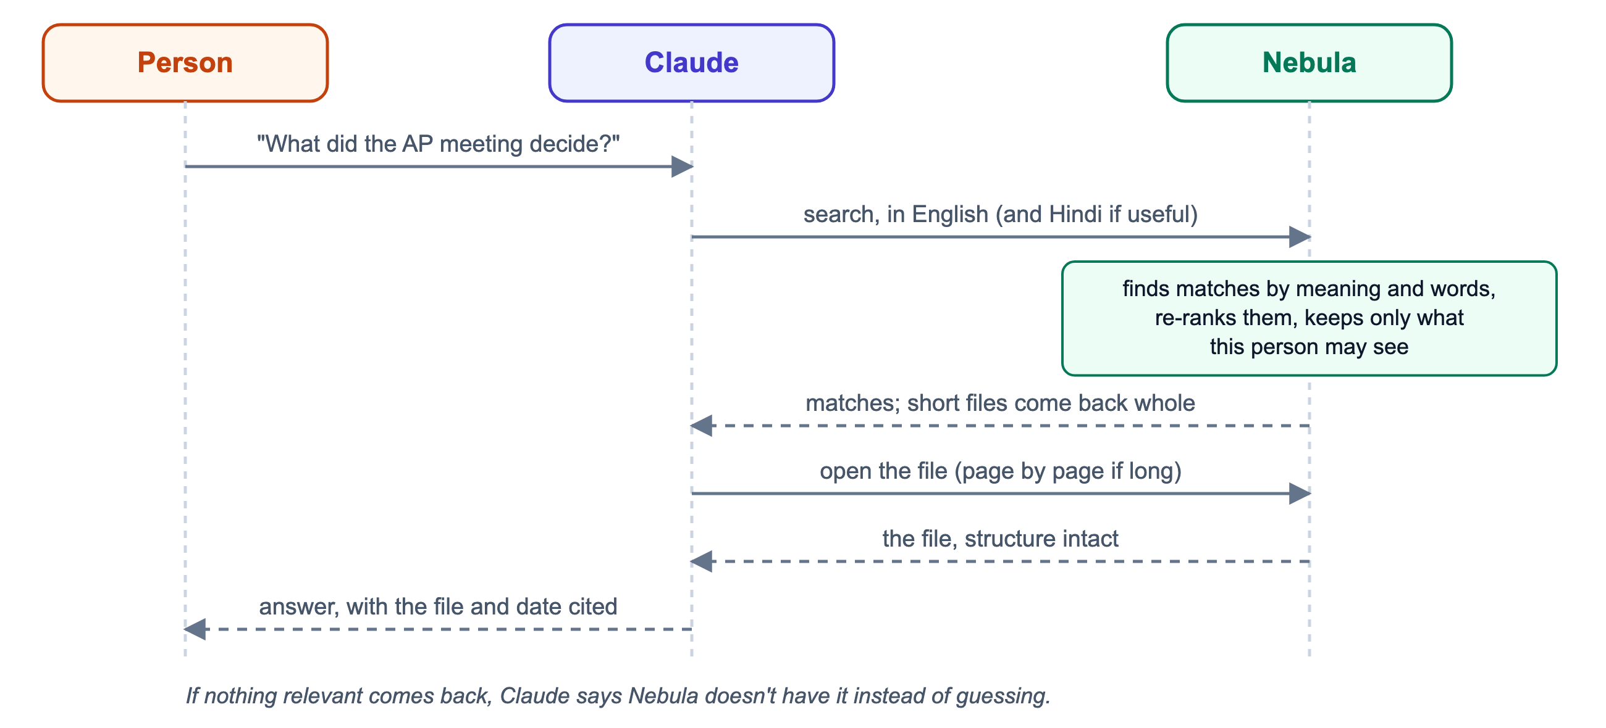
Figure 3. A question, end to end. The access check happens inside Nebula, before Claude sees anything.

Keeping files current
Edits in Drive reach Nebula through Drive's change feed, which Nebula checks every two minutes. Only files whose content changed are downloaded again, and only the changed parts are re-indexed. Someone who can't wait can tell Claude, "I've updated this doc, use the new version." Claude refreshes that one file and answers once it's ready. In testing, that took 24 seconds.
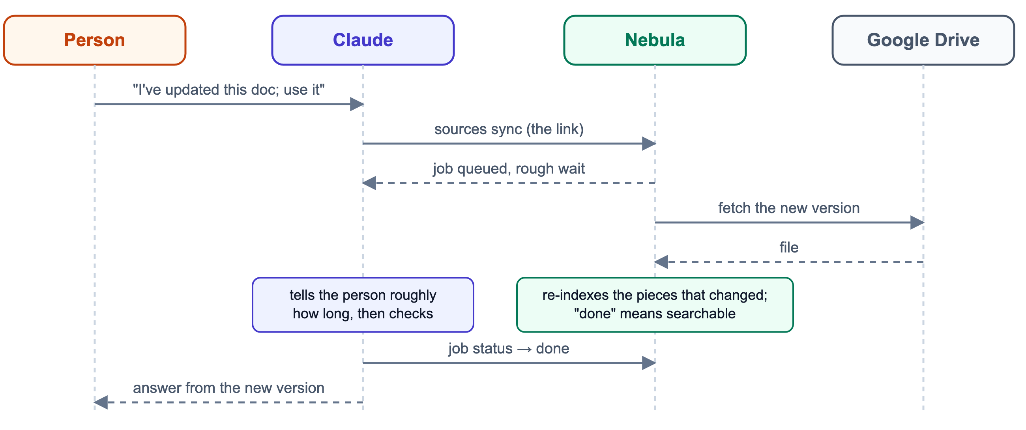
Figure 4. Refreshing one file on request. "Done" only comes back once the new version is searchable.

Reading what text extraction missed
Text extraction misses scanned pages, charts and pictures of tables. Nebula checks every file part by part and lists what it couldn't read. Claude can open such a part as an image, read it, and save what it says back to Nebula. From then on it's searchable for everyone who can open the file. Hindi typed in the old Kruti Dev font, common in government documents, is converted to proper Hindi automatically.
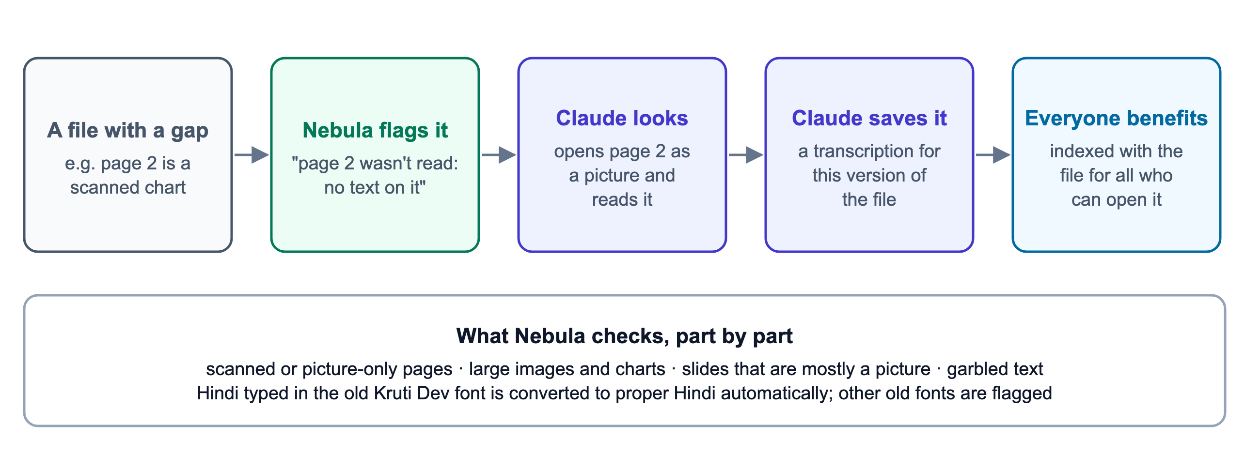
Figure 5. Filling a gap once, for everyone.

Saving and sharing knowledge
People can also ask Claude to save what they've worked out, such as a decision, a corrected figure, a lesson or a summary page about a programme. Saved items have an owner and are marked draft or verified, and corrections keep their history. Teams can share ways of working as reusable skills, and a lead can hand work over when someone changes role. This part is built and covered by automated tests, but hasn't been used for real work yet.

Who can see what
- Google Drive: each file follows its own Drive sharing, including Google Groups and the whole RL domain, and changes when the sharing does.
- Granola: a meeting note is visible to the people who were in the meeting.
- Notion: Notion doesn't expose who may read a page, so a collection is shared with a whole team and restricted pages are left out.
- Saved knowledge: belongs to a team or a person, and can be shared further on purpose.
Every search, open, download and spreadsheet query is checked against the person asking.
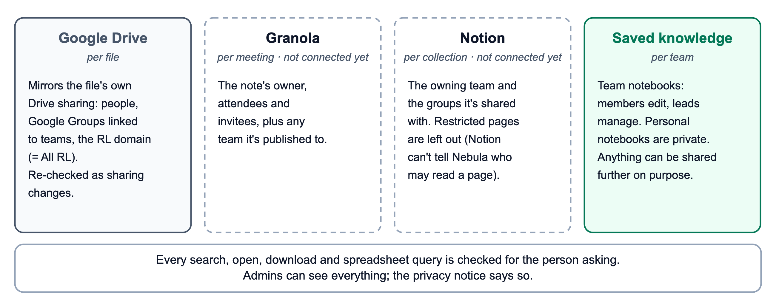
Figure 6. Who sees what, by source. The dashed sources are built but not yet connected.

How it's built
Nebula runs on AWS. Two containers run the code. The API service answers Claude through the Model Context Protocol (MCP) and handles Google sign-in, while the worker finds new shares, syncs and reads files, and prepares them for search. One PostgreSQL database holds people, access rules, file contents, saved knowledge, the search index (pgvector) and spreadsheet tables for number questions. Original files sit in S3. Nebula reads Drive without storing any Google key, and its multilingual search models run inside its own containers.
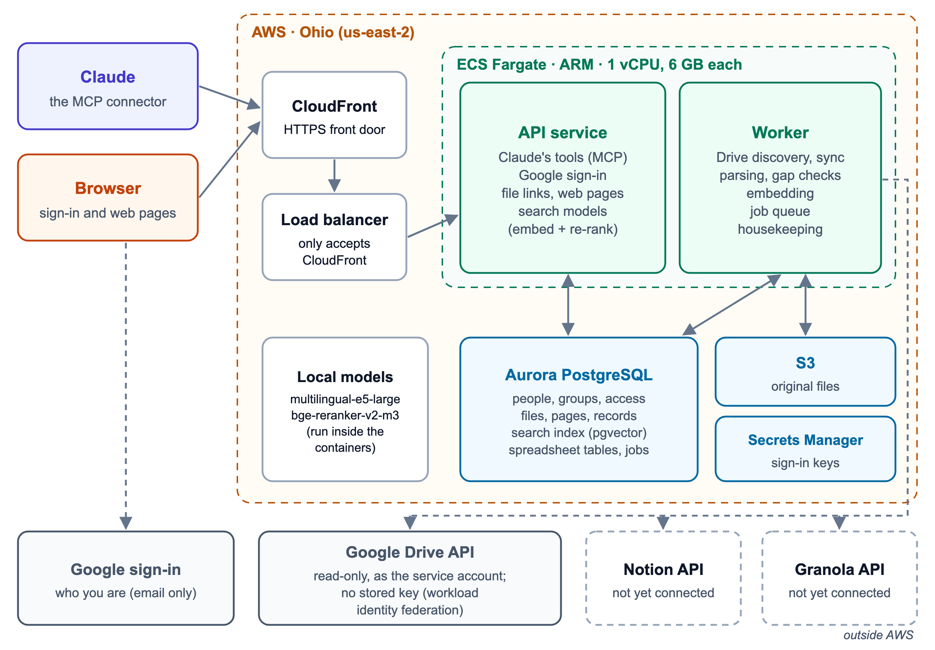
Figure 7. The deployment, and the outside services it talks to.
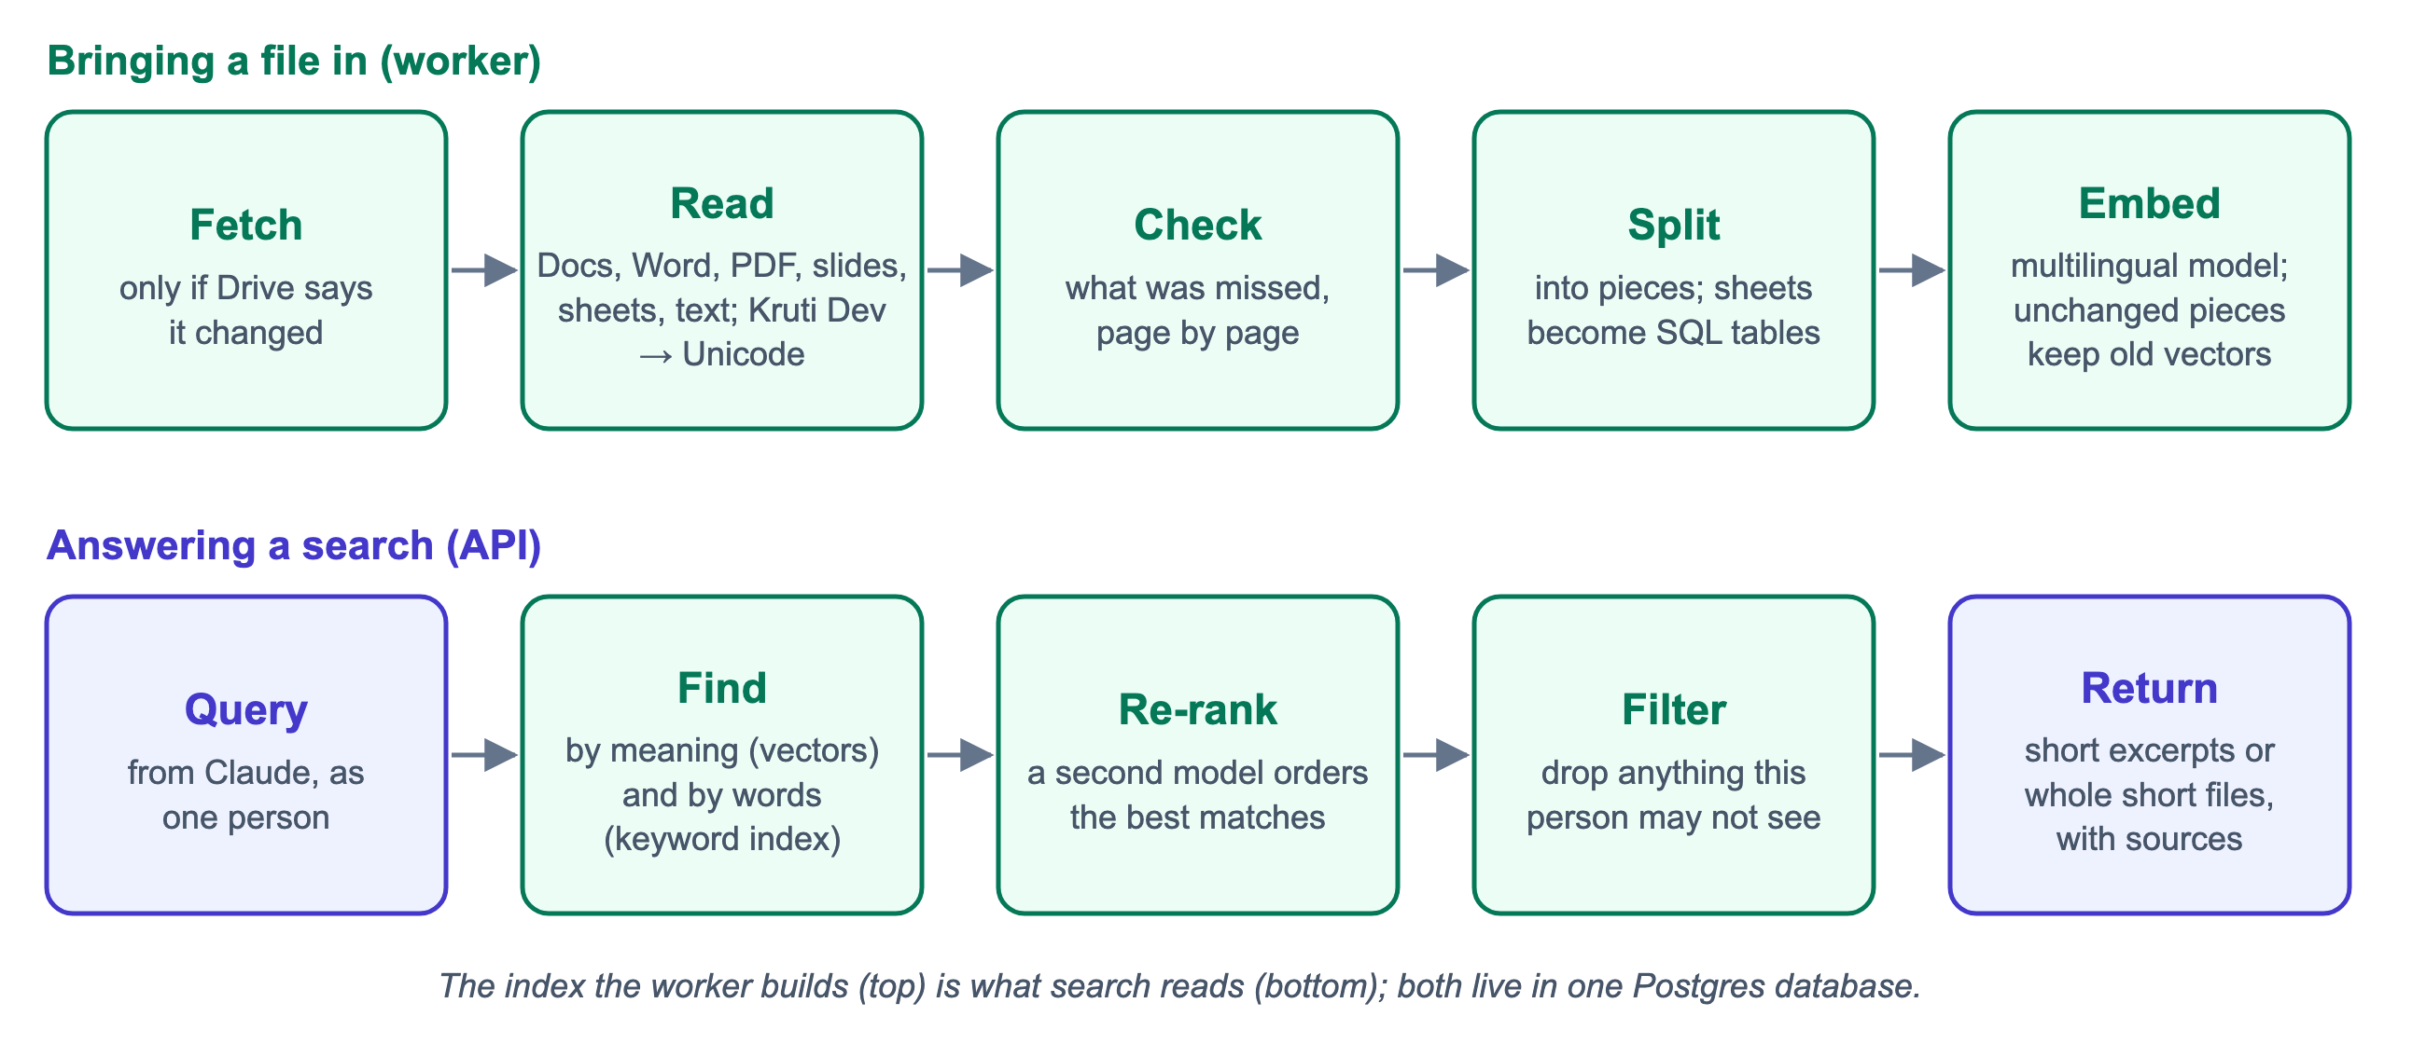
Figure 8. What happens to a file on the way in, and to a question on the way back.

What we've verified
These were tested on the live deployment with real Drive files and real Claude conversations.
What we tested | Result
Connecting Nebula to Claude and signing in with Google | Works
Finding and reading a shared Drive file | Each of the five people it was shared with found it and got the full text
The same file, for someone it isn't shared with | Couldn't find it or open it
Sharing a folder with Nebula | Picked up automatically, with who shared it
Editing a file in Drive | Change detected; the new version was searchable 24 seconds after a refresh request
"Use the new version" in a chat | Claude refreshed the file, waited, and answered from the new version
A long document (33,000 characters) | Read in full, beginning to end
A page that is only a chart | Claude read it from the image and saved it; it became searchable
A question the documents can't answer | Claude said Nebula doesn't have it rather than guessing
Behind these, 140 automated tests cover the product's behaviour, including who can see what.

What's still open, and what's next
Still open:
- Notion and Granola aren't connected to live accounts yet.
- Shared Drives haven't been tested live.
- Search speed hasn't been measured at scale.
- Writing changes back to Drive isn't built.
Next:
- Test with real RL questions. 38 are written, with expected answers, in English, Hindi and Hinglish.
- Connect Notion and Granola.
- Run a small pilot with a handful of people for two weeks.
- Tune search speed and add monitoring before a wider rollout.

