Running Nebula on AWS: what it costs
Estimate at on-demand list prices, us-east-2 · October 2026
The default stack costs about $166 a month, or about $5.50 a day, even when nobody uses it. Most of that is for parts that run around the clock: two containers, the database's minimum capacity, the load balancer and the public IP addresses. Use adds relatively little until the API scales out or the database works harder. A busier month, with three API containers and the database averaging 1 ACU, comes to about $288.
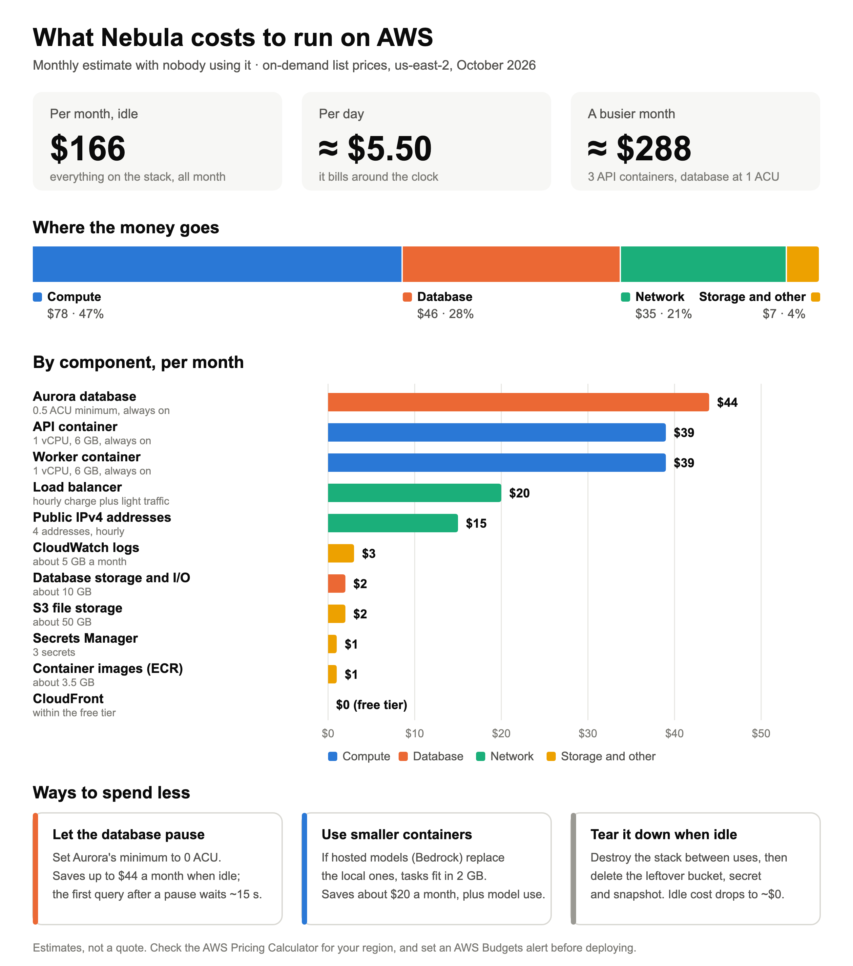

How each number is worked out
Each line is the AWS on-demand list price in us-east-2. Hourly charges are counted for 730 hours a month. Storage and logs assume light, early use.
Component | What it is | How it's priced | Monthly
Compute |  |  | $78
API container | 1 vCPU, 6 GB, ARM | $0.03238/vCPU-hour + $0.00356/GB-hour | $39
Worker container | 1 vCPU, 6 GB, ARM | Same as the API container | $39
Database |  |  | $46
Aurora database | 0.5 ACU minimum | $0.12 per ACU-hour | $44
Storage and I/O | About 10 GB | $0.10 per GB-month + I/O requests | $2
Network |  |  | $35
Load balancer | Application LB | $0.0225 per hour + light capacity use | $20
Public IPv4 addresses | 4 addresses | $0.005 per address-hour | $15
CloudFront | HTTPS front door | Within the free tier (1 TB a month) | $0
Storage and other |  |  | $7
CloudWatch logs | About 5 GB a month | $0.50 per GB ingested | $3
S3 file storage | About 50 GB | $0.023 per GB-month plus requests | $2
Secrets Manager | 3 secrets | $0.40 per secret a month | $1
Container images (ECR) | About 3.5 GB | $0.10 per GB-month | $1
Total, idle |  |  | $166

Ways to spend less
- Let the database pause. Set Aurora's minimum capacity to 0 ACU and it pauses when idle, saving up to $44 a month. The first query after a pause waits about 15 seconds.
- Use smaller containers. The 6 GB per container is for the search models running locally. If a hosted model service such as Amazon Bedrock replaces them, the containers fit in 2 GB, which saves about $20 a month (the model calls are then billed per use).
- Tear it down when idle. Destroying the stack stops nearly all of the cost. The S3 bucket, the app secret and a final database snapshot are kept on purpose, so delete those by hand too.

Keep an eye on it
Before deploying, set an AWS Budgets alert a little above the expected monthly figure, so a surprise shows up in days rather than on the bill. A few days after any deploy, check the actual spend in Cost Explorer against this estimate. Prices change, so confirm them in the AWS Pricing Calculator for your region.

