* Git/GitHub - Pushing a changed project
* From the file where the .git folder is on your project

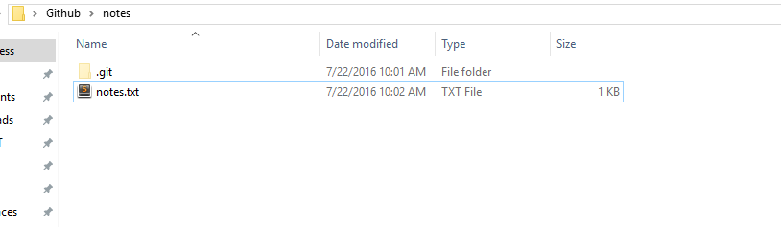

* R-click to ‘git bash here’
* ‘git status’ to see the changed files

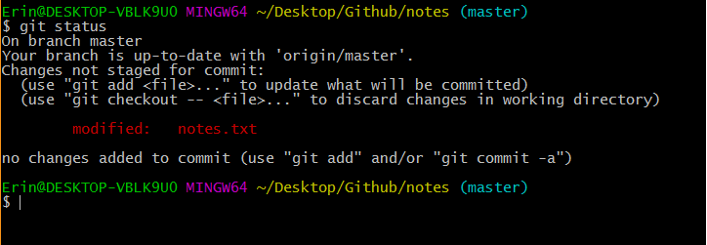

* ‘git add .’ to add only modified or new files since the last commit
* ‘git status’ to see that they are now staged
* (I added another document here so that’s why there is a surprise .docx)

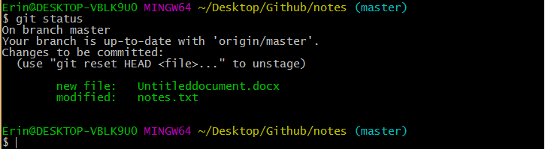

* ‘git commit -m “your message here”

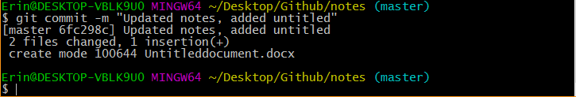

* ‘git status’ to see you are ready to push
* The Key line here is “Your branch is ahead of ‘origin/master’ by 1 commit.

(use “git push” to publish your local commits)

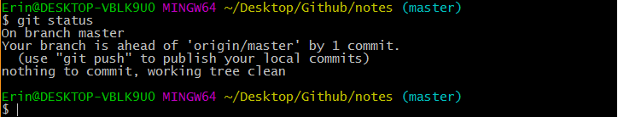

* Now we ‘git push’ to publish

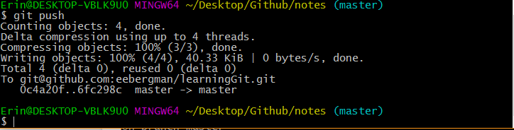

Things to remember!!

Git wants to help you. If you can’t remember the correct way to finish typing a command type

‘Git’ and press ‘tab’ until it offers you a list of commands.

Check your online repo to make 100% sure that your updates were correctly published online. That is the most important part of Version Control. That is where our commits are saved away from our computer in case the files are corrupted, the whole computer gets corrupted, or even worse your laptop goes missing.