* Git/Github - Pushing a new project

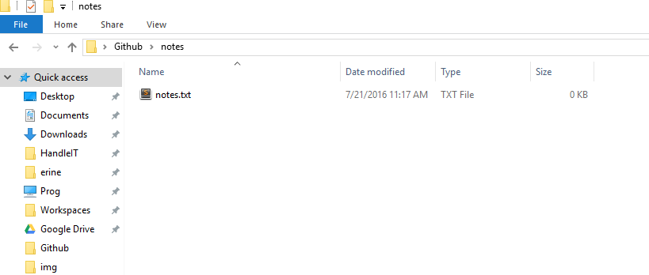

* R-click in the white space
* And click “Open Git Bash Here”

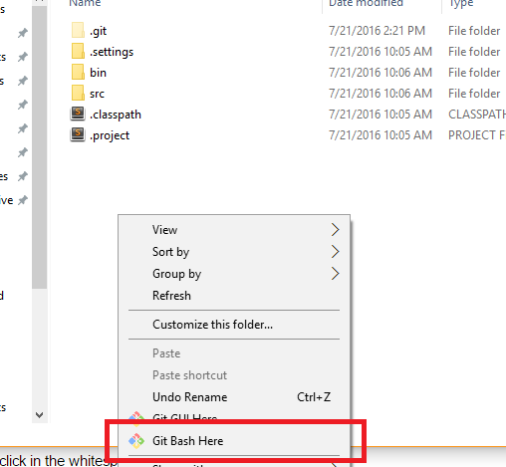

* Use the command ‘git init’ to initialize a new local git repo

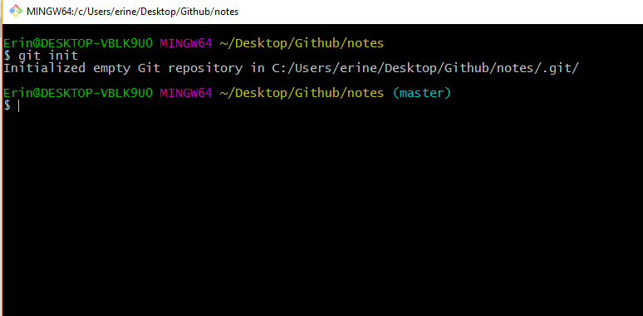

* ‘git status’ will show that our new project is currently still unstaged

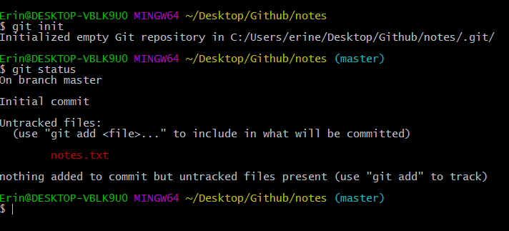

* ‘git add .’ Is used to stage the changes or new files
* ‘git status’ to see those changes

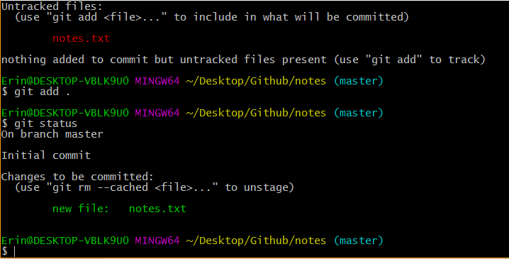

* ‘git commit -m “insert your comment here”
  + flag m (-m) is used to tell git that you are inserting a message about the commit

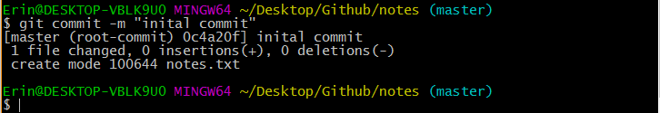

* Now we must create the online repo at github.com
* From your Github Profile, in the upper right corner click on the +



* And select ‘New repository’

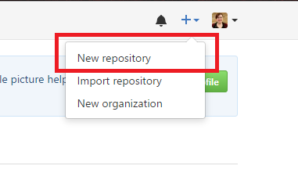

* Now name your new online repo
* Do not add a .gitignore
* Do not initialize with a README
* Click ‘Create Repository’

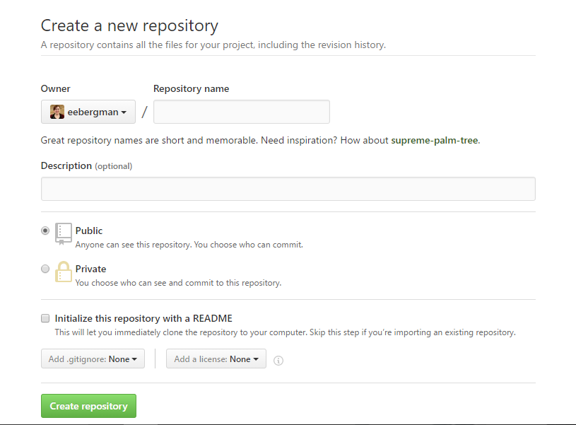

* Because we initialized a local repo on our computer already
* We are going to copy the two lines from the second option on this page
* Click the ‘copy to clipboard button’ on the far right

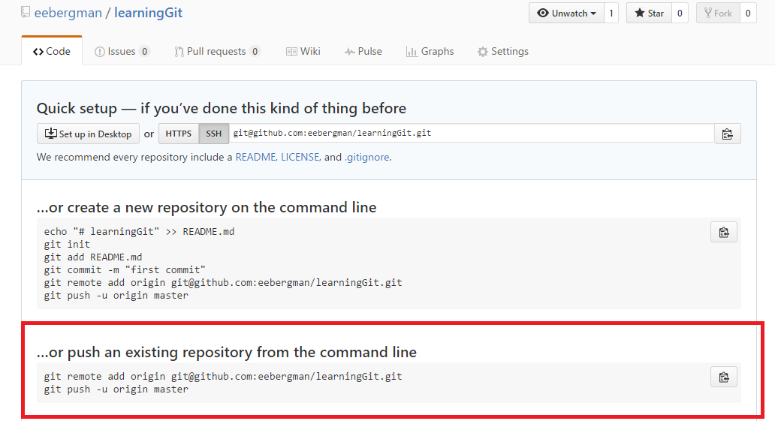

* Now back to the command line
* Right click to paste in here.
* It automatically submits the first line for you but waits for you to submit the second
* The first line tells your local repo where on the internet to find your remote repo
* The second pushes the local repo to the remote repo

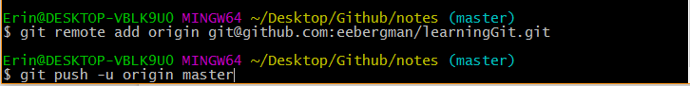

* Now, press enter to send the final push

