* Git/GitHub - Pushing a changed project
* From the file where the .git folder is on your project

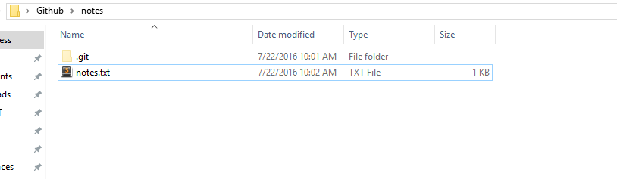

* R-click to ‘git bash here’
* ‘git status’ to see the changed files

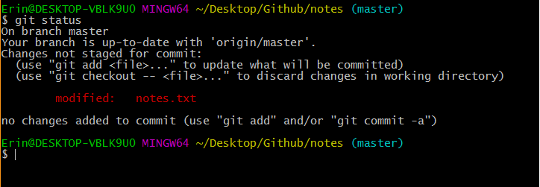

* ‘git add .’ to add only modified or new files since the last commit