Recovering the Learner: Institutional Design for Three Founding Principles of Higher Education
A case study in governance design for a federated public university under German higher education law
2026

Abstract
The founding arrangement of the University of Bologna, established at the close of the eleventh century, embedded three structural principles that most contemporary universities no longer exhibit: learning was the institution's actual purpose rather than an input to institutional survival; the accountability relationship ran from the institution toward the learner rather than the reverse; and the range of what was taught followed demonstrated need rather than inherited disciplinary supply. Over nine centuries, this arrangement inverted, gradually and without any single deliberate decision, into the institution-centred governance familiar today. This paper examines a contemporary institutional design — a federated, fully online public university operating under the higher education law of Baden-Württemberg, Germany — that attempts to recover these three principles as binding governance commitments rather than aspirational language. For each principle, the paper sets out the concrete governance mechanics already in place and the specific institutional innovation required to make the principle operative, arguing throughout that the limiting factor is interpretive rather than legal: existing German higher education statute permits considerably more learner-centred design than institutional convention typically exercises.
Keywords: higher education governance, learner-centred design, federated university, German higher education law, institutional accountability

Introduction
When the University of Bologna took shape in the late eleventh century, its governing logic was, by modern standards, unusual: students hired their professors, set the terms of engagement, and could dismiss a professor who failed to deliver. The knowledge a student sought — most often Roman law, at a moment when Europe's political order badly needed a vocabulary for reasoning about sovereignty and authority — was the point. Certification was secondary. Accountability ran from the professor toward the student, not from the student upward through an institutional hierarchy.
This is not offered as a romantic origin story. Medieval Bologna served a narrow population — wealthy men who could afford to travel and study for years without earning — and its exclusions were real and serious. What is offered instead is a structural observation: three principles were architecturally present in that original design, and each has progressively diminished across the centuries since, not through any single decision but through the accumulation of institutional self-preservation layered on top of an original purpose that gradually became invisible. Modern universities are shaped by accreditation compliance, ranking position, research output metrics, and enrolment retention — all pursued, nominally, in the name of learning, yet structurally disconnected from whether learning actually occurs.
Three principles, reconstructed from that founding arrangement, form the organising structure of this paper:
Principle 1 — Learning is the goal
An institution exists to produce learning — not credentials, not research output, not ranking position, not accreditation compliance as ends in themselves.

Principle 2 — The learner directs the learning relationship
Accountability runs toward the learner's development and access, not toward the institution's self-preservation.

Principle 3 — What is available to learn is determined by learner need
The range of what an institution teaches follows demonstrated need, not inherited disciplinary structure or supply-side convenience.

This paper examines how these three principles are being operationalised — deliberately, structurally, and as binding governance commitments — in the design of a newly established federated public university in Baden-Württemberg, Germany. The institution is built to serve learners the traditional campus model structurally excludes: working adults, caregivers, people without local access to a university, and career changers seeking modular, verifiable qualification rather than a multi-year residential commitment. It operates entirely within the German Land's higher education statute (the Landeshochschulgesetz), and every mechanism described below is either already specified in the institution's founding governance documents or grounded directly in a provision of that statute.
The paper's central claim is a modest but, in the authors' experience, underappreciated one: recovering learner-centred governance in a modern, legally regulated higher education system is substantially an interpretive project rather than a legislative one. Existing statute typically permits more structural innovation than institutional habit exercises. Each of the three sections below therefore does two things: it describes the concrete governance mechanics that operationalise one of the three principles, and it identifies the specific point at which the institution had to look past conventional practice — not past the law — to make that mechanism real.

Part I — Learning Is the Goal
The problem this principle addresses: modern institutions reward proxies — grades, throughput, publication counts, retention rates — that can be optimised independently of whether learning actually occurs. A student who asks "what do I need to know?" and a student who asks "what do I need to do to pass?" occupy different educational relationships, even seated in the same room.

Governance mechanics
- Credentials are issued at the level of the completed learning module, not only at the point of degree completion. Partial progress therefore carries real, portable, externally verifiable value from the first completed unit onward, rather than value being withheld until a multi-year commitment is finished.
- Curriculum is organised around demonstrated competency — what a learner can actually do — rather than content coverage. A dedicated academic body holds authority over this standard, and that authority is structurally insulated from short-term financial or enrolment pressure: no executive or administrative body may direct how curriculum quality is assessed.
- Institutional performance is tracked through two deliberately separate instruments rather than one blended dashboard: a health-monitoring instrument (is the institution currently functioning — enrolment, completion, satisfaction) and a transformation-tracking instrument (is the institution becoming what it said it would become — measured through learner capability and outcome indicators). Keeping these separate prevents healthy monitoring numbers from quietly substituting for evidence of actual learning progress.
- A recurring, peer-based developmental review asks, on its own terms, whether the institution is achieving the purpose it set for itself — deliberately distinct from, and conducted prior to, formal accreditation compliance review, which asks a narrower question about regulatory conformity.

The innovation required
Nothing in German higher education law requires content-transmission pedagogy or grade-centred assessment. A German university's examination regulations (Prüfungsordnung) are an institution-authored instrument, not a state-dictated syllabus, and the statute grants considerable latitude in assessment design. The innovation is not, therefore, a workaround of legal constraint. It is a specific governance design choice available under ordinary university statute and rarely exercised: the deliberate constitutional insulation of academic and curricular authority from the bodies responsible for financial sustainability and executive strategy. Where that insulation is absent — where financial or enrolment pressure can, even informally, shape what counts as a passing standard — institutional survival will eventually be optimised for at learning's expense, regardless of the mission statement in force at founding. Building that insulation into the university's own binding statute, rather than leaving it as good practice, is the structural move this principle requires.
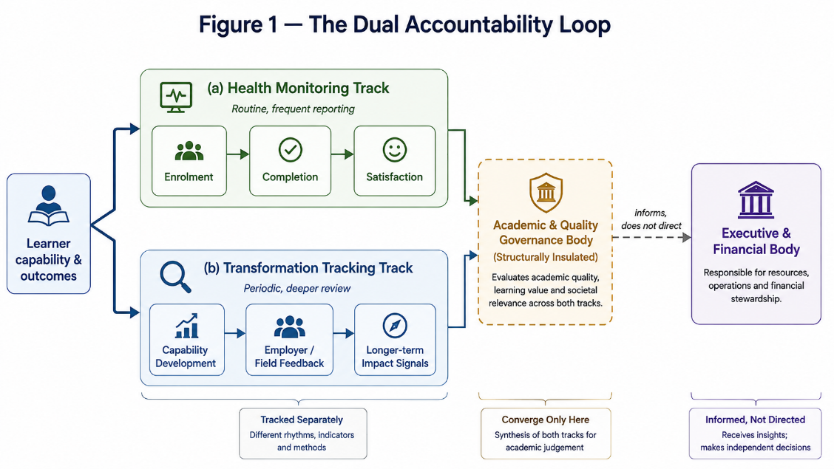
Figure 1: : Institutional performance is measured on two axes that are tracked separately so one cannot substitute for the other

Part II — The Learner Directs the Learning Relationship
The problem this principle addresses: student "voice" mechanisms in most universities are advisory, symbolic, or structurally disconnected from the bodies that actually hold decision authority — participation without power. Genuine self-governance, as the literature on institutional design has long shown, depends on participants having real standing in rule-making and monitoring, not merely a channel for expressing an opinion that a separate body may disregard.

Governance mechanics
- Students hold statutory voting seats in the university's central academic governance body — not a consultative role, but a genuine vote in the body that sets academic standards and approves curricula.
- Deliberation and formal decision are structurally separated. Alongside the bounded, formal voting session, the same academic community convenes in a distinct, recurring deliberative forum whose explicit purpose is unhurried strategic conversation before matters are put to a vote — so participation is not reduced to ratifying decisions effectively made elsewhere.
- A parallel mechanism extends this logic outward: representatives of the wider society the institution serves — regional employers, alumni, civic actors — are given not merely a seat but an explicit obligation to raise concerns proactively rather than wait to be asked, with their findings made public rather than filed internally. Silence from this body is treated as a signal worth investigating, not a reassurance.
- Teaching staff whose engagement with the institution becomes substantial and sustained — beyond an occasional guest contribution — can earn individual voting standing in academic governance, grounded in a specific statutory category that most institutions' founding documents leave unused without ever examining whether it applies.

The innovation required
German higher education law delegates meaningful discretion to a university's own founding statute over the voting rights of academic staff engaged through formal inter-institutional cooperation arrangements, as distinct from staff merely co-opted from another institution on an informal basis. In practice, most founding statutes do not exercise this discretion; they default to the narrower, more conservative reading without confirming that the broader reading is actually foreclosed. The innovation demonstrated here was procedural rather than legislative: reading the statute's operative text directly, rather than relying on institutional convention or secondary summary, and finding that "the most restrictive plausible interpretation" and "what the law in fact permits" were not the same thing. The same discipline — checking a claim against primary legal text rather than accepting an inherited institutional habit — is the transferable lesson of this section, independent of the specific statutory provision involved.

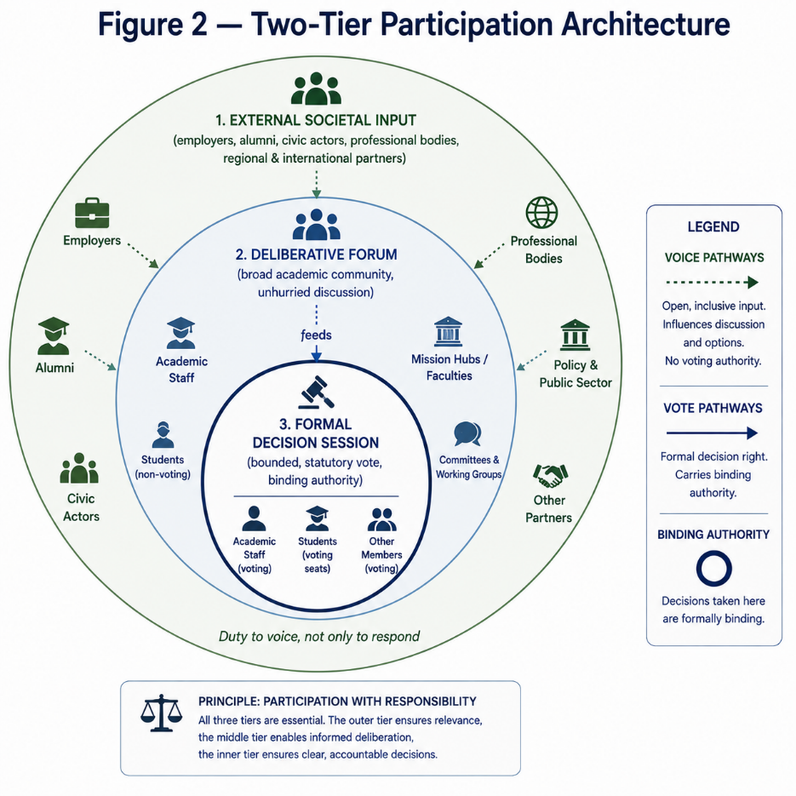

Part III — What Is Available to Learn Is Determined by Learner Need
The problem this principle addresses: faculty and departmental structures in most universities are, once established, effectively permanent. They are organised around inherited academic disciplines — a supply-side logic — rather than around the problems learners and society actually need addressed, and restructuring or closing an academic unit happens rarely, regardless of whether its continued relevance can still be demonstrated.

Governance mechanics
- Academic units are organised explicitly around real-world societal challenges rather than inherited disciplines, under an enforced rule that no unit may be named for a single academic discipline alone. A unit addressing, for instance, health in an ageing population necessarily draws on computer science, medicine, ethics, and public policy simultaneously, rather than each discipline being housed in a separate, self-contained department.
- A formal, statute-grounded lifecycle governs these units — not only how a unit is created, but an explicit procedure and defined trigger conditions for renaming it and, crucially, for closing a unit whose societal relevance has genuinely lapsed. Very few universities specify a closure procedure for an academic unit at all.
- Opening, closing, or substantially reshaping a unit must rest on a documented case of societal need, combining a qualitative account (does an external, independent panel still find this challenge compelling) with a quantitative one (is the unit demonstrably achieving what it set out to achieve, against a stated, measurable objective). Ordinary organic growth of an existing programme — new specialisations, enrolment growth — is explicitly exempted from this heavier process and remains a fast, local decision, so responsiveness to genuine need does not collapse into bureaucratic overhead on routine curricular development.
- A federated delivery model allows partner institutions to contribute existing teaching capacity into a shared credentialing architecture, so the range of what is available to learners can expand to meet demonstrated demand without every institution needing to duplicate every discipline internally.

The innovation required
German higher education law leaves the internal organisational structure of a university — how it divides itself into faculties or comparable units, and under what conditions those units are created or dissolved — very substantially to the institution's own statute. A comparative review of several European universities' actual governing texts shows this authority typically concentrated in a university's executive leadership or its external oversight body, with the academic senate holding, at most, a consultative role rather than the decisive one commonly assumed. The innovation here is the deliberate use of that latitude: building an explicit, documented societal-need requirement into the creation and closure of academic units, where comparable institutions default to unstructured executive or purely internal discretion. This does not require new legislation. It requires an institution willing to specify, in its own binding statute, a standard of justification for its own structure that most institutions leave implicit or unstated entirely.

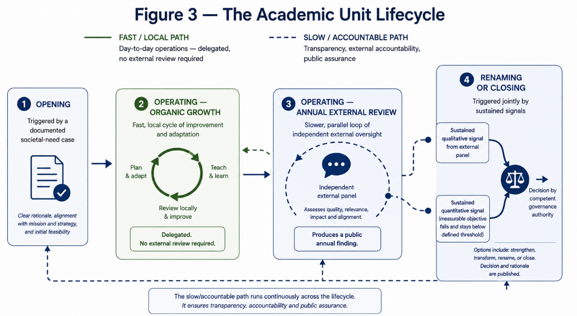

Conclusion
Three principles, three sets of governance mechanics, and one recurring finding: very little of what is required to recover learner-directed governance actually requires new legislation. In each of the three cases examined above, the structural room already existed within current German higher education law. It went unused not because the law forecloses it, but because institutional convention defaults to the narrowest available interpretation and rarely tests that default against the statute's actual text. The single most transferable lesson of this design work may be procedural rather than architectural: read the law itself, not the inherited institutional habit of reading it.
Two honest qualifications belong at the close of this argument, not buried within it. First, specification is not the same as lived practice. Every mechanism described above is structurally in place; none has yet been tested by the pressures — financial, political, reputational — that will eventually test it in genuine operation. A governance architecture that reads well on paper is a necessary condition for learner-centred governance, not a sufficient demonstration of it. Second, recovering these three principles does not mean recreating medieval Bologna, nor should it. The original arrangement served a narrow population under conditions with no bearing on twenty-first-century access, equity, or scale. What transfers across nine centuries is not the specific arrangement but its directional logic: an institution that takes learning seriously must be willing to treat the direction of its own accountability — toward the learner, or toward itself — as a design choice requiring active, continuous defence, rather than a default setting that drifts, gradually and without any single decision, toward institutional self-preservation. That drift is, after all, exactly how the original arrangement was lost the first time.

References
Council of the European Union. (2022). Council Recommendation on a European approach to micro-credentials for lifelong learning and employability.
Deci, E. L., & Ryan, R. M. (1985). Intrinsic motivation and self-determination in human behavior. Plenum.
Dewey, J. (1916). Democracy and education: An introduction to the philosophy of education. Macmillan.
European Higher Education Area. (2018). Paris Communiqué.
European Higher Education Area. (2020). Rome Communiqué.
Freire, P. (1970/2000). Pedagogy of the oppressed. Continuum.
Hirschman, A. O. (1970). Exit, voice, and loyalty: Responses to decline in firms, organizations, and states. Harvard University Press.
Illich, I. (1971). Deschooling society. Harper & Row.
Ostrom, E. (1990). Governing the commons: The evolution of institutions for collective action. Cambridge University Press.
Vygotsky, L. S. (1978). Mind in society: The development of higher psychological processes. Harvard University Press.

