Open University of Germany (OUG)
OUG Skill Profile Atlas
Competence coverage, progression, AI readiness and human capabilities
Bachelor of Computer Science (B.Sc.)
Assembled: 2026-07-30

31  Modules | 192  Total ECTS | 141  Unique skills | 23  Domains touched | 38  AI-related skills | 57  Human-tagged skills
Generated from machine-readable module and competence data.

Report contents
- Module index
- Executive skill profile
- Competence-domain inventory
- Bloom taxonomy profile
- AI skill profile
- Human and meta-skill profile
- Progression by academic year
- Profiles by stream
- Domain coverage across streams
- Module skill profiles

Module index
Code | Module | Stream | Year | Sem. | ECTS | Skills
T4INF1601 | Scientific Programming & Experimentation | Data, AI & Intelligent Systems | 1 | — | 5 | 15
T4INF1602 | Foundation of Intelligent Systems | Data, AI & Intelligent Systems | 1 | — | 5 | 16
T4INF1001 | Mathematics I — Linear Algebra | Mathematical & Theoretical Foundations | 1 | — | 5 | 4
T4INF1002 | Theoretical Computer Science I — Logic and Formal Foundations | Mathematical & Theoretical Foundations | 1 | — | 5 | 4
T4INF1003 | Theoretical Computer Science II — Algorithms and Complexity | Mathematical & Theoretical Foundations | 1 | — | 5 | 4
T4INF1007 | Mathematics II — Analysis | Mathematical & Theoretical Foundations | 1 | — | 5 | 3
T4INF1004 | Programming | Programming & Software Construction | 1 | — | 5 | 17
T4INF1101 | Web & Application Engineering | Programming & Software Construction | 1 | — | 5 | 15
T4INF1005 | Key Skills | Research, Professional & Societal Practice | 1 | — | 5 | 11
T4INF1006 | Computer Engineering I — Digital Technology | Systems, Platforms & Security | 1 | — | 5 | 8
T4INF2003 | Software Engineering Fundamentals | Unknown | 1 | — | 5 | 37
T4_1000 | Work Integrated Project I | Work Integrated Learning / Praxisprojekte | 1 | — | 20 | 6
T4INF2004 | Database Systems | Data, AI & Intelligent Systems | 2 | — | 6 | 15
T4INF2601 | Data Science | Data, AI & Intelligent Systems | 2 | — | 5 | 18
T4INF9006 | Design Thinking | Human-Centred & Societal Computing | 2 | — | 5 | 18
T4INF2001 | Mathematics III — Applied Mathematics and Statistics | Mathematical & Theoretical Foundations | 2 | — | 6 | 4
T4INF2002 | Theoretical Computer Science III — Formal Languages and Compiler Construction | Mathematical & Theoretical Foundations | 2 | — | 6 | 4
T4INF2005 | Computer Engineering II | Systems, Platforms & Security | 2 | — | 8 | 10
T4INF2006 | IT Security | Systems, Platforms & Security | 2 | — | 5 | 10
T4_2000 | Work Integrated Project II | Work Integrated Learning / Praxisprojekte | 2 | — | 20 | 6
T4INF3103 | Database Systems II | Data, AI & Intelligent Systems | 3 | — | 5 | 17
T4INF3915 | Technology Seminar Applied Artificial Intelligence | Data, AI & Intelligent Systems | 3 | — | 5 | 14
T4INF4902.1 | Selected Topics in Computer Science — Natural Language Processing | Data, AI & Intelligent Systems | 3 | — | 5 | 13
T4INF4348 | Human-Machine Interaction | Human-Centred & Societal Computing | 3 | — | 5 | 20
T4INF4900 | Gamification | Human-Centred & Societal Computing | 3 | — | 5 | 14
T4INF3102 | Advanced Software Engineering | Programming & Software Construction | 3 | — | 5 | 21
T4INF4900.1 | Games and Gaming | Programming & Software Construction | 3 | — | 3 | 17
T4INF3906 | Applied Computer Science Research | Research, Professional & Societal Practice | 3 | — | 5 | 10
T4INF4324 | Consulting, Technical Sales and Law | Research, Professional & Societal Practice | 3 | — | 5 | 11
T4INF4902 | Quantum Computing | Systems, Platforms & Security | 3 | — | 5 | 8
T4_3000 | Work Integrated Project III | Work Integrated Learning / Praxisprojekte | 3 | — | 8 | 5

Executive skill profile
How to read this profile
Counts show how often a competence appears across the selected modules. Unique-skill counts remove repetition, while learning-outcome occurrences show curricular emphasis. Bloom levels describe the cognitive demand encoded in the learning outcomes; they are not grades or performance results.

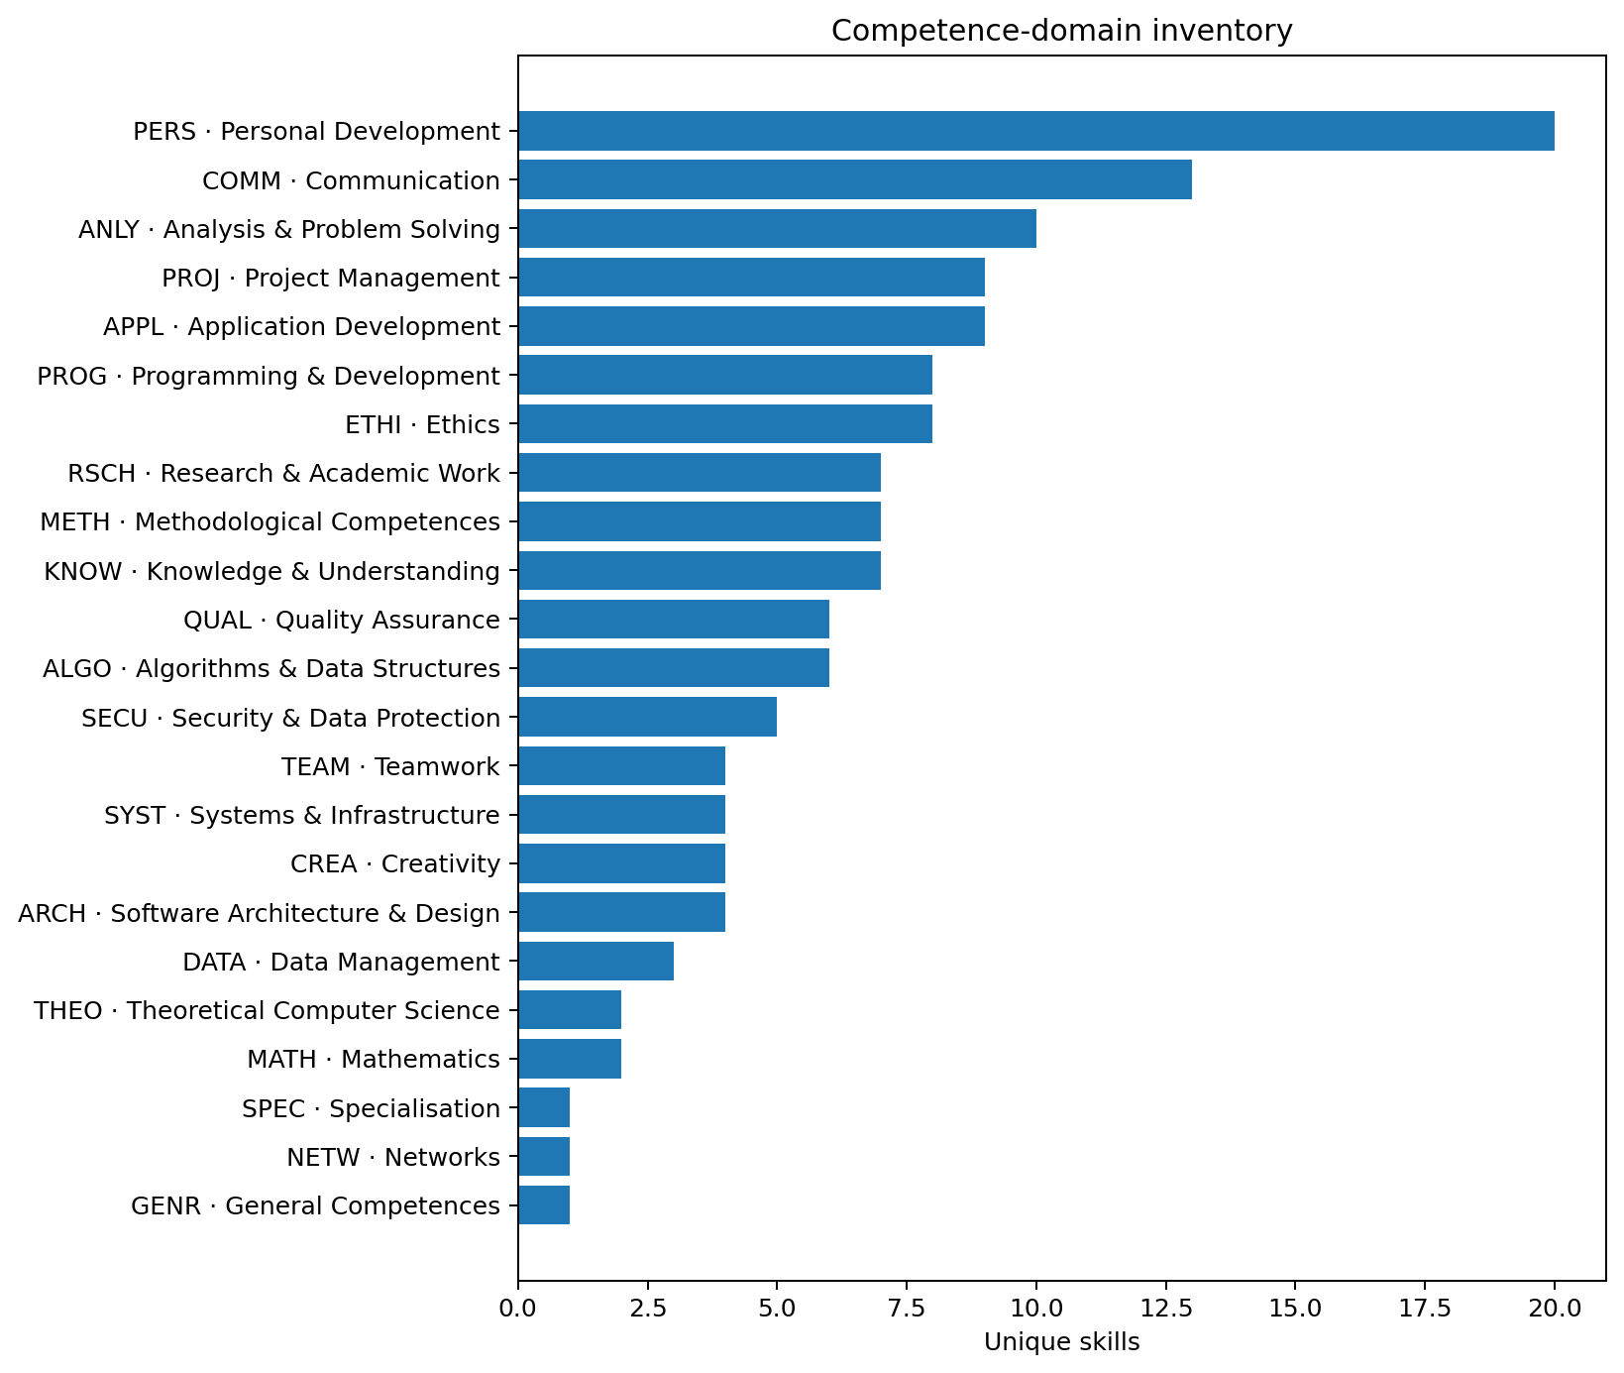
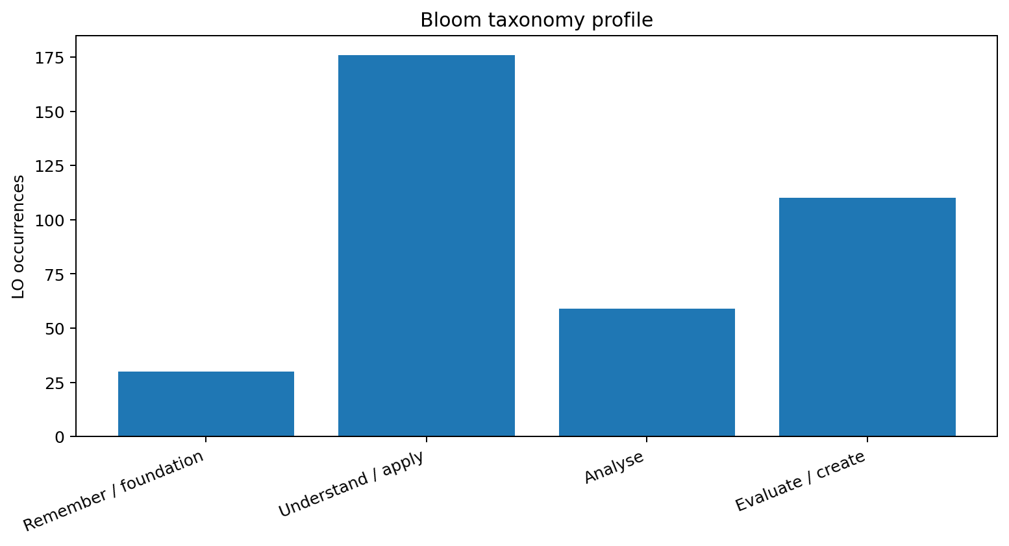

Competence-domain inventory
Domain | Domain name | Skills | Modules | LO occurrences | Years | Streams
ALGO | Algorithms & Data Structures | 6 | 6 | 9 | 1, 2, 3 | Data, AI & Intelligent Systems, Mathematical & Theoretical Foundations, Programming & Software Construction, Systems, Platforms & Security
ANLY | Analysis & Problem Solving | 10 | 28 | 52 | 1, 2, 3 | Data, AI & Intelligent Systems, Human-Centred & Societal Computing, Mathematical & Theoretical Foundations, Programming & Software Construction, Research, Professional & Societal Practice, Systems, Platforms & Security, Unknown, Work Integrated Learning / Praxisprojekte
APPL | Application Development | 9 | 13 | 22 | 1, 2, 3 | Data, AI & Intelligent Systems, Human-Centred & Societal Computing, Mathematical & Theoretical Foundations, Programming & Software Construction, Unknown
ARCH | Software Architecture & Design | 4 | 11 | 11 | 1, 2, 3 | Data, AI & Intelligent Systems, Mathematical & Theoretical Foundations, Programming & Software Construction, Unknown
COMM | Communication | 13 | 17 | 30 | 1, 2, 3 | Data, AI & Intelligent Systems, Human-Centred & Societal Computing, Mathematical & Theoretical Foundations, Programming & Software Construction, Research, Professional & Societal Practice, Unknown
CREA | Creativity | 4 | 5 | 8 | 1, 2, 3 | Human-Centred & Societal Computing, Programming & Software Construction
DATA | Data Management | 3 | 2 | 4 | 2, 3 | Data, AI & Intelligent Systems
ETHI | Ethics | 8 | 8 | 13 | 1, 2, 3 | Data, AI & Intelligent Systems, Human-Centred & Societal Computing, Programming & Software Construction, Research, Professional & Societal Practice, Systems, Platforms & Security
GENR | General Competences | 1 | 1 | 1 | 1 | Systems, Platforms & Security
KNOW | Knowledge & Understanding | 7 | 19 | 37 | 1, 2, 3 | Data, AI & Intelligent Systems, Human-Centred & Societal Computing, Programming & Software Construction, Research, Professional & Societal Practice, Systems, Platforms & Security, Unknown, Work Integrated Learning / Praxisprojekte
MATH | Mathematics | 2 | 4 | 8 | 1, 2 | Mathematical & Theoretical Foundations, Systems, Platforms & Security
METH | Methodological Competences | 7 | 21 | 40 | 1, 2, 3 | Data, AI & Intelligent Systems, Human-Centred & Societal Computing, Mathematical & Theoretical Foundations, Programming & Software Construction, Research, Professional & Societal Practice, Systems, Platforms & Security, Unknown, Work Integrated Learning / Praxisprojekte
NETW | Networks | 1 | 1 | 1 | 2 | Systems, Platforms & Security
PERS | Personal Development | 20 | 22 | 43 | 1, 2, 3 | Data, AI & Intelligent Systems, Human-Centred & Societal Computing, Programming & Software Construction, Research, Professional & Societal Practice, Systems, Platforms & Security, Unknown, Work Integrated Learning / Praxisprojekte
PROG | Programming & Development | 8 | 11 | 21 | 1, 2, 3 | Data, AI & Intelligent Systems, Programming & Software Construction, Systems, Platforms & Security, Unknown
PROJ | Project Management | 9 | 10 | 20 | 1, 2, 3 | Data, AI & Intelligent Systems, Human-Centred & Societal Computing, Programming & Software Construction, Research, Professional & Societal Practice, Unknown, Work Integrated Learning / Praxisprojekte
QUAL | Quality Assurance | 6 | 6 | 11 | 1, 3 | Human-Centred & Societal Computing, Programming & Software Construction, Unknown
RSCH | Research & Academic Work | 7 | 8 | 15 | 1, 3 | Data, AI & Intelligent Systems, Human-Centred & Societal Computing, Research, Professional & Societal Practice, Work Integrated Learning / Praxisprojekte
SECU | Security & Data Protection | 5 | 1 | 5 | 2 | Systems, Platforms & Security
SPEC | Specialisation | 1 | 1 | 1 | 3 | Programming & Software Construction
SYST | Systems & Infrastructure | 4 | 3 | 5 | 1, 2 | Systems, Platforms & Security
TEAM | Teamwork | 4 | 10 | 14 | 1, 2, 3 | Data, AI & Intelligent Systems, Human-Centred & Societal Computing, Programming & Software Construction, Research, Professional & Societal Practice, Unknown, Work Integrated Learning / Praxisprojekte
THEO | Theoretical Computer Science | 2 | 4 | 4 | 1, 2, 3 | Mathematical & Theoretical Foundations, Systems, Platforms & Security

Bloom taxonomy profile

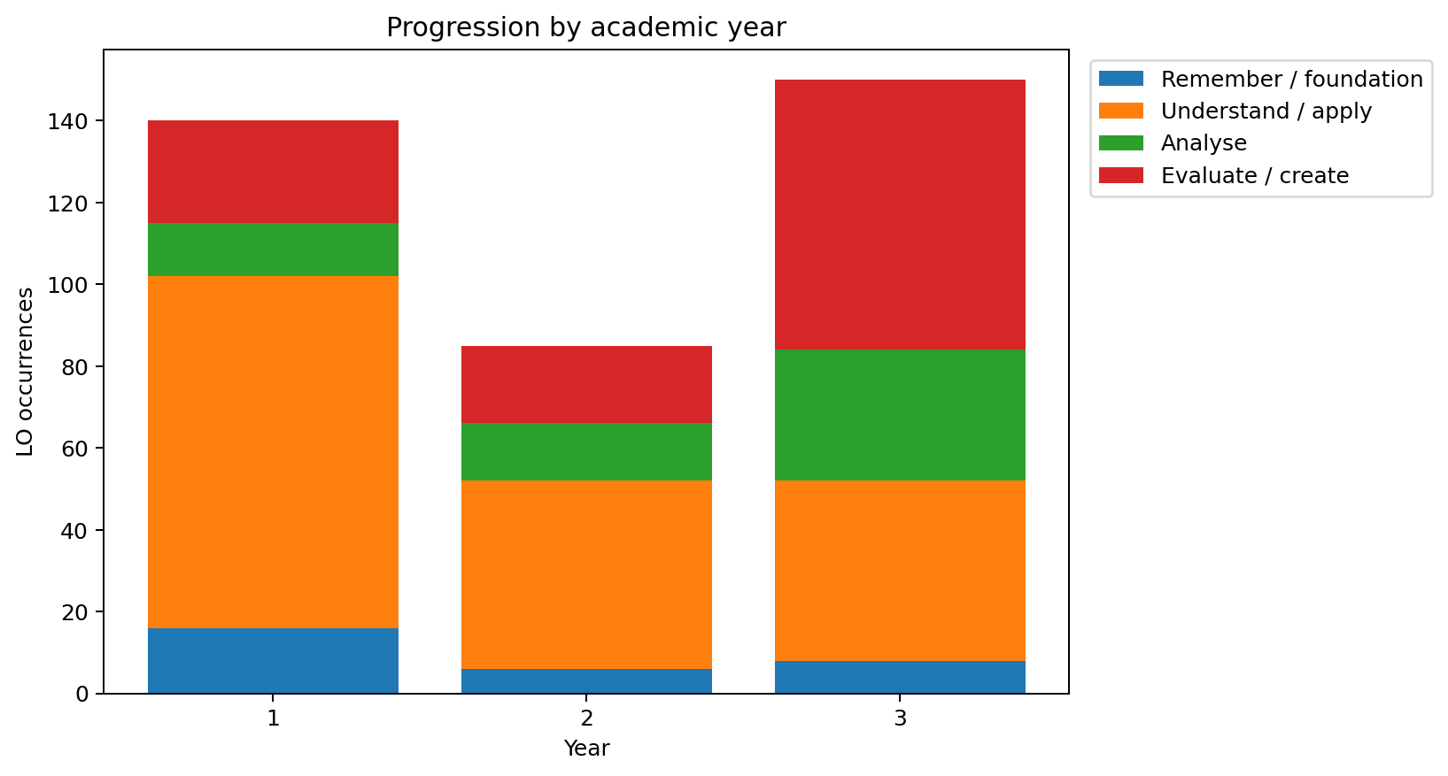
Bloom level | LO occurrences | Skills | Modules
Remember / foundation | 30 | 8 | 19
Understand / apply | 176 | 57 | 30
Analyse | 59 | 28 | 26
Evaluate / create | 110 | 48 | 27

AI skill profile
How to read this profile
AI-related skills are identified from the codebook's AI flag, AI-domain labels, or AI-upskilling meta-skill marker. The report distinguishes the breadth of AI domains from repeated use of the same competence across modules.

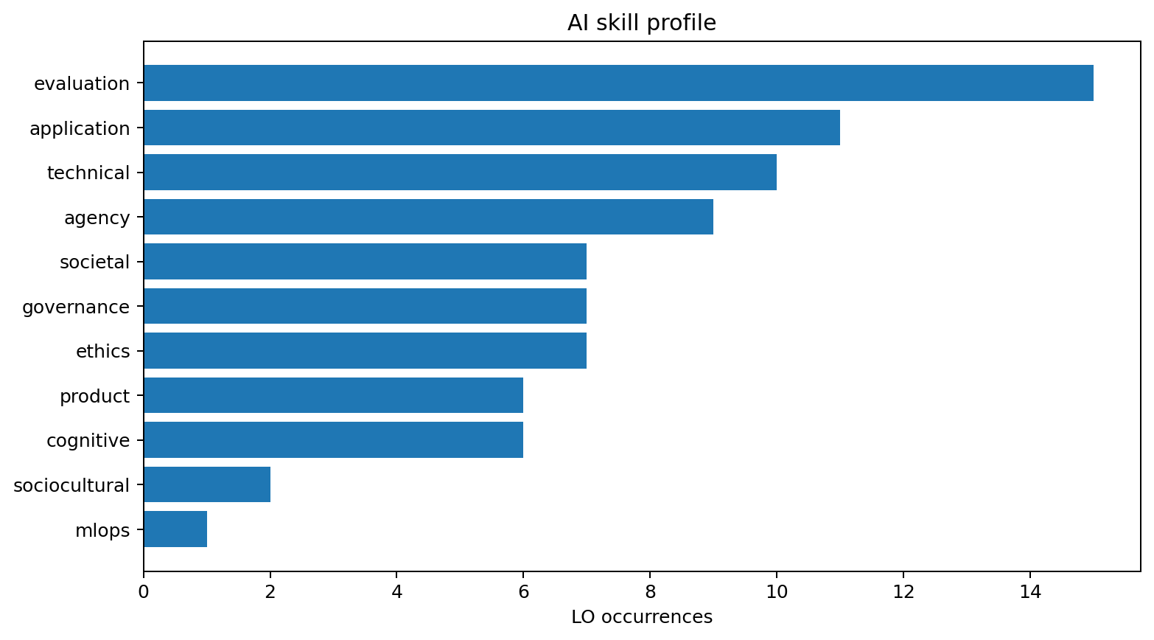
Code | Skill | Domain | Bloom level | AI domains | Modules
ALGO-2-02 | Applying optimisation methods to ML training | ALGO | Understand / apply | technical | T4INF2601
ANLY-3-03 | Defining AI‑specific success metrics | ANLY | Analyse | evaluation, product | T4INF1003, T4INF2001
ANLY-4-03 | Evaluating AI output | ANLY | Evaluate / create | evaluation | T4INF2003, T4INF3102, T4INF3915, T4INF4902.1
ANLY-4-04 | Reflecting on AI's cognitive effects in analytical processes | ANLY | Evaluate / create | cognitive | T4INF3102, T4INF3915
ANLY-4-05 | Evaluating factual consistency of LLM outputs | ANLY | Evaluate / create | evaluation | T4INF3915
APPL-2-04 | Using AI tools | APPL | Understand / apply | application | T4INF1004, T4INF1101, T4INF1601, T4INF1602, T4INF2003, T4INF2601, T4INF3915
APPL-2-05 | Structuring and optimising prompts for LLMs | APPL | Understand / apply | application | T4INF1602
APPL-3-01 | Integrating AI tools into development workflows | APPL | Analyse | application, evaluation | T4INF4900.1, T4INF4902.1
ARCH-3-02 | Designing Retrieval‑Augmented Generation (RAG) pipelines | ARCH | Analyse | application, evaluation | T4INF3915
COMM-3-02 | Communicating about AI with non-technical audiences | COMM | Analyse | societal | T4INF4324
COMM-3-03 | Handling AI uncertainty in stakeholder communication | COMM | Analyse | societal | T4INF4348
COMM-4-01 | Negotiating cultural and social dimensions of AI in professional dialogue | COMM | Evaluate / create | sociocultural | T4INF4348
COMM-4-03 | Facilitating ethical decision‑making (workshops, protocols) | COMM | Evaluate / create | governance | T4INF4348
CREA-3-01 | Analysing AI's influence on creative processes | CREA | Analyse | cognitive | T4INF4900.1
CREA-4-02 | Designing human-centred systems in AI-mediated contexts | CREA | Evaluate / create | agency, cognitive | T4INF4348
ETHI-2-02 | Recognising AI bias and fairness issues | ETHI | Understand / apply | ethics | T4INF1602, T4INF2006, T4INF2601, T4INF4902.1
ETHI-3-01 | Analysing AI's societal effects | ETHI | Analyse | societal | T4INF1602, T4INF2601, T4INF4900.1
ETHI-3-02 | Conducting an algorithmic impact assessment (AIA) | ETHI | Analyse | ethics, governance | T4INF4348
ETHI-4-01 | Evaluating AI governance frameworks | ETHI | Evaluate / create | governance | T4INF4348
ETHI-4-02 | Reflecting on AI and social justice | ETHI | Evaluate / create | sociocultural | T4INF1602
ETHI-4-03 | Assessing legal requirements for AI systems | ETHI | Evaluate / create | governance | T4INF4324
ETHI-4-04 | Designing AI governance structures and policies | ETHI | Evaluate / create | governance | T4INF4324
KNOW-1-05 | Knowing the foundational principles of AI systems | KNOW | Remember / foundation | technical | T4INF1602, T4INF2601
KNOW-2-02 | Explaining how AI models work and where they fail | KNOW | Understand / apply | technical | T4INF2004, T4INF2601, T4INF3103, T4INF3915, T4INF4902.1
METH-3-02 | Orchestrating ML workflows and tracking experiments | METH | Analyse | mlops | T4INF3915
PERS-2-05 | Making independent decisions about AI use | PERS | Understand / apply | agency | T4INF1004, T4INF1101, T4INF1602, T4INF2601
PERS-4-09 | Reflecting on AI use | PERS | Evaluate / create | agency | T4INF2003, T4INF3915, T4INF4900.1
PERS-4-10 | Asserting human agency in AI-mediated contexts | PERS | Evaluate / create | agency | T4INF3906
PERS-4-11 | Reflecting on AI's cognitive effects | PERS | Evaluate / create | cognitive | T4INF3906
PROG-3-01 | Analysing AI-assisted software development processes | PROG | Analyse | evaluation, technical | T4INF3102
PROJ-4-05 | Developing AI product strategy and roadmap | PROJ | Evaluate / create | product | T4INF4324, T4INF4900
PROJ-4-06 | Evaluating business case and ROI for AI projects | PROJ | Evaluate / create | product | T4INF4324, T4INF4900
RSCH-2-02 | Using AI responsibly in academic work | RSCH | Understand / apply | ethics, evaluation | T4INF1005, T4INF3906
RSCH-3-01 | Analysing AI's effects on research and knowledge production | RSCH | Analyse | cognitive, societal | T4INF3906
RSCH-4-02 | Evaluating AI systems as research objects | RSCH | Evaluate / create | evaluation | T4INF1601, T4INF3915
RSCH-4-03 | Evaluating the societal implications of own work | RSCH | Evaluate / create | governance, societal | T4INF4348
SECU-3-01 | Analysing AI-specific security risks | SECU | Analyse | technical | T4INF2006
SECU-3-02 | Applying risk frameworks to AI systems | SECU | Analyse | governance | T4INF2006

Human and meta-skill profile
How to read this profile
Human capability is represented through explicit human-skill tags, meta-skill categories and broader capability clusters. Empty fields are not interpreted as absence of human learning; they indicate that no explicit tag was present.

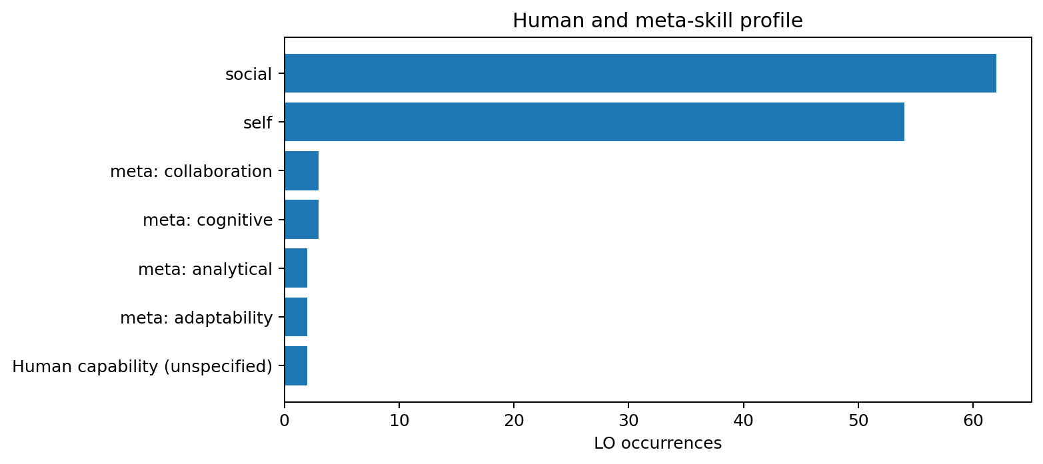
Code | Skill | Human tag | Meta-skill category | Capability clusters | Modules
ALGO-4-02 | Recognising and abstracting patterns | — | analytical | cognitive, technological | T4INF3102
ANLY-4-04 | Reflecting on AI's cognitive effects in analytical processes | self | — | cognitive, technological | T4INF3102, T4INF3915
APPL-3-01 | Integrating AI tools into development workflows | self | — | creative-aesthetic, technological | T4INF4900.1, T4INF4902.1
COMM-2-01 | Presenting results | social | — | human-social, personal-reflective | T4INF1005, T4INF1101, T4INF1601, T4INF2003, T4INF3915, T4INF4900, T4INF4900.1, T4INF4902.1
COMM-2-02 | Communicating professionally | social | — | human-social, personal-reflective | T4INF1005
COMM-2-03 | Documenting work | social | — | human-social, personal-reflective | T4INF1005
COMM-2-04 | Describing content | social | — | human-social, personal-reflective | T4INF1005, T4INF2601, T4INF3906
COMM-2-05 | Explaining relationships | social | — | human-social, personal-reflective | T4INF1005
COMM-2-06 | Exchanging views with experts | social | — | human-social, personal-reflective | T4INF1002, T4INF1004, T4INF1601, T4INF2003, T4INF2004, T4INF3103
COMM-3-01 | Analysing perspectives critically | social | — | human-social, personal-reflective | T4INF2003, T4INF3103
COMM-3-02 | Communicating about AI with non-technical audiences | social | — | human-social, personal-reflective | T4INF4324
COMM-3-03 | Handling AI uncertainty in stakeholder communication | social | — | human-social, personal-reflective | T4INF4348
COMM-4-01 | Negotiating cultural and social dimensions of AI in professional dialogue | social | — | human-social, personal-reflective | T4INF4348
COMM-4-02 | Integrating cross-disciplinary perspectives | social | — | human-social, personal-reflective | T4INF4324, T4INF4348, T4INF4900.1
COMM-4-03 | Facilitating ethical decision‑making (workshops, protocols) | social | — | human-social, personal-reflective | T4INF4348
COMM-4-04 | Documenting decisions (Architecture Decision Records) | social | collaboration | human-social, personal-reflective | T4INF3102
CREA-3-01 | Analysing AI's influence on creative processes | self | — | creative-aesthetic, human-social | T4INF4900.1
CREA-4-02 | Designing human-centred systems in AI-mediated contexts | self | — | creative-aesthetic, human-social | T4INF4348
ETHI-2-02 | Recognising AI bias and fairness issues | self | — | human-social, personal-reflective | T4INF1602, T4INF2006, T4INF2601, T4INF4902.1
ETHI-3-01 | Analysing AI's societal effects | social | — | human-social, personal-reflective | T4INF1602, T4INF2601, T4INF4900.1
ETHI-3-02 | Conducting an algorithmic impact assessment (AIA) | social | — | human-social, personal-reflective | T4INF4348
ETHI-4-02 | Reflecting on AI and social justice | social | — | human-social, personal-reflective | T4INF1602
ETHI-4-04 | Designing AI governance structures and policies | social | — | human-social, personal-reflective | T4INF4324
PERS-2-01 | Adapting to new situations | self | — | human-social, personal-reflective | T4INF3102, T4INF4900
PERS-2-02 | Giving and receiving feedback | social | — | human-social, personal-reflective | T4INF2003
PERS-2-03 | Sharing expertise | social | — | human-social, personal-reflective | T4INF2003
PERS-2-04 | Working independently | self | — | human-social, personal-reflective | T4INF1004, T4INF1101, T4INF1601, T4INF1602, T4INF2003, T4INF2004, T4INF2601, T4INF4902.1
PERS-2-05 | Making independent decisions about AI use | self | — | human-social, personal-reflective | T4INF1004, T4INF1101, T4INF1602, T4INF2601
PERS-4-01 | Identifying strengths and weaknesses | self | — | human-social, personal-reflective | T4_1000, T4INF2003
PERS-4-02 | Taking responsibility | self | — | human-social, personal-reflective | T4_1000, T4INF1005, T4INF4324
PERS-4-03 | Making adjustments | self | — | human-social, personal-reflective | T4INF2003
PERS-4-04 | Reflecting critically | self | — | human-social, personal-reflective | T4_3000, T4INF2003, T4INF3102
PERS-4-05 | Developing critical judgement | self | — | human-social, personal-reflective | T4INF3102, T4INF3103
PERS-4-06 | Resolving conflicts | social | — | human-social, personal-reflective | T4INF2003
PERS-4-07 | Improving purposefully | self | — | human-social, personal-reflective | T4_2000, T4INF2003
PERS-4-08 | Deriving improvements | self | — | human-social, personal-reflective | T4INF2003
PERS-4-09 | Reflecting on AI use | self | — | human-social, personal-reflective | T4INF2003, T4INF3915, T4INF4900.1
PERS-4-10 | Asserting human agency in AI-mediated contexts | self | — | human-social, personal-reflective | T4INF3906
PERS-4-11 | Reflecting on AI's cognitive effects | self | — | human-social, personal-reflective | T4INF3906
PERS-4-12 | Reflecting on uncertainty and developing personal resilience | self | — | human-social, personal-reflective | T4INF4900.1, T4INF9006
PERS-4-13 | Recognising and communicating the limits of one's own knowledge | self | cognitive | human-social, personal-reflective | T4INF9006
PERS-4-14 | Reflecting on and adapting learning strategies | self | cognitive | human-social, personal-reflective | T4INF1005, T4INF4900
PERS-4-15 | Embracing and navigating change as an opportunity | self | adaptability | human-social, personal-reflective | T4INF4348, T4INF4902
PROG-3-02 | Analysing and extending existing codebases | social | — | cognitive, technological | T4INF4900.1
PROJ-3-02 | Analysing uncertainty in project planning | self | — | cognitive, human-social | T4INF4900.1
PROJ-4-03 | Establishing and aligning a shared project vision | social | — | cognitive, human-social | T4INF4900.1, T4INF9006
PROJ-4-04 | Controlling scope evolution in iterative development | social | — | cognitive, human-social | T4INF4900.1
PROJ-4-05 | Developing AI product strategy and roadmap | social | — | cognitive, human-social | T4INF4324, T4INF4900
PROJ-4-07 | Negotiating priorities and saying 'no' with justification | social | collaboration | cognitive, human-social | T4INF4900, T4INF9006
QUAL-4-01 | Conducting systematic failure analysis | — | analytical | creative-aesthetic, technological | T4INF3102
RSCH-2-02 | Using AI responsibly in academic work | self | — | cognitive, personal-reflective | T4INF1005, T4INF3906
RSCH-3-01 | Analysing AI's effects on research and knowledge production | self | — | cognitive, personal-reflective | T4INF3906
RSCH-4-03 | Evaluating the societal implications of own work | social | — | cognitive, personal-reflective | T4INF4348
TEAM-2-01 | Contributing to teams | social | — | human-social, personal-reflective | T4_2000, T4INF1101, T4INF1601, T4INF2003, T4INF3102, T4INF3103, T4INF9006
TEAM-2-02 | Acting team-orientedly | social | — | human-social, personal-reflective | T4INF2003, T4INF3906
TEAM-2-03 | Fostering collaboration | social | — | human-social, personal-reflective | T4INF2003
TEAM-4-01 | Building teams | social | — | human-social, personal-reflective | T4INF2003, T4INF4348, T4INF4900.1, T4INF9006

Progression by academic year
year | Modules | Total ECTS | Unique skills | Domains touched | AI-related skills | Human-tagged skills
1 | 12 | 75 | 75 | 19 | 12 | 28
2 | 8 | 61 | 63 | 19 | 10 | 13
3 | 11 | 56 | 91 | 18 | 30 | 43

1
Modules: T4_1000, T4INF1001, T4INF1002, T4INF1003, T4INF1004, T4INF1005, T4INF1006, T4INF1007, T4INF1101, T4INF1601, T4INF1602, T4INF2003
Domains touched: PERS (21), ANLY (17), KNOW (16), COMM (13), APPL (12), PROG (11), METH (9), MATH (6), QUAL (6), TEAM (6), ARCH (5), RSCH (4), ALGO (4), ETHI (3), PROJ (3), THEO (1), SYST (1), GENR (1), CREA (1)
Bloom level: Remember / foundation (16), Understand / apply (86), Evaluate / create (25), Analyse (13)
AI domains: application (6), evaluation (4), agency (4), ethics (2), product (1), technical (1), societal (1), sociocultural (1)

2
Modules: T4_2000, T4INF2001, T4INF2002, T4INF2004, T4INF2005, T4INF2006, T4INF2601, T4INF9006
Domains touched: ANLY (13), METH (13), KNOW (9), PROJ (6), PERS (6), APPL (5), SECU (5), SYST (4), PROG (4), TEAM (3), ETHI (3), MATH (2), THEO (2), ARCH (2), COMM (2), DATA (2), CREA (2), NETW (1), ALGO (1)
Bloom level: Analyse (14), Understand / apply (46), Evaluate / create (19), Remember / foundation (6)
AI domains: technical (5), ethics (2), evaluation (1), product (1), governance (1), societal (1), application (1), agency (1)

3
Modules: T4_3000, T4INF3102, T4INF3103, T4INF3906, T4INF3915, T4INF4324, T4INF4348, T4INF4900, T4INF4900.1, T4INF4902, T4INF4902.1
Domains touched: ANLY (22), METH (18), PERS (16), COMM (15), KNOW (12), RSCH (11), PROJ (11), ETHI (7), PROG (6), QUAL (5), TEAM (5), APPL (5), CREA (5), ARCH (4), ALGO (4), DATA (2), SPEC (1), THEO (1)
Bloom level: Evaluate / create (66), Analyse (32), Understand / apply (44), Remember / foundation (8)
AI domains: evaluation (10), cognitive (6), governance (6), societal (5), technical (4), agency (4), application (4), product (4), ethics (3), mlops (1), sociocultural (1)

Profiles by stream
stream | Modules | Total ECTS | Unique skills | Domains touched | AI-related skills | Human-tagged skills
Data, AI & Intelligent Systems | 7 | 36 | 45 | 14 | 17 | 14
Human-Centred & Societal Computing | 3 | 15 | 39 | 12 | 9 | 18
Mathematical & Theoretical Foundations | 6 | 32 | 16 | 8 | 1 | 1
Programming & Software Construction | 4 | 18 | 54 | 15 | 9 | 23
Research, Professional & Societal Practice | 3 | 15 | 27 | 9 | 9 | 16
Systems, Platforms & Security | 4 | 23 | 31 | 13 | 3 | 2
Unknown | 1 | 5 | 37 | 11 | 3 | 17
Work Integrated Learning / Praxisprojekte | 3 | 48 | 15 | 7 | 0 | 5

Data, AI & Intelligent Systems
Modules: T4INF1601, T4INF1602, T4INF2004, T4INF2601, T4INF3103, T4INF3915, T4INF4902.1
Domains touched: KNOW (21), METH (18), ANLY (11), APPL (10), PROG (9), PERS (9), COMM (8), ETHI (6), ARCH (5), DATA (4), RSCH (3), TEAM (2), PROJ (1), ALGO (1)
Bloom level: Remember / foundation (12), Understand / apply (58), Analyse (17), Evaluate / create (21)
AI domains: technical (8), application (7), evaluation (7), ethics (3), agency (3), societal (2), sociocultural (1), cognitive (1), mlops (1)

Human-Centred & Societal Computing
Modules: T4INF4348, T4INF4900, T4INF9006
Domains touched: METH (8), PROJ (8), ANLY (6), CREA (5), COMM (5), PERS (5), KNOW (3), ETHI (3), RSCH (3), TEAM (3), APPL (2), QUAL (1)
Bloom level: Remember / foundation (3), Understand / apply (17), Analyse (6), Evaluate / create (26)
AI domains: governance (4), societal (2), product (2), agency (1), cognitive (1), ethics (1), sociocultural (1)

Mathematical & Theoretical Foundations
Modules: T4INF1001, T4INF1002, T4INF1003, T4INF1007, T4INF2001, T4INF2002
Domains touched: ANLY (7), MATH (6), ALGO (3), APPL (2), THEO (2), COMM (1), ARCH (1), METH (1)
Bloom level: Understand / apply (14), Evaluate / create (4), Remember / foundation (1), Analyse (4)
AI domains: evaluation (2), product (2)

Programming & Software Construction
Modules: T4INF1004, T4INF1101, T4INF3102, T4INF4900.1
Domains touched: PERS (9), ANLY (8), PROG (7), QUAL (7), APPL (6), KNOW (5), METH (5), COMM (5), ARCH (4), PROJ (4), CREA (3), TEAM (3), ALGO (2), SPEC (1), ETHI (1)
Bloom level: Remember / foundation (4), Understand / apply (30), Analyse (15), Evaluate / create (21)
AI domains: application (3), agency (3), evaluation (3), cognitive (2), technical (1), societal (1)

Research, Professional & Societal Practice
Modules: T4INF1005, T4INF3906, T4INF4324
Domains touched: COMM (8), RSCH (7), PERS (5), ANLY (4), KNOW (2), ETHI (2), PROJ (2), TEAM (1), METH (1)
Bloom level: Remember / foundation (2), Understand / apply (15), Evaluate / create (13), Analyse (2)
AI domains: ethics (2), evaluation (2), cognitive (2), societal (2), governance (2), product (2), agency (1)

Systems, Platforms & Security
Modules: T4INF1006, T4INF2005, T4INF2006, T4INF4902
Domains touched: ANLY (7), SYST (5), SECU (5), KNOW (3), METH (3), ALGO (3), MATH (2), PROG (2), THEO (2), GENR (1), NETW (1), ETHI (1), PERS (1)
Bloom level: Remember / foundation (5), Understand / apply (19), Analyse (8), Evaluate / create (4)
AI domains: technical (1), governance (1), ethics (1)

Unknown
Modules: T4INF2003
Domains touched: PERS (10), ANLY (4), TEAM (4), PROG (3), QUAL (3), COMM (3), PROJ (3), KNOW (2), APPL (2), METH (2), ARCH (1)
Bloom level: Remember / foundation (2), Understand / apply (18), Analyse (4), Evaluate / create (13)
AI domains: evaluation (1), application (1), agency (1)

Work Integrated Learning / Praxisprojekte
Modules: T4_1000, T4_2000, T4_3000
Domains touched: ANLY (5), PERS (4), RSCH (2), METH (2), PROJ (2), KNOW (1), TEAM (1)
Bloom level: Remember / foundation (1), Understand / apply (5), Evaluate / create (8), Analyse (3)

Domain coverage across streams
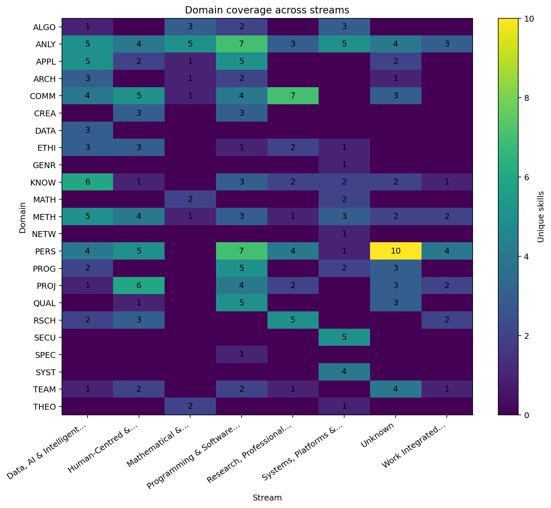

Module skill profiles

T4INF1601 · Scientific Programming & Experimentation
Data, AI & Intelligent Systems  Stream | 1  Year | —  Semester | 5  ECTS | 15  Skills | 2  AI-related skills
Programming language concepts; programming in an appropriate language (variables, data types, control structures, data structures, modularisation); scientific computing with appropriate tools; data preprocessing; statistical analysis; data visualisation; responsible use of AI-assisted tools in data analysis.
Domains touched: KNOW (3), PROG (2), APPL (2), COMM (2), ANLY (1), ARCH (1), METH (1), RSCH (1), TEAM (1), PERS (1)
Bloom level: Remember / foundation (2), Understand / apply (10), Analyse (1), Evaluate / create (2)

AI skill profile
- APPL-2-04 · Using AI tools — application
- RSCH-4-02 · Evaluating AI systems as research objects — evaluation

Human and meta-skill profile
- COMM-2-01 · Presenting results — human-social, personal-reflective, social
- COMM-2-06 · Exchanging views with experts — human-social, personal-reflective, social
- PERS-2-04 · Working independently — human-social, personal-reflective, self
- TEAM-2-01 · Contributing to teams — human-social, personal-reflective, social

Skills
Code | Skill | Domain | Bloom level | AI | Human
ANLY-3-01 | Analysing problem statements | ANLY | Analyse | — | —
APPL-2-02 | Using tools | APPL | Understand / apply | — | —
APPL-2-04 | Using AI tools | APPL | Understand / apply | ✓ | —
ARCH-2-02 | Designing solutions | ARCH | Understand / apply | — | —
COMM-2-01 | Presenting results | COMM | Understand / apply | — | social
COMM-2-06 | Exchanging views with experts | COMM | Understand / apply | — | social
KNOW-1-02 | Knowing foundational concepts | KNOW | Remember / foundation | — | —
KNOW-1-03 | Knowing terms and roles | KNOW | Remember / foundation | — | —
KNOW-2-01 | Understanding interdependencies | KNOW | Understand / apply | — | —
METH-2-02 | Applying methods | METH | Understand / apply | — | —
PERS-2-04 | Working independently | PERS | Understand / apply | — | self
PROG-2-03 | Implementing solutions | PROG | Understand / apply | — | —
PROG-4-01 | Developing software | PROG | Evaluate / create | — | —
RSCH-4-02 | Evaluating AI systems as research objects | RSCH | Evaluate / create | ✓ | —
TEAM-2-01 | Contributing to teams | TEAM | Understand / apply | — | social
Back to module index

T4INF1602 · Foundation of Intelligent Systems
Data, AI & Intelligent Systems  Stream | 1  Year | —  Semester | 5  ECTS | 16  Skills | 7  AI-related skills
Unit 1 (Algorithms): Fundamental concepts and algorithms for intelligent systems; bionic foundations; evolutionary algorithms; regressor and classifier; introduction to neural networks. Unit 2 (Ethics & Law): Foundations of ethics in CS; compliance; GDPR; criminal law; civil liability; copyright; patent law; societal effects of AI systems.
Domains touched: KNOW (3), METH (3), ETHI (3), PROG (2), APPL (2), PERS (2), ARCH (1)
Bloom level: Remember / foundation (3), Understand / apply (9), Analyse (2), Evaluate / create (2)

AI skill profile
- APPL-2-04 · Using AI tools — application
- APPL-2-05 · Structuring and optimising prompts for LLMs — application
- ETHI-2-02 · Recognising AI bias and fairness issues — ethics
- ETHI-3-01 · Analysing AI's societal effects — societal
- ETHI-4-02 · Reflecting on AI and social justice — sociocultural
- KNOW-1-05 · Knowing the foundational principles of AI systems — technical
- PERS-2-05 · Making independent decisions about AI use — agency

Human and meta-skill profile
- ETHI-2-02 · Recognising AI bias and fairness issues — human-social, personal-reflective, self
- ETHI-3-01 · Analysing AI's societal effects — human-social, personal-reflective, social
- ETHI-4-02 · Reflecting on AI and social justice — human-social, personal-reflective, social
- PERS-2-04 · Working independently — human-social, personal-reflective, self
- PERS-2-05 · Making independent decisions about AI use — human-social, personal-reflective, self

Skills
Code | Skill | Domain | Bloom level | AI | Human
APPL-2-04 | Using AI tools | APPL | Understand / apply | ✓ | —
APPL-2-05 | Structuring and optimising prompts for LLMs | APPL | Understand / apply | ✓ | —
ARCH-2-02 | Designing solutions | ARCH | Understand / apply | — | —
ETHI-2-02 | Recognising AI bias and fairness issues | ETHI | Understand / apply | ✓ | self
ETHI-3-01 | Analysing AI's societal effects | ETHI | Analyse | ✓ | social
ETHI-4-02 | Reflecting on AI and social justice | ETHI | Evaluate / create | ✓ | social
KNOW-1-02 | Knowing foundational concepts | KNOW | Remember / foundation | — | —
KNOW-1-03 | Knowing terms and roles | KNOW | Remember / foundation | — | —
KNOW-1-05 | Knowing the foundational principles of AI systems | KNOW | Remember / foundation | ✓ | —
METH-2-01 | Selecting methods | METH | Understand / apply | — | —
METH-2-02 | Applying methods | METH | Understand / apply | — | —
METH-3-01 | Transferring theoretical knowledge to complex real-world contexts | METH | Analyse | — | —
PERS-2-04 | Working independently | PERS | Understand / apply | — | self
PERS-2-05 | Making independent decisions about AI use | PERS | Understand / apply | ✓ | self
PROG-2-03 | Implementing solutions | PROG | Understand / apply | — | —
PROG-4-01 | Developing software | PROG | Evaluate / create | — | —
Back to module index

T4INF1001 · Mathematics I — Linear Algebra
Mathematical & Theoretical Foundations  Stream | 1  Year | —  Semester | 5  ECTS | 4  Skills | 0  AI-related skills
Foundations of discrete mathematics; fundamental algebraic structures; vector spaces and linear mappings; determinants, eigenvalues, diagonalisability; complex numbers; application examples from computer science and engineering.
Domains touched: MATH (2), ANLY (1), APPL (1)
Bloom level: Understand / apply (3), Evaluate / create (1)

Skills
Code | Skill | Domain | Bloom level | AI | Human
ANLY-2-03 | Understanding concepts | ANLY | Understand / apply | — | —
APPL-4-02 | Transferring concepts to problems | APPL | Evaluate / create | — | —
MATH-2-01 | Applying mathematical methods | MATH | Understand / apply | — | —
MATH-2-02 | Mastering formal methods | MATH | Understand / apply | — | —
Back to module index

T4INF1002 · Theoretical Computer Science I — Logic and Formal Foundations
Mathematical & Theoretical Foundations  Stream | 1  Year | —  Semester | 5  ECTS | 4  Skills | 0  AI-related skills
Algebraic structures: relations, orderings, mappings; formal logic: propositional logic, predicate logic; algorithm theory: recursion, termination and complexity, correctness; basic knowledge of declarative programming (logical/functional).
Domains touched: THEO (1), ALGO (1), ANLY (1), COMM (1)
Bloom level: Understand / apply (3), Remember / foundation (1)

Human and meta-skill profile
- COMM-2-06 · Exchanging views with experts — human-social, personal-reflective, social

Skills
Code | Skill | Domain | Bloom level | AI | Human
ALGO-1-01 | Knowing algorithms | ALGO | Remember / foundation | — | —
ANLY-2-02 | Solving problems | ANLY | Understand / apply | — | —
COMM-2-06 | Exchanging views with experts | COMM | Understand / apply | — | social
THEO-2-01 | Transferring theoretical knowledge | THEO | Understand / apply | — | —
Back to module index

T4INF1003 · Theoretical Computer Science II — Algorithms and Complexity
Mathematical & Theoretical Foundations  Stream | 1  Year | —  Semester | 5  ECTS | 4  Skills | 1  AI-related skills
Introduction to algorithms; complexity theory: O-notation, complexity classes (P, NP, NP-complete); search and sorting algorithms, hashing; correctness of algorithms; data structures: sets, lists, stacks, queues; trees, binary search trees, balanced graphs and graph algorithms; coding: compression, error-detecting and error-correcting codes.
Domains touched: ALGO (2), ANLY (2)
Bloom level: Analyse (2), Evaluate / create (1), Understand / apply (1)

AI skill profile
- ANLY-3-03 · Defining AI‑specific success metrics — evaluation, product

Skills
Code | Skill | Domain | Bloom level | AI | Human
ALGO-3-01 | Analysing complexity | ALGO | Analyse | — | —
ALGO-4-01 | Designing algorithms | ALGO | Evaluate / create | — | —
ANLY-2-01 | Classifying information | ANLY | Understand / apply | — | —
ANLY-3-03 | Defining AI‑specific success metrics | ANLY | Analyse | ✓ | —
Back to module index

T4INF1007 · Mathematics II — Analysis
Mathematical & Theoretical Foundations  Stream | 1  Year | —  Semester | 5  ECTS | 3  Skills | 0  AI-related skills
Analysis: sequences and series; continuity; differential calculus of one real variable; integral calculus of one real variable; applications in computer science and engineering; first implementation of mathematical algorithms as programmes.
Domains touched: MATH (2), ANLY (1)
Bloom level: Understand / apply (3)

Skills
Code | Skill | Domain | Bloom level | AI | Human
ANLY-2-03 | Understanding concepts | ANLY | Understand / apply | — | —
MATH-2-01 | Applying mathematical methods | MATH | Understand / apply | — | —
MATH-2-02 | Mastering formal methods | MATH | Understand / apply | — | —
Back to module index

T4INF1004 · Programming
Programming & Software Construction  Stream | 1  Year | —  Semester | 5  ECTS | 17  Skills | 2  AI-related skills
Procedural programming: algorithm description, data types, I/O, control structures, functions, string processing, structured and dynamic data types, pointers, memory management. Object-oriented programming: OOP design, class concept, inheritance, polymorphism, templates/generics, class libraries, garbage collection.
Domains touched: PROG (3), KNOW (2), QUAL (2), APPL (2), ANLY (2), PERS (2), ALGO (1), ARCH (1), METH (1), COMM (1)
Bloom level: Remember / foundation (2), Understand / apply (12), Analyse (2), Evaluate / create (1)

AI skill profile
- APPL-2-04 · Using AI tools — application
- PERS-2-05 · Making independent decisions about AI use — agency

Human and meta-skill profile
- COMM-2-06 · Exchanging views with experts — human-social, personal-reflective, social
- PERS-2-04 · Working independently — human-social, personal-reflective, self
- PERS-2-05 · Making independent decisions about AI use — human-social, personal-reflective, self

Skills
Code | Skill | Domain | Bloom level | AI | Human
ALGO-2-01 | Applying data structures | ALGO | Understand / apply | — | —
ANLY-2-02 | Solving problems | ANLY | Understand / apply | — | —
ANLY-3-01 | Analysing problem statements | ANLY | Analyse | — | —
APPL-2-02 | Using tools | APPL | Understand / apply | — | —
APPL-2-04 | Using AI tools | APPL | Understand / apply | ✓ | —
ARCH-2-02 | Designing solutions | ARCH | Understand / apply | — | —
COMM-2-06 | Exchanging views with experts | COMM | Understand / apply | — | social
KNOW-1-02 | Knowing foundational concepts | KNOW | Remember / foundation | — | —
KNOW-1-03 | Knowing terms and roles | KNOW | Remember / foundation | — | —
METH-2-02 | Applying methods | METH | Understand / apply | — | —
PERS-2-04 | Working independently | PERS | Understand / apply | — | self
PERS-2-05 | Making independent decisions about AI use | PERS | Understand / apply | ✓ | self
PROG-2-01 | Applying programming paradigms | PROG | Understand / apply | — | —
PROG-2-03 | Implementing solutions | PROG | Understand / apply | — | —
PROG-4-01 | Developing software | PROG | Evaluate / create | — | —
QUAL-2-01 | Testing software | QUAL | Understand / apply | — | —
QUAL-3-01 | Evaluating code quality | QUAL | Analyse | — | —
Back to module index

T4INF1101 · Web & Application Engineering
Programming & Software Construction  Stream | 1  Year | —  Semester | 5  ECTS | 15  Skills | 2  AI-related skills
Client-server architectures and internet protocols; markup and styling languages for web content; client-side and server-side programming; frameworks and libraries; architectural patterns for modern web applications; user-centred design and accessibility; responsible use of AI-assisted development tools; web projects (individual and group work).
Domains touched: KNOW (3), APPL (3), PERS (2), ARCH (1), METH (1), QUAL (1), CREA (1), COMM (1), PROG (1), TEAM (1)
Bloom level: Remember / foundation (2), Understand / apply (12), Evaluate / create (1)

AI skill profile
- APPL-2-04 · Using AI tools — application
- PERS-2-05 · Making independent decisions about AI use — agency

Human and meta-skill profile
- COMM-2-01 · Presenting results — human-social, personal-reflective, social
- PERS-2-04 · Working independently — human-social, personal-reflective, self
- PERS-2-05 · Making independent decisions about AI use — human-social, personal-reflective, self
- TEAM-2-01 · Contributing to teams — human-social, personal-reflective, social

Skills
Code | Skill | Domain | Bloom level | AI | Human
APPL-2-01 | Integrating into contexts | APPL | Understand / apply | — | —
APPL-2-03 | Implementing user interfaces | APPL | Understand / apply | — | —
APPL-2-04 | Using AI tools | APPL | Understand / apply | ✓ | —
ARCH-2-02 | Designing solutions | ARCH | Understand / apply | — | —
COMM-2-01 | Presenting results | COMM | Understand / apply | — | social
CREA-2-01 | Applying user-centred design principles | CREA | Understand / apply | — | —
KNOW-1-02 | Knowing foundational concepts | KNOW | Remember / foundation | — | —
KNOW-1-03 | Knowing terms and roles | KNOW | Remember / foundation | — | —
KNOW-2-01 | Understanding interdependencies | KNOW | Understand / apply | — | —
METH-2-01 | Selecting methods | METH | Understand / apply | — | —
PERS-2-04 | Working independently | PERS | Understand / apply | — | self
PERS-2-05 | Making independent decisions about AI use | PERS | Understand / apply | ✓ | self
PROG-4-01 | Developing software | PROG | Evaluate / create | — | —
QUAL-2-03 | Applying accessibility guidelines | QUAL | Understand / apply | — | —
TEAM-2-01 | Contributing to teams | TEAM | Understand / apply | — | social
Back to module index

T4INF1005 · Key Skills
Research, Professional & Societal Practice  Stream | 1  Year | —  Semester | 5  ECTS | 11  Skills | 1  AI-related skills
Unit 1 — Business Management: foundations of business management (goals, planning, legal forms), accounting and cost accounting, financing and investment, holistic business simulation. Unit 2 — Academic Writing: literature research and evaluation, substantive and formal aspects of scholarly work, technical and academic document types, producing short reports (DE/EN), exemplary project documentation. Unit 3 — Presentation, Learning and Working Techniques: presentation techniques and visualisation, learning and working techniques, responsible use of AI tools in academic work, reflection on own learning strategies, professional self-concept.
Domains touched: COMM (5), RSCH (2), PERS (2), KNOW (1), ANLY (1)
Bloom level: Remember / foundation (1), Understand / apply (8), Evaluate / create (2)

AI skill profile
- RSCH-2-02 · Using AI responsibly in academic work — ethics, evaluation

Human and meta-skill profile
- COMM-2-01 · Presenting results — human-social, personal-reflective, social
- COMM-2-02 · Communicating professionally — human-social, personal-reflective, social
- COMM-2-03 · Documenting work — human-social, personal-reflective, social
- COMM-2-04 · Describing content — human-social, personal-reflective, social
- COMM-2-05 · Explaining relationships — human-social, personal-reflective, social
- PERS-4-02 · Taking responsibility — human-social, personal-reflective, self
- PERS-4-14 · Reflecting on and adapting learning strategies — cognitive, human-social, personal-reflective, self
- RSCH-2-02 · Using AI responsibly in academic work — cognitive, personal-reflective, self

Skills
Code | Skill | Domain | Bloom level | AI | Human
ANLY-2-03 | Understanding concepts | ANLY | Understand / apply | — | —
COMM-2-01 | Presenting results | COMM | Understand / apply | — | social
COMM-2-02 | Communicating professionally | COMM | Understand / apply | — | social
COMM-2-03 | Documenting work | COMM | Understand / apply | — | social
COMM-2-04 | Describing content | COMM | Understand / apply | — | social
COMM-2-05 | Explaining relationships | COMM | Understand / apply | — | social
KNOW-1-01 | Possessing subject knowledge | KNOW | Remember / foundation | — | —
PERS-4-02 | Taking responsibility | PERS | Evaluate / create | — | self
PERS-4-14 | Reflecting on and adapting learning strategies | PERS | Evaluate / create | — | cognitive, self
RSCH-2-01 | Researching literature | RSCH | Understand / apply | — | —
RSCH-2-02 | Using AI responsibly in academic work | RSCH | Understand / apply | ✓ | self
Back to module index

T4INF1006 · Computer Engineering I — Digital Technology
Systems, Platforms & Security  Stream | 1  Year | —  Semester | 5  ECTS | 8  Skills | 0  AI-related skills
Number systems and codes; logical operations and their representation; switching algebra and formal methods (normal forms, K-maps); combinational circuits: analysis and design; sequential circuits: state machines, state diagrams; circuit technology and interfacing; semiconductor memory. Foundation for computer architecture, operating systems, and system-level programming.
Domains touched: MATH (2), ANLY (2), KNOW (1), SYST (1), METH (1), GENR (1)
Bloom level: Remember / foundation (2), Understand / apply (5), Analyse (1)

Skills
Code | Skill | Domain | Bloom level | AI | Human
ANLY-2-02 | Solving problems | ANLY | Understand / apply | — | —
ANLY-3-01 | Analysing problem statements | ANLY | Analyse | — | —
GENR-1-01 | Possessing professional capabilities | GENR | Remember / foundation | — | —
KNOW-1-02 | Knowing foundational concepts | KNOW | Remember / foundation | — | —
MATH-2-01 | Applying mathematical methods | MATH | Understand / apply | — | —
MATH-2-02 | Mastering formal methods | MATH | Understand / apply | — | —
METH-2-02 | Applying methods | METH | Understand / apply | — | —
SYST-2-02 | Programming at system level | SYST | Understand / apply | — | —
Back to module index

T4INF2003 · Software Engineering Fundamentals
Unknown  Stream | 1  Year | —  Semester | 5  ECTS | 37  Skills | 3  AI-related skills
Software process models; phases of software engineering and their relationships; requirements engineering and management, use cases; analysis and design models (e.g. UML, SADT); software architectures, interface design, software design and design patterns; code guidelines and code quality: reviewing and test planning, execution and evaluation; continuous integration; version control; operation and maintenance; phase-specific documentation; execution of a concrete software development project in medium-sized project teams
Domains touched: PERS (10), ANLY (4), TEAM (4), PROG (3), QUAL (3), COMM (3), PROJ (3), KNOW (2), APPL (2), METH (2), ARCH (1)
Bloom level: Remember / foundation (2), Understand / apply (18), Analyse (4), Evaluate / create (13)

AI skill profile
- ANLY-4-03 · Evaluating AI output — evaluation
- APPL-2-04 · Using AI tools — application
- PERS-4-09 · Reflecting on AI use — agency

Human and meta-skill profile
- COMM-2-01 · Presenting results — human-social, personal-reflective, social
- COMM-2-06 · Exchanging views with experts — human-social, personal-reflective, social
- COMM-3-01 · Analysing perspectives critically — human-social, personal-reflective, social
- PERS-2-02 · Giving and receiving feedback — human-social, personal-reflective, social
- PERS-2-03 · Sharing expertise — human-social, personal-reflective, social
- PERS-2-04 · Working independently — human-social, personal-reflective, self
- PERS-4-01 · Identifying strengths and weaknesses — human-social, personal-reflective, self
- PERS-4-03 · Making adjustments — human-social, personal-reflective, self
- PERS-4-04 · Reflecting critically — human-social, personal-reflective, self
- PERS-4-06 · Resolving conflicts — human-social, personal-reflective, social
- PERS-4-07 · Improving purposefully — human-social, personal-reflective, self
- PERS-4-08 · Deriving improvements — human-social, personal-reflective, self
- PERS-4-09 · Reflecting on AI use — human-social, personal-reflective, self
- TEAM-2-01 · Contributing to teams — human-social, personal-reflective, social
- TEAM-2-02 · Acting team-orientedly — human-social, personal-reflective, social
- TEAM-2-03 · Fostering collaboration — human-social, personal-reflective, social
- TEAM-4-01 · Building teams — human-social, personal-reflective, social

Skills
Code | Skill | Domain | Bloom level | AI | Human
ANLY-2-02 | Solving problems | ANLY | Understand / apply | — | —
ANLY-3-01 | Analysing problem statements | ANLY | Analyse | — | —
ANLY-4-01 | Evaluating solution approaches | ANLY | Evaluate / create | — | —
ANLY-4-03 | Evaluating AI output | ANLY | Evaluate / create | ✓ | —
APPL-2-02 | Using tools | APPL | Understand / apply | — | —
APPL-2-04 | Using AI tools | APPL | Understand / apply | ✓ | —
ARCH-2-02 | Designing solutions | ARCH | Understand / apply | — | —
COMM-2-01 | Presenting results | COMM | Understand / apply | — | social
COMM-2-06 | Exchanging views with experts | COMM | Understand / apply | — | social
COMM-3-01 | Analysing perspectives critically | COMM | Analyse | — | social
KNOW-1-03 | Knowing terms and roles | KNOW | Remember / foundation | — | —
KNOW-1-04 | Knowing the software development process | KNOW | Remember / foundation | — | —
METH-2-01 | Selecting methods | METH | Understand / apply | — | —
METH-2-02 | Applying methods | METH | Understand / apply | — | —
PERS-2-02 | Giving and receiving feedback | PERS | Understand / apply | — | social
PERS-2-03 | Sharing expertise | PERS | Understand / apply | — | social
PERS-2-04 | Working independently | PERS | Understand / apply | — | self
PERS-4-01 | Identifying strengths and weaknesses | PERS | Evaluate / create | — | self
PERS-4-03 | Making adjustments | PERS | Evaluate / create | — | self
PERS-4-04 | Reflecting critically | PERS | Evaluate / create | — | self
PERS-4-06 | Resolving conflicts | PERS | Evaluate / create | — | social
PERS-4-07 | Improving purposefully | PERS | Evaluate / create | — | self
PERS-4-08 | Deriving improvements | PERS | Evaluate / create | — | self
PERS-4-09 | Reflecting on AI use | PERS | Evaluate / create | ✓ | self
PROG-2-02 | Using development tools | PROG | Understand / apply | — | —
PROG-2-03 | Implementing solutions | PROG | Understand / apply | — | —
PROG-4-01 | Developing software | PROG | Evaluate / create | — | —
PROJ-2-01 | Executing projects | PROJ | Understand / apply | — | —
PROJ-4-01 | Planning projects | PROJ | Evaluate / create | — | —
PROJ-4-02 | Connecting disciplines | PROJ | Evaluate / create | — | —
QUAL-2-02 | Applying coding guidelines | QUAL | Understand / apply | — | —
QUAL-3-01 | Evaluating code quality | QUAL | Analyse | — | —
QUAL-3-02 | Conducting reviews and testing | QUAL | Analyse | — | —
TEAM-2-01 | Contributing to teams | TEAM | Understand / apply | — | social
TEAM-2-02 | Acting team-orientedly | TEAM | Understand / apply | — | social
TEAM-2-03 | Fostering collaboration | TEAM | Understand / apply | — | social
TEAM-4-01 | Building teams | TEAM | Evaluate / create | — | social
Back to module index

T4_1000 · Work Integrated Project I
Work Integrated Learning / Praxisprojekte  Stream | 1  Year | —  Semester | 20  ECTS | 6  Skills | 0  AI-related skills
Completion of Project Assignment I on a practical problem with clear reference to programme-specific theoretical study content. Development of practical skills oriented towards relevant course content. Introduction to scholarly writing guidelines, topic selection, structure of a project assignment, literature search and evaluation.
Domains touched: ANLY (2), PERS (2), KNOW (1), RSCH (1)
Bloom level: Remember / foundation (1), Understand / apply (2), Evaluate / create (2), Analyse (1)

Human and meta-skill profile
- PERS-4-01 · Identifying strengths and weaknesses — human-social, personal-reflective, self
- PERS-4-02 · Taking responsibility — human-social, personal-reflective, self

Skills
Code | Skill | Domain | Bloom level | AI | Human
ANLY-2-02 | Solving problems | ANLY | Understand / apply | — | —
ANLY-3-01 | Analysing problem statements | ANLY | Analyse | — | —
KNOW-1-01 | Possessing subject knowledge | KNOW | Remember / foundation | — | —
PERS-4-01 | Identifying strengths and weaknesses | PERS | Evaluate / create | — | self
PERS-4-02 | Taking responsibility | PERS | Evaluate / create | — | self
RSCH-2-01 | Researching literature | RSCH | Understand / apply | — | —
Back to module index

T4INF2004 · Database Systems
Data, AI & Intelligent Systems  Stream | 2  Year | —  Semester | 6  ECTS | 15  Skills | 1  AI-related skills
Fundamental concepts and data modelling (Entity Relationship model); current and historical database models; relational data model; normal forms; relational database design; multi-user operation and transaction concepts; database system architectures; introduction to SQL (practical project).
Domains touched: KNOW (3), ANLY (2), METH (2), APPL (2), DATA (2), ARCH (1), COMM (1), PERS (1), PROJ (1)
Bloom level: Remember / foundation (1), Understand / apply (9), Evaluate / create (3), Analyse (2)

AI skill profile
- KNOW-2-02 · Explaining how AI models work and where they fail — technical

Human and meta-skill profile
- COMM-2-06 · Exchanging views with experts — human-social, personal-reflective, social
- PERS-2-04 · Working independently — human-social, personal-reflective, self

Skills
Code | Skill | Domain | Bloom level | AI | Human
ANLY-3-01 | Analysing problem statements | ANLY | Analyse | — | —
ANLY-4-01 | Evaluating solution approaches | ANLY | Evaluate / create | — | —
APPL-2-02 | Using tools | APPL | Understand / apply | — | —
APPL-2-06 | Applying object‑relational mapping and database access patterns | APPL | Understand / apply | — | —
ARCH-4-01 | Constructing software architectures | ARCH | Evaluate / create | — | —
COMM-2-06 | Exchanging views with experts | COMM | Understand / apply | — | social
DATA-2-02 | Designing and implementing ETL/ELT processes | DATA | Understand / apply | — | —
DATA-3-02 | Analysing data quality management and data lineage | DATA | Analyse | — | —
KNOW-1-04 | Knowing the software development process | KNOW | Remember / foundation | — | —
KNOW-2-01 | Understanding interdependencies | KNOW | Understand / apply | — | —
KNOW-2-02 | Explaining how AI models work and where they fail | KNOW | Understand / apply | ✓ | —
METH-2-01 | Selecting methods | METH | Understand / apply | — | —
METH-2-02 | Applying methods | METH | Understand / apply | — | —
PERS-2-04 | Working independently | PERS | Understand / apply | — | self
PROJ-4-01 | Planning projects | PROJ | Evaluate / create | — | —
Back to module index

T4INF2601 · Data Science
Data, AI & Intelligent Systems  Stream | 2  Year | —  Semester | 5  ECTS | 18  Skills | 7  AI-related skills
Unit 1 (Data Science Foundations): Tools; data collection and preprocessing; exploratory data analysis; visualisation; statistical inference; regression models; fundamental ML algorithms and data mining; ethical issues and data dependency; Explainable AI. Unit 2 (Machine Learning): Introduction to ML; symbolic learning; neural network foundations; probabilistic models; deep learning; design and implementation of selected techniques.
Domains touched: KNOW (4), METH (3), APPL (2), ETHI (2), PROG (2), PERS (2), ALGO (1), ANLY (1), COMM (1)
Bloom level: Remember / foundation (3), Understand / apply (11), Analyse (2), Evaluate / create (2)

AI skill profile
- ALGO-2-02 · Applying optimisation methods to ML training — technical
- APPL-2-04 · Using AI tools — application
- ETHI-2-02 · Recognising AI bias and fairness issues — ethics
- ETHI-3-01 · Analysing AI's societal effects — societal
- KNOW-1-05 · Knowing the foundational principles of AI systems — technical
- KNOW-2-02 · Explaining how AI models work and where they fail — technical
- PERS-2-05 · Making independent decisions about AI use — agency

Human and meta-skill profile
- COMM-2-04 · Describing content — human-social, personal-reflective, social
- ETHI-2-02 · Recognising AI bias and fairness issues — human-social, personal-reflective, self
- ETHI-3-01 · Analysing AI's societal effects — human-social, personal-reflective, social
- PERS-2-04 · Working independently — human-social, personal-reflective, self
- PERS-2-05 · Making independent decisions about AI use — human-social, personal-reflective, self

Skills
Code | Skill | Domain | Bloom level | AI | Human
ALGO-2-02 | Applying optimisation methods to ML training | ALGO | Understand / apply | ✓ | —
ANLY-4-01 | Evaluating solution approaches | ANLY | Evaluate / create | — | —
APPL-2-02 | Using tools | APPL | Understand / apply | — | —
APPL-2-04 | Using AI tools | APPL | Understand / apply | ✓ | —
COMM-2-04 | Describing content | COMM | Understand / apply | — | social
ETHI-2-02 | Recognising AI bias and fairness issues | ETHI | Understand / apply | ✓ | self
ETHI-3-01 | Analysing AI's societal effects | ETHI | Analyse | ✓ | social
KNOW-1-02 | Knowing foundational concepts | KNOW | Remember / foundation | — | —
KNOW-1-03 | Knowing terms and roles | KNOW | Remember / foundation | — | —
KNOW-1-05 | Knowing the foundational principles of AI systems | KNOW | Remember / foundation | ✓ | —
KNOW-2-02 | Explaining how AI models work and where they fail | KNOW | Understand / apply | ✓ | —
METH-2-01 | Selecting methods | METH | Understand / apply | — | —
METH-2-02 | Applying methods | METH | Understand / apply | — | —
METH-3-01 | Transferring theoretical knowledge to complex real-world contexts | METH | Analyse | — | —
PERS-2-04 | Working independently | PERS | Understand / apply | — | self
PERS-2-05 | Making independent decisions about AI use | PERS | Understand / apply | ✓ | self
PROG-2-03 | Implementing solutions | PROG | Understand / apply | — | —
PROG-4-01 | Developing software | PROG | Evaluate / create | — | —
Back to module index

T4INF9006 · Design Thinking
Human-Centred & Societal Computing  Stream | 2  Year | —  Semester | 5  ECTS | 18  Skills | 0  AI-related skills
Unit 1 — Design Thinking I: Design Thinking process (Empathize, Define, Ideate, Prototype, Test); user research and persona development; problem framing; rapid prototyping; user testing basics; teamwork in interdisciplinary groups; reflection on limits of own knowledge. Unit 2 — Design Thinking II: advanced user research; service design and service blueprinting; business model innovation and business model canvas; design sprints; stakeholder management; innovation metrics; managing complex innovation projects; facilitation and decision support.
Domains touched: METH (4), PROJ (4), ANLY (3), CREA (2), PERS (2), TEAM (2), KNOW (1)
Bloom level: Remember / foundation (1), Understand / apply (7), Evaluate / create (9), Analyse (1)

Human and meta-skill profile
- PERS-4-12 · Reflecting on uncertainty and developing personal resilience — human-social, personal-reflective, self
- PERS-4-13 · Recognising and communicating the limits of one's own knowledge — cognitive, human-social, personal-reflective, self
- PROJ-4-03 · Establishing and aligning a shared project vision — cognitive, human-social, social
- PROJ-4-07 · Negotiating priorities and saying 'no' with justification — cognitive, collaboration, human-social, social
- TEAM-2-01 · Contributing to teams — human-social, personal-reflective, social
- TEAM-4-01 · Building teams — human-social, personal-reflective, social

Skills
Code | Skill | Domain | Bloom level | AI | Human
ANLY-2-01 | Classifying information | ANLY | Understand / apply | — | —
ANLY-2-02 | Solving problems | ANLY | Understand / apply | — | —
ANLY-4-01 | Evaluating solution approaches | ANLY | Evaluate / create | — | —
CREA-2-01 | Applying user-centred design principles | CREA | Understand / apply | — | —
CREA-4-01 | Creating innovatively | CREA | Evaluate / create | — | —
KNOW-1-01 | Possessing subject knowledge | KNOW | Remember / foundation | — | —
METH-2-01 | Selecting methods | METH | Understand / apply | — | —
METH-2-02 | Applying methods | METH | Understand / apply | — | —
METH-2-03 | Using process models | METH | Understand / apply | — | —
METH-3-01 | Transferring theoretical knowledge to complex real-world contexts | METH | Analyse | — | —
PERS-4-12 | Reflecting on uncertainty and developing personal resilience | PERS | Evaluate / create | — | self
PERS-4-13 | Recognising and communicating the limits of one's own knowledge | PERS | Evaluate / create | — | cognitive, self
PROJ-4-01 | Planning projects | PROJ | Evaluate / create | — | —
PROJ-4-02 | Connecting disciplines | PROJ | Evaluate / create | — | —
PROJ-4-03 | Establishing and aligning a shared project vision | PROJ | Evaluate / create | — | social
PROJ-4-07 | Negotiating priorities and saying 'no' with justification | PROJ | Evaluate / create | — | collaboration, social
TEAM-2-01 | Contributing to teams | TEAM | Understand / apply | — | social
TEAM-4-01 | Building teams | TEAM | Evaluate / create | — | social
Back to module index

T4INF2001 · Mathematics III — Applied Mathematics and Statistics
Mathematical & Theoretical Foundations  Stream | 2  Year | —  Semester | 6  ECTS | 4  Skills | 1  AI-related skills
Applied Mathematics: foundations of multidimensional differential and integral calculus, differential equations and systems, numerical methods. Statistics: descriptive statistics, random experiments and probability distributions, inferential statistics, applications in computer science.
Domains touched: MATH (2), ANLY (1), APPL (1)
Bloom level: Understand / apply (2), Analyse (1), Evaluate / create (1)

AI skill profile
- ANLY-3-03 · Defining AI‑specific success metrics — evaluation, product

Skills
Code | Skill | Domain | Bloom level | AI | Human
ANLY-3-03 | Defining AI‑specific success metrics | ANLY | Analyse | ✓ | —
APPL-4-02 | Transferring concepts to problems | APPL | Evaluate / create | — | —
MATH-2-01 | Applying mathematical methods | MATH | Understand / apply | — | —
MATH-2-02 | Mastering formal methods | MATH | Understand / apply | — | —
Back to module index

T4INF2002 · Theoretical Computer Science III — Formal Languages and Compiler Construction
Mathematical & Theoretical Foundations  Stream | 2  Year | —  Semester | 6  ECTS | 4  Skills | 0  AI-related skills
Formal languages and automata: grammars, Chomsky hierarchy (types 0–3), regular languages and finite automata, context-free languages and pushdown automata, connection between Turing machines and decidability. Compiler construction: lexical analysis (scanner), syntactic analysis (parser top-down/bottom-up), syntax-directed translation, semantic analysis.
Domains touched: THEO (1), ARCH (1), METH (1), ANLY (1)
Bloom level: Evaluate / create (1), Understand / apply (2), Analyse (1)

Skills
Code | Skill | Domain | Bloom level | AI | Human
ANLY-3-01 | Analysing problem statements | ANLY | Analyse | — | —
ARCH-2-01 | Modelling subject matter | ARCH | Understand / apply | — | —
METH-2-02 | Applying methods | METH | Understand / apply | — | —
THEO-4-01 | Constructing formal languages | THEO | Evaluate / create | — | —
Back to module index

T4INF2005 · Computer Engineering II
Systems, Platforms & Security  Stream | 2  Year | —  Semester | 8  ECTS | 10  Skills | 0  AI-related skills
Unit 1 — Computer Architecture: von Neumann architecture, system components, arithmetic logic unit, control unit and microprogramming, pipelining and performance evaluation, bus interface, semiconductor memory, interfaces. Unit 2 — Operating Systems: processes and threads, inter-process synchronisation and communication, scheduling, memory management (paging, segmentation, virtual memory), file systems and protection mechanisms. Unit 3 — System-Level Programming: programming model for machine-level programming, instruction set and addressing modes, control structures and subroutines via stack, HW/SW interrupts, user/supervisor mode, independent development of assembly programmes.
Domains touched: SYST (3), ANLY (2), PROG (2), KNOW (1), METH (1), THEO (1)
Bloom level: Remember / foundation (1), Understand / apply (6), Analyse (3)

Skills
Code | Skill | Domain | Bloom level | AI | Human
ANLY-2-02 | Solving problems | ANLY | Understand / apply | — | —
ANLY-3-01 | Analysing problem statements | ANLY | Analyse | — | —
KNOW-1-01 | Possessing subject knowledge | KNOW | Remember / foundation | — | —
METH-2-04 | Automating dependencies and build processes | METH | Understand / apply | — | —
PROG-2-05 | Safely applying manual memory management and reference semantics | PROG | Understand / apply | — | —
PROG-3-03 | Designing and synchronising concurrent programs | PROG | Analyse | — | —
SYST-2-01 | Configuring systems | SYST | Understand / apply | — | —
SYST-2-02 | Programming at system level | SYST | Understand / apply | — | —
SYST-3-03 | Analysing real‑time constraints and limited resources | SYST | Analyse | — | —
THEO-2-01 | Transferring theoretical knowledge | THEO | Understand / apply | — | —
Back to module index

T4INF2006 · IT Security
Systems, Platforms & Security  Stream | 2  Year | —  Semester | 5  ECTS | 10  Skills | 3  AI-related skills
Fundamental security concepts and problems; threat analysis and security concepts; base mechanisms: encryption, hash functions, authentication codes, signature algorithms, public-key procedures, and cryptographic foundations; security models; network security and protocols (X.509, OAuth); security of web-based applications (XSS, SQL injection, microservices); secure programming (OWASP Top Ten); data protection and GDPR; embedded security; AI-specific attack vectors (adversarial examples, model inversion, poisoning); risk frameworks for AI systems (EU AI Act, ISO/IEC); ethical dimensions of IT deployment.
Domains touched: SECU (5), METH (1), NETW (1), ETHI (1), ANLY (1), SYST (1)
Bloom level: Understand / apply (6), Analyse (3), Evaluate / create (1)

AI skill profile
- ETHI-2-02 · Recognising AI bias and fairness issues — ethics
- SECU-3-01 · Analysing AI-specific security risks — technical
- SECU-3-02 · Applying risk frameworks to AI systems — governance

Human and meta-skill profile
- ETHI-2-02 · Recognising AI bias and fairness issues — human-social, personal-reflective, self

Skills
Code | Skill | Domain | Bloom level | AI | Human
ANLY-4-02 | Weighing alternatives | ANLY | Evaluate / create | — | —
ETHI-2-02 | Recognising AI bias and fairness issues | ETHI | Understand / apply | ✓ | self
METH-2-01 | Selecting methods | METH | Understand / apply | — | —
NETW-2-01 | Understanding networks | NETW | Understand / apply | — | —
SECU-2-01 | Ensuring IT security | SECU | Understand / apply | — | —
SECU-2-02 | Implementing data protection | SECU | Understand / apply | — | —
SECU-3-01 | Analysing AI-specific security risks | SECU | Analyse | ✓ | —
SECU-3-02 | Applying risk frameworks to AI systems | SECU | Analyse | ✓ | —
SECU-3-03 | Analysing and applying low‑level security mechanisms | SECU | Analyse | — | —
SYST-2-05 | Automated deployment and operation of web applications | SYST | Understand / apply | — | —
Back to module index

T4_2000 · Work Integrated Project II
Work Integrated Learning / Praxisprojekte  Stream | 2  Year | —  Semester | 20  ECTS | 6  Skills | 0  AI-related skills
Capture of industrial problem statements in appropriate context and complexity. Application of operational methods, techniques, and skills. Implementation of tasks through well-conceived concepts, sound planning, and project management. Completion of Project Assignment II.
Domains touched: ANLY (2), METH (1), PROJ (1), PERS (1), TEAM (1)
Bloom level: Analyse (1), Understand / apply (3), Evaluate / create (2)

Human and meta-skill profile
- PERS-4-07 · Improving purposefully — human-social, personal-reflective, self
- TEAM-2-01 · Contributing to teams — human-social, personal-reflective, social

Skills
Code | Skill | Domain | Bloom level | AI | Human
ANLY-3-01 | Analysing problem statements | ANLY | Analyse | — | —
ANLY-4-01 | Evaluating solution approaches | ANLY | Evaluate / create | — | —
METH-2-01 | Selecting methods | METH | Understand / apply | — | —
PERS-4-07 | Improving purposefully | PERS | Evaluate / create | — | self
PROJ-2-01 | Executing projects | PROJ | Understand / apply | — | —
TEAM-2-01 | Contributing to teams | TEAM | Understand / apply | — | social
Back to module index

T4INF3103 · Database Systems II
Data, AI & Intelligent Systems  Stream | 3  Year | —  Semester | 5  ECTS | 17  Skills | 1  AI-related skills
Unit 1 (Current Database Architectures and Technologies): Introduction to data warehouse and business intelligence; DWH architecture; multidimensional data model; physical implementation; data integration process and ETL; DB technology for data warehouse; NoSQL paradigms; requirements of AI systems on data infrastructure. Unit 2 (Database Technology Lab): Practical application of Unit 1 content — data modelling, implementation of a data warehouse solution, involving domain experts, presentation and reflection of results.
Domains touched: KNOW (4), METH (4), ANLY (2), COMM (2), DATA (2), PERS (1), PROG (1), TEAM (1)
Bloom level: Understand / apply (7), Remember / foundation (2), Evaluate / create (3), Analyse (5)

AI skill profile
- KNOW-2-02 · Explaining how AI models work and where they fail — technical

Human and meta-skill profile
- COMM-2-06 · Exchanging views with experts — human-social, personal-reflective, social
- COMM-3-01 · Analysing perspectives critically — human-social, personal-reflective, social
- PERS-4-05 · Developing critical judgement — human-social, personal-reflective, self
- TEAM-2-01 · Contributing to teams — human-social, personal-reflective, social

Skills
Code | Skill | Domain | Bloom level | AI | Human
ANLY-3-01 | Analysing problem statements | ANLY | Analyse | — | —
ANLY-4-01 | Evaluating solution approaches | ANLY | Evaluate / create | — | —
COMM-2-06 | Exchanging views with experts | COMM | Understand / apply | — | social
COMM-3-01 | Analysing perspectives critically | COMM | Analyse | — | social
DATA-2-03 | Applying dimensional modelling | DATA | Understand / apply | — | —
DATA-3-02 | Analysing data quality management and data lineage | DATA | Analyse | — | —
KNOW-1-03 | Knowing terms and roles | KNOW | Remember / foundation | — | —
KNOW-1-04 | Knowing the software development process | KNOW | Remember / foundation | — | —
KNOW-2-01 | Understanding interdependencies | KNOW | Understand / apply | — | —
KNOW-2-02 | Explaining how AI models work and where they fail | KNOW | Understand / apply | ✓ | —
METH-2-01 | Selecting methods | METH | Understand / apply | — | —
METH-2-02 | Applying methods | METH | Understand / apply | — | —
METH-3-01 | Transferring theoretical knowledge to complex real-world contexts | METH | Analyse | — | —
METH-3-03 | Using data workflow orchestration | METH | Analyse | — | —
PERS-4-05 | Developing critical judgement | PERS | Evaluate / create | — | self
PROG-4-01 | Developing software | PROG | Evaluate / create | — | —
TEAM-2-01 | Contributing to teams | TEAM | Understand / apply | — | social
Back to module index

T4INF3915 · Technology Seminar Applied Artificial Intelligence
Data, AI & Intelligent Systems  Stream | 3  Year | —  Semester | 5  ECTS | 14  Skills | 9  AI-related skills
Independent study, presentation, and discussion of advanced learning methods and symbolic AI: learning methods and data preparation (CNN, Autoencoder, PCA); ensemble learning (Random Forest); recurrent networks and reinforcement learning; ML on time series (RNN, LSTM); methods, libraries, and tools; training optimisation and regularisation; transfer learning; transformer architecture. Independent literature review, experimental work, and completion of a scientific written assignment (Hausarbeit).
Domains touched: ANLY (4), METH (3), RSCH (2), KNOW (1), APPL (1), COMM (1), PERS (1), ARCH (1)
Bloom level: Understand / apply (4), Evaluate / create (7), Analyse (3)

AI skill profile
- ANLY-4-03 · Evaluating AI output — evaluation
- ANLY-4-04 · Reflecting on AI's cognitive effects in analytical processes — cognitive
- ANLY-4-05 · Evaluating factual consistency of LLM outputs — evaluation
- APPL-2-04 · Using AI tools — application
- ARCH-3-02 · Designing Retrieval‑Augmented Generation (RAG) pipelines — application, evaluation
- KNOW-2-02 · Explaining how AI models work and where they fail — technical
- METH-3-02 · Orchestrating ML workflows and tracking experiments — mlops
- PERS-4-09 · Reflecting on AI use — agency
- RSCH-4-02 · Evaluating AI systems as research objects — evaluation

Human and meta-skill profile
- ANLY-4-04 · Reflecting on AI's cognitive effects in analytical processes — cognitive, self, technological
- COMM-2-01 · Presenting results — human-social, personal-reflective, social
- PERS-4-09 · Reflecting on AI use — human-social, personal-reflective, self

Skills
Code | Skill | Domain | Bloom level | AI | Human
ANLY-4-01 | Evaluating solution approaches | ANLY | Evaluate / create | — | —
ANLY-4-03 | Evaluating AI output | ANLY | Evaluate / create | ✓ | —
ANLY-4-04 | Reflecting on AI's cognitive effects in analytical processes | ANLY | Evaluate / create | ✓ | self
ANLY-4-05 | Evaluating factual consistency of LLM outputs | ANLY | Evaluate / create | ✓ | —
APPL-2-04 | Using AI tools | APPL | Understand / apply | ✓ | —
ARCH-3-02 | Designing Retrieval‑Augmented Generation (RAG) pipelines | ARCH | Analyse | ✓ | —
COMM-2-01 | Presenting results | COMM | Understand / apply | — | social
KNOW-2-02 | Explaining how AI models work and where they fail | KNOW | Understand / apply | ✓ | —
METH-2-01 | Selecting methods | METH | Understand / apply | — | —
METH-3-01 | Transferring theoretical knowledge to complex real-world contexts | METH | Analyse | — | —
METH-3-02 | Orchestrating ML workflows and tracking experiments | METH | Analyse | ✓ | —
PERS-4-09 | Reflecting on AI use | PERS | Evaluate / create | ✓ | self
RSCH-4-01 | Working scientifically | RSCH | Evaluate / create | — | —
RSCH-4-02 | Evaluating AI systems as research objects | RSCH | Evaluate / create | ✓ | —
Back to module index

T4INF4902.1 · Selected Topics in Computer Science — Natural Language Processing
Data, AI & Intelligent Systems  Stream | 3  Year | —  Semester | 5  ECTS | 13  Skills | 4  AI-related skills
Unit: Natural Language Processing (1 of 2 semesters of umbrella module T4INF4902). Linguistic foundations (morphology, lexis, phrase structure, semantics, pragmatics); building NLP components (tokenisation, POS tagging, named entity recognition, sentence boundary detection); encodings and embeddings (BERT, ELMo); applying ML methods for NLP (supervised, unsupervised, reinforcement learning); text classification and sentiment detection; implementing simple speech recognition and text generation systems to understand how modern LLMs work.
Domains touched: KNOW (3), PROG (2), METH (2), ARCH (1), APPL (1), ANLY (1), ETHI (1), PERS (1), COMM (1)
Bloom level: Remember / foundation (1), Understand / apply (8), Analyse (2), Evaluate / create (2)

AI skill profile
- ANLY-4-03 · Evaluating AI output — evaluation
- APPL-3-01 · Integrating AI tools into development workflows — application, evaluation
- ETHI-2-02 · Recognising AI bias and fairness issues — ethics
- KNOW-2-02 · Explaining how AI models work and where they fail — technical

Human and meta-skill profile
- APPL-3-01 · Integrating AI tools into development workflows — creative-aesthetic, self, technological
- COMM-2-01 · Presenting results — human-social, personal-reflective, social
- ETHI-2-02 · Recognising AI bias and fairness issues — human-social, personal-reflective, self
- PERS-2-04 · Working independently — human-social, personal-reflective, self

Skills
Code | Skill | Domain | Bloom level | AI | Human
ANLY-4-03 | Evaluating AI output | ANLY | Evaluate / create | ✓ | —
APPL-3-01 | Integrating AI tools into development workflows | APPL | Analyse | ✓ | self
ARCH-2-02 | Designing solutions | ARCH | Understand / apply | — | —
COMM-2-01 | Presenting results | COMM | Understand / apply | — | social
ETHI-2-02 | Recognising AI bias and fairness issues | ETHI | Understand / apply | ✓ | self
KNOW-1-03 | Knowing terms and roles | KNOW | Remember / foundation | — | —
KNOW-2-01 | Understanding interdependencies | KNOW | Understand / apply | — | —
KNOW-2-02 | Explaining how AI models work and where they fail | KNOW | Understand / apply | ✓ | —
METH-2-02 | Applying methods | METH | Understand / apply | — | —
METH-3-01 | Transferring theoretical knowledge to complex real-world contexts | METH | Analyse | — | —
PERS-2-04 | Working independently | PERS | Understand / apply | — | self
PROG-2-03 | Implementing solutions | PROG | Understand / apply | — | —
PROG-4-01 | Developing software | PROG | Evaluate / create | — | —
Back to module index

T4INF4348 · Human-Machine Interaction
Human-Centred & Societal Computing  Stream | 3  Year | —  Semester | 5  ECTS | 20  Skills | 7  AI-related skills
Unit 1 — Interactive Systems: history of human-machine interaction; standards and guidelines; foundations of human perception; fundamental interaction forms; human-centred design, usability and user experience; software ergonomics and accessibility; methods and tools for developing interactive systems; current technological developments and outlook; application contexts of interactive systems. Unit 2 — Integration Seminar Digitalisation: current topics in digital transformation through group work and seminar formats; interdisciplinary integration of computer science, society, law, and ethics; international real-world projects with authentic stakeholders; algorithmic impact assessments; EU AI Act and regulatory frameworks; intercultural collaboration; societal implications of digital systems.
Domains touched: COMM (4), APPL (2), CREA (2), METH (2), ANLY (2), ETHI (2), KNOW (1), QUAL (1), PERS (1), RSCH (1), TEAM (1), PROJ (1)
Bloom level: Remember / foundation (1), Understand / apply (4), Analyse (4), Evaluate / create (11)

AI skill profile
- COMM-3-03 · Handling AI uncertainty in stakeholder communication — societal
- COMM-4-01 · Negotiating cultural and social dimensions of AI in professional dialogue — sociocultural
- COMM-4-03 · Facilitating ethical decision‑making (workshops, protocols) — governance
- CREA-4-02 · Designing human-centred systems in AI-mediated contexts — agency, cognitive
- ETHI-3-02 · Conducting an algorithmic impact assessment (AIA) — ethics, governance
- ETHI-4-01 · Evaluating AI governance frameworks — governance
- RSCH-4-03 · Evaluating the societal implications of own work — governance, societal

Human and meta-skill profile
- COMM-3-03 · Handling AI uncertainty in stakeholder communication — human-social, personal-reflective, social
- COMM-4-01 · Negotiating cultural and social dimensions of AI in professional dialogue — human-social, personal-reflective, social
- COMM-4-02 · Integrating cross-disciplinary perspectives — human-social, personal-reflective, social
- COMM-4-03 · Facilitating ethical decision‑making (workshops, protocols) — human-social, personal-reflective, social
- CREA-4-02 · Designing human-centred systems in AI-mediated contexts — creative-aesthetic, human-social, self
- ETHI-3-02 · Conducting an algorithmic impact assessment (AIA) — human-social, personal-reflective, social
- PERS-4-15 · Embracing and navigating change as an opportunity — adaptability, human-social, personal-reflective, self
- RSCH-4-03 · Evaluating the societal implications of own work — cognitive, personal-reflective, social
- TEAM-4-01 · Building teams — human-social, personal-reflective, social

Skills
Code | Skill | Domain | Bloom level | AI | Human
ANLY-3-01 | Analysing problem statements | ANLY | Analyse | — | —
ANLY-4-01 | Evaluating solution approaches | ANLY | Evaluate / create | — | —
APPL-2-03 | Implementing user interfaces | APPL | Understand / apply | — | —
APPL-4-01 | Designing user interfaces | APPL | Evaluate / create | — | —
COMM-3-03 | Handling AI uncertainty in stakeholder communication | COMM | Analyse | ✓ | social
COMM-4-01 | Negotiating cultural and social dimensions of AI in professional dialogue | COMM | Evaluate / create | ✓ | social
COMM-4-02 | Integrating cross-disciplinary perspectives | COMM | Evaluate / create | — | social
COMM-4-03 | Facilitating ethical decision‑making (workshops, protocols) | COMM | Evaluate / create | ✓ | social
CREA-2-01 | Applying user-centred design principles | CREA | Understand / apply | — | —
CREA-4-02 | Designing human-centred systems in AI-mediated contexts | CREA | Evaluate / create | ✓ | self
ETHI-3-02 | Conducting an algorithmic impact assessment (AIA) | ETHI | Analyse | ✓ | social
ETHI-4-01 | Evaluating AI governance frameworks | ETHI | Evaluate / create | ✓ | —
KNOW-1-01 | Possessing subject knowledge | KNOW | Remember / foundation | — | —
METH-2-01 | Selecting methods | METH | Understand / apply | — | —
METH-3-01 | Transferring theoretical knowledge to complex real-world contexts | METH | Analyse | — | —
PERS-4-15 | Embracing and navigating change as an opportunity | PERS | Evaluate / create | — | adaptability, self
PROJ-4-02 | Connecting disciplines | PROJ | Evaluate / create | — | —
QUAL-2-03 | Applying accessibility guidelines | QUAL | Understand / apply | — | —
RSCH-4-03 | Evaluating the societal implications of own work | RSCH | Evaluate / create | ✓ | social
TEAM-4-01 | Building teams | TEAM | Evaluate / create | — | social
Back to module index

T4INF4900 · Gamification
Human-Centred & Societal Computing  Stream | 3  Year | —  Semester | 5  ECTS | 14  Skills | 2  AI-related skills
Analysis of existing gamification concepts and game mechanics; synthesis of an original gamification concept for a real use case (including integration of game mechanics into products, services, or communities); psychological foundations of gamification (intrinsic/extrinsic motivation, flow, self-determination theory); ethical dimensions: addictive mechanics, dark patterns, unequal user experiences; gamification frameworks (Octalysis, MDA); business case and product strategy; AI-assisted personalisation opportunities; research in gamification; presentation and defence of the concept.
Domains touched: PROJ (3), METH (2), RSCH (2), PERS (2), KNOW (1), ANLY (1), CREA (1), ETHI (1), COMM (1)
Bloom level: Remember / foundation (1), Analyse (1), Evaluate / create (6), Understand / apply (6)

AI skill profile
- PROJ-4-05 · Developing AI product strategy and roadmap — product
- PROJ-4-06 · Evaluating business case and ROI for AI projects — product

Human and meta-skill profile
- COMM-2-01 · Presenting results — human-social, personal-reflective, social
- PERS-2-01 · Adapting to new situations — human-social, personal-reflective, self
- PERS-4-14 · Reflecting on and adapting learning strategies — cognitive, human-social, personal-reflective, self
- PROJ-4-05 · Developing AI product strategy and roadmap — cognitive, human-social, social
- PROJ-4-07 · Negotiating priorities and saying 'no' with justification — cognitive, collaboration, human-social, social

Skills
Code | Skill | Domain | Bloom level | AI | Human
ANLY-3-01 | Analysing problem statements | ANLY | Analyse | — | —
COMM-2-01 | Presenting results | COMM | Understand / apply | — | social
CREA-4-01 | Creating innovatively | CREA | Evaluate / create | — | —
ETHI-2-01 | Acting ethically | ETHI | Understand / apply | — | —
KNOW-1-01 | Possessing subject knowledge | KNOW | Remember / foundation | — | —
METH-2-01 | Selecting methods | METH | Understand / apply | — | —
METH-2-02 | Applying methods | METH | Understand / apply | — | —
PERS-2-01 | Adapting to new situations | PERS | Understand / apply | — | self
PERS-4-14 | Reflecting on and adapting learning strategies | PERS | Evaluate / create | — | cognitive, self
PROJ-4-05 | Developing AI product strategy and roadmap | PROJ | Evaluate / create | ✓ | social
PROJ-4-06 | Evaluating business case and ROI for AI projects | PROJ | Evaluate / create | ✓ | —
PROJ-4-07 | Negotiating priorities and saying 'no' with justification | PROJ | Evaluate / create | — | collaboration, social
RSCH-2-01 | Researching literature | RSCH | Understand / apply | — | —
RSCH-4-01 | Working scientifically | RSCH | Evaluate / create | — | —
Back to module index

T4INF3102 · Advanced Software Engineering
Programming & Software Construction  Stream | 3  Year | —  Semester | 5  ECTS | 21  Skills | 3  AI-related skills
Unified Process; visions and use cases; design patterns; refactoring; design heuristics; software quality assurance methods; requirements engineering; usability and SW ergonomics; SW management; feasibility studies and technology decisions; DevOps and automation; AI in software development processes; current topics and trends in software engineering.
Domains touched: ANLY (6), QUAL (3), METH (3), PERS (3), ARCH (1), PROG (1), TEAM (1), PROJ (1), ALGO (1), COMM (1)
Bloom level: Understand / apply (5), Evaluate / create (10), Analyse (6)

AI skill profile
- ANLY-4-03 · Evaluating AI output — evaluation
- ANLY-4-04 · Reflecting on AI's cognitive effects in analytical processes — cognitive
- PROG-3-01 · Analysing AI-assisted software development processes — evaluation, technical

Human and meta-skill profile
- ALGO-4-02 · Recognising and abstracting patterns — analytical, cognitive, technological
- ANLY-4-04 · Reflecting on AI's cognitive effects in analytical processes — cognitive, self, technological
- COMM-4-04 · Documenting decisions (Architecture Decision Records) — collaboration, human-social, personal-reflective, social
- PERS-2-01 · Adapting to new situations — human-social, personal-reflective, self
- PERS-4-04 · Reflecting critically — human-social, personal-reflective, self
- PERS-4-05 · Developing critical judgement — human-social, personal-reflective, self
- QUAL-4-01 · Conducting systematic failure analysis — analytical, creative-aesthetic, technological
- TEAM-2-01 · Contributing to teams — human-social, personal-reflective, social

Skills
Code | Skill | Domain | Bloom level | AI | Human
ALGO-4-02 | Recognising and abstracting patterns | ALGO | Evaluate / create | — | analytical
ANLY-2-01 | Classifying information | ANLY | Understand / apply | — | —
ANLY-3-01 | Analysing problem statements | ANLY | Analyse | — | —
ANLY-4-01 | Evaluating solution approaches | ANLY | Evaluate / create | — | —
ANLY-4-02 | Weighing alternatives | ANLY | Evaluate / create | — | —
ANLY-4-03 | Evaluating AI output | ANLY | Evaluate / create | ✓ | —
ANLY-4-04 | Reflecting on AI's cognitive effects in analytical processes | ANLY | Evaluate / create | ✓ | self
ARCH-4-01 | Constructing software architectures | ARCH | Evaluate / create | — | —
COMM-4-04 | Documenting decisions (Architecture Decision Records) | COMM | Analyse | — | collaboration, social
METH-2-01 | Selecting methods | METH | Understand / apply | — | —
METH-2-02 | Applying methods | METH | Understand / apply | — | —
METH-3-01 | Transferring theoretical knowledge to complex real-world contexts | METH | Analyse | — | —
PERS-2-01 | Adapting to new situations | PERS | Understand / apply | — | self
PERS-4-04 | Reflecting critically | PERS | Evaluate / create | — | self
PERS-4-05 | Developing critical judgement | PERS | Evaluate / create | — | self
PROG-3-01 | Analysing AI-assisted software development processes | PROG | Analyse | ✓ | —
PROJ-4-02 | Connecting disciplines | PROJ | Evaluate / create | — | —
QUAL-3-01 | Evaluating code quality | QUAL | Analyse | — | —
QUAL-3-02 | Conducting reviews and testing | QUAL | Analyse | — | —
QUAL-4-01 | Conducting systematic failure analysis | QUAL | Evaluate / create | — | analytical
TEAM-2-01 | Contributing to teams | TEAM | Understand / apply | — | social
Back to module index

T4INF4900.1 · Games and Gaming
Programming & Software Construction  Stream | 3  Year | —  Semester | 3  ECTS | 17  Skills | 4  AI-related skills
Game architecture and design patterns for game projects (Game-State-Pattern, component systems); player experience design: interaction, feedback, and psychological engagement principles; specialisation in game engines and technologies (Unity, Godot, Unreal Engine); analysing and extending existing codebases in collaborative development workflows; iterative project planning: managing uncertainty, scope, and shared project vision; code quality: pull requests, code reviews, documentation, and team conventions; responsible integration and critical oversight of AI tools in game development; analysis of AI influence on creative processes: generative assets, procedural content, AI-assisted level design; ethical dimensions of game design: engagement mechanics, representation, and accessibility; tutorial production and knowledge documentation; team dynamics, interdisciplinary collaboration, and personal resilience.
Domains touched: PROJ (3), CREA (2), PROG (2), COMM (2), PERS (2), ARCH (1), SPEC (1), APPL (1), QUAL (1), TEAM (1), ETHI (1)
Bloom level: Evaluate / create (9), Analyse (7), Understand / apply (1)

AI skill profile
- APPL-3-01 · Integrating AI tools into development workflows — application, evaluation
- CREA-3-01 · Analysing AI's influence on creative processes — cognitive
- ETHI-3-01 · Analysing AI's societal effects — societal
- PERS-4-09 · Reflecting on AI use — agency

Human and meta-skill profile
- APPL-3-01 · Integrating AI tools into development workflows — creative-aesthetic, self, technological
- COMM-2-01 · Presenting results — human-social, personal-reflective, social
- COMM-4-02 · Integrating cross-disciplinary perspectives — human-social, personal-reflective, social
- CREA-3-01 · Analysing AI's influence on creative processes — creative-aesthetic, human-social, self
- ETHI-3-01 · Analysing AI's societal effects — human-social, personal-reflective, social
- PERS-4-09 · Reflecting on AI use — human-social, personal-reflective, self
- PERS-4-12 · Reflecting on uncertainty and developing personal resilience — human-social, personal-reflective, self
- PROG-3-02 · Analysing and extending existing codebases — cognitive, social, technological
- PROJ-3-02 · Analysing uncertainty in project planning — cognitive, human-social, self
- PROJ-4-03 · Establishing and aligning a shared project vision — cognitive, human-social, social
- PROJ-4-04 · Controlling scope evolution in iterative development — cognitive, human-social, social
- TEAM-4-01 · Building teams — human-social, personal-reflective, social

Skills
Code | Skill | Domain | Bloom level | AI | Human
APPL-3-01 | Integrating AI tools into development workflows | APPL | Analyse | ✓ | self
ARCH-4-01 | Constructing software architectures | ARCH | Evaluate / create | — | —
COMM-2-01 | Presenting results | COMM | Understand / apply | — | social
COMM-4-02 | Integrating cross-disciplinary perspectives | COMM | Evaluate / create | — | social
CREA-3-01 | Analysing AI's influence on creative processes | CREA | Analyse | ✓ | self
CREA-4-01 | Creating innovatively | CREA | Evaluate / create | — | —
ETHI-3-01 | Analysing AI's societal effects | ETHI | Analyse | ✓ | social
PERS-4-09 | Reflecting on AI use | PERS | Evaluate / create | ✓ | self
PERS-4-12 | Reflecting on uncertainty and developing personal resilience | PERS | Evaluate / create | — | self
PROG-3-02 | Analysing and extending existing codebases | PROG | Analyse | — | social
PROG-4-01 | Developing software | PROG | Evaluate / create | — | —
PROJ-3-02 | Analysing uncertainty in project planning | PROJ | Analyse | — | self
PROJ-4-03 | Establishing and aligning a shared project vision | PROJ | Evaluate / create | — | social
PROJ-4-04 | Controlling scope evolution in iterative development | PROJ | Evaluate / create | — | social
QUAL-3-02 | Conducting reviews and testing | QUAL | Analyse | — | —
SPEC-3-01 | Deepening specialisation | SPEC | Analyse | — | —
TEAM-4-01 | Building teams | TEAM | Evaluate / create | — | social
Back to module index

T4INF3906 · Applied Computer Science Research
Research, Professional & Societal Practice  Stream | 3  Year | —  Semester | 5  ECTS | 10  Skills | 4  AI-related skills
New research topics from computer science and adjacent fields are explored in group work and seminar format. Core activities include: independently engaging with a current research field, systematic literature research and evaluation, critical analysis of AI influences on knowledge production and scholarly practice, reflection on human agency in AI-mediated research processes, responsible and transparent use of AI tools in scholarly work, and written and oral presentation of results as a seminar paper and talk.
Domains touched: RSCH (5), PERS (2), ANLY (1), COMM (1), TEAM (1)
Bloom level: Remember / foundation (1), Understand / apply (5), Analyse (1), Evaluate / create (3)

AI skill profile
- PERS-4-10 · Asserting human agency in AI-mediated contexts — agency
- PERS-4-11 · Reflecting on AI's cognitive effects — cognitive
- RSCH-2-02 · Using AI responsibly in academic work — ethics, evaluation
- RSCH-3-01 · Analysing AI's effects on research and knowledge production — cognitive, societal

Human and meta-skill profile
- COMM-2-04 · Describing content — human-social, personal-reflective, social
- PERS-4-10 · Asserting human agency in AI-mediated contexts — human-social, personal-reflective, self
- PERS-4-11 · Reflecting on AI's cognitive effects — human-social, personal-reflective, self
- RSCH-2-02 · Using AI responsibly in academic work — cognitive, personal-reflective, self
- RSCH-3-01 · Analysing AI's effects on research and knowledge production — cognitive, personal-reflective, self
- TEAM-2-02 · Acting team-orientedly — human-social, personal-reflective, social

Skills
Code | Skill | Domain | Bloom level | AI | Human
ANLY-2-03 | Understanding concepts | ANLY | Understand / apply | — | —
COMM-2-04 | Describing content | COMM | Understand / apply | — | social
PERS-4-10 | Asserting human agency in AI-mediated contexts | PERS | Evaluate / create | ✓ | self
PERS-4-11 | Reflecting on AI's cognitive effects | PERS | Evaluate / create | ✓ | self
RSCH-1-01 | Knowing current developments | RSCH | Remember / foundation | — | —
RSCH-2-01 | Researching literature | RSCH | Understand / apply | — | —
RSCH-2-02 | Using AI responsibly in academic work | RSCH | Understand / apply | ✓ | self
RSCH-3-01 | Analysing AI's effects on research and knowledge production | RSCH | Analyse | ✓ | self
RSCH-4-01 | Working scientifically | RSCH | Evaluate / create | — | —
TEAM-2-02 | Acting team-orientedly | TEAM | Understand / apply | — | social
Back to module index

T4INF4324 · Consulting, Technical Sales and Law
Research, Professional & Societal Practice  Stream | 3  Year | —  Semester | 5  ECTS | 11  Skills | 5  AI-related skills
Unit 1 — Law: structure of German law; civil and contract law; legal persons, contract formation, general terms and conditions, agency; breach of contract and liability for defects; copyright, trademark, patents; data protection law (GDPR); e-contracting; competition law; legal requirements for AI systems (EU AI Act). Unit 2 — Consulting and Technical Sales: external and internal consulting; consulting methods and communication; technical sales and industrial buying process; acquisition planning and account management; cost and revenue accounting; strategic planning and selling to top management; negotiation techniques (Harvard concept); conflict management; presentation and moderation; leadership.
Domains touched: ETHI (2), ANLY (2), PROJ (2), COMM (2), KNOW (1), METH (1), PERS (1)
Bloom level: Understand / apply (2), Evaluate / create (8), Analyse (1)

AI skill profile
- COMM-3-02 · Communicating about AI with non-technical audiences — societal
- ETHI-4-03 · Assessing legal requirements for AI systems — governance
- ETHI-4-04 · Designing AI governance structures and policies — governance
- PROJ-4-05 · Developing AI product strategy and roadmap — product
- PROJ-4-06 · Evaluating business case and ROI for AI projects — product

Human and meta-skill profile
- COMM-3-02 · Communicating about AI with non-technical audiences — human-social, personal-reflective, social
- COMM-4-02 · Integrating cross-disciplinary perspectives — human-social, personal-reflective, social
- ETHI-4-04 · Designing AI governance structures and policies — human-social, personal-reflective, social
- PERS-4-02 · Taking responsibility — human-social, personal-reflective, self
- PROJ-4-05 · Developing AI product strategy and roadmap — cognitive, human-social, social

Skills
Code | Skill | Domain | Bloom level | AI | Human
ANLY-4-01 | Evaluating solution approaches | ANLY | Evaluate / create | — | —
ANLY-4-02 | Weighing alternatives | ANLY | Evaluate / create | — | —
COMM-3-02 | Communicating about AI with non-technical audiences | COMM | Analyse | ✓ | social
COMM-4-02 | Integrating cross-disciplinary perspectives | COMM | Evaluate / create | — | social
ETHI-4-03 | Assessing legal requirements for AI systems | ETHI | Evaluate / create | ✓ | —
ETHI-4-04 | Designing AI governance structures and policies | ETHI | Evaluate / create | ✓ | social
KNOW-2-01 | Understanding interdependencies | KNOW | Understand / apply | — | —
METH-2-02 | Applying methods | METH | Understand / apply | — | —
PERS-4-02 | Taking responsibility | PERS | Evaluate / create | — | self
PROJ-4-05 | Developing AI product strategy and roadmap | PROJ | Evaluate / create | ✓ | social
PROJ-4-06 | Evaluating business case and ROI for AI projects | PROJ | Evaluate / create | ✓ | —
Back to module index

T4INF4902 · Quantum Computing
Systems, Platforms & Security  Stream | 3  Year | —  Semester | 5  ECTS | 8  Skills | 0  AI-related skills
Foundations of quantum mechanics for information processing: qubits, quantum states, superposition, entanglement, measurement, and decoherence. Quantum logic gates and quantum circuits. Quantum algorithms: Shor's algorithm (factorisation), Grover's algorithm (database search), quantum parallelism. Physical realisations: superconducting qubits, photonics, ion traps. Complexity theory in the quantum context: BQP, quantum speedup. Error correction and decoherence as practical limits. Application domains: cryptography (post-quantum cryptography), optimisation, simulation, AI. Societal and security-relevant implications.
Domains touched: ALGO (3), ANLY (2), KNOW (1), THEO (1), PERS (1)
Bloom level: Remember / foundation (2), Understand / apply (2), Analyse (1), Evaluate / create (3)

Human and meta-skill profile
- PERS-4-15 · Embracing and navigating change as an opportunity — adaptability, human-social, personal-reflective, self

Skills
Code | Skill | Domain | Bloom level | AI | Human
ALGO-1-01 | Knowing algorithms | ALGO | Remember / foundation | — | —
ALGO-3-01 | Analysing complexity | ALGO | Analyse | — | —
ALGO-4-01 | Designing algorithms | ALGO | Evaluate / create | — | —
ANLY-2-03 | Understanding concepts | ANLY | Understand / apply | — | —
ANLY-4-01 | Evaluating solution approaches | ANLY | Evaluate / create | — | —
KNOW-1-01 | Possessing subject knowledge | KNOW | Remember / foundation | — | —
PERS-4-15 | Embracing and navigating change as an opportunity | PERS | Evaluate / create | — | adaptability, self
THEO-2-01 | Transferring theoretical knowledge | THEO | Understand / apply | — | —
Back to module index

T4_3000 · Work Integrated Project III
Work Integrated Learning / Praxisprojekte  Stream | 3  Year | —  Semester | 8  ECTS | 5  Skills | 0  AI-related skills
Capture of industrial problem statements in broad context and comprehensive complexity. Deep understanding of organisational and content-related interdependencies, structures, products, and processes of the dual partner. Contribution to the improvement of technical and organisational processes. Development of solution ideas based on theory and practice.
Domains touched: ANLY (1), METH (1), RSCH (1), PERS (1), PROJ (1)
Bloom level: Evaluate / create (4), Analyse (1)

Human and meta-skill profile
- PERS-4-04 · Reflecting critically — human-social, personal-reflective, self

Skills
Code | Skill | Domain | Bloom level | AI | Human
ANLY-4-01 | Evaluating solution approaches | ANLY | Evaluate / create | — | —
METH-3-01 | Transferring theoretical knowledge to complex real-world contexts | METH | Analyse | — | —
PERS-4-04 | Reflecting critically | PERS | Evaluate / create | — | self
PROJ-4-01 | Planning projects | PROJ | Evaluate / create | — | —
RSCH-4-01 | Working scientifically | RSCH | Evaluate / create | — | —
Back to module index

