**ABSTRACT**

Wordoku provides a simple interface for new version of the well-known sudoku game. In this variant you'll have to fill the square with a 9-letter word. You'll notice that it is a totally different experience from the original sudoku with numbers.

One of the benefits of playing Sudoku for brain health is to**promote thinking skill**. You can get this benefit while you practicing your logical thinking process when you are solving a puzzle. Indeed, playing Sudoku will train your brain and improve your thinking skill.

This game will find a spot in your favorites since it combines aspects of the all-time great game sudoku with letters.

**Key Words:** *Wordoku*

**TABLE OF CONTENTS**

LIST OF FIGURES iii

LIST OF TABLES iv

LIST OF ABBREVIATION v

CHAPTER 1: INTRODUCTION 1

1.1 Background 1

1.2 Problem Statement 1

1.3 Objectives 1

1.4 Applications 2

1.5 Project Features 2

1.6 System Requirement 2

1.6.1 Software Requirement 2

1.6.2 Hardware Requirement 3

CHAPTER 2: LITERATURE REVIEW 4

CHAPTER 3: METHODOLOGY 5

3.1 Introduction 5

3.2 Project Block Diagram 6

3.3 System Analysis and Design 7

3.4 Working principle 8

3.5 Implementation 8

CHAPTER 4: RESULT AND ANALYSIS 9

CHAPTER 5: CONCLUSION 10

REFERENCES 11

APPENDICES 12

LIST OF FIGURES

**FIGURE PAGE**

Figure 3.1: -------------------------------------------------------------------------- 5

Figure 3.2: --------------------------------------------------------------------------- 5

Figure 3.3: --------------------------------------------------------------------------- 6

Figure 5.1: ---------------------------------------------------------------------------- 10

Figure 5.2: ---------------------------------------------------------------------------- 10

Figure 5.3: ----------------------------------------------------------------------------- 11

Figure 5.4: ----------------------------------------------------------------------------- 11

Figure 5.5: ----------------------------------------------------------------------------- 12

Figure 5.6: ----------------------------------------------------------------------------- 12

Figure 5.7: ----------------------------------------------------------------------------- 13

Figure 5.8: ----------------------------------------------------------------------------- 13

# LIST OF TABLES

**TABLE PAGE**

Table 1.1: ---------------------------------------------------------------------------- 2

Table 1.2: ---------------------------------------------------------------------------- 3

Table 2.1: ---------------------------------------------------------------------------- 7

# LIST OF ABBREVIATION

|  |
| --- |
| **Abbreviation Defination**  IDE Integrated Development Environment  RAM Random Access Memory  ROM Read Only Memory |

# INTRODUCTION

## Background

The history of Sudoku dates back to an 18th Century Swiss mathematician’s game called “Latin Squares” and some of the first number puzzles to appear in newspapers were published in France in 1895. a freelance puzzle inventor from Connersville, Indiana, USA in 1979 when it was published in *Dell Pencil Puzzles and Word Games* magazine. The puzzle was known as “Number Place,” since it involved placing individual numbers into empty spots on a 9 x 9 grid.The game first appeared in Japan in 1984 where it was given the name “Sudoku,” which means, “the digits are limited

to one occurrence.”a number puzzle was much more successful in Japanese culture. Also, Japan tends to love puzzles, since it is a country where millions of people make lengthy commutes by train or bus, and they need to kill time while waiting for the next stop. Later in modern age it was upgraded in the alphabetical form and it is named as Wordoku.

## Problem Statement

* As most of us are in dilemma, how to kill boredom during free time ? Wordoku can be a best option.
* Few decade ago, it was playable in only newspapers which comes every week but now computer can generate unlimited wordoku table. 😊

## Objectives

* Playable virtually everywhere.
* Entertainment.
* Brain Workout.

## Applications

* Helps with clarity of mind
* Mathematics

## Project Features

* Provides the every letter must appear exactly once in each row, column, and 9x9 block.

## System Requirement

### Software Requirement

* Dev c++ IDE or (any IDE or compiler)

### Hardware Requirement

* General PC with 1GB RAM(Minimum),100 GB ROM(Minimum)
* Processor i3 and higher
* VDU(13-inch to 15-inch wide-screen with a 1280 × 800 or 1366 × 768 resolution)

# LITERATURE REVIEW

In Literature review, include what you have studied related to your project. Previous works done…….. Also include reference for the words you have taken from other literatures.

The first project we reviewed was of Tarun Kumar from “Ims Engineering College, Gaziabaad” where he performed sudoku project in java swing. He had posted the project in March 16, 2015 where he has clearly explained his project regarding following topic. He used Java swing and code blocks to create the project. This project included features like scope of project, Solving methods etc. The user interface was simple and easy to use[1].

We also reviewed another project done by Gokul das at Oct 15, 2005. In this Project he created soduko game using C#. The Application starts with a nice looking splash form which leads to a Matrix sudoku table. Its was consists that rules of sudoku, Good Graphical presentation, Auto check the inserted value is correct or not, Auto generation of sudoku table etc [2].

On the basis of our study and research related to Wordoku game, many of the projects related to sudoku are Wordoku only. Many of the projects that we reviewed contained features like Generating automatic sudoku table, auto check the correct value, good graphics etc. They used their own header file externally. So, we decided to combine this feature in our game Wordoku. As we know making of Worduko game with the reference of sudoku is crucial thing. With these features everyone can play this game with different variant like number as well as alphabetical so they won’t get bored easily. This game is paperless and it reduces the limitation different sudoku table which required time.

# METHODOLOGY

## Introduction

We have used Dev-C++ IDE for development. [Dev-C++](http://dev-cpp.com/) is a full-featured C and C++ Integrated Development Environment (IDE) for Windows platforms. We have used some mathematical logics and algorithm to make it efficient.

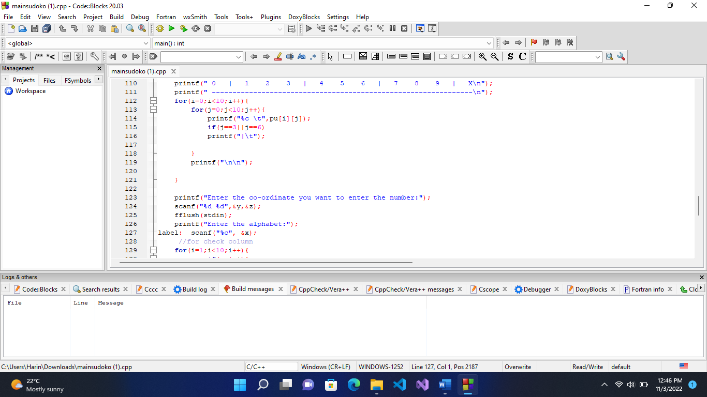

Fig 3.1 Dev c++

* Placing elements on the board
* Grid checking algorithm
* Row and column checking algorithm

**Brute Force Solving Method**

A simple way to solve this puzzle to simply try filling each blank square with the alphabets a to i until a valid solution is found.

## Project Block Diagram

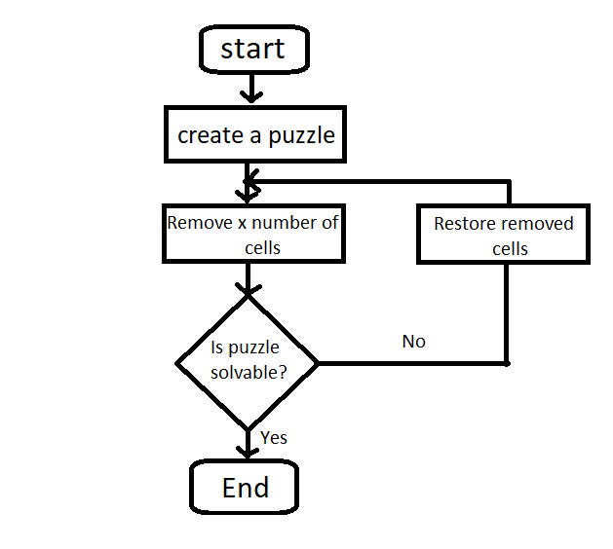

Fig 3.2 Flowchart of wordoku

The application starts with a nice looking console form which leads to a Wordoku table. After the table presented user have to put valid value inside the table according to the rule, after finishing the puzzle its complete then they can exit the application.

## Working principle

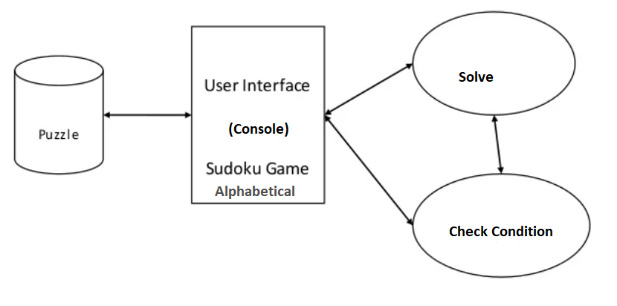

Fig 3.4 Block diagram of process

## Implementation

## We will use c language on developing the concept of sudoku not with numbers with alphabets. For this we will use the concept of matrix of 9×9. It will be hard for 26 alphabets so to make it a bit easier we do it for only 9 alphabets(a-z). Then likewise sudoku here we can decide where the initials value to be given for the problem. The programmer will decide to give the few letters on which position. Then the player or user cannot place ta same alphabet that is already in the same row or column of diagonal. If that case is seen then the compiler will display error and tells the user to put other options on that particular position.

Here's the algorithm of our game :

1. Frist we need to make a 9×9 matrix

2. Then we will assign few characters at certain position of their randomly.

3. The user or player needs to put the values on positions where they want but they need to understand that they couldn’t repeat the characters in same row or column elements.

4. If the values are repeated...then the error is displayed.

# RESULT AND ANALYSIS

First, we have our console as shown below in the Fig 5.1. The rule is given on our initial console as well as the puzzle table. The insertion of character on the table is based as co-ordinate system, we have to give co-ordinate to insert our character at a possible place. Fig 5.2 shows the selection of the place by giving co-ordinate. If user insert the co-ordinate that contain already a character then it shows error as shown in Fig 5.3. If the user select wrong co-ordinate and want to re-select the co-ordinate that he sure about it, there is a option that user can re-position their co-ordinate as shown in the Fig 5.7. According to the game rule user must not place more than one character in a single row and column though if user insert the character that is already present in a row or column it shows error as shown in the Fig 5.8. All the result output of our program is available on the appendices chapter.

After analyzing our program we found functional error. i.e If the user insert character in one of the available box of the table but later he finds that the inserted value is wrong and he wants to insert other character in that co-ordinate but character is already placed in that box so it throw error which becomes greatest drawback of our program. This shows in the Fig 5.5.

# CONCLUSION

Through creating this wordoku table and make this puzzle works according to the rules through algorithm and logics. It feels we have improved our programming ability. This was perhaps the largest program int terms of time invested and lines of code written that we have created. The code is not of the highest quality, and it is severely lacking in documentation, but some of the problems posed by the project were a good challenge to solve. Writing the algorithm and logics has demonstrated the advantages of logic building capacity. Finally, we have experienced participating in this project.

The program of this wordoku puzzle is playable but little hard to understand the concept. However, the implementation could likely be improved to execute faster. Furthermore ,there are many logic solving techniques that have not been lamentedted.

It works in that it successfully check grids of a given character of hints. Also it successfully check the row and column to meet the criteria of the puzzle. In the future it we can upgrade it by adding random table generation, auto solving the given puzzle table, we can design levels according to easy to hard, well organized GUI, user can ask for hint etc.

# REFERENCES

TARUN KUMAR Follow Student at IMSEC (no date) *Project Report on sudoku*, *Share and Discover Knowledge on SlideShare*. Available at: https://www.slideshare.net/TARUNKUMAR362/project-report-on-sudoku (Accessed: November 6, 2022).[1]

TARUN KUMAR Follow Student at IMSEC (no date) *Project Report on sudoku*, *Share and Discover Knowledge on SlideShare*. Available at: https://www.slideshare.net/TARUNKUMAR362/project-report-on-sudoku (Accessed: November 6, 2022).[1]

# APPENDICES

We have the output of WORDOKU as shown below. Including its table.

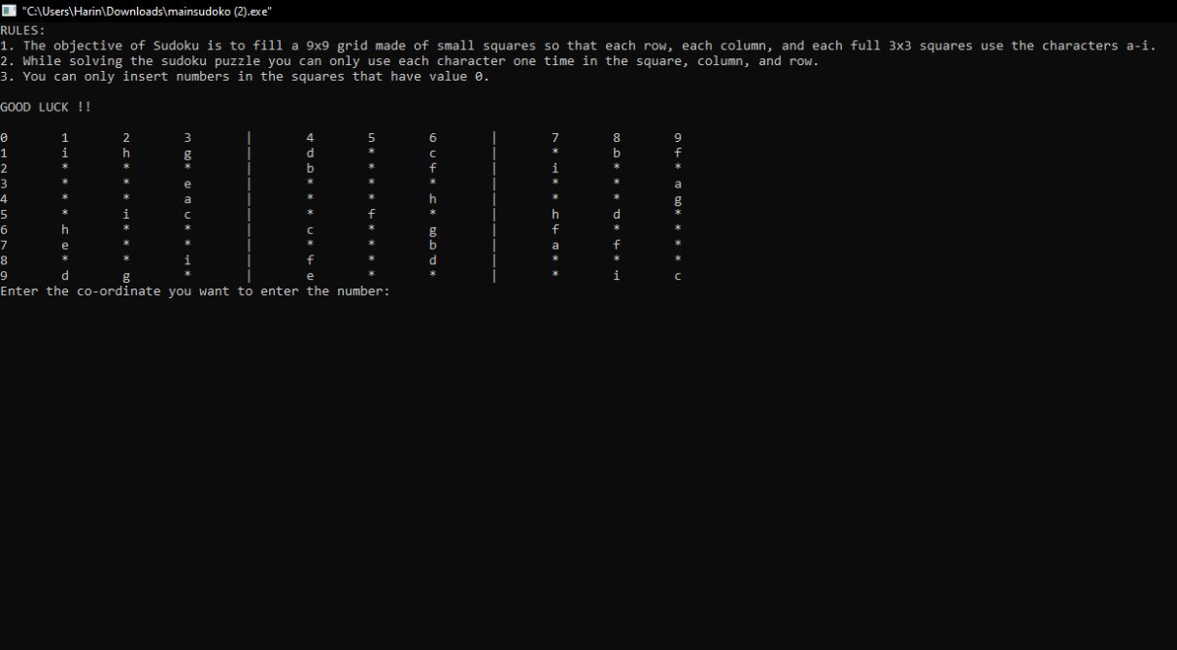

Fig 5.1: Wordoku initial console

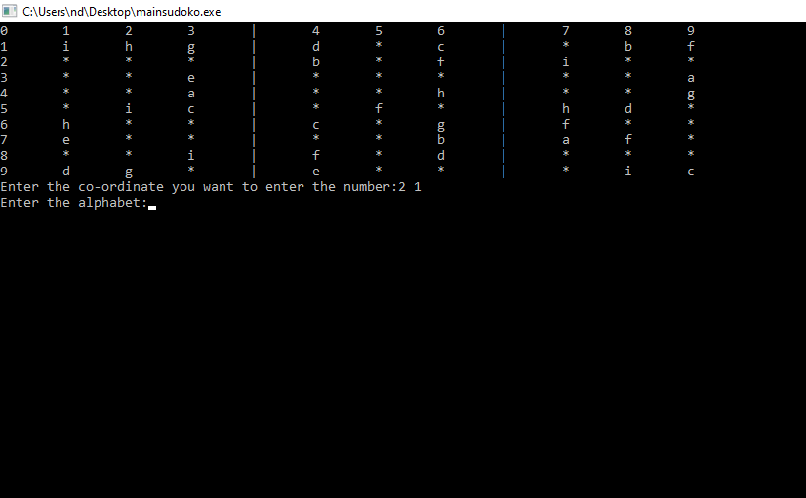

Fig 5.2: selecting position to insert value

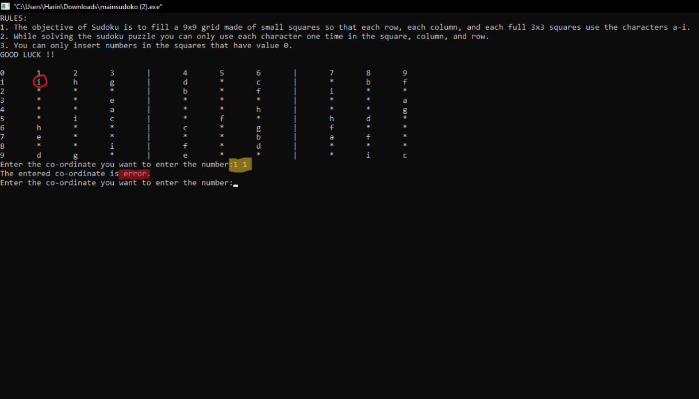

Fig 5.3: inserting invalid value

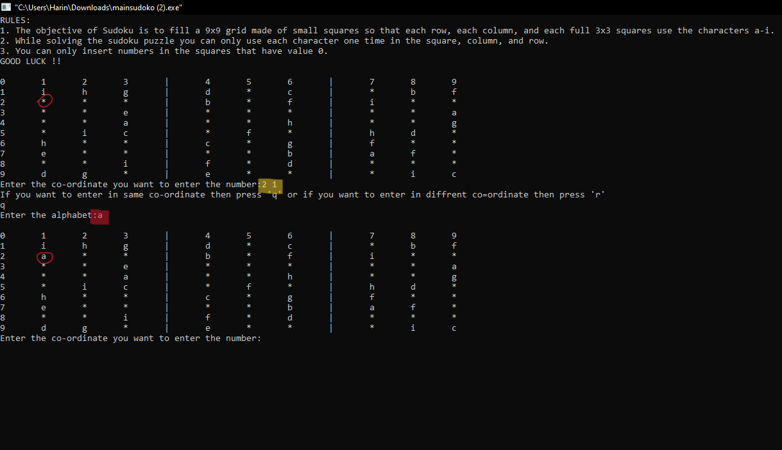

Fig 5.4: inserting possible value

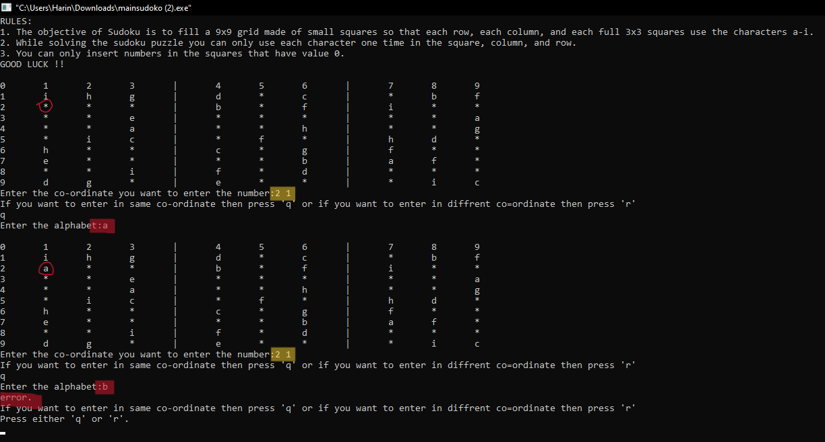

Fig 5.5: Drawbacks of our project

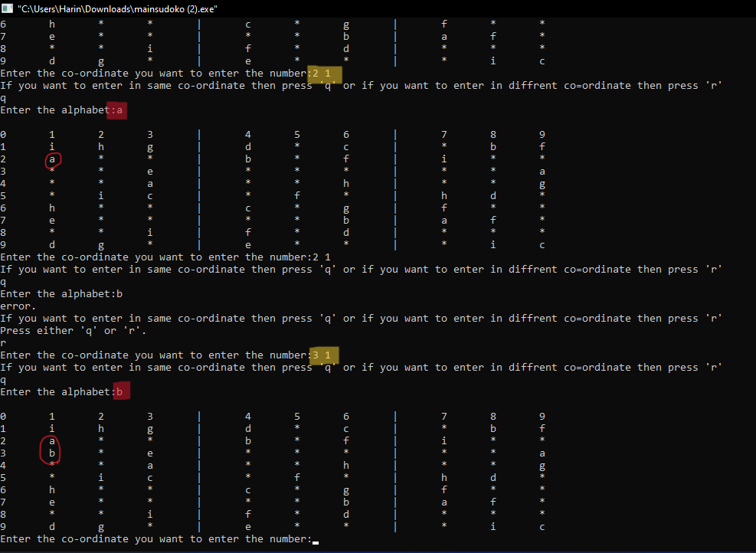

Fig 5.6: inserting possible value again

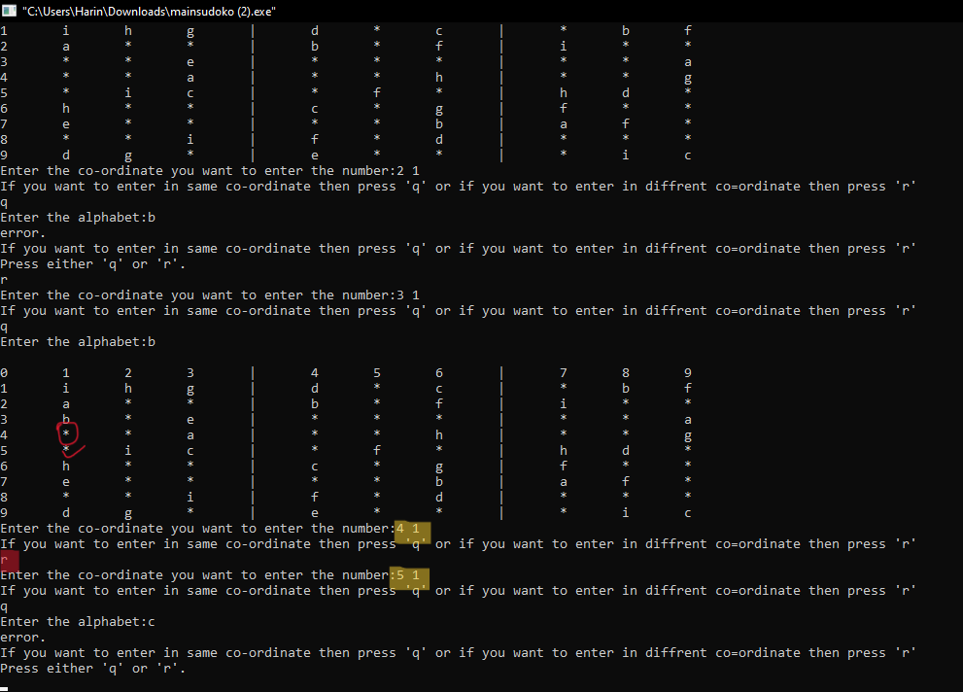

Fig 5.7: Re-selecting coordinate to insert

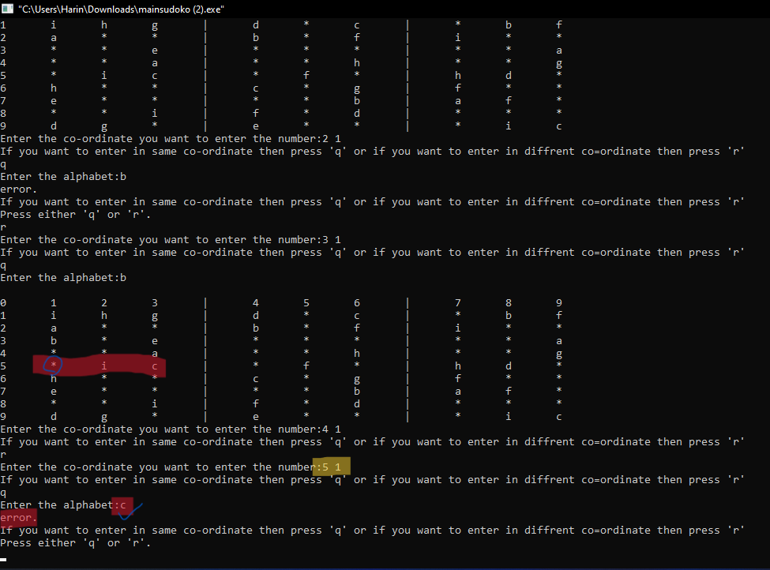

Fig 5.8: Inserting value which is already present in row