Student Name: Cody Hudson

Student Number: 8000603642

Student Email: hudsoc1@unlv.nevada.edu

Design Assignment 1A:

Q: Write, simulate, and demonstrate using Atmel Studio 7 an assembly code for the AVR ATMEGA328p microcontroller that performs the following functions:

1. Perform a multiplication of a 16-bit multiplicand with an 8-bit multiplier without using the MUL instruction. Use iterative addition to perform the above multiplication.

2. Registers R25:R24 hold the 16-bit multiplicand, R22 hold 8-bit multiplier, and R20:R19:R18 should hold the result.

3. Verify your algorithm and answers using the AVR mul instruction or C or any high-level program.

4. Determine the execution time @ 16MHz/#cycles of your algorithm using the simulation.

CODE:

;

; Project_1A.asm

;

; Created: 2/7/2019 6:29:52 PM

; Author : Cody Hudson

;

.include<m328pdef.inc>

start:

.ORG 00

; SETTING 'R22' FOR 8-BIT MULTIPLIER

; FOR EXAMPLE MULTIPLIER IS '5'

LDI R22, 0x05 ; 5

LDI R23, 0x05 ; 5 SECOND VARIABLE NEEDED FOR MULTIPLIER

; SETTING 'R25' AND 'R24' FOR 16-BIT MULTIPLICAND

; FOR EXAMPLE 16-BIT IS '23373'

LDI R25, 0x5B ; HIGH REGISTER

LDI R24, 0x4D ; LOW REGISTER

; FIRST LOOP PERFORMS ITERATIVE ADDITION EXITING AND

; REJOINING WHENEVER THERE IS A CARRY TO LABEL 'C1' TO

; THE HIGH REGISTER

L1: ADD R19, R25 ; ITERATIVE ADDING OF 'MIDDLE NIBBLE'

DEC R22 ; R22 = R22-1

BRCS C1 ; IF CARRY SET GO TO 'C1'

BRNE L1 ; IF R22 DOES NOT EQUAL 0 BRANCH TO 'L1'

; SECOND LOOP PERFORMS ITERATIVE ADDITION EXITING AND

; REJOINING WHENEVER THERE IS A CARRY TO LABEL 'C2' TO

; THE LOW REGISTER

L2: ADD R18, R24 ; ITERATIVE ADDING OF 'RIGHT NIBBLE'

DEC R23 ; R23 = R23-1

BRCS C2 ; IF CARRY SET GO TO 'C2'

BRNE L2 ; IF R22 DOES NOT EQUAL 0 BRANCH TO 'L2'

END:

RJMP END ; CONTINUOUS LOOP TO END

; COUNTS ALL THE CARRYS FROM 'MIDDLE NIBBLE' AND PLACES THEM IN

; 'R20' FOR LEFT NIBBLE

C1: SUBI R20, -1 ; CREATING 'LEFT NIBBLE'

CLC ; CLEARS CARRY

CPI R22,0 ; COMPARE 'R22' WITH INTEGER VALUE '0'

BREQ L2 ; IF 'R22' = 0 BRANCH TO 'L2'

RJMP L1 ; RETURN TO 'L1' IF ALL OTHER CONSTRAINTS HAVENT BEEN MET

; COUNTS ALL THE CARRYS FROM THE 'RIGHT NIBBLE' AND ADDS THEM TO

; 'SECOND NIBBLE'

C2: SUBI R17, -1 ; CREATING CARRY FOR 'SECOND NIBBLE'

CLC ; CLEARS CARRY

ADD R19, R17 ; ADD CARRY FROM 'RIGHT NIBBLE' TO 'MIDDLE NIBBLE'

BRCS C1 ; IF NOW THERE IS A NEW CARY GENERATED BRANCH TO 'C1'

CPI R23, 0 ; COMPARE 'R23' WITH INTERGER VALUE '0'

BREQ END ; IF 'R22' = 0 BRANCH TO 'END'

RJMP L2; RETURN TO 'L2' IF ALL OTHER CONSTRAINTS HAVENT BEEN MET

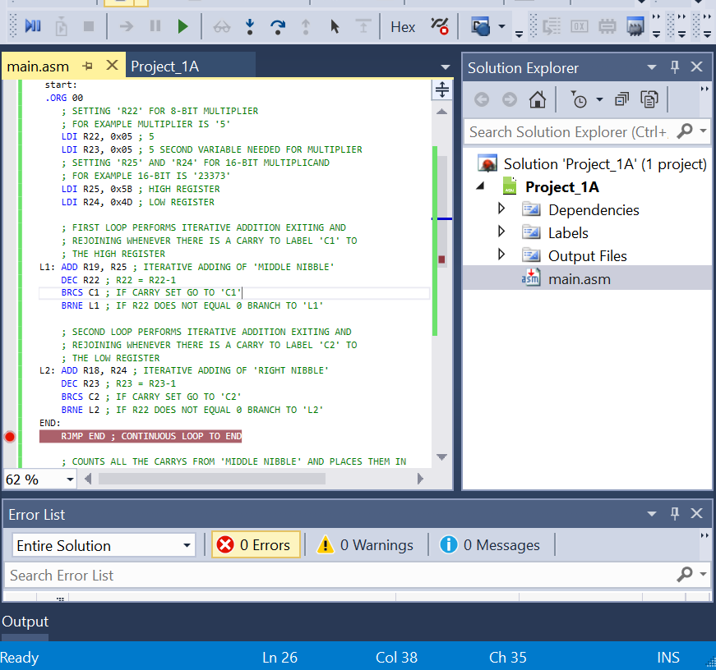

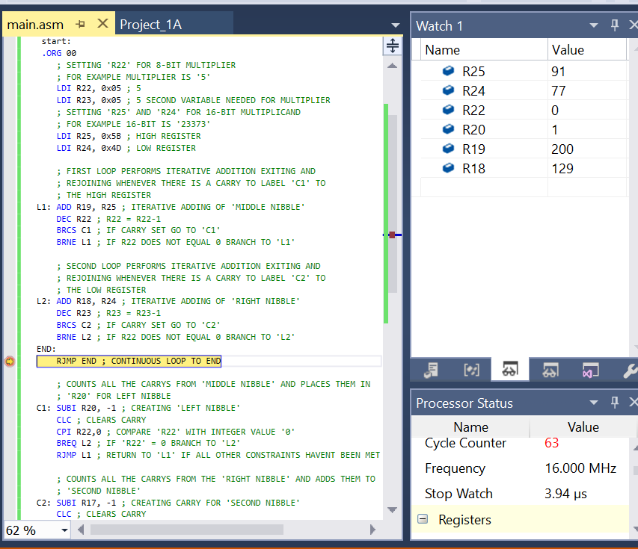

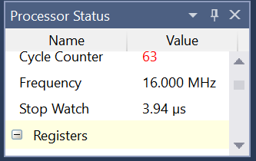

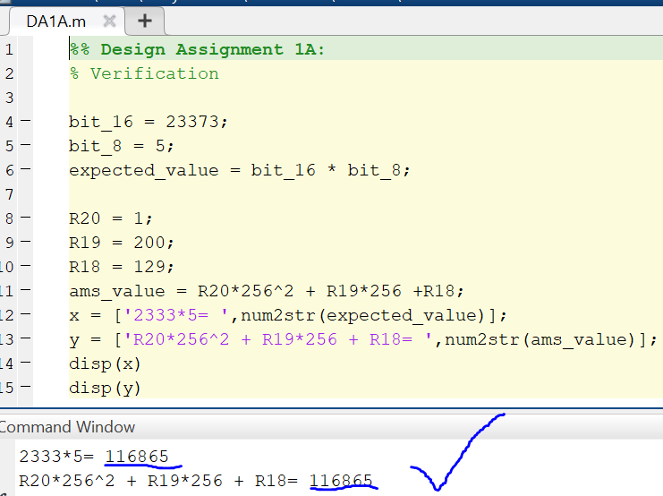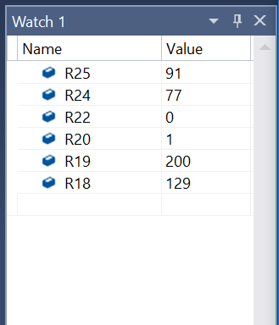

Execution time at 16.00 MHz is 3.94us

Verification done in matlab: