CPE301 – SPRING 2019

Design Assignment 2A

Student Name: Cody Hudson

Student #: 8000603642

Student Email: hudsoc1@unlv.nevada.edu

Primary Github address: https://github.com/eed911/class_proj.git

Directory:

https://github.com/eed911/class_proj/tree/master/DesignAssignments/DA2A/Project_2A

1. **COMPONENTS LIST AND CONNECTION BLOCK DIAGRAM w/ PINS**

List of Components used

* ATmega328P Xplained
* Muli Function Shield
  + LED
  + Button

Block diagram with pins used in the Atmega328P

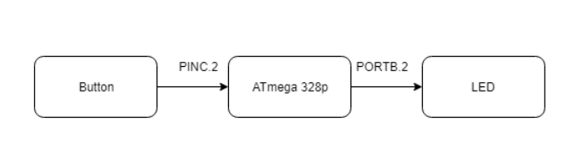

1. **INITIAL/MODIFIED/DEVELOPED CODE OF TASK 1/A**

Task 1 Assembly Code:

; EXP1_ASM.asm

;

; Created: 3/2/2019 12:24:09 PM

; Author : hudsoc1

;

LDI R16, 0x04 ;LOADS THE VALUE 0b00000100 INTO R16

LDI R20, 0x00 ;LOADS THE VALUE 0b00000000 INTO R20

OUT DDRB, R16 ;SETS PULL UP RESISTOR IN B2

MAIN:

OUT PORTB, R16 ;SETS PORTB PIN 2 HIGH

// CALLS THE CREATED DELAY SUBROUTINE 435ms

RCALL DELAY_435MS

OUT PORTB, R20 ;SETS ALL PINS IN PORTB LOW

// CALLES THE CREATED DELAY SUBROUTINE 270ms

RCALL DELAY_270MS

RJMP MAIN ;CREATES ENDLESS LOOP FOR THE WAVE GENERATED

//CREATED FUNCITON FOR A DELAY OF 435ms

//USES 4x DELAY 100ms, 3x DELAY 10ms, 1x DELAY 5ms

DELAY_435MS:

RCALL DELAY_100MS

RCALL DELAY_100MS

RCALL DELAY_100MS

RCALL DELAY_100MS

RCALL DELAY_10MS

RCALL DELAY_10MS

RCALL DELAY_10MS

RCALL DELAY_5MS

RET

//CREATED FUNCITON FOR A DELAY OF 270ms

//USES 2x DELAY 100ms, 3x DELAY 10ms, 1x DELAY 50ms

DELAY_270MS:

RCALL DELAY_100MS

RCALL DELAY_100MS

RCALL DELAY_50MS

RCALL DELAY_10MS

RCALL DELAY_10MS

RCALL DELAY_10MS

RET

//CREATED FUNCITON FOR A DELAY OF 100ms

//USES 2x DELAY 50ms

DELAY_100MS:

RCALL DELAY_50MS

RCALL DELAY_50MS

RET

//CREATED FUNCITON FOR A DELAY OF 100ms

//USES 5x DELAY 10ms

DELAY_50MS:

RCALL DELAY_10MS

RCALL DELAY_10MS

RCALL DELAY_10MS

RCALL DELAY_10MS

RCALL DELAY_10MS

RET

//CREATED FUNCITON FOR A DELAY OF 100ms

//USES 2x DELAY 5ms

DELAY_10MS:

RCALL DELAY_5MS

RCALL DELAY_5MS

RET

//CREATED FUNCITON FOR A DELAY OF 100ms

//USES 5x DELAY 1ms

DELAY_5MS:

RCALL DELAY_1MS

RCALL DELAY_1MS

RCALL DELAY_1MS

RCALL DELAY_1MS

RCALL DELAY_1MS

RET

//CREATED FUNCITON FOR A DELAY OF 1ms

DELAY_1MS:

PUSH R16 ;PUSHES VALUE OF R16 ONTO STACK

PUSH R18 ;PUSHES VALUE OF R18 ONTO STACK

LDI R16,255 ;LOADS A VALUE OF 255 INTO R16

LDI R18, 6 ;LOADS A VALUE OF 6 INTO R18

DELAY_1A:

DELAY1_B:

NOP ;SEQUECE OF DOING NOTHING TO TAKE UP 8 CLOCK CYCLES

NOP

NOP

NOP

NOP

NOP

NOP

NOP

DEC R16 ;DECREMENT R16 255 TIMES

BRNE DELAY1_B ;REPEAT THIS LOOP UNTIL R16 = 0

DEC R18 ;DECREENT R18 6 TIMES

BRNE DELAY1_B ;REPEAT THIS LOOP UNTIL R18 = 0

POP R18 ;POP VALUE OF R18 OUT OF STACK

POP R16 ;POP VALUE OF R16 OUT OF STACK

RET ;RETURN TO THE WHEN WAS CALLED

Task 1 C++ Code:

/*

* EXP1_C.c

*

* Created: 3/2/2019 1:34:56 PM

* Author : hudsoc1

*/

#define *F_CPU* 16000000UL //SETS THE FREQUECY OF MY OPERTION FOR DELAYS

#include <avr/io.h>

#include <util/delay.h>

int main(void)

{

DDRB |= (1<<PORTB2); //INITIALIZES DIRECITON OF PORTB.2 AS AN OUTPUT

while (1)

{

PORTB |= (1<<PORTB2); //SETS PORTB.2 HIGH

*_delay_ms*(435); //DELAY OF 435ms

PORTB &= ~ (1<<PORTB2); //SETS PORTB.2 LOW

*_delay_ms*(290); //DLEAY OF 290ms

}

}

1. **DEVELOPED MODIFIED CODE OF TASK 2/A from TASK 1/A**

Task 2 Assembly Code:

/*

* EXP2_ASM.asm

*

* Created: 3/2/2019 10:59:01 AM

* Author: hudsoc1

*/

.ORG 0

LDI R16, 0x04 ;LOADS 0b00000100 IN R 16

OUT DDRB, R16 ;SETS DIRECTION AS OUTPUT AT BIT 3

OUT PORTB, R16 ;SETS PULL UP RESISTOR AT PIN 3 OF B

LDI R17, 0x00 ;LOADS 0b00000000 INTO R17

OUT DDRC, R17 ;SETS DIRECTION AS INPUT FOR ALL C

OUT PORTC, R16 ;SETS PULL UP RESISTOR AT PIN 3 OF C

NOP

MAIN:

IN R20, PINC ;READS INPUT FROM PIN C SETS TO R20

COM R20 ;TAKE 1 COMPLEIMENT OF R20

ANDI R20, 0x04 ;ANDS THE COMPLIMENT OF THE INPUT WITH 0b00000100

CPI R20, 0x04 ;COMPARES R20 WITH 0b00000100 IF TRUE MOVE ON

BRNE MAIN ; IF NOT TURE REPEAT UNTIL TRUE

LIGHT_ON:

LDI R21, 0xFB ;LOADS 0b11111011 ONTO R21

OUT PORTB, R21 ;TURNS ON LED

RCALL DELAY_1250MS

OUT PORTB, R16 ;TURN OFF LED

RJMP MAIN ;REPEAT

//CREATED FUNCITON FOR A DELAY OF 1.25s

//USES 1x DELAY_1s, 2xDELAY_100ms, 1x DELAY_50ms

DELAY_1250MS:

RCALL DELAY_1S

RCALL DELAY_100MS

RCALL DELAY_100MS

RCALL DELAY_50MS

RET

//CREATED FUNCITON FOR A DELAY OF 1s

//USES 10x DELAY 100Ms

DELAY_1S:

RCALL DELAY_100MS

RCALL DELAY_100MS

RCALL DELAY_100MS

RCALL DELAY_100MS

RCALL DELAY_100MS

RCALL DELAY_100MS

RCALL DELAY_100MS

RCALL DELAY_100MS

RCALL DELAY_100MS

RCALL DELAY_100MS

RET

//CREATED FUNCITON FOR A DELAY OF 100ms

//USES 2x DELAY 50ms

DELAY_100MS:

RCALL DELAY_50MS

RCALL DELAY_50MS

RET

//CREATED FUNCITON FOR A DELAY OF 100ms

//USES 5x DELAY 10ms

DELAY_50MS:

RCALL DELAY_10MS

RCALL DELAY_10MS

RCALL DELAY_10MS

RCALL DELAY_10MS

RCALL DELAY_10MS

RET

//CREATED FUNCITON FOR A DELAY OF 100ms

//USES 2x DELAY 5ms

DELAY_10MS:

RCALL DELAY_5MS

RCALL DELAY_5MS

RET

//CREATED FUNCITON FOR A DELAY OF 100ms

//USES 5x DELAY 1ms

DELAY_5MS:

RCALL DELAY_1MS

RCALL DELAY_1MS

RCALL DELAY_1MS

RCALL DELAY_1MS

RCALL DELAY_1MS

RET

//CREATED FUNCITON FOR A DELAY OF 1ms

DELAY_1MS:

PUSH R16 ;PUSHES VALUE OF R16 ONTO STACK

PUSH R18 ;PUSHES VALUE OF R18 ONTO STACK

LDI R16,255 ;LOADS A VALUE OF 255 INTO R16

LDI R18, 6 ;LOADS A VALUE OF 6 INTO R18

DELAY_1A:

DELAY1_B:

NOP ;SEQUECE OF DOING NOTHING TO TAKE UP 8 CLOCK CYCLES

NOP

NOP

NOP

NOP

NOP

NOP

NOP

DEC R16 ;DECREMENT R16 255 TIMES

BRNE DELAY1_B ;REPEAT THIS LOOP UNTIL R16 = 0

DEC R18 ;DECREENT R18 6 TIMES

BRNE DELAY1_B ;REPEAT THIS LOOP UNTIL R18 = 0

POP R18 ;POP VALUE OF R18 OUT OF STACK

POP R16 ;POP VALUE OF R16 OUT OF STACK

RET ;RETURN TO THE WHEN WAS CALLED

Task 2 C++ Code:

/*

* EXP2_C.c

*

* Created: 3/2/2019 1:47:48 PM

* Author : hudsoc1

*/

#define *F_CPU* 16000000UL //SETS THE FREQUENCY OF 16MHz FOR DELAY

#include <avr/io.h>

#include <util/delay.h>

int main (void)

{

DDRB |= (1<<PORTB2); //SETS THE DIRECTION OF PORTB.2 AS OUTPUT

PORTB |= (1<<PORTB2); //ENABLE PULL UP RESISTOR OF PORTB.2

DDRC &= (0 << PORTC2); //SETS THE DIRECTION OF PORTC.2 AS AN INPUT

PORTC |= (1 << PORTC2); //ENABLES PULL UP RESISTOR OF PORTC.2

while (1)

{

if (!(PINC & (1<<PINC2))) //IF BUTTON IS PUSHED DO THIS

{

PORTB &= ~(1<<PORTB2); //TURN PORTB.2 LED ON

*_delay_ms*(1250); //DELAY FOR 1.25s

}

else //IF BUTTON ISNT PUSHED DO THIS

PORTB |= (1<<PORTB2); //TURN PORTB.2 LED OFF

}

return 0;

}

1. **SCHEMATICS**

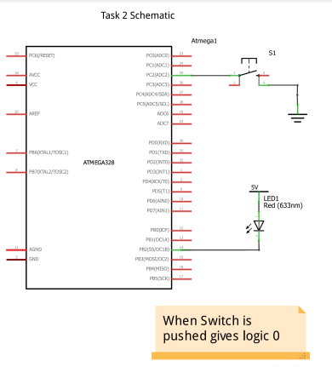

1. **SCREENSHOTS OF EACH TASK OUTPUT (ATMEL STUDIO OUTPUT)**

Task 1 Assembly:

Waveform Period of 750ms: High for 460ms:

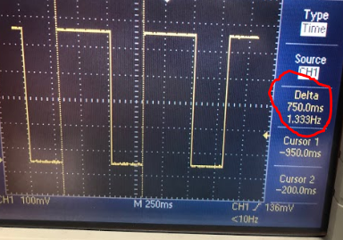 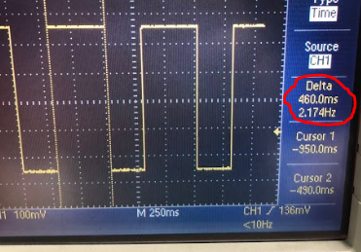

Low for 290ms:

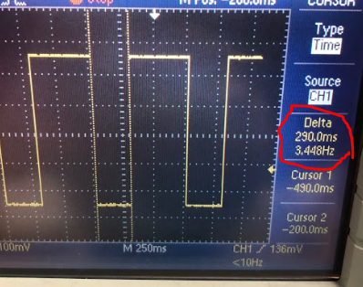

460/750 = 61% Duty Cycle

Task 1 C++:

Waveform Period 754ms: High for 463ms:

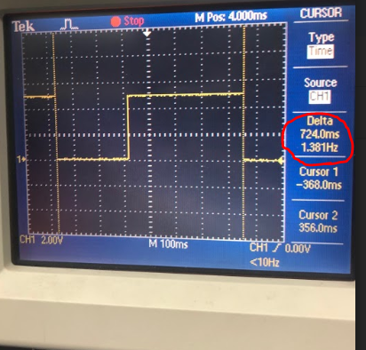 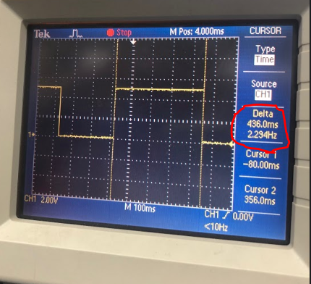

Low for 288ms:

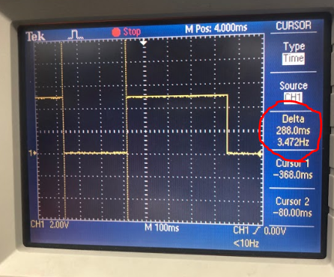

436/724 = 60.2% Duty Cycle

Task 2:

Task 2 has no pictures just videos of the operation.

1. **SCREENSHOT OF EACH DEMO (BOARD SETUP)**

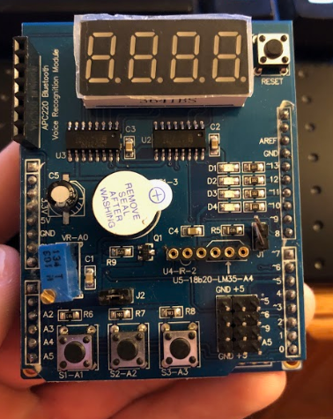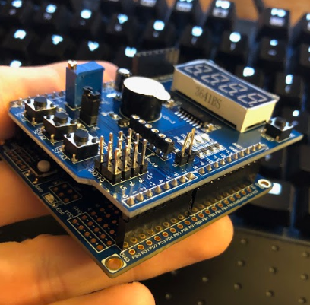

1. **VIDEO LINKS OF EACH DEMO**

Demo1:

<https://youtu.be/y_VuG_R42oM>

Demo2:

<https://youtu.be/VlTlZ6rMEFk>

Demo3:

<https://youtu.be/eg1sdz4SaIw>

Demo4:

<https://youtu.be/YraekL3LWx4>

1. **GITHUB LINK OF THIS DA**

**Student Academic Misconduct Policy**

<http://studentconduct.unlv.edu/misconduct/policy.html>

“This assignment submission is my own, original work”.

NAME OF THE STUDENT