CPE301 – SPRING 2019

Design Assignment 3B

Student Name: Cody Hudson

Student #: 8000603642

Student Email: hudsoc1@unlv.nevada.edu

Primary Github address: https://github.com/eed911/class_proj.git

Directory:

https://github.com/eed911/class_proj/tree/master/DesignAssignments/DA3B/Project_3B

1. **COMPONENTS LIST AND CONNECTION BLOCK DIAGRAM w/ PINS**

List of Components used

* ATmega328P Xplained
* RS-232
* Temperature Sensor LM34

Block diagram with pins used in the Atmega328P

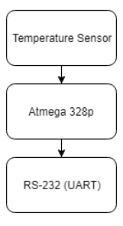

1. **INITIAL/MODIFIED/DEVELOPED CODE OF TASK 1/A**

1. Write a C AVR program that will monitor the LM34/35 connected to an Analog pin

(PC5) to display the temperature in F on the serial terminal every 1 sec. Use a timer

with interrupt for the 1 sec delay. Use a FTDI chip for serial to USB conversion.

2. Use the ATMEL Studio Data Visualizer or any Charting program to display the values

in time

Code:

/*

* DA3B_C.c

*

* Created: 3/28/2019 7:03:24 PM

* Author : Cody Hudson

*/

#define *F_CPU* 16000000UL

#include <avr/io.h>

#include <util/delay.h>

#include <avr/interrupt.h>

#include <stdio.h>

#define BAUDRATE 9600

#define BAUD_PRESCALLER (((*F_CPU* / (BAUDRATE * 16UL)))-1)

//Functions

volatile int Count;

volatile unsigned int adc_temp;

void USART_init( unsigned int ubrr ); //CREATES A VOID FUNCTION "USART_init"

void USART_TX_string(char *data); //CREATES A VOID FUNCITON "USART_TX_string"

void read_adc(void); // Function Declarations

void adc_init(void);

char outs[30]; //SETS VARIABLE "OUTS" AS A MATRIX FOR CONVERSIONS

char str[] = "Lets Get It"; //CREATES STRING "LETS GET IT"

char empty[] = " "; //CREATES EMPTY STRING FOR SPACING

int main(void)

{

Count = 0;

TIMSK0 |= (1<<TOIE0); //SETS THE INERRUPT TO ACTIVATE WHEN TIMMER 0 GETS OVERFLOW FLAG

sei (); //SETS GLOBAL INTERRUPT

TCCR0A = 0x00; //SETS NORMAL MODE ON TIMMER

TCCR0B |= (1<<CS02)|(1<<CS00); //SETS PRESCALER TO 1024

adc_init(); // Initialize the ADC

USART_init(BAUD_PRESCALLER); //SETS THE BAUD PRESCALLER

USART_TX_string("Connected!\r\n"); //PRINTS "CONNECTED" TO SERIAL. WE MADE IT!!

while (1){

if (Count > 59){ //IF COUNT IS > 60 EXICUTE THIS

read_adc();

*snprintf*(outs,sizeof(outs),"%3d\r\n", adc_temp); // print it

USART_TX_string(outs);

Count = 0; //RESETS THE COUNT VARIABLE BACK TO 0

}

} //WAITS HERE FOR TIMMER INTERUPT

}

/* INIT ADC */

void adc_init(void)

{

/** Setup and enable ADC **/

ADMUX = (0<<REFS1)| // Reference Selection Bits

(1<<REFS0)| // AVcc - external cap at AREF

(0<<ADLAR)| // ADC Left Adjust Result

(1<<MUX2)| // Analog Channel Selection Bits

(0<<MUX1)| // ADC5 (PC2 PIN?)

(1<<MUX0);

ADCSRA = (1<<ADEN)| // ADC ENable

(0<<ADSC)| // ADC Start Conversion

(0<<ADATE)| // ADC Auto Trigger Enable

(0<<ADIF)| // ADC Interrupt Flag

(0<<ADIE)| // ADC Interrupt Enable

(1<<ADPS2)| // ADC Prescaler Select Bits

(0<<ADPS1)|

(1<<ADPS0);

}

/* READ ADC PINS */

void read_adc(void)

{

unsigned char i = 4;

adc_temp = 0;

while (i--)

{

ADCSRA |= (1<<ADSC);

while(ADCSRA & (1<<ADSC));

adc_temp+= ADC;

*_delay_ms*(50);

}

adc_temp = adc_temp / 4 - 100; // Average a few samples

}

/*INT USART (RS-232)*/

void USART_init( unsigned int ubrr ){

UBRR0H = (unsigned char)(ubrr>>8); //SIZING THE PRESCALLER

UBRR0L = (unsigned char)ubrr;

UCSR0B = (1 << TXEN0); //Enable Tx interrupt

UCSR0C = (3 << UCSZ00); //asynchronous 8 N 1

}

/* SEND A STRING TO TEH RS-232*/

void USART_TX_string(char *data) { //FUNCTION CREATED IN ORDER TO SEND THROUGH SERIAL

while (*data != '\0') {

while (!(UCSR0A & (1<<UDRE0)));

UDR0 = *data;

data++;

}

}

ISR (TIMER0_OVF_vect){ //TV0V FLAG INTERUPT

while (Count < 60){ //WHILE COUNT IS LESS THAN 60 LOOP

if ((TIFR0 & 0x01) == 1){ //IF TV0V FLAG IS HIGH DO THIS

TIFR0 = 0X01; //CLEAR FLAG

Count++; //INCREMENT COUNT

}

}

}

1. **SCHEMATICS**

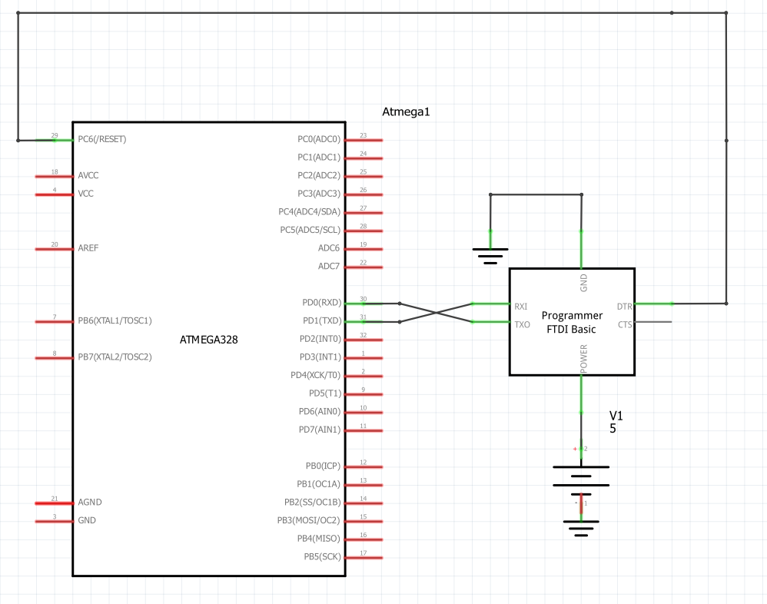

1. **SCREENSHOTS OF EACH TASK OUTPUT (ATMEL STUDIO OUTPUT)**

N/a all demonstration is done via video on YouTube

1. **SCREENSHOT OF EACH DEMO (BOARD SETUP)**

Screenshot of demo:

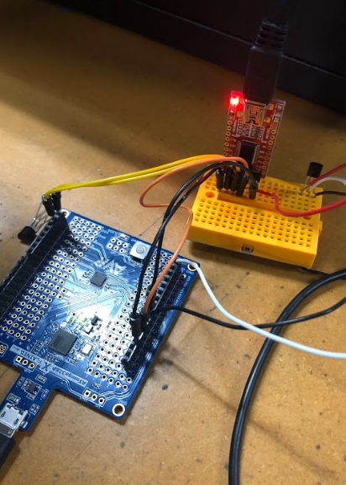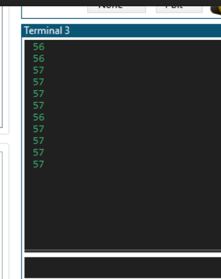

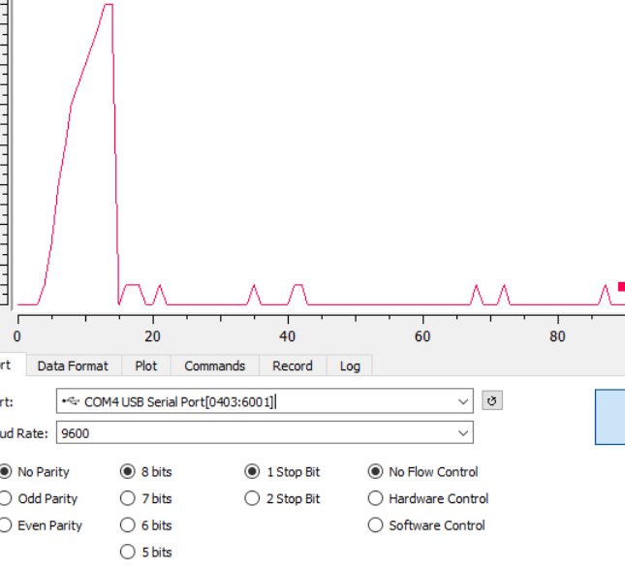

1. **VIDEO LINKS OF EACH DEMO**

Demo1:

<https://youtu.be/W49N2Hjcf1Q>

1. **GITHUB LINK OF THIS DA**

https://github.com/eed911/class_proj.git

**Student Academic Misconduct Policy**

<http://studentconduct.unlv.edu/misconduct/policy.html>

“This assignment submission is my own, original work”.

NAME OF THE STUDENT