CPE301 – SPRING 2019

Design Assignment 4B

Student Name: Cody Hudson

Student #: 8000603642

Student Email: hudsoc1@unlv.nevada.edu

Primary Github address: https://github.com/eed911/class_proj.git

Directory:

https://github.com/eed911/class_proj/tree/master/DesignAssignments/DA4B/Project_4B

1. **COMPONENTS LIST AND CONNECTION BLOCK DIAGRAM w/ PINS**

* Task 1:
  + Potentiometer
  + Stepper Motor
  + UNL2003 Driver Breakout Board
  + Atmega328P

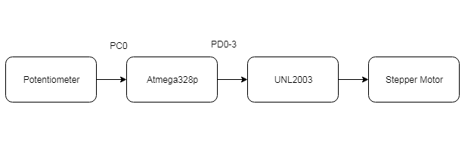

* Task 2:
  + Potentiometer
  + Servo Motor
  + Atmega328p

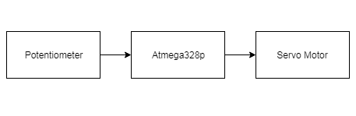

1. **INITIAL/MODIFIED/DEVELOPED CODE OF TASK 1**

/*

* DA4B.c

*

* Created: 4/24/2019 5:34:55 PM

* Author: hudsoc1

*/

#define *F_CPU* 16000000UL

#include <avr/io.h>

#include <util/delay.h>

#include <avr/interrupt.h>

#include <stdio.h>

/* Function Declarations /*

void read_adc(void);

void adc_init(void);

int start_value = 1699; // Initialize timer1

volatile unsigned int adc_value;

volatile int OVFCount; // Setup global overflow counter

volatile double float_value;

volatile int RPMvalue;

float c = 1699; // Needed offset for Affine Transformation

char outs[20];

int main(void)

{

adc_init(); // Initialize the ADC

*_delay_ms*(125); // 125ms delay

TCCR1B |= (1<<WGM12)|(1<<CS11); // CTC mode Prescaler 8

TIMSK1 |= (1<<OCIE1A); // Turn on interrupt Mask for OCR1A

OCR1A = start_value; // Initialize Timer at longest possible value, 20,000us

sei(); // global int

DDRD = 0xFF; // Set PortD as an output

OVFCount = 0; // Initialize global overflow counter

while (1)

{

read_adc();

/*

Affine Transformation

PWM output = adc_value*(39999-1699)/(1024-0) + 1699

*/

float_value = adc_value;

RPMvalue = (float_value*37.4033) + c;

OCR1A = RPMvalue; // Load newest time measurement value

}

}

/* Timer 1 Compare Interrupt Routine */

ISR(TIMER1_COMPA_vect){

OVFCount++; // Increment overflow flag counter

int count; // Initialize local counter

count = OVFCount; // Let local counter mimic global counter variable

// Step 1

if(count == 1){

PORTD = 0xE;

}

// Step 2

if(count == 2) {

PORTD = 0xC;

}

// Step 3

if(count == 3) {

PORTD = 0xD;

}

// Step 4

if(count == 4) {

PORTD = 0x9;

}

// Step 5

if(count == 5) {

PORTD = 0xB;

}

// Step 6

if(count == 6) {

PORTD = 0x3;

}

// Step 7

if(count == 7) {

PORTD = 0x7;

}

// Step 8

if(count == 8) {

PORTD = 0x6;

}

// Reset Counter if gone through all steps

if(count == 8){

OVFCount = 0; // Restart Stepper Counter

}

}

/* INIT ADC */

void adc_init(void)

{

/** Setup and enable ADC **/

ADMUX = (0<<REFS1)| // Reference Selection Bits

(1<<REFS0)| // AVcc - external cap at AREF

(0<<ADLAR)| // ADC Left Adjust Result

(0<<MUX2)| // Analog Channel Selection Bits

(0<<MUX1)| // ADC0 (PC0 PIN23)

(0<<MUX0);

ADCSRA = (1<<ADEN)| // ADC ENable

(0<<ADSC)| // ADC Start Conversion

(0<<ADATE)| // ADC Auto Trigger Enable

(0<<ADIF)| // ADC Interrupt Flag

(0<<ADIE)| // ADC Interrupt Enable

(1<<ADPS2)| // ADC Prescaler Select Bits

(0<<ADPS1)|

(1<<ADPS0);

}

/* READ ADC PINS */

void read_adc(void)

{

unsigned char i = 4;

adc_value = 0;

while (i--)

{

ADCSRA |= (1<<ADSC);

while(ADCSRA & (1<<ADSC));

adc_value+= ADC;

*_delay_ms*(50);

}

adc_value = adc_value / 4; // Average a few samples

}

1. **INITIAL/MODIFIED/DEVELOPED CODE OF TASK 2**

/*

* DA4B.c

*

* Created: 4/24/2019 5:35:22 PM

* Author: hudsoc1

*/

#define *F_CPU* 16000000UL

#include <avr/io.h>

#include <util/delay.h>

#include <stdio.h>

#define BAUDRATE 9600

#define BAUD_PRESCALLER (((*F_CPU* / (BAUDRATE * 16UL))) - 1)

/* Function Declarations /*

void read_adc(void);

void adc_init(void);

void USART_init( unsigned int ubrr );

void USART_tx_string( char *data );

volatile unsigned int adc_value;

volatile double float_value;

volatile int PWMvalue;

float c = 97; // Needed offset for Affine Transformation

char outs[20];

int main(void)

{

// Configure Timer 1

TCCR1A |= (1<<COM1A1)|(1<<COM1B1)|(1<<WGM11); // Non inverted PWM, Prescalar 64, Fast PWM

TCCR1B|=(1<<WGM13)|(1<<WGM12)|(1<<CS11)|(1<<CS10);

ICR1 = 4999; // PWM Frequency = 50Hz, Period = 20ms

DDRB |= (1<<PORTB1); // Sets PORTB1 to an output for PWM

adc_init(); // Initialize the ADC

USART_init(BAUD_PRESCALLER); // Initialize the USART

USART_tx_string("Connected!\r\n");

*_delay_ms*(125); // delay for 125ms

while(1)

{

read_adc();

/*

Affine Transformation

PWM output = adc_value*(535-97)/(1024-0) + 97

*/

float_value = adc_value;

PWMvalue = (float_value*0.4277343) + c;

*snprintf*(outs,sizeof(outs),"%3d\r\n", PWMvalue); // print it

USART_tx_string(outs);

OCR1A = PWMvalue; // sets the top value for compare to be == solved pwm value for angle alignment

*_delay_ms*(125); // wait for 125ms

}

}

/* INIT ADC */

void adc_init(void)

{

/** Setup and enable ADC **/

ADMUX = (0<<REFS1)| // Reference Selection Bits

(1<<REFS0)| // AVcc - external cap at AREF

(0<<ADLAR)| // ADC Left Adjust Result

(0<<MUX2)| // Analog Channel Selection Bits

(0<<MUX1)| // ADC0 (PC0 PIN23)

(0<<MUX0);

ADCSRA = (1<<ADEN)| // ADC ENable

(0<<ADSC)| // ADC Start Conversion

(0<<ADATE)| // ADC Auto Trigger Enable

(0<<ADIF)| // ADC Interrupt Flag

(0<<ADIE)| // ADC Interrupt Enable

(1<<ADPS2)| // ADC Prescaler Select Bits

(0<<ADPS1)|

(1<<ADPS0);

}

/* READ ADC PINS */

void read_adc(void)

{

unsigned char i = 4;

adc_value = 0;

while (i--)

{

ADCSRA |= (1<<ADSC);

while(ADCSRA & (1<<ADSC));

adc_value+= ADC;

*_delay_ms*(50);

}

adc_value = adc_value / 4; // Average a few samples

}

/* INIT USART (RS-232) */

void USART_init( unsigned int ubrr )

{

UBRR0H = (unsigned char)(ubrr>>8);

UBRR0L = (unsigned char)ubrr;

UCSR0B = (1 << TXEN0); // Enable RX, TX & RX interrupt

UCSR0C = (3 << UCSZ00); //asynchronous 8 N 1

}

/* SEND A STRING TO THE RS-232 */

void USART_tx_string( char *data )

{

while ((*data != '\0'))

{

while (!(UCSR0A & (1 <<UDRE0)));

UDR0 = *data;

data++;

}

}

1. **SCHEMATICS**

Task 1 & 2:

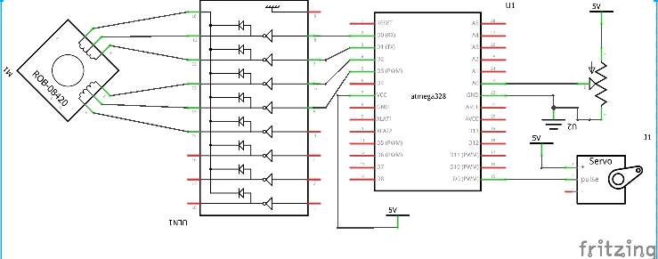

1. **SCREENSHOTS OF EACH TASK OUTPUT (ATMEL STUDIO OUTPUT)**

N/A everything to show was visible with by video. No screenshots needed from Atmel studio.

1. **SCREENSHOT OF EACH DEMO (BOARD SETUP)**

Task 1 & 2:

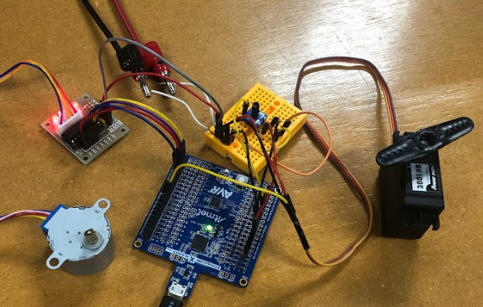

1. **VIDEO LINKS OF EACH DEMO**

Task 1:

https://www.youtube.com/watch?v=FnEBUKTndro

Task 2:

https://www.youtube.com/watch?v=IKqbdOgiK-k

1. **GITHUB LINK OF THIS DA**

https://github.com/eed911/class_proj.git

**Student Academic Misconduct Policy**

<http://studentconduct.unlv.edu/misconduct/policy.html>

“This assignment submission is my own, original work”.

Cody Hudson