|  |  |
| --- | --- |
| **Congressional age vs. ______** | **R squared value** |
| Number of followers | 0.0079 |
| Number of followers per capita | 0.01 |
| Number of users following | 0.0008 |
| Number of users following per capita | 0.0005 |
| Tweets per month | 0.031 |

**Table 1: R-squared values from linear correlations found for congressional age vs. number of followers, following, and tweets per month**

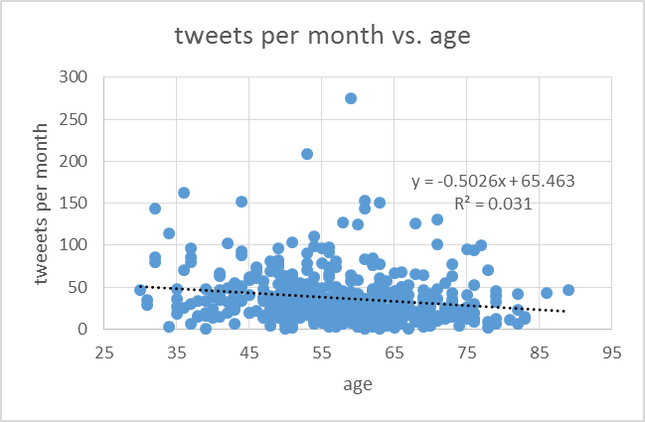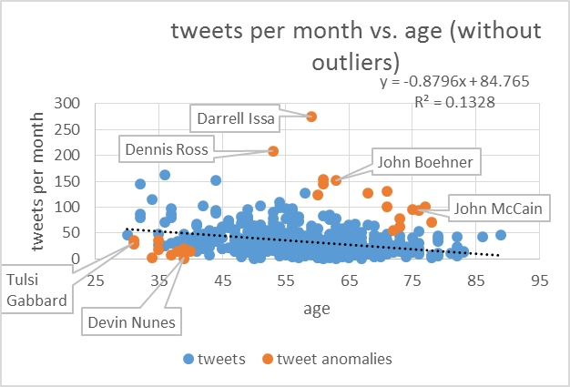

**Figure 1: Linear correlation for tweets per month vs. age with and without outliers**

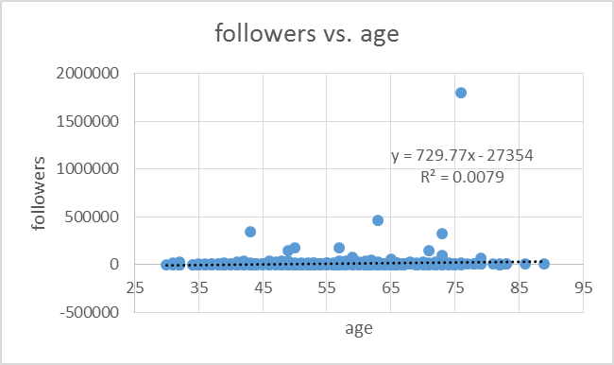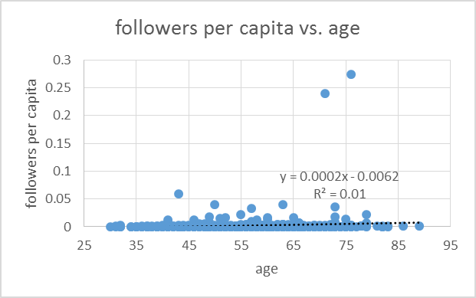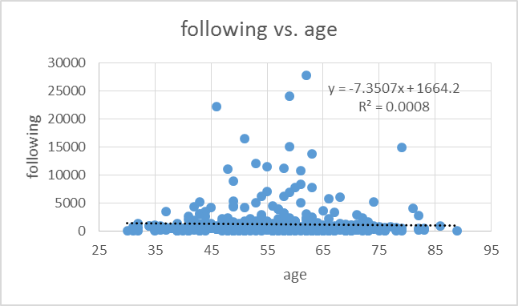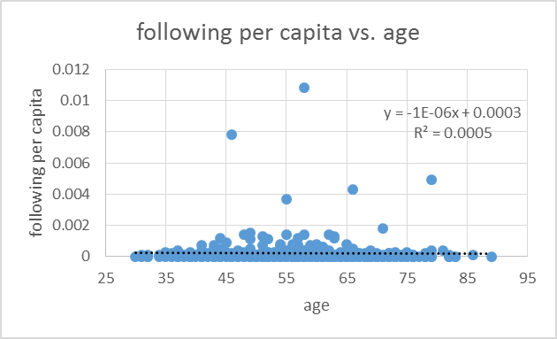

**Figure 2: Linear correlation for number of followers of congresspeople vs. congressperson’s age; number of people congresspeople are following vs. congressperson’s age**

|  |  |  |  |  |
| --- | --- | --- | --- | --- |
| **Age** | **Tweets per Month** | **Status** | **Name** | **Party** |
| 39 | 0.10 | House of Representatives | Devin Nunes | R |
| 34 | 3.04 | House of Representatives | Jaime Herrera Beutler | R |
| 37 | 6.73 | House of Representatives | Jared Polis | D |
| 40 | 14.06 | House of Representatives | Ben LujÃ¡n | D |
| 38 | 14.41 | House of Representatives | Joaquin Castro | D |
| 39 | 17.53 | House of Representatives | Tim Ryan | D |
| 39 | 17.73 | House of Representatives | Jon Runyan | R |
| 35 | 18.54 | House of Representatives | Adam Kinzinger | R |
| 39 | 19.67 | House of Representatives | Derek Kilmer | D |
| 31 | 29.33 | House of Representatives | Tulsi Gabbard | D |
| 31 | 35.06 | House of Representatives | Aaron Schock | R |
| 35 | 35.75 | House of Representatives | Tom Cotton | R |
| 72 | 55.33 | House of Representatives | Alan Lowenthal | D |
| 73 | 62.73 | Senate | Patrick Leahy | D |
| 78 | 70.10 | Senate | James Inhofe | R |
| 73 | 77.28 | House of Representatives | Steny Hoyer | D |
| 76 | 94.37 | Senate | John McCain | R |
| 75 | 94.88 | Senate | John Rockefeller | D |
| 77 | 100.45 | House of Representatives | Eddie Johnson | D |
| 71 | 100.81 | Senate | Mitch McConnell | R |
| 60 | 124.28 | House of Representatives | Ileana Ros-Lehtinen | R |
| 68 | 126.44 | House of Representatives | John Garamendi | D |
| 71 | 131.02 | Senate | Bernard Sanders | I |
| 61 | 144.21 | Senate | John Cornyn | R |
| 63 | 151.17 | House of Representatives | John Boehner | R |
| 61 | 152.80 | Senate | Michael Crapo | R |
| 53 | 209.00 | House of Representatives | Dennis Ross | R |
| 59 | 275.46 | House of Representatives | Darrell Issa | R |

**Table 2: Outliers of Figure 1 matched with # tweets per month made by congressperson, their status, name, and party.**

|  |  |  |  |  |
| --- | --- | --- | --- | --- |
| **Age** | **Followers** | **Status** | **Name** | **Party** |
| 76 | 1798403 | Senate | John McCain | R |
| 63 | 468004 | House of Representatives | John Boehner | R |
| 43 | 343185 | House of Representatives | Paul Ryan | R |
| 73 | 320304 | House of Representatives | Nancy Pelosi | D |
| 50 | 177324 | Senate | Rand Paul | R |
| 57 | 175742 | House of Representatives | Michele Bachmann | R |
| 71 | 149654 | Senate | Bernard Sanders | I |
| 49 | 142391 | House of Representatives | Eric Cantor | R |
| 73 | 98852 | Senate | Harry Reid | D |
| 59 | 80078 | House of Representatives | Darrell Issa | R |
| 79 | 67125 | Senate | Charles Grassley | R |
| 65 | 62467 | Senate | Thomas Coburn | R |
| 62 | 52147 | Senate | Charles Schumer | D |

**Table 3: Most followed congresspeople**

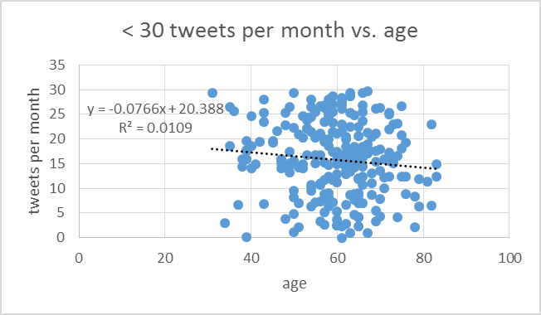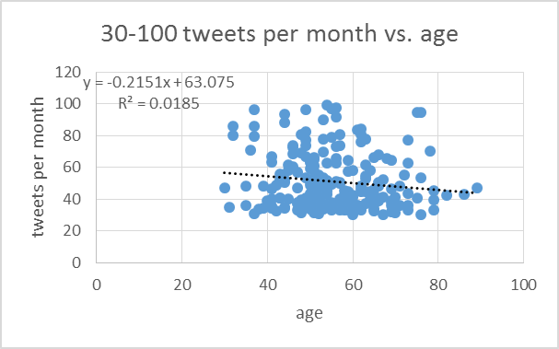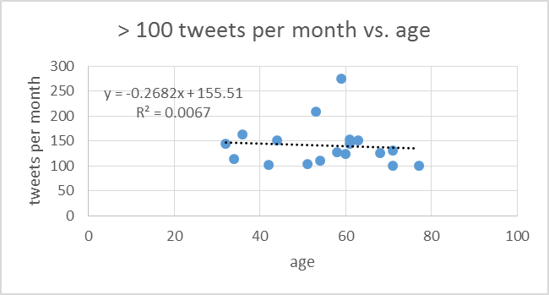

**Figure 3: Linear correlation for tweets made per month vs. congressperson’s age. Three categories were analyzed, a) congresspeople making < 30 tweets per month, b) congresspeople making 30-100 tweets per month, c) congresspeople making > 100 tweets per month.**

|  |  |  |  |  |
| --- | --- | --- | --- | --- |
| **Age** | **Following** | **Status** | **Name** | **Party** |
| 62 | 27825 | Senate | Charles Schumer | D |
| 59 | 24086 | House of Representatives | Darrell Issa | R |
| 46 | 22141 | House of Representatives | Jason Chaffetz | R |
| 51 | 16494 | Senate | Patrick Toomey | R |
| 59 | 14975 | House of Representatives | Karen Bass | D |
| 79 | 14948 | Senate | Charles Grassley | R |
| 63 | 13700 | House of Representatives | John Boehner | R |
| 53 | 11999 | House of Representatives | Loretta Sanchez | D |
| 55 | 11417 | House of Representatives | Bruce Braley | D |
| 58 | 11163 | Senate | Mark Warner | D |
| 48 | 11028 | House of Representatives | Kevin McCarthy | R |
| 61 | 10741 | House of Representatives | Vern Buchanan | R |
| 49 | 8872 | House of Representatives | Eric Cantor | R |
| 61 | 8364 | Senate | John Cornyn | R |
| 60 | 7752 | House of Representatives | Dan Benishek | R |

**Table 4: Congresspeople following the most twitter users.**

**Figure 4: Linear correlation for number of people following congresspeople vs. congressperson’s age in two categories. The graph to the left only correlates the data for congresspeople with < 100,000 followers and the graph to the right only correlates data for congresspeople with > 100,000 people followers.**

**Figure 5: Linear correlation for number of people congresspeople are following vs. congressperson’s age in two categories. The graph to the left only correlates the data for congresspeople following < 10,000 people and the graph to the right only correlates data for congresspeople following > 10,000 people.**

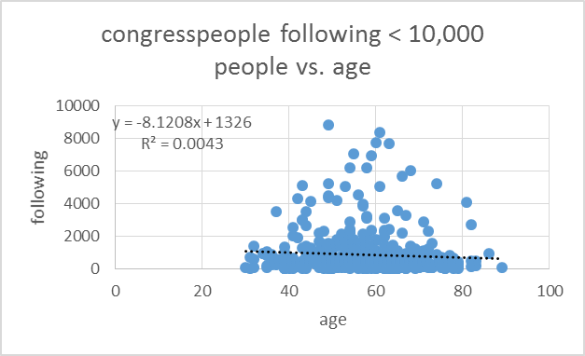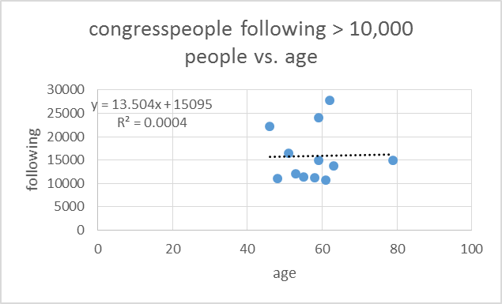

|  |  |  |  |
| --- | --- | --- | --- |
|  | **p-value** | **outliers excluded** | **p-value excluding outliers** |
| **Status vs. tweets per month** | **0.02454** | > 30 tweets per month | 0.2346022 |
| **Status vs. following per capita** | **0.093848** |  |  |
| Status vs. following | 0.467911 | > 10,000 following | 0.367331 |
| *Status vs. followers* | 0.143284 | > 100,000 followers | **5.04212E-08** |
| **Status vs. followers per capita** | **0.024612** |  |  |
| *Party vs. tweets per month* | 0.238769 | > 30 tweets per month | **0.001163** |
| **Party vs. following per capita** | **0.079642** |  |  |
| ***Party vs. following*** | **0.038098** | < 10,000 following | **0.000174** |
| Party vs. followers per capita | 0.11412 |  |  |
| Party vs. followers | 0.150374 | > 100,000 followers | 0.674636 |
| Gender vs. tweets per month | 0.501575 | > 30 tweets per month | 0.503728 |
| Gender vs. following per capita | 0.305149 |  |  |
| Gender vs. following | 0.989266 | > 10,000 following | 0.426535 |
| Gender vs. followers per capita | 0.554183 |  |  |
| Gender vs. followers | 0.554183 | > 100,000 followers | 0.127365 |

**Table 5: P-value statistics for congressional demographics vs. twitter activity (tweets made per month, number of followers, number of people followed) with and without outliers**

|  |  |
| --- | --- |
|  | **R squared value** |
| Percentage of population 18 to 24 vs. followers | 0.0002 |
| Percentage of population 18 to 24 vs. followers per capita | 0.0004 |
| Percentage of population 18 to 24 vs. following | 0.005 |
| Percentage of population 18 to 24 vs. following per capita | 0.0036 |
| Percentage of population 18 to 24 vs. tweets per month | 0.0016 |
| Percentage of population 65 and over vs. followers | 0.0008 |
| Percentage of population 65 and over vs. followers per capita | 0.0034 |
| Percentage of population 65 and over vs. following | 0.0011 |
| Percentage of population 65 and over vs. following per capita | 0.000007 |
| Percentage of population 65 and over vs. tweets per month | 0.0016 |
| Median age vs. followers | 0.0001 |
| Median age vs. followers per capita | 0.003 |
| Median age vs. following | 0.0021 |
| Median age vs. following per capita | 0.0005 |
| Median age vs. tweets per month | 0.0002 |

**Table 6: R-squared values from linear regressions done for voter age vs. twitter activity (number of followers, number of people followed, tweets made per month)**

**Figure 6: (top) Comparison of common words used by Republicans and Democrats in 200 most recent tweets and (bottom) comparison of common words used by Republicans and Democrats after the Boston bombing (between April 15 and April 22)**

**Figure 7: (top) list of top 25 words used in tweets by Republicans and Democrats in 200 most recent tweets made. Words in the middle indicate common words to both Republicans and Democrats. (bottom) list of top 25 words used in tweets overall by Republicans and Democrats after Boston bombing made between April 15 and April 22. Words in middle indicate common words to both Republicans and Democrats.**

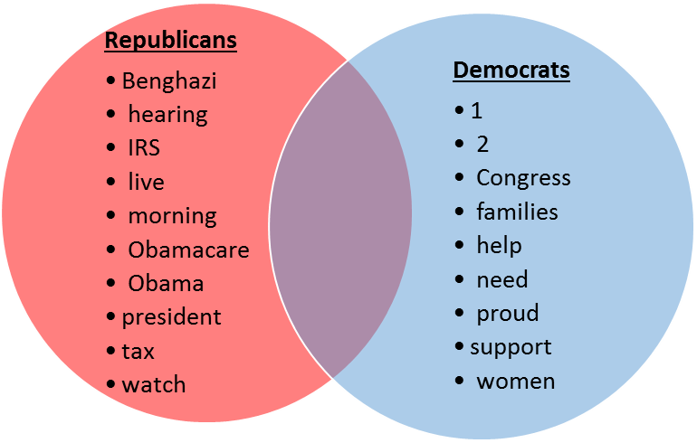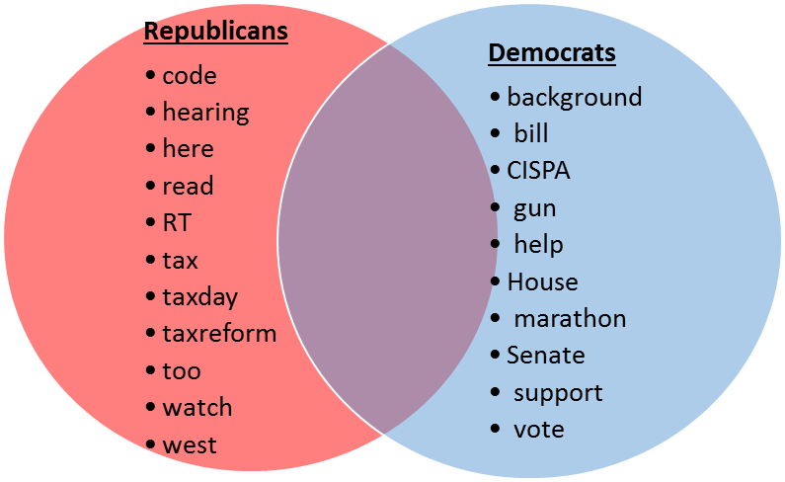

|  |  |  |  |
| --- | --- | --- | --- |
| **Rank** | **Overall** | **Republicans** | **Democrats** |
|  | today | today | today |
|  | is | is | is |
|  | great | house | great |
|  | House | here | more |
|  | more | great | House |
|  | are | are | are |
|  | here | more | 2 |
|  | RT | RT | bill |
|  | bill | budget | women |
|  | budget | Obama | act |
|  | act | president | proud |
|  | 2 | hearing | jobs |
|  | thanks | obamacare | thanks |
|  | jobs | IRS | Congress |
|  | President | Benghazi | here |
|  | hearing | bill | RT |
|  | was | watch | support |
|  | watch | live | need |
|  | need | act | more |
|  | Senate | tax | was |
|  | proud | thanks | help |
|  | tax | morning | budget |
|  |  | was | 1 |
|  |  | jobs | families |

**Table 7: Rank of most common words amongst 200 most recent tweets for all congresspeople.**

|  |  |  |  |
| --- | --- | --- | --- |
| **Rank** | **Overall** | **Republicans** | **Democrats** |
|  | Boston | Boston | Boston |
|  | today | today | today |
|  | is | is | is |
|  | are | tax | are |
|  | prayers | prayers | thoughts |
|  | thoughts | are | prayers |
|  | tax | taxday | great |
|  | great | thoughts | those |
|  | those | more | families |
|  | more | code | Senate |
|  | victims | great | CISPA |
|  | families | those | victims |
|  | thanks | RT | more |
|  | RT | victims | bill |
|  | hearing | hearing | support |
|  | CISPA | here | thanks |
|  | taxday | watch | vote |
|  | bill | thanks | House |
|  | here | families | help |
|  | House | west | marathon |
|  | Senate | taxreform | act |
|  | watch | too | background |
|  | act | read | gun |
|  | immigration | act | 2 |

**Table 8: Ranks of most common words amongst all words tweeted after Boston bombinb**