hw3

Enbo Tian

2022/2/28

# Graphical Model 1

## a)

rm(list = ls())  
X <- c("cold", "hot", "mild")  
# day 0  
day0 = replicate(5,sample(X,size = 1,prob=c(1/3,1/3,1/3)))  
# function of day  
dayk <- function(day){  
 dayk <- rep(0,5)  
 for (i in 1:5){  
 if (day[i] == "cold"){  
 dayk[i] = sample(c("cold", "hot", "mild"),size =1,prob = c(1/2,1/4,1/4))  
 }  
 else if (day[i] == "hot"){  
 dayk[i] = sample(c("cold", "hot", "mild"),size =1,prob = c(1/3,1/3,1/3))  
 }  
 else if(day[i] == "mild"){  
 dayk[i]= sample(c("cold", "hot", "mild"),size =1,prob = c(1/4,1/4,1/2))  
 }  
 }  
 dayk  
}  
# day 1:5  
day1 <- dayk(day0)  
day2 <- dayk(day1)  
day3 <- dayk(day2)  
day4 <- dayk(day3)  
  
day <- data.frame(day0, day1, day2, day3, day4)  
day

## day0 day1 day2 day3 day4  
## 1 mild mild hot hot mild  
## 2 mild hot cold hot hot  
## 3 cold cold mild mild cold  
## 4 hot cold hot mild mild  
## 5 mild cold hot mild mild

## b)

# P(day0)  
p0 <- c(1/3,1/3,1/3)  
# p (k given k-1)  
pgiven <- matrix(c(1/2,1/4,1/4,1/3,1/3,1/3,1/4,1/4,1/2),ncol=3)  
# marginal prob  
p1 <- pgiven%*%p0  
p2 <- pgiven%*%p1  
p3 <- pgiven%*%p2  
margp <- data.frame(p0,p1,p2,p3)  
margp

## p0 p1 p2 p3  
## 1 0.3333333 0.3611111 0.3634259 0.3636188  
## 2 0.3333333 0.2777778 0.2731481 0.2727623  
## 3 0.3333333 0.3611111 0.3634259 0.3636188

## c)

# 3|2hot   
p3g2 <- c(1/3,1/3,1/3)  
p3g2

## [1] 0.3333333 0.3333333 0.3333333

# p(1|2="hot") = p(2|1)*p(1)/p(2 = "hot")  
p1 <- c(p1)  
p2 <- c(p2)  
p3 <- c(p3)  
p1g2 <- pgiven * p1 / p2   
p1g2 <- c(p1g2[,2])  
p1g2

## [1] 0.3312102 0.3389831 0.3312102

# p(0|1) = p(1|0)*p(0)/p(1|2="hot")  
p0g1 <- pgiven * p0 /p1g2  
p0g1

## [,1] [,2] [,3]  
## [1,] 0.5032051 0.3354701 0.2516026  
## [2,] 0.2458333 0.3277778 0.2458333  
## [3,] 0.2516026 0.3354701 0.5032051

## d)

# give day2 is hot  
day2 = "hot"  
# get most probable day1  
if (max(p1g2) == p1g2[1]){  
 day1 = "cold"  
 i = 1  
}else if(max(p1g2) == p1g2[2]){  
 day1 = "hot"  
 i = 2  
}else if(max(p1g2) == p1g2[3]){  
 day1 = "mild"  
 i =3  
}  
# get most probable day0  
new_p0g1 <- p0g1[,i]  
if (max(new_p0g1) == new_p0g1[1]){  
 day0 = "cold"  
}else if(max(new_p0g1) == new_p0g1[2]){  
 day0 = "hot"  
}else if(max(new_p0g1) == new_p0g1[3]){  
 day0 = "mild"  
}  
# Same prob for day3 given hot of day2  
c(day0,day1,day2)

## [1] "cold" "hot" "hot"

the most probable report for day 0 to 2 are “cold” “hot” “hot”, and

we have the same probability for day3.

# Graphical Model 2

## a)

mi <- c(-2, 2 ,0)  
# height function  
height <- function(statep){  
 m <- replicate(5,sample(mi,size = 1,prob = statep))  
 y <- rep(0,5)  
 for (i in 1:5){  
 y[i] <- rnorm(1,m,1)  
 }  
 y  
}  
# get height  
y0 <- height(p0)  
y1 <- height(p1)  
y2 <- height(p2)  
y3 <- height(p3)  
datay <- data.frame(y0,y1,y2,y3)  
datay

## y0 y1 y2 y3  
## 1 2.511762 -1.536019 0.03102007 -0.88238828  
## 2 2.133691 -2.829667 -0.71771823 -0.03544213  
## 3 2.609272 -2.645629 -0.45645577 1.62213386  
## 4 1.782848 -1.309067 -0.26663822 -0.52945762  
## 5 1.400379 -2.158521 -0.42731199 0.83383134

## b)

m <- c(2,0,-2,-2)  
y0 <-replicate(5,rnorm(1,m[1],1))   
y1 <-replicate(5,rnorm(1,m[2],1))  
y2 <-replicate(5,rnorm(1,m[3],1))  
y3 <-replicate(5,rnorm(1,m[4],1))  
data2y<- data.frame(y0,y1,y2,y3)  
data2y

## y0 y1 y2 y3  
## 1 1.6746606 -0.7783034 -1.6931646 -1.7411468  
## 2 1.3366571 -0.6038038 0.1484034 -3.7888110  
## 3 0.9875342 1.2656318 -2.1430355 -1.2360920  
## 4 1.7316862 -1.1488038 -1.0097901 -0.8994421  
## 5 2.4540002 -0.9465946 -1.6004229 -1.1189140

## c)

Y0 =0.7  
Y1 =1.5  
Y2 =-1.8  
Y3 =-1  
  
#p(y0|x0)  
d0 <- rep(0,3)  
d0[1] <- dnorm(Y0,-2,1)  
d0[2] <- dnorm(Y0,0,1)  
d0[3] <- dnorm(Y0,2,1)  
#p(y1|x1)  
d1 <- rep(0,3)  
d1[1] <- dnorm(Y1,-2,1)  
d1[2] <- dnorm(Y1,0,1)  
d1[3] <- dnorm(Y1,2,1)  
#p(y2|x2)  
d2 <- rep(0,3)  
d2[1] <- dnorm(Y2,-2,1)  
d2[2] <- dnorm(Y2,0,1)  
d2[3] <- dnorm(Y2,2,1)  
#p(y1|x1)  
d3 <- rep(0,3)  
d3[1] <- dnorm(Y3,-2,1)  
d3[2] <- dnorm(Y3,0,1)  
d3[3] <- dnorm(Y3,2,1)  
# p(x0)*p(y0|x0)*p(x1|x0)*p(y1|x1)*p(x2|x1)*p(y2|x2)*p(x3|x2)*p(y3|x3)  
mp <- p0*d0*pgiven*d1*pgiven*d2*pgiven*d3  
sum(mp[,1])

## [1] 4.060199e-06

sum(mp[,2])

## [1] 9.549811e-06

sum(mp[,3])

## [1] 4.031672e-06

# Gaussian Mixture Model

## a)

rm(list = ls())  
library("readxl")  
data <- read_excel("gmm_data.xlsx")  
plot(data$Var1,data$Var2)

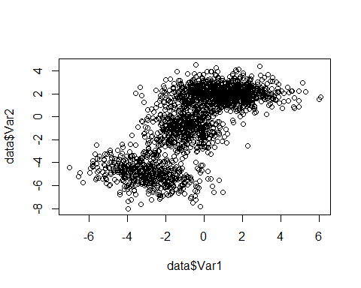 the number of clusters is 3.

## b)

library(fMultivar)

## 载入需要的程辑包：timeDate

## 载入需要的程辑包：timeSeries

## 载入需要的程辑包：fBasics

msnFit(data)

##   
## Title:  
## Skew Normal Parameter Estimation   
##   
## Call:  
## msnFit(x = data)  
##   
## Model:  
## Skew Normal Distribution  
##   
## Estimated Parameter(s):  
## $beta  
## Var1 Var2  
## [1,] 1.455257 3.191867  
##   
## $Omega  
## Var1 Var2  
## Var1 8.146794 11.70847  
## Var2 11.708474 22.46951  
##   
## $alpha  
## Var1 Var2   
## -0.8598872 -10.2055688   
##   
##   
## Description:  
## Mon Feb 28 19:07:39 2022 by user: 11193

library(ellipse)

##   
## 载入程辑包：'ellipse'

## The following object is masked from 'package:graphics':  
##   
## pairs

rho = cor(data)  
y_on_x <- lm(data$Var2 ~ data$Var1)  
x_on_y <- lm(data$Var1 ~ data$Var2)  
plot_legend <- c("99% CI green", "95% CI red","90% CI blue",  
 "Y on X black", "X on Y brown")  
plot(data, xlab = "X", ylab = "Y",col = "grey")  
lines(ellipse(rho), col="red")  
lines(ellipse(rho, level = .99), col="green")  
lines(ellipse(rho, level = .90), col="blue")  
abline(y_on_x)  
abline(x_on_y, col="brown")  
legend(3,1,legend=plot_legend,cex = .5, bty = "n")

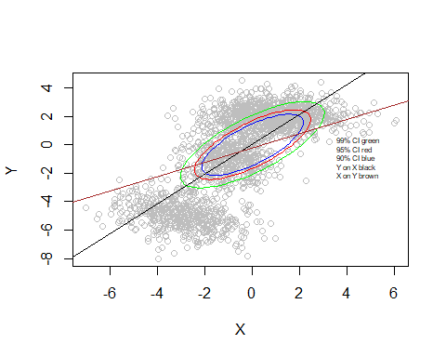 ## c)

library(MGMM)  
d <- as.matrix(data)  
K2GMM <- FitGMM(d,k=2)

## Objective increment: 10.8   
## Objective increment: 0.793   
## Objective increment: 0.21   
## Objective increment: 0.184   
## Objective increment: 0.218   
## Objective increment: 0.27   
## Objective increment: 0.336   
## Objective increment: 0.418   
## Objective increment: 0.519   
## Objective increment: 0.644   
## Objective increment: 0.799   
## Objective increment: 0.99   
## Objective increment: 1.23   
## Objective increment: 1.52   
## Objective increment: 1.89   
## Objective increment: 2.35   
## Objective increment: 2.93   
## Objective increment: 3.67   
## Objective increment: 4.6   
## Objective increment: 5.77   
## Objective increment: 7.21   
## Objective increment: 8.89   
## Objective increment: 10.6   
## Objective increment: 12   
## Objective increment: 12.2   
## Objective increment: 10.8   
## Objective increment: 8.22   
## Objective increment: 5.53   
## Objective increment: 3.51   
## Objective increment: 2.22   
## Objective increment: 1.42   
## Objective increment: 0.928   
## Objective increment: 0.614   
## Objective increment: 0.411   
## Objective increment: 0.276   
## Objective increment: 0.187   
## Objective increment: 0.127   
## Objective increment: 0.0864   
## Objective increment: 0.059   
## Objective increment: 0.0403   
## Objective increment: 0.0276   
## Objective increment: 0.0189   
## Objective increment: 0.0129   
## Objective increment: 0.00888   
## Objective increment: 0.0061   
## Objective increment: 0.00419   
## Objective increment: 0.00288   
## Objective increment: 0.00198   
## Objective increment: 0.00136   
## Objective increment: 0.000935   
## Objective increment: 0.000643   
## Objective increment: 0.000442   
## Objective increment: 0.000304   
## Objective increment: 0.000209   
## Objective increment: 0.000144   
## Objective increment: 9.91e-05   
## Objective increment: 6.82e-05   
## Objective increment: 4.69e-05   
## Objective increment: 3.23e-05   
## Objective increment: 2.22e-05   
## Objective increment: 1.53e-05   
## Objective increment: 1.05e-05   
## Objective increment: 7.25e-06   
## Objective increment: 4.99e-06   
## Objective increment: 3.43e-06   
## Objective increment: 2.36e-06   
## Objective increment: 1.63e-06   
## Objective increment: 1.12e-06   
## Objective increment: 7.71e-07   
## 68 update(s) performed before reaching tolerance limit.

plot(data, xlab = "X", ylab = "Y",col = "grey")  
points(K2GMM@Means[[1]][1],K2GMM@Means[[1]][2],col = "red")  
points(K2GMM@Means[[2]][1],K2GMM@Means[[2]][2],col = "dark green")

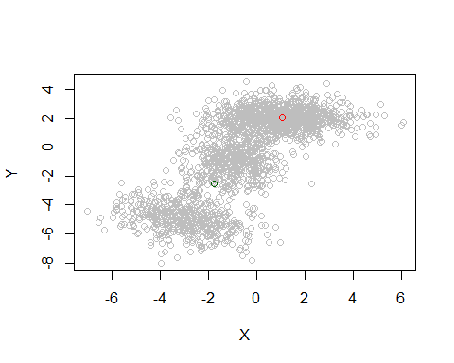 ## d)

K3GMM <- FitGMM(d,k=3)

## Objective increment: 17.1   
## Objective increment: 3.64   
## Objective increment: 1.16   
## Objective increment: 0.414   
## Objective increment: 0.163   
## Objective increment: 0.0716   
## Objective increment: 0.0356   
## Objective increment: 0.02   
## Objective increment: 0.0126   
## Objective increment: 0.00851   
## Objective increment: 0.00604   
## Objective increment: 0.0044   
## Objective increment: 0.00325   
## Objective increment: 0.00241   
## Objective increment: 0.0018   
## Objective increment: 0.00134   
## Objective increment: 0.000998   
## Objective increment: 0.000743   
## Objective increment: 0.000553   
## Objective increment: 0.000412   
## Objective increment: 0.000306   
## Objective increment: 0.000228   
## Objective increment: 0.000169   
## Objective increment: 0.000126   
## Objective increment: 9.32e-05   
## Objective increment: 6.91e-05   
## Objective increment: 5.13e-05   
## Objective increment: 3.8e-05   
## Objective increment: 2.82e-05   
## Objective increment: 2.09e-05   
## Objective increment: 1.55e-05   
## Objective increment: 1.15e-05   
## Objective increment: 8.52e-06   
## Objective increment: 6.32e-06   
## Objective increment: 4.68e-06   
## Objective increment: 3.47e-06   
## Objective increment: 2.57e-06   
## Objective increment: 1.9e-06   
## Objective increment: 1.41e-06   
## Objective increment: 1.05e-06   
## Objective increment: 7.74e-07   
## 40 update(s) performed before reaching tolerance limit.

plot(data, xlab = "X", ylab = "Y",col = "grey")  
points(K3GMM@Means[[1]][1],K3GMM@Means[[1]][2],col = "red")  
points(K3GMM@Means[[2]][1],K3GMM@Means[[2]][2],col = "dark green")  
points(K3GMM@Means[[3]][1],K3GMM@Means[[3]][2],col = "blue")

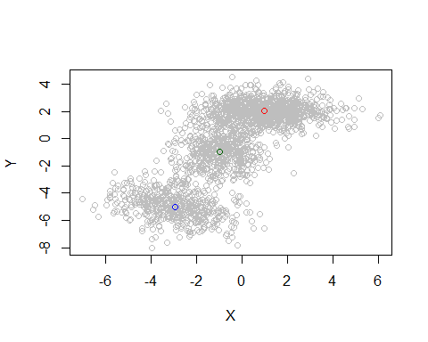 ## e)

# Sigma_i = dx * d covariance matrix  
si <- diff(data$Var1) %*% diff(rho)  
si[1:20,]

## Var1 Var2  
## [1,] 0.2714496 -0.2714496  
## [2,] 0.7881399 -0.7881399  
## [3,] 0.7121274 -0.7121274  
## [4,] -0.8031689 0.8031689  
## [5,] -0.6439405 0.6439405  
## [6,] -0.3233667 0.3233667  
## [7,] 0.8456699 -0.8456699  
## [8,] -1.2999374 1.2999374  
## [9,] 1.1007313 -1.1007313  
## [10,] 0.4108798 -0.4108798  
## [11,] 0.1088834 -0.1088834  
## [12,] -0.4082431 0.4082431  
## [13,] 0.5513425 -0.5513425  
## [14,] -0.1791793 0.1791793  
## [15,] 0.5668767 -0.5668767  
## [16,] -1.3834752 1.3834752  
## [17,] 0.2978884 -0.2978884  
## [18,] -0.1558065 0.1558065  
## [19,] 1.0285411 -1.0285411  
## [20,] -0.3159542 0.3159542

# Poisson Mixture Model

## 1)

rm(list = ls())

library("readxl")  
data <- read_excel("poisson_data.xlsx")  
x <- data$X  
hist(x)

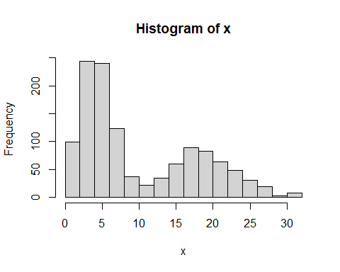 From the plot it may fit two distribution from 1-10 and 10-30

## b)

library(MASS)  
lambda <- fitdistr(x,densfun="Poisson")  
lambda

## lambda   
## 10.37833333   
## ( 0.09299791)

a <- 0:30  
b <- dpois(a,lambda$estimate)  
hist(x,xlim=c(0,30),ylim= c(0,250))  
par(new=TRUE)  
plot(a,b,yaxt="n",xaxt="n",xlab="",ylab="")

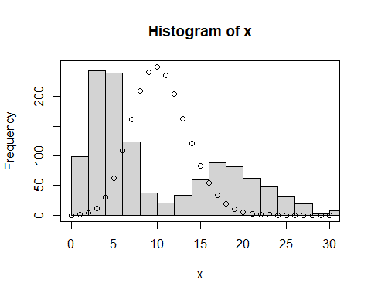 a simple poisson distribution is not a good fit.

## c)

library(mixtools)

## mixtools package, version 1.2.0, Released 2020-02-05  
## This package is based upon work supported by the National Science Foundation under Grant No. SES-0518772.

##   
## 载入程辑包：'mixtools'

## The following object is masked from 'package:ellipse':  
##   
## ellipse

mixture <- normalmixEM(x,lambda = 0.092997,k=2)

## number of iterations= 24

summary(mixture)

## summary of normalmixEM object:  
## comp 1 comp 2  
## lambda 0.604878 0.395122  
## mu 4.722448 19.036712  
## sigma 2.052662 4.708305  
## loglik at estimate: -3707.207

## d)

plot(mixture, density=TRUE)

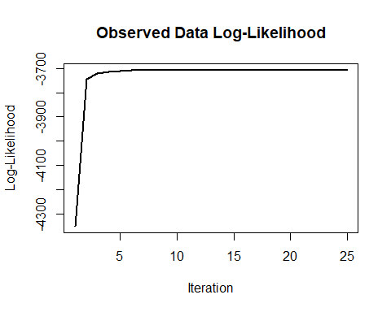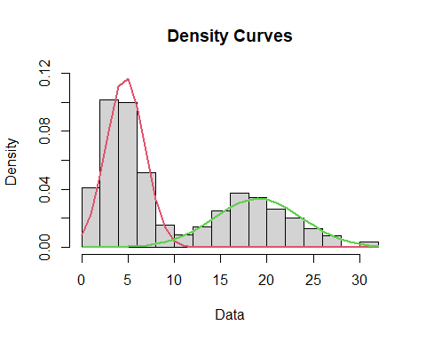

## e)

the single poisson distribution can not fit the data very well, the mixture model give two poisson distribution and separate the data into two modle, which fit the data better.