**STANDARD OPERATING PROCEDURE FOR SEMI-AUTOMATED BATCH COUNTING OF DAB-STAINED CELLS FOR IMMUNOHISTOCHEMICAL ANALYSIS**

# 1. SUMMARY

This SOP describes how to use the ImageJ macro *Batch Counting IHC* to semi-automatically count cells that have been DAB-stained for immunohistochemical analysis.

# 2. SOFTWARE and CODES

* ImageJ
  + Colour Deconvolution plugin by Gabriel Landini
  + Batch Counting IHC macro
* Excel

**9. METHODS**

# 9.1- ImageJ Picture Set-Up and Running the Macro

# Before beginning, make sure each image to be counted has the same keyword. Then go to Plugins >> Macros >> Edit… and open Batch Counting IHC.

# Notice the highlighted ‘keyword’ variable in the image below. Change the word in the parentheses to the new keyword used to name the images to be counted.

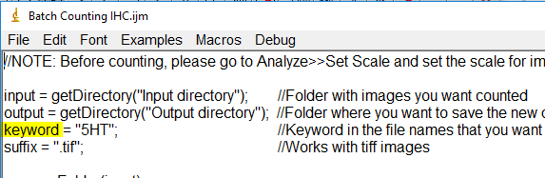

# File >> Save to save the macro with the specified keyword.

# Now open one of the images to be counted.

# Use the ‘Straight’ tool and draw a line along the scale.

# Go to Analyze >> Set Scale. This dialog box will show up. Change the ‘Known distance’ to the scale size (in this case to 100). In ‘Unit of Length’ input um. Check the box for ‘Global’ and then click ‘OK.’

**9.2 Running Batch Counting IHC**

# Open ImageJ. Go to Plugins >> Macros >> Run... and locate/run the Batch Counting IHC macro

# Two prompts will open one after another. In the first (titled ‘Input Directory’), locate the folder that contains the images to be counted. In the second (titled ‘Output Directory’), locate the folder where the counted images will be saved.

# Follow the prompts as they pop up until completion.

# A. TIPS & THOUGHTS

Occasional glitches will occur, just continue through the process and when prompted with the ‘Save Image’ box, click ‘NO’ to redo that section.

**B. FUTURE ADDITIONS**

None planned.

# 10. REFERENCES

ImageJ image analysis software. [http://rsb.info.nih.gov/ij/]

Colour Deconvolution ImageJ plugin. [<https://imagej.net/Colour_Deconvolution>[]](http://biotech.ucsd.edu/uct/)