**Step 1: Connect the circuit**

Connect the circuit according to the circuit connection diagram in the “Fritzing” folder.

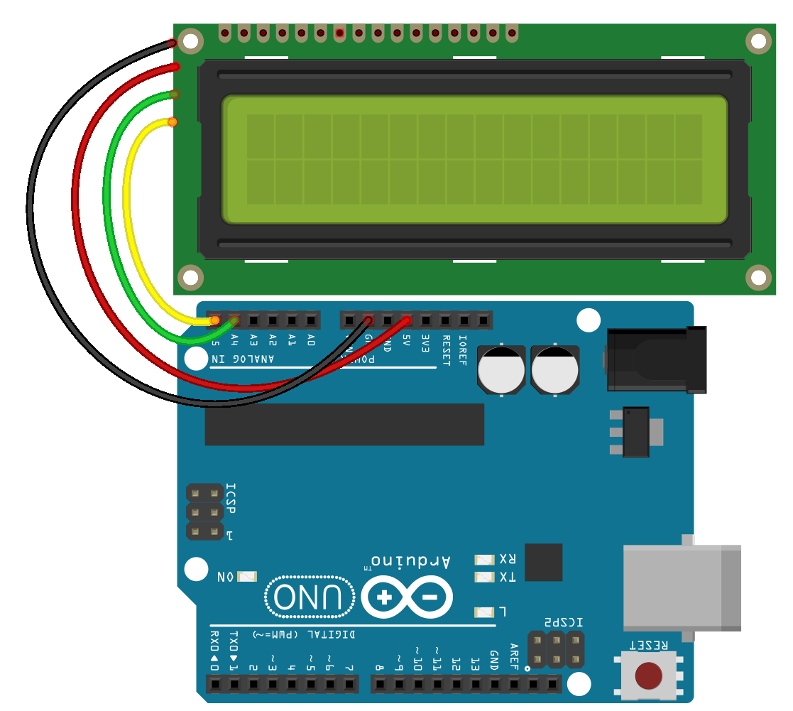

**Step 2: Open the test code IDE and add the library file**

Before you upload the code to the control board, you neeed to add the LiquidCrystal_I2C library.  
1) Open the “ I2C_LCD1602/Test_Code/i2c_lcd1602_test/i2c_lcd1602_test.ino ” in Arduino IDE.  
2) Include the “ I2C_LCD1602/Library/LiquidCrystal_I2C.zip ” as shown below.

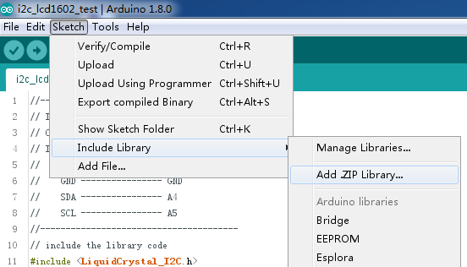

**Step 3: Compile the code and upload it to the Arduino Board.**