**Step1:**Connecting circuit

OLED Molude ------- Arduino Uno

GND ----------------- GND

VCC ------------------- 5V

SCL ------------------- A5

SDA ------------------ A4

or

OLED Module ------- Arduino Mega2560

GND ------------------------ GND

VCC -------------------------- 5V

SCL -------------------------- A5

SDA ------------------------- D20

**Step2:**Install the Arduino IDE in your computer.For detailed steps,refer to

<https://www.arduino.cc/en/Guide/HomePage>

**Step3:**Add U8glib library.

1) Through the links at the bottom of the page to **download** [U8glib.zip](http://wiki.sunfounder.cc/images/0/0f/U8glib.zip).

2)the Arduino IDE, import the library from the "**Add Library**" Menu.

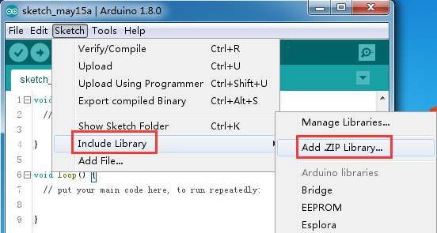

3) Find the **u8glib.zip**，clink **open**.

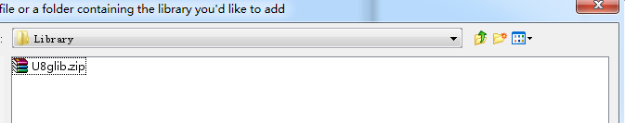

**Step4：**Open **Graphics_Test.ino**, Before clicking the Upload icon, set the **Port** and **Board** under **Tools** menu.Then upload the code to the board

