**Supplementary Materials**

**Table S1.** Study site locations and details. Treatment (EXP) denotes orchards with flower strips, and (CON) identifies orchards without flower strips. All orchards were planted with one of three cider apple varieties (‘Gilly’, ‘Hastings’ and ‘Amanda’) in uniform rows (2.75 m between trees, 4.5 m between rows), which were inter-planted with a second ‘polliniser’ variety every four to seven rows to encourage cross-pollination.

|  |  |  |  |  |  |  |  |
| --- | --- | --- | --- | --- | --- | --- | --- |
| **Orchard Name** | **Latitude** | **Longitude** | **Treatment** | **Size (ha)** | **Main Var.** | **Polliniser Var.** | **Yr. Planted** |
| 40A | 52°06′15.26″N | 002°55′23.30″W | EXP | 16.9 | Hastings | Gilly | 2008 |
| ABM | 52°05′03.79″N | 002°54′22.46″W | EXP | 4.33 | Amanda | Gilly | 2007 |
| MOR | 52°07′13.62″N | 002°54′41.44″W | EXP | 10.73 | Hastings | Gilly | 2009 |
| PHP | 52°05′23.16″N | 002°54′36.98″W | EXP | 8.09 | Gilly | Hastings | 2009 |
| PHP W | 52°05′28.28″N | 002°55′04.62″W | CON | 7.28 | Hastings | Fiona | 2006 |
| WHOPE | 52°09′27.39″N | 002°47′27.18″W | CON | 5.85 | Amanda | Vicky | 2007 |
| WEST1 | 52°12′12.32″N | 002°54′51.92″W | CON | 5.6 | Hastings | Debbie | 2007 |
| WEST2 | 52°12′19.72″N | 002°56′24.01″W | CON | 7.7 | Gilly | Fiona | 2008 |

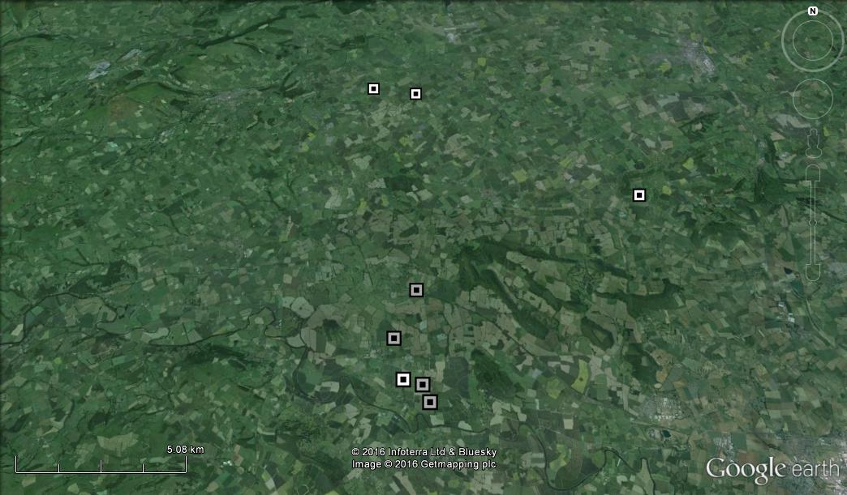

**Figure S1.** Geographic locations of the eight study orchards (white squares represent control orchards, grey squares represent flower strip orchards).

**Table S2.** Average (± standard error of the mean, SE) number of flowerheads per m2 of flowering plant species in flower strip alleyways and control alleyways in flower strip orchards during summer 2012 (Campbell et al., *unpublished*). Asterisk denotes unsown species.

|  |  |  |  |  |  |  |
| --- | --- | --- | --- | --- | --- | --- |
| Scientific name | Plant Family | Common name | Mean (strips) | SE (strips) | Mean (control) | SE (control) |
| *Ammi majus* | Apiaceae | Queen Anne's lace | 0.06 | 0.02 | 0.00 | 0.00 |
| *Centaurea montana* | Asteraceae | Mountain cornflower | 0.02 | 0.01 | 0.00 | 0.00 |
| *Daucus carota* | Apiaceae | Wild carrot | 1.39 | 0.17 | 0.00 | 0.00 |
| *Lobularia maritima* | Cruciferae | Sweet alyssum | 0.07 | 0.02 | 0.00 | 0.00 |
| *Lotus corniculatus* | Fabaceae | Bird's foot trefoil | 6.53 | 0.49 | 0.00 | 0.00 |
| *Medicago sativa* | Fabaceae | Alfalfa | 0.01 | 0.01 | 0.00 | 0.00 |
| *Phacelia tanacetifolia* | Boraginaceae | Phacelia | 0.04 | 0.02 | 0.00 | 0.00 |
| *Prunella vulgaris\** | Lamiaceae | Self-heal | 0.03 | 0.02 | 0.15 | 0.05 |
| *Ranunculus repens\** | Ranunculaceae | Creeping buttercup | 0.27 | 0.09 | 0.21 | 0.05 |
| *Taraxacum spp.\** | Asteraceae | Dandelion | 0.00 | 0.00 | 0.02 | 0.01 |
| *Trifolium hybridum* | Fabaceae | Alsike clover | 10.14 | 0.70 | 0.00 | 0.00 |
| *Trifolium pratense* | Fabaceae | Red clover | 8.95 | 0.87 | 0.04 | 0.02 |
| *Trifolium repens* | Fabaceae | White clover | 4.98 | 0.34 | 1.83 | 0.36 |
| *Vicia cracca* | Fabaceae | Tufted vetch | 0.45 | 0.09 | 0.00 | 0.00 |
| *Vicia sativa* | Fabaceae | Common vetch | 3.33 | 0.35 | 0.00 | 0.00 |
| **Total Abundance** | **-** | **-** | **36.25** | **1.48** | **2.25** | **0.36** |

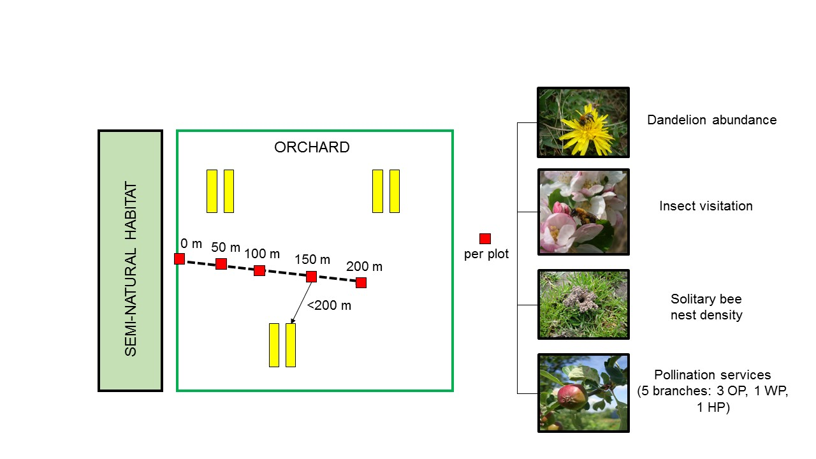

**Figure S2.** We recorded insect visitor abundance and richness, solitary bee nest density, blossom density, fruit set (OP – open-pollinated branches, WP – wind-pollinated, HP – hand-pollinated) and dandelion flower abundance in plots 0, 50, 100, 150 and 200 m away from an orchard edge that was bordered by semi-natural habitat (woodland, grassland, mature hedgerow). Plots in flower strip orchards bisected areas with flower strips to ensure they were <200 m away from a flower strip (yellow bars).

**Table S3.** Identity of insect visitor taxa and the number of visits made to apple flowers and flowering plant species in flower strips (2012, Campbell et al., unpublished). Data from 2013 shows number of visits made in flower strip orchards and total number of visits observed across all orchards and plots (in brackets). Flower strip species (Lc = *Lotus corniculatus*, Tr = *Trifolium repens*, Tp = *Trifolium pratense*, Th = *Trifolium hybridum*, Vc = *Vicia cracca*, Vs = *Vicia sativa*, Cm = *Centaurea montana*, Pt = *Phacelia tanacetifolia*, Dc = *Daucus carota* and To = *Taraxacum* spp.).

|  |  |  |  |  |  |  |  |  |  |  |  |  |  |
| --- | --- | --- | --- | --- | --- | --- | --- | --- | --- | --- | --- | --- | --- |
| **Visitor taxa** | | **Apple blossom** | **Flower strips (2012)** | | | | | | | | | |  |
| Genus | Species | May-June 2013 | *Lc* | *Tr* | *Tp* | *Th* | *Vc* | *Vs* | *Cm* | *Pt* | *Dc* | *To* | Both |
| Andrena | *A. nigroaena* | 152 (170) |  | 6 |  | 7 |  | 2 |  |  |  |  | X |
|  | *A. haemorrhoa* | 37 (55) |  | 3 |  |  |  |  |  | 1 |  | 1 | X |
|  | *A. nitida* | 9 (13) |  |  |  | 2 |  |  |  |  |  |  | X |
|  | *A. scotica* | 15 (17) |  |  |  |  |  |  |  |  |  |  |  |
|  | *A.subopaca/minutula* | 0 (1) |  |  |  |  |  |  |  |  | 66 |  | X |
|  | *A. cineraria* | 18 (28) |  | 1 | 1 |  |  |  |  |  |  | 1 | X |
| Apis | *A. mellifera* | 38 (80) | 7 | 173 |  | 309 |  |  | 1 |  | 2 |  | X |
| Bombus | *B. terrestris/lucorum* | 23 (30) | 18 | 44 | 24 | 38 |  | 1 | 1 |  |  |  | X |
|  | *B. hypnorum* | 3 (3) |  |  |  |  |  |  |  |  |  |  |  |
|  | *B. pascuorum* | 4 (7) | 15 | 35 | 222 | 24 | 16 | 9 | 1 | 3 |  |  | X |
|  | *B. pratorum* | 0 (3) |  |  | 2 |  |  |  |  |  |  |  | X |
|  | *B. lapidarius* | 12 (13) | 87 | 39 | 49 | 41 | 2 |  | 1 |  | 2 |  | X |
| Osmia | *O. bicornis* | 0 (2) |  |  |  |  |  |  |  |  |  |  |  |
| Bibio | *B. marci* | 4 (8) |  |  |  |  |  |  |  |  |  |  |  |
| Dasysyrphus | *sp1* | 0 (1) |  |  |  |  |  |  |  |  |  |  |  |
| Eupeodes | *spp.* | 0 (1) | 1 | 1 | 1 |  |  |  |  |  | 2 |  | X |
| Eristalis | *spp.* | 2 (21) | 2 | 4 | 12 | 25 |  |  |  |  | 91 | 2 | X |
| Platycheirus | *spp.* | 0 (4) | 3 | 1 | 1 | 3 | 1 | 1 |  |  | 1 |  | X |
| Heliophilus | *spp.* | 0 (2) |  |  |  |  |  |  |  |  |  |  |  |
| Rhyngia | *sp1* | 0 (3) |  |  |  |  |  |  |  |  |  |  |  |
| Syrphus | *spp.* | 3 (3) | 1 |  | 2 | 7 |  |  |  |  | 1 | 2 | X |
|  | *crane fly* | 2 (2) |  |  |  |  |  |  |  |  |  |  |  |
| Empis | *sp1* | 0 (4) |  | 2 |  | 1 |  |  |  |  | 2 |  | X |
|  | *unknown fly* | 1 (3) |  |  |  |  |  |  |  |  |  |  |  |
|  | *unknown beetle* | 0 (1) |  |  |  |  |  |  |  |  |  |  |  |
| **Total visits** |  | **331 (475)** | **134** | **309** | **314** | **457** | **19** | **13** | **4** | **4** | **167** | **6** | - |
| **Total Richness** |  | **15 (25)** | **8** | **11** | **9** | **10** | **3** | **4** | **4** | **2** | **8** | **4** | **15** |

**Table S4.** Moran’s test results of models where flower strip treatment was significant.

|  |  |  |  |  |  |  |
| --- | --- | --- | --- | --- | --- | --- |
| **Response Variable** | **Transf.** | **Fixed effects** | **Observed (Moran's *I*)** | **Expected** | **SD** | ***P*** |
| honeybee visit rate | Sqrt | Flower x distance + wild insects | -0.174 | -0.029 | 0.107 | 0.175 |
| wild insect visit rate |  | Flower + Dandelion | -0.077 | -0.029 | 0.106 | 0.651 |
| Wild bee visit rate |  | Flower x Distance | -0.112 | -0.029 | 0.105 | 0.428 |

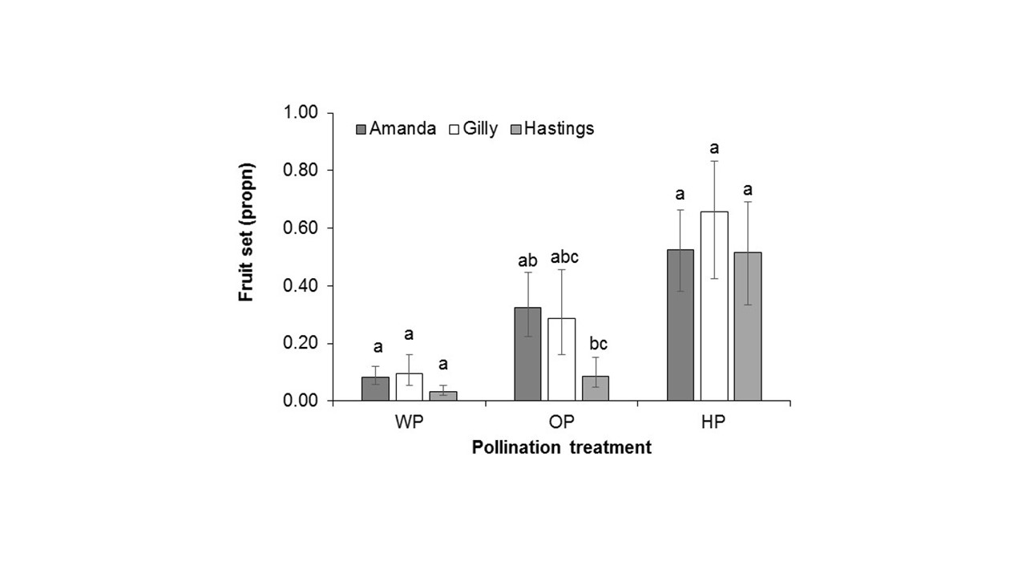

**Figure S3.** Model parameter estimates of initial fruit set for three varieties under different pollination treatments (WP = wind-pollination, OP = open-pollination, HP = hand-pollination. Error bars represent standard errors and different letters show significant differences between varieties within each treatment level based on Tukey’s HSD test (*P* < 0.05).

The extent of pollination deficits differed somewhat between varieties (Figure S3), with ‘Hastings’ performing poorly in open pollination compared to others tested (‘Gilly’, ‘Amanda’). However, all three varieties performed similarly in other treatments, suggesting that pollination deficits in Hastings may be quantitative, *i.e.* insufficient delivery of pollen grains during period of stigma receptivity, rather than qualitative (*e.g.* compatibility of polliniser varieties, degree of self-fertility). Problems with hastings could potentially be overcome by using polliniser varieties that have an extended flowering period to ensure the greatest degree of overlap with that of hastings, which is considered to be a mid- to late-season cider apple variety.