# Appendix

Dietzel et al., 2024. Winners and losers at enhanced urban roadsides: Trait-based structuring of wild bee communities at local and landscape scale. Biological Conservation.

## A.1: Seed mixture

List of wildflower species and their families included in the standardized mixture, sown in the experimental flowering patches along urban roads in Munich, Germany.

|  |  |
| --- | --- |
| **Family** | **Species** |
| Apiaceae | *Daucus carota* |
|  | *Pastinaca sativa* |
| Asteraceae | *Achillea millefolium* |
|  | *Centaurea cyanus* |
|  | *Centaurea jacea* |
|  | *Centaurea scabiosa* |
|  | *Cichorium intybus* |
|  | *Crepis biennis* |
|  | *Pentanema hirtum* |
|  | *Pentanema salicinum* |
| Boraginacae | *Echium vulgare* |
| Brassicaceae | *Berteroa incana* |
| Campanulaceae | *Campanula rapunculoides* |
| Caprifoliacae | *Scabiosa columbaria* |
| Caryophyllaceae | *Silene noctiflora* |
| Fabaceae | *Anthyllis vulneraria* |
|  | *Lathyrus pratensis* |
|  | *Lotus corniculatus* |
|  | *Medicago falcata* |
|  | *Trifolium medium* |
| Lamiaceae | *Origanum vulgare* |
|  | *Salvia pratensis* |
|  | *Thymus pulegioides* |
| Malvaceae | *Malva moschata* |
| Ranunculaceae | *Consolida regalis* |
|  | *Papaver rhoeas* |

## A.2 Nearby vs. distant control patches

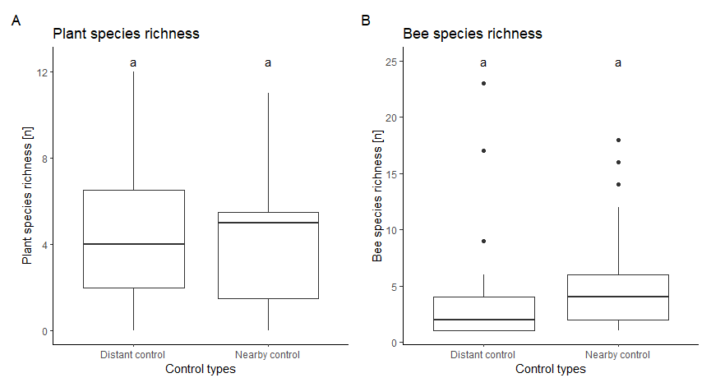Comparison of all control patches nearby the planted wildflower patches and ten distant control patches along two independent roads. Distant controls were arranged similarly in area (4 m x 2 m) and distance from each other (1.3 km) to the nearby controls of the patch triplets. Permutation Analysis of Variance (perm.anova function, RVAideMemoire R- package, n.perm = 1000) indicated no significant difference in A) plant species richness and B) bee-species richness between the two control types, indicated with lower case letters (abc). Therefore, data from distant controls were excluded from the analysis to keep the data structure balanced.

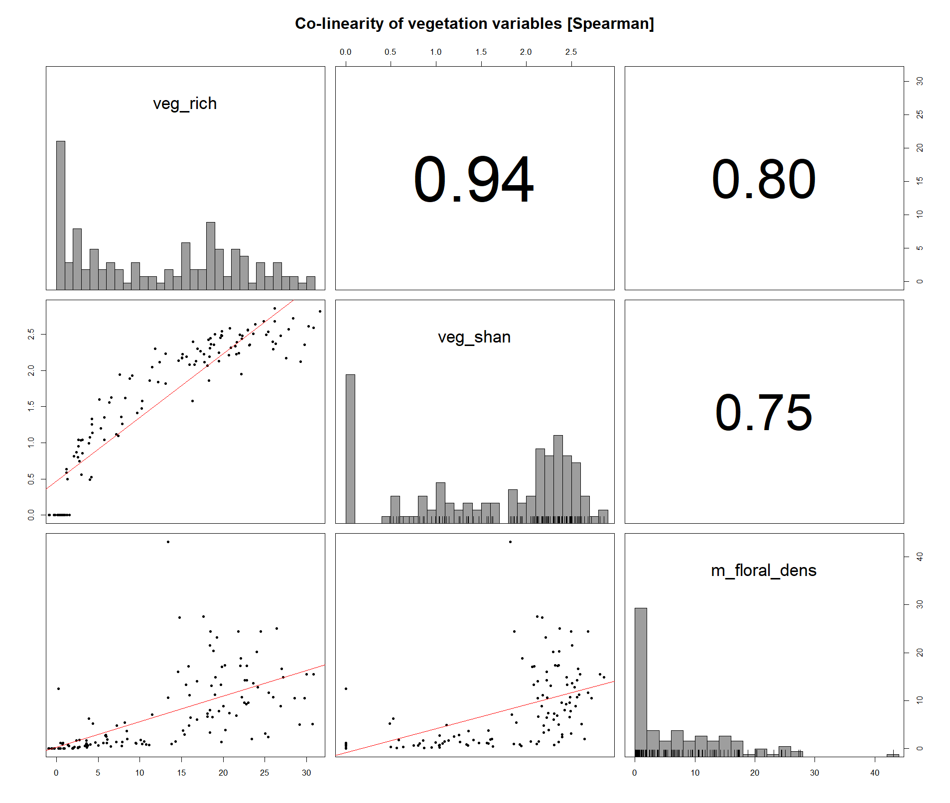A. 3: Correlation matrix of vegetation parameters. Shannon diversity of the vegetation (veg_shan) was closely correlated with plant species richness (veg_rich) and mean density of open flowers (m_floral_dens) and reflected the potential resource availability for bees over the three vegetation periods. Spearman correlation coefficients were all |r| > 0.7.

## A.4: Wildflower patch age

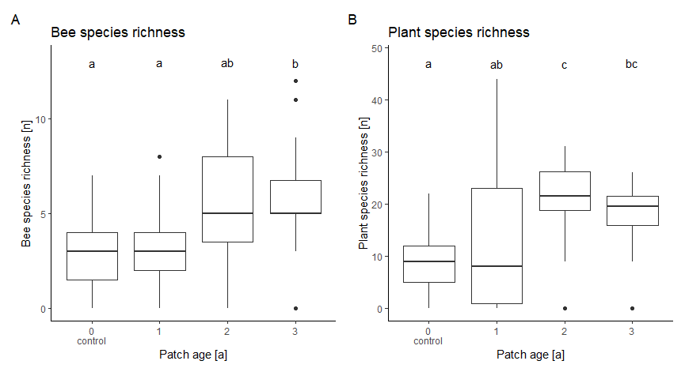A) Bee and B) plant species richness on the experimental roadside patches increased with patch age (time after sowing) during data investigation. `0´ indicates no seeding treatment and is referred to as ´control patch´ in the manuscript. A Permutation Analysis of Variance (perm.anova function, RVAideMemoire R-package, n.perm = 1000) indicated a significant positive relationship between patch age and species richness of bees and plants. Post-hoc pairwise two-sample independence tests across age levels with Bonferroni correction (pairwisePermutationTest function, rcompanion R-package) show significant higher bee richness in 2nd and 3rd years after sowing. Plant richness was significantly higher in the 2nd and 3rd year after sowing than controls, and patches during the establishment year showed high variation. Results of the post-hoc tests are indicated with lowercase letters (abc).

## A.4.1: Wildflower patch development

Stages of vegetation of the experimental patches during the study period. The patches differed visibly in richness and composition according to the sowing year. Pictures of the different successional stages were always taken at the mid-end of June.

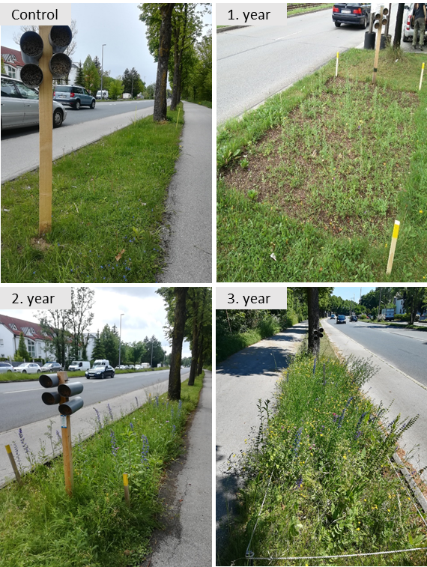

## A.5: Urban land-use data

Land-use types and their cover in m2 from the Open Street Map project (OSM) and their Corine Land Cover (CLC) classification.

|  |  |  |
| --- | --- | --- |
| **Corine Land Cover class** | **Open street map class** | **Area [m2]** |
| Agricultural areas | Farming | 3 045 111 |
| Continuous urban fabric | Traffic | 34 586 545 |
|  | Building | 27 109 398 |
|  | Industrial | 1 470 375 |
| Discontinuous urban fabric | Residential | 47 793 116 |
| Green urban areas | Forest | 7 294 008 |
|  | Park | 6 505 105 |
|  | Scrub | 2 463 584 |
|  | Lawn | 1 862 401 |
|  | Allotment | 1 571 957 |
|  | Meadow | 1 241 645 |
|  | Cemetery | 611 738 |
|  | Grass | 469 360 |
| Inland waters | Water | 604 928 |
|  | **Total** | **136 629 272** |

## A.6: Model results (glmms)

Results of the minimal adequate models presented in the manuscript, analyzing bee abundance, species richness, and functional dispersion of bee communities. Variables indicated by "-” have been excluded by a stepwise backward model selection from the full model.

|  |  |  |  |  |  |  |  |  |  |
| --- | --- | --- | --- | --- | --- | --- | --- | --- | --- |
| **Glmms: Minimal adequate models** | | | | | | | | | |
|  | **Bee abundance** | | | **Bee species richness** | | | **Functional dispersion** | | |
| *Predictors* | *Incidence Rate Ratios* | *CI* | *p* | *Incidence Rate Ratios* | *CI* | *p* | *Estimates* | *CI* | *p* |
| (Intercept) | 3.38 | 2.44 – 4.70 | **<0.001** | 1.78 | 1.36 – 2.33 | **<0.001** | 0.04 | 0.01 – 0.10 | **<0.001** |
| (Intercept) | 3.38 | 2.44 – 4.70 | **<0.001** | 1.78 | 1.36 – 2.33 | **<0.001** | 1.03 | 1.02 – 1.03 |  |
| Year [2020] | 1.58 | 1.24 – 2.00 | **<0.001** | 1.33 | 1.06 – 1.65 | **0.012** | - | - | - |
| Year [2021] | 2.29 | 1.80 – 2.91 | **<0.001** | 1.49 | 1.19 – 1.86 | **<0.001** | - | - | - |
| Vegetation diversity [Shan] | 1.26 | 1.13 – 1.40 | **<0.001** | 1.16 | 1.06 – 1.27 | **0.001** | 1.70 | 1.02 – 2.83 | **0.041** |
| (Intercept) | 52.77 | 18.45 – 220.41 | - | 1.78 | 1.36 – 2.33 | **<0.001** | 0.04 | 0.01 – 0.10 | **<0.001** |
| (Intercept) | 52.77 | 18.45 – 220.41 | - | 1.78 | 1.36 – 2.33 | **<0.001** | 1.03 | 1.02 – 1.03 |  |
| Bee abundance | - | - | - | 1.03 | 1.02 – 1.04 | **<0.001** | - | - | - |
| Distance from center [km] | - | - | - | - | - | - | 1.03 | 1.00 – 1.06 | **0.054** |
| Landscape diversity [Shan] | - | - | - | - | - | - | 2.76 | 1.03 – 7.43 | **0.044** |
| Vegetation div.*Landscape div. | - | - | - | - | - | - | 0.65 | 0.40 – 1.06 | 0.084 |
| **Random Effects** | | | | | | | | | |
| σ2 | 0.41 | | | 0.25 | | | 0.16 | | |
| τ00 | 0.17 rplot | | | 0.01 rplot | | | 0.00 rplot | | |
| ICC | 0.29 | | | 0.01 | | | 0.02 | | |
| N | 26 rplot | | | 26 rplot | | | 26 rplot | | |
| Observations | 197 | | | 197 | | | 197 | | |
| Marginal R2 / Conditional R2 | 0.164 / 0.407 | | | 0.206 / 0.261 | | | 0.126 / 0.144 | | |

## A.7: Total results of the generalized linear latent variable model

All tested interactions are shown on the y-axis. Solid dots represent point estimates of the fourth corner analysis coefficients, and dashed lines represent their 95% confidence intervals. Interactions are significant when confidence intervals do not include zero, indicated with black dots; otherwise gray. Abbreviations: div.: diversity; p/a: perimeter area ratio.

