discrete strategy
- grid size = 100x100
- strategy adjustment samples = total cells
- strategy adjustment temperature = 0.1
- dobule cooperation score = 3 each
- double defection score = 1 each
- betreyal score = 5 for traitor
- neighbourhood size = 3x3
reputation
- reputation interpolation factor = 0.3

Discrete Strategy, Reputation Factor Locked at 0.5
Very quickly converges to mutual cooperation, 3x3 cluster of defectors is introduced at generation 40(while keeping the previously built reputation) causes a cluster of defectors to grow until it absorbs everything.
With reputation factor unlocked, similar result although a bit slower.
5x5 cluster, same result.
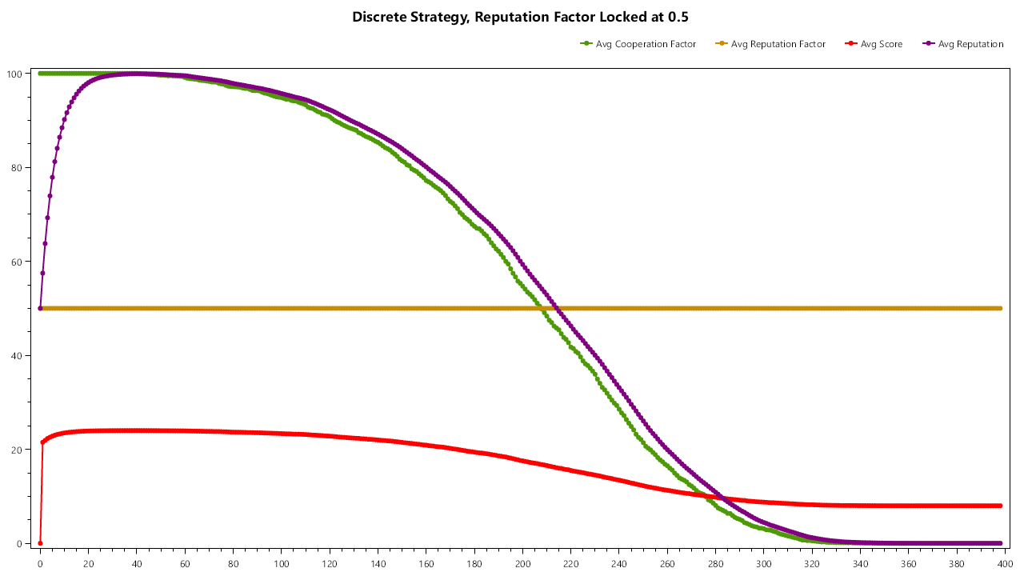
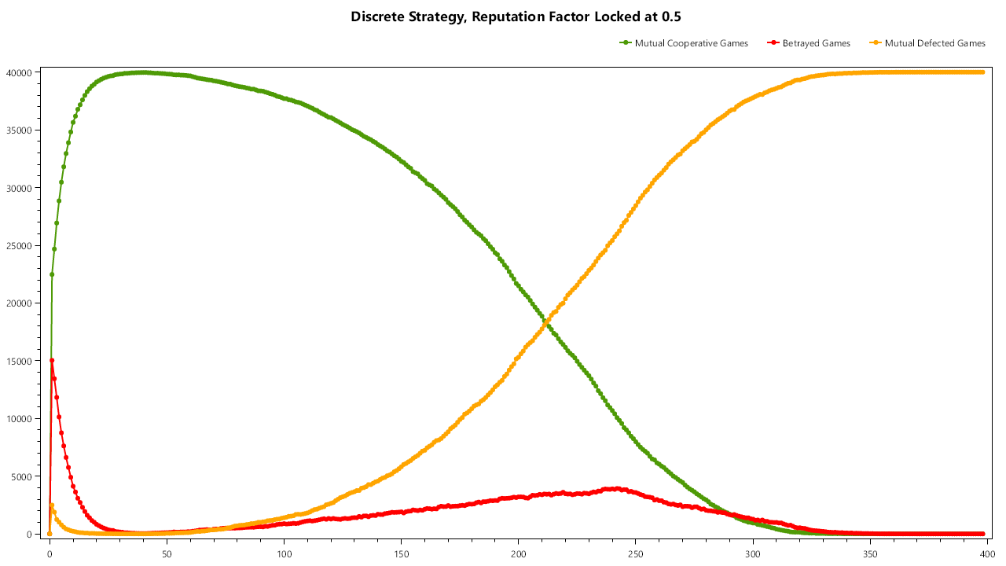

Continuous Strategy Without Randomness.(always cooperate over 50% chance of cooperation and always defect on under 50% chance of defection.)
Clusters of cooperators and defectors immediately form. Cooperator clusters slowly expand by “recruiting” defectors on their edges.
While defectors occasionality sneak behind the cooperator lines and exploit naive cooperators causing outburst of defection.

It’s interesting to see that the agents on boundaries of clusters (both on defector and cooperator side) tend to have the same strategy about 0.5 cooperation and 0.5 reputation factor. The leading factor to them being present on cooperator or defector side is their reputation.

Average defector in a middle of a defector cluster tends to have both cooperation factor and reputation factors low.
Average cooperator in the middle of a cooperator cluster tends to be like an edge agent however over time due to not needing same vigilance as an edge cell the inside of cooperator clusters slowly trends to high cooperator factor and low reputation factor.

This creates the interesting dynamic to where the edges of clusters are very vigilant and resistant to defectors while the insides of cooperation clusters tend to become naive and vulnerable to infiltrating defectors.
