Parameters

discrete strategy
- grid size = 100x100
- strategy adjustment samples = total cells/2
- strategy adjustment temperature = 1
- dobule cooperation score = 3 each
- double defection score = 1 each
- betreyal score = 5 for traitor
continuous strategy
- mutation factor = 0.1
- interpolation factor = 0.7

Discrete Strategy Random Start
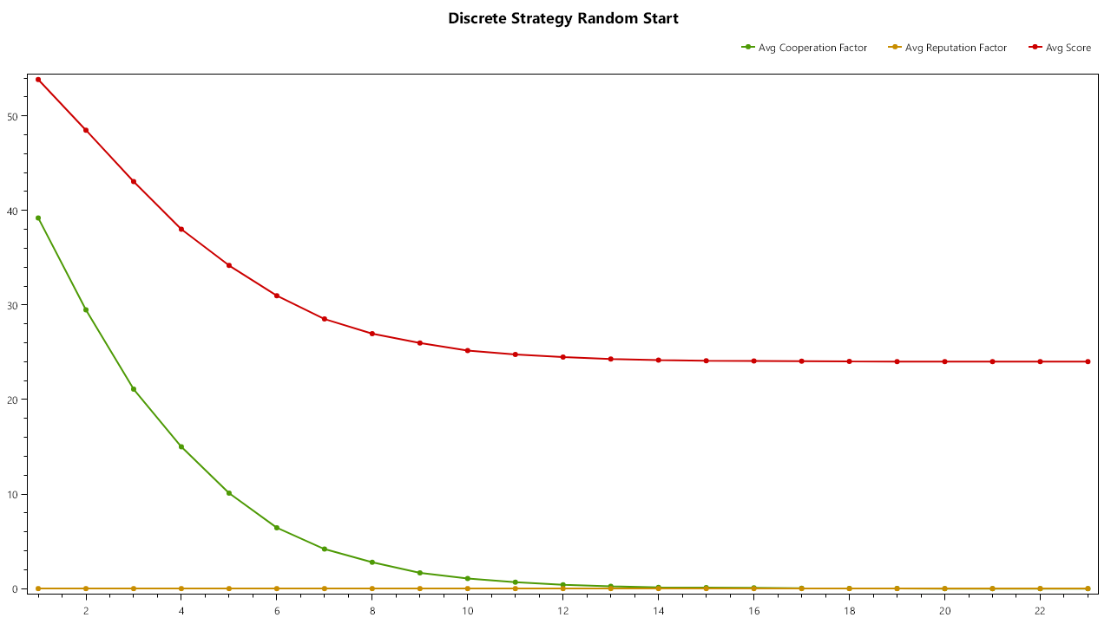

Discrete Strategy 1 defector.
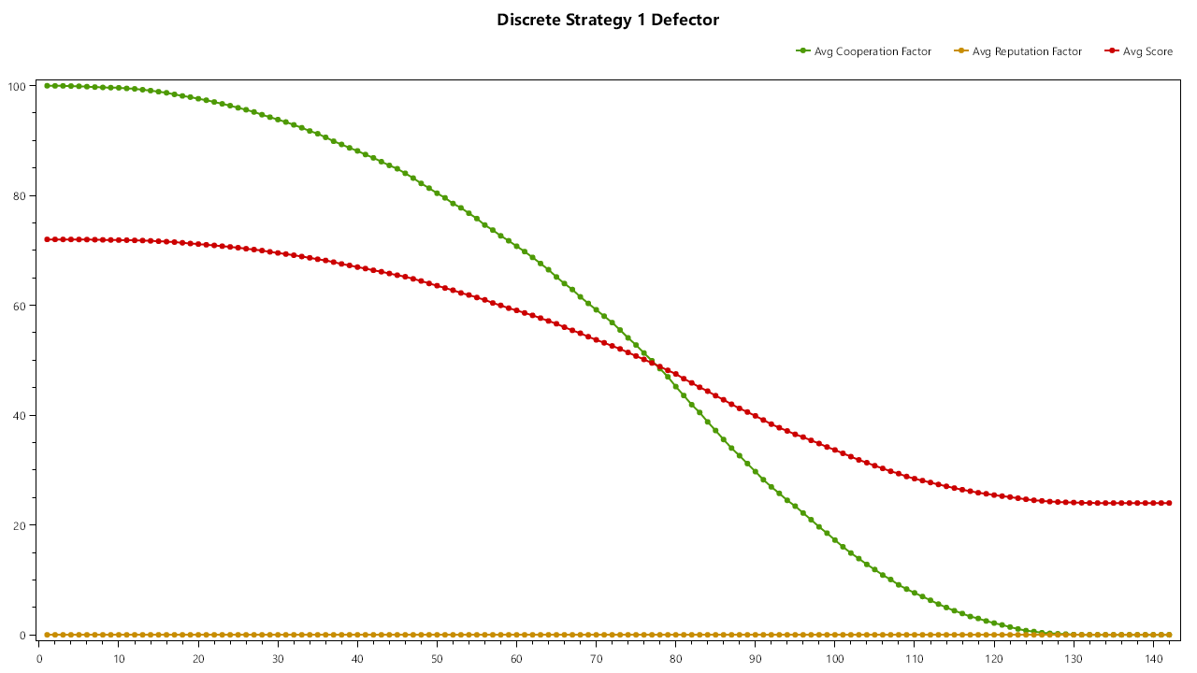

Continuous Strategy Random Start (Mutation factor = 0.01, Interpolation Factor = 0.07)
Cooperation Factor falls unitll reaching 0.2, after which it incrementally decreases to 0.

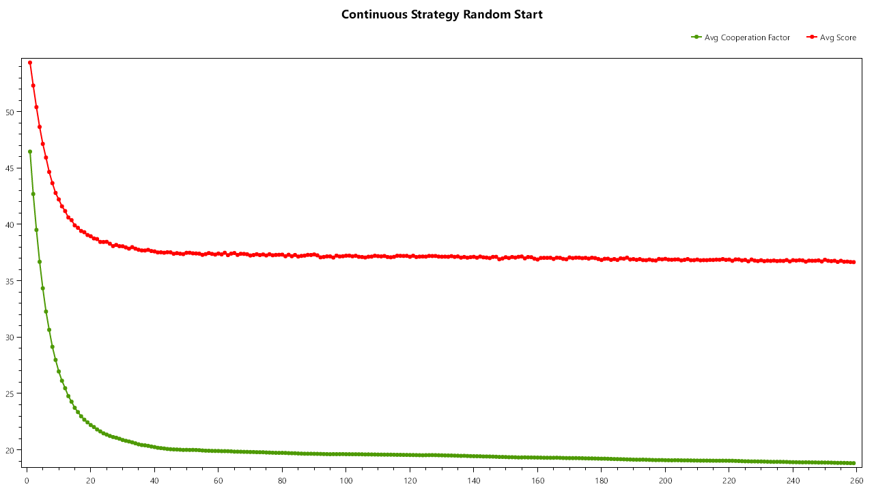
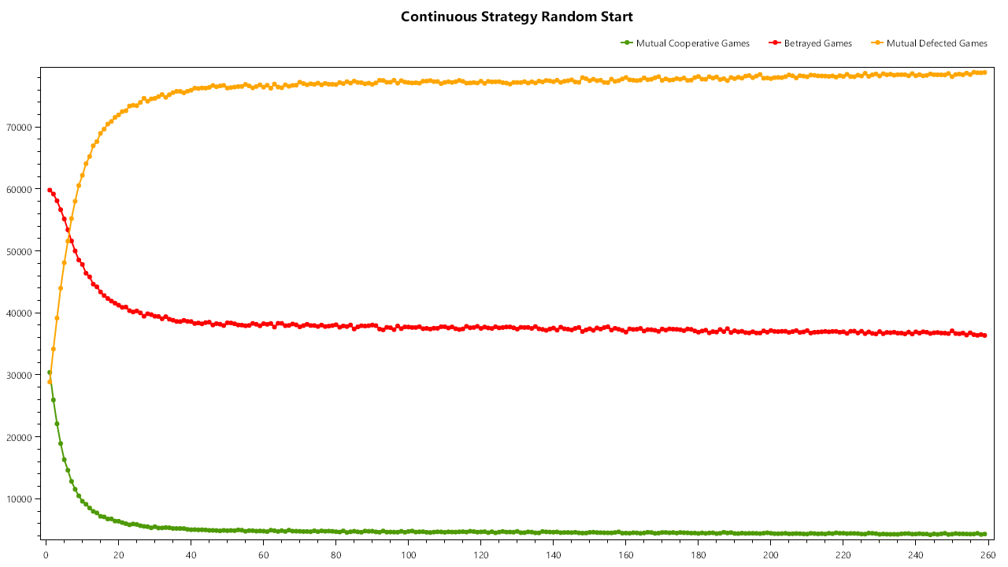

Continous Strategy Random Start (Mutation factor = 0.01, Interpolation factor = 0.95)
Point of stagnation is now 0.05 coop factor.
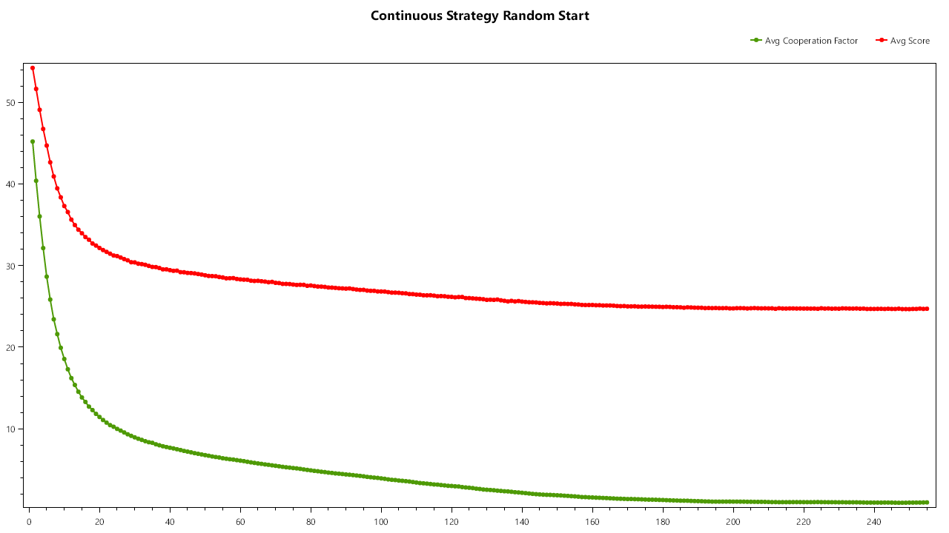
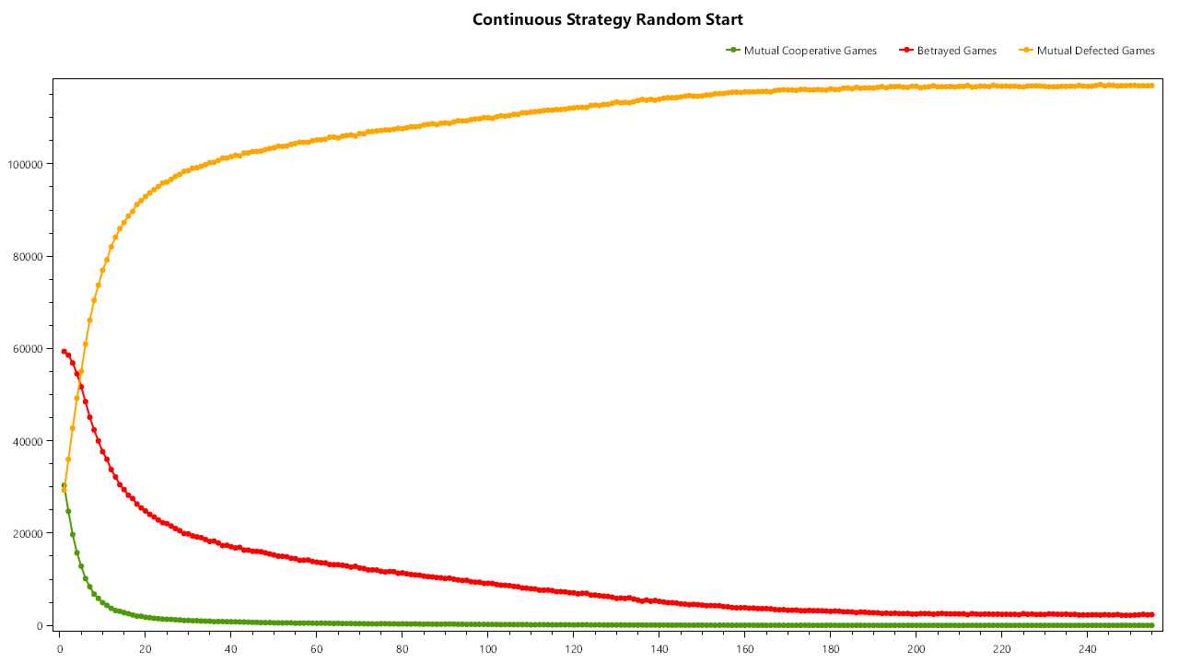

Continous Strategy Random Start (interpolation factor = 0.7, mutation factor = 0.1)
Stagnation at 0.05. Most cells are at 0 defection but the mutation factor brings up some to 0.1 causing this value.

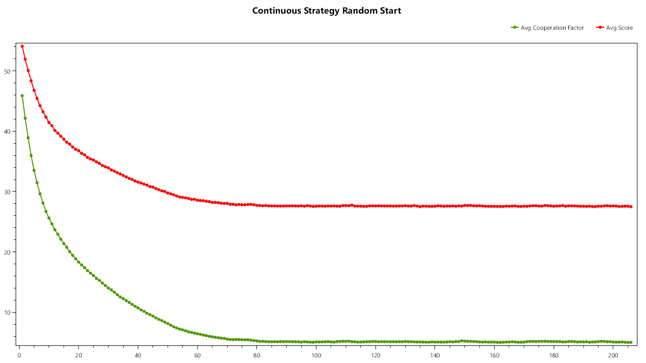
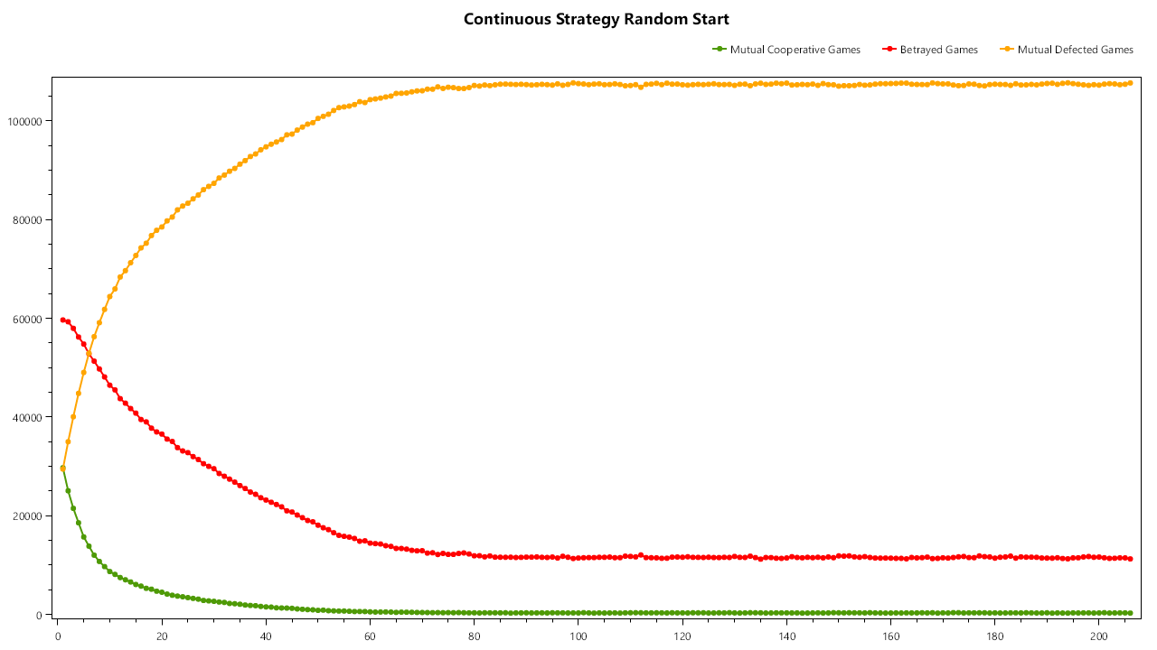

Continuous Strategy, Everyone starts at 1 Cooperation Factor (interpolation factor = 0.7, mutation factor = 0.1)
