RESULTS

Comparing time windows between ROIs and conditions

We considered four EEG frequency bands: 4-8 Hz as theta, 8-12 as alpha in posterior and as mu in anterior areas, 14-20 as beta 1 and 20-32 as beta 2. Mu and alpha were not distinguished in statistical analyses, but only in Discussion.

In a first step, for each frequency band we performed an ANOVA: the selected dependent variable was spectral power normalized to pre-stimulus baseline condition (event related spectral perturbation, ERSP); the selected factors were MOTION (centered or translating), SHAPE (preserved or scrambled walker), ROI (i.e groups of channels reflecting activity of IFG, PMD, SPL, IPL, Psts, EBA-MT+, Occipital), and TIME WINDOW (200-230, 300-360, 390-450, 450-550 and 550-800 ms).

For theta band, we found significant main effects of SHAPE, F_{1, 12} = 14.25, P = 0.003, generalized eta squared (ges) = 0.06; ROI, F_{6, 72}=6.10, P=0.00003, ges=0.11 and TIME WINDOW, F_{4, 48}=84.26, P<10⁻⁷, ges=0.61.
We also found significant interactions between ROI and TIME WINDOW, F_{24, 288}=20.13, P<10⁻⁷, ges=0.13; between SHAPE, ROI and TIME WINDOW, F_{24, 288}=1.84, P=0.01, ges=0.002.

For mu/alpha band we found significant effects of SHAPE, F_{1, 12} = 6.99, P = 0.02, ges = 0.03; ROI, F_{6, 72}=28.68 P<10⁻⁷, ges=0.48 and TIME WINDOW, F_{4, 48}=35.00, P<10⁻⁷, ges=0.27.
We also found significant interactions between MOTION and ROI, F_{6, 72}=2.47, P=0.03, ges=0.007; between ROI and TIME WINDOW, F_{24, 288}=6.92, P<10⁻⁷, ges=0.03 and between MOTION, ROI and TIME WINDOW, F_{24, 288}=2.11, P=0.002, ges=0.002.

For beta 1, we found significant main effects of MOTION, F_{1, 12} = 6.77, P = 0.02, ges = 0.03;
ROI, F_{6, 72}=21.35 P<10⁻⁷, ges=0.45 and TIME WINDOW, F_{4, 48}=17.03, P<10⁻⁷, ges=0.16.
We also found significant interactions between MOTION and TIME WINDOW F_{4, 48} = 6.77, P = 0.004, ges = 0.01; between ROI and TIME WINDOW, F_{24, 288}=4.29, P<10⁻⁷, ges=0.02 and between MOTION, ROI and TIME WINDOW, F_{24, 288}=1.65, P=0.03, ges=0.002.

For beta 2, we found significant main effects of MOTION, F_{1, 12} = 8.56, P = 0.01, ges = 0.04; SHAPE, F_{1, 12} = 8.27, P = 0.01, ges = 0.01; ROI, F_{6, 72}=11.57, P<10⁻⁷, ges=0.31 and TIME WINDOW, F_{4, 48}=9.07, P=0.00002, ges=0.08.
We also found significant interactions between MOTION and TIME WINDOW, F_{4, 48} = 3.47, P = 0.01, ges = 0.01; between SHAPE and TIME WINDOW F_{4, 48} = 4.23, P = 0.005, ges = 0.008 and between ROI and TIME WINDOW, F_{24, 288}=2.51, P=0.0002, ges=0.009.

Importantly, for all bands, we found a significant interaction between MOTION, SHAPE, ROI and TIME WINDOW: respectively F_{24, 288}=1.75, P=0.03, ges=0.001 for theta; F_{24, 288}=1.86, P=0.01, ges=0.0009 for mu/alpha; F_{24, 288}=1.78, P=0.02, ges=0.01 for beta 1 and F_{24, 288}=1.75, P=0.03, ges=0.002 for beta 2.

We performed post hoc t-test comparisons using bootstrap technique with 10000 replications (Delorme 2006). We considered as significant P<0.05 after correcting for multiple comparisons. We applied FDR correction for factor TIME WINDOW and the more conservative Bonferroni correction for other factors.

The effect of translation: distinguishing centered and translating shapes

Table 1 and Figure 1summarize the distinction within the main effect of MOTION, i.e. between centered and translating, without distinguishing between preserved and scrambled walker.
For all bands, differences were found, and mainly between 390 and 550 ms. In posterior areas, for alpha, these differences were exclusively in occipital areas, while for theta they were in EBA-MT+ and pSTS. For beta bands, differences involved the same areas of theta and alpha, plus the inferior and superior parietal lobule. Furthermore, theta showed a specific and prolonged difference in anterior areas (IFG and PMD), involving the whole explored time period.

Band | ROI | Time window
Band | ROI | 200-230 ms | 300-360 ms | 390-450 ms | 450-550 ms | 550-800 ms
Theta | IFG
Theta | PMD
Theta | SPL
Theta | IPL
Theta | pSTS
Theta | EBA-MT+
Theta | Occip
Mu/alpha | IFG
Mu/alpha | PMD
Mu/alpha | SPL
Mu/alpha | IPL
Mu/alpha | pSTS
Mu/alpha | EBA-MT+
Mu/alpha | Occip
Beta 1 | IFG
Beta 1 | PMD
Beta 1 | SPL
Beta 1 | IPL
Beta 1 | pSTS
Beta 1 | EBA-MT+
Beta 1 | Occip
Beta 2 | IFG
Beta 2 | PMD
Beta 2 | SPL
Beta 2 | IPL
Beta 2 | pSTS
Beta 2 | EBA-MT+
Beta 2 | Occip
Table 1. For each ROI and frequency band, significant differences between centered and translating are represented by colored cells.
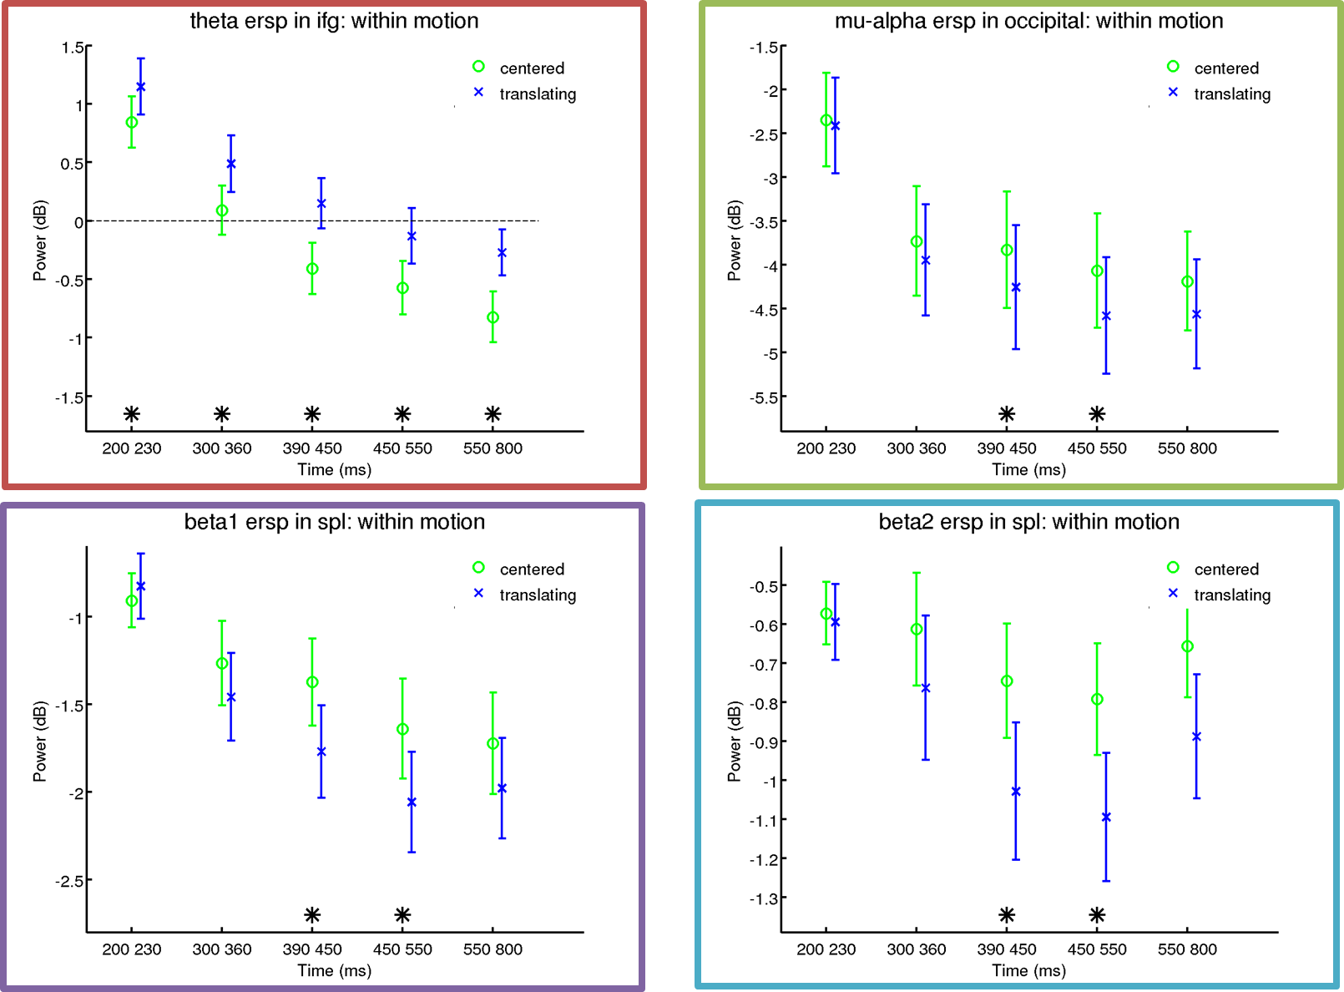
Figure 1. For several representative ROIs and for each frequency band, significant differences between centered and translating are represented by stars.

The effect of shape: distinguishing preserved from scrambled shapes

Table 2 and Figure 2 summarize the distinction within the main effect of SHAPE, i.e. between preserved and scrambled walker, without distinguishing between centered and translating.
Differences related to scrambling began earlier than those previously observed for translation: for all but beta 2 bands, differences were already present in the 200-230 ms time window. Considering occipito-temporo-parietal areas, from posterior to anterior areas, differences involved spectral bands of increasing frequencies: only theta in occipital; theta and alpha in EBA-MT+; theta, alpha and beta 1 in pSTS; beta 1 and beta 2 in SPL. Moreover, as it was observed for MOTION, also for SHAPE theta showed a difference in anterior areas (IFG and PMD), in all time windows, in this case partially involving also mu band.

Band | ROI | Time window
Band | ROI | 200-230 ms | 300-360 ms | 390-450 ms | 450-550 ms | 550-800 ms
Theta | IFG
Theta | PMD
Theta | SPL
Theta | IPL
Theta | pSTS
Theta | EBA-MT+
Theta | Occip
Mu/alpha | IFG
Mu/alpha | PMD
Mu/alpha | SPL
Mu/alpha | IPL
Mu/alpha | pSTS
Mu/alpha | EBA-MT+
Mu/alpha | Occip
Beta 1 | IFG
Beta 1 | PMD
Beta 1 | SPL
Beta 1 | IPL
Beta 1 | pSTS
Beta 1 | EBA-MT+
Beta 1 | Occip
Beta 2 | IFG
Beta 2 | PMD
Beta 2 | SPL
Beta 2 | IPL
Beta 2 | pSTS
Beta 2 | EBA-MT+
Beta 2 | Occip
Table 2 For each ROI and frequency band, significant differences between preserved and scrambled walker are represented by colored cells.

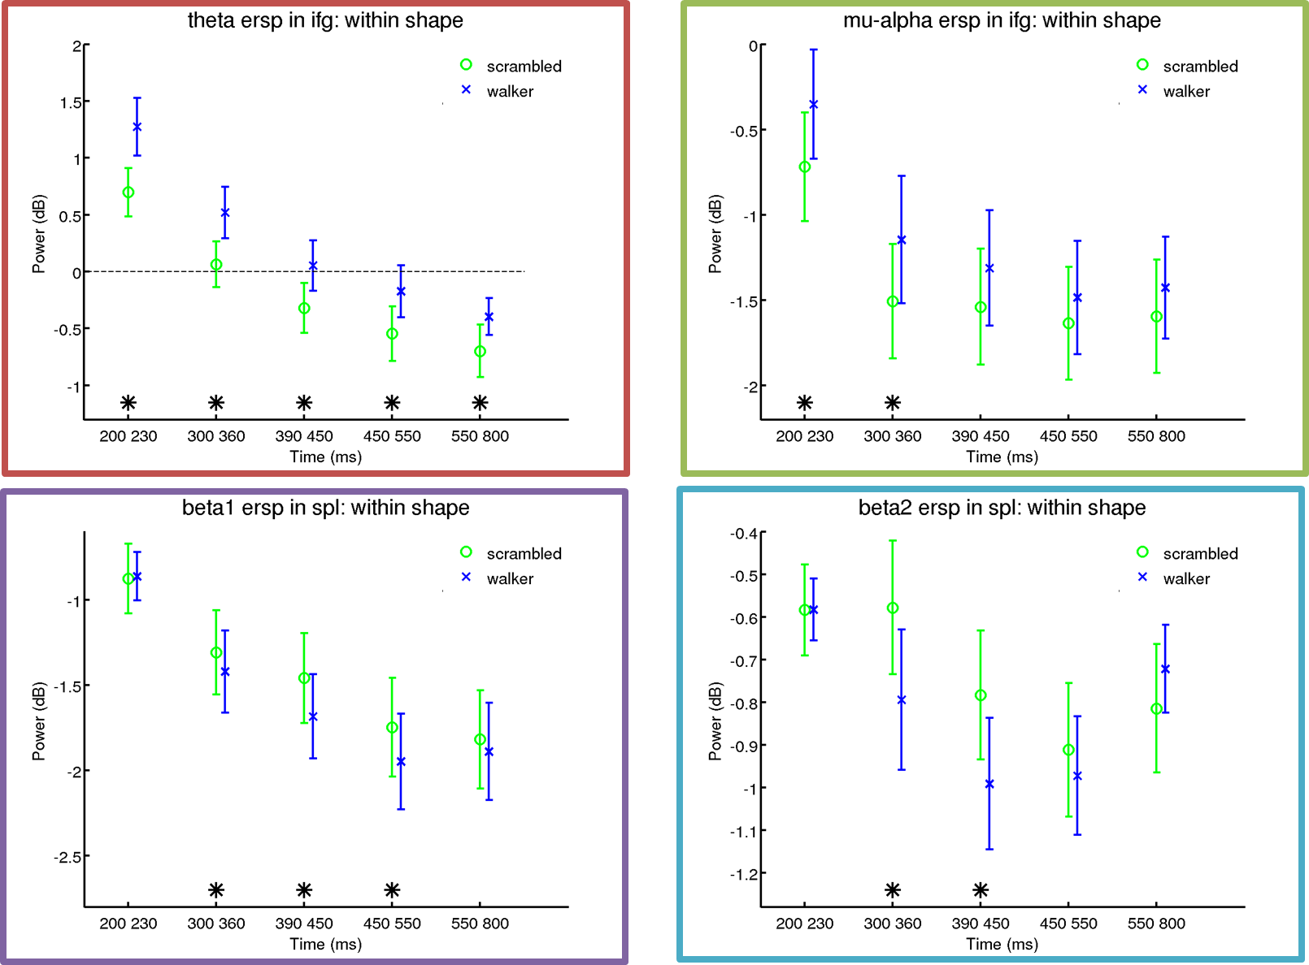
Figure 2 For several representative ROIs and for each frequency band, significant differences between preserved and scrambled walker are represented by stars.

Distinguishing scrambled and preserved walker when the shape is centered

Table 3 and Figure 3 summarize the distinction between preserved and scrambled walker considering only when the shape is centered.
Only theta and beta bands showed significant differences.
Differences in beta 1 were mainly in posterior areas (pSTS and SPL) and, occasionally (200-230 ms), in PMD; conversely, differences in theta were essentially in anterior areas (PMD and IFG) and, occasionally (300-360 ms), in pSTS. Beta 2 was significant only in SPL between 390 and 450 ms.

Band | ROI | Time window
Band | ROI | 200-230 ms | 300-360 ms | 390-450 ms | 450-550 ms | 550-800 ms
Theta | IFG
Theta | PMD
Theta | SPL
Theta | IPL
Theta | pSTS
Theta | EBA-MT+
Theta | Occip
Mu/alpha | IFG
Mu/alpha | PMD
Mu/alpha | SPL
Mu/alpha | IPL
Mu/alpha | pSTS
Mu/alpha | EBA-MT+
Mu/alpha | Occip
Beta 1 | IFG
Beta 1 | PMD
Beta 1 | SPL
Beta 1 | IPL
Beta 1 | pSTS
Beta 1 | EBA-MT+
Beta 1 | Occip
Beta 2 | IFG
Beta 2 | PMD
Beta 2 | SPL
Beta 2 | IPL
Beta 2 | pSTS
Beta 2 | EBA-MT+
Beta 2 | Occip
Table 3 For each ROI and frequency band, significant differences between centered walker and centered scrambled are represented by colored cells.

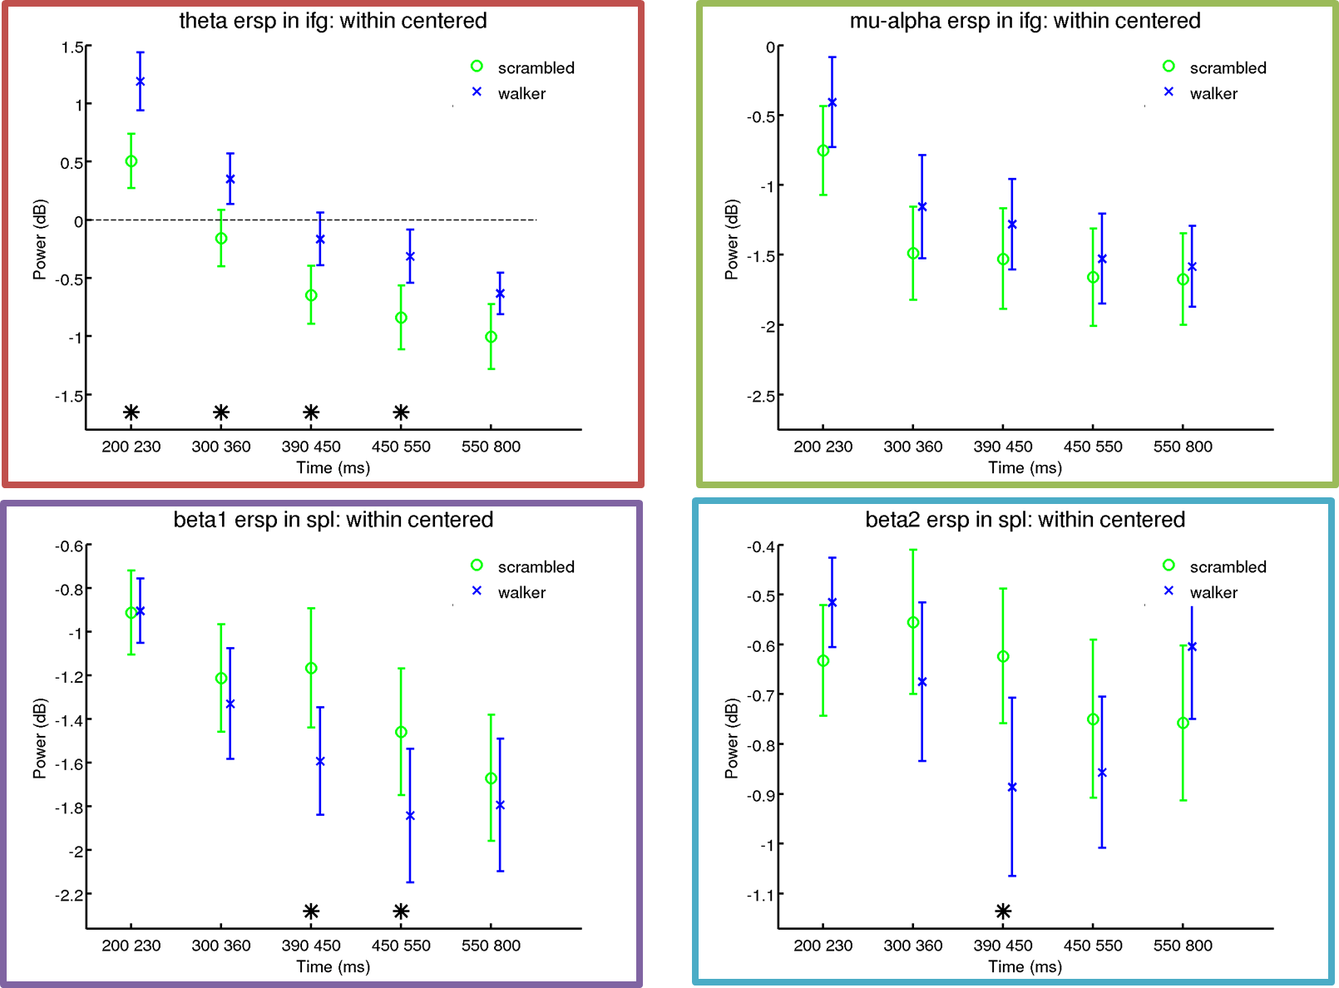
Figure 3 For several representative ROIs and for each frequency band, significant differences between centered walker and centered scrambled are represented by stars.

Distinguishing scrambled and walker when the shape is translating

Table 4 and Figure 4 summarize the distinction between preserved and scrambled shapes considering only when the shape is translating.
Theta and mu bands showed a joint and prolonged difference during the whole explored time period and in an extended network involving essentially all considered ROIs (excluding occipital for alpha).
Furthermore, beta 2 showed a specific difference in posterior areas (EBA-MT+, IPL, SPL) in the 300-360 ms time window.

Band | ROI | Time window
Band | ROI | 200-230 ms | 300-360 ms | 390-450 ms | 450-550 ms | 550-800 ms
Theta | IFG
Theta | PMD
Theta | SPL
Theta | IPL
Theta | pSTS
Theta | EBA-MT+
Theta | Occip
Mu/alpha | IFG
Mu/alpha | PMD
Mu/alpha | SPL
Mu/alpha | IPL
Mu/alpha | pSTS
Mu/alpha | EBA-MT+
Mu/alpha | Occip
Beta 1 | IFG
Beta 1 | PMD
Beta 1 | SPL
Beta 1 | IPL
Beta 1 | pSTS
Beta 1 | EBA-MT+
Beta 1 | Occip
Beta 2 | IFG
Beta 2 | PMD
Beta 2 | SPL
Beta 2 | IPL
Beta 2 | pSTS
Beta 2 | EBA-MT+
Beta 2 | Occip
Table 4 For each ROI and frequency band, significant differences between translating walker and translating scrambled are represented by colored cells.

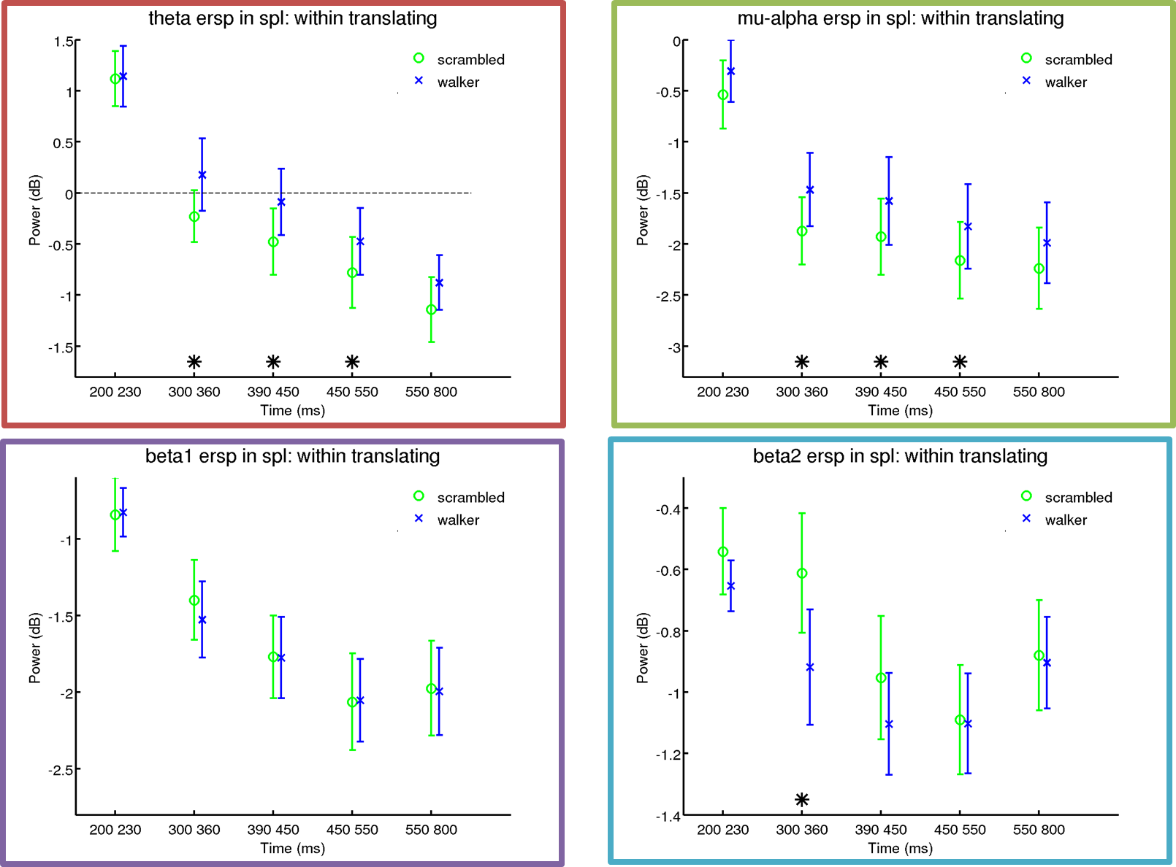
Figure 4. For several representative ROIs and for each frequency band, significant differences between translating walker and translating scrambled are represented by stars.

The effect of translation when the shape is preserved

Table 5 and Figure 5 summarize the distinction between translating and centered, considering only when the shape of the walker is preserved (i.e. not scrambled).
Differences were found mainly in beta 2 band, in all but PMD, where, instead, beta 1was significant (300-450 ms). Alpha showed an early significant difference (200-230 ms) in SPL, while theta preserved an occasional and late significance in IFG (390-450 ms and 550-800 ms).

Band | ROI | Time window
Band | ROI | 200-230 ms | 300-360 ms | 390-450 ms | 450-550 ms | 550-800 ms
Theta | IFG
Theta | PMD
Theta | SPL
Theta | IPL
Theta | pSTS
Theta | EBA-MT+
Theta | Occip
Mu/alpha | IFG
Mu/alpha | PMD
Mu/alpha | SPL
Mu/alpha | IPL
Mu/alpha | pSTS
Mu/alpha | EBA-MT+
Mu/alpha | Occip
Beta 1 | IFG
Beta 1 | PMD
Beta 1 | SPL
Beta 1 | IPL
Beta 1 | pSTS
Beta 1 | EBA-MT+
Beta 1 | Occip
Beta 2 | IFG
Beta 2 | PMD
Beta 2 | SPL
Beta 2 | IPL
Beta 2 | pSTS
Beta 2 | EBA-MT+
Beta 2 | Occip
Table 5 For each ROI and frequency band, significant differences between translating walker and centered walker are represented by colored cells.

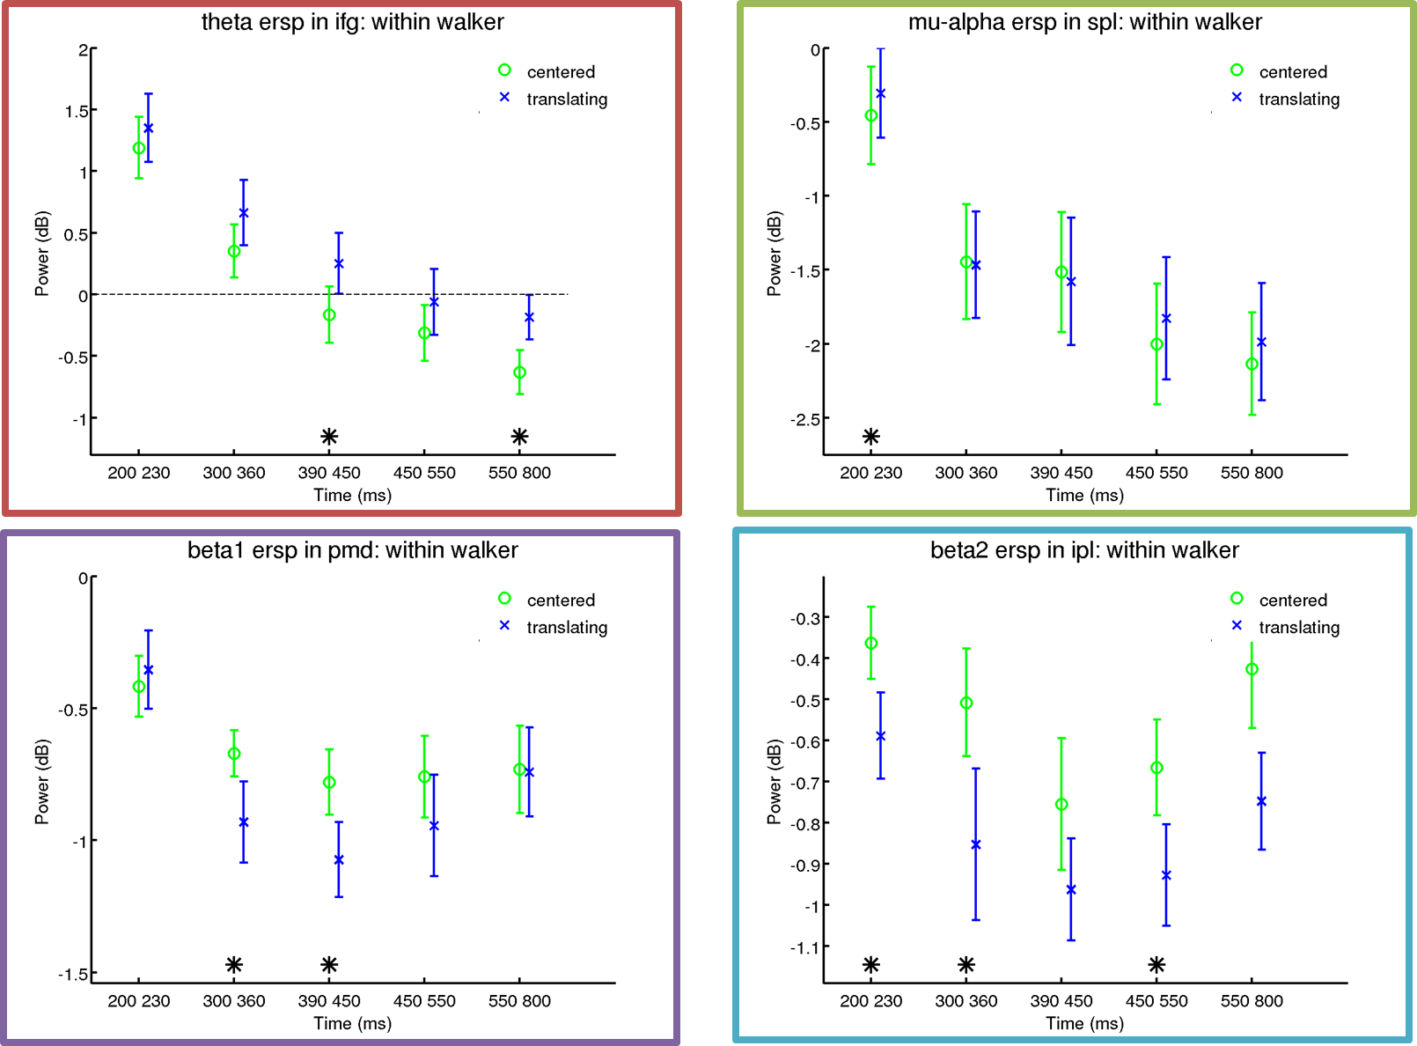
Figure 5. For several representative ROIs and for each frequency band, significant differences between translating walker and centered walker are represented by stars.

The effect of translation when the shape is scrambled

Table 6 and Figure 6 summarize the distinction between translating and centered shapes considering only when the shape of the walker is scrambled.
Mainly alpha (390-800 ms), and sporadically beta2 (390-450 ms), were significant in occipital areas.
Alpha showed a specific difference in EBA-MT+ between 300 and 360 ms.
Beta 1 (300-800 ms), and - sporadically - alpha (300-360 ms) and beta 2 (450-550 ms), were significant in the parietal lobules.
Finally, theta showed a peculiar prolonged (200-230 ms and 390-800 ms) difference in anterior areas (IFG and PMD).

Band | ROI | Time window
Band | ROI | 200-230 ms | 300-360 ms | 390-450 ms | 450-550 ms | 550-800 ms
Theta | IFG
Theta | PMD
Theta | SPL
Theta | IPL
Theta | pSTS
Theta | EBA-MT+
Theta | Occip
Mu/alpha | IFG
Mu/alpha | PMD
Mu/alpha | SPL
Mu/alpha | IPL
Mu/alpha | pSTS
Mu/alpha | EBA-MT+
Mu/alpha | Occip
Beta 1 | IFG
Beta 1 | PMD
Beta 1 | SPL
Beta 1 | IPL
Beta 1 | pSTS
Beta 1 | EBA-MT+
Beta 1 | Occip
Beta 2 | IFG
Beta 2 | PMD
Beta 2 | SPL
Beta 2 | IPL
Beta 2 | pSTS
Beta 2 | EBA-MT+
Beta 2 | Occip
Table 6 For each ROI and frequency band, significant differences between translating scrambled and centered walker are represented by colored cells.

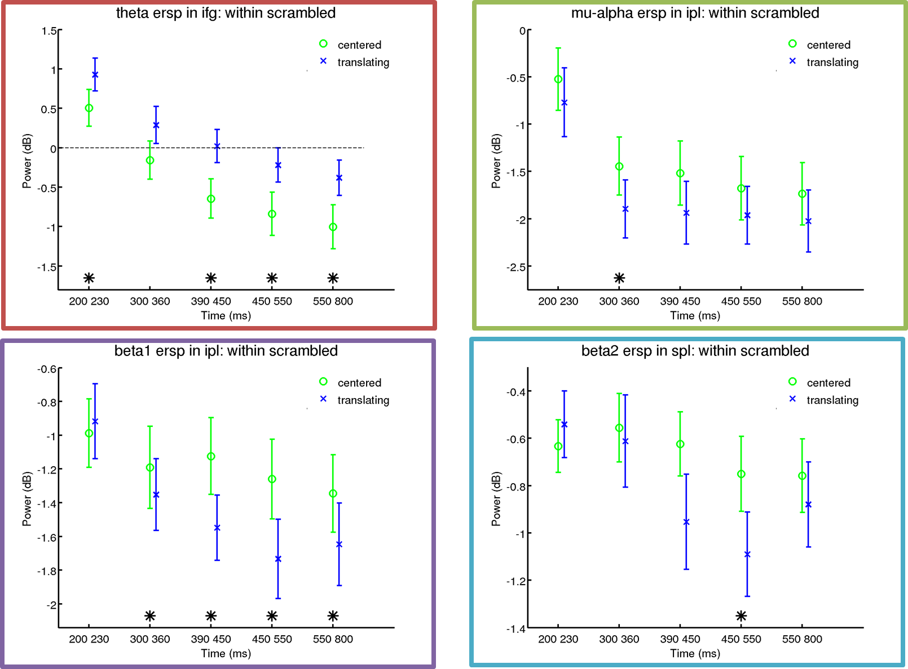
Figure 6. For several representative ROIs and for each frequency band, significant differences between translating scrambled and centered walker are represented by stars.

Comparing patterns between ROIs and conditions

As a further step, for each frequency band and ROI, we compared temporal patterns of ERSP between different conditions, evaluating the same comparisons previously described for time windows.
Detailed results of this analysis are reported in Supplementary Information.

