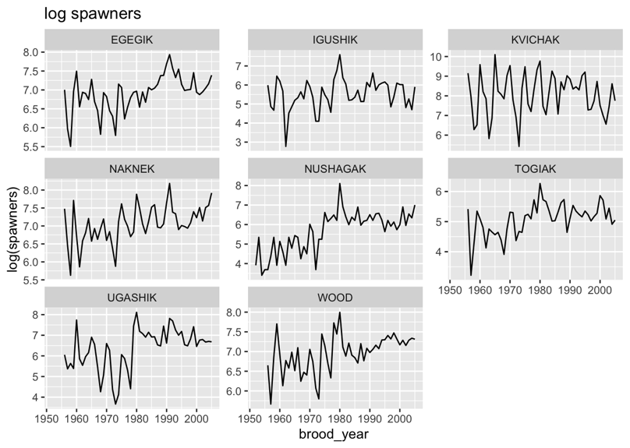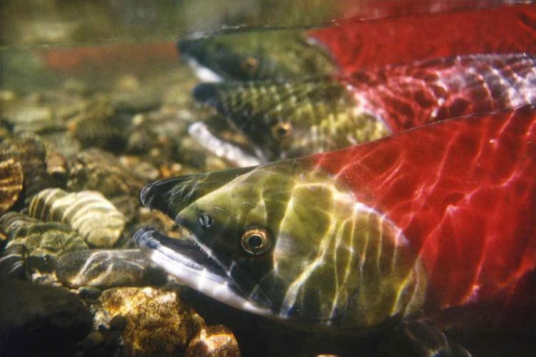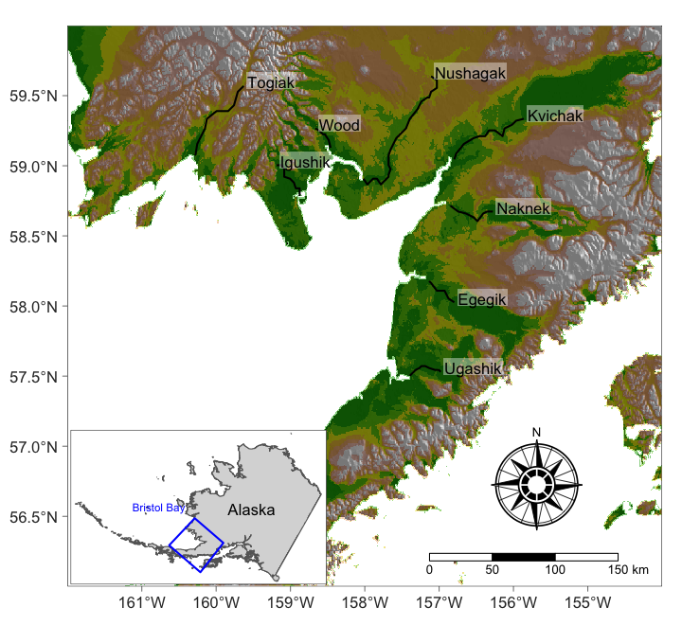

**See the course website for more information**

<https://atsa-es.github.io/atsa/>

This course gives students an overview of the theory and practical aspects of fitting time series models to fisheries and environmental data. The course will cover topics ranging from autocorrelation and crosscorrelation, autoregressive (AR) and moving average (MA) models, univariate and multivariate state-space models, estimating model parameters, and assessing model performance. The course is focused almost exclusively on problems and analyses in the time domain, and only briefly addresses methods for the frequency domain. In general, students will focus on conceptualizing analyses, implementing analyses, and making inference from the results.

Weekly labs focus on practical analysis of fisheries and environmental data sets.

Prerequisites: Experience with R and R programming,

**Fish 550**

**Applied Time Series Analysis**

Spring Quarter 2023 | 5 Credits

M Scheuerell, E Ward and E Holmes

T 10:00-11:20 (lec) / Th 10:00-12:20 (lec+lab)