HackDay Quarto Book

Eli Holmes

Jon Peake

Table of contents

# Prefix

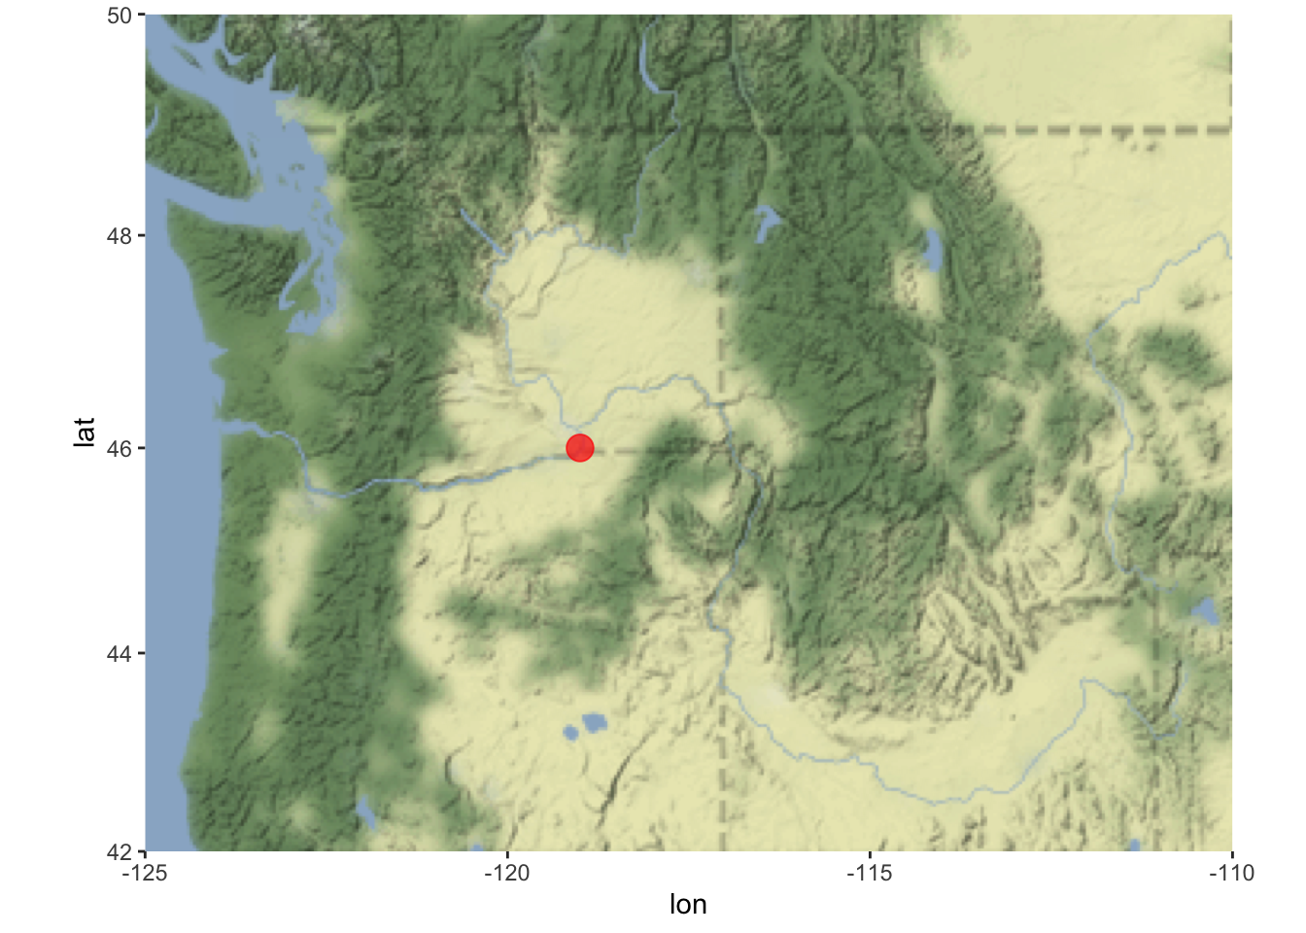

|  | mpg | cyl | disp | hp | drat | wt | qsec | vs | am | gear | carb |
| --- | --- | --- | --- | --- | --- | --- | --- | --- | --- | --- | --- |
| Mazda RX4 | 21.0 | 6 | 160.0 | 110 | 3.90 | 2.620 | 16.46 | 0 | 1 | 4 | 4 |
| Mazda RX4 Wag | 21.0 | 6 | 160.0 | 110 | 3.90 | 2.875 | 17.02 | 0 | 1 | 4 | 4 |
| Datsun 710 | 22.8 | 4 | 108.0 | 93 | 3.85 | 2.320 | 18.61 | 1 | 1 | 4 | 1 |
| Hornet 4 Drive | 21.4 | 6 | 258.0 | 110 | 3.08 | 3.215 | 19.44 | 1 | 0 | 3 | 1 |
| Hornet Sportabout | 18.7 | 8 | 360.0 | 175 | 3.15 | 3.440 | 17.02 | 0 | 0 | 3 | 2 |
| Valiant | 18.1 | 6 | 225.0 | 105 | 2.76 | 3.460 | 20.22 | 1 | 0 | 3 | 1 |
| Duster 360 | 14.3 | 8 | 360.0 | 245 | 3.21 | 3.570 | 15.84 | 0 | 0 | 3 | 4 |
| Merc 240D | 24.4 | 4 | 146.7 | 62 | 3.69 | 3.190 | 20.00 | 1 | 0 | 4 | 2 |
| Merc 230 | 22.8 | 4 | 140.8 | 95 | 3.92 | 3.150 | 22.90 | 1 | 0 | 4 | 2 |
| Merc 280 | 19.2 | 6 | 167.6 | 123 | 3.92 | 3.440 | 18.30 | 1 | 0 | 4 | 4 |
| Merc 280C | 17.8 | 6 | 167.6 | 123 | 3.92 | 3.440 | 18.90 | 1 | 0 | 4 | 4 |
| Merc 450SE | 16.4 | 8 | 275.8 | 180 | 3.07 | 4.070 | 17.40 | 0 | 0 | 3 | 3 |
| Merc 450SL | 17.3 | 8 | 275.8 | 180 | 3.07 | 3.730 | 17.60 | 0 | 0 | 3 | 3 |
| Merc 450SLC | 15.2 | 8 | 275.8 | 180 | 3.07 | 3.780 | 18.00 | 0 | 0 | 3 | 3 |
| Cadillac Fleetwood | 10.4 | 8 | 472.0 | 205 | 2.93 | 5.250 | 17.98 | 0 | 0 | 3 | 4 |
| Lincoln Continental | 10.4 | 8 | 460.0 | 215 | 3.00 | 5.424 | 17.82 | 0 | 0 | 3 | 4 |
| Chrysler Imperial | 14.7 | 8 | 440.0 | 230 | 3.23 | 5.345 | 17.42 | 0 | 0 | 3 | 4 |
| Fiat 128 | 32.4 | 4 | 78.7 | 66 | 4.08 | 2.200 | 19.47 | 1 | 1 | 4 | 1 |
| Honda Civic | 30.4 | 4 | 75.7 | 52 | 4.93 | 1.615 | 18.52 | 1 | 1 | 4 | 2 |
| Toyota Corolla | 33.9 | 4 | 71.1 | 65 | 4.22 | 1.835 | 19.90 | 1 | 1 | 4 | 1 |
| Toyota Corona | 21.5 | 4 | 120.1 | 97 | 3.70 | 2.465 | 20.01 | 1 | 0 | 3 | 1 |
| Dodge Challenger | 15.5 | 8 | 318.0 | 150 | 2.76 | 3.520 | 16.87 | 0 | 0 | 3 | 2 |
| AMC Javelin | 15.2 | 8 | 304.0 | 150 | 3.15 | 3.435 | 17.30 | 0 | 0 | 3 | 2 |
| Camaro Z28 | 13.3 | 8 | 350.0 | 245 | 3.73 | 3.840 | 15.41 | 0 | 0 | 3 | 4 |
| Pontiac Firebird | 19.2 | 8 | 400.0 | 175 | 3.08 | 3.845 | 17.05 | 0 | 0 | 3 | 2 |
| Fiat X1-9 | 27.3 | 4 | 79.0 | 66 | 4.08 | 1.935 | 18.90 | 1 | 1 | 4 | 1 |
| Porsche 914-2 | 26.0 | 4 | 120.3 | 91 | 4.43 | 2.140 | 16.70 | 0 | 1 | 5 | 2 |
| Lotus Europa | 30.4 | 4 | 95.1 | 113 | 3.77 | 1.513 | 16.90 | 1 | 1 | 5 | 2 |
| Ford Pantera L | 15.8 | 8 | 351.0 | 264 | 4.22 | 3.170 | 14.50 | 0 | 1 | 5 | 4 |
| Ferrari Dino | 19.7 | 6 | 145.0 | 175 | 3.62 | 2.770 | 15.50 | 0 | 1 | 5 | 6 |
| Maserati Bora | 15.0 | 8 | 301.0 | 335 | 3.54 | 3.570 | 14.60 | 0 | 1 | 5 | 8 |
| Volvo 142E | 21.4 | 4 | 121.0 | 109 | 4.11 | 2.780 | 18.60 | 1 | 1 | 4 | 2 |

Lorem ipsum dolor sit amet, consectetur adipiscing elit. Integer commodo gravida justo consectetur condimentum. Proin eget felis non nunc tristique malesuada vel ut tortor. Vivamus lacinia aliquet lorem in congue. In hac habitasse platea dictumst. Etiam non felis iaculis, efficitur libero in, porta nunc. Sed sit amet nisi non justo scelerisque feugiat. Pellentesque porta consectetur sapien, porttitor iaculis ligula fermentum ac. Pellentesque fermentum elementum lacus non tempus. Aenean eu leo lobortis, vulputate mi at, varius sapien. In congue consectetur ultricies. Maecenas volutpat facilisis arcu, eget sodales tellus consequat nec. Integer ullamcorper ex nec leo aliquam tempus. Orci varius natoque penatibus et magnis dis parturient montes, nascetur ridiculus mus. Nunc dui massa, facilisis at aliquet eu, malesuada vel neque. Donec fermentum elit eu tortor euismod, sed mollis lacus blandit.

# 1. Introduction

Lorem ipsum dolor sit amet, consectetur adipiscing elit. Integer commodo gravida justo consectetur condimentum. Proin eget felis non nunc tristique malesuada vel ut tortor. Vivamus lacinia aliquet lorem in congue. In hac habitasse platea dictumst. Etiam non felis iaculis, efficitur libero in, porta nunc. Sed sit amet nisi non justo scelerisque feugiat. Pellentesque porta consectetur sapien, porttitor iaculis ligula fermentum ac. Pellentesque fermentum elementum lacus non tempus. Aenean eu leo lobortis, vulputate mi at, varius sapien. In congue consectetur ultricies. Maecenas volutpat facilisis arcu, eget sodales tellus consequat nec. Integer ullamcorper ex nec leo aliquam tempus. Orci varius natoque penatibus et magnis dis parturient montes, nascetur ridiculus mus. Nunc dui massa, facilisis at aliquet eu, malesuada vel neque. Donec fermentum elit eu tortor euismod, sed mollis lacus blandit.

## 1.1 Subsection

Lorem ipsum dolor sit amet, consectetur adipiscing elit. Integer commodo gravida justo consectetur condimentum. Proin eget felis non nunc tristique malesuada vel ut tortor. Vivamus lacinia aliquet lorem in congue. In hac habitasse platea dictumst. Etiam non felis iaculis, efficitur libero in, porta nunc. Sed sit amet nisi non justo scelerisque feugiat. Pellentesque porta consectetur sapien, porttitor iaculis ligula fermentum ac. Pellentesque fermentum elementum lacus non tempus. Aenean eu leo lobortis, vulputate mi at, varius sapien. In congue consectetur ultricies. Maecenas volutpat facilisis arcu, eget sodales tellus.

# 2. References

Quarto has powerful references functionality. You can easily insert citations from Zotero libraries that you maintain in the cloud (on Zotero). This allows the whole team to update the library and you can sync up to that library. Read about this on the Quarto documentation on [citations](https://quarto.org/docs/visual-editor/technical.html#citations). Google youtube videos on this also to see it in action.

Add a .bib file in to your project or add a linked Zotero library via RStudio in Visual mode with Tools > Project Options… > R Markdown > select custom libraries from the Zotero dropdown.

The you can type @ and you will see a dropdown of the references in your libraries. You can then select the ones to add. If you don’t see the one you need, you can paste in the DOI and it will be added to your references file (with all the info). The references will be added to your references section of your book automatically.

See the references.qmd file for how to include the references.

* @ansley1981 will produce Ansley and Davis (1981)
* [@ansley1981] will produce (Ansley and Davis 1981).

# 3. Figures and Tables

Markdown is a simple formatting syntax for authoring HTML, PDF, and MS Word documents. For more details on using R Markdown see <http://rmarkdown.rstudio.com>.

## 3.1 Code

You can embed an R code chunk like this:

summary(cars)

speed dist   
 Min. : 4.0 Min. : 2.00   
 1st Qu.:12.0 1st Qu.: 26.00   
 Median :15.0 Median : 36.00   
 Mean :15.4 Mean : 42.98   
 3rd Qu.:19.0 3rd Qu.: 56.00   
 Max. :25.0 Max. :120.00

## 3.2 Including Plots

You can also embed plots and reference them, like so Figure 3.1.

|  |
| --- |
| Figure 3.1: Plot of pressure |

Note that the echo = FALSE parameter was added to the code chunk to prevent printing of the R code that generated the plot.

## 3.3 Including Tables

You can also embed tables and reference them with Table 3.1.

library(knitr)  
kable(head(iris))

|  |  |  |  |  |  |  |  |  |  |  |  |  |  |  |  |  |  |  |  |  |  |  |  |  |  |  |  |  |  |  |  |  |  |  |  |
| --- | --- | --- | --- | --- | --- | --- | --- | --- | --- | --- | --- | --- | --- | --- | --- | --- | --- | --- | --- | --- | --- | --- | --- | --- | --- | --- | --- | --- | --- | --- | --- | --- | --- | --- | --- |
| Table 3.1: Iris Data   | Sepal.Length | Sepal.Width | Petal.Length | Petal.Width | Species | | --- | --- | --- | --- | --- | | 5.1 | 3.5 | 1.4 | 0.2 | setosa | | 4.9 | 3.0 | 1.4 | 0.2 | setosa | | 4.7 | 3.2 | 1.3 | 0.2 | setosa | | 4.6 | 3.1 | 1.5 | 0.2 | setosa | | 5.0 | 3.6 | 1.4 | 0.2 | setosa | | 5.4 | 3.9 | 1.7 | 0.4 | setosa | |

# References

Ansley, H. L. H., and C. D. Davis. 1981. “Migration and Standing Stock of Fishes Associated with Artificial and Natural Reefs on Georgia’s Outer Continental Shelf.” Brunswick, Georgia, USA.