Library Management System Documentation

Types of Users:
- Admin
- Librarian
- User
Functionality:
1.Admin:
Login:-Login to the applicationa as a admin.
Add User:-Clicks on add button,add user and click submit.
Update User:-Clicks on update button, update the user details in the form and then submit.
Seach User:-Clicks on Search button,search for particular user by UserId.
Remove User:-Search for a user and then clicks on Remove button to remove the user.
Logout:-Click on logout to logout from the application

2.Librarian:
Login:-Login as librarian to the application.
Add Books:-Add books whenever new books are available.
Delete Books:-Clicks on Delete Button to delete book.
Allocate a Book to a user:-Allocates a book to a user based on requests.
Deallocate a book from a user:-Deallocate a book once user returns the book.
Renewal of a book:-Renew a book once the validity of a book is over.
Logout:-Click on logout to logout from the application

3.User:
Login:-Login to the application as a user.
Search:-Searches for a book by name,or by category or by author.
Request for book:- Click on request for book link to request for a book
Request for Renew :-Click on request for renew to renew the book

Logout:-Click on logout to logout from the application

View Pages:

• Login Page (common for all user type)
o Accept User id and password
• Admin User Pages
o Admin Home Page
1. Form for search a user
2. View all users
3. Delete option (hyperlink) for every user
4. Update option (hyperlink) for every user
5. Option (hyperlink) for create new user
6. Option for (hyperlink) Logout o Search page § Option (hyperlink) for home page
7. Form for search a user
8. View searched user
9. Delete option (hyperlink) for every user
10. Update option (hyperlink) for every user
11. Option for (hyperlink) Logout
o Update Page
1. Option (hyperlink) for home page
2. Form to accept user details with old values
3. Option for (hyperlink) Logout
• Normal User Pages
o Normal User Home Page
1. Option (hyperlink) for home page
2. One form for search a book/category/author
3. Display the books the user borrowed
4. Option for (hyperlink) Logout
o Search Page
1. Option (hyperlink) for home page
2. One form for search a book/category/author
3. Display the book details which is available
4. Option (hyperlink) to request a book
5. Option for (hyperlink) Logout

• Librarian User Pages
o Librarian User Home Page
1. Option (hyperlink) for home page
2. Form to insert a book

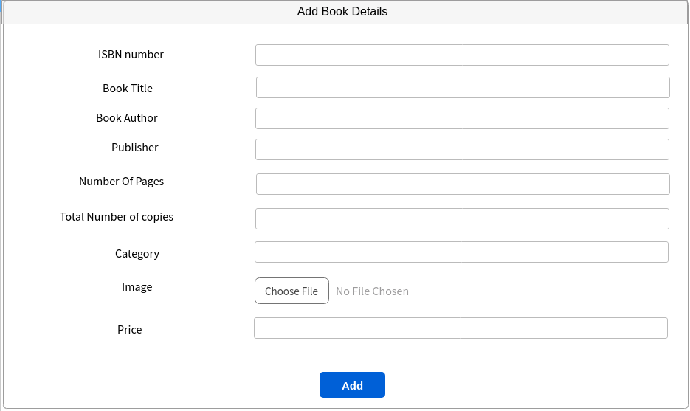

3. Option (hyperlink) to allot book to a user
4. Option (hyperlink) to accept the returned book
5. Check all the allotted books
6. Option (hyperlink) to go to the User Request Page
7. Option for (hyperlink) Logout
o Allot Book Page
1. Option (hyperlink) for home page
2. Form to accept user id, book id, and date to allot the book
3. Option for (hyperlink) Logout o Return Book Page
4. Option (hyperlink) for home page
5. Form to accept user id, book id, and date to return the book
6. Option for (hyperlink) Logout
o Allotted Book Page
1. Option (hyperlink) for home page
2. View all allotted books
3. Option (hyperlink) to return book
4. Option for (hyperlink) Logout
o User Request Page

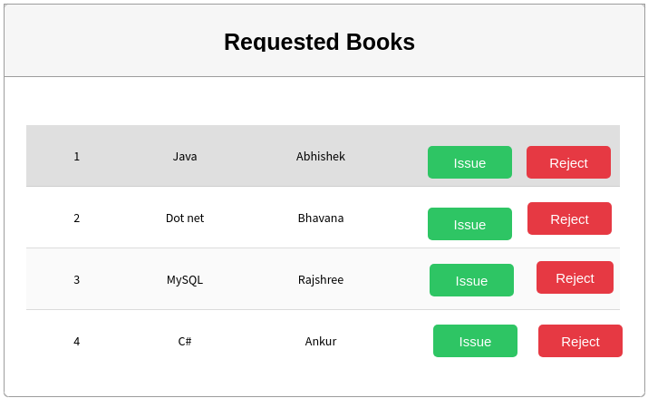
1. Option (hyperlink) for home page
2. View all the user request for the books
3. Option (hyperlink) to accept the request
4. Option (hyperlink) to reject the request
5. Option for (hyperlink) Logout

Data base:

Table Name: Book_Details

NAME | TYPE | ATTRIBUTES
ISBN_NO | Int(35) | Primary Key
BOOK_TITLE | Varchar(35)
LANGUAGE | Varchar(35)
CATEGORY | Varchar(35)
AUTHOR_NAME | Varchar(35)
QUANTITY | Int(35)
NUMBER_OF_PAGES | Int
PUBLISHER_NAME | Varchar(35)

Table Name: User_Details

NAME | TYPE | ATTRIBUTES
USER_ID | Int(35) | Primary key
FIRST_NAME | Varchar(35)
LAST_NAME | Varchar
EMAIL_ID | varchar(35) | Not Null
PASSWORD | Varchar(35)
ROLE | Varchar
CONTACT_NUMBER | Int
DOB | Date

