How Klander works
My study and presentation guide
Ethan Jekhine · October 2026
Read this to understand every part of Klander well enough to explain it, demo it and answer questions about it.
Companion to: Klander project report
Contents

1. Klander in one minute
Klander is a free calendar app for friend groups. Everyone has their own calendar, but you can see your friends' weeks, with privacy you control on every event. You can add plans by typing a sentence like "basketball thurs 7pm" or by taking a photo of a poster or timetable, and AI turns it into events. It pulls in your uni timetable and other calendar links, and your family can follow your plans from Apple Calendar. It installs on an iPhone straight from Safari, with no App Store, and costs nothing to run.
If you only remember three things:
- Privacy lives in the database. The app can't leak what the database won't hand over.
- It works with the calendars people already use by reading and publishing standard .ics calendar links.
- AI drafts, the human decides. Smart add never saves anything until you've checked it.

2. The big picture
Think of Klander like a restaurant:
Restaurant | Klander | What it does
The menu and the waiter | The app on your phone (React) | Shows you everything and takes your orders
The kitchen's storeroom | The database (Postgres on Supabase) | Where everything is kept
The bouncer on the storeroom door with a guest list | Row Level Security (RLS) | Checks who you are and only hands over what you're allowed to have
Your wristband | Your login token (JWT) | Proves who you are on every request
The chefs in the back | Edge Functions | Do the jobs that need secret ingredients (API keys) the waiter mustn't hold
The delivery driver on a timer | pg_cron | Goes out every 3 hours to fetch your uni timetable
A specialist consultant | Gemini AI | Reads your sentence or photo and suggests events
The building the restaurant is in | Vercel | Hosts the app so anyone can open klander.vercel.app
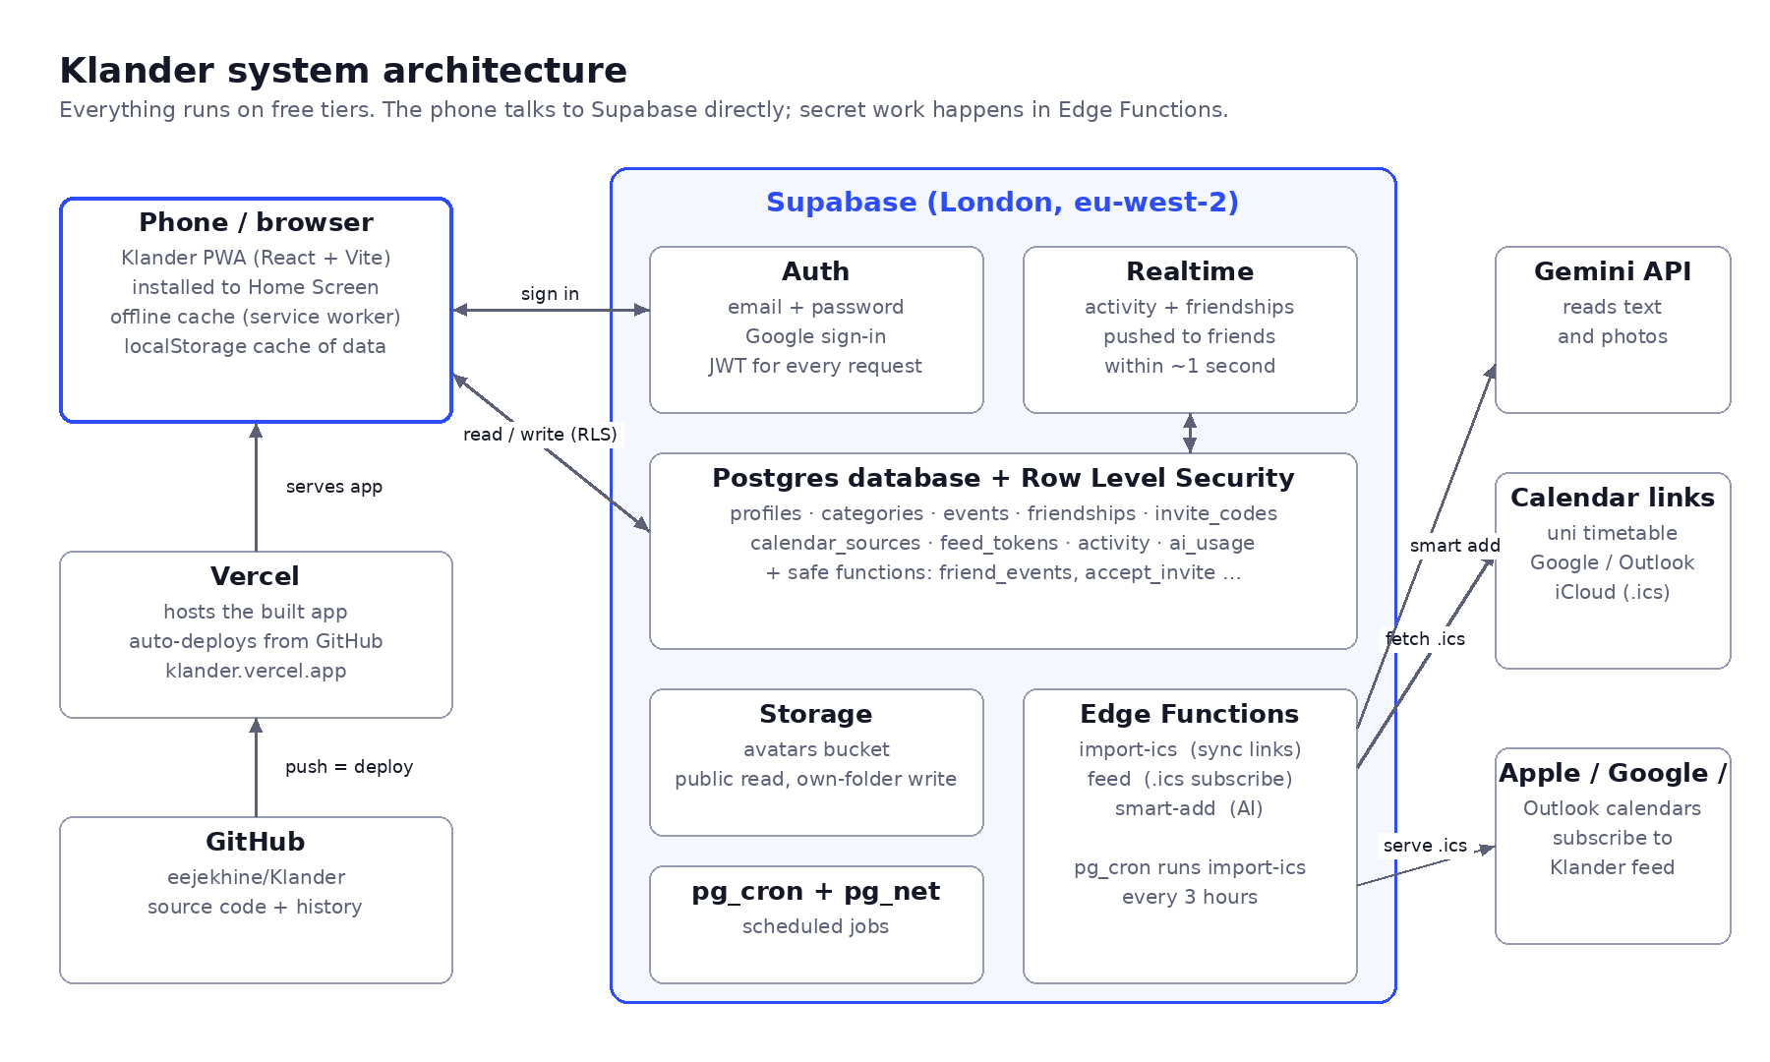
How the parts connect

3. What happens when you add an event
Follow "Gym, Tuesday 17:00" from your thumb to your friend's screen:
- You tap +, fill in the editor and press Save.
- The app sends the event to Supabase with your login token attached.
- The database's RLS rule on events checks that owner_id equals the user in your token. If someone tried to save an event as you, it would be refused here.
- The event is saved as one row. If it repeats, the repeat rule is saved too (e.g. weekly on Tuesdays), not hundreds of copies.
- A database trigger notices the new event and writes a line in the activity table: "Ethan added Gym, Tue 17:00". It applies privacy as it writes: busy events get no title, and private events get no line at all.
- Realtime sees the new activity line and pushes it to any friend who has Klander open. The RLS rule on activity means only your friends receive it.
- Your friend's app reloads your events by calling friend_events(), which hands over only what that friend is allowed to see. Gym appears in your colour within about a second.

4. Accounts and signing in

Email and password
- Supabase Auth stores your email and a hashed password. Even the database owner never sees the real password.
- When you sign up, a trigger automatically creates your profile and five default categories (Work, Uni, Sport, Social, Personal).
- When you sign in, Supabase gives the app a JWT (login token): a signed note that says "this is user 1234" and expires after an hour. The app refreshes it automatically.

Continue with Google (OAuth)
- You tap the button. The app sends you to Google with Klander's Client ID.
- You sign in with Google and agree to share your name and email.
- Google sends you back to Supabase's callback address with a one-time code. That's why the redirect URI had to be set in Google Cloud: Google only sends codes to addresses on the list, which is what caused the redirect_uri_mismatch error.
- Supabase swaps the code for your Google details using the Client Secret, which only Supabase knows, creates or finds your account, and sends you back to klander.vercel.app signed in.

5. How privacy works
Every table has Row Level Security switched on. Out of the box, nobody can see anything; each rule opens up one specific thing. For example, the rule on events is:
create policy "Users manage own events" on public.events for all to authenticated
using ((select auth.uid()) = owner_id) -- you can only see rows you own
with check ((select auth.uid()) = owner_id); -- you can only save rows as yourself

So how do friends see your events if they can't read the events table? Through one carefully written database function, friend_events():
- It only looks at people you have an accepted friendship with.
- It drops Private events.
- It rewrites Busy events to just "Busy" with no location.
- It never returns notes.
You set the event to… | Your friend sees…
Friends | Title, time and place
Busy only | A striped block called "Busy"
Private | Nothing
Why this matters (good interview point): if privacy were only hidden in the app, anyone who knew how to call the API directly could read everything. Because the database itself enforces it, even a bug in the app or a technical user can't see more than they're allowed. I tested this by pretending to be different users and checking what each one got back.

6. Friends and invite links

Adding by username
- send_friend_request("sam_k") runs in the database. It refuses yourself and usernames that don't exist, and won't create duplicates.
- If Sam had already sent you a request, it just accepts it.
- Only the person who received a request can accept it. The rules even stop people editing any column except "status".

Invite links
- Everyone has a random invite code that only they can see, e.g. klander.vercel.app/?invite=3f9a….
- When someone opens it, the app saves the code until they've signed up or signed in, then calls accept_invite(code), which makes them friends straight away.
- Because whoever has the link becomes your friend, the app warns you to only share it with people you want to add.

Live updates and the activity feed
- A trigger on events writes privacy-safe lines to activity.
- Realtime pushes new activity lines and friend-request changes to open apps.
- The app waits 0.4 seconds, then refreshes (so 5 quick changes cause 1 refresh).
- It also refreshes every minute and whenever you reopen the app, as a backup.

7. Repeating events and the clock change
A repeating event is stored once with a rule, like FREQ=WEEKLY;BYDAY=MO,TU,WE,TH,FR ("every weekday"). When you look at a week, the app works out the actual dates.

The clock-change problem
Computers store times in UTC. My shift starts at 23:30 in London:
- In October (British Summer Time, UTC+1) that's 22:30 UTC.
- After the clocks go back on 25 October (GMT, UTC+0) it's 23:30 UTC.
If the app just added "1 week" in UTC, the shift would show at 22:30 after the clocks changed. The fix is floating time: work out the repeats using the local wall-clock time (always 23:30), then convert each one back to the real moment. A test checks this across 25 October.

Skipping one week
"Delete only this one" doesn't delete the series. It adds that date to the event's list of skipped dates (exdates), so the app jumps over it when working out the repeats.

Overnight events
If you set an end time earlier than the start (23:30 → 08:30), the editor moves the end to the next day automatically. The week view splits it across both days.

8. Calendar links (import and subscribe)

The .ics format
Almost every calendar app can share a calendar as an .ics file at a link. webcal:// is the same thing; it just tells your phone "open this in a calendar app". It's plain text, like this:
BEGIN:VEVENT
UID:lec-1
SUMMARY:Intro to Data Science
DTSTART;TZID=Europe/London:20261005T100000
RRULE:FREQ=WEEKLY;BYDAY=MO
END:VEVENT

Bringing calendars in (import-ics)
- You paste a link. Klander saves it in calendar_sources.
- The import-ics Edge Function downloads it on the server. Your phone can't do this, because browsers block downloading from other websites.
- It reads every event, fixes time zones (including Outlook's odd names like "GMT Standard Time"), keeps repeats as rules, handles moved and cancelled lectures, and ignores events older than 4 months.
- It upserts by the event's UID: new ones are added, changed ones updated, and ones that vanished from the feed deleted.
- pg_cron runs this every 3 hours for everyone. Sync now runs it straight away.

Sending Klander out (feed)
- Klander gives you a secret link: …/functions/v1/feed?token=<36 random characters>.
- Apple, Google or Outlook check that link regularly. The feed function returns your Klander-made events as an .ics file.
- It writes times in London time with a time-zone definition, so other apps also get the clock change right.
- Imported events aren't included, because they already live in the calendar they came from.
- Anyone with the link can read it, which is why there's a "make a new link" button that kills the old one.

9. Smart add (AI)
- You type a sentence and/or choose a photo. The phone shrinks the photo (max 1600 px) so it uploads fast.
- The app calls the smart-add Edge Function, sending the current date and time so "thurs" can be worked out.
- The function checks you're signed in and haven't used your 30 requests in the last 24 hours.
- It sends Gemini the photo or text plus a list of rules (UK dates, 24-hour times, overnight shifts end the next day, never make things up) and a JSON schema: an exact form the answer has to fill in.
- If one Gemini model is busy, it tries the next one.
- It checks the answer (real dates, real times) and sends back drafts.
- You see editable cards. Anything the AI wasn't sure about is flagged, and nothing is saved until you tap Add.
Why the API key is in an Edge Function: if the Gemini key were in the app, anyone could open the browser tools, copy it, and run up usage on my account. On the server it stays secret, and the daily limit stops abuse.

10. Hosting, deploying and secrets
Thing | Where it lives | How it changes
App code | GitHub: eejekhine/Klander | git commit + git push
Live app | Vercel (klander.vercel.app) | Vercel rebuilds automatically on every push (~1 min)
Database structure | Supabase | Named migrations; full copy in supabase/schema.sql
Edge Functions | Supabase | Deployed separately; source in supabase/functions/
Public keys | Vercel environment variables | Supabase URL + publishable key (safe to be public)
Secret keys | Supabase Edge Function secrets | GEMINI_API_KEY; the service role key never leaves Supabase
Google sign-in | Google Cloud project "Klander" + Supabase provider settings | Client ID/secret, redirect URI, JavaScript origins
Why the app sometimes looks old after a push: it's a PWA, so it saves itself for offline use. After a deploy, the first open can show the saved version. It updates in the background, and the next open has the new version.

11. Where things are in the code
File / folder | What's in it
src/App.jsx | Decides which screen to show: loading, sign in, reset password or the app
src/Shell.jsx | Loads your data; shows first-time setup if you have no username
src/CalendarApp.jsx | The main screen: header, views, people strip, + and Smart add buttons, all sheets
src/views/ | TimeGrid (day/week), MonthView, AgendaView (list)
src/components/ | Sign in, onboarding, event editor, settings, friends, calendars, smart add, event viewers
src/lib/dates.js | Repeat expansion, overlap layout, date formatting, repeat presets
src/lib/store.js | Loading/saving your profile, categories and events + offline cache
src/lib/friends.js | Friends, requests, friend events, activity, live updates, invite links
src/lib/sync.js | Linked calendars and your subscribe links
src/lib/smart.js | Photo shrinking, calling smart add, turning drafts into events
src/styles/app.css | All styling, light and dark colour tokens
supabase/functions/ | import-ics, feed, smart-add, and the shared .ics parser
supabase/schema.sql | The whole database structure and security rules
vite.config.js | Build settings and the PWA manifest (name, icons, colours)

12. Costs and limits
Service | Cost now | Limit to know
Supabase | £0 | Free project pauses after a week of no use; 500 MB database; 1 GB storage
Vercel | £0 | Hobby plan is for non-commercial use
Gemini | £0 (free tier) | Free tier may use data for training; switch to paid (~35p/month) before strangers use it
Smart add | — | 30 per person per day (my own limit)
Calendar refresh | — | Every 3 hours, or Sync now
Carbon estimate: roughly 0.2–1.2 kg CO₂e to build and 1.5–5 kg CO₂e a year to run for my friend group (about 10–30 km of driving). These are estimates.

13. Presenting Klander

3-minute talk
Time | Say | Show
0:00 | "My friends and I could never find a time to meet. Our plans live in group chats and five different calendars. So I built Klander." | Home screen icon, open the app
0:20 | "It's a normal calendar first: day, week, month, list. My night shift repeats every weekday and stays at 23:30 even when the clocks change." | Week view with night shifts
0:50 | "The point is friends. Each friend has a colour. I control privacy on every event: friends see details, just busy, or nothing. That's enforced by the database, not just hidden in the app." | People strip, a busy block, the editor's privacy options
1:30 | "Adding plans is quick. I type 'basketball thurs 7pm at the edge', or take a photo of a poster, and AI drafts the event. I check it, then save." | Smart add live
2:10 | "It works with what people already use: it imports my uni timetable link and my mum sees my plans in Apple Calendar." | Calendars screen
2:35 | "It's a PWA on React and Supabase, costs £0 a month, and has 67 recorded tests. Next: birthdays, a free-time finder, chat and a weekly photo story." | Roadmap page

Demo checklist
- Have two accounts signed in (phone + laptop private window) to show live updates.
- Pre-load a week with lectures, shifts and a couple of friend events.
- Have a poster or screenshot ready for smart add, plus a backup sentence in case the signal is bad.
- Open the app once beforehand so the latest version is loaded.

14. Questions you might be asked
Question | A good answer
Did you write the code yourself? | I built it with Claude, an AI assistant. It walked me through each stage and wrote most of the code, especially the hard parts. I came up with the idea and features, made the design and privacy decisions, set up all the services (Supabase, Google sign-in, Gemini, GitHub, Vercel), deployed it, and tested it. I can explain how every part works.
Why a web app and not an iPhone app? | A native iPhone app needs a £99/year developer account, and free builds expire every 7 days. A PWA installs from Safari for free, works on Android and laptops too, and is one codebase.
How do you stop people seeing private events? | Row Level Security in the database. People can only read their own events table rows. Friends get events through one function that drops private events and turns busy ones into "Busy" before anything leaves the database. I tested it by pretending to be different users.
What's Row Level Security? | Rules attached to each database table that decide, row by row, what the current signed-in user can read or change.
Why Supabase over Firebase? | It's real SQL (Postgres), which suits relational data like friendships and is useful for my degree. It also has RLS, auth, realtime, storage and functions in one free project.
How do live updates work? | A trigger writes an activity line whenever an event changes. Supabase Realtime pushes it to friends who have the app open, and their app refreshes.
What was the hardest bug? | Time. Repeating events had to stay at local time across the clock change, and calendar files from Outlook use Windows time-zone names. I used floating time for repeats and a fallback to London time for unknown zones, both covered by tests.
How do you keep the AI from making mistakes? | Strict rules and a JSON schema; checks on every date and time; low-confidence events are flagged; and nothing saves until the user confirms.
Isn't the API key exposed? | No. It's a server-side secret in an Edge Function. The app only holds the Supabase publishable key, which is safe because RLS protects the data.
How did you test it? | Database security tests as fake users, unit tests for repeats, layout and the calendar parser, live tests of the deployed functions, automated phone-size UI tests with screenshots, and real use with two accounts. 67 recorded tests, all passing.
What does it cost? | £0 a month on free tiers. The only planned cost is about 35p a month for paid AI before opening it to the public.
What would you do differently? | Set up a separate test database from day one for full end-to-end tests, and design offline editing earlier.
What's next? | Themes and automatic birthdays, then a free-time finder, chat, a weekly photo "My Week" story, and lock-screen notifications.
Is it GDPR-safe? | Data is in the EU (London), access is locked down by RLS, and before launch I'm adding a privacy page, data export and account deletion.

15. Mini glossary
Word | Plain meaning
Front end / back end | What you see (the app) / what stores and protects the data (Supabase)
API | The way the app asks the server for things
JWT | Your signed login token
RLS | Per-row security rules in the database
Trigger | Code the database runs automatically when something changes
Edge Function | Small server program for anything that needs secrets
Cron | A timer that runs a job on a schedule
PWA | A website you can install like an app
.ics | The standard calendar file format
Upsert | Insert if new, update if it already exists
Migration | A saved, named change to the database structure

