Klander
A shared calendar for friend groups: project report
Ethan Jekhine
Portfolio project · October 2026
Live app: klander.vercel.app
Code: github.com/eejekhine/Klander
Built with React, Supabase, Gemini and Vercel, with Claude as AI development assistant
Contents

Summary
Klander is a free calendar app for groups of friends. Everyone has their own account and calendar. You can see your friends' weeks with privacy you control per event (full details, "Busy" only, or private), and add events by typing a sentence or taking a photo. It pulls in calendar links such as a uni timetable and publishes its own link for Apple, Google and Outlook. It installs on an iPhone from Safari without the App Store, and runs on free tiers for £0 a month.
Problem | Friends can't easily see when each other are free; plans get lost in group chats
Solution | A shared-by-default personal calendar with privacy levels, live updates and AI quick-add
Stack | React + Vite PWA · Supabase (Postgres, Auth, RLS, Realtime, Storage, Edge Functions, pg_cron) · Gemini · Vercel
Status | 5 of 12 phases shipped and live; phases 6–12 designed
Testing | 67 recorded tests across database security, logic, live functions and UI, all passing
My role | Idea, requirements, every product decision, all service setup and configuration, deployment and real-world testing. Claude walked me through each stage and wrote most of the code.

1. Analysis

1.1 Background and the problem
I work a night shift as a warehouse operative (Monday to Friday, 23:30 to 08:30), I started a Data Science with AI degree at Leeds Beckett in September 2026, and I play basketball and volleyball. My friends all have their own mix of uni, work and sport. Trying to find a time when we are all free usually means a long group chat, people forgetting what they said, and plans that never happen.
Each of us already uses a calendar, but they are all separate. Google Calendar and Apple Calendar can share calendars, but you have to share each calendar with each person one at a time, and nobody does it. Tools like When2meet are good for one meeting, but you fill them in from scratch every time and they forget everything afterwards. My uni timetable lives in a separate system again.
The problem: there is no simple, free place where a group of friends can each keep their own calendar, see each other's weeks at a glance with sensible privacy, and add plans quickly from the messages, posters and screenshots where plans actually come from.

1.2 Stakeholders
Stakeholder | Who they are | What they need from Klander
Me (primary user and developer) | Student and night-shift worker in Leeds, mainly uses an iPhone | One calendar for shifts, lectures and sport; see friends' free time; a real portfolio project
My friends (5–6 people) | Students and workers with irregular weeks | Quick sign-up, see each other's weeks, control what others can see, add plans quickly
My mum | Uses Apple Calendar for everything | See my plans in Apple Calendar without installing anything new
Future employers / reviewers | People reading my portfolio | Evidence of a complete, secure, well-tested full-stack app with clear reasoning

1.3 Gathering requirements
I started by writing out everything I wanted the app to do in plain language, then turned it into a list of features and grouped them into phases. The first request was: "a calendar app that my friends can use and make their own accounts, where we can see each other's week, and where I can take a picture or type some text and turn it into an event." From there I asked for more ideas and picked the ones that solved real problems for my group.
As the project went on, testing it myself led to new requirements, which is why the plan changed between phases:
- Calendar links: my uni gives me a calendar link for my timetable, so the app needed to read those links and stay in sync with Apple, Google and Outlook.
- Friends before sync: I swapped the order of two phases so that the friends feature (the main reason for the app) came earlier.
- Testing before inviting friends: I didn't want to send the app to friends until I was sure the privacy and friends features worked, so I tested with a second account first.
- Later ideas (themes, birthdays, chat, photo memories, notifications) came from using the app and are scoped in Section 6.

1.4 Research into existing solutions
I compared the tools my friends and family already use. This is a summary of how each one fits our problem, based on using them, rather than a full feature audit.
Existing solution | Strengths | Why it doesn't solve our problem
Google Calendar | Free, reliable, good on Android, can subscribe to links | Sharing is per calendar and per person; no friend list or "see everyone's week" view; no privacy levels designed for friend groups
Apple Calendar (iCloud) | Built into iPhones; my mum already uses it | Shared calendars are awkward to set up for a group; no easy way to compare several people's free time
When2meet-style polls | Great for finding one meeting time | Starts from scratch every time and does not know your real calendar
Group chats | Where plans actually start | Plans get lost in the scroll; no calendar, no reminders
Social calendar apps | Built around friends | Usually need an App Store install and an account for everyone, and may not read uni timetable links
What I took from this: Klander should (1) be a real personal calendar first, (2) layer friends on top with privacy levels per event, (3) read and publish standard calendar links so it works alongside Apple, Google and Outlook rather than replacing them, and (4) make adding events faster than typing them out.

1.5 Objectives
These are the measurable objectives I set for the first five phases. Section 5 evaluates each one.
# | Objective | How I will know it is met
1 | People can create their own account with email or Google and set a unique username, display name and colour | A new user can sign up, confirm, and reach the calendar in under 2 minutes; usernames are unique
2 | A full personal calendar: day, week, month and list views; create, edit and delete events | Every view displays the same events correctly at phone width (390 px)
3 | Repeating events, including overnight shifts, that stay at the right local time when the clocks change | A weekday 23:30–08:30 shift still shows at 23:30 after 25 October 2026
4 | Delete a single occurrence of a repeating event, or the whole series | Skipped date disappears; other repeats remain
5 | Categories with colours, and a visibility setting on every event (Friends, Busy only, Private) | Category colours show in all views; visibility is saved per event
6 | Installable on iPhone for free and usable offline (read-only) | Add to Home Screen opens full-screen; last calendar shows with no signal
7 | Add friends by username or invite link, and see friends' events in their colour | Two test accounts see each other's events after accepting
8 | Privacy is enforced by the database, not just hidden in the app | A stranger sees 0 events; Busy shows only "Busy"; Private never leaves the owner's account
9 | Friends' changes appear live, with an activity feed | A change on one device appears on the other within seconds
10 | Import calendar links (.ics / webcal) that refresh automatically, and publish a link other apps can subscribe to | Linked calendar refreshes at least every 3 hours; Apple Calendar can subscribe to Klander
11 | Turn a typed sentence, photo or screenshot into events that I can review before saving | Common sentences produce the correct date and time; nothing saves without confirmation
12 | Running cost of £0 per month for my friend group | All services on free tiers

1.6 Constraints
- Cost: I am a student, so everything has to run on free tiers. Paying £99 a year for an Apple developer account was not an option.
- iPhone without the App Store: most of my friends use iPhones. Free sideloaded apps expire every 7 days, so the app had to be a Progressive Web App (PWA) installed from Safari.
- Time: I work nights, so I could only work on the project in short sessions. The work was split into phases with a clear "done when" for each.
- Privacy: the app stores friends' personal schedules, so data protection had to be designed in from the start, not added later.
- My experience: I study Computer Science but had not built a full-stack app with authentication, a cloud database and serverless functions before, so I needed guidance (see 1.9).

1.7 Choosing the technology
I compared options for each part of the system before starting.

App type
Option | Pros | Cons | Decision
Native iOS app (Swift) | Best performance, widgets, App Store | £99/year Apple fee; iPhone only; free builds expire every 7 days | Rejected
Progressive Web App (React + Vite) | Free; works on iPhone, Android and desktop; installs to Home Screen; one codebase | No home-screen widgets; iPhone push needs iOS 16.4+ | Chosen
Plain HTML/JS (like my other tools) | Simple, no build step | Hard to manage at this size | Rejected

Backend
Option | Pros | Cons | Decision
Supabase | Postgres (SQL I can learn from), auth, realtime, storage and functions in one free project; Row Level Security for privacy | Free projects pause after a week of no use | Chosen
Firebase | Popular, generous free tier | NoSQL makes the friends/privacy queries harder; less useful for my SQL learning | Rejected
Own server | Full control | Costs money, more to secure and maintain | Rejected

AI for smart add
Option | Cost for ~7 people | Notes | Decision
Gemini (free tier) | £0 | Reads text and images; free tier may use data to improve Google's models | Chosen for now
Claude Haiku | ~£1/month | Needs prepaid credit | Rejected for now
Gemini (paid) | ~35p/month | Data not used for training | Planned before launch
Hosting is on Vercel (free, deploys automatically when I push to GitHub).

1.8 Development approach
I used an iterative, phased approach. Each phase had a list of features and a "done when" test. At the end of each phase I tested it myself, fixed what I found, pushed it live and then decided the next phase, sometimes changing the order based on what I learned. I tracked the plan in an interactive roadmap page.
Phase | Content | Status
1. Setup | Supabase, PWA, hosting, accounts | Done
2. Your calendar | Views, events, repeats, categories, settings | Done
3. Import & sync | Calendar links in, subscribe link out | Done
4. Friends | Requests, invites, overlay, privacy, live updates, activity | Done
5. Smart add | AI from text, photos and timetables | Done
6–12 | Themes & birthdays, plans, chat, memories, notifications, insights, launch | Designed (Section 6)

1.9 Tools and AI assistance
I built Klander with Claude (Anthropic's AI assistant) as my development partner, and I want to be clear about who did what.
What Claude did: walked me through each stage step by step, explained the options and trade-offs, and wrote most of the code, especially the difficult parts: the database security rules, the repeating-event logic, the calendar file (.ics) parser, the serverless functions and the AI prompt. It also ran automated tests on the code it wrote.
What I did:
- Came up with the idea, the name and the features, and decided what to build in each phase and in what order.
- Made the product decisions: privacy levels, PWA rather than native, free tiers, which AI provider, and which features to cut or add.
- Set up and configured every service myself: the Supabase project settings, Google Cloud sign-in (OAuth client, redirect URLs), the Gemini API key, the GitHub repository and the Vercel deployment with its environment variables.
- Ran the app on my Mac and iPhone, tested every feature with real use and a second account, found problems and reported them so they could be fixed (Section 3 lists them).
- Pushed each version live with Git.
Using an AI assistant is now a normal part of professional software development. The skill I practised was directing it well: deciding what to build, checking the output, testing it properly, and understanding how the system works well enough to explain it. The companion document "How Klander works" is my own study guide for that.

2. Design

2.1 System architecture
Klander has three main parts: the app that runs on the phone, Supabase, which holds the data and runs the server-side code, and a few outside services (Gemini for AI, plus other people's calendar links). The phone talks to Supabase directly. Anything that needs a secret key, or must not be trusted to the phone, runs in an Edge Function on Supabase's servers.
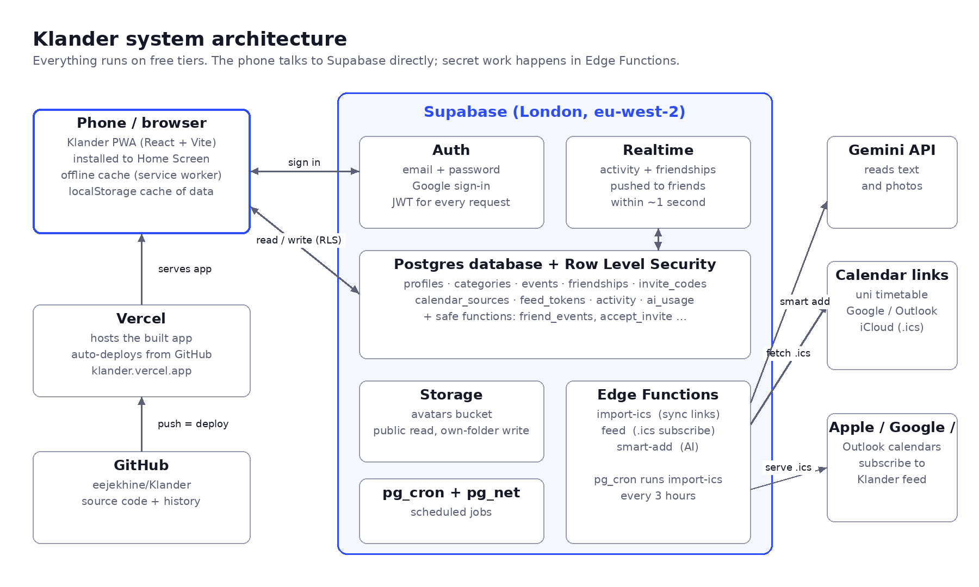
Figure 1: Klander system architecture
Part | Technology | Job
Front end | React 18 + Vite, vite-plugin-pwa | All screens; installable; caches the app for offline use
Hosting | Vercel | Serves the built app at klander.vercel.app; redeploys on every Git push
Accounts | Supabase Auth | Email/password and Google sign-in; gives the app a signed token (JWT) that proves who you are
Database | Supabase Postgres + Row Level Security | Stores everything; RLS rules decide which rows each person can read or change
Live updates | Supabase Realtime | Pushes friends' activity and friend requests to open apps
Files | Supabase Storage | Profile photos
Server code | Supabase Edge Functions (Deno/TypeScript) | import-ics (sync calendar links), feed (publish .ics), smart-add (AI)
Scheduling | pg_cron + pg_net | Calls import-ics every 3 hours
AI | Google Gemini API | Reads sentences and photos and returns structured event data

2.2 Data model
I designed the database around one row per real thing: people (profiles), events, categories, friendships and linked calendars. Events store a repeat rule instead of one row per repeat, so a weekly lecture for a whole term is a single row.
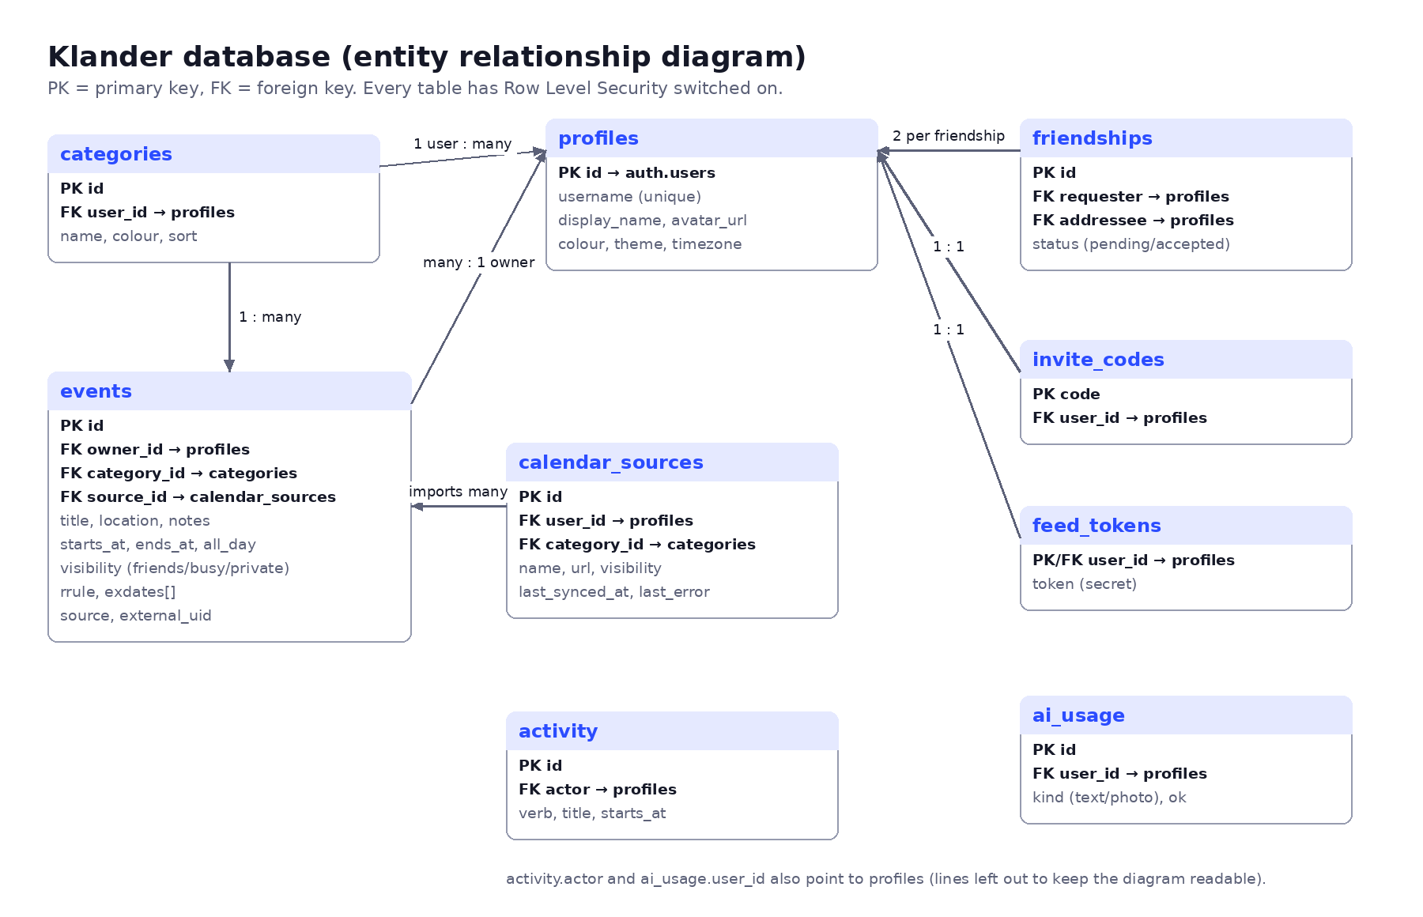
Figure 2: Entity relationship diagram
Table | Purpose | Key design decisions
profiles | One per user | Created automatically by a trigger on sign-up; username is case-insensitive (citext) and unique; colour is checked to be a hex code
categories | Work, Uni, Sport, Social, Personal | Five defaults created on sign-up; each user owns their own
events | Every event | starts_at/ends_at stored in UTC; rrule holds the repeat rule; exdates lists skipped dates; visibility is friends/busy/private; source records how it was made
friendships | Requests and friends | One row per pair; a unique index on (least, greatest) stops duplicate pairs; only the status column can be updated
invite_codes | Personal invite links | Random 18-character code; only the owner can read it
calendar_sources | Linked .ics calendars | Stores the link, last sync time, last error and the category/privacy to apply
feed_tokens | Secret subscribe link | 36-character random token; can be reset
activity | Activity feed | Written only by a database trigger, never by the app; privacy is applied when it's written
ai_usage | Smart-add limit | One row per AI request so each user is limited to 30 per day

2.3 Security and privacy design
Because the app holds friends' schedules, I made the database itself responsible for privacy rather than the app. If the app had a bug, or someone used the API directly, they still could not see data they shouldn't.

Row Level Security (RLS)
Every table has RLS switched on. By default nobody can see anything; each policy then opens up exactly one thing:
Table | Who can do what
events | You can read and write only your own events. Friends never query this table directly.
profiles | Any signed-in user can read basic profiles (so you can search usernames); you can only update your own.
friendships | You can see rows you are part of; only the person who received a request can accept it; either person can remove it; nobody can insert directly.
activity | Visible only to friends of the person who did it.
invite_codes, feed_tokens, calendar_sources, ai_usage | Owner only.
storage (avatars) | Anyone can view photos; you can only upload into a folder named after your own user id.

Privacy levels on events
Level | What friends see
Friends | Title, time and location (never notes)
Busy only | A block labelled "Busy" at that time, with no title or location
Private | Nothing at all
Friends' events come from one database function, friend_events(). It runs with elevated rights (SECURITY DEFINER) but always filters by the signed-in user, joins only accepted friendships, drops private events and rewrites busy ones before anything leaves the database. Friend requests and invite links also go through functions (send_friend_request, accept_invite), so the rules (no duplicates, no friending yourself, invites only work with a valid code) can't be bypassed.

Secrets
- The app only contains the Supabase publishable key, which is safe to be public because RLS protects the data.
- The service role key and the Gemini API key exist only inside Edge Functions as server-side secrets.
- The scheduled sync proves itself with a random secret stored in a private schema that the API cannot reach.
- The import function refuses links to private network addresses, so it can't be tricked into fetching internal resources.

2.4 Key algorithms

Expanding repeating events across clock changes
A repeating event is stored once, with a rule such as FREQ=WEEKLY;BYDAY=MO,TU,WE,TH,FR. To show a week, the app expands the rule into actual dates. The tricky part is British Summer Time: my 23:30 shift is 22:30 UTC in October but 23:30 UTC in November. If the expansion was done in UTC, the shift would move to 22:30 after the clocks change. The solution uses "floating time": the local wall-clock time is converted as if it were UTC, the repeats are generated, then each result is read back as local time.
FUNCTION expandEvents(events, from, to):
results = []
FOR each event IN events:
duration = event.end - event.start
IF event has no repeat rule:
IF event overlaps [from, to): add event
CONTINUE
rule = parse(event.rrule) with start = toFloating(event.start) // local 23:30 -> "23:30Z"
FOR each f IN rule.between(toFloating(from - duration), toFloating(to)):
start = fromFloating(f) // "23:30Z" -> local 23:30
IF start IN event.exdates: CONTINUE // skipped occurrence
end = start + duration
IF start < to AND end > from: add copy of event with start, end
RETURN results sorted by start

Laying out overlapping events in a day column
Events that overlap in time have to sit side by side. Events are sorted by start time and grouped into clusters of events that overlap each other. Within a cluster, each event goes into the first column that is free when it starts (a greedy interval-colouring approach). Each event's width is then 1 divided by the number of columns in its cluster.
sort events by start, longest first
FOR each event:
IF event.start >= end of current cluster: finish cluster
add event to cluster; cluster.end = max(cluster.end, event.end)
finish cluster:
columns = [] // end time of the last event in each column
FOR each event in cluster:
c = first column whose end <= event.start, else a new column
columns[c] = event.end; event.col = c
every event in cluster gets width = 1 / number of columns

Importing a calendar link
- Turn webcal:// into https://, refuse private addresses, then download (25-second timeout, 8 MB limit).
- Parse the .ics file and register any time zones it defines.
- For each event: work out the real start/end instant. If the time zone is missing or a Windows name such as "GMT Standard Time", fall back to the user's zone (Europe/London).
- Keep repeat rules as rules. Moved occurrences become their own event, and the original date is added to the series' skipped dates. Cancelled events are dropped.
- Upsert by (source, UID) so re-syncing updates rather than duplicates, then delete events that have disappeared from the feed.
- Record the sync time and count, and add one "updated their linked calendar" activity row (not one per event).

Smart add pipeline
- The phone shrinks the photo to at most 1600 px (JPEG) and sends it with the text, the current local date and time, and the time zone.
- The Edge Function checks the user is signed in and under 30 requests in the last 24 hours.
- It sends Gemini a set of rules (UK dates, resolve "thurs" to the next Thursday, 24-hour times, overnight shifts end the next day, never invent details) plus a strict JSON schema the reply must follow.
- If a model is unavailable or rate-limited, it tries the next model in a list.
- The reply is validated (real dates, real times, allowed repeat values) and returned as drafts. Nothing is saved until the user reviews and confirms.

2.5 User interface design
The UI is designed phone-first (390 px wide) because that's how my friends will use it.
- Navigation: a header with the month, Today, back/forward and your avatar; a Day/Week/Month/List switch; and a strip of people (You plus each friend) you can tap to show or hide.
- Adding: a blue + button for a manual event and a "Smart add" button for AI.
- Editing: bottom sheets rather than new pages, so you never lose your place.
- Colour: each person has a colour, and your own events use category colours. Friends' events have a dotted edge, and busy blocks are striped so you can tell them apart at a glance.
- Accessibility: 16 px inputs (stops iPhone zooming), visible keyboard focus, labels on every control, reduced-motion support, and both light and dark themes built from the same colour tokens.
Token | Light | Dark | Use
--bg | #F3F4F8 | #0F111A | Page background
--surface | #FFFFFF | #181B27 | Cards and sheets
--ink | #151827 | #ECEEF6 | Main text
--accent | #2B4CFF | #7D93FF | Buttons, today, links
--now | #E0477A | #FF7AA6 | Current-time line
Fonts | Unbounded (headings), DM Sans (text) |  | Loaded from Google Fonts

2.6 Server API design (Edge Functions and RPCs)
Endpoint | Called by | Input → output | Auth
rpc send_friend_request | App | username → sent / accepted / already_sent / not_found / self | Signed-in user
rpc accept_invite | App (invite link) | code → friend's username or invalid | Signed-in user
rpc friend_events | App | (none) → friends' events with privacy applied | Signed-in user
rpc my_invite_code / my_feed_token | App | (reset?) → code / token | Signed-in user
POST /functions/v1/import-ics | App or schedule | {source_id} → {count, added, removed} | User token, or cron secret
GET /functions/v1/feed?token= | Apple/Google/Outlook | token → .ics file | Secret token in URL
POST /functions/v1/smart-add | App | {text, image, now, tz} → {events[], message, remaining} | User token + daily limit

2.7 Test strategy
- Database security tests: SQL scripts that pretend to be different users (by setting the signed-in user inside a transaction) and check what each can see and change. They roll back afterwards, so no test data is left behind.
- Unit tests for the logic that is easy to get wrong: repeat expansion across the clock change, overlap layout, the .ics parser, and converting AI drafts into events.
- Live tests of the deployed Edge Functions, using a test account and a real public calendar (UK bank holidays from gov.uk).
- Automated UI tests in a headless browser at iPhone size (390 × 844), with screenshots of every screen in light and dark mode.
- Real-world testing by me on my Mac and iPhone, including a second account to act as a friend.

3. Development
I built Klander in five phases. For each phase I describe what was built, who did what, the problems we hit and how they were fixed. All code is in my GitHub repository (eejekhine/Klander), with one commit per phase.

3.1 Phase 0: Planning and roadmap
- I wrote the feature list and asked for more ideas, then picked the ones I wanted: friends' weeks, photo/text to event, invites and RSVPs, privacy per event, groups, recurring events, timetable import, travel time and more.
- We researched real costs. For 5–6 friends everything runs on free tiers (£0/month). The only paid option is AI, at roughly 35p to £1 a month if I switch to a paid tier.
- I asked for the roadmap as an interactive HTML page rather than a document, with tickable checklists per phase. I also renamed the app from "Cylinderr" to Klander.
- I chose the build approach: a new Supabase project in London, code in a folder on my Mac, React + Vite, and phases 1–2 first.

3.2 Phase 1: Setup

What was built
- A new Supabase project (klander, eu-west-2 London region).
- A React + Vite project with vite-plugin-pwa: web manifest, service worker, app icons (a calendar with a "K") and the iPhone home-screen meta tags.
- A Git repository in ~/Sites/klander with the first commit, pushed to GitHub and deployed on Vercel at klander.vercel.app.

My role
- Installed Node.js on my Mac when node -v showed it was missing, and ran the app locally with npm install and npm run dev.
- Created the GitHub repository, pushed the code and set up Vercel, including the two environment variables (Supabase URL and publishable key).
- Configured Supabase Authentication: Site URL and Redirect URLs so email links come back to the app.
- Set up Google sign-in end to end: created a Google Cloud project, the OAuth client and client secret, added the authorised JavaScript origins and redirect URI, and enabled the Google provider in Supabase.

Problems and fixes
Problem | Cause | Fix
zsh: command not found: node | Node.js wasn't installed on my Mac | Installed the LTS version from nodejs.org and reopened Terminal
Confirmation email link didn't open the app | Supabase's Site URL was still the default | The account was confirmed anyway; I set the Site URL and Redirect URLs in Supabase
git push: repository not found | The GitHub repo hadn't been created yet | Created the empty repo on GitHub, then pushed again
Pasted the Vercel setup URL instead of the app URL | The project hadn't been deployed yet | Clicked Create Project; the app went live at klander.vercel.app
"Continue with Google" didn't work | The Google provider wasn't enabled | Created the OAuth client in Google Cloud and enabled it in Supabase
Google: Error 400 redirect_uri_mismatch | The Supabase callback URL wasn't listed in Google Cloud | Added https://…supabase.co/auth/v1/callback as an authorised redirect URI
GitHub said "This repository moved" | I renamed the repo to Klander with a capital K | Pushes still worked; updated the remote with git remote set-url

3.3 Phase 2: Your calendar

What was built
- Database: profiles, categories, events and the avatars storage bucket, all with RLS. A trigger creates a profile and five default categories when someone signs up.
- Accounts: sign in, create account, forgot password, set new password, Google sign-in, and a first-time setup screen for username, display name and colour.
- Views: week (time grid with a "now" line), day, month (up to three events per day plus "+N more") and a 60-day list.
- Events: a bottom-sheet editor with title, all-day, start/end, repeat, category, visibility, location and notes. An end time earlier than the start automatically moves to the next day, which handles night shifts.
- Repeats: daily, weekdays, weekly, fortnightly, monthly and yearly, with an optional end date. You can delete one occurrence or the whole series.
- Settings: profile photo (cropped and resized on the phone before upload), name, username, colour, theme (match phone / light / dark), category editor, install instructions and sign out.
- Offline: the last loaded profile, categories and events are cached so the calendar still shows without signal.
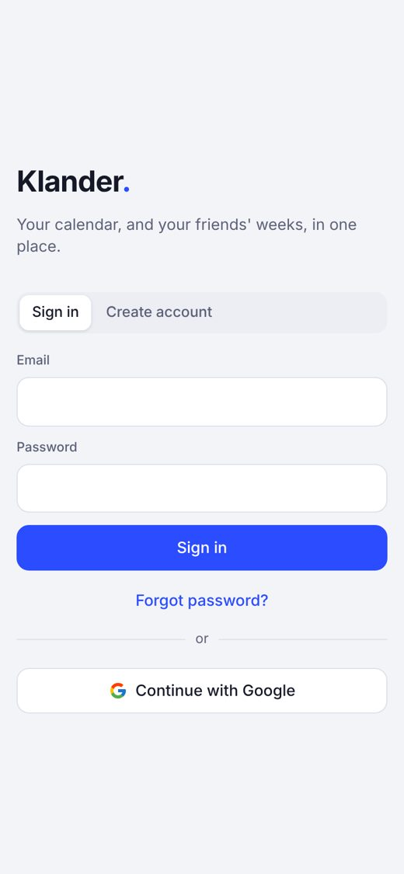  Sign in | 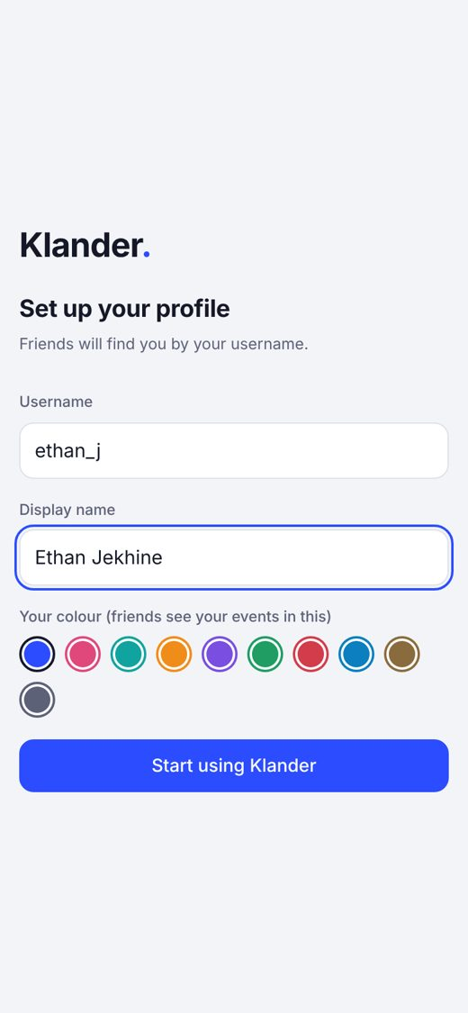  First-time setup | 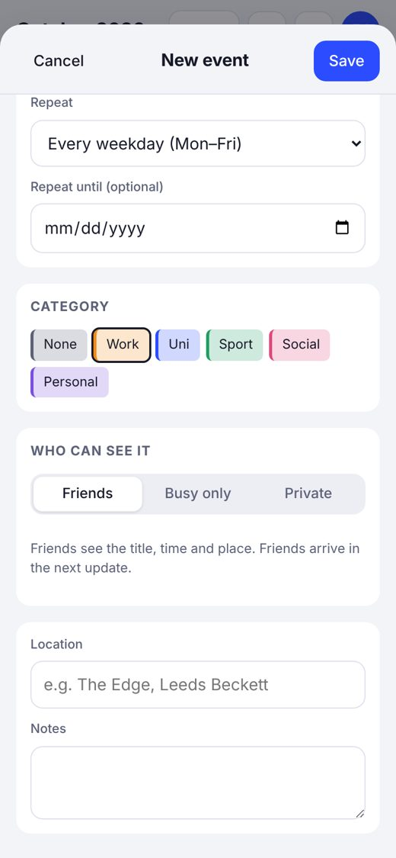  Event editor

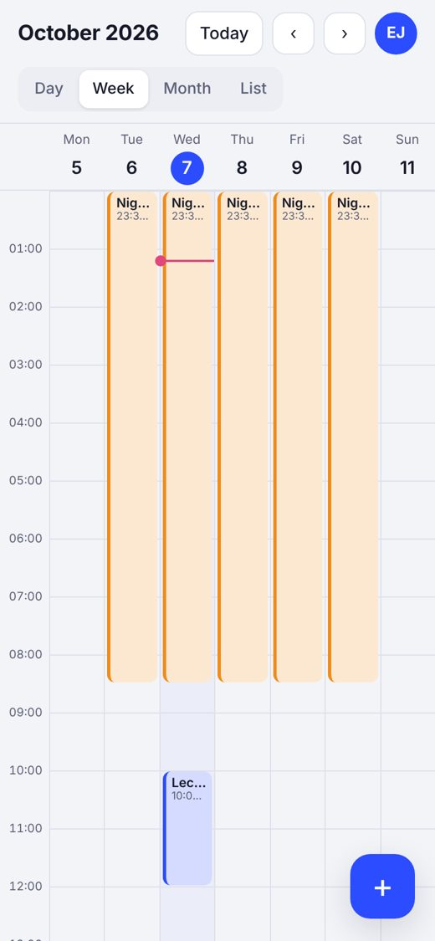  Week view | 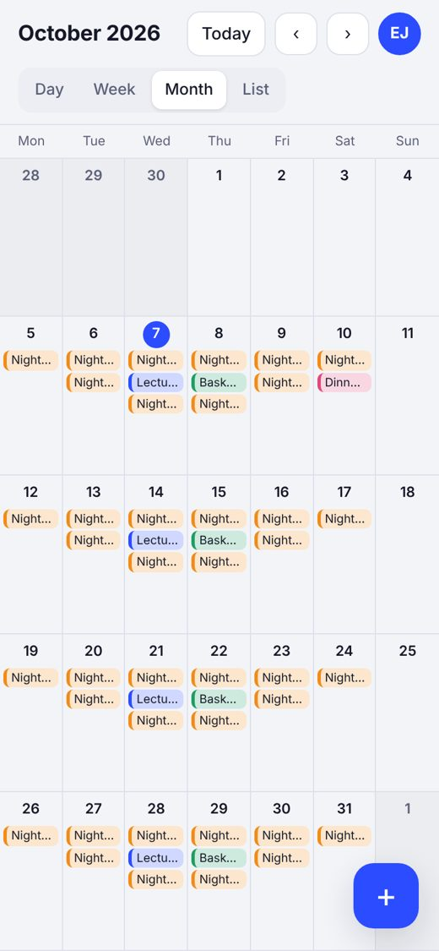  Month view | 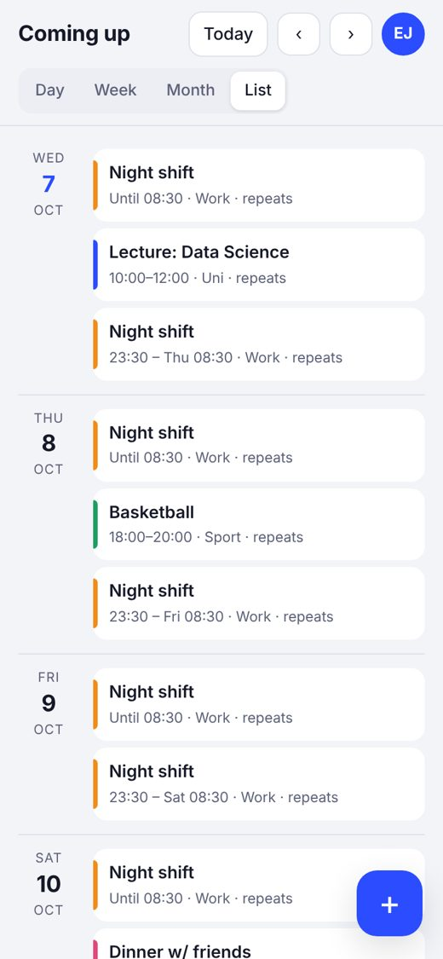  List view

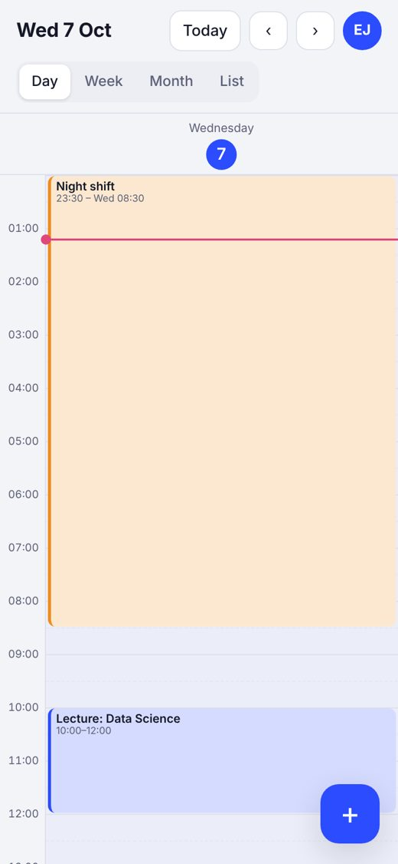  Day view | 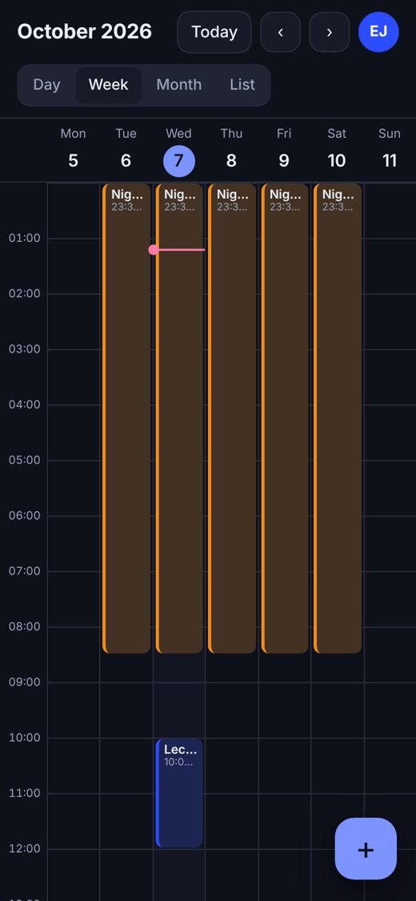  Dark mode | 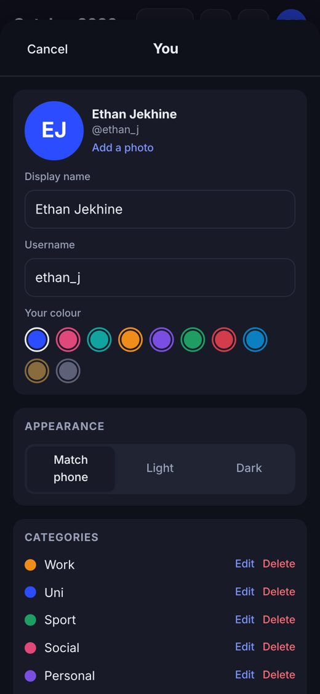  Settings

Problems and fixes
Problem | Fix
Event titles were vertically centred in the week view (buttons centre their content by default) | Changed the event blocks to a top-aligned flex column
The visibility buttons wrapped onto two lines on a phone | Shortened the labels to "Friends", "Busy only" and "Private"
In the list view, an overnight shift on its second day showed "23:30 – Wed 08:30", which was confusing | Shows "Until 08:30" when the event started the day before
Repeat end dates were being shifted by the time-zone conversion | Stored the end date in the same "floating" format as the start, and verified it with a unit test

3.4 Phase 4: Friends (built before phase 3)
I asked whether the friends feature could be added before putting the app online. It could, because it lives in the database and app code, so I moved it earlier. The main reason for the app is seeing friends' weeks.

What was built
- Database: friendships, invite_codes and the functions send_friend_request, accept_invite, my_invite_code and friend_events. Friendships can only be created through these functions.
- Friends sheet: add by @username, a "Share my invite link" button (uses the phone's share menu), accept or decline requests, cancel sent requests, remove friends, and show or hide each friend.
- Invite links: opening klander.vercel.app/?invite=CODE remembers the code until you are signed in, then makes you friends automatically and shows a confirmation.
- Calendar overlay: friends' events in their colour with their first name. Busy blocks are striped, and tapping a friend's event opens a read-only view.
- Live updates and activity feed (finished in the same round as phase 3): a database trigger writes privacy-safe activity rows; Realtime pushes them to friends within about a second; the friends sheet shows "Sam added Gym · Tue 17:00"; a red badge counts unseen activity.
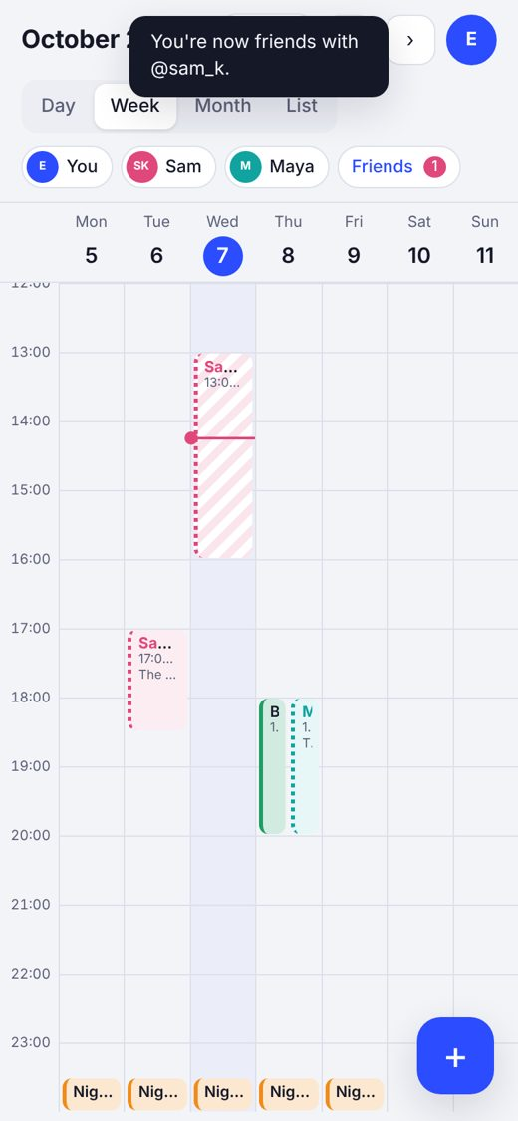  Friends on the week | 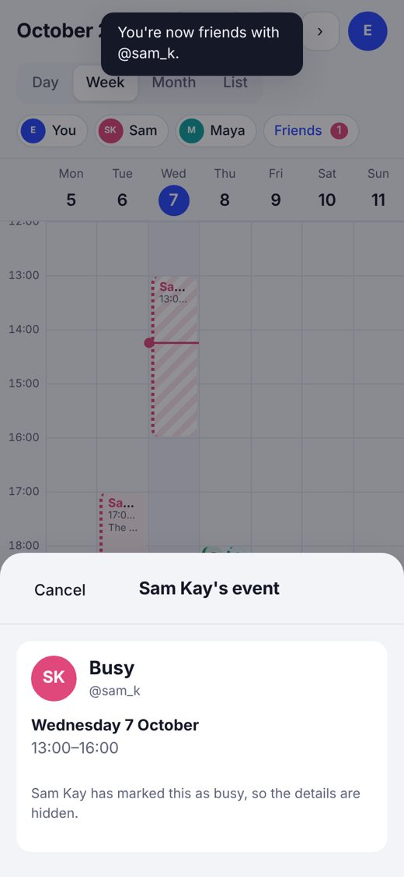  A friend's busy block | 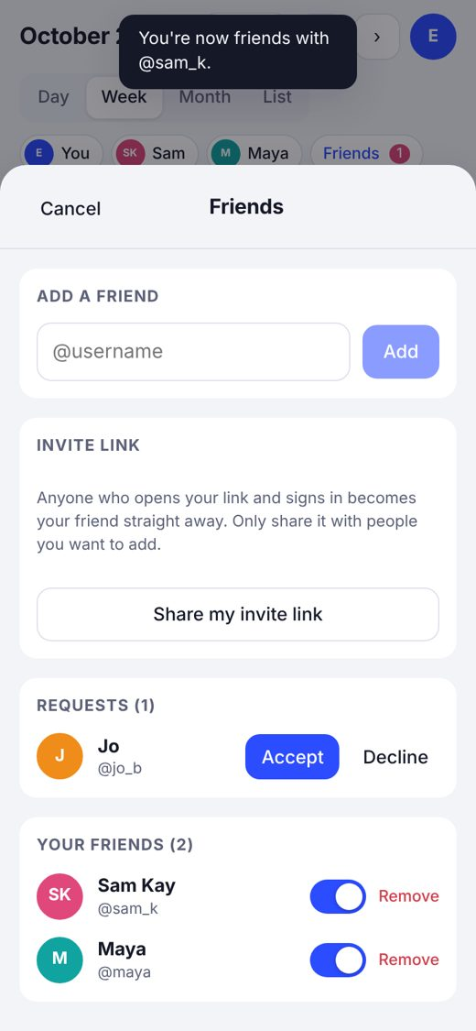  Friends sheet

My role
- Decided the privacy model (Friends / Busy only / Private) and that invite links should make you friends instantly.
- Insisted on testing before sending it to friends: I created a second account with a "+test" email address in a private window and checked live updates, busy blocks and private events between the two accounts.

3.5 Phase 3: Import and sync

What was built
- Linked calendars: paste any .ics or webcal link (uni timetable, Google "secret iCal address", Outlook published calendar, iCloud public calendar), with a name, category and privacy. Imported events are read-only in Klander and show where they came from.
- import-ics Edge Function: downloads and parses the link (see 2.4), upserts the events and removes stale ones. You can run it from Sync now, and it also runs automatically every 3 hours via pg_cron.
- feed Edge Function: publishes your Klander-made events as an .ics file at a secret link. Buttons subscribe to it from Apple Calendar (webcal://), Google Calendar or Outlook. It writes a London time-zone definition so repeating events stay correct across clock changes in other apps.
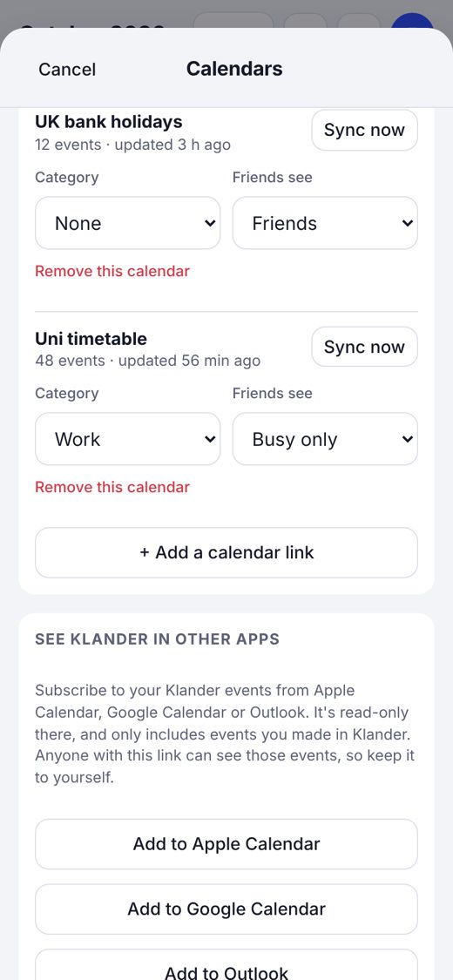  Linked calendars | 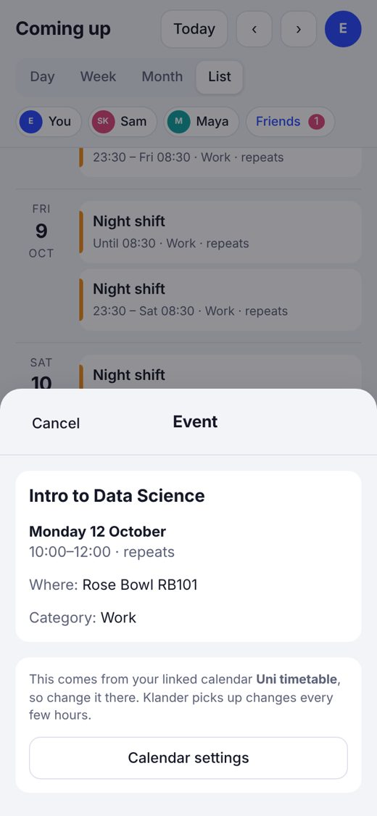  An imported lecture | 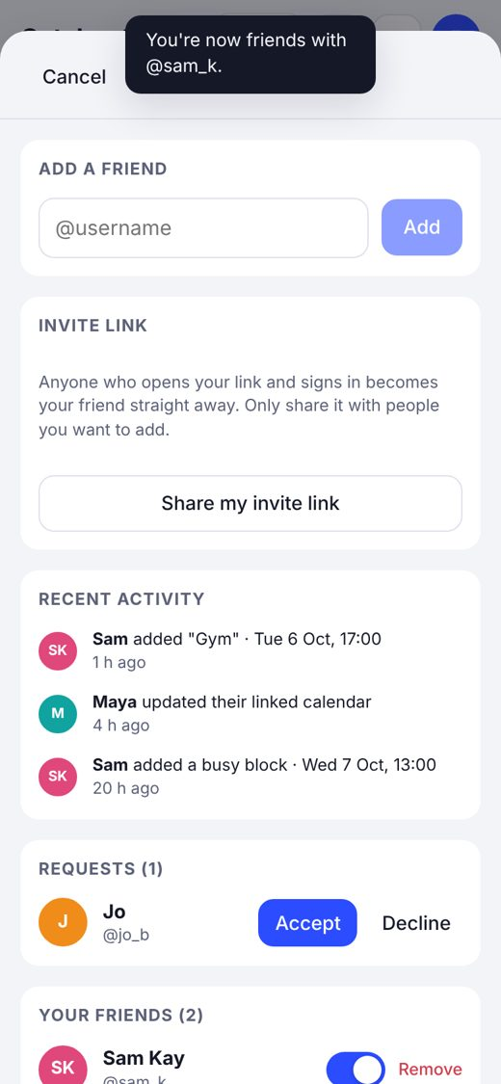  Activity feed

Problems and fixes
Problem | Fix
A database change that dropped an index needed manual approval and timed out | Rewrote it as a change that only adds things (a new unique constraint), which applied straight away
The first deployment of import-ics accidentally contained a placeholder instead of the shared parser file | Spotted straight away and redeployed with the real file before anything used it
Outlook calendars use Windows time-zone names that the parser doesn't know | Falls back to the user's own zone (Europe/London); tested with "GMT Standard Time"
A calendar link could point at a private address | The function refuses localhost and private network ranges

3.6 Phase 5: Smart add

What was built
- Smart add sheet: type a sentence (with example chips to tap), take or choose a photo, or paste a screenshot.
- smart-add Edge Function: calls Gemini with a strict JSON schema and UK-specific rules, falls back to another model if one is busy, validates the reply and limits each person to 30 requests a day.
- Review screen: each event becomes an editable card with a switch to leave it out. You can set category and privacy for all at once, and anything the AI is less than 60% sure about is flagged. Timetables become weekly repeats on the right days.
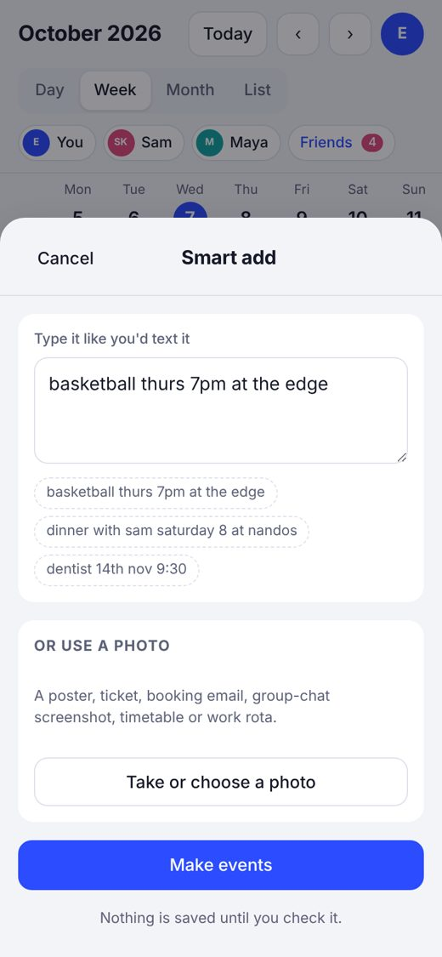  Typing a sentence | 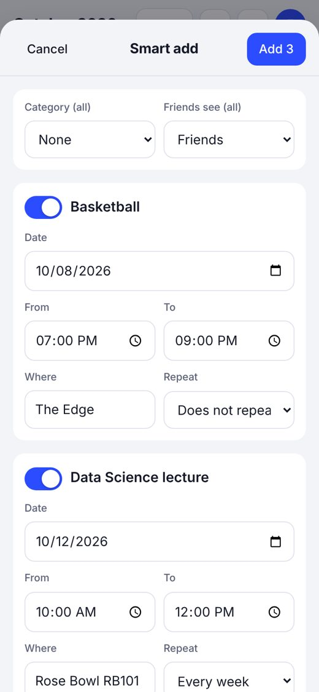  Review before saving | 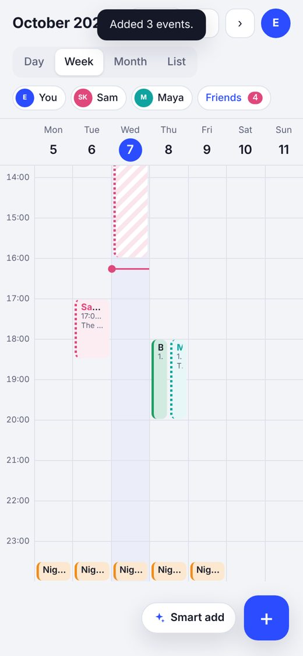  Saved to the calendar

My role
- Chose Gemini's free tier after comparing costs, created the API key in Google AI Studio and added it as the GEMINI_API_KEY secret in Supabase.
- Tested it live with real sentences and screenshots.

Problems and fixes
Problem | Fix
On a phone, the date and time boxes on the review cards were wider than the screen | Put the date on its own row and the times in a two-column row; inputs can now shrink
After pushing, Smart add didn't appear on my phone | The installed app was still showing its cached version; it updated after a short wait and a refresh
My Gemini key didn't start with "AIza" as expected | Newer Google keys use a different format; it worked as soon as it was saved

3.7 Version control and deployment
Commit | Contents
7c2897c | Klander v0.1: accounts, calendar views, events, recurring, categories, PWA
5d3bce3 | Add friends: requests, invite links, friends' week overlay, privacy
4a37ce7 | Calendar links import, Klander subscribe feed, live updates, friends activity feed
56bb07c | Smart add: type or photo to events with Gemini
Each git push triggers a new Vercel build. Database changes were applied as named migrations, and the full schema is in Appendix A.

4. Testing
Testing happened at four levels: database security, logic (unit tests), live server functions, and the user interface. Section 4.6 covers my own real-world testing. Every result below is the actual output recorded when the test was run.

4.1 Database security tests
These tests run inside the database while pretending to be a particular signed-in user, or a logged-out visitor. Test users are created inside the test and everything is rolled back at the end, so the live database is untouched.

Phase 2: your own data
# | Test | Expected | Actual | Result
S1 | User inserts their own repeating event | Allowed | 1 event saved | Pass
S2 | New user gets default categories on sign-up | 5 categories | 5 categories | Pass
S3 | A different user tries to read the first user's events | 0 rows | 0 rows | Pass
S4 | A different user tries to read their categories | 0 rows | 0 rows | Pass
S5 | A different user tries to rename their profile | 0 rows changed | 0 rows changed | Pass
S6 | A different user tries to delete their events | 0 rows deleted | 0 rows deleted | Pass
S7 | Logged-out visitor reads events / profiles | 0 / 0 | 0 / 0 | Pass
S8 | Supabase security advisor | No warnings | No warnings | Pass

Phase 4: friends and privacy (Alice, Bob, Carl)
Bob has three events: Gym (Friends, location "The Edge", with a private note), Doctor (Busy only) and Diary (Private).
# | Test | Expected | Actual | Result
F1 | Alice views Bob's events before they are friends | 0 | 0 | Pass
F2 | Alice sends a request to bob_t | sent | sent | Pass
F3 | Alice sends the same request again | already_sent | already_sent | Pass
F4 | Alice requests a username that doesn't exist | not_found | not_found | Pass
F5 | Alice requests herself | self | self | Pass
F6 | Alice tries to accept her own request | 0 rows | 0 rows | Pass
F7 | Alice tries to insert an accepted friendship directly | Blocked | Blocked | Pass
F8 | Alice views Bob's events while the request is pending | 0 | 0 | Pass
F9 | Bob accepts | 1 row | 1 row | Pass
F10 | Alice now views Bob's events | Busy (no location), Gym/The Edge; no Diary | Busy/-, Gym/The Edge | Pass
F11 | Alice reads Bob's events table directly | 0 | 0 | Pass
F12 | Alice reads anyone's invite codes | 0 | 0 | Pass
F13 | Carl uses a fake invite code | invalid | invalid | Pass
F14 | Carl uses Bob's real invite code | friends with bob_t; sees 2 events | bob_t; 2 events | Pass
F15 | Carl sees only his own friendships | 1 | 1 | Pass
F16 | Logged-out visitor calls friend_events | Blocked | Blocked | Pass

Activity feed and calendar links
# | Test | Expected | Actual | Result
A1 | Bob adds Gym (Friends), Doctor (Busy), Diary (Private), then makes Gym private and Diary public | added Gym, added (no title), removed, added Diary | added:Gym, added:-, removed:-, added:Diary | Pass
A2 | Bob tries to write a fake activity row as Alice | Blocked | Blocked | Pass
A3 | Bob adds a calendar link to Alice's account | Blocked | Blocked | Pass
A4 | Alice reads others' calendar links / feed tokens | 0 / 0 | 0 / 0 | Pass
A5 | A stranger reads activity | 0 | 0 | Pass
A6 | A user calls the cron-secret check or reads private secrets | Blocked | Blocked | Pass

4.2 Unit tests: logic

Repeating events across the clock change
Weekday night shift 23:30–08:30 from Monday 19 October 2026, repeating until 30 October, with Wednesday 21 October skipped. The clocks go back on Sunday 25 October.
# | Test | Expected | Actual | Result
R1 | Occurrences before the clock change | 23:30 → 08:30 | Mon 19, Tue 20, Thu 22, Fri 23 at 23:30 | Pass
R2 | Occurrences after the clock change | Still 23:30 | Mon 26 – Fri 30 at 23:30 | Pass
R3 | Skipped date | Wed 21 missing | Wed 21 missing | Pass
R4 | No weekend occurrences | Sat/Sun absent | Absent | Pass
R5 | Repeat rule round-trip | weekdays until 2026-10-30 | preset weekdays, until 2026-10-30 | Pass
R6 | Overlap layout: shift tail (00:00–08:30) and 07:00–09:00 event | Side by side, 2 columns | col 0 and col 1 of 2 | Pass

Calendar file (.ics) parser
# | Input | Expected | Actual | Result
I1 | Weekly lecture 10:00 Europe/London in October | 09:00 UTC (BST) | 09:00 UTC | Pass
I2 | EXDATE 26 Oct 10:00 (after clock change) | 10:00 UTC skipped | 10:00 UTC in exdates | Pass
I3 | Moved occurrence (RECURRENCE-ID) | Own event + original skipped | Separate row + exdate added | Pass
I4 | All-day reading week 2–6 Nov | All-day, ends 7 Nov | all_day true, ends 7 Nov | Pass
I5 | Outlook "GMT Standard Time" 15:00 | 15:00 London | 15:00 UTC (GMT) | Pass
I6 | UTC time 09:00Z | 09:00 UTC | 09:00 UTC | Pass
I7 | Event from 2020 | Ignored (too old) | Not imported | Pass
I8 | STATUS:CANCELLED | Ignored | Not imported | Pass
I9 | Escaped comma in title | "Intro to Data Science, Lecture" | Correct | Pass
I10 | Klander feed → parse again (round trip) | Same times, rule and skip | Identical | Pass
I11 | Long title in feed | Folded at 75 bytes | Folded correctly | Pass

Smart add: AI draft to event
# | Draft from AI | Expected event | Actual | Result
M1 | Basketball 8 Oct 19:00, no end | 19:00–20:00 (1 hour default) | 18:00Z–19:00Z (BST) | Pass
M2 | Night shift 23:30–08:30, weekdays | Ends next day; Mon–Fri rule | Ends 13 Oct; BYDAY=MO..FR | Pass
M3 | Lecture weekly Mon & Thu until 11 Dec | Two days a week | Mon 12, Thu 15, Mon 19, Thu 22… | Pass
M4 | Reading week 2–6 Nov, all day | All-day to 7 Nov | Correct | Pass

4.3 Live server tests
These ran against the real deployed functions, triggered from inside the database with pg_net, using a test account.
# | Test | Expected | Actual | Result
L1 | Scheduled sync of the gov.uk UK bank holidays calendar | Imports holidays with correct dates | 200 OK: 12 events, e.g. Summer bank holiday 31 Aug (23:00Z on the 30th) | Pass
L2 | Subscribe feed with a valid token | Valid .ics with London time zone; only Klander-made events | 200 OK; night shift at 23:30 London; no bank holidays | Pass
L3 | Subscribe feed with a wrong token | Not found | 404 Not found | Pass
L4 | Smart add with real sentences after adding the key | Correct drafts | Worked (my own testing) | Pass

4.4 Automated interface tests
A headless Chromium browser at iPhone size (390 × 844, UK time zone) clicked through the app against a simulated backend and saved a screenshot of each step. The screenshots in Section 3 come from these runs.
# | Journey | Expected | Result
U1 | Sign in → first-time setup → calendar | Reaches the week view | Pass
U2 | Create weekday night shift and a weekly event | Both appear, overnight across days | Pass
U3 | Switch Day / Week / Month / List | Same events in every view | Pass
U4 | Delete one repeat | Asks "only this one or every repeat" | Pass
U5 | Dark mode | All text readable | Pass
U6 | Open app from an invite link | Invite notice on sign-in; "You're now friends" after | Pass
U7 | Friends' events, busy block, hide a friend | Coloured, striped, hidden when toggled | Pass
U8 | Add calendar link → import → open imported event | Count shown; event is read-only | Pass
U9 | Get subscribe link | Apple, Google and Outlook buttons | Pass
U10 | Smart add sentence → review → save | 3 drafts, low-confidence one flagged, saved | Pass
U11 | No sideways scrolling at 390 px | Page width 390 | Pass (after layout fix)
U12 | No JavaScript errors in any journey | None | Pass

4.5 Bugs found by testing
Found by | Bug | Status
UI test | Week view event text centred vertically | Fixed
UI test | Visibility buttons wrapping | Fixed
UI test | Overnight shift label confusing on its second day | Fixed
UI test | Smart add review cards wider than the phone | Fixed
Unit test | Repeat end date shifted by time-zone conversion | Fixed
Me | Google sign-in redirect_uri_mismatch | Fixed (configuration)
Me | Smart add not showing after deploy | Cache; resolved itself

4.6 My real-world testing
- Ran the app locally, then live on klander.vercel.app on my Mac and iPhone.
- Created my real account, signed in with Google, and added my night shift and other events.
- Created a second account in a private window to act as a friend, checked that live updates, busy blocks and private events behaved correctly, and confirmed that "everything seems to be working fine" before inviting anyone.
- Tested Smart add with real sentences once the Gemini key was set.
Limitation: the automated tests couldn't connect to the live Supabase API from the build environment, so UI tests used a simulated backend. To cover the gap, security was tested inside the real database, the server functions were tested live through pg_net, and I tested the real app end to end myself.

5. Evaluation

5.1 Against the objectives
# | Objective | Evidence | Outcome
1 | Own accounts (email / Google), username, colour | U1; my live sign-up and Google sign-in; unique citext usernames | Met
2 | Day, week, month, list; create / edit / delete | U2–U3; screenshots in 3.3 | Met
3 | Repeats incl. overnight, correct after clock change | R1–R5; M2 | Met
4 | Delete one occurrence or the series | R3; U4 | Met
5 | Categories and per-event visibility | Editor, settings, S1–S8, F10 | Met
6 | Free iPhone install, offline viewing | PWA installs from Safari; cached data shows offline | Met (read-only offline)
7 | Friends by username or invite link; overlay | F2–F15; U6–U7; tested with a second account | Met
8 | Privacy enforced by the database | F1, F8, F10–F12, F16, A1–A6 | Met
9 | Live updates and activity feed | A1; Realtime tested between two accounts | Met
10 | Import links that refresh; publish a subscribe link | I1–I11; L1–L3; cron every 3 h | Met
11 | Text / photo / screenshot to reviewable events | M1–M4; U10; my live testing | Met
12 | £0 per month | All free tiers (see 5.3) | Met

5.2 What went well
- Privacy is enforced in the database. Even with direct API access, nobody can see more than they're allowed to, and I have test evidence for every rule.
- It fits into the calendars people already use. It reads uni, Google, Outlook and iCloud links and publishes its own, so my mum can see my plans in Apple Calendar without installing anything.
- Night shifts and the clock change work correctly. These are easy to get wrong, and both are covered by tests.
- Smart add is genuinely faster than typing, and the review step means a wrong guess never ends up saved.
- It cost nothing to build or run.

5.3 Limitations
Limitation | Impact | Plan
Offline is read-only | Can't add events with no signal | Queue changes offline and sync later
Calendar links are one-way in each direction | Editing an Apple event in Klander isn't possible | Optional two-way iCloud sync (phase 10)
No notifications yet | You have to open the app to see friends' changes | Phase 10 web push
Gemini free tier | Data may be used to improve Google's models | Switch to the paid tier (~35p/month) before strangers use it
Supabase free projects pause after a week idle | App unavailable until restored | Daily use keeps it awake; Pro plan if it grows
UI tests used a simulated backend | Less end-to-end coverage | Add a test Supabase project for full end-to-end tests

5.4 Cost and environmental impact
Running costs are £0 a month: Supabase free tier, Vercel Hobby, and the Gemini free tier with a limit of 30 requests per person per day.
I estimated the carbon footprint (all figures approximate): roughly 0.2–1.2 kg CO₂e to build it, mostly the AI assistance and my own devices, and 1.5–5 kg CO₂e a year to run it for my friend group. That's similar to driving a petrol car 10–30 km a year. Photos (phase 9) would be the biggest future increase, so the plan compresses them on the phone.

5.5 What I learned
- How a real full-stack app fits together: front end, authentication, a relational database, serverless functions, scheduling and deployment.
- Why security belongs in the database (Row Level Security) rather than in the app, and how to test it by pretending to be different users.
- How messy real-world data is: time zones, clock changes, Outlook's time-zone names, cancelled and moved events in calendar files.
- How to configure OAuth sign-in, environment variables and API secrets safely.
- How to direct an AI coding assistant effectively: describe the goal clearly, make the decisions myself, check its work and test thoroughly.

6. Future development
Phases 6–12 are fully designed in my interactive roadmap. Here is a summary.
Phase | Main features
6. Themes & birthdays (next) | Automatic birthdays for you and friends (year optional and never shown), reminders, birthday mode and "plan the birthday"; eight preset themes, theme builder, contrast guard, theme from a photo (on-device colour extraction), AI "vibe" themes, time-of-day themes, shareable theme codes, accessibility options
7. Friends & plans | Free-time finder with overlap heatmap and "suggest a time", "Up for something" free broadcasts, free-now status, who's free tonight, side-by-side view, friend profile cards, close friends privacy level, invites and RSVPs, surprise plans, groups, polls, countdowns, catch-up nudges
8. Chat | Direct messages, group chats, event threads, share events/free slots/polls into chat, "make this an event" with smart add, photos, reactions, block and report
9. Memories & My Week | Photos on events, shared albums, an automatic weekly "My Week" story from photos and calendar, friends' weeks, export as image/video, "On this day"
10. Notifications & sync | Lock-screen push for friend events (batched), friends being free or looking for a time, invites, reminders; notification inbox; quiet hours that follow sleep after night shifts; family calendar link; optional two-way Apple sync
11. Insights | Klander Wrapped, streaks, hangout stats, Training Hub link
12. Launch & portfolio | Privacy page, "download my data" and "delete my account" (UK GDPR), landing page, demo mode, quality pass, paid AI

Appendix A: Database schema
The live schema, consolidated from the migrations applied to the klander Supabase project. It is also saved in the repository as supabase/schema.sql.
-- Klander database schema (Supabase / Postgres 17)
-- Consolidated from the migrations applied to project `klander` (davompbqkwiiiecfuthx), October 2026.
-- Every table has Row Level Security (RLS) switched on.

create extension if not exists citext with schema extensions;
create extension if not exists pg_net;
create extension if not exists pg_cron;

---------------------------------------------------------------------------
-- PROFILES: one row per user, created automatically on sign-up
---------------------------------------------------------------------------
create table public.profiles (
id uuid primary key references auth.users(id) on delete cascade,
username extensions.citext unique check (username ~ '^[a-zA-Z0-9_]{3,20}$'),
display_name text check (char_length(display_name) <= 50),
avatar_url text,
colour text not null default '#2b4cff' check (colour ~ '^#[0-9a-fA-F]{6}$'),
timezone text not null default 'Europe/London',
theme text not null default 'system' check (theme in ('system','light','dark')),
created_at timestamptz not null default now(),
updated_at timestamptz not null default now()
);
alter table public.profiles enable row level security;
create policy "Signed-in users can view profiles" on public.profiles for select to authenticated using (true);
create policy "Users update own profile" on public.profiles for update to authenticated
using ((select auth.uid()) = id) with check ((select auth.uid()) = id);

---------------------------------------------------------------------------
-- CATEGORIES: Work, Uni, Sport, Social, Personal (editable)
---------------------------------------------------------------------------
create table public.categories (
id uuid primary key default gen_random_uuid(),
user_id uuid not null references public.profiles(id) on delete cascade,
name text not null check (char_length(name) between 1 and 30),
colour text not null check (colour ~ '^#[0-9a-fA-F]{6}$'),
sort int not null default 0,
created_at timestamptz not null default now()
);
alter table public.categories enable row level security;
create policy "Users manage own categories" on public.categories for all to authenticated
using ((select auth.uid()) = user_id) with check ((select auth.uid()) = user_id);

---------------------------------------------------------------------------
-- CALENDAR SOURCES: linked .ics / webcal calendars (uni timetable etc.)
---------------------------------------------------------------------------
create table public.calendar_sources (
id uuid primary key default gen_random_uuid(),
user_id uuid not null references public.profiles(id) on delete cascade,
name text not null check (char_length(name) between 1 and 60),
url text not null check (url ~* '^(https?|webcal)://'),
category_id uuid references public.categories(id) on delete set null,
visibility text not null default 'busy' check (visibility in ('friends','busy','private')),
last_synced_at timestamptz,
last_error text,
event_count int not null default 0,
created_at timestamptz not null default now()
);
alter table public.calendar_sources enable row level security;
create policy "Users manage own calendar sources" on public.calendar_sources for all to authenticated
using ((select auth.uid()) = user_id) with check ((select auth.uid()) = user_id);

---------------------------------------------------------------------------
-- EVENTS
---------------------------------------------------------------------------
create table public.events (
id uuid primary key default gen_random_uuid(),
owner_id uuid not null references public.profiles(id) on delete cascade,
title text not null check (char_length(title) between 1 and 300),
notes text check (char_length(notes) <= 2000),
location text check (char_length(location) <= 200),
starts_at timestamptz not null,
ends_at timestamptz not null,
all_day boolean not null default false,
category_id uuid references public.categories(id) on delete set null,
visibility text not null default 'friends' check (visibility in ('friends','busy','private')),
rrule text, -- repeat rule, e.g. FREQ=WEEKLY;BYDAY=MO,TU,WE,TH,FR
exdates timestamptz[] not null default '{}', -- skipped occurrences
source text not null default 'manual' check (source in ('manual','text','photo','import')),
source_id uuid references public.calendar_sources(id) on delete cascade,
external_uid text, -- UID from the imported .ics
created_at timestamptz not null default now(),
updated_at timestamptz not null default now(),
check (ends_at >= starts_at),
constraint events_source_uid_key unique (source_id, external_uid)
);
create index events_owner_start_idx on public.events(owner_id, starts_at);
alter table public.events enable row level security;
create policy "Users manage own events" on public.events for all to authenticated
using ((select auth.uid()) = owner_id) with check ((select auth.uid()) = owner_id);

---------------------------------------------------------------------------
-- FRIENDS
---------------------------------------------------------------------------
create table public.friendships (
id uuid primary key default gen_random_uuid(),
requester uuid not null references public.profiles(id) on delete cascade,
addressee uuid not null references public.profiles(id) on delete cascade,
status text not null default 'pending' check (status in ('pending','accepted')),
created_at timestamptz not null default now(),
check (requester <> addressee)
);
create unique index friendships_pair_idx on public.friendships (least(requester, addressee), greatest(requester, addressee));
alter table public.friendships enable row level security;
create policy "See own friendships" on public.friendships for select to authenticated using ((select auth.uid()) in (requester, addressee));
create policy "Accept requests sent to you" on public.friendships for update to authenticated
using ((select auth.uid()) = addressee) with check ((select auth.uid()) = addressee and status = 'accepted');
create policy "Remove own friendships" on public.friendships for delete to authenticated using ((select auth.uid()) in (requester, addressee));
revoke insert, update on public.friendships from authenticated, anon;
grant update (status) on public.friendships to authenticated; -- only the status column

create table public.invite_codes (
code text primary key default encode(extensions.gen_random_bytes(9), 'hex'),
user_id uuid not null unique references public.profiles(id) on delete cascade,
created_at timestamptz not null default now()
);
alter table public.invite_codes enable row level security;
create policy "See own invite code" on public.invite_codes for select to authenticated using ((select auth.uid()) = user_id);

create table public.feed_tokens (
user_id uuid primary key references public.profiles(id) on delete cascade,
token text not null unique default encode(extensions.gen_random_bytes(18), 'hex'),
created_at timestamptz not null default now()
);
alter table public.feed_tokens enable row level security;
create policy "See own feed token" on public.feed_tokens for select to authenticated using ((select auth.uid()) = user_id);

create table public.activity (
id bigint generated always as identity primary key,
actor uuid not null references public.profiles(id) on delete cascade,
verb text not null check (verb in ('added','changed','removed','synced')),
title text,
starts_at timestamptz,
created_at timestamptz not null default now()
);
alter table public.activity enable row level security;
create policy "Friends see activity" on public.activity for select to authenticated using (public.is_friend(actor));

create table public.ai_usage (
id bigint generated always as identity primary key,
user_id uuid not null references public.profiles(id) on delete cascade,
kind text not null check (kind in ('text','photo')),
ok boolean not null default true,
created_at timestamptz not null default now()
);
alter table public.ai_usage enable row level security;
create policy "See own AI usage" on public.ai_usage for select to authenticated using ((select auth.uid()) = user_id);

---------------------------------------------------------------------------
-- FUNCTIONS (security definer = run with owner rights, each checks auth.uid())
---------------------------------------------------------------------------
create function public.is_friend(other uuid) returns boolean language sql stable security definer set search_path = '' as $$
select exists (select 1 from public.friendships f where f.status = 'accepted'
and ((f.requester = (select auth.uid()) and f.addressee = other) or (f.addressee = (select auth.uid()) and f.requester = other)));
$$;

-- Friends' events with privacy applied: private never returned, busy shows only "Busy", notes never shared
create function public.friend_events()
returns table (id uuid, owner_id uuid, title text, location text, starts_at timestamptz, ends_at timestamptz,
all_day boolean, visibility text, rrule text, exdates timestamptz[])
language sql stable security definer set search_path = '' as $$
select e.id, e.owner_id,
case when e.visibility = 'busy' then 'Busy' else e.title end,
case when e.visibility = 'busy' then null else e.location end,
e.starts_at, e.ends_at, e.all_day, e.visibility, e.rrule, e.exdates
from public.events e
join public.friendships f on f.status = 'accepted'
and ((f.requester = (select auth.uid()) and f.addressee = e.owner_id)
or (f.addressee = (select auth.uid()) and f.requester = e.owner_id))
where e.visibility <> 'private';
$$;

-- Also defined (see repo migrations for full bodies):
-- send_friend_request(username) -> 'sent' | 'accepted' | 'already_sent' | 'already_friends' | 'not_found' | 'self'
-- my_invite_code() -> creates/returns your invite code
-- accept_invite(code) -> instantly friends with the code's owner
-- my_feed_token(reset bool) -> creates/returns (or resets) your subscribe link token
-- handle_new_user() trigger on auth.users: creates profile + 5 default categories
-- log_event_activity() trigger on events: writes privacy-safe rows to activity (skips imported events)
-- touch_updated_at() trigger on profiles/events
-- check_cron_secret(s) (service_role only) + private.app_secrets for the scheduled sync

---------------------------------------------------------------------------
-- STORAGE + REALTIME + SCHEDULE
---------------------------------------------------------------------------
-- avatars bucket: public read; users can only write inside a folder named after their own id
-- alter publication supabase_realtime add table public.activity, public.friendships;
-- select cron.schedule('klander-calendar-refresh', '7 */3 * * *', 'select private.run_calendar_refresh()');

Appendix B: Key code excerpts

B1. Expanding repeating events (src/lib/dates.js)
Uses "floating time" so repeats stay at the same local time across clock changes.
const toFloating = d => new Date(Date.UTC(d.getFullYear(), d.getMonth(), d.getDate(), d.getHours(), d.getMinutes(), d.getSeconds()))
const fromFloating = d => new Date(d.getUTCFullYear(), d.getUTCMonth(), d.getUTCDate(), d.getUTCHours(), d.getUTCMinutes(), d.getUTCSeconds())

/** Expand stored events into concrete occurrences overlapping [from, to). */
export function expandEvents(events, from, to) {
const out = []
for (const ev of events) {
const start = new Date(ev.starts_at)
const end = new Date(ev.ends_at)
const durMin = differenceInMinutes(end, start)
if (!ev.rrule) {
if (start < to && end > from) out.push({ ...ev, start, end, key: ev.id })
continue
}
let opts
try { opts = RRule.parseString(ev.rrule) } catch { continue }
// UNTIL is written as local wall-clock time with a Z suffix (see buildRRule), so it is already "floating".
const rule = new RRule({ ...opts, dtstart: toFloating(start) })
const ex = new Set((ev.exdates || []).map(x => new Date(x).getTime()))
const occ = rule.between(toFloating(addMinutes(from, -durMin)), toFloating(to), true)
for (const f of occ) {
const s = fromFloating(f)
if (ex.has(s.getTime())) continue
const e = addMinutes(s, durMin)
if (s < to && e > from) out.push({ ...ev, start: s, end: e, key: `${ev.id}:${s.getTime()}`, occurrence: s })
}
}
return out.sort((a, b) => a.start - b.start || b.end - a.end)
}

B2. Overlap layout (src/lib/dates.js)
/** Lay out timed events for one day column: returns [{ev, top, height, left, width}] in % / minutes. */
export function layoutDay(occurrences, day) {
const dayStart = startOfDay(day)
const dayEnd = addDays(dayStart, 1)
const items = occurrences
.filter(o => !o.all_day && o.start < dayEnd && o.end > dayStart)
.map(o => {
const s = o.start < dayStart ? dayStart : o.start
const e = o.end > dayEnd ? dayEnd : o.end
const top = differenceInMinutes(s, dayStart)
return { ev: o, top, bottom: Math.max(top + 20, differenceInMinutes(e, dayStart)) }
})
.sort((a, b) => a.top - b.top || b.bottom - a.bottom)

// cluster overlapping events, then assign columns greedily inside each cluster
const result = []
let cluster = [], clusterEnd = -1
const flush = () => {
const cols = []
for (const it of cluster) {
let c = cols.findIndex(end => end <= it.top)
if (c === -1) { c = cols.length; cols.push(0) }
cols[c] = it.bottom
it.col = c
}
for (const it of cluster) result.push({ ...it, cols: cols.length })
cluster = []
}
for (const it of items) {
if (it.top >= clusterEnd && cluster.length) flush()
cluster.push(it)
clusterEnd = Math.max(clusterEnd, it.bottom)
}
if (cluster.length) flush()
return result
}

B3. Friends' events with privacy applied (database function)
-- Friends' events with privacy applied: private never returned, busy shows only "Busy", notes never shared
create function public.friend_events()
returns table (id uuid, owner_id uuid, title text, location text, starts_at timestamptz, ends_at timestamptz,
all_day boolean, visibility text, rrule text, exdates timestamptz[])
language sql stable security definer set search_path = '' as $$
select e.id, e.owner_id,
case when e.visibility = 'busy' then 'Busy' else e.title end,
case when e.visibility = 'busy' then null else e.location end,
e.starts_at, e.ends_at, e.all_day, e.visibility, e.rrule, e.exdates
from public.events e
join public.friendships f on f.status = 'accepted'
and ((f.requester = (select auth.uid()) and f.addressee = e.owner_id)
or (f.addressee = (select auth.uid()) and f.requester = e.owner_id))
where e.visibility <> 'private';
$$;

B4. Activity trigger (database)
Writes a privacy-safe activity row whenever an event changes. Imported events are skipped so a timetable sync doesn't flood the feed.
create function public.log_event_activity() returns trigger
language plpgsql security definer set search_path = '' as $$
declare v_old text; v_new text;
begin
if coalesce(new.source_id, old.source_id) is not null then return null; end if;
v_old := case when tg_op in ('UPDATE','DELETE') then old.visibility end;
v_new := case when tg_op in ('INSERT','UPDATE') then new.visibility end;
if tg_op = 'INSERT' then
if v_new = 'private' then return null; end if;
insert into public.activity(actor, verb, title, starts_at)
values (new.owner_id, 'added', case when v_new = 'busy' then null else new.title end, new.starts_at);
elsif tg_op = 'UPDATE' then
if v_old = 'private' and v_new = 'private' then return null; end if;
if v_new = 'private' then
insert into public.activity(actor, verb) values (new.owner_id, 'removed');
else
insert into public.activity(actor, verb, title, starts_at)
values (new.owner_id, case when v_old = 'private' then 'added' else 'changed' end,
case when v_new = 'busy' then null else new.title end, new.starts_at);
end if;
else
if v_old = 'private' then return null; end if;
insert into public.activity(actor, verb) values (old.owner_id, 'removed');
end if;
return null;
end; $$;

B5. Live updates (src/lib/friends.js)
// Live updates: friends' changes and friend requests arrive straight away
useEffect(() => {
let timer = null
const soon = () => { clearTimeout(timer); timer = setTimeout(refresh, 400) }
const channel = supabase.channel(`klander-live-${uid}`)
.on('postgres_changes', { event: 'INSERT', schema: 'public', table: 'activity' }, soon)
.on('postgres_changes', { event: '*', schema: 'public', table: 'friendships' }, soon)
.subscribe()
return () => { clearTimeout(timer); supabase.removeChannel(channel) }
}, [uid, refresh])

B6. Reading calendar time zones (supabase/functions/_shared/ics.js)
/** ical.js Time -> { date: Date, allDay: boolean } */
function timeToInstant(ICAL, t, tz) {
if (t.isDate) return { date: zonedToUtc(t.year, t.month, t.day, 0, 0, 0, tz), allDay: true }
const zone = t.zone
const known = zone && (zone === ICAL.Timezone.utcTimezone || (zone.tzid && zone.tzid !== 'floating' && zone.component))
if (known) return { date: t.toJSDate(), allDay: false }
// Floating time, or a TZID the file didn't define (common with Outlook): try it as an IANA zone, else the user's zone
const tzid = zone?.tzid && zone.tzid !== 'floating' ? zone.tzid : null
let useTz = tz
if (tzid) { try { new Intl.DateTimeFormat('en-GB', { timeZone: tzid }); useTz = tzid } catch { /* not IANA */ } }
return { date: zonedToUtc(t.year, t.month, t.day, t.hour, t.minute, t.second, useTz), allDay: false }
}

B7. Smart add prompt rules (supabase/functions/smart-add)
function instructions(now: string, tz: string) {
return `You turn messages, posters, screenshots, tickets, timetables and rotas into calendar events for a UK user.
Right now it is ${now} (time zone ${tz}). Dates are UK style (day before month).
Rules:
- Resolve relative dates ("thurs", "tomorrow", "next week Friday") to the next matching date on or after today.
- Times: 24-hour HH:MM. "7" or "7pm" for an evening activity is 19:00. If no end time, leave end_time null.
- If there is no time at all, set all_day true and start_time null.
- A timetable or rota: one event per distinct class/shift. If it is a weekly timetable, use repeat "weekly" with repeat_days set, and the date of its next occurrence. Shifts that end after midnight need end_date set to the next day.
- Group chats: only make events for plans that are actually proposed or agreed, not past ones.
- Titles: short and natural, no emoji, no dates in the title.
- Never invent details that are not shown. If nothing looks like an event, return an empty list and explain in "message".`
}

B8. Turning an AI draft into an event (src/lib/smart.js)
/** AI draft -> the shape saveEvent() expects. */
export function draftToEvent(d, { category_id = null, visibility = 'friends' } = {}) {
let s, e
if (d.all_day) {
s = startOfDay(at(d.date))
e = addDays(startOfDay(at(d.end_date && d.end_date >= d.date ? d.end_date : d.date)), 1)
} else {
s = at(d.date, d.start_time)
if (d.end_time) {
e = at(d.end_date || d.date, d.end_time)
if (e <= s) e = addDays(e, 1) // e.g. 23:30 -> 08:30 night shift
} else e = addMinutes(s, 60)
}
let rrule = null
if (d.repeat === 'weekly' && d.repeat_days?.length) {
rrule = `FREQ=WEEKLY;BYDAY=${d.repeat_days.join(',')}`
if (d.repeat_until) rrule += `;UNTIL=${d.repeat_until.replace(/-/g, '')}T235959Z`
} else if (d.repeat && d.repeat !== 'none') {
rrule = buildRRule(d.repeat, s, d.repeat_until || null)
}
return {
title: d.title, all_day: !!d.all_day, starts_at: s.toISOString(), ends_at: e.toISOString(),
location: d.location || '', notes: d.notes || '', rrule, exdates: [], category_id, visibility
}
}

Appendix C: Glossary
Term | Meaning
PWA | Progressive Web App: a website that can be installed to the Home Screen and work offline
Supabase | A hosted backend: Postgres database, authentication, storage, realtime and serverless functions
RLS | Row Level Security: database rules deciding which rows each user can read or change
SECURITY DEFINER | A database function that runs with its owner's rights; used carefully to return filtered data
Edge Function | Server-side code (TypeScript on Deno) that runs on Supabase, used for anything needing secrets
JWT | JSON Web Token: the signed token that proves who you are on each request
OAuth | The standard behind "Continue with Google"
.ics / iCalendar | The standard calendar file format used by Apple, Google and Outlook; webcal:// is a link to one
RRULE | A repeat rule in iCalendar format, e.g. FREQ=WEEKLY;BYDAY=MO,TH
EXDATE | A skipped date in a repeating event
pg_cron / pg_net | Postgres extensions for scheduled jobs and making web requests from the database
Realtime | Supabase's service that pushes database changes to open apps
Gemini | Google's AI model, used to read text and photos for smart add
BST / GMT | British Summer Time (UTC+1) and Greenwich Mean Time (UTC+0); clocks change in March and October

