MIT 8103 – ADVANCED DATABASE SYSTEMS

CASE STUDY: KART DIRECT COURIER E-COMMERCE AND DELIVERY MANAGEMENT SYSTEM

PORTFOLIO 3: TRANSACTIONS AND CONCURRENCY

STUDENT NAME: EJEREJE ERERE OYIBO

STUDENT ID: 301908132

SUBMISSION DATE: 6TH NOV, 2026

PORTFOLIO 3: TRANSACTIONS AND CONCURRENCY
Course: MIT 8103 – Advanced Database Systems
Case Study: Kart Direct Courier E-Commerce and Delivery Management System
Database Management System: PostgreSQL

1. Introduction
This portfolio demonstrates the use of transaction management and concurrency control in the Kart Direct Courier database. The practical exercises were carried out using PostgreSQL and the orders table.
Transactions help ensure that database changes are handled reliably. A transaction can be committed when an operation is succeeds or rolled back when the operation needs to be cancelled. Concurrency control is also important because multiple users or sessions may access and modify the same data at the same time.
The exercises conducted in this portfolio demonstrate:
- The use of ROLLBACK to cancel a transaction.
- The use of COMMIT to make a transaction permanent.
- The behavior of two database sessions accessing the same record.
- How PostgreSQL’s transaction isolation prevents one session from seeing another session’s uncommitted changes.
2. Database Environment
The practical exercise was conducted using PostgreSQL through pgAdmin Query Tool.
The orders table was used to test transaction behavior. The record selected for the exercise was order number 5.
The initial committed status of order 5 was Pending. The status was first changed to Confirmed and subsequently used for the commit and concurrency tests.
3. Transaction Rollback Test
3.1 Objective
The objective of this test was to demonstrate how a transaction can be cancelled using the ROLLBACK command. This is useful when a database operation has been performed but should not be retained.

3.2 SQL Implementation
BEGIN;
UPDATE orders
SET order_status = 'Confirmed'
WHERE order_id = 5;

SELECT order_id, order_status
FROM orders
WHERE order_id = 5;

ROLLBACK;
SELECT order_id, order_status
FROM orders
WHERE order_id = 5;
3.3 Explanation
The BEGIN command starts a transaction. The UPDATE statement changes the status of order 5 to Confirmed. A SELECT statement checks the updated value within the transaction.
The ROLLBACK command cancels the transaction. The final SELECT statement checks the status after the rollback.
3.4 Result and Observation
Before the rollback, the status of order 5 was displayed as Confirmed. After the rollback, the status returned to Pending.
This confirmed that the update was not permanently saved. The rollback successfully cancelled the transaction and restored the previously committed value.
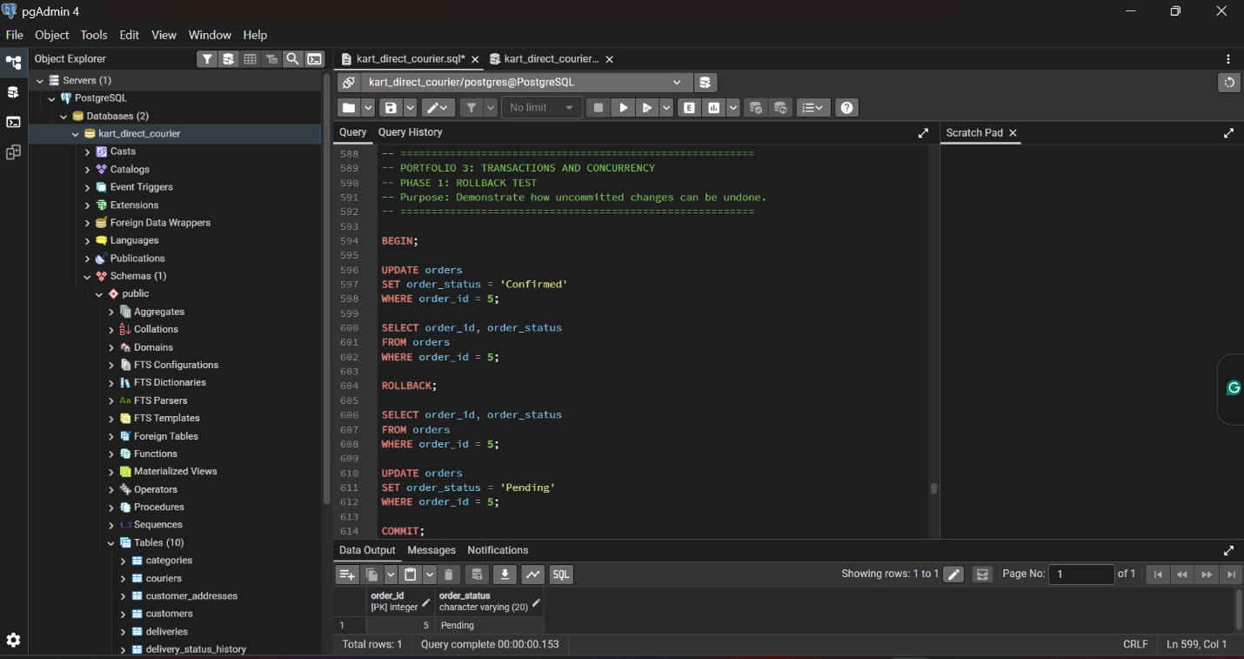Figure 1: Rollback test showing order 5 returning to its previous status, Pending, after the transaction was rolled back.
4. Transaction Commit Test
4.1 Objective
The objective of this test was to demonstrate how the COMMIT command makes a transaction permanent.
4.2 SQL Implementation
BEGIN;
UPDATE orders
SET order_status = 'Confirmed'
WHERE order_id = 5;

SELECT order_id, order_status
FROM orders
WHERE order_id = 5;
COMMIT;
SELECT order_id, order_status
FROM orders
WHERE order_id = 5;

4.3 Explanation
The transaction begins with BEGIN. The order status is updated from Pending to Confirmed. The first SELECT statement verifies the change within the transaction.
The COMMIT command saves the change permanently. The final SELECT statement confirms that the new status remains in the database after the transaction has been committed.
4.4 Result and Observation
The status of order 5 was successfully changed to Confirmed. After the COMMIT command, the record continued to show Confirmed.
This demonstrated that the transaction was successfully committed and the change became permanent.
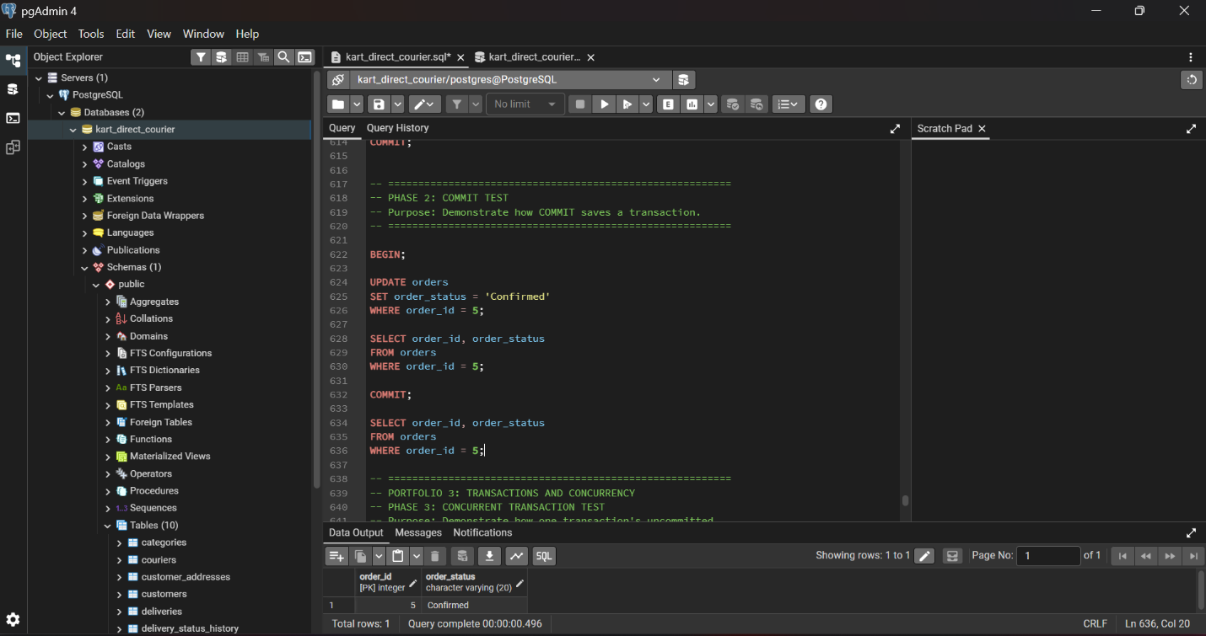
Figure 2: Commit test showing order 5 retaining the status Confirmed after the transaction was committed.
5. Concurrency and Transaction Isolation Test
5.1 Objective
The objective of this test was to examine how PostgreSQL handles concurrent access to the same record from two database sessions.
Two separate pgAdmin Query Tool sessions were used:
- Session A: Performed an update to order 5.
- Session B: Retrieved the same order while Session A’s transaction was still open.
The test was conducted using PostgreSQL’s default READ COMMITTED isolation behavior.
5.2 Session A: Begin Transaction and Update
The following SQL was executed in Session A:
BEGIN;
UPDATE orders
SET order_status = 'Processing'
WHERE order_id = 5;

SELECT order_id, order_status
FROM orders
WHERE order_id = 5;
Session A displayed the order status as Processing. However, the transaction had not yet been committed.
5.3 Session B: Read the Record Before Commit
While Session A’s transaction was still open, the following query was executed in Session B:
SELECT order_id, order_status
FROM orders
WHERE order_id = 5;
Session B displayed the status as Confirmed, even though Session A had already updated the record to Processing.
This occurred because Session A’s update was still uncommitted. Under READ COMMITTED, Session B could not see the uncommitted change and instead read the last committed value.
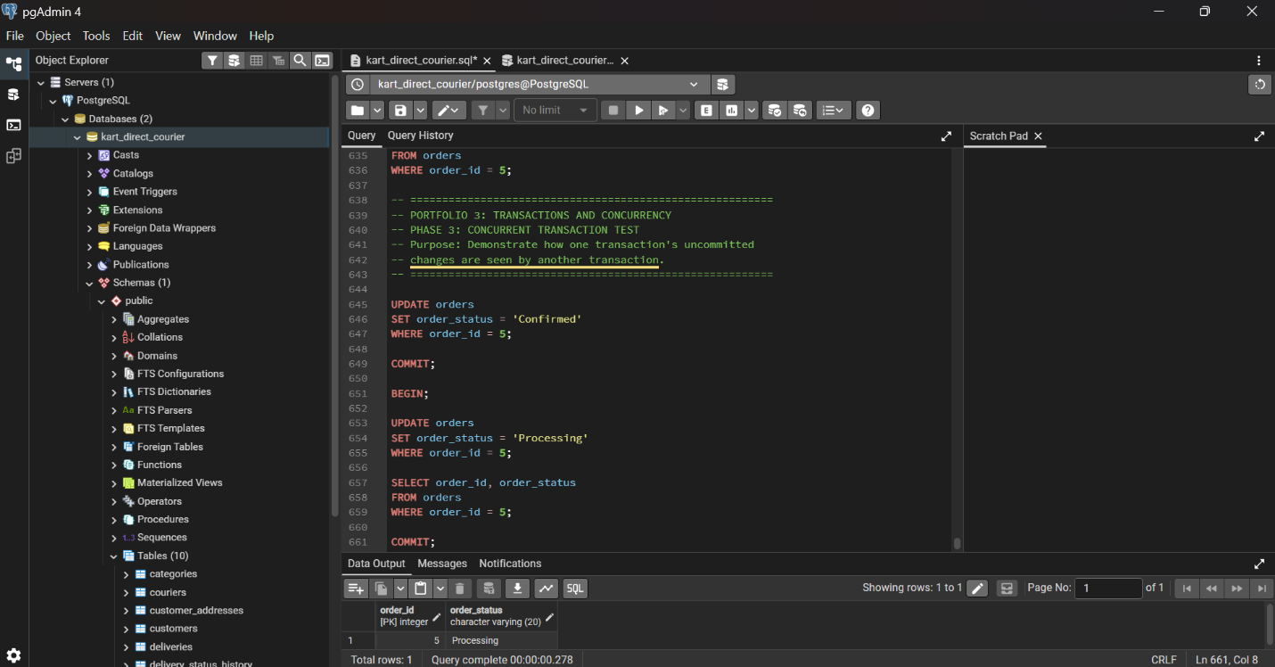
Figure 3: Concurrent read before commit, showing Session A with Processing and Session B with Confirmed while Session A’s transaction remained uncommitted. . (Session A)
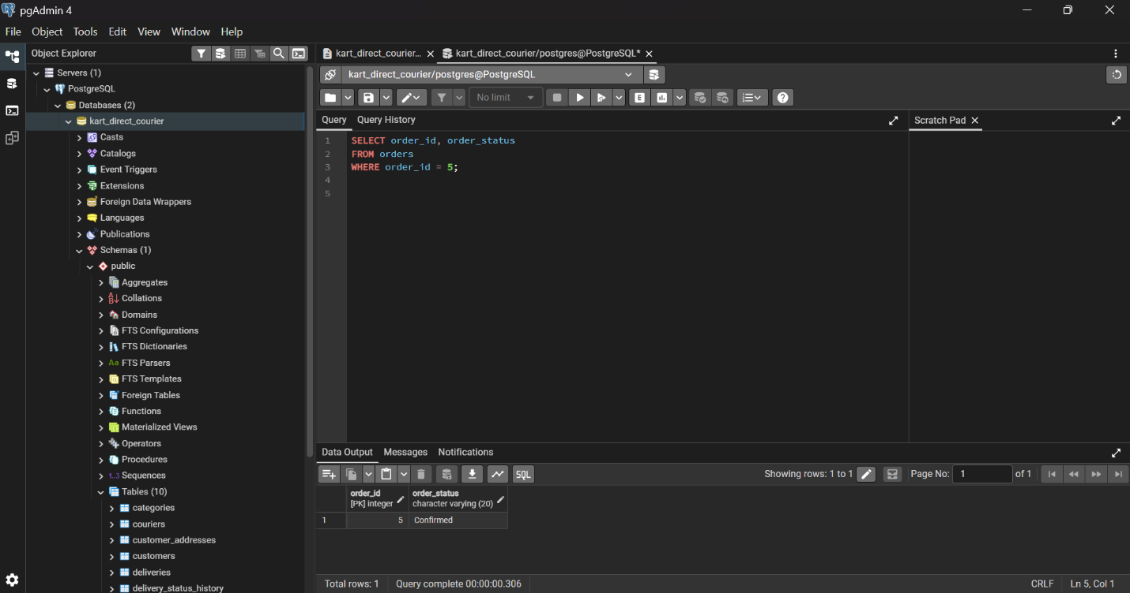
Figure 4: Concurrent read before commit, showing Session A with Processing and Session B with Confirmed while Session A’s transaction remained uncommitted. (Session B)

5.4 Session A: Commit the Transaction
The following command was executed in Session A:
COMMIT;
This committed the update and made the Processing status permanent.
5.5 Session B: Read the Record After Commit
After Session A committed the transaction, the following query was executed again in Session B:
SELECT order_id, order_status
FROM orders
WHERE order_id = 5;
Session B displayed the status as Processing.
This confirmed that the committed change became visible to subsequent queries in Session B.
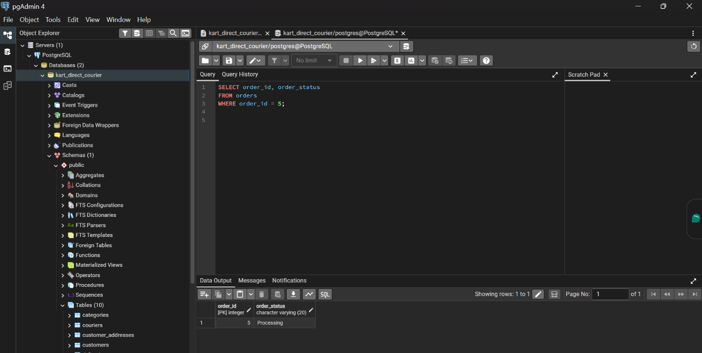
Figure 5: Concurrent read after commit, showing Session B retrieving the updated status Processing after Session A committed the transaction.
6. Discussion of Results
The practical exercises demonstrated the importance of transaction management and isolation in a relational database.
The rollback test showed that a transaction can be cancelled without permanently changing the record. The commit test demonstrated that a successful transaction can be saved permanently using the COMMIT command.
The concurrency test provided further insight into PostgreSQL’s transaction isolation behavior. When Session A updated order 5 to Processing but had not yet committed, Session B continued to read the previously committed value, Confirmed. After Session A committed the transaction, a new query in Session B returned Processing.
This behavior helps protect the database from exposing uncommitted changes to other sessions. It also supports reliable access to shared data when multiple users are working with the database.
7. Conclusion
This portfolio demonstrated transaction management and concurrency behavior in the Kart Direct Courier database using PostgreSQL.
The ROLLBACK test confirmed that uncommitted changes can be cancelled, while the COMMIT test showed that successful changes can be made permanent. The two-session concurrency test demonstrated that PostgreSQL’s READ COMMITTED behavior prevents Session B from reading Session A’s uncommitted update. Once the update was committed, Session B was able to retrieve the new value.
The exercises improved my understanding of how transactions and isolation contribute to data consistency and reliable database operations.
8. Evidence Summary
Figure | Evidence | Screenshot Filename
Figure 1 | Rollback test showing order 5 returning to Pending | P3_Figure_1_Rollback_Test.png
Figure 2 | Commit test showing order 5 retaining Confirmed | P3_Figure_2_Commit_Test.png
Figure 3 | Session A shows Processing; Session B shows Confirmed before commit | P3_Figure_3_Concurrent_Read_Before_Commit.png
Figure 4 | Session B shows Processing after Session A commits | P3_Figure_4_Concurrent_Read_After_Commit.png

9. AI Use Declaration
I used ChatGPT to help me understand some of the database concepts and clarify areas where I needed further explanation while working on this portfolio. The practical exercises were carried out by me using PostgreSQL, and the screenshots presented reflect the results of my work.

