MIT 8103 – ADVANCED DATABASE SYSTEMS

CASE STUDY: KART DIRECT COURIER E-COMMERCE AND DELIVERY MANAGEMENT SYSTEM

PORTFOLIO 4: NOSQL AND ADVANCED DATA MODELS

STUDENT NAME: EJEREJE ERERE OYIBO

STUDENT ID: 301908132

SUBMISSION DATE: 6TH NOV, 2026

PORTFOLIO 4: NOSQL AND ADVANCED DATA MODELS
Course: MIT 8103 – Advanced Database Systems
Case Study: Kart Direct Courier E-Commerce and Delivery Management System
Database Management System: NoSQL (MongoDB)

4.1 Introduction to NoSQL Data Modelling
4.1.1 Introduction
NoSQL databases provide a flexible approach to storing and managing data, particularly in applications where information may have different structures or where related information needs to be stored together.
Unlike relational databases, which organize data into tables consisting of rows and columns, MongoDB stores information in documents using a BSON (Binary JSON) format. These documents are grouped into collections, which serve a similar purpose to tables in relational databases.
For the Kart Direct Courier system, MongoDB was introduced to demonstrate how order information, delivery details, and product information can be represented using a document-based data model.
The implementation focuses on order management and delivery tracking, allowing the system to store an order together with its associated delivery information and ordered items.
4.1.2 Proposed NoSQL Data Model
The proposed data model represents each order as a document within the Orders collection.
The document contains the following fields:
Field | Description
_id | Unique identifier automatically generated by MongoDB
order_id | Identifier assigned to the order
customer_id | Identifier of the customer who placed the order
order_status | Current processing status of the order
order_date | Date the order was placed
delivery | Embedded document containing delivery information
items | Array of embedded documents containing ordered products and quantities
The delivery field is an embedded document containing delivery-related information, while the items field is an array that stores multiple products associated with an order.
This structure allows a single order document to contain several related pieces of information without requiring every item to be stored in a separate collection.
4.1.3 Rationale for the Selected Data Model
The document-based structure was selected because of its flexibility and suitability for an e-commerce and courier delivery application.
First, it allows related order information to be stored together, making it easier to retrieve an order alongside its delivery details and items.
Second, the flexible document structure allows additional fields to be introduced when required without necessarily redesigning the entire database.
Third, embedding delivery details and order items provides a practical way to represent information that belongs directly to an order.
The model also supports efficient retrieval of information through queries on individual fields, embedded documents, and arrays.
This makes MongoDB suitable for demonstrating order management and delivery tracking within the Kart Direct Courier system.
4.2 MongoDB Database Implementation
4.2.1 Database Creation
The MongoDB implementation was carried out using MongoDB Community Server and MongoDB Compass.
A database named kart_direct_courier_nosql was created to hold the NoSQL implementation for the Kart Direct Courier system.
Within the database, a collection named Orders was created to store order documents.
The database and collection were created through the MongoDB Compass graphical interface.
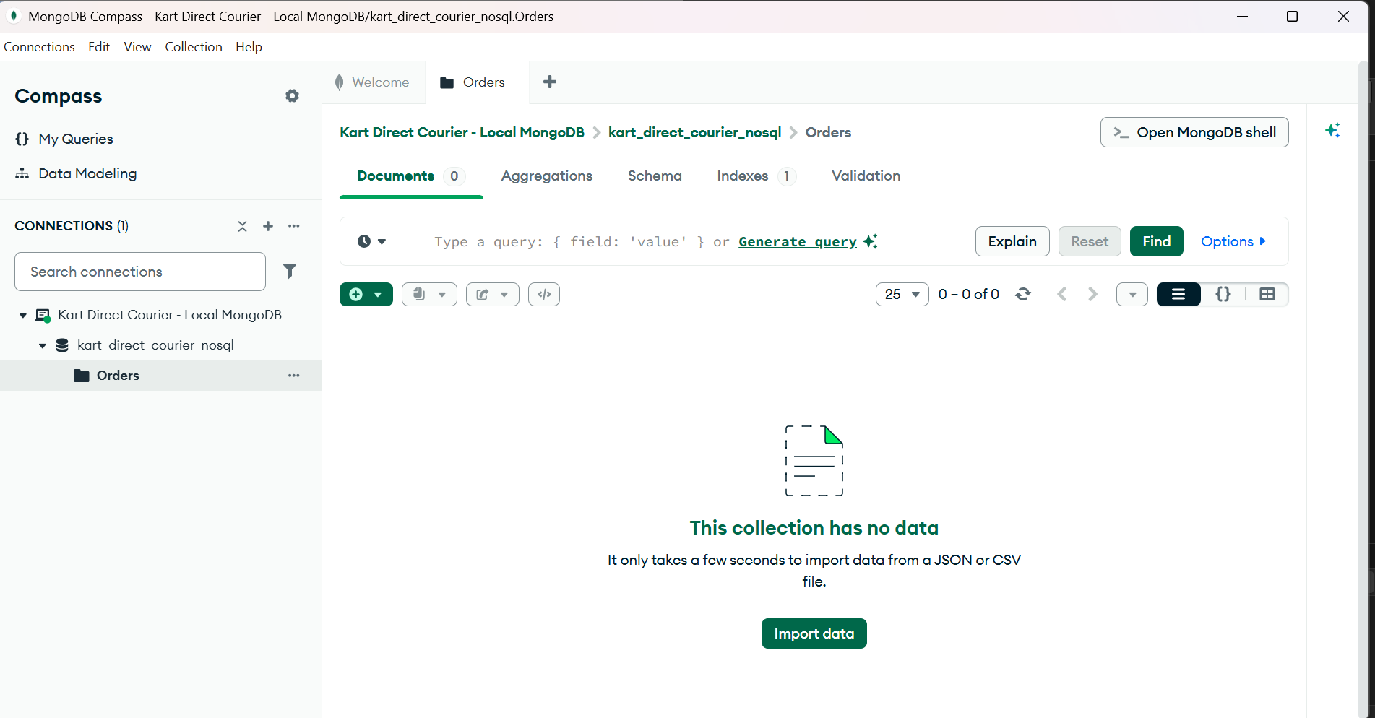
Figure 1: MongoDB database and Orders collection created in MongoDB Compass.
4.2.2 Document Structure and Data Insertion
Two sample order documents were inserted into the Orders collection to demonstrate the document-based structure.
The first document represents Order 5, while the second represents Order 6.
The documents contain order identifiers, customer references, order statuses, dates, delivery information, and arrays of ordered items.
The inserted records are summarized below:
Order ID | Customer ID | Order Status | Order Date
5 | 1 | Pending | 2026-11-04
6 | 2 | Processing | 2026-11-04
The documents also contain embedded delivery information and arrays of ordered products.
The use of embedded documents and arrays demonstrates how MongoDB can represent related information within a single document.
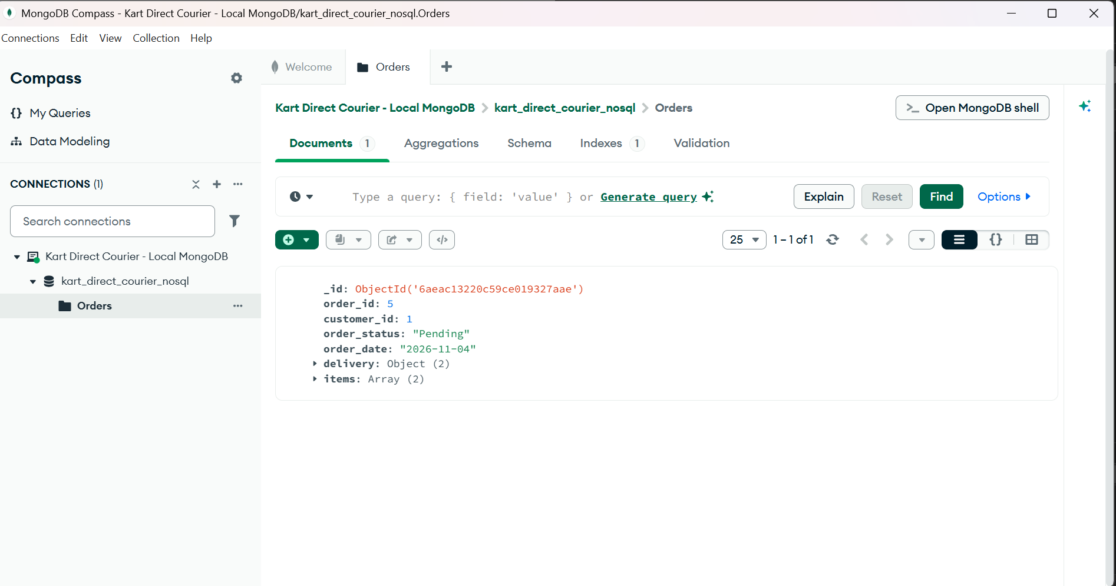
Figure 2: Insertion of the first order document into the Orders collection.

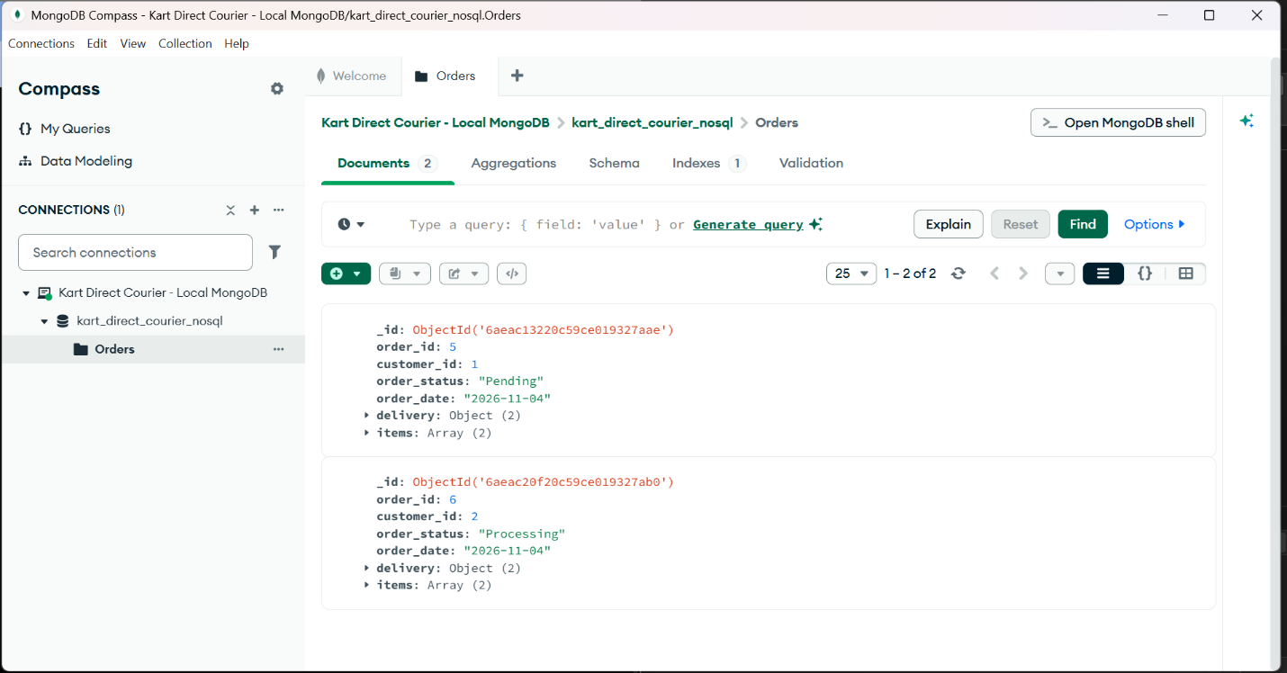
Figure 3: Multiple order documents stored in the Orders collection.

4.2.3 Embedded Documents and Arrays
MongoDB supports the use of embedded documents and arrays to represent related information.
In the Kart Direct Courier implementation, the delivery field contains a nested document that stores delivery-related information.
The items field contains an array of embedded documents. Each item document contains a product_id and a quantity.
For example, Order 6 contains two items:
- Product ID 3 with a quantity of 1.
- Product ID 4 with a quantity of 3.
This structure allows multiple products to be associated with one order while maintaining the relationship between the order and its items.
The implementation demonstrates the flexibility of MongoDB in representing complex and related data structures.
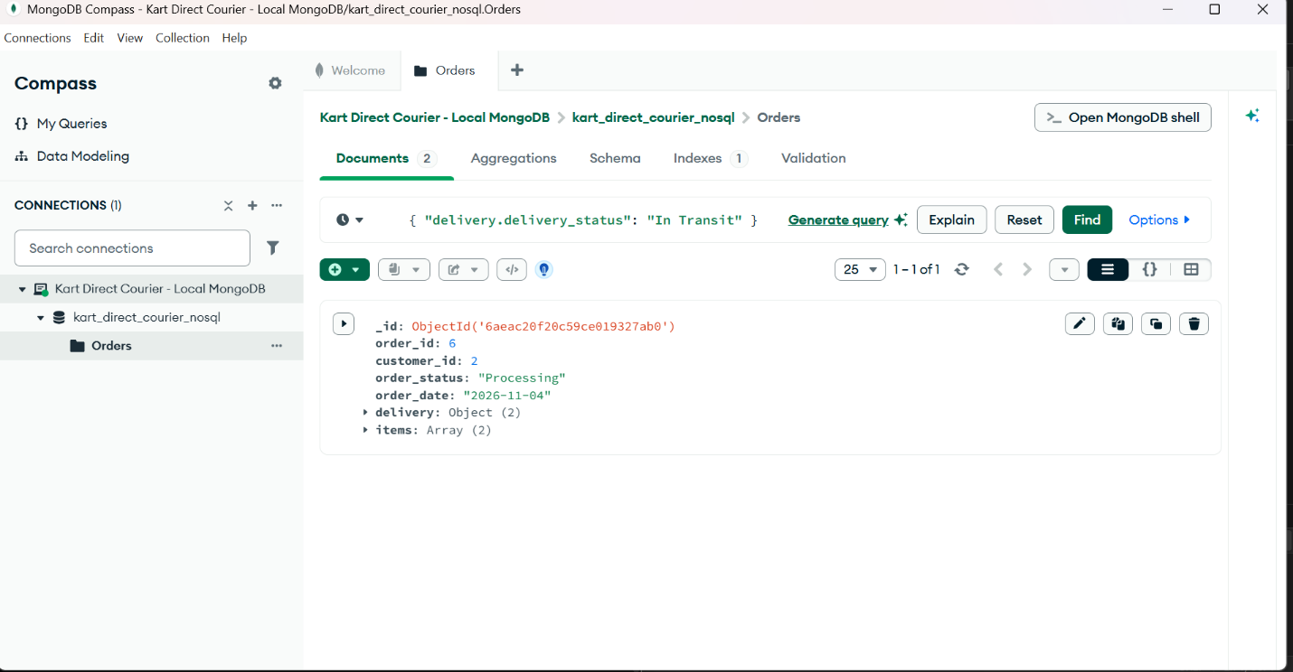
Figure 4: Embedded delivery information and array of ordered items within an order document.

4.3 MongoDB Query Implementation and Results
4.3.1 Introduction
Queries were executed in MongoDB Compass to demonstrate how information can be retrieved from the Orders collection.
The queries focused on retrieving orders based on their processing status, delivery status, and the products contained within their item arrays.
These operations demonstrate the ability of MongoDB to retrieve information from both top-level fields and nested document structures.
4.3.2 Query 1: Retrieve Orders with Pending Status
The following query was used to retrieve orders whose processing status is Pending.
Query:
{
"order_status": "Pending"
}
The query filters the collection using the order_status field.
The result returned Order 5, which belongs to Customer 1 and has a status of Pending.
This demonstrates how MongoDB can retrieve specific records based on a defined condition.
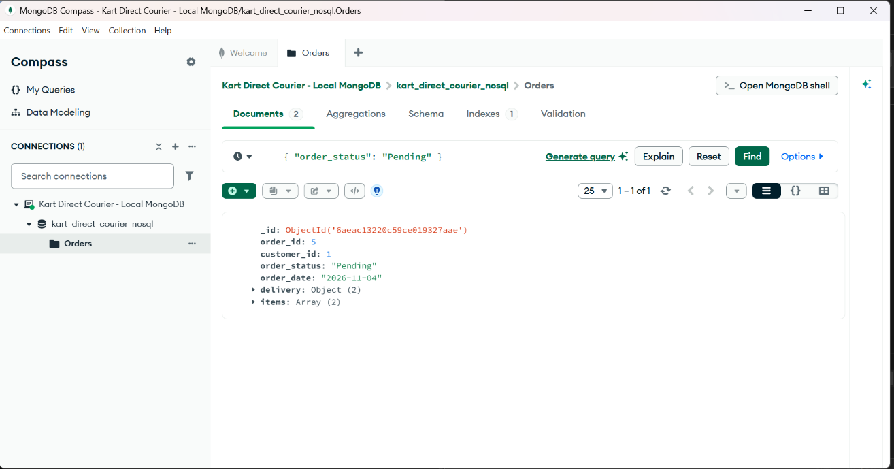
Figure 5: MongoDB query retrieving orders with Pending status.
4.3.3 Query 2: Retrieve Orders with Processing Status
The following query was used to retrieve orders whose processing status is Processing.
Query:
{
"order_status": "Processing"
}
The query returned Order 6, which belongs to Customer 2 and has a status of Processing.
The result demonstrates how MongoDB can filter documents based on their current processing status.
This type of query can be useful for identifying orders that are still undergoing processing within the courier delivery system.
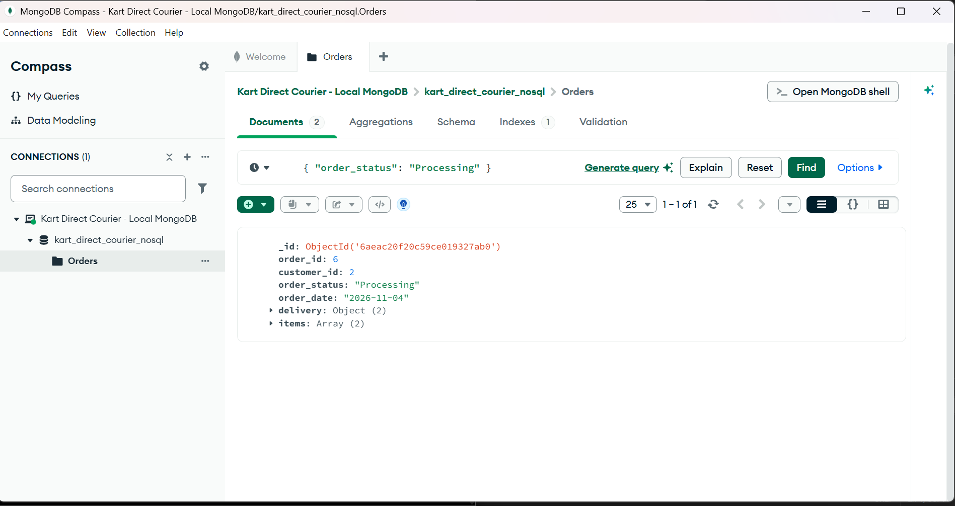
Figure 6: MongoDB query retrieving orders with Processing status.
4.3.4 Query 3: Retrieve Orders Based on Delivery Status
The following query was used to retrieve orders based on the delivery status stored within the embedded delivery document.

Query:
{
"delivery.delivery_status": "In Transit"
}
The query uses dot notation to access the delivery_status field inside the embedded delivery document.
The result returned Order 6, demonstrating that MongoDB supports queries on fields contained within nested documents.
This capability is particularly useful for courier delivery applications where delivery information is stored within an order document.
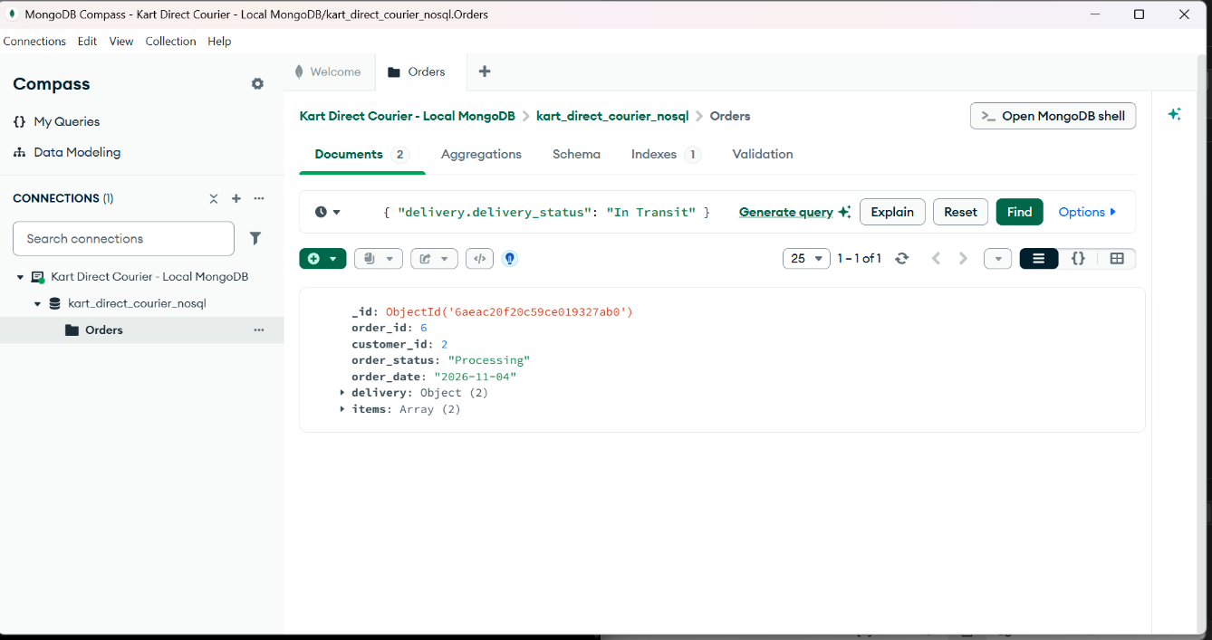
Figure 7: MongoDB query retrieving orders with In Transit delivery status.
4.3.5 Query 4: Retrieve Orders Containing a Specific Product
The following query was used to retrieve orders containing Product ID 3 within the items array.
Query:
{
"items.product_id": 3
}
The query uses dot notation to access the product_id field within the array of embedded item documents.
The result returned Order 6.
The document contains Product ID 3 with a quantity of 1 and Product ID 4 with a quantity of 3.
This demonstrates how MongoDB can retrieve documents based on values stored within arrays of embedded documents.
The functionality is useful for identifying orders containing a particular product without requiring the order items to be stored in a separate collection.
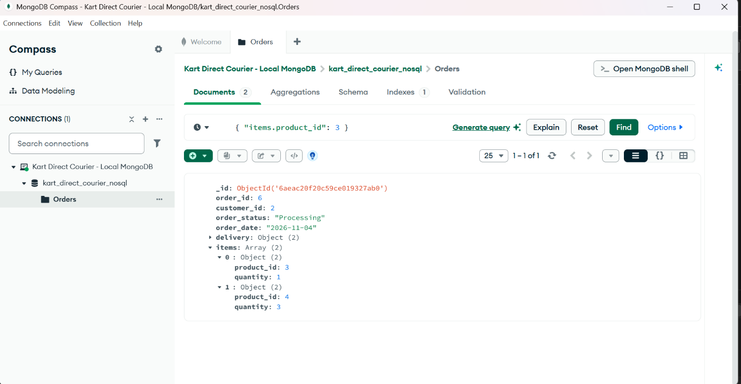
Figure 8: MongoDB query retrieving orders containing Product ID 3.
4.3.6 Summary of Query Results
The queries executed in MongoDB Compass demonstrated the ability to retrieve documents using different filtering conditions.
Query | Filter Condition | Result
Query 1 | order_status = Pending | Order 5
Query 2 | order_status = Processing | Order 6
Query 3 | delivery.delivery_status = In Transit | Order 6
Query 4 | items.product_id = 3 | Order 6
The successful execution of these queries demonstrates that the MongoDB implementation supports the retrieval of order information using top-level fields, embedded documents, and arrays.
4.4 Suitability of MongoDB and Comparison with PostgreSQL
4.4.1 Suitability of MongoDB for Kart Direct Courier
MongoDB is suitable for the Kart Direct Courier system because it provides a flexible document-based structure for managing order and delivery information.
The implementation demonstrated how an order can contain customer references, delivery details, and multiple ordered items within a single document.
This structure is useful for applications where related information needs to be retrieved together.
MongoDB also supports queries on nested fields and arrays, making it possible to retrieve orders based on delivery status or the products they contain.
The flexibility of the document model allows the system to accommodate additional delivery information or order attributes as business requirements change.
However, the use of embedded documents must be carefully considered. Embedding is most appropriate where the related information is commonly accessed together and does not require extensive independent management.
For the Kart Direct Courier system, MongoDB provides a suitable approach for demonstrating flexible order management and delivery tracking.
4.4.2 Comparison Between MongoDB and PostgreSQL
The Kart Direct Courier project uses PostgreSQL as its relational database implementation and MongoDB as its NoSQL implementation.
Both database systems provide useful capabilities, but they organize and manage data differently.
Feature | PostgreSQL | MongoDB
Database model | Relational | Document-based
Data structure | Tables, rows, and columns | Collections and documents
Schema | Structured schema | Flexible document schema
Relationships | Foreign keys and joins | References and embedded documents
Data retrieval | SQL queries | MongoDB query language
Data representation | Normalized relational tables | Documents with nested fields and arrays
Suitable application | Structured transactional data | Flexible and document-oriented data
PostgreSQL is suitable for managing structured data and enforcing relationships between entities through primary keys, foreign keys, and relational constraints.
MongoDB is suitable for applications where related information can be represented within flexible documents.
For Kart Direct Courier, PostgreSQL provides a structured approach to managing customers, products, orders, payments, and deliveries.
MongoDB provides an alternative approach for representing order information together with embedded delivery details and product arrays.
The two database systems therefore demonstrate different approaches to managing the information requirements of the same business.
4.4.3 Conclusion
The implementation of MongoDB for the Kart Direct Courier system demonstrated the practical use of a NoSQL document-based database.
A database named kart_direct_courier_nosql was created, together with an Orders collection containing sample order documents.
The implementation demonstrated the use of embedded documents, arrays, and queries on nested fields.
The successful execution of the queries confirmed that MongoDB can retrieve orders based on their processing status, delivery status, and associated products.
The comparison with PostgreSQL also demonstrated that relational and NoSQL databases provide different but useful approaches to data management.
PostgreSQL offers a structured relational model, while MongoDB provides flexibility through its document-based approach.
Overall, MongoDB was successfully implemented as an alternative data model for the Kart Direct Courier system, demonstrating its suitability for flexible order management and delivery tracking.

