MIT 8103 – ADVANCED DATABASE SYSTEMS

CASE STUDY: KART DIRECT COURIER E-COMMERCE AND DELIVERY MANAGEMENT SYSTEM

PORTFOLIO 1: DATABASE DESIGN AND MODELLING

STUDENT NAME: EJEREJE ERERE OYIBO

STUDENT ID: 301908132

SUBMISSION DATE: 6TH NOV, 2026

PORTFOLIO 1: DATABASE DESIGN AND MODELLING
Course: MIT 8103 – Advanced Database Systems
Case Study: Kart Direct Courier E-Commerce and Delivery Management System
Database Management System: PostgreSQL
1. Case Study: Kart Direct Courier E-Commerce and Delivery Management System
1.1 Introduction and Business Overview
Kart Direct Courier is a simulated Nigerian e-commerce and courier service that sells products to customers and provides delivery services for their orders. The business manages customers, product categories, inventory, orders, payments, couriers, and delivery activities.
As the business grows, it requires an organized database to manage its information efficiently. A relational database provides a structured way to store related records, retrieve information, and maintain data accuracy.
This portfolio presents the design and implementation of a PostgreSQL database for Kart Direct Courier.
1.2 Business Problem
Managing e-commerce and delivery activities without a properly structured database can result in duplicated records, inaccurate stock information, difficulties tracking orders and delays in retrieving customer and payment details.
For instance, if customer details are repeatedly entered for different orders, inconsistencies may occur. Similarly, without proper delivery records, it may be difficult to identify the courier responsible for an order or review previous delivery-status updates.
Kart Direct Courier therefore requires a centralized database that links its business activities and helps reduce these problems.
1.3 Objectives of the Database System
The main objectives of the database system are to:
- Store customer details and delivery addresses.
- Organize products into categories and maintain inventory records.
- Record customer orders and the products included in each order.
- Track payments, including payment methods and transaction statuses.
- Manage courier information and delivery assignments.
- Maintain delivery-status history for tracking purposes.
- Enforce data integrity through keys and constraints.
- Support efficient information retrieval through SQL queries.
1.4 Database Users
The database may be used by different categories of personnel within the business.
- Management: Reviews orders, payments, inventory, and delivery performance.
- Sales and order-processing staff: Access customer and order information.
- Inventory personnel: Monitor product records and stock quantities.
- Finance personnel: Review payment transactions and their statuses.
- Delivery coordinators: Assign couriers and monitor delivery progress.
- Database administrators: Maintain database security, integrity, performance, and availability.
1.5 Major Data Stored
The database stores information about customers, addresses, categories, products, orders, order items, payments, couriers, deliveries and delivery-status history.
These records are distributed across ten related tables. Each table serves a specific purpose, while primary and foreign keys establish relationships between the tables.
1.6 Key Operations Supported
The database supports several important business operations, including:
- Registering customers and recording their addresses.
- Adding products and assigning them to categories.
- Creating orders for customers.
- Recording the products, quantities and prices associated with each order.
- Recording payment amounts, methods and transaction statuses.
- Assigning couriers to deliveries.
- Updating delivery statuses and maintaining their history.
- Retrieving order details by joining related tables.
For example, a JOIN query can combine customer information, order details, products and payment records to provide a consolidated view of customer purchases.
1.7 Database Design and Integrity
PostgreSQL was selected as the relational database management system for this implementation. The database consists of ten tables linked through primary and foreign keys.
Constraints such as UNIQUE, CHECK, and default values help enforce business rules. For example, product prices and stock quantities cannot be negative, order-item quantities must be greater than zero, and order statuses must belong to an approved list.
The design also separates customers, products, orders, payments, and deliveries into different tables to organize the data and reduce unnecessary duplication.
1.8 Expected Benefits
The proposed database is expected to improve the organization and retrieval of business information, support more reliable order processing, provide better visibility into inventory and delivery activities, and help maintain consistent records.
It also provides a foundation for future improvements, such as query optimization, transaction management, NoSQL data modelling, and distributed database technologies.
1.9 Conclusion
The Kart Direct Courier database provides a structured approach to managing the core activities of an e-commerce and courier business. By organizing information into related tables and applying appropriate constraints, the system supports data integrity and efficient information retrieval.
The implementation serves as the foundation for the subsequent database exercises in this portfolio.

2. Relational Schema
A relational schema describes the tables in a database, the attributes stored in each table and the keys used to identify records and establish relationships.
The following schema represents the ten tables implemented for Kart Direct Courier.
Key notation:
- PK: Primary Key
- FK: Foreign Key
- UK: Unique Key or unique constraint
2.1 Customer and Address Tables
CUSTOMERS (customer_id PK, first_name, last_name, email UK, phone, created_at)
Stores customer identification and contact information.
CUSTOMER_ADDRESSES (address_id PK, customer_id FK, address_line, city, state, postal_code, is_default)
Stores customer delivery addresses. The foreign key links each address to a customer.

2.2 Product Tables
CATEGORIES (category_id PK, category_name UK)
Stores the categories used to organize products.
PRODUCTS (product_id PK, category_id FK, product_name, description, unit_price, stock_quantity, is_active)
Stores product details, prices, inventory quantities, and category references.

2.3 Order Tables
ORDERS (order_id PK, customer_id FK, order_date, order_status)
Stores customer orders, including their creation dates and statuses.
ORDER_ITEMS (order_item_id PK, order_id FK, product_id FK, quantity, unit_price, UNIQUE(order_id, product_id))
Stores the individual products included in each order, together with the quantity and price charged. The combination of order_id and product_id is subject to a unique constraint.

2.4 Payment Table
PAYMENTS (payment_id PK, order_id FK, amount, payment_method, payment_status, transaction_reference UK, payment_date)
Stores payment records associated with orders, including transaction references and payment statuses.

2.5 Courier and Delivery Tables
COURIERS (courier_id PK, first_name, last_name, phone UK, is_active)
Stores courier details and active status.
DELIVERIES (delivery_id PK, order_id FK, address_id FK, courier_id FK (nullable), delivery_status, tracking_number UK, dispatched_at, delivered_at)
Stores delivery information, including the destination address, assigned courier and tracking details. The courier_id field allows NULL values, meaning a delivery can be recorded before a courier is assigned. The order_id has both a foreign key constraint and a unique constraint, allowing an order to be associated with at most one delivery record in this design.
DELIVERY_STATUS_HISTORY (history_id PK, delivery_id FK, status, status_time, notes)
Stores delivery-status updates and related notes over time.

2.6 Schema Summary
The schema separates the main business entities into ten tables. Primary keys identify individual records, while foreign keys connect related records. Unique constraints prevent duplicate values where required, and other constraints enforce selected business rules.

3. Entity-Relationship Diagram (ERD)
The Entity-Relationship Diagram provides a visual representation of the database tables and the relationships between them.
The ERD for Kart Direct Courier contains the ten implemented tables:
- CUSTOMERS
- CUSTOMER_ADDRESSES
- CATEGORIES
- PRODUCTS
- ORDERS
- ORDER_ITEMS
- PAYMENTS
- COURIERS
- DELIVERIES
- DELIVERY_STATUS_HISTORY
The relationships show how customer records connect to addresses and orders, how orders connect to order items and payments, how products connect to categories and order items, and how deliveries connect to addresses, couriers and delivery-status history.
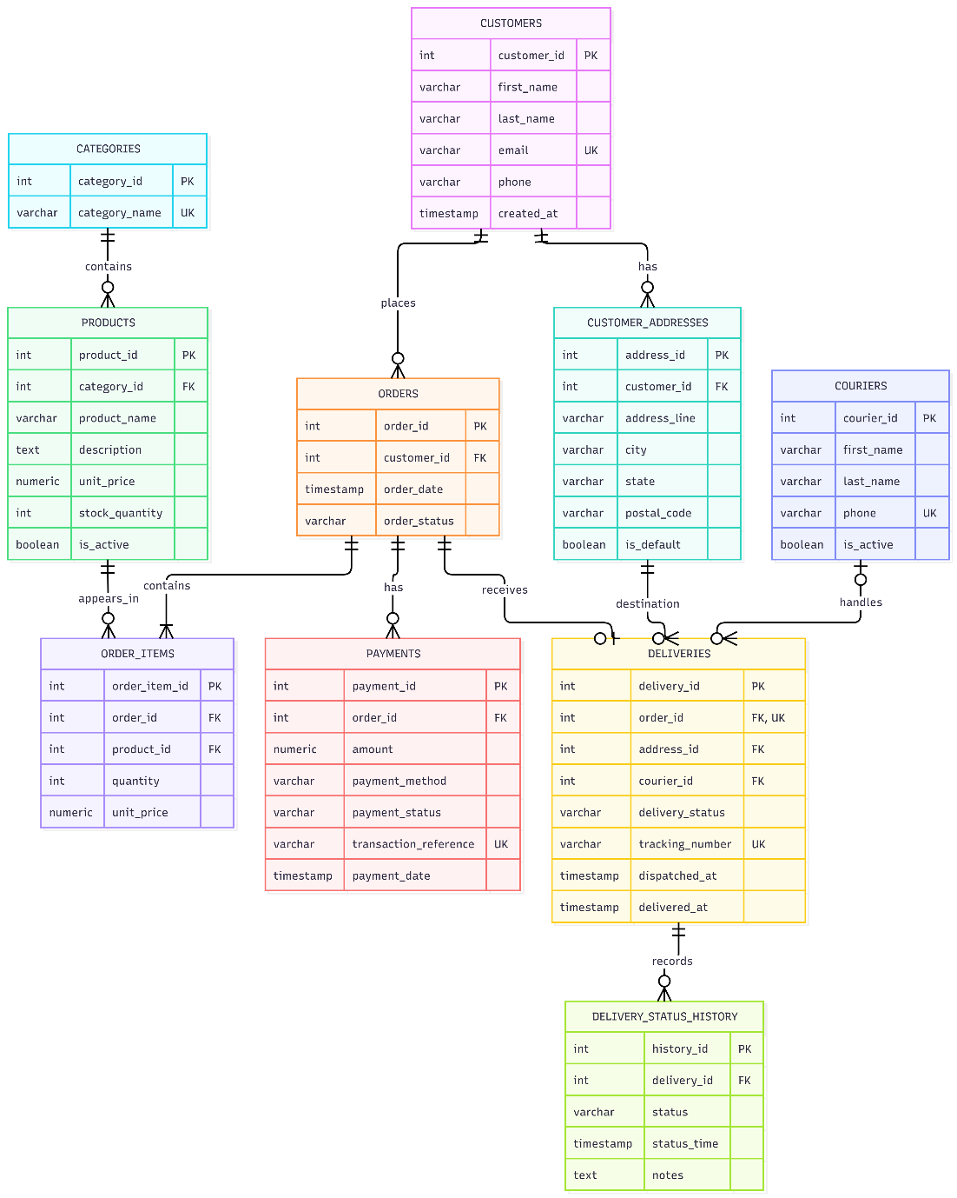
Figure 1: Entity-Relationship Diagram for the Kart Direct Courier database.
The ERD reflects the implemented database structure and shows the primary and foreign keys used to link the tables. In particular, DELIVERIES.order_id is labelled as both a foreign key (FK) and a unique key/constraint (UK), consistent with the implemented design.

4. Keys and Constraints
Database keys and constraints help maintain data integrity by ensuring that records are uniquely identified, relationships are valid, and selected business rules are enforced.
Constraint | Example in Kart Direct Courier | Purpose
Primary key (PK) | customers.customer_id | Uniquely identifies each customer record.
Foreign key (FK) | orders.customer_id | Ensures that an order refers to an existing customer.
Unique constraint (UK) | customers.email | Prevents duplicate customer email addresses.
NOT NULL | products.product_name NOT NULL | Ensures that every product record has a product name.
CHECK | products.unit_price >= 0 | Prevents negative product prices.
DEFAULT | orders.order_date DEFAULT CURRENT_TIMESTAMP | Automatically records the order creation time when no date is supplied.

The database also contains business-specific constraints. For example, order-item quantities must be greater than zero, stock quantities cannot be negative, and order statuses must belong to the permitted list defined in the database.
The order_items table has a unique constraint on the combination of order_id and product_id. This prevents the same product from appearing in multiple separate rows for the same order under the current design.
The deliveries table also has a unique constraint on order_id, meaning that each order can have no more than one delivery record in the implemented schema.
These constraints help prevent invalid records and maintain consistency across related tables.

5. Normalization: First, Second and Third Normal Forms
Normalization is the process of organizing relational tables to reduce unnecessary duplication and minimize insertion, update, and deletion anomalies.
5.1 First Normal Form (1NF)
A table is in First Normal Form when each field contains a single value and repeating groups are avoided.
In Kart Direct Courier, an order containing three different products is represented by three records in ORDER_ITEMS, rather than storing several product names in one field in ORDERS.
This arrangement allows individual order items to be queried and updated separately and makes it easier to analyze the products included in customer orders.
5.2 Second Normal Form (2NF)
A table is in Second Normal Form when it is in First Normal Form and every non-key attribute depends on the whole of each relevant candidate key, rather than only part of a composite candidate key.
In the ORDER_ITEMS table, order_item_id is the primary key, while the combination of order_id and product_id has a unique constraint. The quantity and unit_price attributes describe the product included in a particular order. Storing order items separately from ORDERS and PRODUCTS helps keep order-level and product-level information organised and reduces unnecessary duplication.
5.3 Third Normal Form (3NF)
A table is in Third Normal Form when it is in Second Normal Form and non-key attributes do not depend transitively on a key through another non-key attribute.
For example, category_name is stored in CATEGORIES, while PRODUCTS stores category_id. If a category name changes, it can be updated in one place rather than across multiple product records.
Similarly, customer details are stored in CUSTOMERS, while orders reference customers using customer_id. Delivery-status updates are stored in DELIVERY_STATUS_HISTORY instead of repeatedly adding historical status columns to DELIVERIES.
This structure reduces redundancy and supports more reliable updates.
5.4 Design Consideration: Historical Prices
The ORDER_ITEMS.unit_price attribute stores the price charged for a product in a particular order. Keeping this value in the order-item record preserves the historical purchase price if the current product price changes later.
Payments and delivery information are also stored separately from orders. This separation helps organize the data according to the different business activities being recorded.

6. Implementation Evidence
This section provides evidence that the database design was implemented and tested in PostgreSQL.
6.1 Database and Table Creation
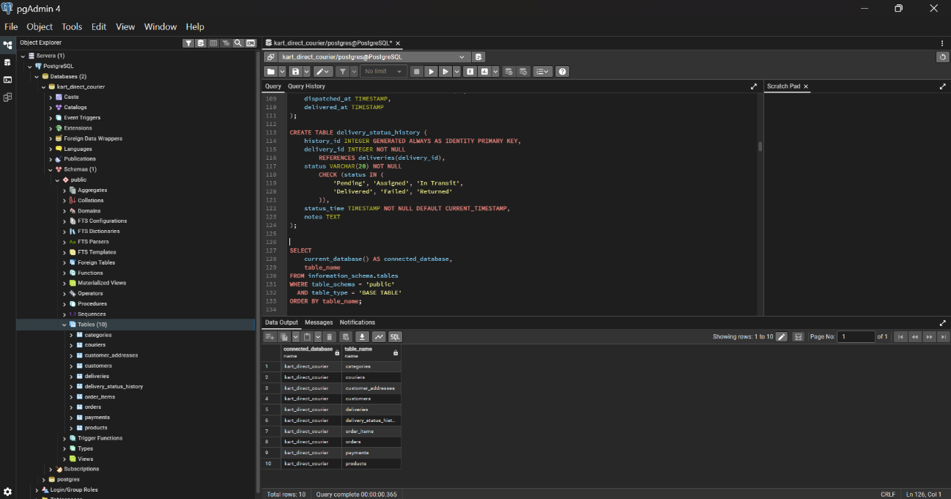
Figure 2: Verification of the Kart Direct Courier database and table creation.
This screenshot demonstrates that the database was created and the required tables are available in PostgreSQL.
6.2 Sample Data Verification
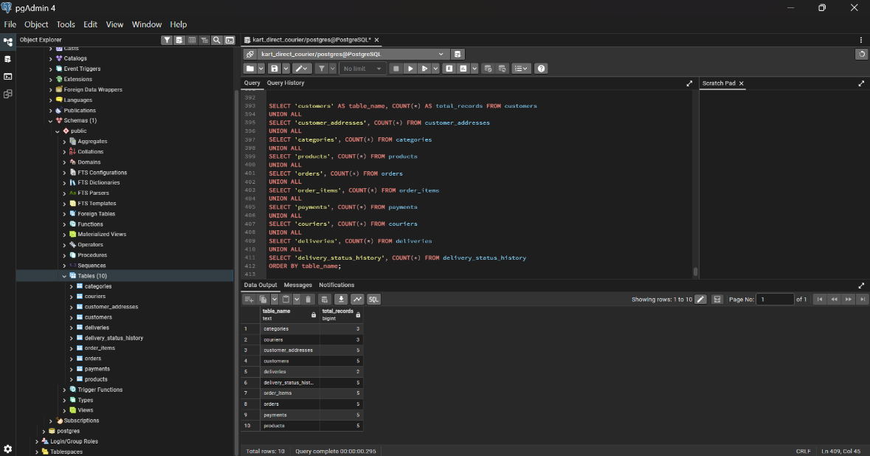
Figure 3: Verification of sample records inserted into the database tables.
The sample records provide test data for customers, addresses, categories, products, orders, order items, payments, couriers, deliveries, and delivery-status history.
The expected record counts after the sample-data insertion are:
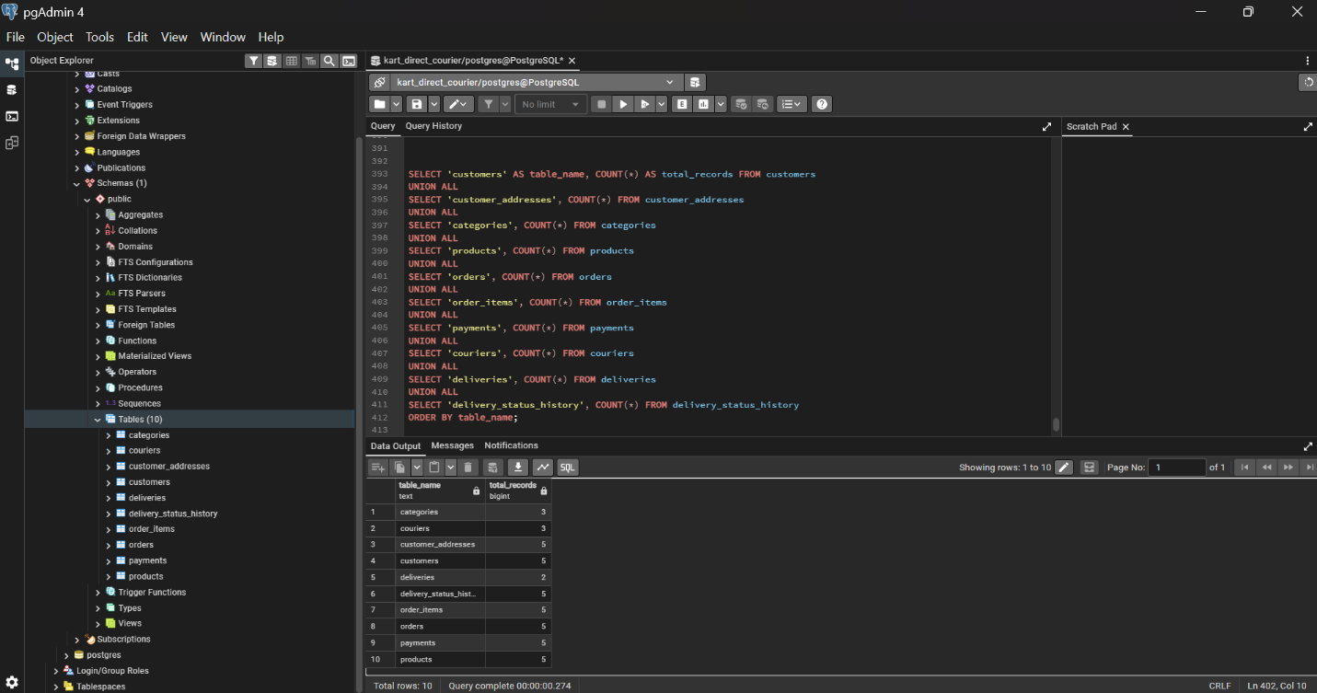
Figure 4: Verification of record counts across the ten Kart Direct Courier database tables.

6.3 Relational JOIN Query
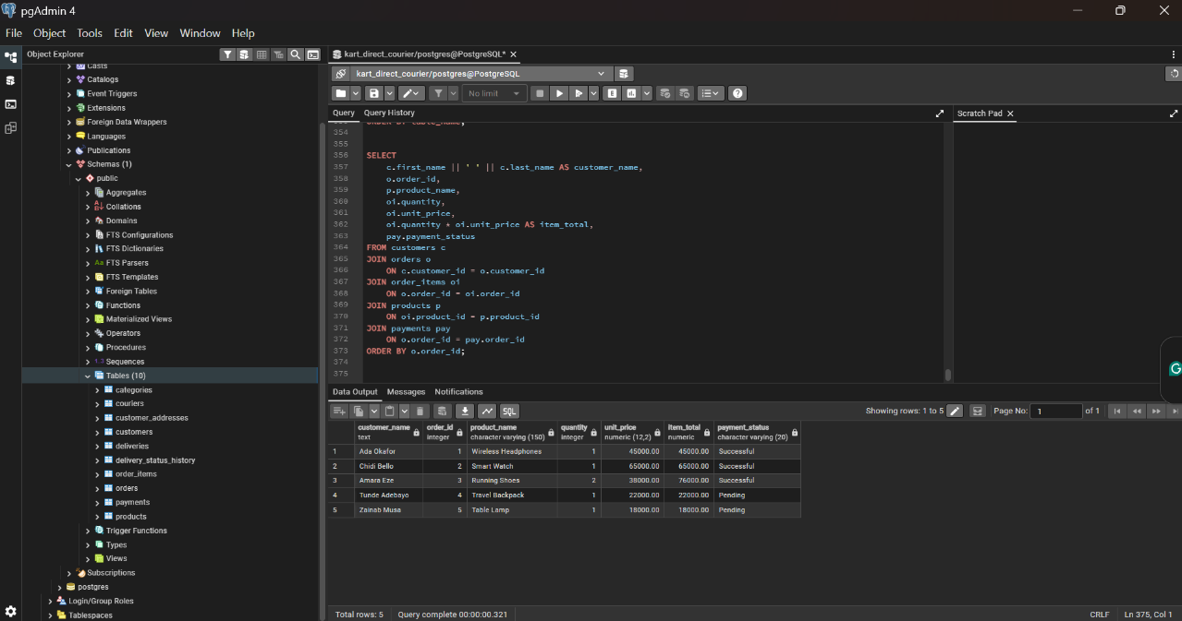
Figure 5: Retrieval of customer orders using a relational JOIN query.
The JOIN query combines information from related tables, including customers, orders, order items, products and payments. This demonstrates how the relational design supports the retrieval of information that is stored across multiple tables.
The query returned five rows in the test performed, demonstrating that the related records could be retrieved successfully using SQL joins.

7. Conclusion
The Kart Direct Courier database was designed and implemented in PostgreSQL using ten related tables. The relational schema identifies the attributes and keys of each table, while the ERD illustrates the relationships between the main business entities.
Primary keys, foreign keys, unique constraints, check constraints, and default values support data integrity and enforce selected business rules. The database structure also separates customer, product, order, payment, and delivery information to reduce unnecessary duplication and support reliable data management.
The successful creation of the tables, insertion of sample data and execution of a relational JOIN query provide evidence that the initial database design is functional. This implementation establishes a foundation for the further exercises in query processing and optimization, transactions and concurrency, NoSQL data models, and distributed and cloud databases.

