MIT 8103 – ADVANCED DATABASE SYSTEMS

CASE STUDY: KART DIRECT COURIER E-COMMERCE AND DELIVERY MANAGEMENT SYSTEM

PORTFOLIO 2: QUERY PROCESSING AND OPTIMISATION

STUDENT NAME: EJEREJE ERERE OYIBO

STUDENT ID: 301908132

SUBMISSION DATE: 6TH NOV, 2026

PORTFOLIO 2: QUERY PROCESSING AND OPTIMISATION
Course: MIT 8103 – Advanced Database Systems
Case Study: Kart Direct Courier E-Commerce and Delivery Management System
Database Management System: PostgreSQL
1. Introduction
This portfolio focuses on query processing and optimization in the Kart Direct Courier database. The objective is to retrieve useful information from the database, calculate order totals, examine query execution plans, and investigate how indexes can support query performance.
The practical exercises were carried out using PostgreSQL and the existing relational database developed in Portfolio 1. The queries demonstrate how related tables can be combined to retrieve business information and how execution plans can be used to understand the operations performed by the database engine.
2. Basic Order Retrieval
The first query retrieves the order ID, order date, order status and customer ID from the orders table. The results are sorted in descending order of order_date, placing the most recent orders first.
The query uses the ORDER BY clause with DESC to arrange the results without changing the underlying records. This type of query is useful for monitoring recent orders and reviewing their processing status.
Figure 1: Basic Order Retrieval Query and Results
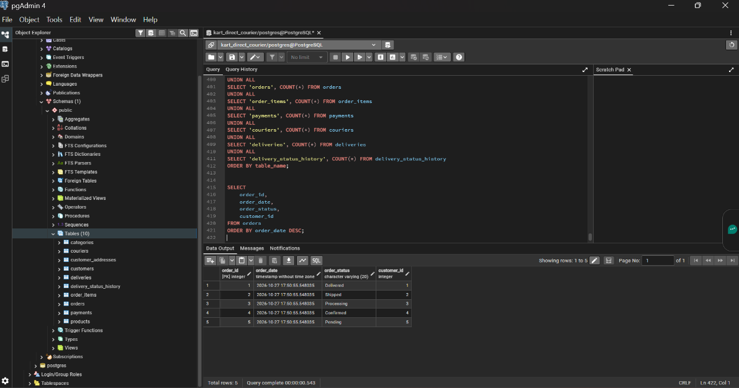
The result displayed the five sample orders in the database, demonstrating that PostgreSQL could retrieve and sort the order records successfully.

3. Order Total Calculation Using Joins and Aggregation
The second query combines the orders, customers and order_items tables using JOIN operations. It retrieves each order's ID and customer name and calculates the total order value using the SUM() aggregate function.
The expression quantity * unit_price calculates the value of each order item, while SUM() adds the item values for each order. The GROUP BY clause groups records by order and customer, and ORDER BY order_total DESC ranks the orders from the highest total to the lowest.
Figure 2: Order Total Calculation Using JOIN and SUM
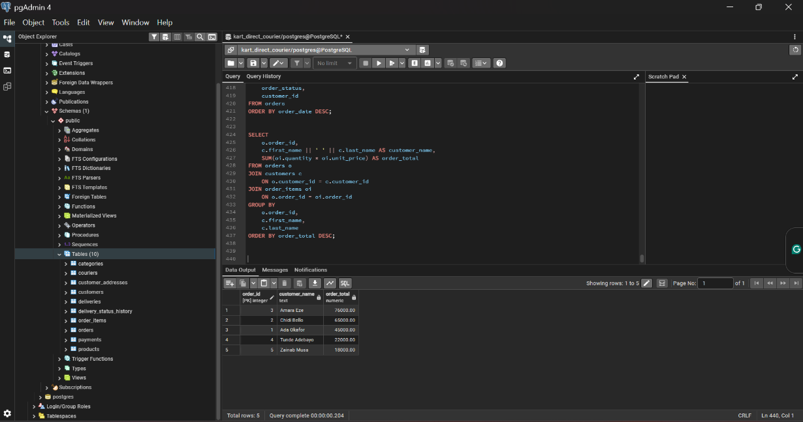
The query returned five orders. Amara Eze's order had the highest total of ₦76,000, followed by Chidi Bello's order at ₦65,000 and Ada Okafor's order at ₦45,000. The results demonstrate how relational joins and aggregate functions can turn individual transaction records into useful business information.
4. Query Execution Plan Analysis
The EXPLAIN ANALYZE command was used to examine the execution of the order-total query. Unlike EXPLAIN alone, EXPLAIN ANALYZE executes the query and reports the actual execution plan and timing information.
The plan generated by PostgreSQL included operations such as sequential scans, hash joins, hash aggregation, and sorting. These operations show how PostgreSQL accessed records, combined related tables, grouped the results, and arranged the final output.

Figure 3: EXPLAIN ANALYZE Plan for the Order Total Query
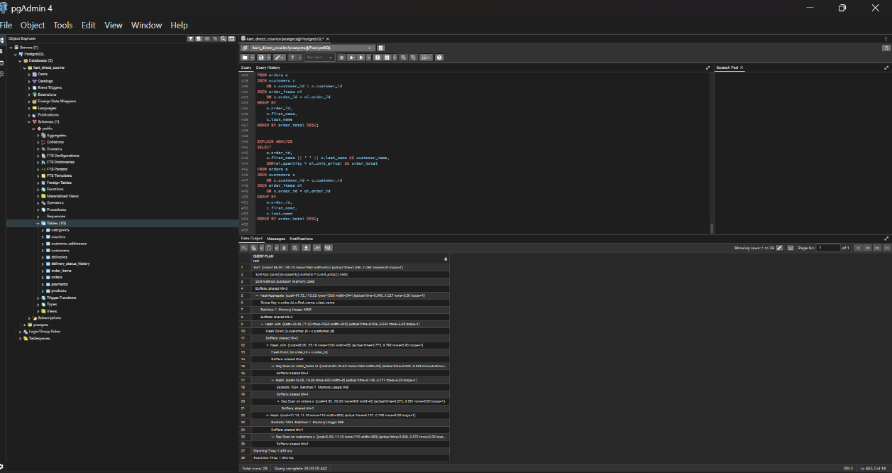
The execution plan provides evidence of the database engine's processing strategy. It also demonstrates that query performance depends not only on the SQL statement but on how PostgreSQL chooses to execute it. The measured execution time for this test was approximately 1.854 milliseconds, although timings can vary between executions and environments.
5. Index Creation and Verification
An index named idx_orders_order_date was created on the order_date column of the orders table. The purpose was to investigate whether an index could assist PostgreSQL when retrieving orders based on their dates.
The index was created using the following SQL statement:
CREATE INDEX idx_orders_order_date
ON orders (order_date);
The index was then verified using the PostgreSQL system view pg_indexes. This view provides information about the indexes defined in the database, including their names and SQL definitions.

Figure 4: Creation of the Order Date Index
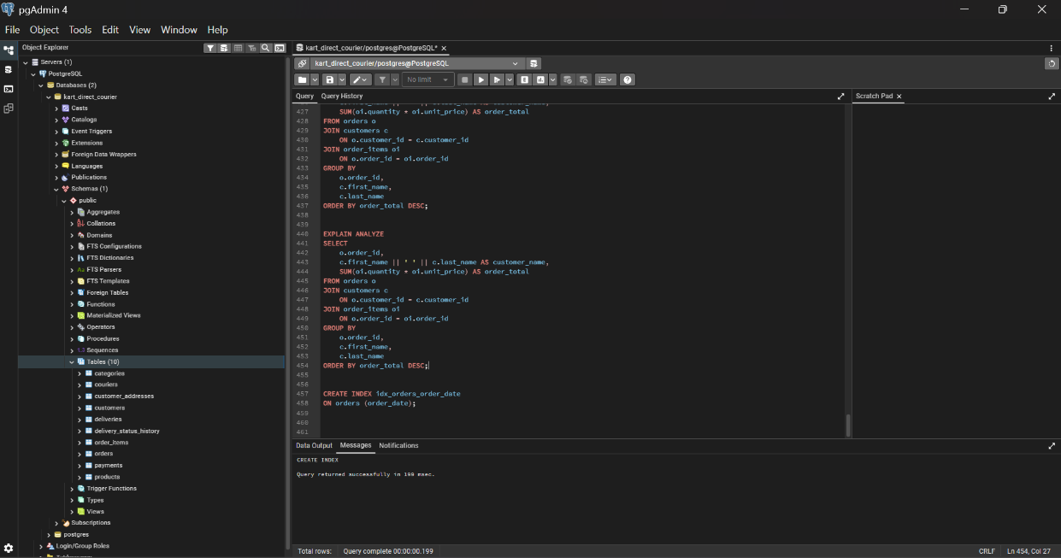

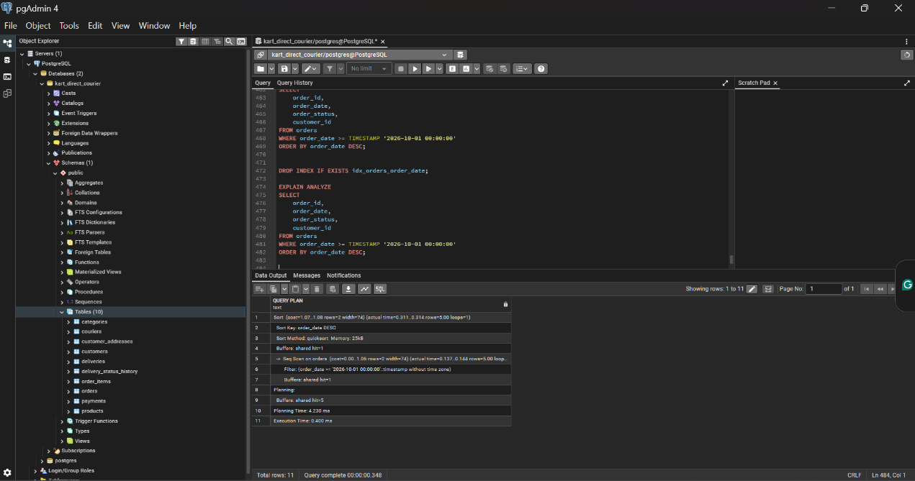
Figure 5: Baseline Execution Plan Without the Date Index

Figure 6: Verification of Indexes on the Orders Table
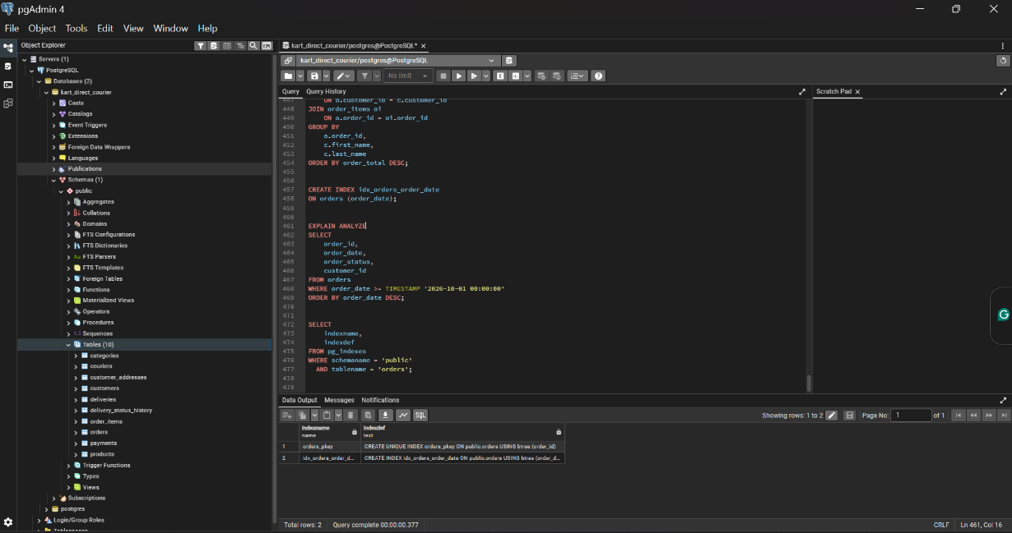
The baseline test was conducted after the date index was dropped. The date-filtered query used EXPLAIN ANALYZE to examine how PostgreSQL retrieved orders placed on or after 1 October 2026. The plan showed a sequential scan followed by sorting. The recorded execution time was approximately 0.400 milliseconds.
The index verification query was used to inspect the indexes present on the orders table. Because the baseline test drops the date index, the verification results depend on when the query is executed relative to index creation and removal.
6. Indexed Query Test and Performance Comparison
After the baseline test, the date index was recreated using CREATE INDEX IF NOT EXISTS. The same date-filtered query was then executed with EXPLAIN ANALYZE to examine the execution plan when the index was available.

Figure 7: Execution Plan with the Order Date Index Available
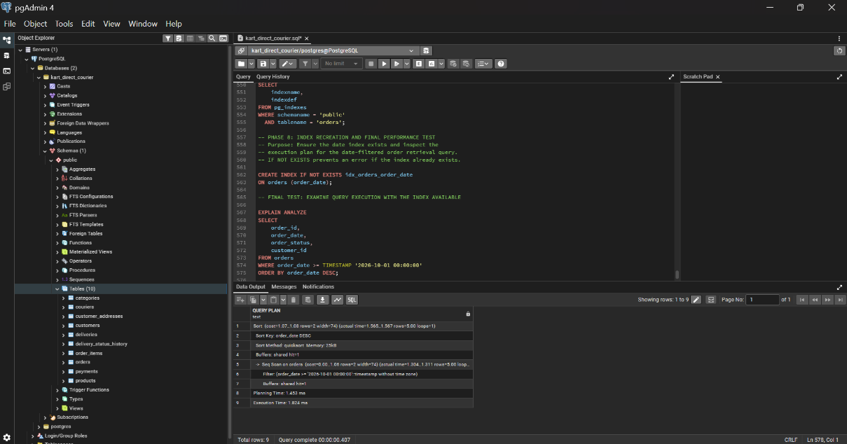
The indexed test still showed a sequential scan and sorting rather than an index scan. This indicates that PostgreSQL did not choose to use the date index for this query in the test environment.
A likely explanation is the small size of the orders table, which contained only five sample records. For a small table, reading the rows directly can be more efficient than using an index. Consequently, the presence of an index does not guarantee that PostgreSQL will select it for every query.
The results demonstrate the importance of examining actual execution plans instead of assuming that creating an index automatically improves performance. The observed timings should also be interpreted cautiously because planning and execution times can vary between runs.
7. Findings and Limitations
The practical exercise demonstrated three important aspects of query processing and optimization.
First, joins and aggregate functions can combine information from multiple relational tables to produce meaningful business results, such as order totals by customer.
Second, EXPLAIN ANALYZE provides insight into PostgreSQL's execution strategy and reports actual execution timing. This makes it useful for investigating how queries are processed.
Third, indexes are a potential optimization technique, but their effectiveness depends on factors such as table size, data distribution, query conditions, and the execution plan selected by PostgreSQL.
A limitation of this exercise is that the database contained only a small sample dataset. The results are therefore insufficient to establish how the index would perform with a much larger volume of orders. Further testing with more records and repeated measurements would be required to make a stronger performance comparison.
8. Conclusion
This portfolio applied SQL query processing and optimization techniques to the Kart Direct Courier database. It demonstrated basic order retrieval, relational joins, aggregate calculations, execution-plan analysis, and index creation.
The practical findings show that query optimization requires more than adding indexes. Execution plans and measured results must be examined to determine whether a proposed optimization is useful in a particular situation. Although the date index was created successfully, PostgreSQL continued to use a sequential scan for the tested date-filtered query. This provided a practical demonstration of how database systems select execution strategies based on the conditions and data available.
References
PostgreSQL Global Development Group. (n.d.). PostgreSQL documentation. https://www.postgresql.org/docs/
AI-use declaration: I used ChatGPT to help me understand some of the database concepts and clarify areas I needed more explanation on while working on this portfolio. The practical exercises were carried out by me using PostgreSQL, and the screenshots presented reflect the results of my work.

