MIT 8103 – ADVANCED DATABASE SYSTEMS

CASE STUDY: KART DIRECT COURIER E-COMMERCE AND DELIVERY MANAGEMENT SYSTEM

Portfolio 5: Distributed and Cloud Database Exercise

STUDENT NAME: EJEREJE ERERE OYIBO

STUDENT ID: 301908132

SUBMISSION DATE: 6TH NOV, 2026

Portfolio 5: Distributed and Cloud Database Exercise
Course: MIT 8103 – Advanced Database Systems
Case Study: Kart Direct Courier E-Commerce and Delivery Management System
Database Management System: PostgreSQL
1. Case Study and Objective
Kart Direct Courier is a simulated courier and logistics business that manages customers, orders, products, payments and delivery-related information. Its database supports order creation and status updates, customer and product records, payment tracking, and operational reporting. This exercise demonstrates how replication can maintain a separate copy of selected operational data for read access and potential recovery use.
2. Replication Design and Configuration
A PostgreSQL logical replication configuration was implemented using two databases on the same PostgreSQL server/cluster. The primary database, kart_direct_courier, acts as the publisher. The second database, kart_direct_courier_sub, acts as the subscriber. The public.orders table is included in the publication orders_publication, and the subscriber uses the subscription orders_subscription to receive changes.
Logical replication was enabled by setting wal_level to logical. A dedicated replication role was used for the subscription connection. The subscriber table was prepared with a matching structure and a primary key on order_id. The subscription was enabled and configured to copy the existing rows before applying subsequent changes.
3. Implementation and Verification
The initial data copy transferred five order records to the subscriber. Replication status was checked through pg_stat_subscription; the displayed received_lsn and latest_end_lsn values matched at the time of the captured check, indicating that the subscriber had caught up with the publisher at that point.
A live change was then tested on order_id 5. The publisher status was changed from Confirmed to Processing, and the subscriber was queried to confirm that it reflected Processing. The publisher was subsequently restored to Confirmed, and the subscriber was checked again to verify that the restored value was replicated. These before-and-after checks provide practical evidence of publisher-to-subscriber replication.
4. Relevance to Kart Direct Courier
Replication can help a logistics system by keeping a secondary copy of selected order data available for reporting or read-oriented workloads, reducing the need for those queries to run against the primary database. A separately hosted replica may also support recovery objectives if the primary system becomes unavailable. Replication is not, by itself, a substitute for backups, monitoring, or a tested recovery plan.
5. Distributed Database Concepts and Limitations
Sharding is a way to split a large dataset across multiple database nodes, for example by customer region or order range. It may improve scale as order volume grows, but adds complexity to cross-shard queries, transactions, and rebalancing. Availability concerns whether the service continues operating during failures. Consistency concerns whether users observe correct and up-to-date data. For order status and payment-related records, the business should prioritize correctness and define how any replication lag is handled.
This practical exercise demonstrates logical replication, not a fully distributed high-availability deployment. Both databases are on the same PostgreSQL server/cluster, so a server-level failure could affect both. A production design would place the replica on separate infrastructure, monitor replication lag, secure the replication connection, and test failover and recovery. Sharding and cloud deployment are discussed conceptually rather than implemented in this exercise.
6. Screenshot Evidence Index
No. | Evidence | Suggested filename
01 | Logical replication setting (wal_level = logical) | P5_01_Logical_Replication_Setting.png
02 | Publication configuration | P5_02_Publication_Created.png
03 | Subscription enabled | P5_03_Subscription_Enabled.png
04 | Initial data copied to subscriber | P5_04_Initial_Data_Copy.png
05 | Replication status and LSN values | P5_05_Replication_LSN_Status.png
06 | Publisher order 5 showing Processing | P5_06_Publisher_Processing.png
07 | Subscriber order 5 showing Processing | P5_07_Subscriber_Processing.png
08 | Publisher order 5 restored to Confirmed | P5_08_Publisher_Confirmed.png
09 | Subscriber order 5 restored to Confirmed | P5_09_Subscriber_Confirmed.png

7. Technical Reflection
This exercise helped me understand the difference between creating a replica and proving that replication is working. Checking the subscription state and LSN values provided a useful status check, while changing an order on the publisher and verifying the corresponding value on the subscriber demonstrated the actual data flow. I also learned that a replica on the same server has important limitations: it can demonstrate replication, but it does not protect against every infrastructure failure. A production system would need a separate replica host and a tested recovery strategy.
8. AI Use Declaration
I used ChatGPT as a learning and drafting aid to help explain PostgreSQL logical replication, organize the Portfolio 5 documentation, and describe the evidence captured during implementation. I reviewed the explanation against my own PostgreSQL setup and screenshots, and tested the replication behaviour by updating order 5 on the publisher and checking the subscriber. I remain responsible for the accuracy and understanding of the submitted work.

Appendix A: Screenshot Evidence
The figures below provide visual evidence of the PostgreSQL logical replication configuration and the publisher-to-subscriber status update test.
Figure 1. Logical replication setting (wal_level = logical)
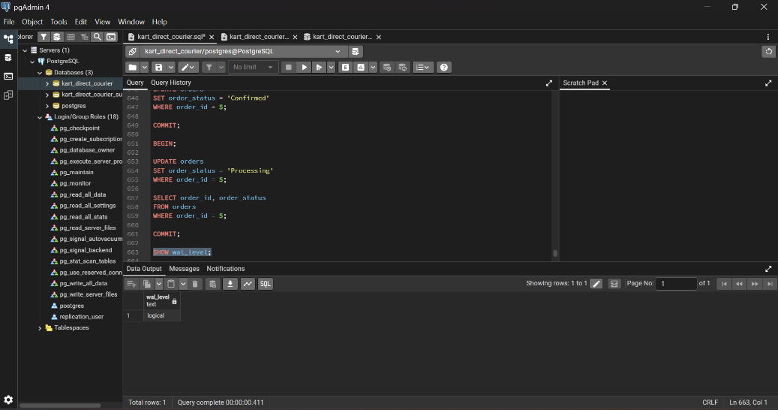
Figure 2. Publication configuration
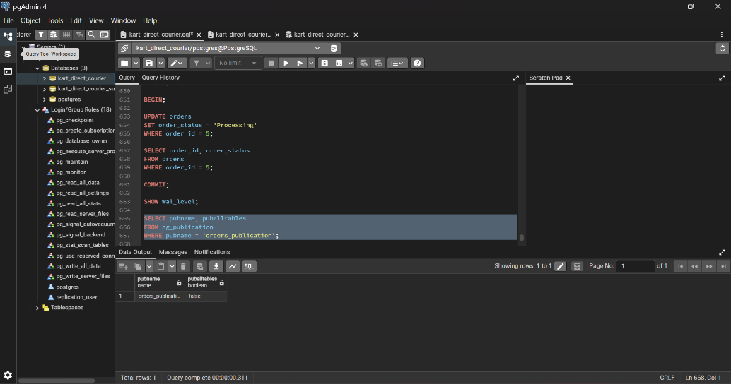
Figure 3. Subscription enabled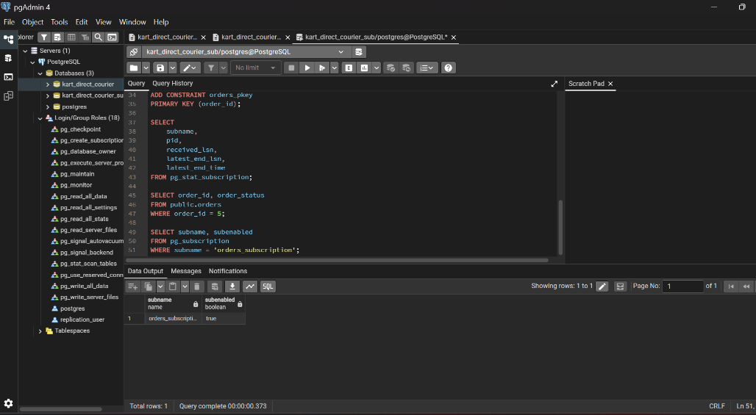
Figure 4. Initial data copied to subscriber
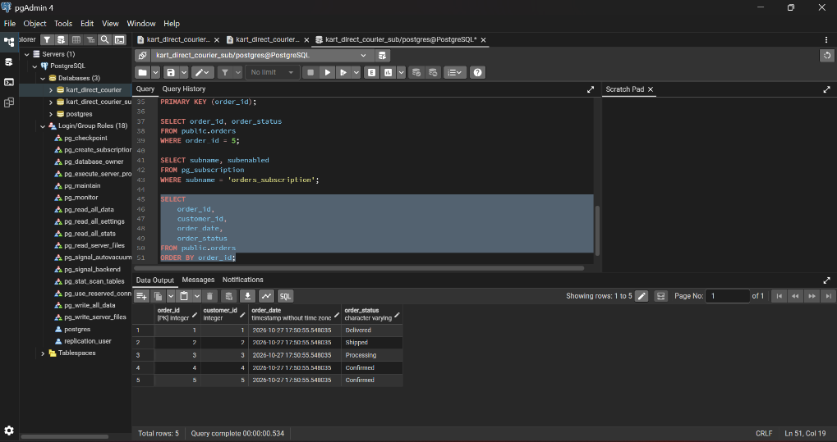
Figure 5. Replication status and LSN values
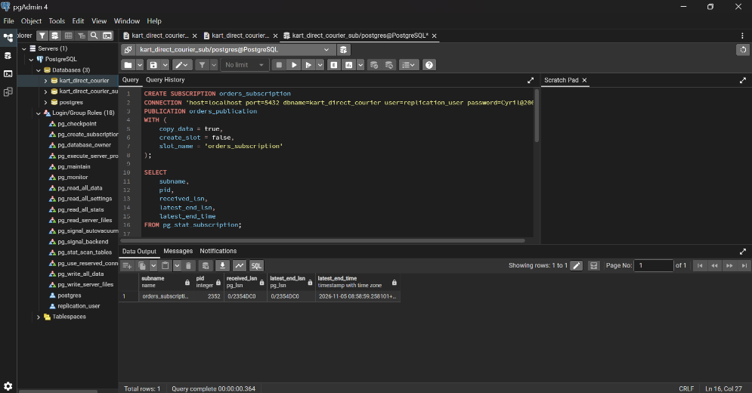

Figure 6. Publisher order 5 showing Processing
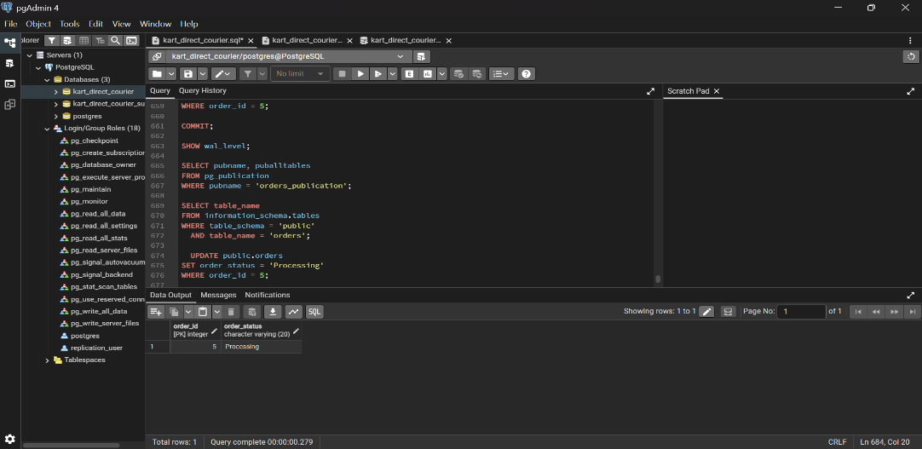

Figure 7. Subscriber order 5 showing Processing
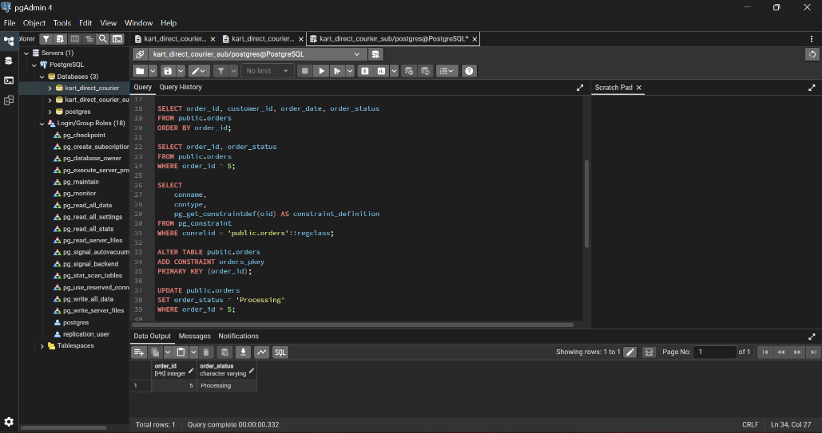

Figure 8. Publisher order 5 restored to Confirmed
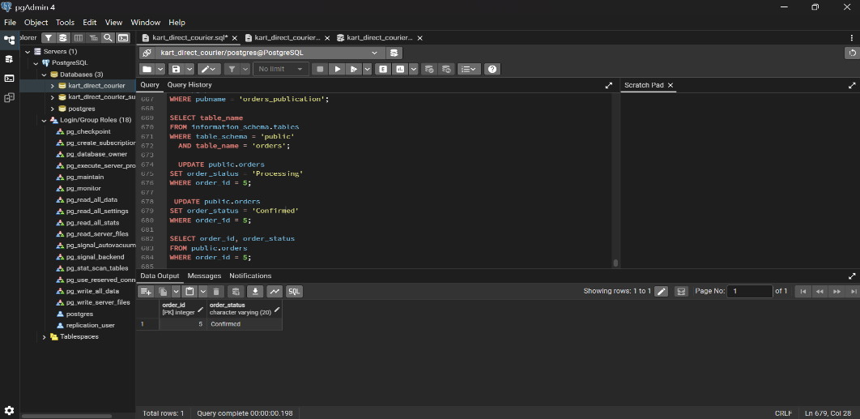
Figure 9. Subscriber order 5 restored to Confirmed


