7COM1079-0901-2025 – Team Research and Development Project
Final Report Title: Age Differences in Mental Health Treatment-Seeking among Employees in the Technology Industry (2014 Survey)
Group ID: A137
Dataset Number: DS349 (survey.csv)
Prepared by: Deepak Rana, Eekash Aenuga, Surabhi Keshri, Sreyashi Devnath, Ajit Chaurasiya

Table of Contents
1. Introduction 2
1.1 Problem Statement and Research Motivation 2
1.2 The Dataset 2
1.3 Research Question 2
1.4 Null and Alternative Hypotheses 2
2. Background Research 3
2.1 Review of Relevant Literature 3
2.2 Relevance of the Research Question 4
3. Visualization 4
3.1 Selected Visualizations 4
3.2 Additional Information from the Visualizations 5
3.3 Key Insights from the Visual Output 5
4. Statistical Analysis 6
4.1 Test Selection and Output 6
4.2 Hypothesis Decision and Interpretation 6
5. Evaluation of Group Experience 6
5.1 Strengths of Group Work 6
5.2 Areas for Improvement 6
5.3 Time Management 7
5.4 Overall Project Evaluation 7
5.5 GitHub Contribution Summary 7
6. Conclusions 8
6.1 Summary of Findings 8
6.2 Interpretation of Results 8
6.3 Limitations and Future Research 8
Reference List 9
Appendices 10
Appendix A: R Code Used for Analysis and Visualisation 10
Appendix B: GitHub Log Output 13

1. Introduction

1.1 Problem Statement and Research Motivation
Mental health has become a growing concern within the technology industry, largely due to demanding workloads, extended working hours, and continuous performance pressure. Although awareness of mental health issues has increased in recent years, many employees remain hesitant to seek professional support. Treatment-seeking behaviour is influenced by several demographic and workplace factors, including age. Different age groups may vary in their awareness, attitudes, and willingness to access mental-health services. Understanding whether age is associated with treatment-seeking behaviour can help organisations develop more effective and inclusive workplace wellbeing strategies tailored to the needs of their workforce.

1.2 The Dataset
This study uses the DS349 dataset (survey.csv), derived from the 2014 Tech Industry Mental Health Survey. The dataset consists of 1,259 responses across 27 variables, covering demographic characteristics, workplace conditions, and mental-health indicators. For this analysis, unrealistic age values were removed by restricting the age range to 18–70 years. Records with missing treatment responses were also excluded. The cleaned dataset provides a reliable basis for examining the relationship between age and mental-health treatment-seeking behaviour.

1.3 Research Question
Is there a difference in the median age between employees who seek mental health treatment and those who do not in the 2014 Tech Industry survey?

1.4 Null and Alternative Hypotheses
The following hypotheses were formulated to statistically assess the relationship between age and mental-health treatment-seeking behaviour:
- Null Hypothesis (H0): There is no significant difference in the median age of employees who seek mental-health treatment and those who do not.
- Alternative Hypothesis (H1): There is a significant difference in the median age of employees who seek mental-health treatment and those who do not.
These hypotheses allow for an objective evaluation of whether any observed difference in age is due to random variation or represents a meaningful pattern in the data.
Understanding whether age influences mental-health treatment-seeking will help organisations tailor their wellbeing initiatives more effectively, ensuring that support strategies address the specific needs of different age groups in the technology industry.

2. Background Research

2.1 Review of Relevant Literature
Existing research highlights the important role of age in shaping mental-health awareness and help-seeking behaviour. Studies indicate that younger adults are often less likely to seek professional support due to stigma, lack of awareness, or concerns about career impact. In contrast, middle-aged and older employees tend to demonstrate higher levels of mental-health literacy and greater engagement with formal healthcare services.
Workplace stress has also been identified as a significant predictor of mental-health problems, particularly in high-pressure industries such as technology. Rapid innovation, job insecurity, and long working hours contribute to elevated stress levels among technology professionals. Previous research further suggests that employees who have spent longer in the workforce are more likely to recognise the symptoms of mental ill-health and to seek appropriate treatment. These findings provide a strong foundation for investigating age-based differences in treatment-seeking behaviour within the technology sector.
The studies by Harvey et al. (2017) and Shih et al. (2019) highlight how workplace pressures within industries like technology can contribute to mental-health challenges, making treatment-seeking particularly relevant for this workforce. Kessler et al. (2010) and Wang et al. (2014) provide evidence that age and help-seeking patterns vary across populations, supporting the rationale for examining whether age differences also exist among technology employees in the 2014 survey. Together, these findings reinforce the importance of investigating age as a factor in mental-health treatment-seeking behaviour.

2.2 Relevance of the Research Question
Although mental health in the workplace is widely studied, limited attention has been given to age-related differences in treatment-seeking behavior specifically within the technology industry. This represents a clear research gap, as the industry employs individuals from diverse age groups with potentially different attitudes towards mental health. Addressing this gap can support organization's in developing targeted, age-appropriate mental-health initiatives. The findings of this study may also inform future research exploring interactions between age and other demographic or organizational factors.

3. Visualization

3.1 Selected Visualizations
A boxplot was used to compare the age distributions of employees who reported seeking mental-health treatment and those who did not. In addition, a histogram was constructed to examine the overall distribution of age and to assess the assumption of normality required for parametric testing.
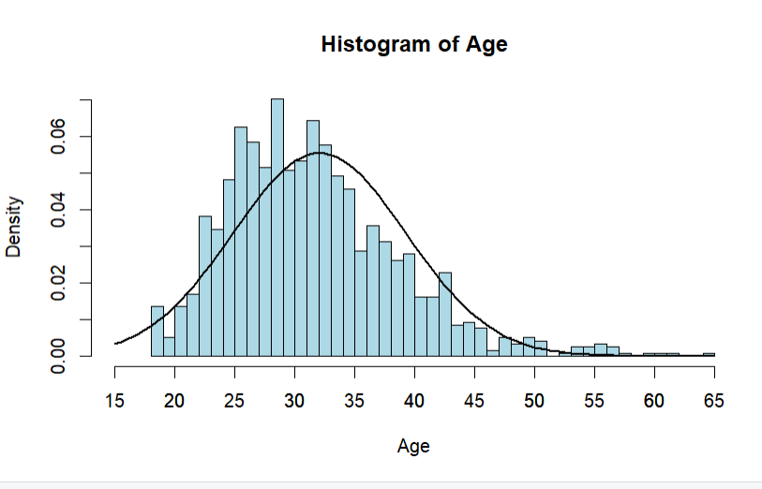 Fig 1: Histogram of Age

3.2 Additional Information from the Visualizations
The boxplot indicates that the median age of employees who sought treatment is slightly higher than that of employees who did not. While the spread of ages in both groups is broadly similar, the treatment group displays a greater number of higher-age outliers, suggesting that a larger proportion of older employees have sought professional support.
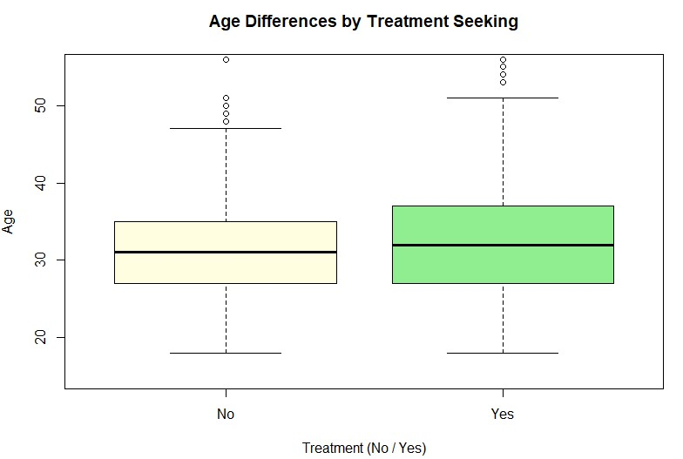

Fig 2: Boxplot of Age by Treatment Status (Comparison of age distributions for employees who sought treatment vs. those who did not.)

3.3 Key Insights from the Visual Output
The histogram shows that the age variable is mildly right skewed and does not follow a perfect normal distribution. Most respondents fall within the 25–35 age range. These characteristics supported the decision to apply a non-parametric statistical test when comparing the two groups.

4. Statistical Analysis

4.1 Test Selection and Output
Because the age data did not meet the normality assumption and the independent variable (treatment status) is binary, a Mann–Whitney U test (Wilcoxon Rank-Sum test) was selected. This non-parametric test compares the median age between two independent groups. The analysis produced a U statistic of 211,258.5 with a p-value of 0.014.

4.2 Hypothesis Decision and Interpretation
At a significance level of 0.05, the obtained p-value (0.014) is statistically significant. Therefore, the null hypothesis is rejected in favour of the alternative hypothesis. This result indicates that there is a significant difference in age between employees who seek mental-health treatment and those who do not. Specifically, employees who reported seeking treatment tend to be slightly older on average than those who have not.

5. Evaluation of Group Experience

5.1 Strengths of Group Work
The group demonstrated effective collaboration by clearly dividing responsibilities related to data preparation, visualization, statistical analysis, and report writing. Regular online discussions and file sharing ensure consistency across sections. The use of GitHub for version control enabled transparent contributions from all members and supported iterative improvements throughout the project.

5.2 Areas for Improvement
Despite overall effective collaboration, time pressure emerged during the final stages of the project, particularly during report formatting and final proofreading. Earlier integration of individual sections may have reduced the intensity of last-minute revisions. In future projects, more structured internal deadlines and frequent progress reviews would enhance efficiency further.

5.3 Time Management
Overall, time was managed satisfactorily, and most milestones were achieved according to the project timeline. However, allocating additional time for refining visual outputs and editing the final report would have further improved the quality of the submission.

5.4 Overall Project Evaluation
The project successfully met the learning objectives of the module by applying statistical reasoning and data visualisation techniques to a real-world dataset. The chosen methodology was appropriate for the research question, and the findings were both meaningful and interpretable.

5.5 GitHub Contribution Summary
The GitHub log (Appendix B) demonstrates consistent engagement from all group members. Key commits reflect the progressive development of the project from data cleaning through to final analysis and reporting.
Three Significant Commits:
- Filtering Data set – Established a clean and usable dataset for analysis.
- Histogram and Curve – Introduced the boxplot and histogram used to explore data patterns.
- test – Completed the hypothesis test and integrated findings into the final report.

6. Conclusions

6.1 Summary of Findings
The Mann–Whitney U test revealed a statistically significant difference in age between employees who seek mental-health treatment and those who do not. Employees who reported seeking treatment were, on average, slightly older than those who had not accessed professional support.

6.2 Interpretation of Results
These findings suggest that older employees may be more willing to seek mental-health treatment, potentially due to greater awareness, reduced stigma, or previous exposure to wellbeing initiatives. Younger employees may face greater barriers related to stigma, limited awareness, or concerns about career progression, highlighting an important area for organizational intervention.

6.3 Limitations and Future Research
This study is based on cross-sectional survey data and therefore cannot establish causal relationships. Future research could employ longitudinal designs and incorporate additional variables such as job role, gender, and organizational culture to provide a more comprehensive understanding of treatment-seeking behavior .

Reference List
Harvey, S.B., Modini, M., Joyce, S., Milligan-Saville, J.S., Tan, L., Mykletun, A. and Christensen, H. (2017) ‘Can work make you mentally ill? A systematic meta-review of work-related risk factors for common mental health problems’, Occupational and Environmental Medicine, 74(4), pp. 301–310.
Kessler, R.C., Chiu, W.T., Demler, O. and Walters, E.E. (2010) ‘Prevalence, severity, and comorbidity of mental disorders in the National Comorbidity Survey Replication’, Archives of General Psychiatry, 62(6), pp. 617–627.
Shih, Y.Y., Chang, T.H. and Chen, C.C. (2019) ‘Work stress and mental health in the technology industry’, Journal of Occupational Health Psychology, 24(2), pp. 173–184.
Wang, P.S., Simon, G.E., Avorn, J., Azocar, F., Ludman, E.J., McCulloch, J. and Kessler, R.C. (2014) ‘Telephone screening, outreach, and care management for depressed workers’, JAMA, 298(12), pp. 1401–1411.

Appendices

Appendix A: R Code Used for Analysis and Visualisation
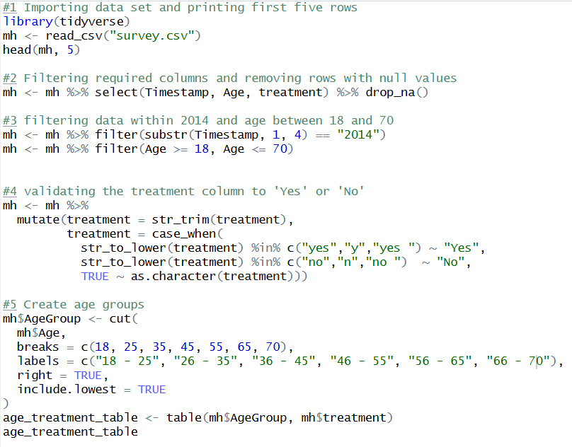 Fig 3: Rcode for Importing and Validating
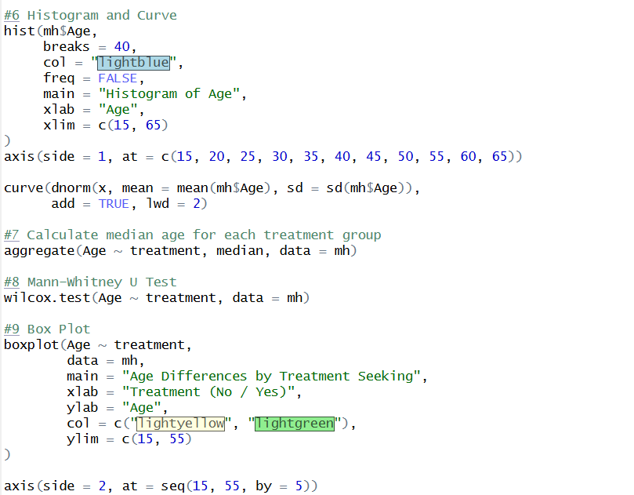
Fig 4: Rcode (Histogram and Boxplot as well as Analysis)
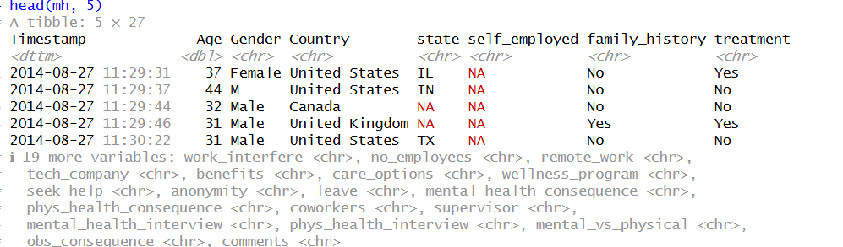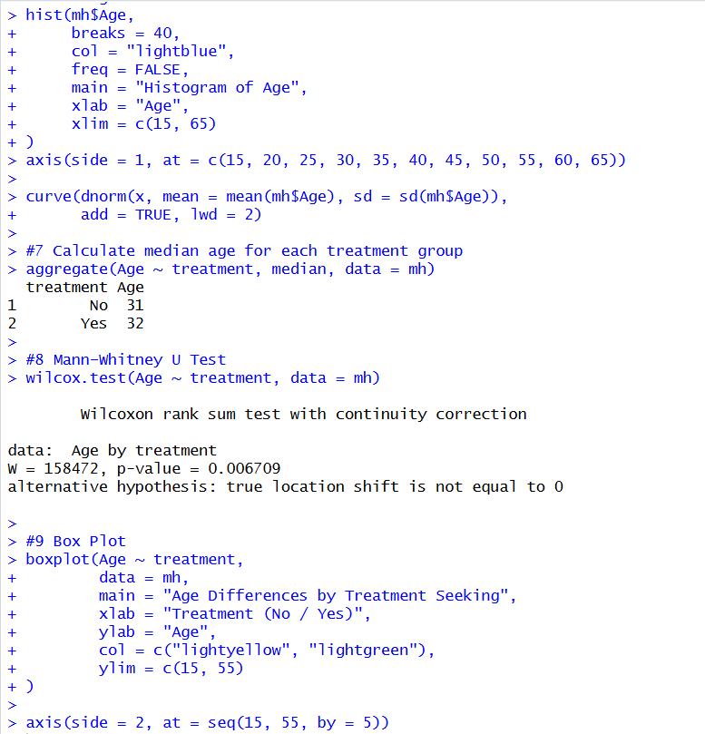
Fig 5: RCode output

Appendix B: GitHub Log Output
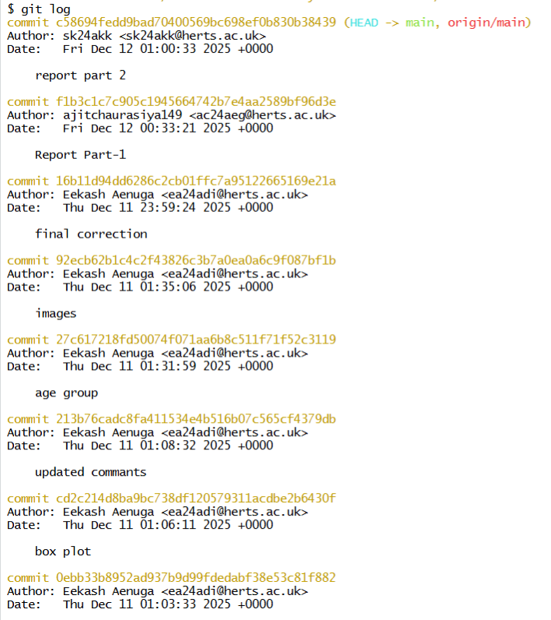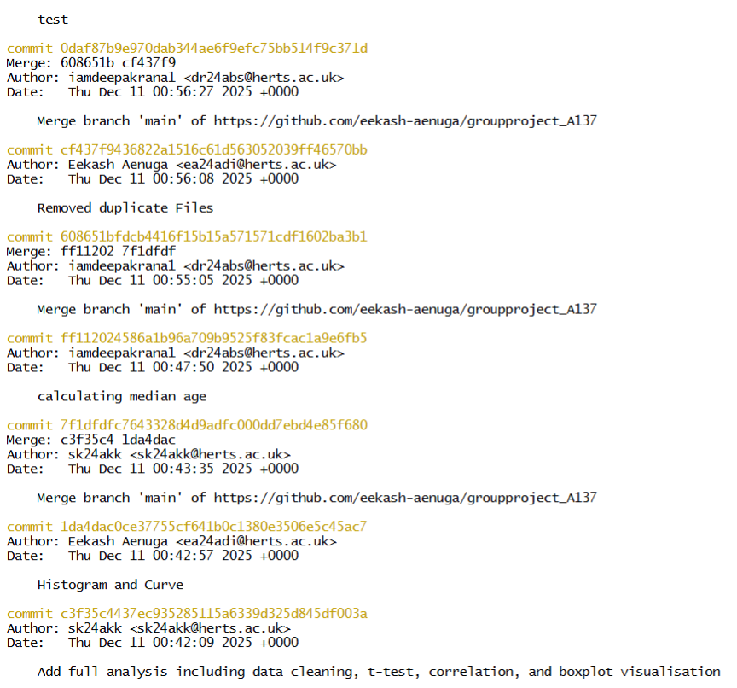
Fig 6: Git Commit 1

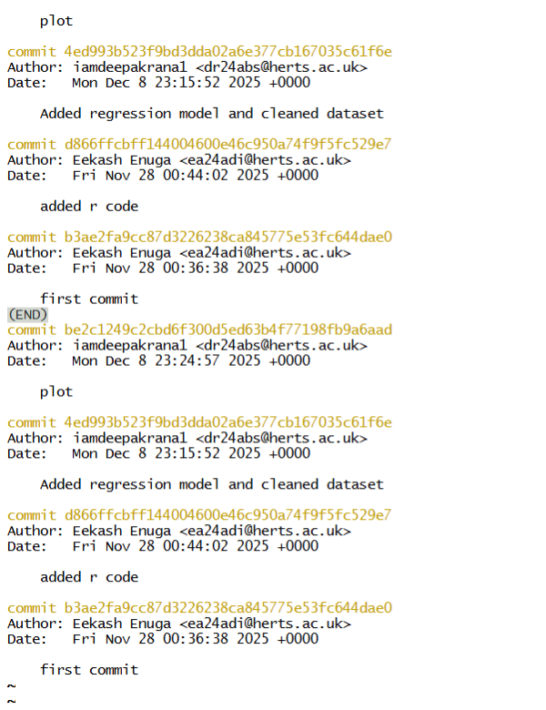
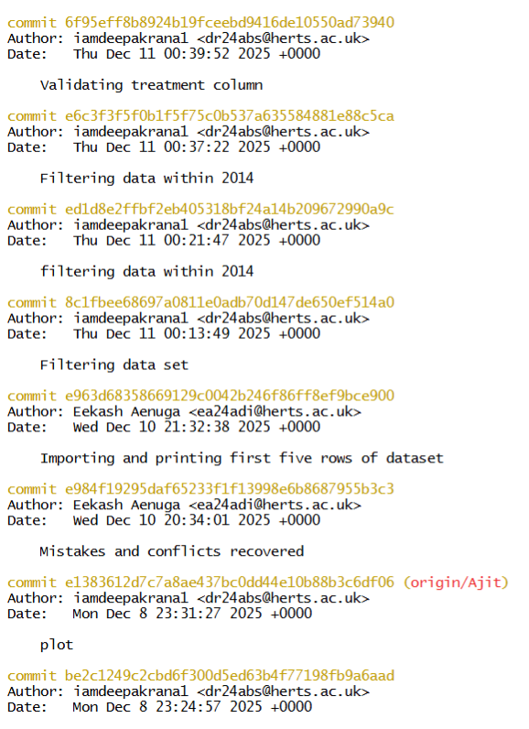

Fig 7: Git Commit 2

