**Income Census Classification**

Classifying the income census of a citizen using Logistic Regression

**Table of Contents**

* [Description](https://github.com/codersurajdiv/Cluster_analysis#description)
* [Getting Started](https://github.com/codersurajdiv/Cluster_analysis#getting-started)
  + [Prerequisites](https://github.com/codersurajdiv/Cluster_analysis#prerequisites)
  + [Installation](https://github.com/codersurajdiv/Cluster_analysis#installation)
* [Usage](https://github.com/codersurajdiv/Cluster_analysis#usage)
* [Results](https://github.com/codersurajdiv/Cluster_analysis#results)
* [Contributing](https://github.com/codersurajdiv/Cluster_analysis#contributing)
* [Author](https://github.com/codersurajdiv/Cluster_analysis#Author)

**Description**

The project applies the logistic regression algorithm to an adult income dataset. By analyzing the training dataset, it predicts outcomes when new citizen details are provided. The analysis focuses on the variables of age, race, gender, and education.

**Getting started**

**Prerequisites**

To run the project, you need to have python and the following packages installed:

* pandas==1.1.5
* matplotlib.pyplot==3.8.4
* scikit-learn==0.24.2
* seaborn==12.0b.3
* scipy==1.13.0

**Installation**

1. Clone the repository
2. Install the required packages

**Usage**

1. Place the "adult.csv" file in the project directory.
2. Run the ipynb script "income_analysis." to perform the model training and generate the results.

**Results**

The analysis generates an downward curve plot to determine the number of citizens holds thier income <=50000 and income >50000 from the dataset.

The final output is a summary presenting how age, education_num varies the income.

Here are the results:

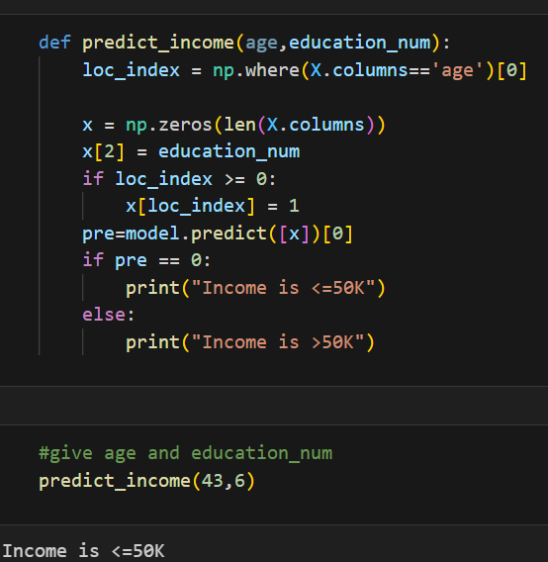

**Contributing**

Contributions are a welcome!

Please adhere to this project's code of conduct.

**Author**

* @eekshitha Divakala