CpG Graphs for all samples

Gria_5

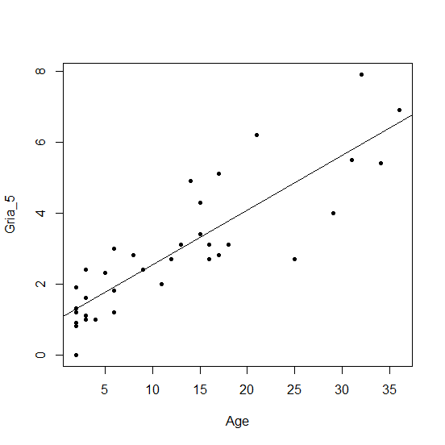

R2=0.749 P-value= 7.09e-13

Gria_1

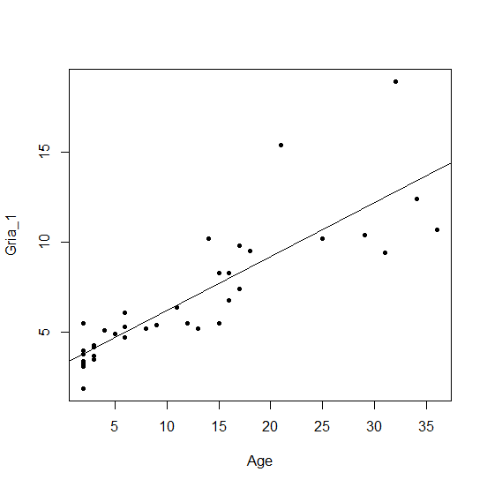

R2=0.7237 P-value= 4.26e-12

Cdkn2a 1

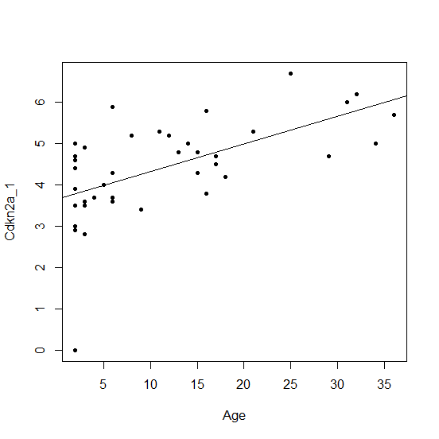

R2=0.3213 P-value= 1.003e-4

Cdkn2a 3

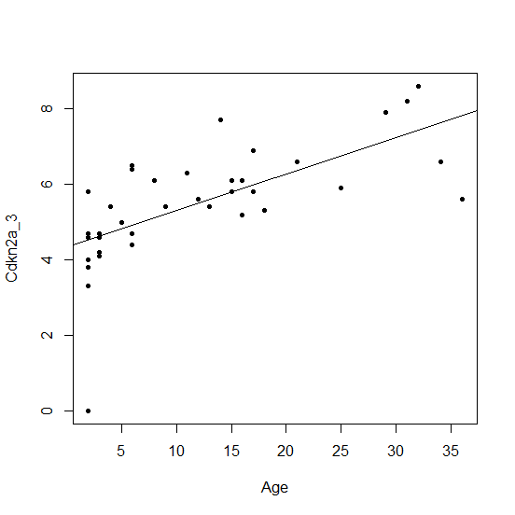

R2=0.4277 P-value= 3.806e-06

Cdkn2a 5

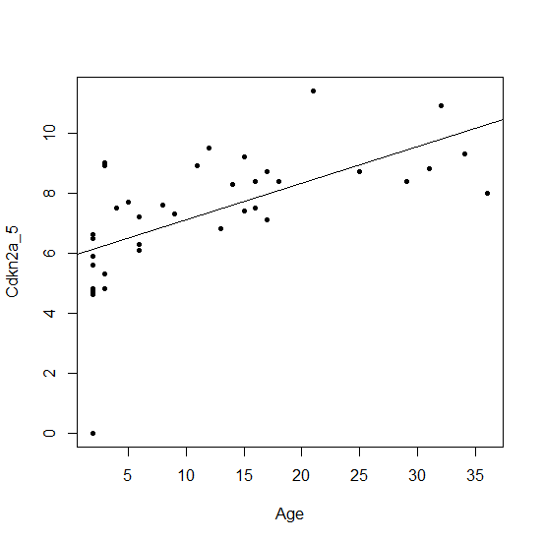

R2=0.3667 P-value= 2.64e-05

TET2 2

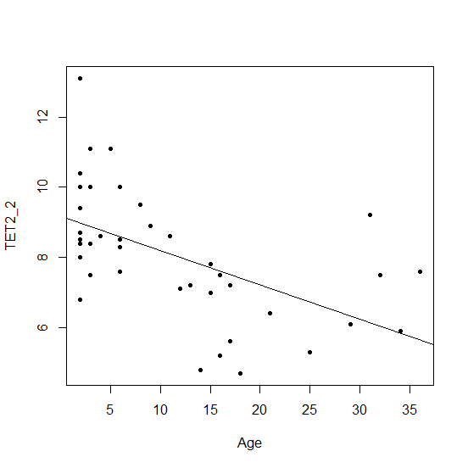

R2=0.2772 P-value= 0.0003412

TET2 4

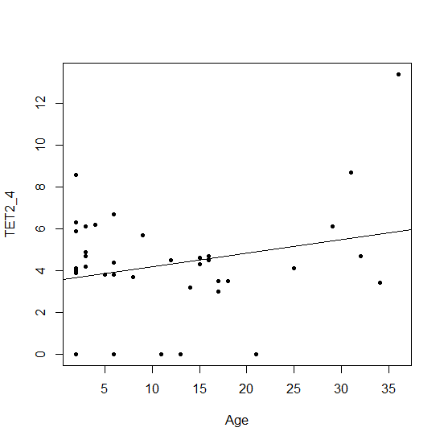

R2=0.03893 P-value= 0.1196

Gria 5

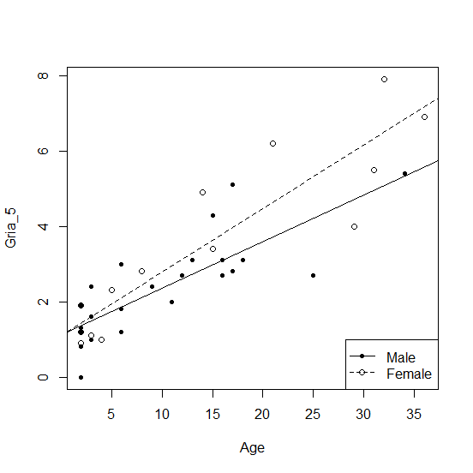

Male R2=0.6259 P=2.53E-06

Female R2=0.8214 P=1.99E-06

***intercept is same but slope is different for males and females

Gria 1

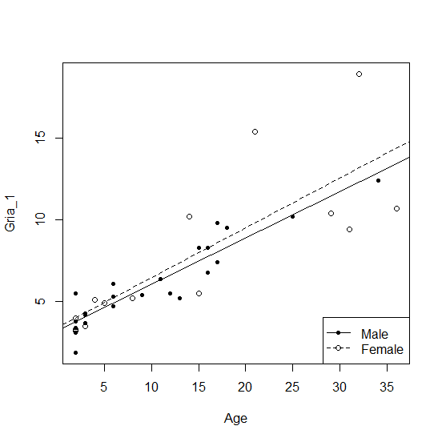

Male R2=0.8495 P=9.95E-11

Female R2=0.6364 P=2.23E-04

Cdkn2a 1

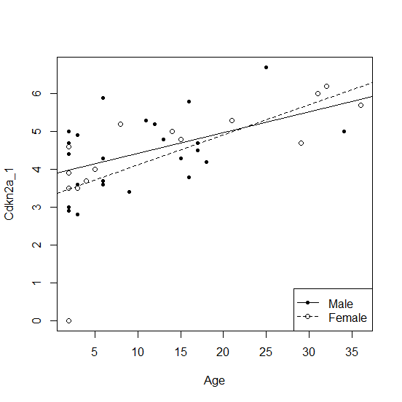

Cdkn2a 3

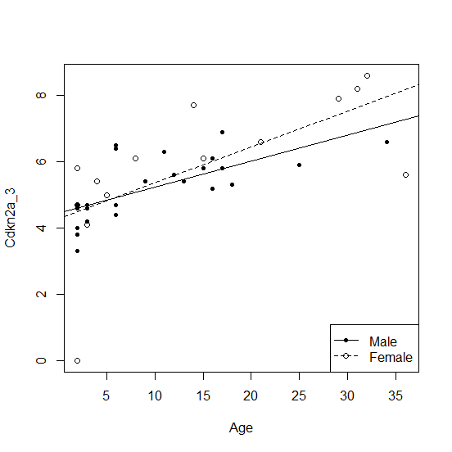

Cdkn2a 5

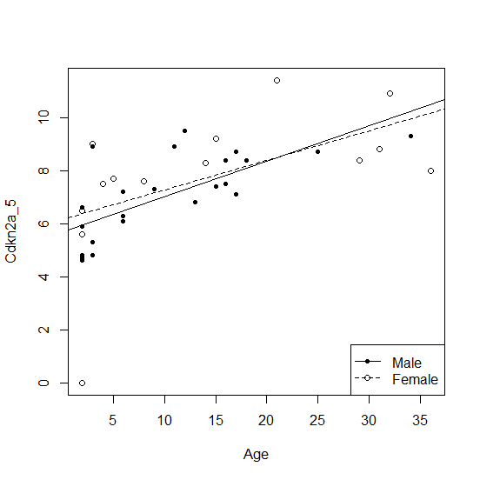

TET2 2

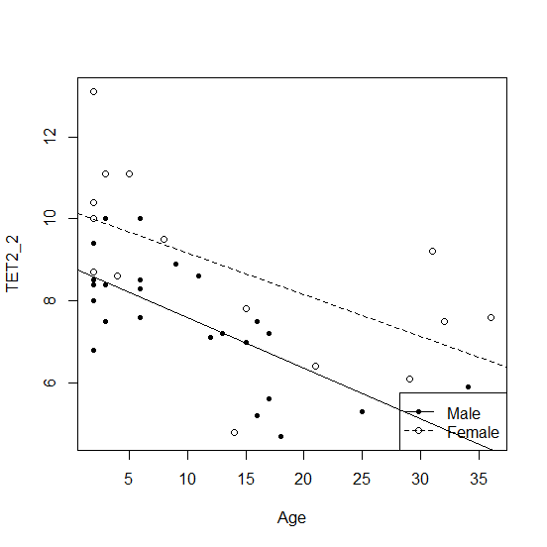

TET2 4

