ST0501 FRONT-END WEB DEVELOPMENT
INDIVIDUAL CA2 REFLECTION JOURNAL

Student Name: KANG ZI XUAN Admin Number: P2618382
Class: DCITP/1A/FT/04 Group No: 3

Objective :
This Reflection Journal requires you to critically analyze your CA2 project decisions, technical issues, and your responsible use of AI tools. Tutors are looking for depth of thought and examples that demonstrate understanding of your work.
Instructions:
- Answer all 3 parts below
- Total word count : 900-1200 words
- Use examples from your CA2 or class activities where relevant
- Submitted individually via BrightSpace.
- Attach your AI prompt logs using the Academic Integrity Declaration link (available in BrightSpace) in Appendix, this will not be included in the wordcount.
Page | Owner | Key content / purpose
Home | Elisa | Mission statement, snapshot of 3 featured tutors, "How it Works" teaser, sign-up CTA.
Sessions | Elisa | Displays the user's booked or upcoming tutoring sessions, including schedule and meeting details.
Profile | Elisa | User profile page where students/parents can view and update their personal information and account details.
Tutor Profile | Zi Xuan | Full tutor bio, qualifications, availability, and "Request This Tutor" button.
About Us | Zi Xuan | The problem (tuition cost vs. exchange-rate advantage), team bios, and why we built TutorBridge.
Resources for Parents | Zi Xuan | Study tips, first-session preparation, and links to free educational resources.
Pricing / Currency Comparison | Shin | Calculator: input subject and hours → live cost comparison with local tuition rates.
Sign-Up / Request a Tutor | Shin | Form for student/parent details, grade level, subject, budget, preferred time slots, with form validation.
How It Works | Shin | Step-by-step guide: browse tutors → choose subject and budget → request a trial → join via Google Meet.
Contact Us | Kalai | General enquiry form that reuses validation patterns from the Sign-Up page.
Shortlist | Kalai | Displays tutors that the user has shortlisted for easy comparison and future booking.
Testimonials / Success Stories | Kalai | Carousel of student success stories and feedback from parents.

Part 1: Reflection on Styling Frameworks & Interactivity
- What changes are made to the original plan? Why are the changes necessary? And what impact do they cause e.g on the website, user experience, performance etc?
- Analyze the trade-offs between using a front-end styling framework (e.g., Bootstrap/Tailwind) and writing custom CSS in your project. How did your choice affect the efficiency, design flexibility, or maintainability of your website?
- Evaluate one interactive feature (e.g., form validation, DOM update, dynamic menu) you implemented: How well does it improve user experience? If you had to enhance it further, what changes would you make and why?

Word Count Suggestion: 250-450 words. (Write your answer here)

One of the main changes made to the original plan was altering the website’s colour scheme. Initially, the background was plain white, but this was updated to teal to create a more engaging and visually appealing design. This change was necessary because colour strongly influences user perception and emotion. While white can feel minimalistic, it sometimes appears too stark or clinical. Teal, on the other hand, conveys freshness and calmness, which enhances the overall user experience. The impact of this adjustment is clear: it improves readability, strengthens brand identity, and makes the site feel more professional and inviting. Although the change does not affect technical performance, it positively influences how long users stay on the site and how they interact with its features. When analyzing the trade-offs between using a front-end styling framework such as Bootstrap or Tailwind and writing custom CSS, the decision comes down to efficiency, flexibility, and maintainability. Frameworks provide prebuilt components and utility classes that speed up development and ensure consistency, which is especially useful for teams. However, they can limit design originality and sometimes add unnecessary code. Custom CSS offers complete creative freedom and leaner styles tailored to the project, but it requires more time and careful organization to maintain. In my project, using a framework improved efficiency and responsiveness, but customizing unique designs required extra effort. This choice ultimately balanced speed with maintainability, though it meant sacrificing some flexibility compared to writing CSS entirely from scratch. For interactivity, I implemented form validation, which greatly improved user experience by preventing incorrect submissions and providing immediate feedback. Users are guided to correct errors before submitting, reducing frustration and ensuring cleaner data collection. To enhance this feature further, I would add clearer error messages that explain exactly what went wrong, visual cues such as highlighted fields or icons to draw attention, and accessibility improvements so that screen readers can convey the feedback effectively. These enhancements would make the interaction smoother, more inclusive, and more intuitive, ultimately strengthening usability and user satisfaction.
Part 2: Reflection on JavaScript & DOM Interactivity
- What changes are made to the original plan? Why are the changes necessary? And what impact do they cause e.g on the website, user experience, performance etc?
- Which JavaScript feature you added (e.g., image gallery, menu toggle, validation) made the biggest impact on your website’s user experience? Why?
- Think about the form your created in CA2 or practiced in class: What makes a form easy or hard for users to complete? What is one improvement you would suggest making a form more user-friendly, and why?

Word Count Suggestion: 250-450 words. (Write your answer here)

One of the main changes made to the original plan was adding a hamburger menu toggle for navigation. Initially, the website used a static navigation bar, which worked fine on larger screens but became cluttered and difficult to use on mobile devices. This change was necessary to improve responsiveness and accessibility, ensuring that users on smaller screens could still navigate easily. The impact of this adjustment was significant: it streamlined the design, reduced visual clutter, and improved the overall user experience without affecting performance. By collapsing the menu into a simple icon that expands on click, the site became more modern, mobile-friendly, and intuitive. The JavaScript feature that made the biggest impact was the hamburger menu toggle itself. This feature enhanced usability by allowing users to access navigation links quickly without overwhelming them with options on small screens. It improved the site’s responsiveness and gave users a smoother, more interactive experience. The toggle also demonstrated effective DOM manipulation, as elements were dynamically shown or hidden based on user interaction, making the site feel more engaging and functional. Thinking about forms created in class, a form is easy to complete when it has clear labels, logical grouping of fields, and real-time validation. It becomes difficult when there are too many fields, unclear instructions, or poor error messages. One improvement I would suggest is adding inline validation with specific feedback. For example, instead of simply saying “Invalid input,” the form could explain “Password must be at least 8 characters and include a number.” This would guide users more effectively, reduce frustration, and make the form more user-friendly. Combined with features like the hamburger menu, these improvements show how DOM and JavaScript interactivity can transform a website into a smoother, more accessible experience.

Part 3: Reflection on AI Usage and Evidence of Understanding

- Analyze your use of AI during this project: Which specific problem or task did AI help you with, and why did you choose to use AI for it?
- Choose one example where you used AI to help with coding for your website. Show the original AI-generated snippet and your modified version. Explain what you changed and why. How did your changes make the code better or fit your project needs?

Word Count Suggestion: 250-450 words. (Write your answer here)

I used AI to mainly support coding tasks and problem-solving with javascript and DOM interactivity. I struggled with writing clean, responsive code for interactive features like toggling menus and validating forms, AI provided quick examples, explained concepts clearly, and gave me a starting point to build from. Instead of searching through multiple tutorials, I could get targeted snippets and adapt them to my project. This saved time, helped me understand best practices, and improved the overall quality of my website’s interactivity.

AI was used to generate starter codes snippets when I needed to implement interactive features like the hamburger menu. Instead of writing everything from scratch, I asked AI to provide a basic JavaScript function to toggle the menu. This saved time and gave me a clear foundation to build on. I chose to use AI because it provided quick, working examples that helped me focus on customizing the feature to my project’s needs rather than struggling with syntax or logic errors. It also acted like a coding assistant, explaining how the DOM was being manipulated, which deepened my understanding.

before
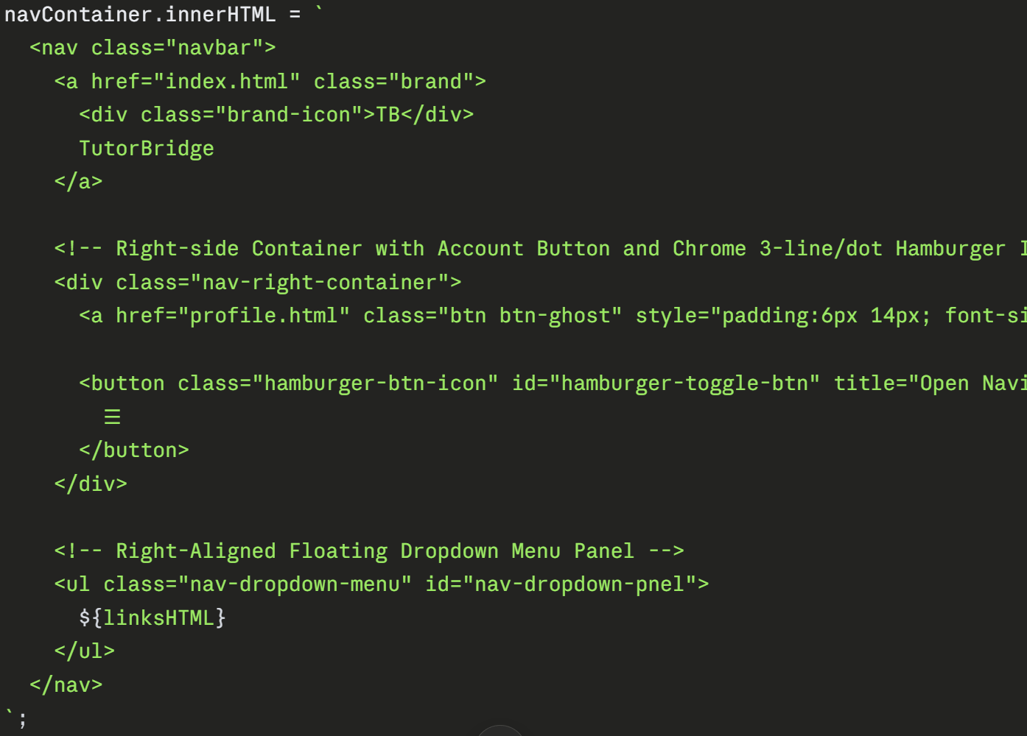
Modified
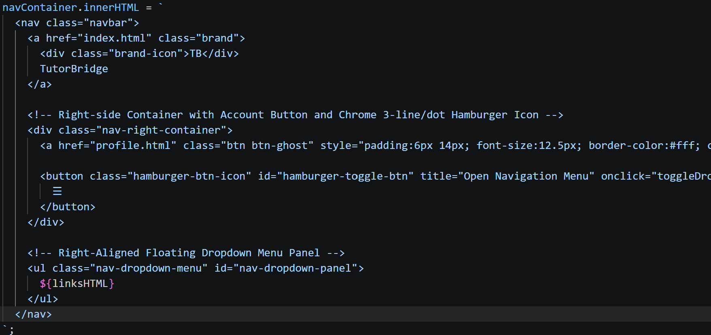

Appendix (e.g AI outputs or evidences you would like to include, this will not be included in the wordcount)

~~ The End ~~

